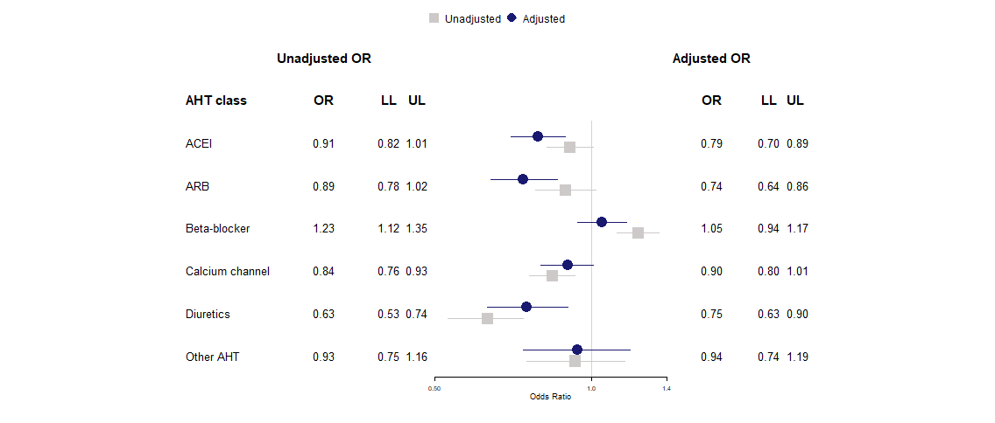 **Supplementary Figure 3 Subgroup case-control analysis** **for confirmed COVID-19 diagnoses showing unadjusted odds ratios (grey) and model adjusted for body mass index, blood pressure, smoking status, frailty level and comorbidities** **(blue) (n = 21,933).**

OR, odds ratio; LL, lower limit 95% confidence interval; UL, upper limit 95% confidence interval; ACEI, angiotensin-converting enzyme inhibitors; ARB, angiotensin receptor blockers