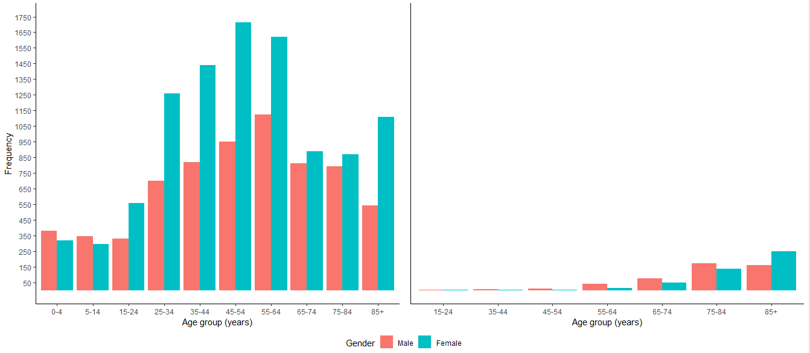

**Supplementary Figure 2: Age and gender distribution of COVID-19 cases (left) and deaths (right).**