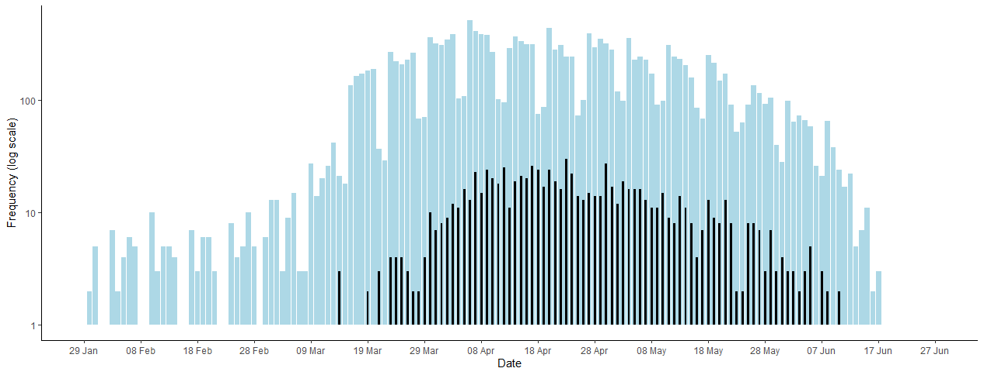

**Supplementary Figure 1: COVID-19 cases by date of diagnosis (blue) and deaths by date of death (black) from 29th January to 25th June 2020**