**Reinfection with SARS-CoV-2 and Failure of Humoral Immunity.**

**Supplement**:

Acknowledgements

Methods

Figure S1: Flow Diagram of Shedding and “Re-positives”

Figure S2: Chest Radiography at Primary Infection and Reinfection

Table S1: Intra-host Single Nucleotide Variants (iSNVs)

Figure S3: Titration curves for Anti-SARS-CoV-2 Serologies

Figure S4: Anti-SARS-CoV-2 IgG subclass distribution

Figure S5: Pseudovirus Neutralization IC50 curves

Table S2: Sequence Acknowledgement Table

**Acknowledgements:**

The authors would like to acknowledge the case patient InCOV139 for graciously donating time and samples to help understand the phenomenon of SARS-CoV-2 reinfection. We would also like to acknowledge the medical staff of Swedish Health Services who have worked tirelessly throughout the pandemic; and the following individuals: Mario Smith, Ismail Omar, Rosette Buyco, Shannon Wiley and the staff of the LabCorp Seattle Microbiology Lab; and Pavitra Roychoudhury, Amin Addetia, and Keith R. Jerome of UW Virology. The authors thank ATUM for providing recombinant SARS-CoV-2 proteins for this study.

**Supplemental Methods:**

PCR Testing:

Quantitative real-time polymerase chain reaction (rt-PCR) was performed in three laboratories. In March, the CTs reported in Table S1 were performed on a lab-developed test at UW Virology in Seattle, WA based on the WHO primers for RdRP and E genes.1 In July, the CTs reported in Table S1 were performed at the LabCorp Microbiology, on-site at Swedish Health Services in Seattle, WA with the Xpert® Xpress SARS-CoV-2 test on the GeneXpert Infinity System (Cepheid, Sunnyvale, CA) as per the manufacturer guideline. The Cepheid assay targets the E and N2 genes. In July, the diagnosis by PCR was confirmed by a lab-developed test at Institute for Systems Biology in Seattle, WA based on the CDC primers for N1gene.2 This test performed on research nasopharyngeal swab collected on D16 after onset of symptoms showed CT = 38.5. Assays across platforms are comparable.3, 4 Figures and descriptive statistics were generated in Stata v13.1 (StataCorp LP, College Station, TX)

UW Virology rapid metagenomic NGS:

In March, rapid metagenomic next-generation sequencing (NGS) was performed.5, 6 Briefly, nasopharyngeal swab samples were filtered, RNA was extracted, then treated with DNAse. Libraries were generated from cDNA and 20 cycles of PCR, then quality controlled prior to sequencing run on MiSeq desktop (Illumina, San Diego, CA) using 180 cycles single-read reagent kit. Trimmed and quality filtered reads were assembled de novo, contigs aligned to the reference sequence (NC_045512), and a consensus sequence was generated. The sequence was deposited in Genbank (MT252824) and GISAID (EPI_ISL_416456). For Table S2, to calculate the percent of reads for the SNV, raw reads were mapped to the reference sequence (NC_045512).

Institute for System Biology multiplex PCR amplicon NGS:

In July, highly multiplexed PCR amplicon NGS was performed on the D16 nasopharyngeal swab, using the ARTIC V3 amplicon primer scheme,7 and modified from the ARTIC protocol,8 to approach the low copy number sample, as follows. RNA was extracted from nasopharyngeal swab samples using the miRNeasy kit (Qiagen, Germantown, MD) and cDNA was synthesized with the LunaScript RT SuperMix kit (NEB, Ipswich, MA). The set of 98 SARS-CoV-2-specific primer pairs were synthesized7 and pooled for multiplex PCR using the following PCR conditions: 98oC for 30 seconds, followed by 40 cycles of 95oC for 15 seconds, 65oC for 5 minutes. The primer set generated overlapping PCR fragments covering the entire viral genome, the average amplicon length being 400 bp with an approximate 100 bp overlap. After cleaning up the PCR products with AMPure XP beads (Beckman Coulter, Indianapolis, IN), Fragmentase (NEB, Ipswich, MA) was added to break down the PCR products to about 200 bp for library construction. The sequencing libraries were prepared with NEBNext Ultra II kit for Illumina (NEB, Ipswich, MA) following manufacturer’s protocol and each library was assigned with a unique 6-base index. Libraries ranging in size from 300 to 500 bp were selected with Pippin HT (Sage Science, Beverly, MA) and the size was confirmed with the Bioanalyzer (Agilent, Santa Clara, CA). Libraries were quantified with the KAPA Library Quantification Kit for Illumina Platforms (Kapa Biosystems, Wilmington, MA) and pooled at a final concentration of 5nM. Pooled libraries were run on NextSeq (Illumina, San Diego, CA) using 300 cycles paired end reagent kit. The raw sequence data was demultiplexed using qcat (https://github.com/nanoporetech/qcat) and assembled against reference genome (NC_045512.2) with Sequencher (Gene Codes, Ann Arbor, MI), allowing for no more than 2 mismatches within a 40 base pair window. Ambiguous bases were amplified via PCR and sent for Sanger sequencing. The mutation at C18877T is confirmed via Sanger sequencing (Primers: Forward CGCACCTGTTGTCTATGTGA, Reverse: GAACCTTTCTACAAGCCGCAT, Sequencing: GGTTTTACAGGTAACCTACA), but amplification was unsuccessful at other positions.

Variant Calling and Phylogenetic Analysis:

Single nucleotide variants (SNV) are given for any positions with variants compared to Wuhan-Hu-1 reference with any % mapped reads > 5% or a variant (**Table S2**). For the purposes of the phylogeny, SNVs were confidently called only if the variant existed in >90% of mapped reads. Consensus viral sequences from InCoV139-March and InCoV139-July were analyzed using Nextstrain software (build 8f28f11) for real-time tracking of pathogen evolution.9 NextClade was used to determine differences from the reference sequence and to ascertain clade,10 which consists of five clades: 19A, 19B, 20A, 20B, and 20C. To visualize the natural history of SARS-CoV-2 evolution in Washington State, we included all Washington sequences present in Nextstrain as of August 24, 2020. We also included additional Washington and non-Washington sequences present in GISAID11 illustrative of major root and intermediate clade nodes for context. For comparison, the pairs of sequences from the two other reinfection cases from Hong Kong and Nevada were also included.12, 13 We subsampled the final tree to 70 sequences to de-clutter the visualization. The sequence acknowledgement table for included samples is given (**Table S4**). Alignment and tree construction proceeded with the default parameters for the Nextstrain pipeline (build 8f28f11); trees were visualized with auspice (auspice.us) and Tree of Life.14 In a sensitivity analyses, ambiguous variants in the July sequence were called with lower SNV thresholds. These analyses could change the clade determination from 20A to 20C, but do not change the phylogenetic conclusion that InCoV139-July (clade 20A or 20C) is distinct from InCoV139-March (clade 19B).

Stanford anti-SARS-CoV-2 ELISA serology and ACE2-RBD blocking antibody assay:

ELISAs with SARS-CoV-2 antigens were performed using protocols as previously described.15 Briefly, 96-well plates that were coated with SARS-CoV-2 RBD, full length spike, or nucleocapsid (N) antigens were incubated with 2-fold serial dilutions of patient plasma samples from 1:50 to 1:3200 alongside a negative and positive plasma control for each plate. Bound antibodies were detected with peroxidase-conjugated anti-human IgG, IgM, or IgA antibodies. IgG subclass assays were completed with 1:100 diluted plasma samples using peroxidase-conjugated anti-human IgG1, IgG2, IgG3, or IgG4 antibodies. A chromogenic reaction was initiated with TMB and quenched with sulfuric acid. The optical density (OD) at 450 nm was read with a microplate reader and adjusted for background OD from blank wells. The cutoff values for positivity were defined as 3 SDs above the mean ODs from pre-pandemic healthy blood donors. Competition ELISAs to detect antibodies blocking binding of ACE2 to RBD were performed. Briefly, 96-well plates coated with SARS-CoV-2 RBD were incubated with patient plasma samples at a dilution of 1:10, alongside a negative and positive plasma control for each plate and with soluble human ACE2 fused to a mouse Fc (ACE2-mFc). The Fc region of ACE2-mFc was detected with peroxidase-conjugated goat anti-mouse IgG. The chromogenic reaction and reading of OD were performed in the same manner as for the Ig isotype and IgG subclass assays. The percentage of ACE2-RBD blocking by anti-RBD plasma antibodies was calculated as the relative decrease in ACE2 binding compared to a negative quality control plasma included in each experiment. Data were analyzed and plotted in GraphPad Prism version 8.0.

Monogram Biosciences, pseudovirus neutralization (PhenoSense® CoV Neutralizing Antibody Assay):

A cell-culture based assay to test neutralizing activity of patient plasma to pseudovirus infection was performed using protocols as previously described.16 Briefly, a lentivirus-based SARS-CoV-2 pseudovirus particle was generated expressing spike proteins on the surface from the Wuhan-Hu-1 reference (Genbank: NC_045512.2) expressing the early D614. A separate pseudovirus particle expressing the transitioned D614G mutation was engineered from site directed mutagenesis on the original Wuhan-Hu-1 strain. Plasma samples were heat inactivated at 56°C for one hour and diluted 1:40 in cell culture medium. Neutralizing antibody (nAb) titres were determined by creating 9 serial three-fold dilutions of test samples which were mixed with ~105 relative light units (RLU) of SARS-CoV2 pseudotyped virus and incubated at 37°C for one hour. Separately, irrelevant virus was used as a specificity control and mixed with test samples. Following the one hour incubation HEK 293 ACE2-transfected cells were added to the well. The plates were incubated for 60-80 hours at 37°C and then assayed for luciferase expression. Neutralization titers are reported as the reciprocal of the serum dilution conferring 50% inhibition (ID50) of pseudovirus infection, adjusting for background florescence. SARS-CoV-2 nAb assay positive and negative control plasma were included on each 96-well assay plate (1 each) along with 6 patient specimens.

Stanford, IGH sequencing and repertoire analysis:

Immunoglobulin heavy chain (IGH) libraries were prepared for high throughput sequencing from cDNA generated from total RNA isolated from PBMCs. Reverse transcription was primed with random hexamer primers, and cDNA was used as template for PCR amplification using barcoded IGHV FR1 primers and isotype specific primers located in the first exon of the constant region for each isotype category (IgM, IgD, IgE, IgA, IgG), with each isotype amplified in a separate reaction, as previously reported.17 Libraries were pooled, gel purified and quantitated prior to sequencing on MiSeq (Illumina), using 600 cycle kits for paired end 300 cycle sequencing. Read pairs were joined and then aligned to IGH germline gene segments using IgBLAST.17, 18 Exact matching to non-primer encoded constant region gene sequence was required for isotype identification. Clonal identities within each subject were inferred using single linkage clustering and the following definition: same IGHV and IGHJ usage (disregarding allele call), equal CDR-H3 length, and minimum 90% CDR-H3 nucleotide identity. Somatic mutation frequency for clones was quantitated with reference to the best matching IGHV germline gene. Data were plotted in R. Single-cell immunoglobulin libraries were prepared using the 10x Single Cell Immune Profiling Solution Kit (v1.1 Chemistry), according to the manufacturer’s instructions. Single-cell Ig libraries were sequenced on an Illumina MiSeq to a minimum sequencing depth of 5,000 reads/cell. Consensus Ig annotation was performed using cellranger vdj (10x Genomics, version 4.0.0 with GRCh38/Ensembl reference data). Further details for repertoire analysis are available in Nielsen et al.19

**Supplemental Figure Legends**

**Figure S1: Flow Diagram for Repositive Analysis.** All PCR samples for hospitalized or Emergency Department patients were analyzed. Unique patients were selected from all samples in subsequent steps who had 1) any single positive test, 2) two or more positive tests (n=176 for shedding duration analysis, **Figure 1A**), and 3) at least three tests in a “re-positive” pattern of positive – negative – positive (n=43 for re-positive analysis, **Figure 1B**).

**Figure S2: Chest Radiography.** A: March Admission, Hospital Day #5 showing hyperinflation of empyesema and bilateral lower lobe infiltrates. B: July Admission, Hospital Day #1: showing baseline emphysema without acute cardiopulmonary disease.

**Figure S3: Titration curves for IgG, IgM and IgA specific for RBD, Spike and N antigens**. Serial twofold plasma dilutions were assayed to determine anti-spike (A), anti-RBD (B), and anti-N (C) IgM, IgG, and IgA antibody titers. Plasma pools from SARS-CoV-2 pre-pandemic healthy blood donors and from COVID-19 patients were used as negative and positive quality control (QC), respectively. Assays were performed in duplicate and mean OD values are shown.

**Figure S4: Anti-SARS-CoV-2 IgG subclass distribution.** Plasma samples collected at D14, D18, D21, and D42 after reinfection COVID-19 diagnosis were analyzed at a 1:100 dilution for their anti-spike (A), anti-RBD (B), and anti-N (C) IgG subclass profile. A SARS-CoV-2 pre-pandemic plasma pool from healthy blood donors was included as negative quality control (QC). Assays were performed in duplicate and mean OD values are shown.

**Figure S5: Pseudovirus Neutralization IC50 curves.** Columns represent the dilution curves for patient sample at day 14 after reinfection and day 42 after reinfection. Rows represent pseudovirus assays expressing the wildtype SARS-CoV-2 D614 (of the 19A clade), newer SARS-CoV-2 G614 (of the 20A clade), and SARS-CoV-1 (2003). Serial three-fold plasma dilutions starting at 1:40 were pre-incubated separately with pseudovirus particles prior to adding ACE2-expressing HEK 293, and the cell cultures were read at 72 hours. The plasma dilution needed to inhibit 50% of infectivity (IC50%) was read from the sigmoidal inhibition curves.

**Figure S1: Flow Diagram of Shedding and “Re-positives**”

**Figure S1: Flow Diagram for Re-positivity Analysis**

Unique Persons Tested for SARS-CoV-2 (N = 11,622)

Total 15,462 resulted samples

(1,082 positive, 14,378 negative, 2 presumptive positive)

10,979 persons never positive

133 persons without a negative test between 2 positive tests

Unique Persons with ≥ 3 Samples in a “Re-positive” Pattern (n = 43)

Total 378 samples

(232 positive, 146 negative)

467 persons with 1 test only

Unique Persons with ≥ 2 Positive Samples (n=176)

Total 831 samples

(615 positive, 215 negative, 1 presumptive positive)

Unique Persons with ≥ 1 Positive Sample (n = 643)

Total 1,331 samples

(1,082 positive, 225 negative, 1 presumptive positive)

**Figure S2: Chest Radiography.** A: March Admission, HD#5 showing hyperinflation of emphysema and bilateral lower lobe infiltrates. B: July Admission, HD#1: showing baseline emphysema without acute cardiopulmonary disease.

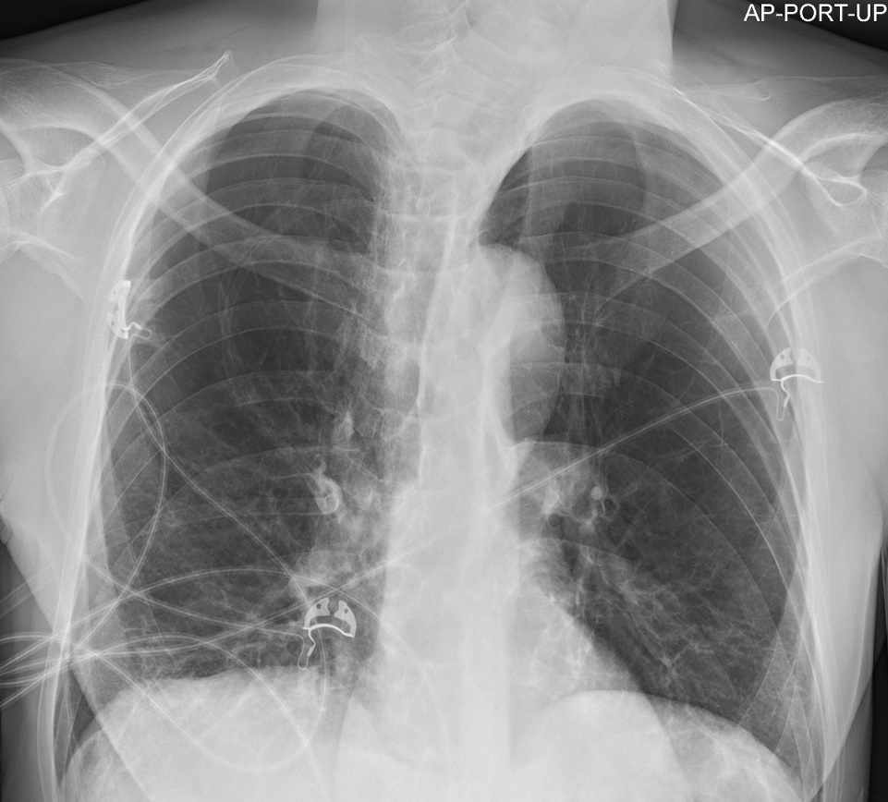

**Table S1: Intra-host Single Nucleotide Variants.**

|  |  |  |  |  |  |  |
| --- | --- | --- | --- | --- | --- | --- |
| **Mutation** | **Date** | **SNV** | **Clade** | **Protein** | **Substitution** | **% reads for SNV** |
| 1 | March | C8782T | 19B | Nsp4 | **-** | 1.00 |
| 2 | March | C17747T | 19B | Helicase | P1427L | 1.00 |
| 3 | March | A17858G | 19B | Helicase | Y1464C | 1.00 |
| 4 | March | C18060T | 19B | Exonuclease | **-** | 1.00 |
| 5 | March | T28144C | 19B | orf8 | L84S | 1.00 |
| 1 | July | C241T | 20A | 5’UTR | **-** | 1.00 |
| 2 | July | C1059Y | 20C | Nsp2 | T85I | 0.19 |
| 3 | July | C3037T | 20A | Nsp3 | **-** | 1.00 |
| 4 | July | C6539Y | unique | Nsp3 | H2092Y | 0.64 |
| 5 | July | G11540K | unique | Nsp6 | V3579F | 0.38 |
| 6 | July | A12557M | WA outbreak | Nsp8 | I4098L | 0.27 |
| 7 | July | C14408T | 20A | RdRp | P314L | 1.00 |
| 8 | July | C18877T* | 20A | Exonuclease | **-** | 0.57 |
| 9 | July | A23403G | 20A | S protein | D614G | 1.00 |
| 10 | July | G25483R | unique | orf3a | A31T | 0.60 |
| 11 | July | G25563T | 20C | orf3a | Q57H | 0.94 |
| 12 | July | C27167Y | unique | M protein | **-** | 0.52 |

* Ambiguity code not given because SNV confirmed with Sanger sequencing.

Canonical mutations are colored in the above table when passing the variant calling method, as follows from this key:

|  |  |  |  |  |
| --- | --- | --- | --- | --- |
| **Color:** | **Clade:** | **Ancestor:** | **Canonical Mutations:** | **Node Viruses:** |
|  | 19A | Root | Reference | Wuhan-Hu-1 |
|  | 19B | 19A | C8782T, and T28144C | WA1 shares C18060T |
|  | 20A | 19A | C3037T, C14408T, A23403G | Germany/BavPat3-ChVir1020 |
|  | 20B | 20A | G28881A, G28882A, G28883C |  |
|  | 20C | 20A | C1059T, and G25563T |  |

**Figure S3**: **Titration curves for IgG, IgM and IgA specific for RBD, Spike and N antigens**.

**Figure S4: Anti-SARS-CoV-2 IgG subclass distribution.**

**Figure S5: Pseudovirus Neutralization IC50 Curves.**

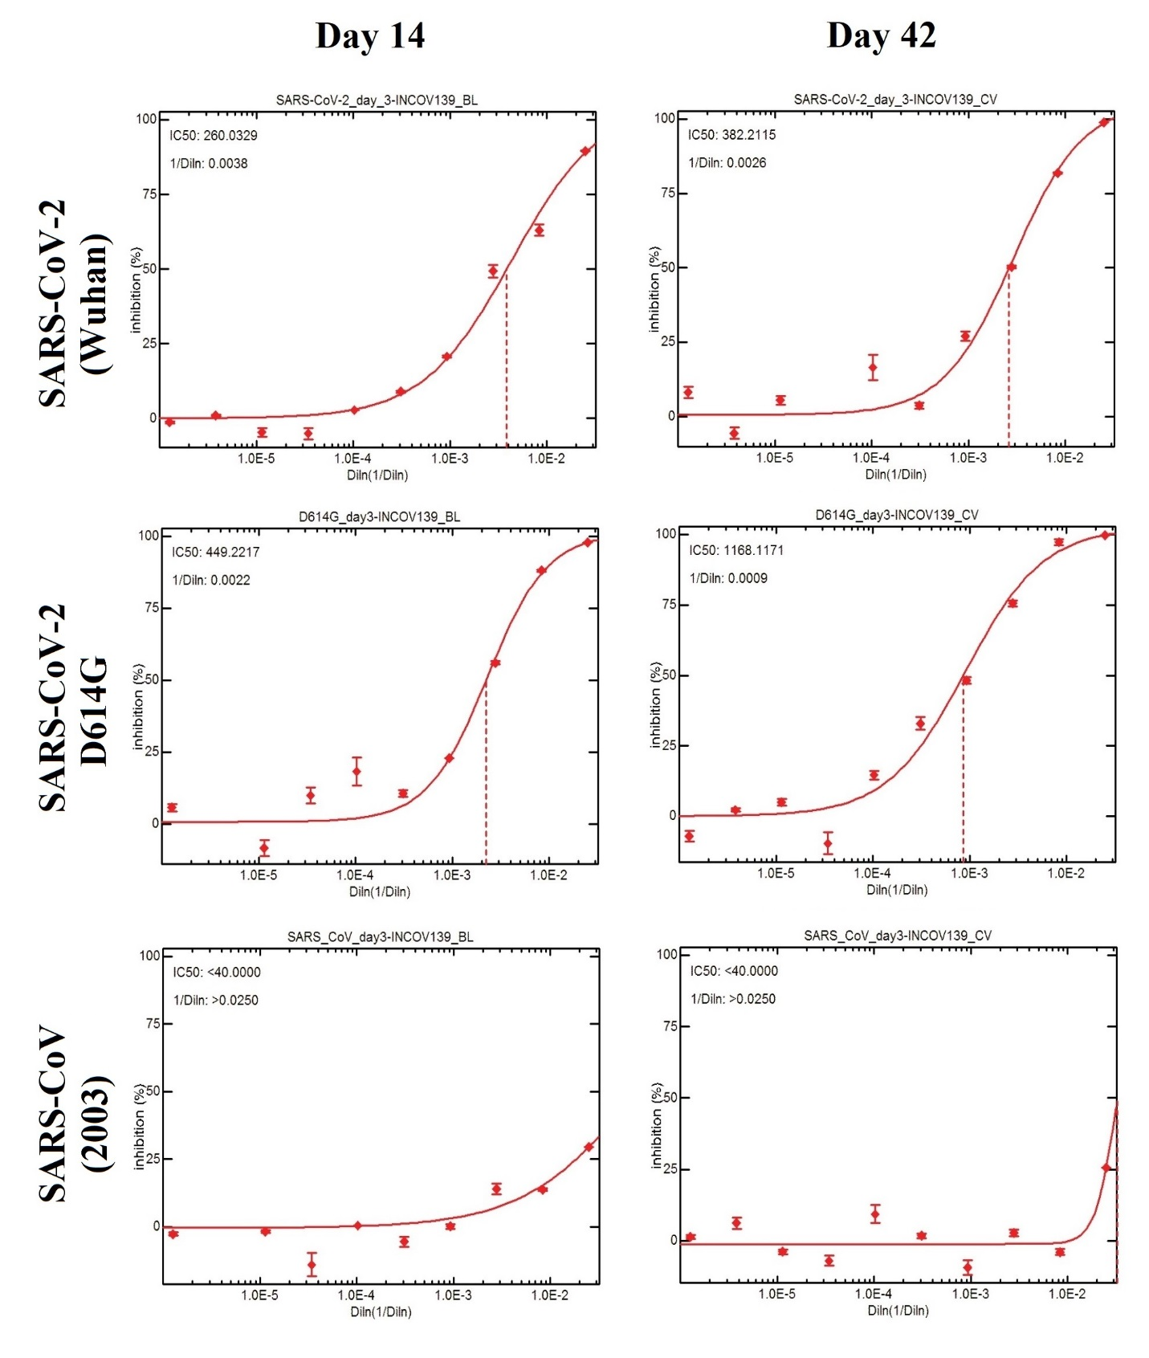

**Table S2: Sequence Acknowledgement Table.**

|  |  |  |  |  |
| --- | --- | --- | --- | --- |
| **GenBank / Name** | **GISAID Accession** | **Collection Date** | **Originating / Submitting Lab** | **Authors:** |
| Wuhan/Hu-1/2019 | EPI_ISL_402125 | 12/26/2019 | China CDC / same | Zhang et al |
| USA/WA1/2020 | EPI_ISL_404895 | 01/19/2020 | PRMCE / US CDC | Queen et al |
| Australia/NSW2153/2020 | EPI_ISL_509505 | 01/25/2020 | SAViD / same | Rawlinson et al |
| Germany/BavPat3-ChVir1020/2020 | EPI_ISL_450200 | 01/28/2020 | Dept Virology / same | Boehmer et al |
| France/HF1463/2020 | EPI_ISL_429968 | 02/21/2020 | CHCLB / NRCVRI | Albert et al |
| USA/WA-S82/2020 | EPI_ISL_417135 | 02/22/2020 | WA DOH / SFS | Chu et al |
| USA/WA3-UW1/2020 | EPI_ISL_413025 | 02/27/2020 | HMC / UW Virology | Roychoudhury et al |
| USA/WA-S47/2020 | EPI_ISL_417100 | 02/29/2020 | WA DOH / SFS | Chu et al |
| Spain/Canarias201939/2020 | EPI_ISL_455326 | 02/29/2020 | HUIGC / ISC | Iglesias-Caballero et al |
| USA/WA-S1488/2020 | EPI_ISL_495663 | 03/08/2020 | SFS / same | Nickerson et al |
| USA/WA-UW62/2020 | EPI_ISL_415627 | 03/09/2020 | UW Virology / same | Roychoudhury et al |
| USA/WA-UW-671/2020 | EPI_ISL_476925 | 03/12/2020 | UW Virology / same | Roychoudhury et al |
| USA/WA-UW197/2020 | EPI_ISL_417346 | 03/12/2020 | UW Virology / same | Roychoudhury et al |
| USA/WA-S540/2020 | EPI_ISL_434300 | 03/24/2020 | WA DOH / SFS | Chu et al |
| USA/WA-S579/2020 | EPI_ISL_434339 | 03/24/2020 | WA DOH / SFS | Chu et al |
| USA/WA-S390/2020 | EPI_ISL_434150 | 03/27/2020 | WA DOH / SFS | Chu et al |
| USA/WA-UW-2909/2020 | EPI_ISL_486047 | 03/28/2020 | UW Virology / same | Roychoudhury et al |
| USA/WA-UW-4243/2020 | EPI_ISL_430939 | 04/01/2020 | UW Virology / same | Roychoudhury et al |
| USA/WA-S333/2020 | EPI_ISL_434093 | 04/04/2020 | WA DOH / SFS | Chu et al |
| USA/WA-S712/2020 | EPI_ISL_449882 | 04/07/2020 | WA DOH / SFS | Chu et al |
| USA/WA-UW-5947/2020 | EPI_ISL_430932 | 04/07/2020 | UW Virology / same | Roychoudhury et al |
| USA/WA-S597/2020 | EPI_ISL_438150 | 04/13/2020 | SFS / same | Chu et al |
| USA/WA-S769/2020 | EPI_ISL_449939 | 04/14/2020 | WA DOH / SFS | Chu et al |
| USA/WA-S884/2020 | EPI_ISL_463374 | 04/17/2020 | WA DOH / SFS | Chu et al |
| USA/WA-S629/2020 | EPI_ISL_438182 | 04/18/2020 | WA DOH / SFS | Chu et al |
| USA/WA-S842/2020 | EPI_ISL_463332 | 04/21/2020 | WA DOH / SFS | Chu et al |
| USA/WA-S862/2020 | EPI_ISL_463352 | 04/22/2020 | WA DOH / SFS | Chu et al |
| USA/WA-S615/2020 | EPI_ISL_438168 | 04/23/2020 | SFS / same | Chu et al |
| USA/WA-S870/2020 | EPI_ISL_463360 | 04/24/2020 | WA DOH / SFS | Chu et al |
| USA/WA-S912/2020 | EPI_ISL_463402 | 04/27/2020 | WA DOH / SFS | Chu et al |
| USA/WA-S889/2020 | EPI_ISL_463379 | 04/28/2020 | WA DOH / SFS | Chu et al |
| USA/WA-S900/2020 | EPI_ISL_463390 | 04/28/2020 | WA DOH / SFS | Chu et al |
| USA/WA-S957/2020 | EPI_ISL_463447 | 04/28/2020 | WA DOH / SFS | Chu et al |
| USA/WA-S1007/2020 | EPI_ISL_463497 | 04/30/2020 | WA DOH / SFS | Chu et al |
| USA/WA-S1043/2020 | EPI_ISL_463533 | 05/03/2020 | WA DOH / SFS | Chu et al |
| USA/WA-S1159/2020 | EPI_ISL_463649 | 05/04/2020 | WA DOH / SFS | Chu et al |
| USA/WA-UW-8686/2020 | EPI_ISL_501155 | 05/06/2020 | UW Virology / same | Roychoudhury et al |
| USA/WA-S1310/2020 | EPI_ISL_495760 | 05/14/2020 | WA DOH / SFS | Nickerson et al |
| USA/WA-S1391/2020 | EPI_ISL_495841 | 05/19/2020 | WA DOH / SFS | Nickerson et al |
| USA/WA-S1413/2020 | EPI_ISL_495863 | 05/20/2020 | WA DOH / SFS | Nickerson et al |
| USA/WA-S1425/2020 | EPI_ISL_495875 | 05/20/2020 | WA DOH / SFS | Nickerson et al |
| USA/WA-S1562/2020 | EPI_ISL_495988 | 05/26/2020 | WA DOH / SFS | Nickerson et al |
| USA/WA-S1837/2020 | EPI_ISL_496263 | 05/27/2020 | WA DOH / SFS | Nickerson et al |
| USA/WA-S1851/2020 | EPI_ISL_496277 | 05/27/2020 | WA DOH / SFS | Nickerson et al |
| USA/WA-S1791/2020 | EPI_ISL_496217 | 06/02/2020 | WA DOH / SFS | Nickerson et al |
| USA/WA-S1940/2020 | EPI_ISL_497368 | 06/02/2020 | WA DOH / SFS | Nickerson et al |
| USA/WA-S1951/2020 | EPI_ISL_497379 | 06/02/2020 | WA DOH / SFS | Nickerson et al |
| USA/WA-S1995/2020 | EPI_ISL_497423 | 06/04/2020 | WA DOH / SFS | Nickerson et al |
| USA/WA-S2173/2020 | EPI_ISL_497601 | 06/08/2020 | WA DOH / SFS | Nickerson et al |
| USA/WA-S2298/2020 | EPI_ISL_497726 | 06/10/2020 | WA DOH / SFS | Nickerson et al |
| USA/WA-S2578/2020 | EPI_ISL_497210 | 06/18/2020 | WA DOH / SFS | Nickerson et al |
| USA/WA-UW-11263/2020 | EPI_ISL_501094 | 06/18/2020 | UW Virology / same | Roychoudhury et al |
| USA/WA-UW-13400/2020 | EPI_ISL_501148 | 07/02/2020 | UW Virology / same | Roychoudhury et al |
| USA/WA-UW-13306/2020 | EPI_ISL_501135 | 07/03/2020 | UW Virology / same | Roychoudhury et al |
| HongKong/HKU-200823-001/2020 | EPI_ISL_516798 | 03/26/2020 | UHK / same | To et al |
| HongKong/HKU-200823-002/2020 | EPI_ISL_516799 | 08/17/2020 | UHK / same | To et al |
| Nevada_First_Case_A | Pending | 04/18/2020 | Pending | Tillett et al |
| Nevada_Second_Case_B | Pending | 06/05/2020 | Pending | Tillett et al |
| USA/WA-UW39/2020 (aka, InCoV139-March) | EPI_ISL_416456 | 03/06/2020 | UW Virology / same | Roychoudhury et al |
| InCoV139-July | Pending | 07/29/2020 | ISB / same | Pending |

Abbreviations: same = same originating and submitting laboratory; China CDC = National Institute for Communicable Disease Control and Prevention, Chinese Center for Disease Control and Prevention; WA DOH = Washington State Department of Health; SFS = Seattle Flu Study; UW Virology = University of Washington Virology Lab; PRMCE = Providence Regional Medical Center Everett; US CDC = Division of Viral Diseases, United States Centers for Disease Control and Prevention; HMC = Harborview Medical Center; SAViD = Area of Virology, Serology and Virology Division, New South Wales Health Pathology Randwick; CHCLB = Centre Hospitalier Compiagne Laboratoire de Biologie; NRCVRI = National Reference Center for Viruses of Respiratory Infections, Institut Pasteur, Paris; UHK = Department of Microbiology, The University of Hong Kong; HUIGC = Hospital Universitario Insular de Gran Canaria; ISC = Instituto de Salud Carlos III; ISB = Institute for Systems Biology.

**References:**

1. WHO. Diagnostic detection of Wuhan coronavirus 2019 by real-time RTPCR-Protocol and preliminary evaluation as of Jan 13, 2020-. <https://www.who.int/docs/default-source/coronaviruse/wuhan-virus-assay-v1991527e5122341d99287a1b17c111902.pdf?sfvrsn=d381fc88_2>

2. CDC. CDC’s Diagnostic Test for COVID-19 Only and Supplies. Accessed September 4, 2020, <https://www.cdc.gov/coronavirus/2019-ncov/lab/virus-requests.html>.

3. Nalla AK, Casto AM, Huang MW, et al. Comparative Performance of SARS-CoV-2 Detection Assays Using Seven Different Primer-Probe Sets and One Assay Kit. *J Clin Microbiol*. 05 2020;58(6)doi:10.1128/JCM.00557-20

4. Lieberman JA, Pepper G, Naccache SN, Huang ML, Jerome KR, Greninger AL. Comparison of Commercially Available and Laboratory-Developed Assays for. *J Clin Microbiol*. Jul 2020;58(8)doi:10.1128/JCM.00821-20

5. Bedford T, Greninger AL, Roychoudhury P, et al. Cryptic transmission of SARS-CoV-2 in Washington State. *medRxiv*. Apr 2020;doi:10.1101/2020.04.02.20051417

6. Greninger AL, Zerr DM, Qin X, et al. Rapid Metagenomic Next-Generation Sequencing during an Investigation of Hospital-Acquired Human Parainfluenza Virus 3 Infections. *J Clin Microbiol*. 01 2017;55(1):177-182. doi:10.1128/JCM.01881-16

7. Quick, J. nCoV-2019 sequencing protocol v3. <https://github.com/joshquick/artic-ncov2019/blob/master/primer_schemes/nCoV-2019/V3/nCoV-2019.tsv>

8. Quick J, Grubaugh ND, Pullan ST, et al. Multiplex PCR method for MinION and Illumina sequencing of Zika and other virus genomes directly from clinical samples. *Nat Protoc*. Jun 2017;12(6):1261-1276. doi:10.1038/nprot.2017.066

9. Hadfield J, Megill C, Bell SM, et al. Nextstrain: real-time tracking of pathogen evolution. *Bioinformatics*. 12 2018;34(23):4121-4123. doi:10.1093/bioinformatics/bty407

10. Hodcroft E, Hadfield J, Neher R, Bedford T. Year-letter Genetic Clade Naming for SARS-CoV-2 on Nextstain.org. Accessed August 29, 2020, <https://nextstrain.org/blog/2020-06-02-SARSCoV2-clade-naming>

11. Elbe S, Buckland-Merrett G. Data, disease and diplomacy: GISAID's innovative contribution to global health. *Glob Chall*. Jan 2017;1(1):33-46. doi:10.1002/gch2.1018

12. To KK, Hung IF, Ip JD, et al. COVID-19 re-infection by a phylogenetically distinct SARS-coronavirus-2 strain confirmed by whole genome sequencing. *Clin Infect Dis*. Aug 2020;doi:10.1093/cid/ciaa1275

13. Tillett RL, Sevinsky JR, Hartley PD, et al. Genomic Evidence for a Case of Reinfection with SARS-CoV-2. THELANCETID-D-20-05376. Accessed August 29, 2020, <https://ssrn.com/abstract=3681489>

14. Letunic I, Bork P. Interactive Tree Of Life (iTOL) v4: recent updates and new developments. *Nucleic Acids Res*. 07 2019;47(W1):W256-W259. doi:10.1093/nar/gkz239

15. Röltgen K, Wirz OF, Stevens BA, et al. SARS-CoV-2 Antibody Responses Correlate with Resolution of RNAemia But Are Short-Lived in Patients with Mild Illness. *medRxiv*. Aug 2020;doi:10.1101/2020.08.15.20175794

16. Folegatti PM, Ewer KJ, Aley PK, et al. Safety and immunogenicity of the ChAdOx1 nCoV-19 vaccine against SARS-CoV-2: a preliminary report of a phase 1/2, single-blind, randomised controlled trial. *Lancet*. Jul 2020;doi:10.1016/S0140-6736(20)31604-4

17. Roskin KM, Jackson KJL, Lee JY, et al. Aberrant B cell repertoire selection associated with HIV neutralizing antibody breadth. *Nat Immunol*. Feb 2020;21(2):199-209. doi:10.1038/s41590-019-0581-0

18. Ye J, Ma N, Madden TL, Ostell JM. IgBLAST: an immunoglobulin variable domain sequence analysis tool. *Nucleic Acids Res*. Jul 2013;41(Web Server issue):W34-40. doi:10.1093/nar/gkt382

19. Nielsen SCA, Yang F, Jackson KJL, et al. Human B cell clonal expansion and convergent antibody responses to SARS-CoV-2. *bioRxiv*. 2020:2020.07.08.194456. doi:10.1101/2020.07.08.194456