**Supplemental Figures**

**Contents**

**Supplementary Figures1**

**Figure S1.** Regional association plot for 9q34.2 locus of meta-GWAS summary statistics2

**Figure S2.** Regional association plot for 9q21.32 locus of meta-GWAS summary statistics3

**Figure S3.** Violin plots show significant single-tissue sQTLs for rs9976829 in *IFNAR2* gene across GTEx tissues4

**Figure S4.** MAGMA gene-property analysis based on 83 tissue types from the GTEx database5

**Figure S5.** Dot plot of top risk genes for COVID-19 for each cell type from human lung tissue7

**Figure S6.** Violin plots of expression for 11 risk genes in 50 cell-types of human lung tissue8

**Figure S7.** Summary of 11 identified genes associated with COVID-19 in potentially druggable categories9

**Figure S8.** Network-based enrichment analysis of 41 COVID-19-related genes10

**Supplemental Figure S1. Regional association plot for 9q34.2 locus of meta-GWAS summary statistics**

Regional association plot showed the association signals of 9q34.2 locus based on the meta-GWAS summary statistics of meta-analyzing the COVID_I GWAS data (controlled for potential population stratification) with ANA5 GWAS data. The purple diamond marks the most strongly-associated SNP of rs576123, which is high linkage disequilibrium (LD) with the reported rs657152 in the Ellinghaus et al. 1 study, with COVID-19. The color illustrates LD information with rs576123, as shown in the color legend. Two SNPs of rs34357864 (P = 9.74 × 10-8) and rs8176719 (P = 4.76 × 10-7), which are not LD with rs576123 (P = 3.37× 10-7) and rs657152 (P = 5.53 × 10-6), showed associations with COVID-19 (see Supplemental Table S1).

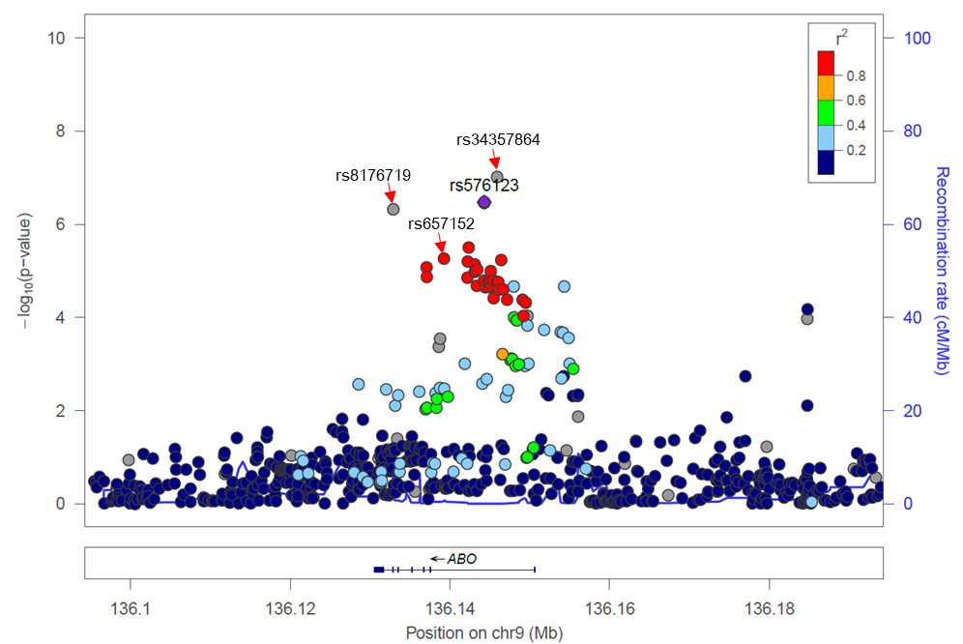

**Supplemental Figure S2. Regional association plot for 9q21.32 locus of meta-GWAS summary statistics**

Regional association plot showed the association signals of 9q21.32 locus based on the meta-GWAS summary statistics of meta-analyzing the COVID_I GWAS data (controlled for potential population stratification) with ANA5 GWAS data. The purple diamond marks the most strongly associated SNP of rs7021189 with COVID-19. The color illustrates LD information with rs7021189, as shown in the color legend.

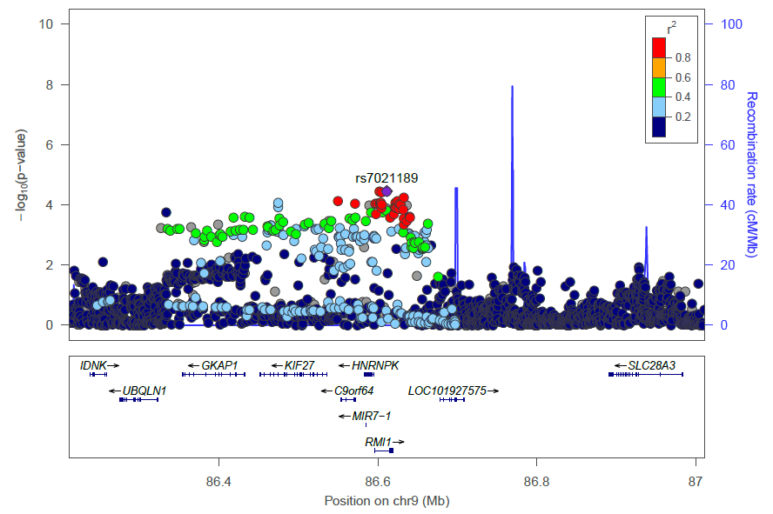

**Supplemental Figure S3. Violin plots show significant single-tissue sQTLs for rs9976829 in *IFNAR2* and *IL10RB* genes across GTEx tissues.**

A) *IFNAR2* gene, and B) *IL10RB* gene. sQTLs is the abbreviation of splicing quantitative trait loci. sQTLs data were based on GTEx Analysis Release (version 8, dbGaP Accession phs000424.v8.p2). Data analysis and visualization were performed by using the web-access tool of GTEx portal (<https://www.gtexportal.org/home/snp/rs9976829>).

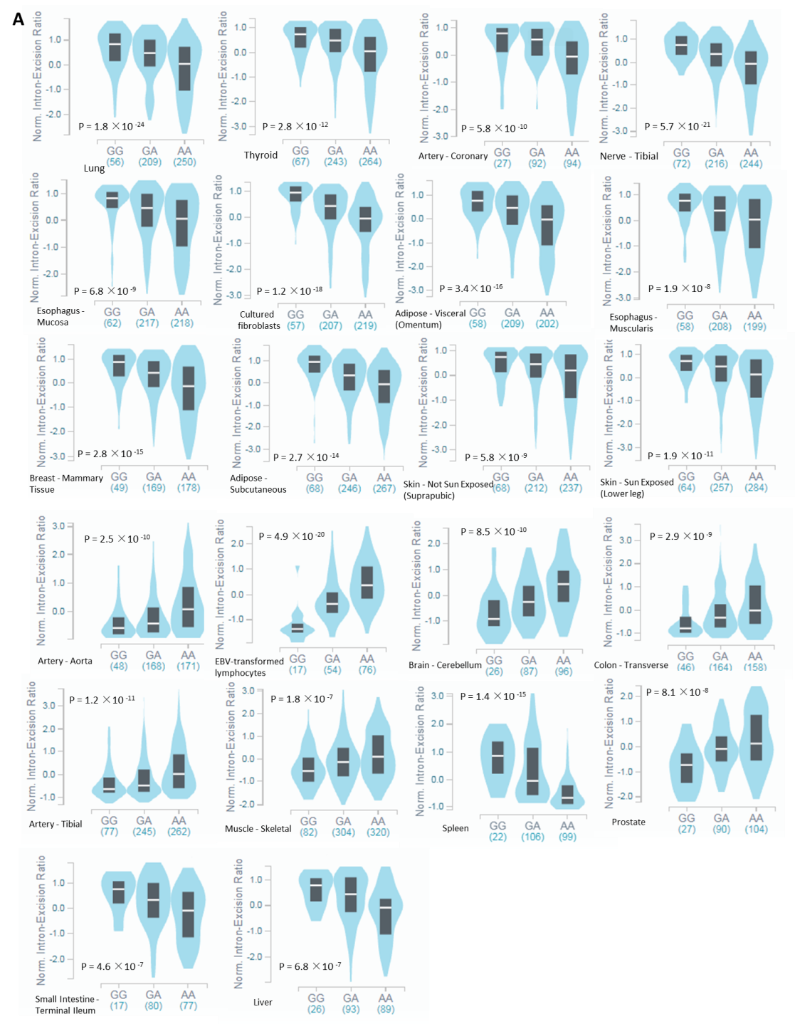

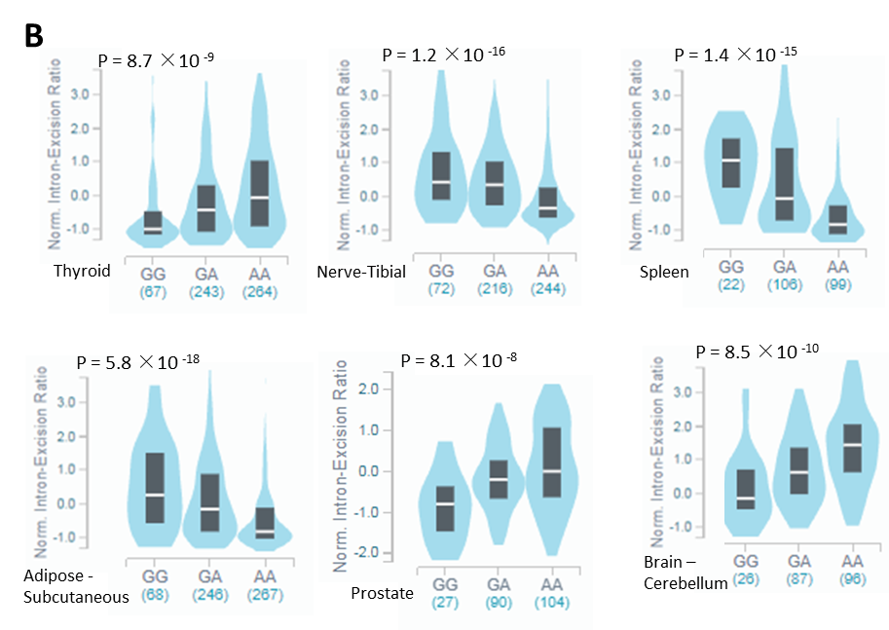

**Supplemental Figure S4. MAGMA gene-property analysis based on 83 tissue types from the GTEx database.**

1. Histogram showed the results from 30 general tissue types; (B) Histogram showed the results from 53 specific tissue types.

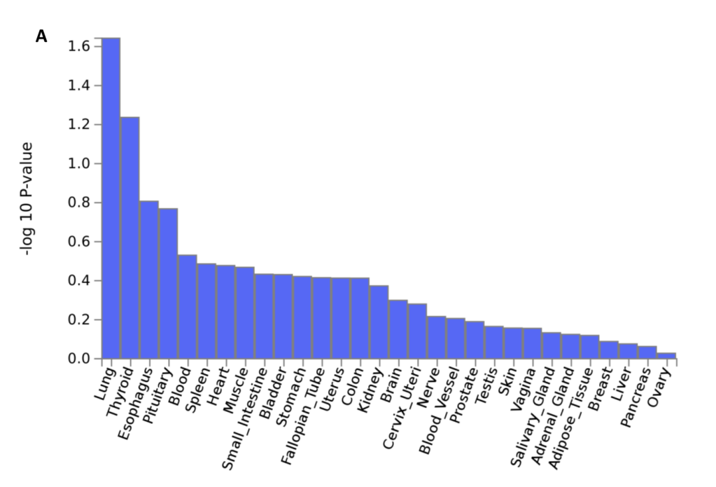

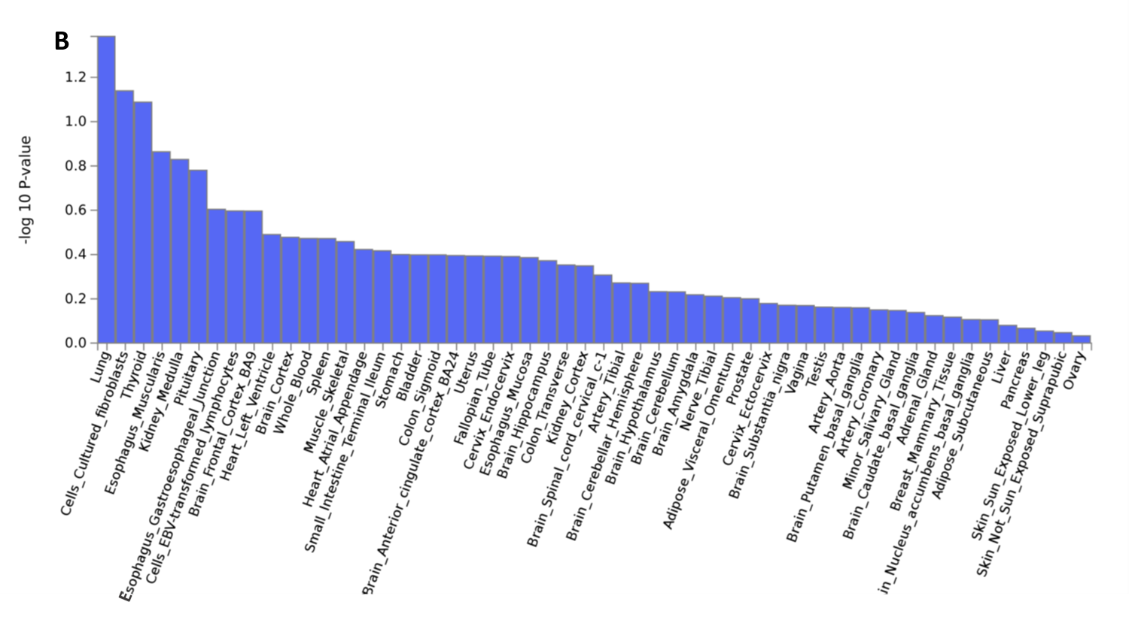

**Supplemental Figure S5. Dot plot of top risk genes for COVID-19 for each cell type from human lung tissue.** Dot size represents fraction of cells within cell type expressing a given gene, and color intensity represents binned count-based expression amounts (log(scaled UMI +1)) among expressing cells.

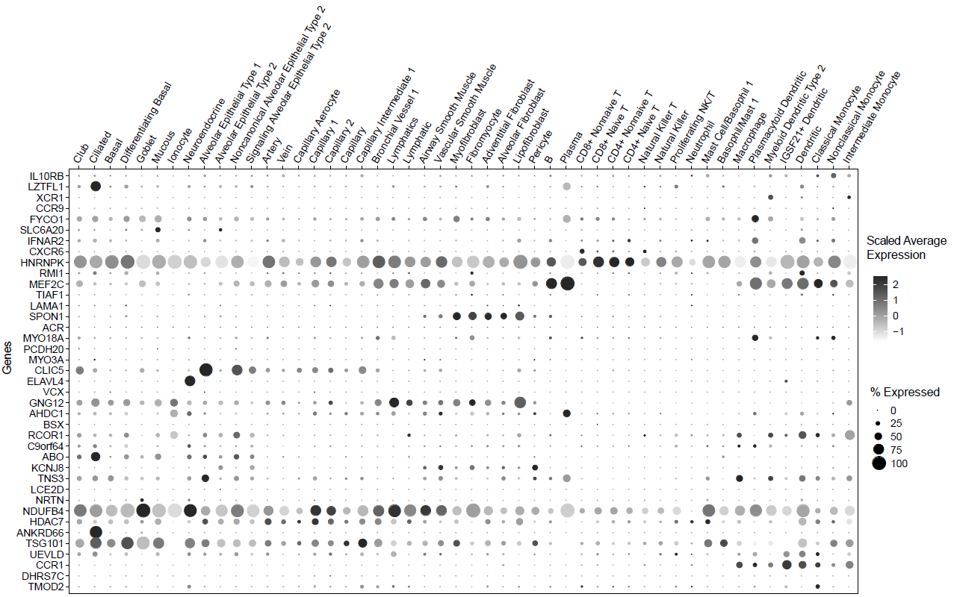

**Supplemental Figure S6. Violin plots of expression for 11 risk genes in 50 cell-types of human lung tissue.** This plot is based on a data set as a part of the Human Lung Atlas, consisting of 50 cell populations across 4 compartments (epithelial, endothelial, stromal and immune) of lung tissue (x axis). y axis represents the expression level with log transformed count. Color legend represents 50 specific cell-types in 4 compartments.

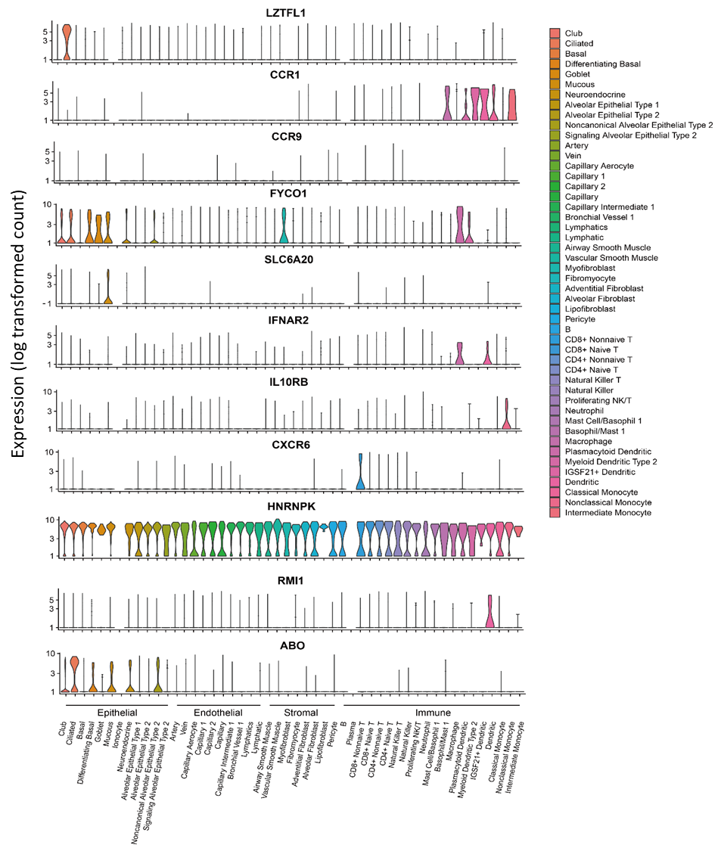

**Supplemental Figure S7. Summary of 11 identified genes associated with COVID-19 in potentially druggable categories.**

The color represents whether genes were matched in druggable categories or not. Green marks matching genes with drug-targets, and range marks marching genes with drug-targets, and blue marks non-matching genes, as shown in the color legend. The data are shown in the Supplemental Tables S9 and S10.

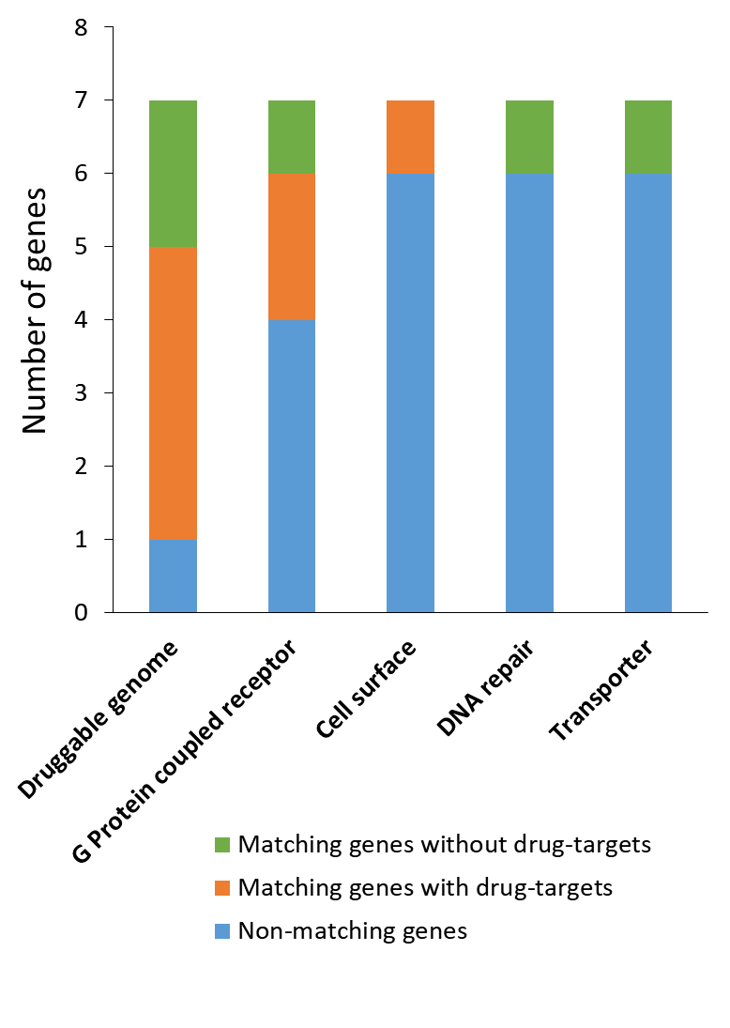

**Supplemental Figure S8. Network-based enrichment analysis of 41 COVID-19-related genes.** The protein-protein interactions (PPI) were based on the database of STRING v11.0. P value from the network-based enrichment analysis is 0.013, indicating these 41 COVID-19-related genes are at least partially biologically connected as a group. Network nodes represent the submitted genes. Network edges represent protein-protein associations based on known interactions derived from curated databases and experimentally determined, and predicted interactions derived from gene neighborhood, gene fusions, and gene co-occurrence.

