Supplemental Digital Content

Edwards T, Santos VS, Wilson AL, et al. SARS-CoV-2 viral load over time and disease severity: a systematic review.

Supplementary Table 1. Risk of bias assessment according to Joanna Briggs tools for case report studies.
Supplementary Table 2. Risk of bias assessment according to Joanna Briggs tools for case series studies.
Supplementary Figure 1. Flowchart of study selection.
Supplementary Figure 2. Distribution of viral loads of all samples. Error bars show median and interquartile range.
Supplementary Figure 3. Distribution of CT values of all samples. Error bars show median and interquartile range.
Supplementary Figure 4. CT values obtained by varied PCR targets. Error bars show median and interquartile range.
Supplementary Figure 5. Median CT values obtained from nasopharyngeal (NP) swabs by disease severity and day post symptoms. Error bars show interquartile range.

Supplementary Table 1. Risk of bias assessment according to Joanna Briggs tools for case report studies.
Author | Risk of bias criteria for case reports
 | 1. Patient demographics clearly described? | 2. Patient history clearly described & depicted as timeline? | 3. Clinical condition of patient on presentation clearly described? | 4. Diagnostic tests & results clearly described? | 5. Clear description of intervention/treatment? | 6. Post-intervention clinical condition clearly described? | 7. Harms or unanticipated events identified & described? | 8. Take away lessons reported? | RATING
Caly (1) | Yes | Yes | Yes | Yes | Yes | Yes | Yes | Yes | Good
Chen (3) | Yes | Unclear | Yes | No | Unclear | Yes | NA | Yes | Fair
Holshue (4) | Yes | Yes | Yes | Yes | Unclear | Yes | NA | Yes | Good
Lee (9) | Yes | Yes | Yes | Yes | Unclear | Yes | NA | Yes | Good
Scott (13) | Yes | No | Yes | Yes | Yes | Yes | NA | Yes | Good
Tan (16) | Yes | No | Yes | Yes | Unclear | Yes | NA | Yes | Fair

Author | Risk of bias criteria for case series
 | 1. Clear criteria for inclusion in case series? | 2. Condition measured in reliable way for all participants? | 3. Valid methods used for identification of the condition? | 4. Consecutive inclusion of participants? | 5. Complete inclusion of all participants? | 6. Clear reporting of participant demographics? | 7. Clear reporting of clinical information? | 8. Outcomes or follow-up results clearly reported? | 9. Presenting site /clinic demographic information clearly reported? | 10. Statistical analysis appropriate? | RATING
Chan (2) | Yes | Yes | Yes | NA | Yes | Yes | Yes | Unclear | NA | Yes | Good
Kam (5) | Yes | Yes | Yes | NA | Yes | Unclear | Yes | Yes | NA | Yes | Good
Kim (6) | Yes | Yes | Yes | Yes | Yes | Yes | Yes | Yes | Yes | Yes | Good
Kim (7) | Yes | Yes | Yes | Yes | Yes | Yes | Yes | Yes | Yes | Yes | Good
Le (8) | Yes | Yes | Yes | NA | Yes | Yes | Unclear | Unclear | NA | Yes | Good
Lescure (10) | Yes | Yes | Yes | Unclear | Unclear | Yes | Yes | Yes | Yes | Yes | Good
Liu (11) | Yes | Yes | Yes | Unclear | Unclear | Yes | Unclear | Yes | Yes | Yes | Fair
Pan (12) | No | Yes | Yes | Unclear | Unclear | No | No | No | No | Yes | Poor
Shen (14) | Yes | Yes | Yes | NA | NA | Yes | Yes | Yes | Yes | Yes | Good
Tan (15) | No | Yes | Yes | Unclear | Unclear | Yes | Yes | Yes | Yes | Yes | Good
To (17) | Unclear | Yes | Yes | Unclear | Unclear | No | No | No | No | Yes | Poor
Woelfel (18) | Yes | Yes | Yes | Unclear | Unclear | No | Yes | No | No | Yes | Poor
Xu (19) | Yes | Yes | Yes | NA | Yes | Yes | Yes | Yes | Yes | Yes | Good
Yang (20) | Yes | Yes | Yes | Unclear | Unclear | No | No | Unclear | Yes | Yes | Fair
Young (21) | Yes | Yes | Yes | NA | Unclear | No | Unclear | Yes | Yes | Yes | Fair
Zhang (22) | Yes | Yes | Yes | Unclear | Yes | No | Unclear | No | Yes | Yes | Fair
Zhang (23) | Unclear | Yes | Yes | Unclear | Unclear | No | Unclear | No | Yes | Yes | Fair
Zou (24) | Yes | Yes | Yes | NA | Yes | Yes | Unclear | No | Yes | Yes | Fair
Supplementary Table 2. Risk of bias assessment according to Joanna Briggs tools for case series studies.

1. Caly L, Druce J, Roberts J, Bond K, Tran T, Kostecki R, et al. Isolation and rapid sharing of the 2019 novel coronavirus (SARS-CoV-2) from the first patient diagnosed with COVID-19 in Australia. The Medical journal of Australia. 2020;212(10):459-62.
2. "Chan J, Yuan S, Kok K, To K, Chu H, Yang J, et al. A familial cluster of pneumonia associated with the 2019 novel coronavirus indicating person-to-person transmission: a study of a family cluster. Lancet. 2020;395(10223):514-23.
3. "Chen D, Xu W, Lei Z, Huang Z, Liu J, Gao Z, et al. Recurrence of positive SARS-CoV-2 RNA in COVID-19: A case report. Int J Infect Dis. 2020;NA.
4. Holshue ML, DeBolt C, Lindquist S, Lofy KH, Wiesman J, Bruce H, et al. First Case of 2019 Novel Coronavirus in the United States. New England Journal of Medicine. 2020;382(10):929-36.
5. "Kam K, Yung C, Cui L, Lin Tzer Pin R, Mak T, Maiwald M, et al. A Well Infant with Coronavirus Disease 2019 (COVID-19) with High Viral Load. Clin Infect Dis. 2020;NA.
6. "Kim E, Chin B, Kang C, Kim N, Kang Y, Choi J, et al. Clinical Course and Outcomes of Patients with Severe Acute Respiratory Syndrome Coronavirus 2 Infection: a Preliminary Report of the First 28 Patients from the Korean Cohort Study on COVID-19. J Korean Med Sci. 2020;35(13):e142.
7. "Kim JY, Ko JH, Kim Y, Kim YJ, Kim JM, Chung YS, et al. Viral Load Kinetics of SARS-CoV-2 Infection in First Two Patients in Korea. J Korean Med Sci. 2020;35(7):e86.
8. "Le T, Takemura T, Moi M, Nabeshima T, Nguyen L, Hoang V, et al. "Severe Acute Respiratory Syndrome Coronavirus 2 Shedding by Travelers, Vietnam, 2020.". Emerg Infect Dis. 2020;26(7).
9. "Lee N, Li C, Tsai H, Chen P, Syue L, Li M, et al. A case of COVID-19 and pneumonia returning from Macau in Taiwan: Clinical course and anti-SARS-CoV-2 IgG dynamic. J Microbiol Immunol Infect. 2020;NA.
10. "Lescure F, Bouadma L, Nguyen D, Parisey M, Wicky P, Behillil S, et al. Clinical and virological data of the first cases of COVID-19 in Europe: a case series. Lancet Infect Dis. 2020;NA.
11. "Liu Y, Yang Y, Zhang C, Huang F, Wang F, Yuan J, et al. Clinical and biochemical indexes from 2019-nCoV infected patients linked to viral loads and lung injury. Sci China Life Sci. 2020;25(5).
12. "Pan Y, Zhang D, Yang P, Poon LLM, Wang Q. Viral load of SARS-CoV-2 in clinical samples. Lancet Infect Dis. 2020;NA.
13. "Scott S, Zabel K, Collins J, Hobbs K, Kretschmer M, Lach M, et al. "First Mildly Ill, Non-Hospitalized Case of Coronavirus Disease 2019 (COVID-19) Without Viral Transmission in the United States - Maricopa County, Arizona, 2020.". Clin Infect Dis. 2020;NA.
14. "Shen C, Wang Z, Zhao F, Yang Y, Li J, Yuan J, et al. Treatment of 5 Critically Ill Patients With COVID-19 With Convalescent Plasma. JAMA. 2020;NA.
15. "Tan L, Kang X, Zhang B, Zheng S, Liu B, Yu T, et al. A special case of COVID-19 with long duration of viral shedding for 49 days. MedRxiv. 2020;NA.
16. "Tan L, Ngoc N, That B, Uyen L, Hong N, Dung N, et al. Duration of viral detection in throat and rectum of a patient with COVID-19. 2020;NA.
17. "To KKW, Tsang OTY, Chik-Yan Yip C, Chan KH, Wu TC, Chan JMC, et al. Consistent detection of 2019 novel coronavirus in saliva. Clin Infect Dis. 2020;NA.
18. "Woelfel R, Corman V, Guggemos W, Seilmaier M, Zange S, Mueller M, et al. Clinical presentation and virological assessment of hospitalized cases of coronavirus disease 2019 in a travel-associated transmission cluster. 2020;NA.
19. "Xu Y, Li X, Zhu B, Liang H, Fang C, Gong Y, et al. Characteristics of pediatric SARS-CoV-2 infection and potential evidence for persistent fecal viral shedding. Nat Med. 2020;NA.
20. "Yang Y, Yang M, Shen C, Wang F, Yuan J, Li J, et al. Evaluating the accuracy of different respiratory specimens in the laboratory diagnosis and monitoring the viral shedding of 2019-nCoV infections. 2020;NA.
21. "Young B, Ong S, Kalimuddin S, Low J, Tan S, Loh J, et al. Epidemiologic Features and Clinical Course of Patients Infected With SARS-CoV-2 in Singapore. JAMA. 2020;NA.
22. "Zhang N, Gong Y, Meng F, Bi Y, Yang P, Wang F. Virus shedding patterns in nasopharyngeal and fecal specimens of COVID-19 patients. MedRxiv. 2020;NA.
23. "Zhang W, Du RH, Li B, Zheng XS, Yang XL, Hu B, et al. Molecular and serological investigation of 2019-nCoV infected patients: implication of multiple shedding routes. Emerg Microbes Infect. 2020;9(1):386-9.
24. "Zou L, Ruan F, Huang M, Liang L, Huang H, Hong Z, et al. SARS-CoV-2 Viral Load in Upper Respiratory Specimens of Infected Patients. N Engl J Med. 2020;382(12):1177-9.

Supplementary Figure 1. Flowchart of study selection.
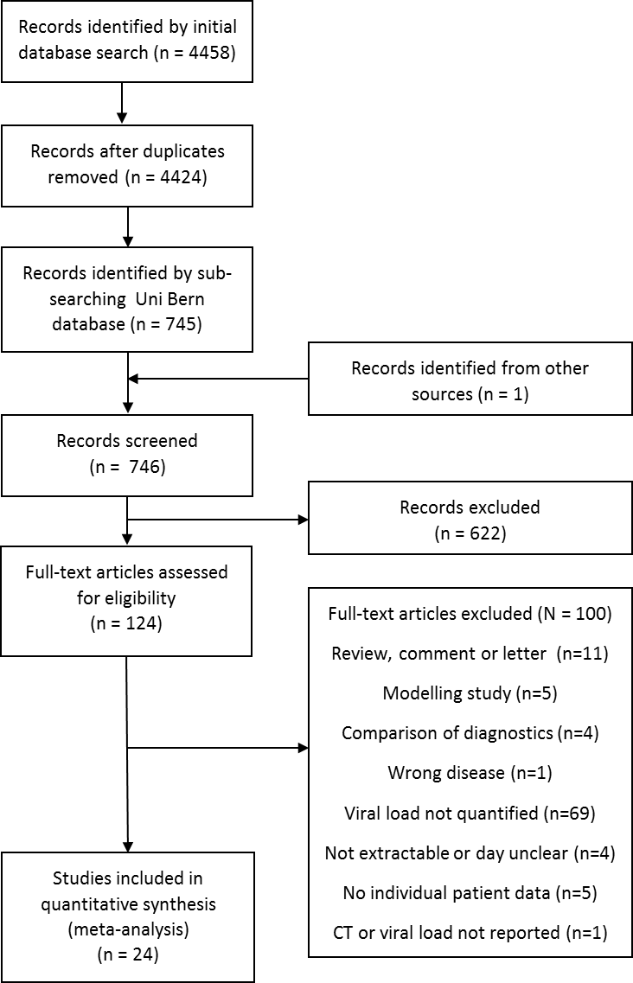

Supplementary Figure 2. Distribution of viral loads of all samples. Error bars show median and interquartile range.

Supplementary Figure 3. Distribution of CT values of all samples. Error bars show median and interquartile range.

Supplementary Figure 2. CT values obtained by varied PCR targets. Error bars show median and interquartile range.

Supplementary Figure 5. Median CT values obtained from nasopharyngeal (NP) swabs by disease severity and day post symptoms. Error bars show interquartile range.

