# Supplementary information

## Supplementary Table 1

Context sequences, PCR annealing temperatures and supplier information for all assays used.

|  |  |
| --- | --- |
| Assay (supplier) | *GNAQ* p.Q209P/L mutation and wild-type (Bio-Rad Laboratories) |
| Context Sequence | AGTGTATCCA TTTTCTTCTC TCTGACCTTT GGCCCCCTAC ATCGACCATT  CTGCAAGGTT AACAATACTC ATATTAATAA CATATAAAGT AAAACTAAAA  AGTCAACATA AATATAGCAC TAC |
| Location (hg19) | chr9:80409459-80409581 |
| Amplicon length | 65nt |
| PCR annealing temperature | 55 °C |

|  |  |
| --- | --- |
| Assay (supplier) | *GNA11* p.Q209P/L mutation and wild-type (Bio-Rad Laboratories) |
| Context Sequence | CTTTCAGGAT GGTGGATGTG GGGGGCCAGC GGTCGGAGCG GAGGAAGTGG  ATCCACTGCT TTGAGAACGT GACATCCATC ATGTTTCTCG TCGCCCTCAG  CGAATACGAC CAAGTCCTGG TGG |
| Location (hg19) | chr19:3118917-3119037 |
| Amplicon length | 62nt |
| PCR annealing temperature | 55 °C |

|  |  |
| --- | --- |
| Assay (supplier) | *CYSLTR2* p.L129Q mutation and wild-type (Sigma-Aldrich) |
| Context Sequence | TCAGGGCTGA CTATTATCTT AGAGGCTCCA ATTGGATATT TGGAGACCTG  GCCTGCAGGA TTATGTCTTA TTCCTTGTAT GTCAACATGT ACAGCAGTAT  TTATTTCCTG ACCGTGCTGA GTGTTGTGCG TTTCCTGGCA ATGGTTCACC  CCTTTCGGCT TCTGCATGTC ACCAGCATCA |
| Location (hg19) | chr13:49281231-49281410 |
| Amplicon length | 101nt |
| PCR annealing temperature | 55 °C |

|  |  |
| --- | --- |
| Assay (supplier) | *SETDB2* rs2057413 variants chr. 13q (Sigma-Aldrich) |
| Context Sequence | AAACTGAGAA ATGTCCACCA AAGTTCAGTA ATAATCCCAA GGAGCTTACT  GTGTAAGTAA CAGCTGAGGA ACCCAGAGTA AATCTAAATT ATTATCAATC  AATTGGTTCT TTTTCA |
| Location (hg19) | chr13:50057047-50057162 |
| Amplicon length | 73nt |
| PCR annealing temperature | 55 °C |

|  |  |
| --- | --- |
| Assay (supplier) | *SPCS1* rs6617variants chr. 3p (Sigma-Aldrich) |
| Context Sequence | TTCCGGGGCC GCCGCCATCG CTCTCCCGGG CTTAGAAGGC CCGGCTACTG ACGCGCAGTG CCAGACCTTA CCCCTCACGG TCCTTAAGTC TCGGTCGCCC TCGCCTCGCA GCCTGCCACC CGCGCTCAGC TGCCCGCCTC CTCAGCCAGC |
| Location (hg19) | chr3:52740112-52740261 |
| Amplicon length | 63nt |
| PCR annealing temperature | 55 °C |

|  |  |
| --- | --- |
| Assay (supplier) | *TERT* reference chr. 5p (Bio-Rad Laboratories) |
| Context Sequence | CACCCCTTGG TGGCGGCTCA CCTGTACGCC TGCAGCAGGA GGATCTTGTA  GATGTTGGTG CACACCGTCT GGAGGCTGTT CACCTAGAGT CGCCAAGAAA  GAGTGAGAAA CGGTAGAAAC CTC |
| Location (hg19) | chr5:1258692-1258814 |
| Amplicon length | 100nt |
| PCR annealing temperature | 55 °C / 60 °C |

|  |  |
| --- | --- |
| Assay (supplier) | *VOPP1* reference chr. 7p (Bio-Rad Laboratories) |
| Context Sequence | TATGGAGAGG GCCCGCACAC AGCACCTGGA GCCACAGCAG TCCTCGTAGG  AGCGGCATCT GTGGAGAGAG GCACAGGCTG GTCAGCACTG AATTGGAAGC  AGCCACCGGA CCAGCCATGC GGC |
| Location (hg19) | chr7:55565326-55565448 |
| Amplicon length | 64nt |
| PCR annealing temperature | 60 °C |

|  |  |
| --- | --- |
| Assay (supplier) | *TTC5* reference chr. 14q (Bio-Rad Laboratories) |
| Context Sequence | TGGTCGCGAT GCCACTGTGG CAACAGCCTG GCTGCTGGAT CCCTGAGGCT  TCCCATTCAC CACTAGCAGG AGGGGCGTCT CCACTCGAAC ACTGGAAAAG  GAATAGTCCT AGAAAAGACA GAC |
| Location (hg19) | chr14:20757798-20757920 |
| Amplicon length | 59nt |
| PCR annealing temperature | 55 °C / 60 °C |

|  |  |
| --- | --- |
| Assay (supplier) | *CDC42* target chr. 1p (Bio-Rad Laboratories) |
| Context Sequence | GGATACAAAA CTATTTCAGC AATGCAGACA ATTAAGTGTG TTGTTGTGGG  CGATGGTGCT GTTGGTAAAA CATGTCTCCT GATATCCTAC ACAACAAACA  AATTTCCATC GGAATATGTA CCG |
| Location (hg19) | chr1:22404951-22405073 |
| Amplicon length | 98nt |
| PCR annealing temperature | 60 °C |

|  |  |
| --- | --- |
| Assay (supplier) | *PTK2* target chr. 8q (Bio-Rad Laboratories) |
| Context Sequence | CAACCAGATG GTCATTCAAA AAAGTTGGAG CTGTAAGTGC TGGCGACTGA  GGACACAGGG TTAATTCCTC GCTGCTGGTG GAAGGCTAGA GAACATCTTC  AAAAGAGGGT AGCAAGACGT GCT |
| Location (hg19) | chr8:141669430-141669552 |
| Amplicon length | 70nt |
| PCR annealing temperature | 60 °C |

|  |  |
| --- | --- |
| Assay (supplier) | *NFAT5* target chr. 16q (Bio-Rad Laboratories) |
| Context Sequence | TGGAAGCCAT GAGAGAGAAT ATGATTTCAG GAAAACTTGG GCACAGAGAA  TTTGGCCTAT CTCAGTATGA CAAACTAATA GCTGTTGTGA TTCATTTAGG  GACTGTTGTT AAATATTTGA TTA |
| Location (hg19) | chr16:69715015-69715137 |
| Amplicon length | 69nt |
| PCR annealing temperature | 60 °C |

## Supplementary Table 2

Clinical and molecular characteristics of *CYSLTR2* mutant uveal melanomas (PUM-1, PUM-2, V4-A9ED, VD-AA8O and YZ-A982) analysed in this study. Part of the information has been obtained from uncontrolled, publicly available data from the original TCGA study on uveal melanoma (ref. Robertson et al. Integrative Analysis Identifies Four Molecular and Clinical Subsets in Uveal Melanoma. Cancer Cell. 2017;32(2):204-20 e15.).

|  |  |  |  |  |  |
| --- | --- | --- | --- | --- | --- |
| **Case** | **PUM-1** | **PUM-2** | **TCGA**  **V4-A9ED** | **TCGA**  **VD-AA8O** | **TCGA**  **YZ-A982** |
| **Institute** | Leiden University  Medical Center | Leiden University  Medical Center | Institut Curie France | University of Liverpool | Ohio State University |
| **Age (range) at diagnosis** | 85-90 | 5-10 | 45 | 77 | 79 |
| **Gender** | Female | Male | Male | Male | Female |
| **Tumour location** | Choroid/  Ciliary body | Iris/  Ciliary body | Choroid/  Ciliary body | Choroid/  Ciliary body | Choroid/  Ciliary body |
| **Tumour basal diameter  in mm (clinical)** | 18.63 | 8 | 17 | 17.3 | 23.64 |
| **Tumour thickness  in mm (clinical)** | 14.16 | 4 | 11 | 11.9 | 15.51 |
| **Tumour basal diameter  in mm (pathological)** | 17 | Ring melanoma | 16 | 13.5 | 25 |
| **Tumour thickness  in mm (pathological)** | 11 | 4 | [Not Available] | [Not Available] | [Not Available] |
| **Extrascleral extension** | 4.5 mm | Absent | Absent | Absent | Absent |
| **Tumour treatment** | Enucleation | Enucleation | Enucleation | Enucleation | Enucleation |
| **Vital status** | Dead | Alive | Alive | Dead | Dead |
| **Time from diagnosis to**  **follow-up in days** | 1111 | 2850 | 1078 | 606 | 841 |
| **Cause of death** | [Not Available] | [Not Applicable] | [Not Applicable] | Metastatic  Uveal Melanoma | Atrial fibrillation complications |
| **Distant metastasis** | [Not Available] | No | No | Yes | No |
| **Locoregional Recurrence** | [Not Available] | No | No | No | No |
| **AJCC primary tumour (T)** | pT3d | pT3 | T3b | T3a | T4b |
| **Cell type** | Mixed | Mixed | Spindle | Epithelioid | Spindle |
| ***BAP1* status** | Aberrant  (loss of  nuclear staining) | Normal  (nuclear staining) | Aberrant  (mutation) | Aberrant  (homozygous loss) | Normal  (no mutation) |
| **Chromosome 3p status** | LOH | Normal | LOH | LOH | Gain |
| **Chromosome 8q status** | Gain | Normal | Normal | Gain | Gain |

## Supplementary Data 1

Methodical overview of all digital PCR experimental setups.

Digital PCR experiments were carried out using the QX200™ Droplet Digital™ PCR System (Bio-Rad Laboratories, Hercules, USA) following the protocols and general guidelines described earlier (6, 15, 31). In short, 20 ng DNA was analysed in a 22 uL reaction volume, using 11 uL ddPCR™ Supermix for Probes (No dUTP, Bio-Rad) and primers and probes in final concentrations of 900 and 250 nM. MIQE context sequences and supplier information for all assays used are provided in **Supplementary Table 1**.

PCR mixtures were partitioned into 20.000 droplets using the AutoDG™ System (Bio-Rad Laboratories). Consequent PCR was performed in a T100 Thermal Cycler using the following protocol: 10 min at 95 °C; 30 s at 94 °C and 1 min at 55 °C or 60 °C (depending on the assay, see **Supplementary Table 1**) for 40 cycles; 10 min at 98 °C; cooling at 12 °C for up to 48 h, until droplet reading. Ramp rate was set to 2 °C/s for all steps. Reading of the droplets was performed using a QX200™ Droplet Reader (Bio-Rad Laboratories).

The *CYSLTR2* p.L129Q mutation was analysed in a duplex experiment using a FAM-labelled probe for the mutant, and HEX-labelled probe for the wild-type allele (**Figure 1**). Mutant allele fractions (MAF) were determined as follows:

$$MAF=\frac{[\text{mutant}]}{\left[\text{mutant}\right]+[\text{wildtype}]}$$

The MAF can be used to estimate the mutated cell fraction (MCF) under heterozygous conditions (i.e. nevus 12B):

$$\text{MCF}=2∙\text{MAF}$$

Chromosomal alterations were analysed in a duplex experiment using a FAM-labelled assay for the target and a HEX-labelled assay for the reference. Targets included *CDC42* (chromosome 1p), *PTK2* (chromosome 8q) and NFAT5 (chromosome 16q), references included *TERT* (chromosome 5p), *VOPP1* (chromosome 7p) and *TTC5* (chromosome 14q), as previously introduced (6, 15).

Copy number values (CNV) were determined as follows:

$$\text{CNV}=2∙\frac{[\text{target}]}{[\text{reference}]}$$

Per sample, all references were tested against each other and the most deviating one was excluded (31).

Concerning the CNV of *CYSLTR2*, a multiplex experiment was carried out using a FAM-labelled assay for mutant *CYSLTR2*, and a HEX-labelled assay for the stable reference. This results in an extra ‘predictive cluster’ for *CYSLTR2* wild-type alleles, which is derived from suboptimal binding of the mutant probe to wild-type alleles in absence of wild-type probe. The multiplex is completed with a cluster double-positive droplets, containing *CYSLTR2* mutant and wild-type alleles:

|  |  |  |  |  |  |  |  |  |  |  |  |  |  |  |  |  |  |  |  |  |  |
| --- | --- | --- | --- | --- | --- | --- | --- | --- | --- | --- | --- | --- | --- | --- | --- | --- | --- | --- | --- | --- | --- |
| **2D plot**  C:\Users\Rogier\AppData\Local\Packages\Microsoft.Office.Desktop_8wekyb3d8bbwe\AC\INetCache\Content.MSO\EA255417.tmp | |  |  |  |  | | --- | --- | --- | --- | | **2D plot annotation** | | | | | ⚫ | *CYSLTR2* mutant+  *CYSLTR2* wild-type-  reference- | ⚫ | *CYSLTR2* mutant+  *CYSLTR2* wild-type-  reference+ | | ⚫ | *CYSLTR2* mutant+  *CYSLTR2* wild-type+  reference- | ⚫ | *CYSLTR2* mutant+  *CYSLTR2* wild-type+  reference+ | | ⚫ | *CYSLTR2* mutant-  *CYSLTR2* wild-type+  reference- | ⚫ | *CYSLTR2* mutant-  *CYSLTR2* wild-type+  reference+ | | ⚫ | *CYSLTR2* mutant-  *CYSLTR2* wild-type-  reference- | ⚫ | *CYSLTR2* mutant-  *CYSLTR2* wild-type-  reference+ | |
|  |  |

**Absolute quantification and interpretation**

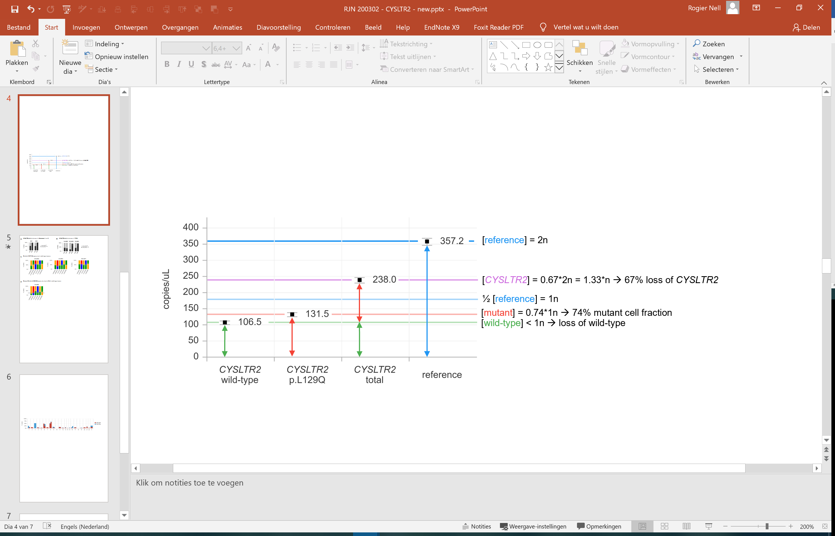

As illustrated above for PUM-1A, the simultaneous quantification of [mutant], [wild-type] and [reference] allows to determine the CNV of (total) *CYSLTR2* (i.e. chromosome 13q):

$$\text{CNV}=2∙\frac{\left[\text{CYSLTR2}\right]}{\left[\text{reference}\right]}=2∙\frac{\left[\text{wild-type + mutant}\right]}{\left[\text{reference}\right]}$$

Moreover, the mutant cell fractions can now be calculated:

$${MCF}_{in case of a loss of wild-type}=2∙\frac{\left[\text{mutant}\right]}{\left[\text{reference}\right]}=CNV∙MAF$$

$${MCF}_{in case of a gain of mutant}=2-2∙\frac{\left[\text{wild-type}\right]}{\left[\text{reference}\right]}=2-\left(CNV*\left(1-MAF\right)\right)$$

Note that these formulas also allow to determine the MCF when the CNV and MAF are determined in separate, non-multiplex experiments.

Concerning the CNV of chromosome 13q, alterations were confirmed by the allelic imbalance of heterozygous common single nucleotide polymorphism rs2057413 in *SETDB2*, located ~776kb from *CYSLTR2* (<https://www.genecards.org>):

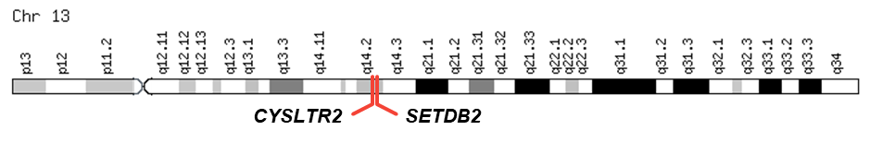

Assuming one of the alleles/variants remains stable, the SNP-based CNV was calculated as follows:

$$CNV=1+\frac{[{var}_{unstable}]}{[{var}_{stable}]}$$

Although the same result obtained using the classic (target/reference) and SNP-based CNV approach, the SNP-based assay is a single-amplicon assay that can be used to prevent biases due to degradation of FFPE-based input material (i.e. PUM-1B and PUM-2B).

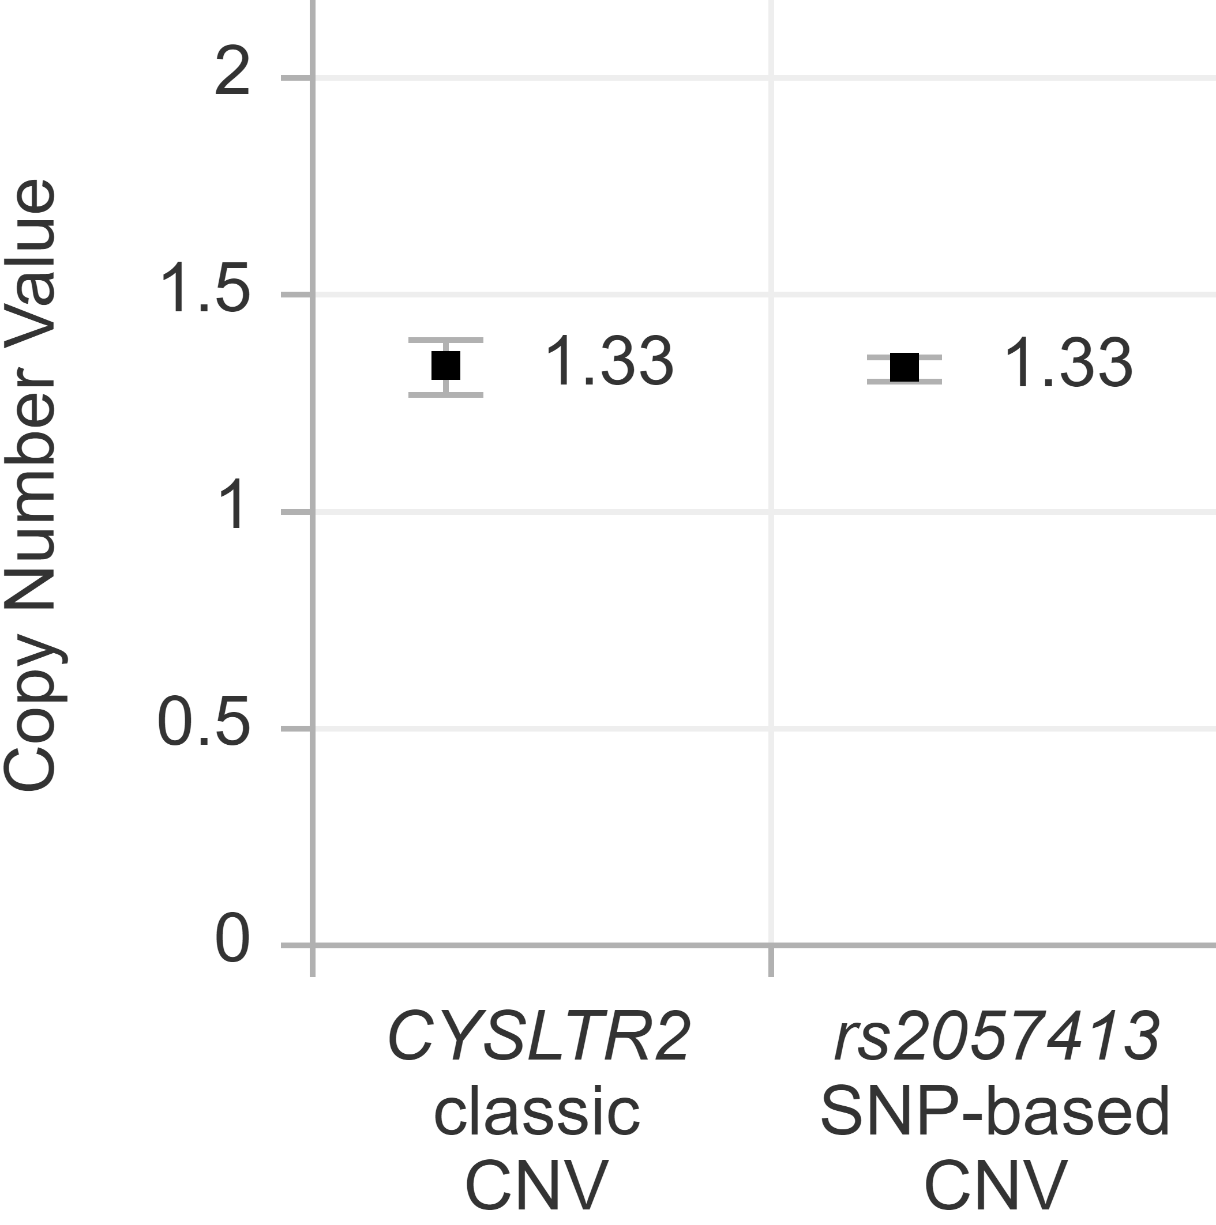

Similarly, a SNP-based CNV for chromosome 3p (rs6617 in *SPCS1*) was used, assuming the variant with the highest concentration is the stable allele.

In all cases, a CNV significantly lower than 2 was interpreted as being the sum of normal cells (CNV=2) and cells with loss (CNV=1). Consequently, the percentage cells with a loss was determined as follows:

$$\% cells with loss=\left(2-CNV\right)∙100\%$$

Likewise, a CNV significantly higher than 2 was interpreted as being the sum of normal cells (CNV=2) and cells with gain (CNV=3). Consequently, the percentage cells with a gain was determined as follows:

$$\% cells with gain=\left(CNV-2\right)∙100\%$$

## Supplementary Figure 1

*CYSLTR2* p.L129Q mutation detected by Sanger sequencing of choroidal nevus 12B (**A**), compared to the reference sequence from a healthy control (**B**).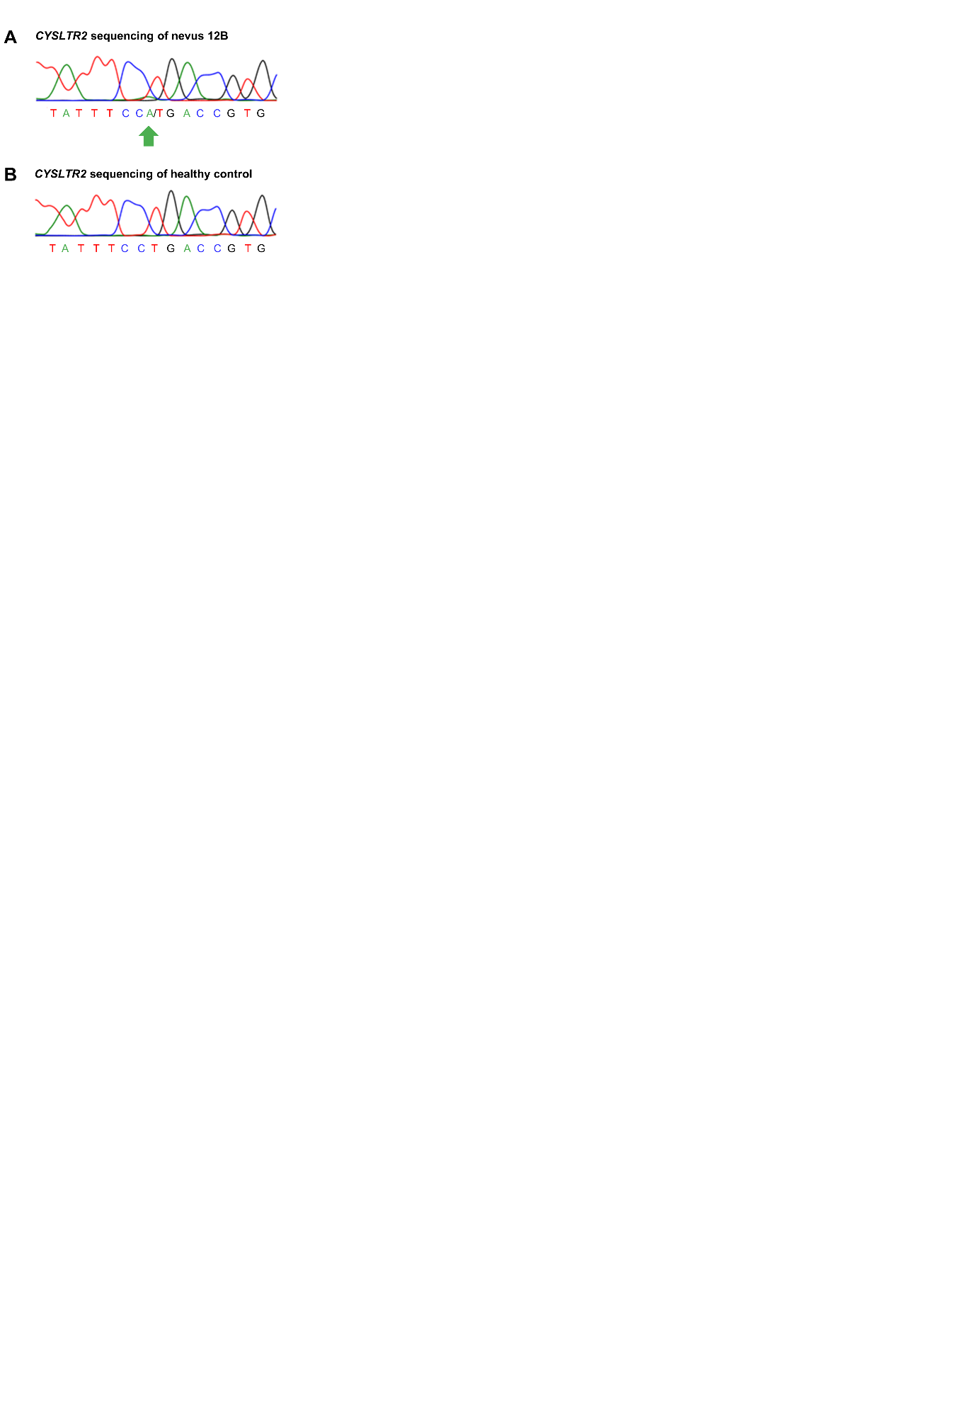

## Supplementary Figure 2

SNP-array copy number profile and B-allele fractions of *CYSLTR2* mutant melanoma TCGA-V4-A9ED (**A**), TCGA-VD-AA8O (**B**) and TCGA-YZ-A982 (**C**).

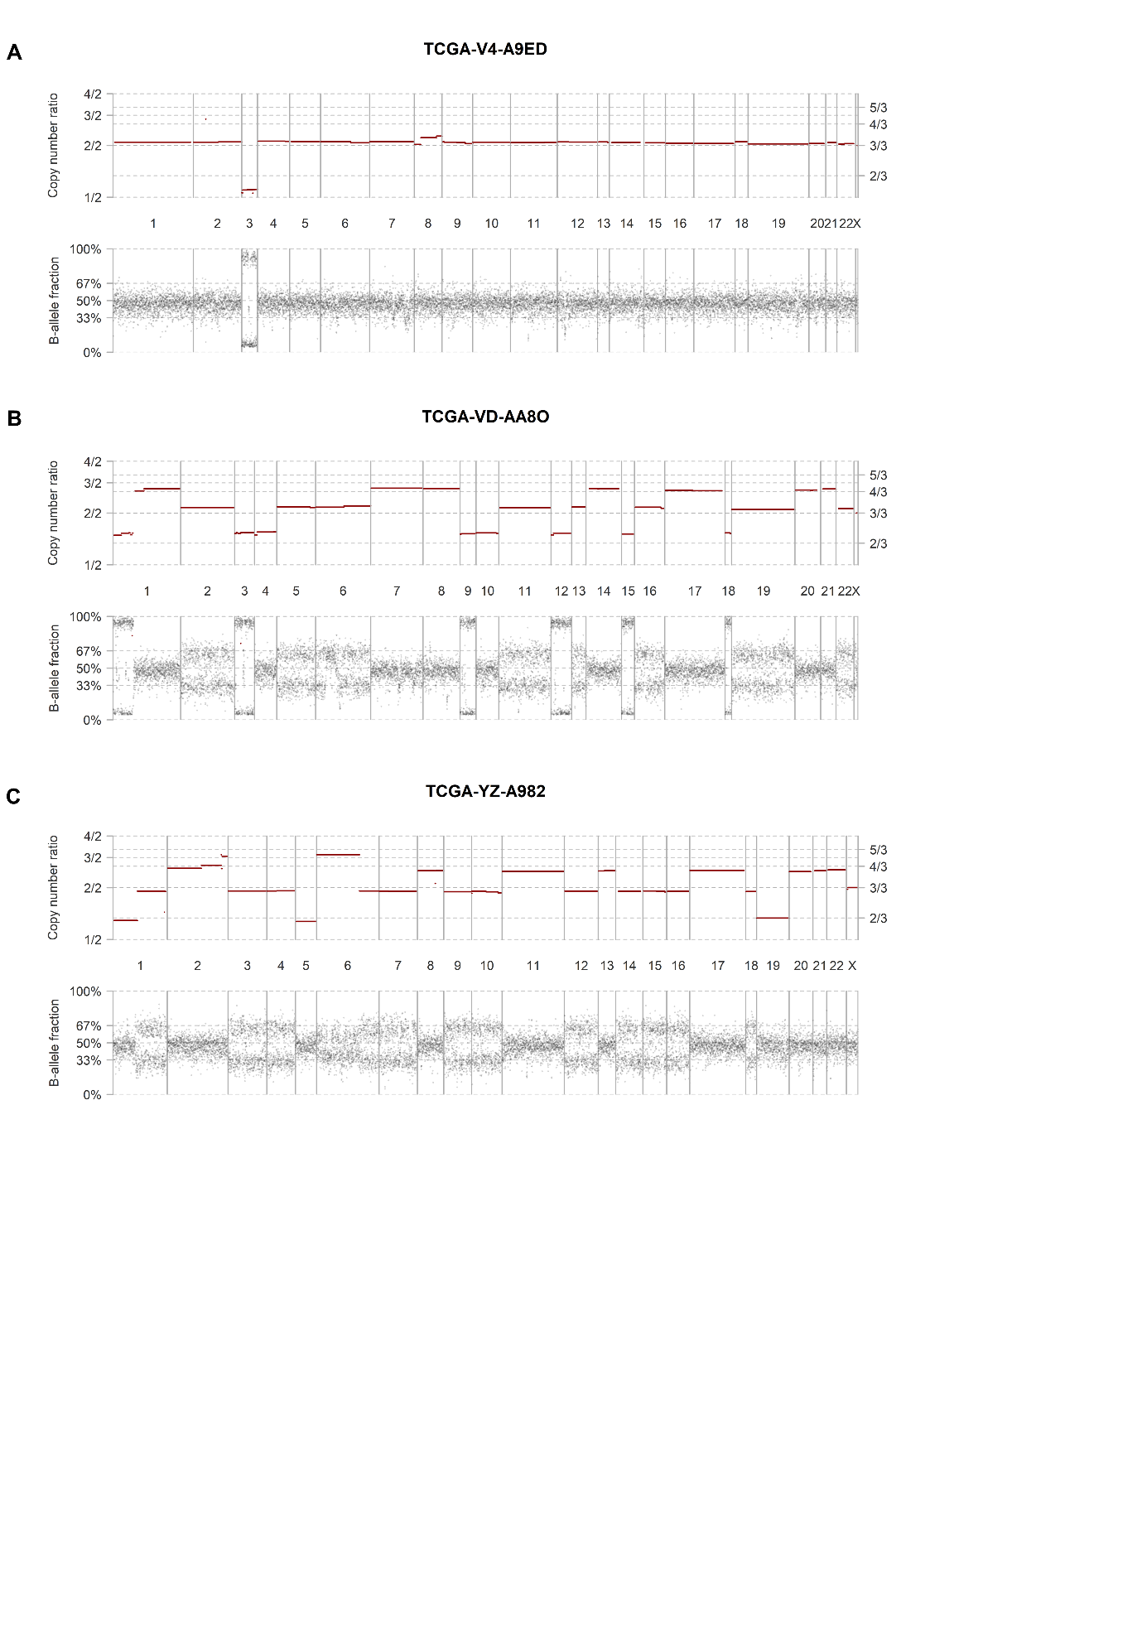

## Supplementary Figure 3

Distribution of arm-level copy number alterations in 77 *CYSLTR2* wild-type uveal melanomas from the TCGA cohort. Alterations involving chromosome 13q (*CYSLTR2* locus) are uncommon in *CYSLTR2* wild-type uveal melanomas.

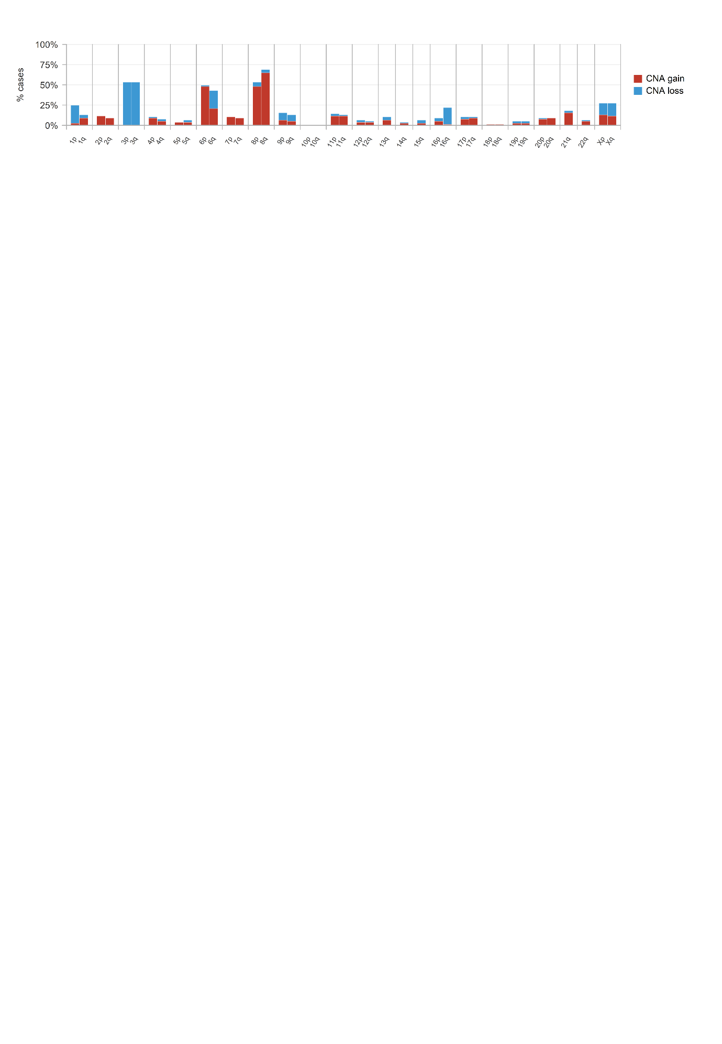

## Supplementary Figure 4

Origin of *CYSLTR2* expression and characterization of the immune microenvironment in uveal melanoma. Single cell RNA expression analysis of the five tumours with >5% *CYSLTR2*+ cells UMM059 (**A**), UMM066 (**B**), UMM064 (**C**), UMM063 (**D**) and UMM069 (**D**). tSNE plots per tumour are presented, with expression levels per cell of marker genes *CYSLTR2* (leukotriene receptor), *MLANA* (melanoma cells), *CD14* (monocytes/macrophages), *CD3D* (T cells), *ALOX5AP* and *ALOX5* (leukotriene synthesis), *MITF* and *TYR* (pigmentation) and *ETV5* and *DUSP4* (MAPK activation). In all tumours *CYSLTR2* was expressed in a subpopulation of melanoma cells that presented with high expression of genes involved in pigmentation. In UMM066, UMM063 and UMM069, *CYSLTR2* expressing cells also showed expression of the MAPK activation markers. In addition to these melanoma cells, *DUSP4* was highly expressed in T cells. Enzymes catalysing the synthesis of leukotrienes are expressed by tumour-associated immune cells, both T cells and monocytes/macrophages (e.g. in UMM063).

