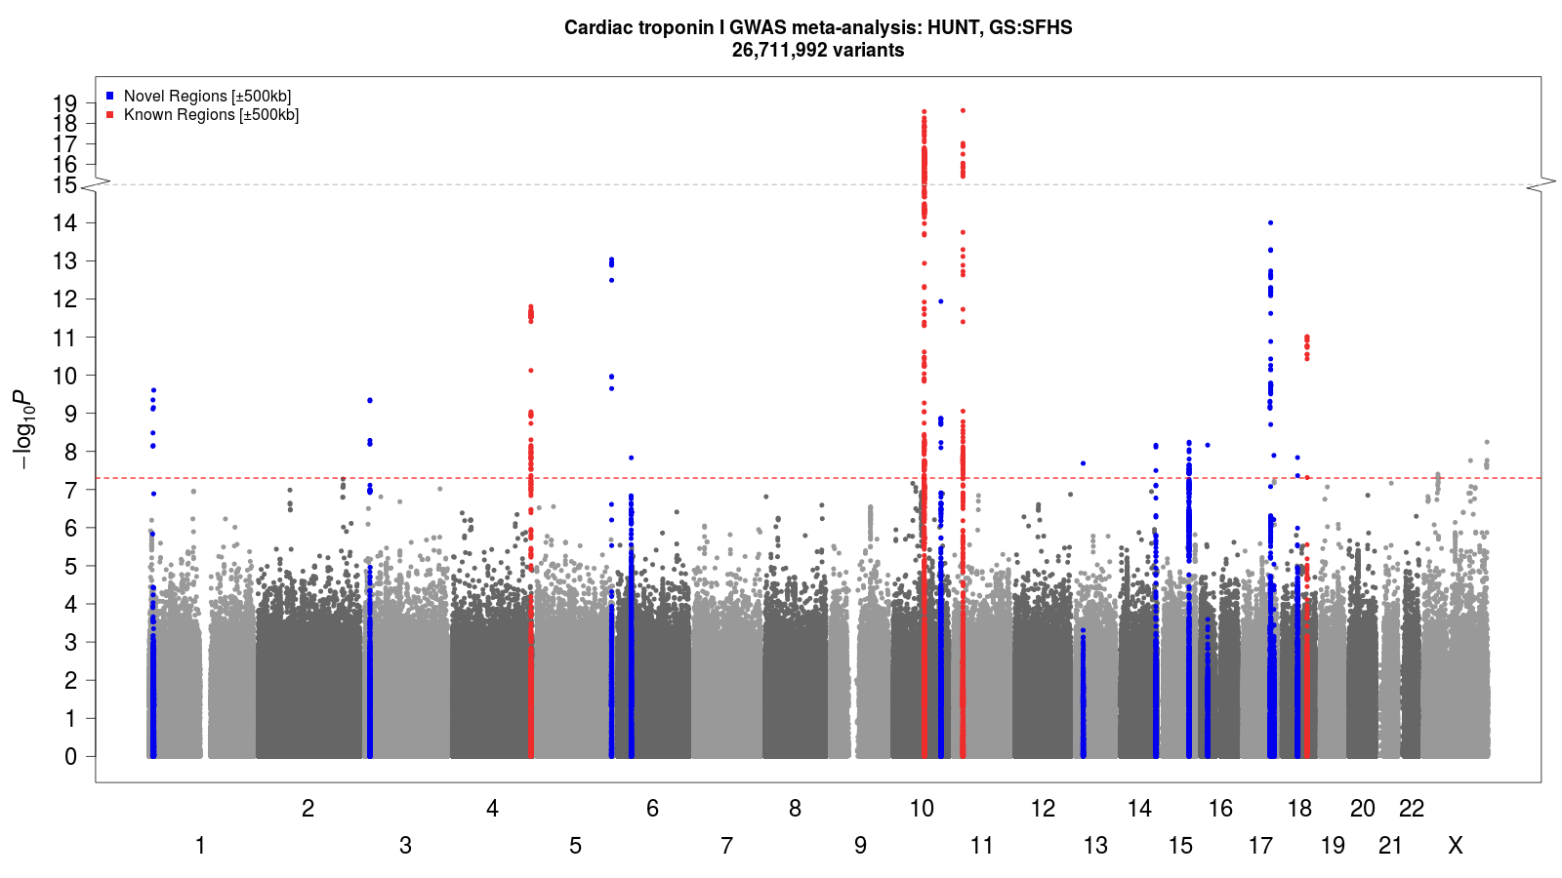
Supplemental Figure F1: Manhattan plot: Genomic loci associated (p-value < 5×10⁻⁸ ) with cTnI concentration in HUNT + GS:SFHS GWAS meta-analysis. Chromosomes are given on the x-axis and -log(p-value) for the genetic variants are given on the y-axis.
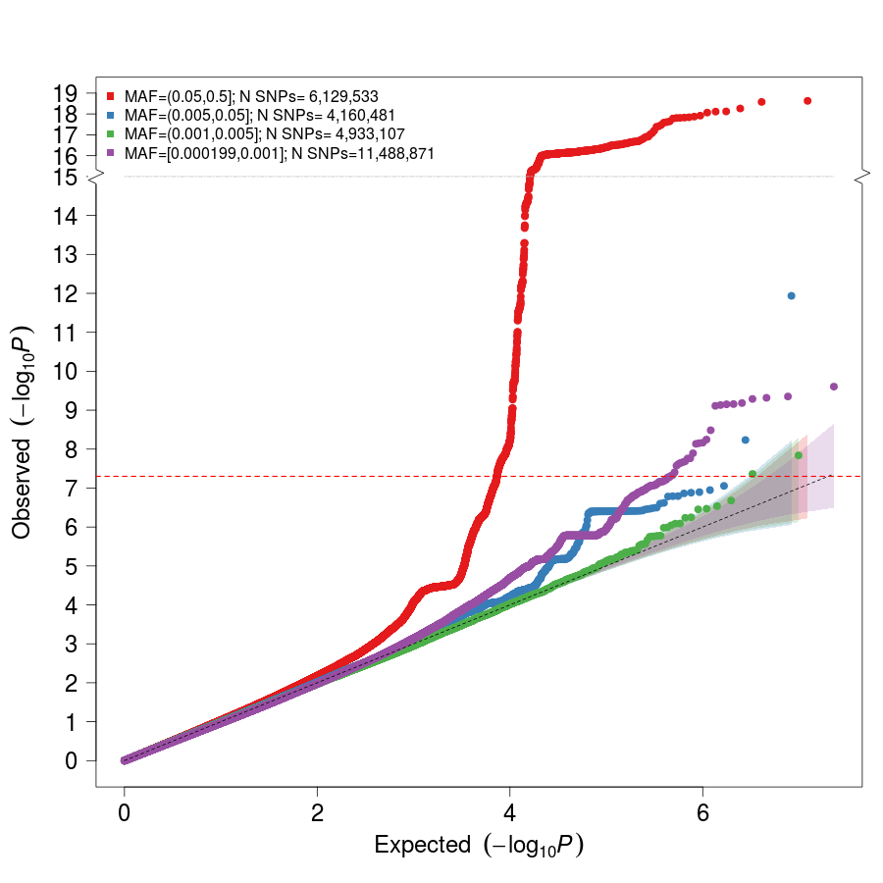
Supplemental Figure F2: Quantile-quantile plot for HUNT + GS:SFHS GWAS meta-analysis summary statistics. The inflation factor λ = 1.02 (based on single nucleotide polymorphisms with MAF > 0.01).
Supplemental Table S2: Study Descriptives: cTnI concentration
 |  |  | cTnI concentration (ng/L) |  |  |  | Age (years) |  |  | Sex  (% male/female)
 | Min | Max | IQR | Median | N | Min | Max | IQR | Median
HUNT | 0 | 850.28 | 1.4, 4.4 | 2.5 | 29 839 | 20 | 103 | 47, 70 | 59 | 45/55
GS:SFHS | 0.6 | 1004.5 | 0.6, 3.1 | 1.9 | 18 276 | 18 | 99 | 37, 59 | 49 | 42/58

Supplemental Table S3: Study Descriptives: Change in cTnI over time (HUNT)
cTnI difference / follow-up time (ng/L*years) |  |  |  |  | Age at follow-up start (years) |  |  |  | Follow-up time (years, months) |  |  |  | Sex  (% male/female)
Min | Max | IQR | Median | N | Min | Max | IQR | Median | Min | Max | IQR | Median
-51.77 | 38.15 | -0.18, -0.01 | -0.10 | 5 178 | 20 | 94.5 | 36.6, 63.6 | 48.6 | 9.9 | 11.9 | 10.5, 11.1 | 11.7 | 45/55

Supplemental Table S4: Sensitivity analysis in HUNT
 |  | Reference (no exclusions) |  |  | Excluding 5 253 individuals with comorbidities
rsID | Chr:Pos:Ref:Alt | Effect Size | SE | P-value | Effect Size | SE | P-value
rs7650482 | 3:12800305:A:G | 0.04 | 0.01 | 1×10⁻⁷ | 0.04 | 0.01 | 1×10⁻⁵
rs12331618 | 4:186218785:A:G | 0.03 | 0.01 | 7×10⁻⁵ | 0.03 | 0.01 | 9×10⁻⁵
rs2731672 | 5:177415473:T:C | 0.05 | 0.01 | 1×10⁻⁸ | 0.06 | 0.02 | 2×10⁻⁹
rs9391746 | 6:32715903:G:T | 0.09 | 0.02 | 7×10⁻⁶ | 0.08 | 0.02 | 3×10⁻⁴
rs2270552 | 10:74103992:C:T | -0.06 | 0.01 | 9×10⁻¹² | -0.05 | 0.01 | 8×10⁻⁹
rs7080536 | 10:113588287:G:A | -0.10 | 0.02 | 9×10⁻⁷ | -0.10 | 0.02 | 9×10⁻⁶
rs7481951 | 11:22250324:A:T | 0.05 | 0.01 | 3×10⁻¹⁰ | 0.06 | 0.01 | 4×10⁻¹¹
rs4283165 | 14:103137158:G:A | 0.03 | 0.01 | 1×10⁻⁴ | 0.04 | 0.01 | 1×10⁻⁵
rs8024538 | 15:84825188:A:T | 0.03 | 0.01 | 2×10⁻⁴ | 0.03 | 0.01 | 1×10⁻⁴
rs1801690 | 17:66212167:C:G | 0.10 | 0.02 | 5×10⁻¹¹ | 0.12 | 0.02 | 7×10⁻¹²
rs151313792 | 18:36681510:G:A | 0.32 | 0.06 | 2×10⁻⁷ | 0.31 | 0.07 | 6×10⁻⁶
rs12604424 | 18:59353974:T:C | 0.04 | 0.01 | 3×10⁻³ | 0.05 | 0.01 | 5×10⁻⁴
Genomic variants are given as rsID and chromosome (Chr), position in genome build GRCh38 (Pos), reference allele (Ref) and alternate allele (Alt). Effect sizes with standard errors (SE) correspond to the alternate allele. The comorbidities that qualified for exclusion in the sensitivity analysis were impaired kidney function or a history of heart failure, cardiomyopathy, atrial fibrillation or diabetes mellitus.

Supplemental Table S7: DEPICT gene set enriched with genes in cTnI associated genetic loci
Original gene set ID | Original gene set description | P-value
MP:0001711 | Abnormal placenta morphology | 2×10⁻¹⁸
The p-value cut-off for cTnI associated loci was set to 1×10⁻⁵. Results with a false discovery rate < 0.05 are excluded.

Supplemental Table S8: DEPICT: Tissue types with enrichment of the expression of cTnI associated genes
MeSH term | MeSH first level term | MeSH second level term | Nominal P-value
A07.541 | Heart | Cardiovascular system | 0.0013
A07.541.560 | Heart Ventricles | Cardiovascular system | 0.0015
A14.549.167 | Dentition | Stomatognathic system | 0.0023
The p-value cut-off for cTnI associated loci was set to to 1×10⁻⁵.

Supplemental Table S11: Significant associations between cTnI index variants and cis-eQTLs
rsID | Chr:Pos:Ref:Alt | Gencode ID | Gene Symbol | P-value | Tissue
rs2270552 | 10:74103992:C:T | ENSG00000156110.13 | ADK | 4×10⁻²⁰ | Transverse colon
rs7481951 | 11:22250324:A:T | ENSG00000171714.10 | ANO5 | 1×10⁻²⁵ | Transverse colon
rs7650482 | 3:12800305:A:G | ENSG00000213943.3 | KRT18P17 | 9×10⁻²⁹ | Testis
rs2270552 | 10:74103992:C:T | ENSG00000185009.12 | AP3M1 | 2×10⁻¹⁸ | Sigmoid colon
rs2270552 | 10:74103992:C:T | ENSG00000156110.13 | ADK | 2×10⁻¹⁴ | Sigmoid colon
rs7481951 | 11:22250324:A:T | ENSG00000171714.10 | ANO5 | 7×10⁻¹⁷ | Sigmoid colon
rs7481951 | 11:22250324:A:T | ENSG00000171714.10 | ANO5 | 1×10⁻²⁴ | Adipose, subcutaneous
rs7481951 | 11:22250324:A:T | ENSG00000171714.10 | ANO5 | 1×10⁻²⁰ | Esophagus muscularis
rs7481951 | 11:22250324:A:T | ENSG00000171714.10 | ANO5 | 9×10⁻²² | Skin, not sun exposed suprapubic
rs7481951 | 11:22250324:A:T | ENSG00000171714.10 | ANO5 | 2×10⁻²³ | Skin, not sun exposed, lower leg
rs2270552 | 10:74103992:C:T | ENSG00000156110.13 | ADK | 2×10⁻²⁹ | Lung
rs7481951 | 11:22250324:A:T | ENSG00000171714.10 | ANO5 | 4×10⁻⁴⁴ | Lung
rs2731672 | 5:177415473:T:C | ENSG00000131187.9 | F12 | 2×10⁻²⁸ | Liver
rs7481951 | 11:22250324:A:T | ENSG00000171714.10 | ANO5 | 3×10⁻²⁴ | Adipose visceral omentum
rs12331618 | 4:186218785:A:G | ENSG00000145476.15 | CYP4V2 | 9×10⁻²¹ | Tibial nerve
rs7481951 | 11:22250324:A:T | ENSG00000171714.10 | ANO5 | 4×10⁻⁷⁷ | Tibial nerve
rs12331618 | 4:186218785:A:G | ENSG00000156110.13 | ADK | 6×10⁻¹² | Tibial artery
rs7481951 | 11:22250324:A:T | ENSG00000171714.10 | ANO5 | 5×10⁻⁶⁸ | Tibial artery
rs7481951 | 11:22250324:A:T | ENSG00000171714.10 | ANO5 | 1×10⁻³⁹ | Aortic artery
rs7650482 | 3:12800305:A:G | ENSG00000144712.11 | CAND2 | 4×10⁻⁴³ | Thyroid
rs7481951 | 11:22250324:A:T | ENSG00000171714.10 | ANO5 | 8×10⁻⁴⁷ | Thyroid
rs7650482 | 3:12800305:A:G | ENSG00000213943.3 | KRT18P17 | 1×10⁻²⁹ | Skeletal muscle
rs7650482 | 3:12800305:A:G | ENSG00000144712.11 | CAND2 | 8×10⁻⁶⁹ | Skeletal muscle
rs7650482 | 3:12800305:A:G | ENSG00000272263.1 | Antisense to CAND2 | 2×10⁻²² | Skeletal muscle
Genomic variants are given as rsID and chromosome (Chr), position in genome build GRCh38 (Pos), reference allele (Ref) and alternate allele (Alt). The variants are
genome-wide significant index variants in the cTnI GWAS meta-analysis and the cis-eQTL data is from samples of European ancestry in the GTEx v8 database.
All associations with a Bonferroni corrected p-value < 1×10⁻⁹ are included in the table.

Supplemental Table S13: : cTnI index variants that are significantly associated (p-value < 2.8×10⁻⁵) with human diseases in the UK Biobank
rsID | Chr:Pos:Ref:Alt | AF | N | Trait | P-value
rs7650482 | 3:12800305:A:G | 0.65 | 14820 | Atrial fibrillation and flutter | 3×10⁻¹⁰
rs7650482 | 3:12800305:A:G | 0.65 | 24681 | Cardiac arrhythmias | 1×10⁻⁹
rs12331618 | 4:186218785:A:G | 0.51 | 3900 | Phlebitis and thrombophlebitis | 2×10⁻⁷
rs12331618 | 4:186218785:A:G | 0.51 | 4257 | Pulmonary heart disease | 4×10⁻⁷
rs12331618 | 4:186218785:A:G | 0.51 | 3587 | Phlebitis and thrombophlebitis of lower extremities | 8×10⁻⁷
rs9391746* | 6:32715903:G:T | 0.06 | 2293 | Psoriasis and related disorders* | 3×10⁻³³
rs9391746* | 6:32715903:G:T | 0.06 | 2237 | Psoriasis* | 3×10⁻³³
rs9391746* | 6:32715903:G:T | 0.06 | 1684 | Psoriasis vulgaris* | 6×10⁻²⁶
rs9391746* | 6:32715903:G:T | 0.06 | 2103 | Intestinal malapsorption (non-celiac)* | 2×10⁻²⁵
rs9391746* | 6:32715903:G:T | 0.06 | 1855 | Celiac disease* | 1×10⁻²⁴
rs9391746* | 6:32715903:G:T | 0.06 | 708 | Psoriatic arthropathy* | 8×10⁻¹⁰
Genomic variants are given as rsID and chromosome (Chr), position in genome build GRCh38 (Pos), reference allele (Ref) and alternate allele (Alt). Allele frequency (AF) is given for the alternate allele. The number of individuals in each analysis (N) is given per phecode.
*Findings from the HLA region

Supplemental Table S14: cTnI index variants that are significantly associated (p-value < 2.8×10⁻⁵) with continuous traits and biomarkers in the UK Biobank
rsID | Chr:Pos:Ref:Alt | AF | N | Trait | P-value
rs7650482 | 3:12800305:A:G | 0.64 | 407 399 | Waist-hip ratio | 1×10⁻⁷
rs7650482 | 3:12800305:A:G | 0.64 | 407 289 | Standing height | 5×10⁻⁷
rs7650482 | 3:12800305:A:G | 0.64 | 407 289 | Aspartate aminotransferase 1 | 2×10⁻⁸
rs7650482 | 3:12800305:A:G | 0.64 | 407 399 | Basal metabolic rate | 6×10⁻⁵
rs27316772 | 5:177415473:T:C | 0.74 | 407 289 | Standing height | 2×10⁻⁹
rs27316772 | 5:177415473:T:C | 0.74 | 407 399 | Basal metabolic rate | 4×10⁻⁴⁹
rs7481951 | 11:22250324:A:T | 0.59 | 407 289 | Aspartate aminotransferase 1 | 7×10⁻⁴²
rs8024538 | 15:84825188:A:T | 0.53 | 407 289 | Aspartate aminotransferase 1 | 6×10⁻¹²
rs1801690 | 17:66212167:C:G | 0.06 | 407 289 | Aspartate aminotransferase 1 | 2×10⁻¹⁹
Genomic variants are given as rsID and chromosome (Chr), position in genome build GRCh38 (Pos), reference allele (Ref) and
alternate allele (Alt). Allele frequency (AF) is given for the alternate allele. The number of individuals in each analysis (N) is given
per trait.

Supplemental Table S15: Human diseases that are significantly (p-value < 2.8×10⁻⁵) with cTnI PRS in the UK Biobank
Phecode | Description | P-value | N_{cases} | N_{controls}
427.2 | Atrial fibrillation and flutter | 5×10⁻⁶ | 14 792 | 380 170
427.0 | Cardiac arrhythmias | 1×10⁻⁵ | 24 629 | 380 170

Supplemental Table S16: Continuous traits and biomarkers significantly (p-value < 2.8×10⁻⁵) associated with cTnI PRS in the UK Biobank
Trait | P-value | N
Standing height | 6×10⁻¹² | 407 289
Aspartate aminostransferase 1 | 2×10⁻⁶ | 387 672
Whole body fat free mass | 2×10⁻⁶ | 401 015
Whole body water mass | 5×10⁻⁶ | 401 050
Basal metabolic rate | 7×10⁻⁶ | 401 039

Supplemental Table S17: Evaluation of the causal effects between cTnI concentrations, HF and AMI using two-sample Mendelian Randomization
Exposure | Outcome | Method | N_{variants} | Effect Size | SE | P-value | 95% CI_{lower} | 95% CI_{upper} | OR | OR 95%CI_{lower} | OR 95%CI_{upper}
cTnI | HF | Inverse Variance Weighted | 11 | 0.19 | 0.09 | 0.05 | 0.00 | 0.37 | 1.20 | 1.00 | 1.45
cTnI | HF | MR Egger | 11 | 0.31 | 0.32 | 0.36 | -0.32 | 0.94 | 1.36 | 0.72 | 2.56
cTnI | HF | Penalized weighted median | 11 | 0.14 | 0.09 | 0.14 | -0.04 | 0.31 | 1.14 | 0.96 | 1.37
cTnI | HF | Weighted median | 11 | 0.15 | 0.09 | 0.11 | -0.03 | 0.33 | 1.16 | 0.97 | 1.38
cTnI | HF | Weighted mode | 11 | 0.09 | 0.16 | 0.57 | -0.22 | 0.41 | 1.10 | 0.80 | 1.51
HF | cTnI | Inverse Variance Weighted | 11 | 0.14 | 0.07 | 0.06 | -0.00 | 0.28 | - | - | -
HF | cTnI | MR Egger | 11 | 0.18 | 0.22 | 0.44 | -0.25 | 0.60 | - | - | -
HF | cTnI | Penalized weighted median | 11 | 0.16 | 0.06 | 0.01 | 0.04 | 0.28 | - | - | -
HF | cTnI | Weighted median | 11 | 0.14 | 0.06 | 0.02 | 0.01 | 0.26 | - | - | -
HF | cTnI | Weighted mode | 11 | 0.25 | 0.14 | 0.11 | -0.03 | 0.53 | - | - | -
cTnI | AMI | Inverse Variance Weighted | 11 | 0.00 | 0.00 | 0.73 | -0.01 | 0.00 | 1.00 | 0.99 | 1.00
cTnI | AMI | MR Egger | 11 | -0.01 | 0.01 | 0.23 | -0.02 | 0.01 | 0.99 | 0.98 | 1.01
cTnI | AMI | Penalized weighted median | 11 | 0.00 | 0.00 | 0.71 | -0.01 | 0.00 | 1.00 | 0.99 | 1.00
cTnI | AMI | Weighted median | 11 | 0.00 | 0.00 | 0.71 | -0.01 | 0.00 | 1.00 | 0.99 | 1.00
cTnI | AMI | Weighted mode | 11 | 0.00 | 0.01 | 0.40 | -0.01 | 0.01 | 1.00 | 0.99 | 1.01
Effect size (approximating 1 standard deviation of the distribution of the rank transformed cTnI concentrations) with standard error (SE) and 95% confidence interval (CI) for the causal effect of the exposures on the outcomes is given per method. Odds ratios (OR) with 95% CI is given for the binary outcomes.

