College campuses and COVID-19 mitigation: clinical and economic value
Supplementary Materials

Elena Losina, PhD ^{1,2,3,4}
Valia Leifer, AB ^{1,2}
Lucia Millham, AB ^{3, 5}
Christopher Panella, BS ⁵
Emily P. Hyle, MD, MSc ^{3, 5, 6}
Amir Mohareb, MD ^{5, 6}
Anne M. Neilan, MD, MPH ^{5, 6, 8}
Andrea L. Ciaranello, MD, MPH ^{3, 5, 6}
Pooyan Kazemian*, PhD ⁹
Kenneth A. Freedberg*, MD, MSc ^{3, 5, 6, 7, 10}

* Drs. Kazemian and Freedberg contributed equally to this work

Affiliations:
- Policy and Innovation eValuation in Orthopedic Treatments (PIVOT) Center, Department of Orthopedic Surgery, Brigham and Women's Hospital, Boston, MA
- Orthopedic and Arthritis Center for Outcomes Research (OrACORe), Department of Orthopedic Surgery, Brigham and Women's Hospital, Boston, MA
- Harvard Medical School, Boston, MA
- Department of Biostatistics, Boston University School of Public Health, Boston, MA
- Medical Practice Evaluation Center, Massachusetts General Hospital, Boston, MA
- Division of Infectious Diseases, Department of Medicine, Massachusetts General Hospital, Boston, MA
- Division of General Internal Medicine, Department of Medicine, MGH, Boston, MA
- Division of General Academic Pediatrics, Department of Pediatrics, Massachusetts General Hospital, Boston, MA
- Department of Operations, Weatherhead School of Management, Case Western Reserve University; Cleveland, OH
- Department of Health Policy and Management, Harvard T. H. Chan School of Public Health, Boston, MA

Corresponding author:
Elena Losina, PhD
Orthopedic and Arthritis Center for Outcomes Research
Brigham and Womens’ Hospital
60 Fenwood Rd, 5016
Boston, MA, 02115

Table of contents:
Supplemental methods 4
Table S1. Clinical characteristics of COVID-19 infection in the US 9
Figure S1. Budgetary impact of COVID-19 mitigation strategies, by test cost (USD) 13
Literature cited 18
Supplemental methods
Heterogeneous mixing in the CEACOV model
The CEACOV model can accommodate a user-defined number of mutually exclusive and collectively exhaustive subcohorts. For the purposes of this analysis we consider 3 subcohorts: (1) students, (2) faculty, and (3) community. With 3 subcohorts, the contact-hours within and between the subcohorts are described by the following contact matrix.
$$C=\left[\begin{matrix}c_{11} & c_{12} & c_{13} \\ c_{21} & c_{22} & c_{23} \\ c_{31} & c_{32} & c_{33}\end{matrix}\right]$$
The per person force of infection is proportional to the contact hours and size of each subcohort as well as the force of transmission from infected individuals. We have:
$$f_{k}\left(t\right)=\sum_{j=1}^{3}{\frac{\left(\frac{c_{jk}}{c_{j1}+c_{j2}+c_{j3}}\right)\sum_{s∈S}{I_{s}^{j}\left(t\right)r_{s}}}{N_{k}}} ∀k∈\{1,2,3\}$$
in which,
- $f_{k}\left(t\right)$ is the force of infection to each person in subcohort k on day t
- $I_{s}^{j}(t)$ is the number of infected individuals in subcohort j who are in infection state s on day t. The set of infection states, S, is defined as S={asymptomatic, mild/moderate disease, severe disease, critical disease, recuperation}.
- $r_{s}$ is the effective transmission rate from a person in infection state s
- $N_{k}$ is the size of subcohort k
In the above formula, $\sum_{s∈S}{I_{s}^{j}\left(t\right)r_{s}}$ gives the force of transmission from all infected individuals in subcohort $j$. $\left(\frac{c_{jk}}{c_{j1}+c_{j2}+c_{j3}}\right)$ is the proportion of this force which is directed towards subcohort $k$ and is divided among the $N_{k}$ members of subcohort $k$.

Calibration and validation of CEACOV
We initialized the model with a cohort of 1 million simulated persons who are meant to represent the 6.9 million people in the population of Massachusetts (MA) in 2020. Each person’s age category was drawn at model start based on MA age distribution data (1). To approximate the prevalence of COVID-19 at the start of the MA epidemic, in mid-March, 2020, the prevalence of COVID-19 at model start was set to 0.14% (2). We tracked the number of people in each health state over 30 days for calibration, and 15 days for validation, totaling a 45-day horizon (3,4). We calibrated transmission to the first 30 days of the COVID-19 epidemic in MA (from mid-March to mid-April, 2020) and used data from the remaining 15 days in April (through 4/30) to validate the model. We assumed the reported number of COVID-19-attributable deaths would be close to the actual number of deaths. Thus, the number of reported COVID-19-attributable deaths was the main calibration target. We removed 59% of deaths to account for the deaths occurring in long term care facilities (LTCF) and not in the community. To ensure good model fit, we checked the mean absolute percentage error (MAPE) and the median absolute percentage error (MEDAPE) for modeled and observed the number of deaths over the validation horizon.

Derivation of infectivity rate
We derived infectivity/contact-hour from published literature based on the rate of infection among household contacts in Wuhan, China, where household infection rate ranged from 28% (spouses) to 17% (other household members) (5). Using an average household size of 4 people, we estimated an average rate of 21% transmission over 3 days, considering both latency and pre-symptomatic periods and the average time between symptom onset in the index person and subsequently infected person. From the Bureau of Labor Statistics, we estimated that members of the same household spent on average 11.89 hours/day at home (6), resulting in an estimated infectivity rate/contact-hour of 0.002.

Additional details on cohort characteristics
Based on data from Cornell University, University of California, Penn State University, California State University, and University of Maryland, on average 25% of faculty are over age 60 (7–11). Using data from college towns, including Cambridge, MA, Ithaca, NY and Austin, TX 16% of the surrounding community are over age 60 (Table 1) (12–14). We stratified our population groups by their COVID-19 disease status: we assumed that 1% of students, 1% of faculty and 4% of community members had active COVID-19 (symptomatic or asymptomatic), 89% of students (94% faculty, 81% community) were susceptible to COVID-19 and the reminder in each population already had the disease, recovered, and were assumed to be immune. To account for influenza like illness (ILI) symptoms from infections other than SARS-COV-2, we incorporated a small proportion of individuals developing daily ILI symptoms, using age-stratified rates from the CDC ILI network (15–17).

Derivation of COVID-19-like illness inputs
In our model, individuals with similar symptoms to COVID-19 but due to other conditions (“COVID-19-like-illness”), may present for symptom screening or laboratory testing. Estimates of the number of people presenting for testing with “COVID-19-like illness” are uncertain at the time this analysis is being conducted; therefore, we made assumptions informed by available literature from influenza-like illness. Data from the National Ambulatory Medical Care Survey (NAMCS) were used to estimate the age-stratified per-person daily rate of presenting to one’s primary care physician (18). Of these visits, 15% were assumed to be related to COVID-19, based on estimates from New Jersey, where approximately 15% of people presenting with influenza-like symptoms did not have influenza; among these, 75% were assumed to have symptoms due to conditions other than COVID-19 (15).

Derivation of quality-adjusted life-years (QALYs) lost per group
Students and faculty were each assigned given utility based on available data. Given that there are currently no available utility data for COVID-19; we calculated each group’s utility based on their relative age range, and if they were healthy (19), had influenza (20) (as proxy for utility if symptomatic with COVID-19), or had pneumonia (21) (as a proxy for those in the hospital with COVID-19). We then calculated different COVID-19 utility decrements if they were symptomatic, in isolation, or in the hospital with severe or critical illness, by transmission group (22). To calculate total number of days while symptomatic for students and faculty, we assumed 50% of students were symptomatic for 5 days, and 70% of faculty were symptomatic for 10 days. We then multiplied the number of symptom-days by the symptom state utility decrement assigned to each group. To calculate the utility decrement for those on inpatient floors in the hospital (severe state), we subtracted the utility with pneumonia from the utility of healthy persons in each group. For those in the ICU (critical state), we assumed that they lost all utility assigned as a healthy person. The utility decrement was then used to calculate QALYs lost by multiplying the utility decrement due to each condition (healthy, symptomatic, in hospital, in ICU) by the number of days spent in that condition (as specified per model run). For those who died, we assumed that faculty died due to COVID-19 at an average age of 65. We used life expectancy from age 65 and adjusted for quality of life using normative utility data in the US (19).

Table S1. Clinical characteristics of COVID-19 infection in the US.
Parameter | Value |  |  |  | Source
Natural history
Probability of COVID-19 severity,ª  stratified by age | Asymptomatic infection | Mild/moderate illness | Severe illness | Critical illness
<20y | 0.594 | 0.471 | 0.005 | 0.0001 | Der. From (3,23,24)
20-59y | 0.262 | 0.720 | 0.018 | 0.007
≥60y | 0.180 | 0.788 | 0.001 | 0.031
Duration of illness state among hospitalized patients, stratified by COVID-19 severity, mean, days^{b} | Asymptomatic infection | Mild/moderate illness | Severe illness | Critical illness
Pre-infectious latent to asymptomatic state | 2.6 | 2.6 | 2.6 | 2.6 | Der. From (25–27)
Asymptomatic to mild/moderate state | -- | 2.0 | 2.0 | 2.0 | (27)
Mild/moderate to severe state | -- | -- | 6.5 | 3.0 | (17)
Severe to critical illness state | -- | -- | 10.5 | 7.1 | (28)
Critical illness to recuperation state | -- | -- | -- | 11.9 | (28)

Table S1, continued. Clinical characteristics of COVID-19 infection in the US
Parameter | Value |  |  |  | Source
Natural history, continued
Duration of illness state among non-hospitalized patients, stratified by COVID-19 severity, mean, days^{b} | Asymptomatic infection | Mild/moderate illness | Severe illness | Critical illness
Pre-infectious latent to asymptomatic state | 2.6 | 2.6 | 2.6 | 2.6 | Der. From (25,26)
Asymptomatic to mild/moderate state | -- | 2.0 | 2.0 | 2.0 | (25,27)
Mild/moderate to severe state | -- | -- | 6.5 | 3.0 | (17)
Severe to critical illness state |  |  |  | 6.5 | (28)
Duration of viral shedding, stratified by COVID-19 severity, mean, days^{b} | Asymptomatic infection | Mild/moderate illness | Severe illness | Critical illness
 | 9.5 | 10 | 19 | 24 | (25,28,29)

Table S1, continued. Clinical characteristics of COVID-19 infection in the US.
Parameter | Value |  |  | Source
Natural History, continued
Daily probability of mortality in the critical state, stratified by age | <20y | 20-59y | ≥60y
Hospital care | 6.00 E6 | 0.004 | 0.050 | Der. From (25,28)
No hospital care | 0.118 | 0.166 | 0.203 | Der. From (23,30,31)
Daily probability of onward transmission, stratified by disease state
Asymptomatic | 0.2394
Mild/moderate | 0.1948
Severe | 0.0135 |  |  | Der. From (25,29,32,33)
Critical | 0.0107
Recuperation | 0.0135

Table S1, continued. Clinical characteristics of COVID-19 infection in the US.

Parameter | Value | Source
Natural History, continued
Persons with other respiratory illnesses exhibiting mild/moderate COVID-like symptoms, daily, % | 0.01 | (15–17)
Duration of mild/moderate COVID-like symptoms, mean, days | 5 | Asm.

Abbreviations: COVID-19, coronavirus disease, 2019; Der, derived; Asm, assumption.
ª Severity probability refers to the likelihood that an individual, once infected with SARS-CoV-2, will eventually progress to the specified severity of COVID-19 disease.
^{b} Durations of illness state and of viral shedding were derived from model inputs of transition probabilities. See eTable 1 for more details.

Figure S1. Budgetary impact of COVID-19 mitigation strategies, by test cost (USD)
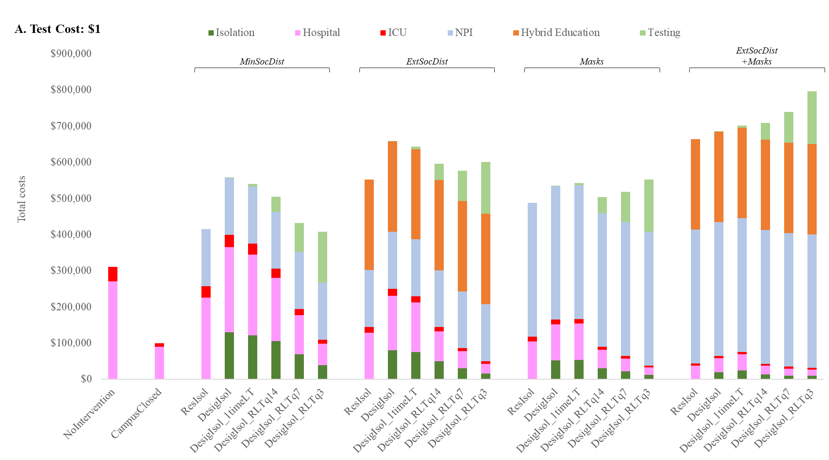

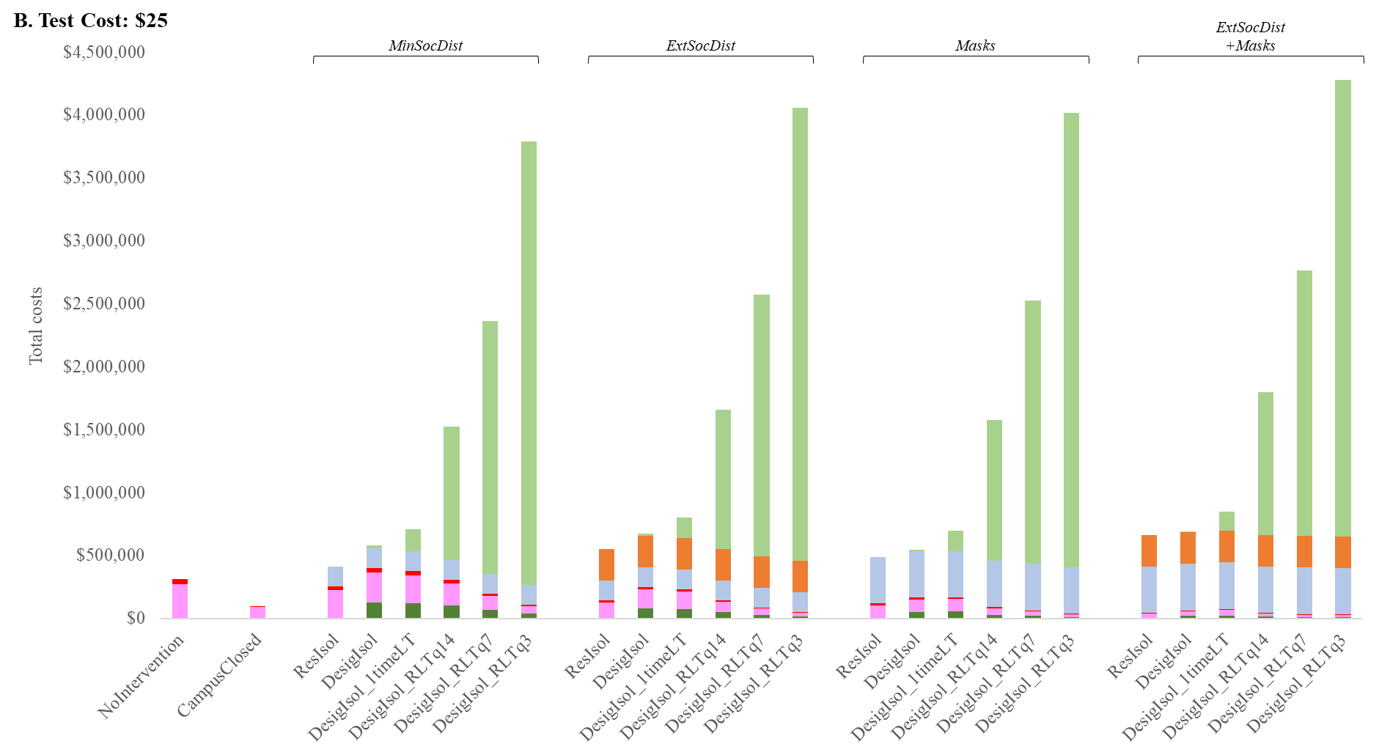
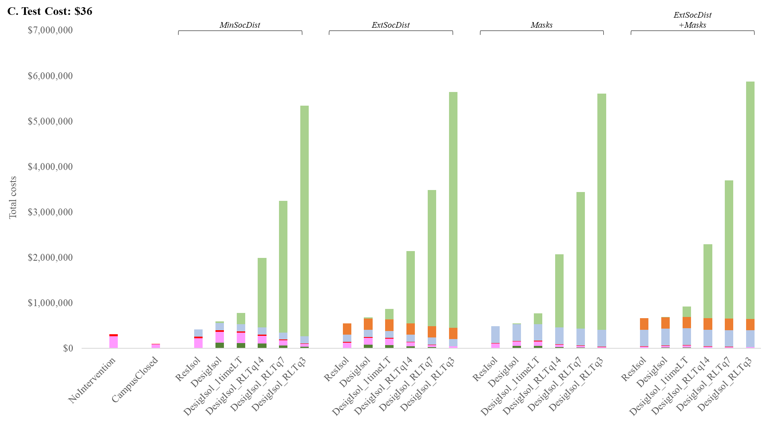
ADDIN ZOTERO_ITEM CSL_CITATION {"citationID":"vcpuw7jP","properties":{"formattedCitation":"\\super 33\\nosupersub{}","plainCitation":"33","noteIndex":0},"citationItems":[{"id":84,"uris":["http://zotero.org/users/local/jMRSEXDw/items/P4Z4L65G"],"uri":["http://zotero.org/users/local/jMRSEXDw/items/P4Z4L65G"],"itemData":{"id":84,"type":"report","title":"Medicare Administrative Contractor (MAC) COVID-19 test pricing","URL":"https://www.cms.gov/files/document/mac-covid-19-test-pricing.pdf","author":[{"literal":"Centers for Medicare and Medicaid Services"}],"issued":{"date-parts":[["2020",5,19]]}}}],"schema":"https://github.com/citation-style-language/schema/raw/master/csl-citation.json"} 33
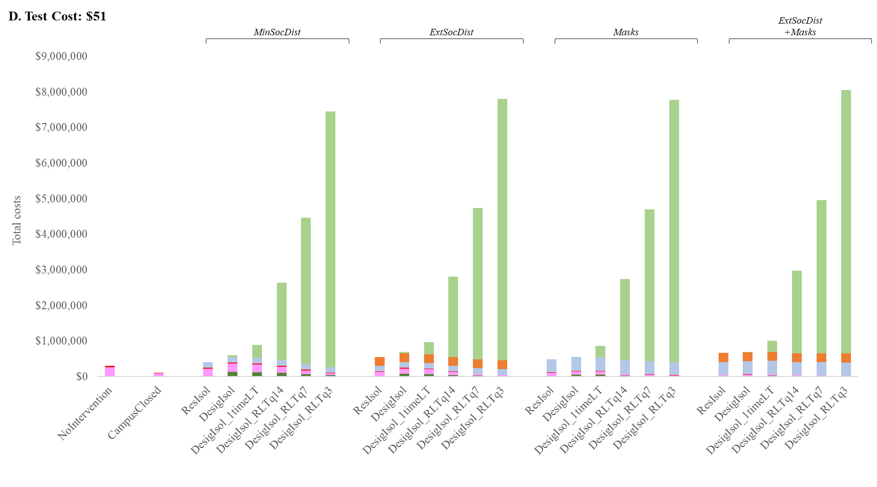

Figure Legends
Figure S1. Budgetary impact of COVID-19 mitigation strategies, by test cost (USD)
Each panel represents the total costs for each COVID-19 mitigation strategy, for different test costs. Panel A represented the total costs for a $1 test, Panel B represents the total cost given a $25 test, Panel C considers a $36 test (a frequently referenced current cost for PCR test), and Panel D represents a $51 dollar test (another referenced cost for current PCR test).(34) On the left are the No intervention and Campus Closed strategies. Each following set of 6 bars represents isolation and testing strategies for Minimal social distancing, Extensive social distancing, Mask Policy, and combined Extensive Social Distancing and Mask Policy. In Panel A ($1 test cost), total costs decrease with more testing for Minimal social distancing, as infections are prevented and hospital and ICU costs decrease while test costs remain low. Total costs stay relatively stable in Panel A in any strategies that include Extensive social distancing or Mask policy, as either hybrid education costs or additional NPI costs are added. Panels B, C, and D indicate that test costs outweigh all other costs when tests are more expensive and any amount of routine testing is done. Across all panels, within each broad category, strategies involving residence isolation and no testing are cheaper than strategies involving quarantine isolation or any testing across all test costs.
Abbreviations: ResIsol: residence isolation; DesigIsol: designated isolation; LT: laboratory test; RLT: routine laboratory test; q: every X days; MinSocDist: Minimal social distancing strategy; ExtSocDist: Extensive social distancing strategy; Masks: Masks strategy; ExtSocDist+Masks: Extensive social distancing + Masks strategy.
Literature cited
1. Census profile: Massachusetts [Internet]. Census Reporter. [cited 2020 Aug 9]. Available from: http://censusreporter.org/profiles/04000US25-massachusetts/
2. Massachusetts Department of Public Health. Archive of COVID-19 cases in Massachusetts [Internet]. [cited 2020 Aug 9]. Available from: https://www.mass.gov/info-details/archive-of-covid-19-cases-in-massachusetts
3. Massachusetts Department of Public Health. COVID-19 Dashboard [Internet]. 2020 [cited 2020 Aug 9]. Available from: https://www.mass.gov/doc/covid-19-dashboard-april-20-2020/download
4. Yourish K, Lai K, Ivory D, Smith M. One-third of all U.S. coronavirus deaths are nursing home residents or workers [Internet]. The New York Times. [cited 2020 Aug 9]. Available from: https://www.nytimes.com/interactive/2020/05/09/us/coronavirus-cases-nursing-homes-us.html
5. Li W, Zhang B, Lu J, Liu S, Chang Z, Cao P, et al. The characteristics of household transmission of COVID-19. Clin Infect Dis Off Publ Infect Dis Soc Am. 2020 Apr 17;
6. Bureau of Labor Statistics. Table 1. Time spent in primary activities and percent of the civilian population engaging in each activity, averages per day by sex, 2019 annual averages [Internet]. 2020 [cited 2020 Aug 9]. Available from: https://www.bls.gov/news.release/atus.t01.htm
7. Whalen ML. A focus on faculty. Division of Planning and Budget. [Internet]. Cornell University 2007-2008 Financial Plan. 2007 [cited 2020 Aug 9]. Available from: https://dpb.cornell.edu/documents/1000381.pdf
8. Faculty age distribution: fall 2017. PennState University Budget Office. [Internet]. [cited 2020 Aug 9]. Available from: https://budget.psu.edu/Factbook/hrdynamic/FacultyDistributionByAgePSULaw.aspx?ReportCode=Age&YearCode=2017humors&FBPlusIndc=N
9. 2011 Accountability report. University of California [Internet]. [cited 2020 Aug 9]. Available from: https://accountability.universityofcalifornia.edu/2011/index/6.2.2
10. Age distribution of full-time employees by employee group: fall 2019. The California State University. [Internet]. [cited 2020 Aug 9]. Available from: https://www2.calstate.edu:443/csu-system/faculty-staff/employee-profile/csu-staff/Pages/age-distribution-of-full-time-employee-headcount-by-faculty-and-staff-status.aspx
11. Statewide instructional faculty age distribution by employment status: report for university system of Maryland, fall 2019. USM Data Journals. [Internet]. USM IRIS. [cited 2020 Aug 9]. Available from: https://www.usmd.edu/IRIS/DataJournal/Faculty-Staff/?report=Instructional-Faculty-Age-by-Employment-Status
12. Census profile: Cambridge, MA [Internet]. Census Reporter. [cited 2020 Aug 9]. Available from: http://censusreporter.org/profiles/16000US2511000-cambridge-ma/
13. Census profile: Ithaca, NY Metro Area [Internet]. Census Reporter. [cited 2020 Aug 9]. Available from: http://censusreporter.org/profiles/31000US27060-ithaca-ny-metro-area/
14. Census profile: Austin, TX [Internet]. Census Reporter. [cited 2020 Aug 9]. Available from: http://censusreporter.org/profiles/16000US4805000-austin-tx/
15. Why a study showing that covid-19 is everywhere is good news. The Economist [Internet]. [cited 2020 Aug 9]; Available from: https://www.economist.com/graphic-detail/2020/04/11/why-a-study-showing-that-covid-19-is-everywhere-is-good-news
16. Centers for Disease Control and Prevention. Percentage of visits of ILI by age group reported by a subset of ILINet providers [Internet]. 2020 [cited 2020 Aug 9]. Available from: https://www.cdc.gov/coronavirus/2019-ncov/covid-data/covidview/07242020/percent-ili-visits-age.html
17. Wang D, Hu B, Hu C, Zhu F, Liu X, Zhang J, et al. Clinical characteristics of 138 hospitalized patients with 2019 novel coronavirus-infected pneumonia in Wuhan, China. JAMA. 2020 Feb 7;
18. Rui P, Okeyode T. National ambulatory medical care survey: 2016 national summary tables [Internet]. National Center for Health Statistics, Centers for Disease Control and Prevention, 2019. [cited 2020 Aug 9]. Available from: https://www.cdc.gov/nchs/data/ahcd/namcs_summary/2016_namcs_web_tables.pdf
19. Jia H, Lubetkin EI. Estimating EuroQol EQ-5D scores from population Healthy Days data. Med Decis Mak Int J Soc Med Decis Mak. 2008 Aug;28(4):491–9.
20. Yang J, Jit M, Zheng Y, Feng L, Liu X, Wu JT, et al. The impact of influenza on the health related quality of life in China: an EQ-5D survey. BMC Infect Dis. 2017 16;17(1):686.
21. Andrade LF, Saba G, Ricard J-D, Messika J, Gaillat J, Bonnin P, et al. Health related quality of life in patients with community-acquired pneumococcal pneumonia in France. Health Qual Life Outcomes. 2018 Feb 2;16(1):28.
22. Kolovos S, Bosmans JE, van Dongen JM, van Esveld B, Magai D, van Straten A, et al. Utility scores for different health states related to depression: individual participant data analysis. Qual Life Res Int J Qual Life Asp Treat Care Rehabil. 2017;26(7):1649–58.
23. Mizumoto K, Kagaya K, Zarebski A, Chowell G. Estimating the asymptomatic proportion of coronavirus disease 2019 (COVID-19) cases on board the Diamond Princess cruise ship, Yokohama, Japan, 2020. Euro Surveill Bull Eur Sur Mal Transm Eur Commun Dis Bull. 2020;25(10).
24. Haridy R. CDC Director warns 25 percent of COVID-19 cases may present no symptoms [Internet]. New Atlas. 2020 [cited 2020 Aug 9]. Available from: https://newatlas.com/health-wellbeing/covid-19-cases-contagious-asymptomatic-presymptomatic-cdc-director
25. WHO-China Joint Mission on Coronavirus Disease 2019. Report of the WHO-China joint mission on coronavirus disease 2019 (COVID-19) [Internet]. 2020 Feb [cited 2020 Aug 9]. Available from: https://www.who.int/docs/default-source/coronaviruse/who-china-joint-mission-on-covid-19-final-report.pdf
26. Li R, Pei S, Chen B, Song Y, Zhang T, Yang W, et al. Substantial undocumented infection facilitates the rapid dissemination of novel coronavirus (SARS-CoV-2). Science. 2020 01;368(6490):489–93.
27. He X, Lau EHY, Wu P, Deng X, Wang J, Hao X, et al. Temporal dynamics in viral shedding and transmissibility of COVID-19. Nat Med. 2020;26(5):672–5.
28. Zhou F, Yu T, Du R, Fan G, Liu Y, Liu Z, et al. Clinical course and risk factors for mortality of adult inpatients with COVID-19 in Wuhan, China: a retrospective cohort study. Lancet Lond Engl. 2020 28;395(10229):1054–62.
29. Hu Z, Song C, Xu C, Jin G, Chen Y, Xu X, et al. Clinical characteristics of 24 asymptomatic infections with COVID-19 screened among close contacts in Nanjing, China. Sci China Life Sci. 2020;63(5):706–11.
30. Richardson S, Hirsch JS, Narasimhan M, Crawford JM, McGinn T, Davidson KW, et al. Presenting characteristics, comorbidities, and outcomes among 5700 patients hospitalized with COVID-19 in the New York City area. JAMA. 2020 Apr 22;
31. Sanders GD, Neumann PJ, Basu A, Brock DW, Feeny D, Krahn M, et al. Recommendations for conduct, methodological practices, and reporting of cost-effectiveness analyses: second panel on cost-effectiveness in health and medicine. JAMA. 2016 Sep 13;316(10):1093–103.
32. Liu Y, Gayle AA, Wilder-Smith A, Rocklöv J. The reproductive number of COVID-19 is higher compared to SARS coronavirus. J Travel Med. 2020 13;27(2).
33. Yang Y, Yang M, Shen C, Wang F, Yuan J, Li J, et al. Evaluating the accuracy of different respiratory specimens in the laboratory diagnosis and monitoring the viral shedding of 2019-nCoV infections. medRxiv. 2020 Feb 17;2020.02.11.20021493.
34. Centers for Medicare and Medicaid Services. Medicare Administrative Contractor (MAC) COVID-19 test pricing [Internet]. 2020 May. Available from: https://www.cms.gov/files/document/mac-covid-19-test-pricing.pdf

