**Supplementary information**

**Quantifying respiratory tract deposition of airborne graphene nanoplatelets: The impact of plate-like shape and folded structure**

Hanchao Gao1,2,3, Tobias Hammer2,3,, Xiaole Zhang2,3, Weidong He2,3, Guangbiao Xu‍1* and Jing Wang2,3*

1 Key Laboratory of Textile Science & Technology, Ministry of Education, College of Textiles, Donghua University, No. 2999 North Renmin Road, Songjiang, Shanghai 201620, China

2 Institute of Environmental Engineering, ETH Zurich, 8093 Zurich, Switzerland

3 Advanced Analytical Technologies, Empa, Ueberlandstrasse 129, 8600 Dübendorf, Switzerland

**\*Corresponding authors**

E-mail address: guangbiao_xu@dhu.edu.cn (G. Xu)

jing.wang@ifu.baug.ethz.ch (J. Wang)



**Fig. S1** The thickness of airborne GNPs measured from SEM images and well fitted by the normal distribution.



**Fig. S2** (a-b) SEM images of airborne GNPs (the folded GNPs were picked out manually and highlighted in yellow circles), (c) geometric diameter distribution of airborne GNPs measured from (a) and (b), (d) the relationship between folding frequency and GNPs geometric diameter.



**Fig. S3** Comparison of GNPs aerodynamic diameter between analytical expression derivation and APS measurement.



**Fig. S4** Comparison of the drag force among planar GNPs, 60º folded GNPs, 120º folded GNPs, and totally folded GNPs.



**Fig. S5** Comparison of spherical particles respiratory deposition between human and different animals (rat, pig and rabbit), (a) total deposition, (b) head airway deposition, (c) TB deposition, (d) alveolar deposition.

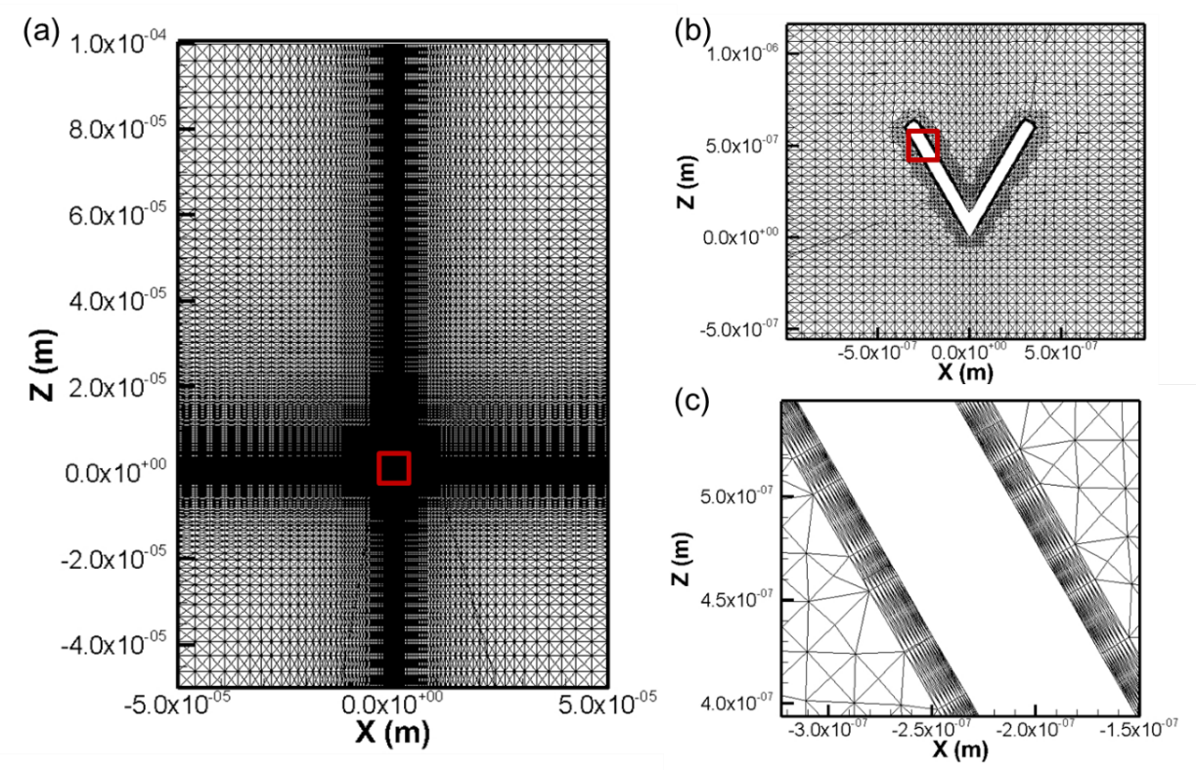

**Fig. S6** Mesh of the calculation domain. (a) grading mesh of the whole domain generated using blockMesh tool, (b) enlarged mesh for the region near the particle, (c) enlarged mesh for the additional thin layers on the surface.

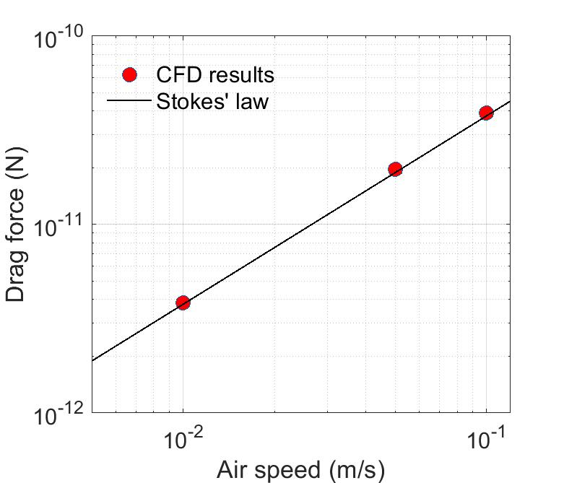

**Fig. S7** Comparison between the CFD results with the Stokes’ law for spherical particles.

**Table S1**. The folding frequency of GNPs with different geometric diameters

|  |  |  |  |  |  |
| --- | --- | --- | --- | --- | --- |
| GNPs geometric diameter (μm) | Number of folded GNPs | Number of uncertain GNPs | | Number of total GNPs | Folding frequency |
| 0 – 1 | 12 | 5 | 84 | | 0.143 ± 0.030 |
| 1 – 2 | 32 | 8 | 131 | | 0.244 ± 0.031 |
| 2 – 3 | 17 | 4 | 62 | | 0.274 ± 0.032 |

**Table S2**. Numerical simulation results of drag force of folded GNPs with folding angle of 60º and 120º

|  |  |  |  |  |  |  |  |
| --- | --- | --- | --- | --- | --- | --- | --- |
| Folding angle | Orientation | Diameter  (m) | Thick  (m) | Velocity  (m/s) | Pressure force  (N) | Viscous force  (N) | Total drag force  (N) |
| 60° | Vertical | 1.40E-06 | 6.60E-08 | 0.00001 | 5.21E-16 | 4.97E-16 | 1.01776E-15 |
|  |  | 1.40E-06 | 6.60E-08 | 0.0001 | 5.21E-15 | 4.97E-15 | 1.01776E-14 |
|  |  | 1.40E-06 | 6.60E-08 | 0.0005 | 2.60E-14 | 2.49E-14 | 5.08879E-14 |
|  | Parallel | 1.40E-06 | 6.60E-08 | 0.00001 | 8.54933E-17 | 7.53656E-16 | 8.39149E-16 |
|  |  | 1.40E-06 | 6.60E-08 | 0.0001 | 8.54933E-16 | 7.53656E-15 | 8.39149E-15 |
|  |  | 1.40E-06 | 6.60E-08 | 0.0005 | 4.27466E-15 | 3.76828E-14 | 4.19575E-14 |
| 120° | Vertical | 1.40E-06 | 6.60E-08 | 0.00001 | 9.24472E-16 | 3.25787E-16 | 1.25026E-15 |
|  |  | 1.40E-06 | 6.60E-08 | 0.0001 | 9.24471E-15 | 3.25787E-15 | 1.25026E-14 |
|  |  | 1.40E-06 | 6.60E-08 | 0.0005 | 4.62235E-14 | 1.62894E-14 | 6.25129E-14 |
|  | Parallel | 1.40E-06 | 6.60E-08 | 0.00001 | 8.95946E-17 | 8.37566E-16 | 9.27161E-16 |
|  |  | 1.40E-06 | 6.60E-08 | 0.0001 | 8.95946E-16 | 8.37566E-15 | 9.27161E-15 |
|  |  | 1.40E-06 | 6.60E-08 | 0.0005 | 4.47973E-15 | 4.18783E-14 | 4.63581E-14 |

**Table S3.** Lung volume and breathing pattern of humans and different kinds of animals in the MPPD model

|  |  |  |  |  |  |  |
| --- | --- | --- | --- | --- | --- | --- |
| Parameter | FRC  (ml) | URT  (ml) | Breathing frequency  (per min) | Tidal volume  (ml) | | Specification |
| Human | 3300 | 50 | 12 | 625 | Male | |
| Rat | 4 | 0.42 | 102 | 2 | 330g rat | |
| Pig | 999 | 137.5 | 16 | 449 | 27 kg pig | |
| Rabbit | 43.7 | 7 | 41 | 29 | 2.9 kg rabbit | |

**Table S4.** Typical path lung model for human

|  |  |  |  |  |  |  |  |
| --- | --- | --- | --- | --- | --- | --- | --- |
|  | Generation number | Number of tubes | L  (cm) | d  (cm) | θ | φ | V  (cm3) |
| Tracheobronchial | 1 | 1 | 10 | 2.01 | 0 | 0 | 31.73 |
|  | 2 | 2 | 4.36 | 1.56 | 33 | 20 | 16.67 |
|  | 3 | 4 | 1.78 | 1.13 | 34 | 31 | 7.14 |
|  | 4 | 8 | 0.965 | 0.827 | 22 | 43 | 4.15 |
|  | 5 | 16 | 0.995 | 0.651 | 20 | 39 | 5.30 |
|  | 6 | 32 | 1.01 | 0.574 | 18 | 39 | 8.36 |
|  | 7 | 64 | 0.890 | 0.435 | 19 | 40 | 8.47 |
|  | 8 | 128 | 0.962 | 0.373 | 22 | 36 | 13.46 |
|  | 9 | 256 | 0.867 | 0.322 | 28 | 39 | 18.07 |
|  | 10 | 512 | 0.667 | 0.257 | 22 | 45 | 17.72 |
|  | 11 | 1024 | 0.556 | 0.198 | 33 | 43 | 17.53 |
|  | 12 | 2048 | 0.446 | 0.156 | 34 | 45 | 17.46 |
|  | 13 | 4096 | 0.359 | 0.118 | 37 | 45 | 16.08 |
|  | 14 | 8192 | 0.275 | 0.092 | 39 | 60 | 14.98 |
|  | 15 | 16384 | 0.212 | 0.073 | 39 | 60 | 14.54 |
|  | 16 | 32768 | 0.168 | 0.060 | 51 | 60 | 15.57 |
| Alveolar region | 17 | 65536 | 0.134 | 0.054 | 45 | 60 | 20.11 |
|  | 18 | 131072 | 0.120 | 0.050 | 45 | 60 | 30.88 |
|  | 19 | 262144 | 0.092 | 0.047 | 45 | 60 | 41.84 |
|  | 20 | 524288 | 0.080 | 0.045 | 45 | 60 | 66.71 |
|  | 21 | 1048576 | 0.070 | 0.044 | 45 | 60 | 111.61 |
|  | 22 | 2097152 | 0.063 | 0.044 | 45 | 60 | 200.89 |
|  | 23 | 4194304 | 0.057 | 0.043 | 45 | 60 | 347.19 |

L is airway segment length, d is segment diameter, θ is bifurcation angle, φ is gravitational angle, and V is volume.

*1. Drag force and equivalent diameters of GNPs with folding angles of 60º and 120º*

*1.1 Drag force of GNPs with folding angles of 60º and 120º*

For GNPs with folding angle of 60°, the drag force and particle velocity was fitted into a linear relationship:

$F_{D_folded (60°, perpendicular)}=7.2*{10}^{-5}d_{g}V_{folded \left(60°\right)}$,

$F_{D_folded (60°, parallel)}=6.0*{10}^{-5}d_{g}V_{folded \left(60°\right)}$.

For GNPs with folding angle of 120°, the drag force was expressed as:

$F_{D_folded (120°, perpendicular)}=8.9*{10}^{-5}d_{g}V_{folded (120°)}$,

$F_{D_folded (120°, parallel)}=6.6*{10}^{-5}d_{g}V_{folded (120°)}$.

where the unit of *FD_folded* is N, the unit of *dg* is m, and the unit of *Vfolded* is m s-1.

*1.2 Equivalent diameters of GNPs with folding angles of 60º and 120º*

*1.2.1 Aerodynamic diameter da*

For GNPs with folding angle of 60° and perpendicular orientation, the drag force FD_folded (60°, perpendicular) and particle velocity Vfolded (60°) was fitted into a linear relationship:

$$F_{D_folded (60°, perpendicular)}=7.2*{10}^{-5}d_{g}{V_{folded (60°)} }_{}$$

where the unit of *FD_folded* is N, the unit of *dg* is m, and the unit of *Vfolded* is m s-1.

By equaling the settling velocity of sphere *VTS_sphere* with that of platelet-shaped particle, the aerodynamic diameter da_folded (60°, perpendicular) of the GNPs with folding angle of 60° and perpendicular orientation was calculated as:

$$d_{a_folded (60°, perpendicular)}=\sqrt{250020ρ_{p}d_{g}tη}$$

Similarly, the aerodynamic diameter da_folded (60°, parallel) at parallel orientation was calculated as:

$$d_{a_folded (60°, parallel)}=\sqrt{300420ρ_{p}d_{g}tη}$$

For GNPs with folding angle of 60° and random orientation,

$$d_{a_folded (60°)}= d_{a_folded (60°, perpendicular)}\sin^{2}φ+d_{a_folded (60°, parallel)}\cos^{2}φ$$

with *sin2φ =* 2/3 and *cos2φ* = 1/3.

Using the same derivation method, the aerodynamic diameter of GNPs with folding angle of 120° was calculated as:

$$d_{a_folded (120°, perpendicular)}=\sqrt{202248ρ_{p}d_{g}tη}$$

$$d_{a_folded (120°, parallel)}=\sqrt{271908ρ_{p}d_{g}tη}$$

where the unit of *da_folded*, *dg* and *t* is m, and the unit of *ρp* is kg m-3.

*1.2.2 Sedimentation diameter dg*

Compared with aerodynamic diameter which standardizes for both shape and density, the sedimentation diameter only took the shape effect into account. Using the similar calculation method, the sedimentation diameter of GNPs with folding angle of 60° was calculated as:

$$d_{s_folded (60°, perpendicular)}=\sqrt{250020d_{g}tη}$$

$$d_{s_folded (60°, parallel)}=\sqrt{300420d_{g}tη}$$

For GNPs with folding angle of 120°, the sedimentation diameter was calculated as:

$$d_{s_folded (120°, perpendicular)}=\sqrt{202248d_{g}tη}$$

$$d_{s_folded (120°, parallel)}=\sqrt{271908d_{g}tη}$$

where the unit of *ds_folded*, *dg* and *t* is m.

*1.2.3 Mobility diameter dm*

The particle reached terminal electrostatic velocity as the electrostatic force balanced the drag force. For GNPs with folding angle of 60° and perpendicular orientation,

$$V_{TE_folded (60°, perpendicular)}= \frac{neE}{7.2*{10}^{-5}d_{g}}$$

By equaling the terminal electrostatic velocity of sphere with that of GNPs, the mobility diameter of GNPs with folding angle of 60° and perpendicular orientation was expressed as:

$$d_{m_folded (60°, perpendicular)}=\frac{7.2*{10}^{-5}d_{g}}{3πη}$$

Similarly, the mobility diameter dm_folded (60°, parallel) at parallel orientation was calculated as:

$$d_{m_folded (60°, parallel)}=\frac{5.99*{10}^{-5}d_{g}}{3πη}$$

Using the same derivation method, the mobility diameter of GNPs with folding angle of 120° was calculated as:

$$d_{m_folded (120°, perpendicular)}=\frac{8.9*{10}^{-5}d_{g}}{3πη}$$

$$d_{m_folded (120°, parallel)}=\frac{6.62*{10}^{-5}d_{g}}{3πη}$$

where the unit of *dm_folded*, *dg* is m.