Supplementary Material

# Supplementary Methods

## Sampling and recruitment

The delivery lead for the National Police Wellbeing was invited to a telephone discussion regarding the study and asked whether they were willing to take part. For NHS trusts, senior executives were approached regarding the study and invited to a telephone discussion. It was agreed with the first senior executive that we would aim to recruit the full sub-cohort of general healthcare workers at their trust, alongside the NHS screening programme. As such, all subsequent discussions with senior executives focused on recruiting only staff who had previously had a positive nasal or throat swab. NHS trusts were approached up until the end of our recruitment period which was on 26 June.

If they decided to take part, all relevant study information, including study protocol, participant information sheet, consent form, questionnaire (via link to a study portal), and template email for sending out to potential participants, was sent to the relevant Research & Development team and/or bespoke delivery team. Once all research governance documentation was in place, the template email was sent out to staff via an all staff email, detailing the eligibility criteria and the link to study registration via an online study portal. For the NHS trusts where only individuals who had a previous positive swab, two recruitment strategies were given to the trust (1) send out an all-staff email with details of the study, specifying recruitment for only those with previous positive swab result or (2) email or text sent only to staff known to have had a previous positive swab (depending on availability).

Any individual who was interested in the study could access the online study portal where they could read the participant information sheet to find out more about the study. If they agreed to take part, they could complete the consent form and epidemiological questionnaire regarding their previous exposure and symptom history (Appendix 1). They were then directed to a link to book an appointment at their own workplace clinic, and availability was given on a first-come-first-serve basis. The study portal was closed once our recruitment figures had met our required sample size. At the clinic appointment, the individual would re-consent via signature, and a venous blood sample was taken, which was linked back to their questionnaire via a unique study number.

## Sample size calculations

The sample size was determined based on the overall EDSAB-HOME study aim of measuring the accuracy of home antibody testing kits. Details will be presented in a subsequent paper addressing this separate aim.

## Adaptation of WHO criteria for UK context

|  |  |
| --- | --- |
| **WHO definition** | **Local adaptation** |
| **Confirmed case**  A person with laboratory confirmation of COVID-19 laboratory infection, irrespective or clinical signs and symptoms | **Confirmed**   * Q24 - Yes, and I tested positive (3)   OR   * I did not recognise that I had symptoms, but I tested positive when I was screened (5) |
| **Suspect case**   1. A patient with acute respiratory illness (fever and at least one sign/symptom of respiratory disease, e.g. cough, shortness of breath), AND a history of travel to or residence in a location resporting community transmission of COVID-19 disease during the 14 days prior to symptom onset;   OR   1. A patient with any acute respiratory illness AND having been in contact with a confirmed or probable case (see definition of contact) in the last 14 days prior to symptom onset   OR   1. A patient with severe acute respiratory illness (fever and at least one sign/symptom of respiratory disease, e.g. cough, shortness of breath AND requiring hospitalisation) AND in the absence of an alternate diagnosis that fully explains the clinical presentation | **Late (Suspected)**   * Q24 - Yes, I had symptoms but I was not tested (1)   AND   * Q26 – After 2020-03-05   OR   * Q24 – Yes, I had symptoms, had a test, but it failed (4)   AND   * Q26 – After 2020-03-05   OR   * Q24 – Yes, I had symptoms but I was not tested (1)   AND   * Q33 – I was in contact with confirmed COVID-19 case(s) (1) OR I was in contact with suspected COVID-19 case(s) (2)   OR   * Q36 – Yes, COVID-19 was suspected/confirmed |
| **Probable case**   1. A suspect case for whom testing for the COVID-19 virus is inconclusive   OR   1. A suspect case for whom testing could not be performed for any reason | **Early (Probable)**   * Q24 – Yes, I had symptoms but I was not tested (1)   AND   * Q26 – Before or equal to 2020-03-05   OR   * Q24 - Yes, I had symptoms, had a test, but it failed (4)   AND   * Q26 – Before or equal to 2020-03-05 |
| **Uncertain** | **Uncertain**  Q24 – Yes, I had symptoms but my test(s) were all negative |
| **No** | **No**  None of the above |

Q24 = “Do you think you have had COVID-19 (the disease caused by the SARS-CoV-2 coronavirus?”

Q26 = “Approximately when did your COVID-19 like illness start?”

Q33 = “In the 14 days before your symptoms started, choose the statement which best described your situation”

Q36 = “Did you have to go to hospital?”

The reference standard for test accuracy estimates was WHO confirmed cases using previous PCR. However, in the three months prior to recruitment many symptomatic patients did not receive PCR testing at the time of symptoms. Therefore we also report index test results in relation to WHO suspected, probable and uncertain categories, adapted to the setting as described above. Due to the issues with the reference standard of these cases we define this as proportion negative rather than specificity.

# Supplementary Figures

## Figure S1: Timeline for site recruitment



## Figure S2: Age-sex pyramids, by recruitment group

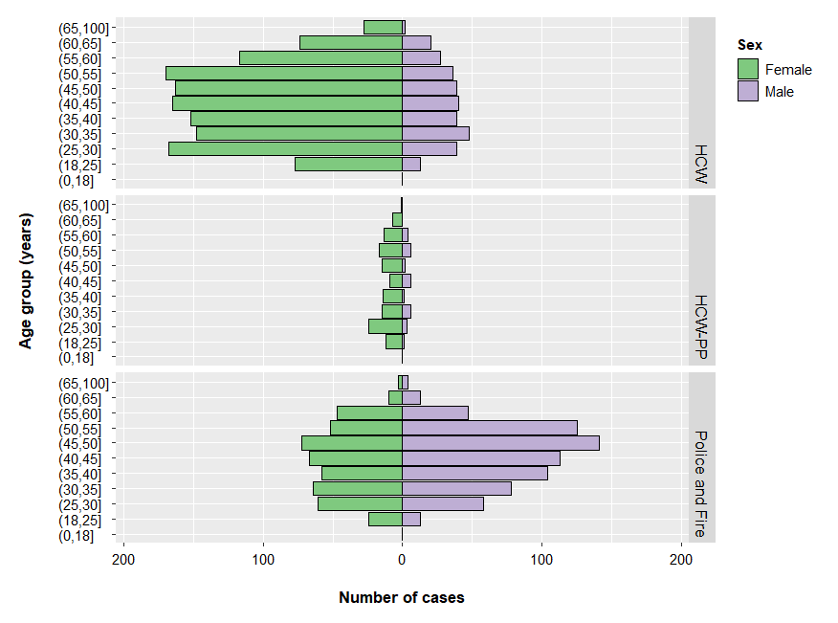

## Figure S3 Seropositive and seronegative subjects differ in symptom onset and anosmia

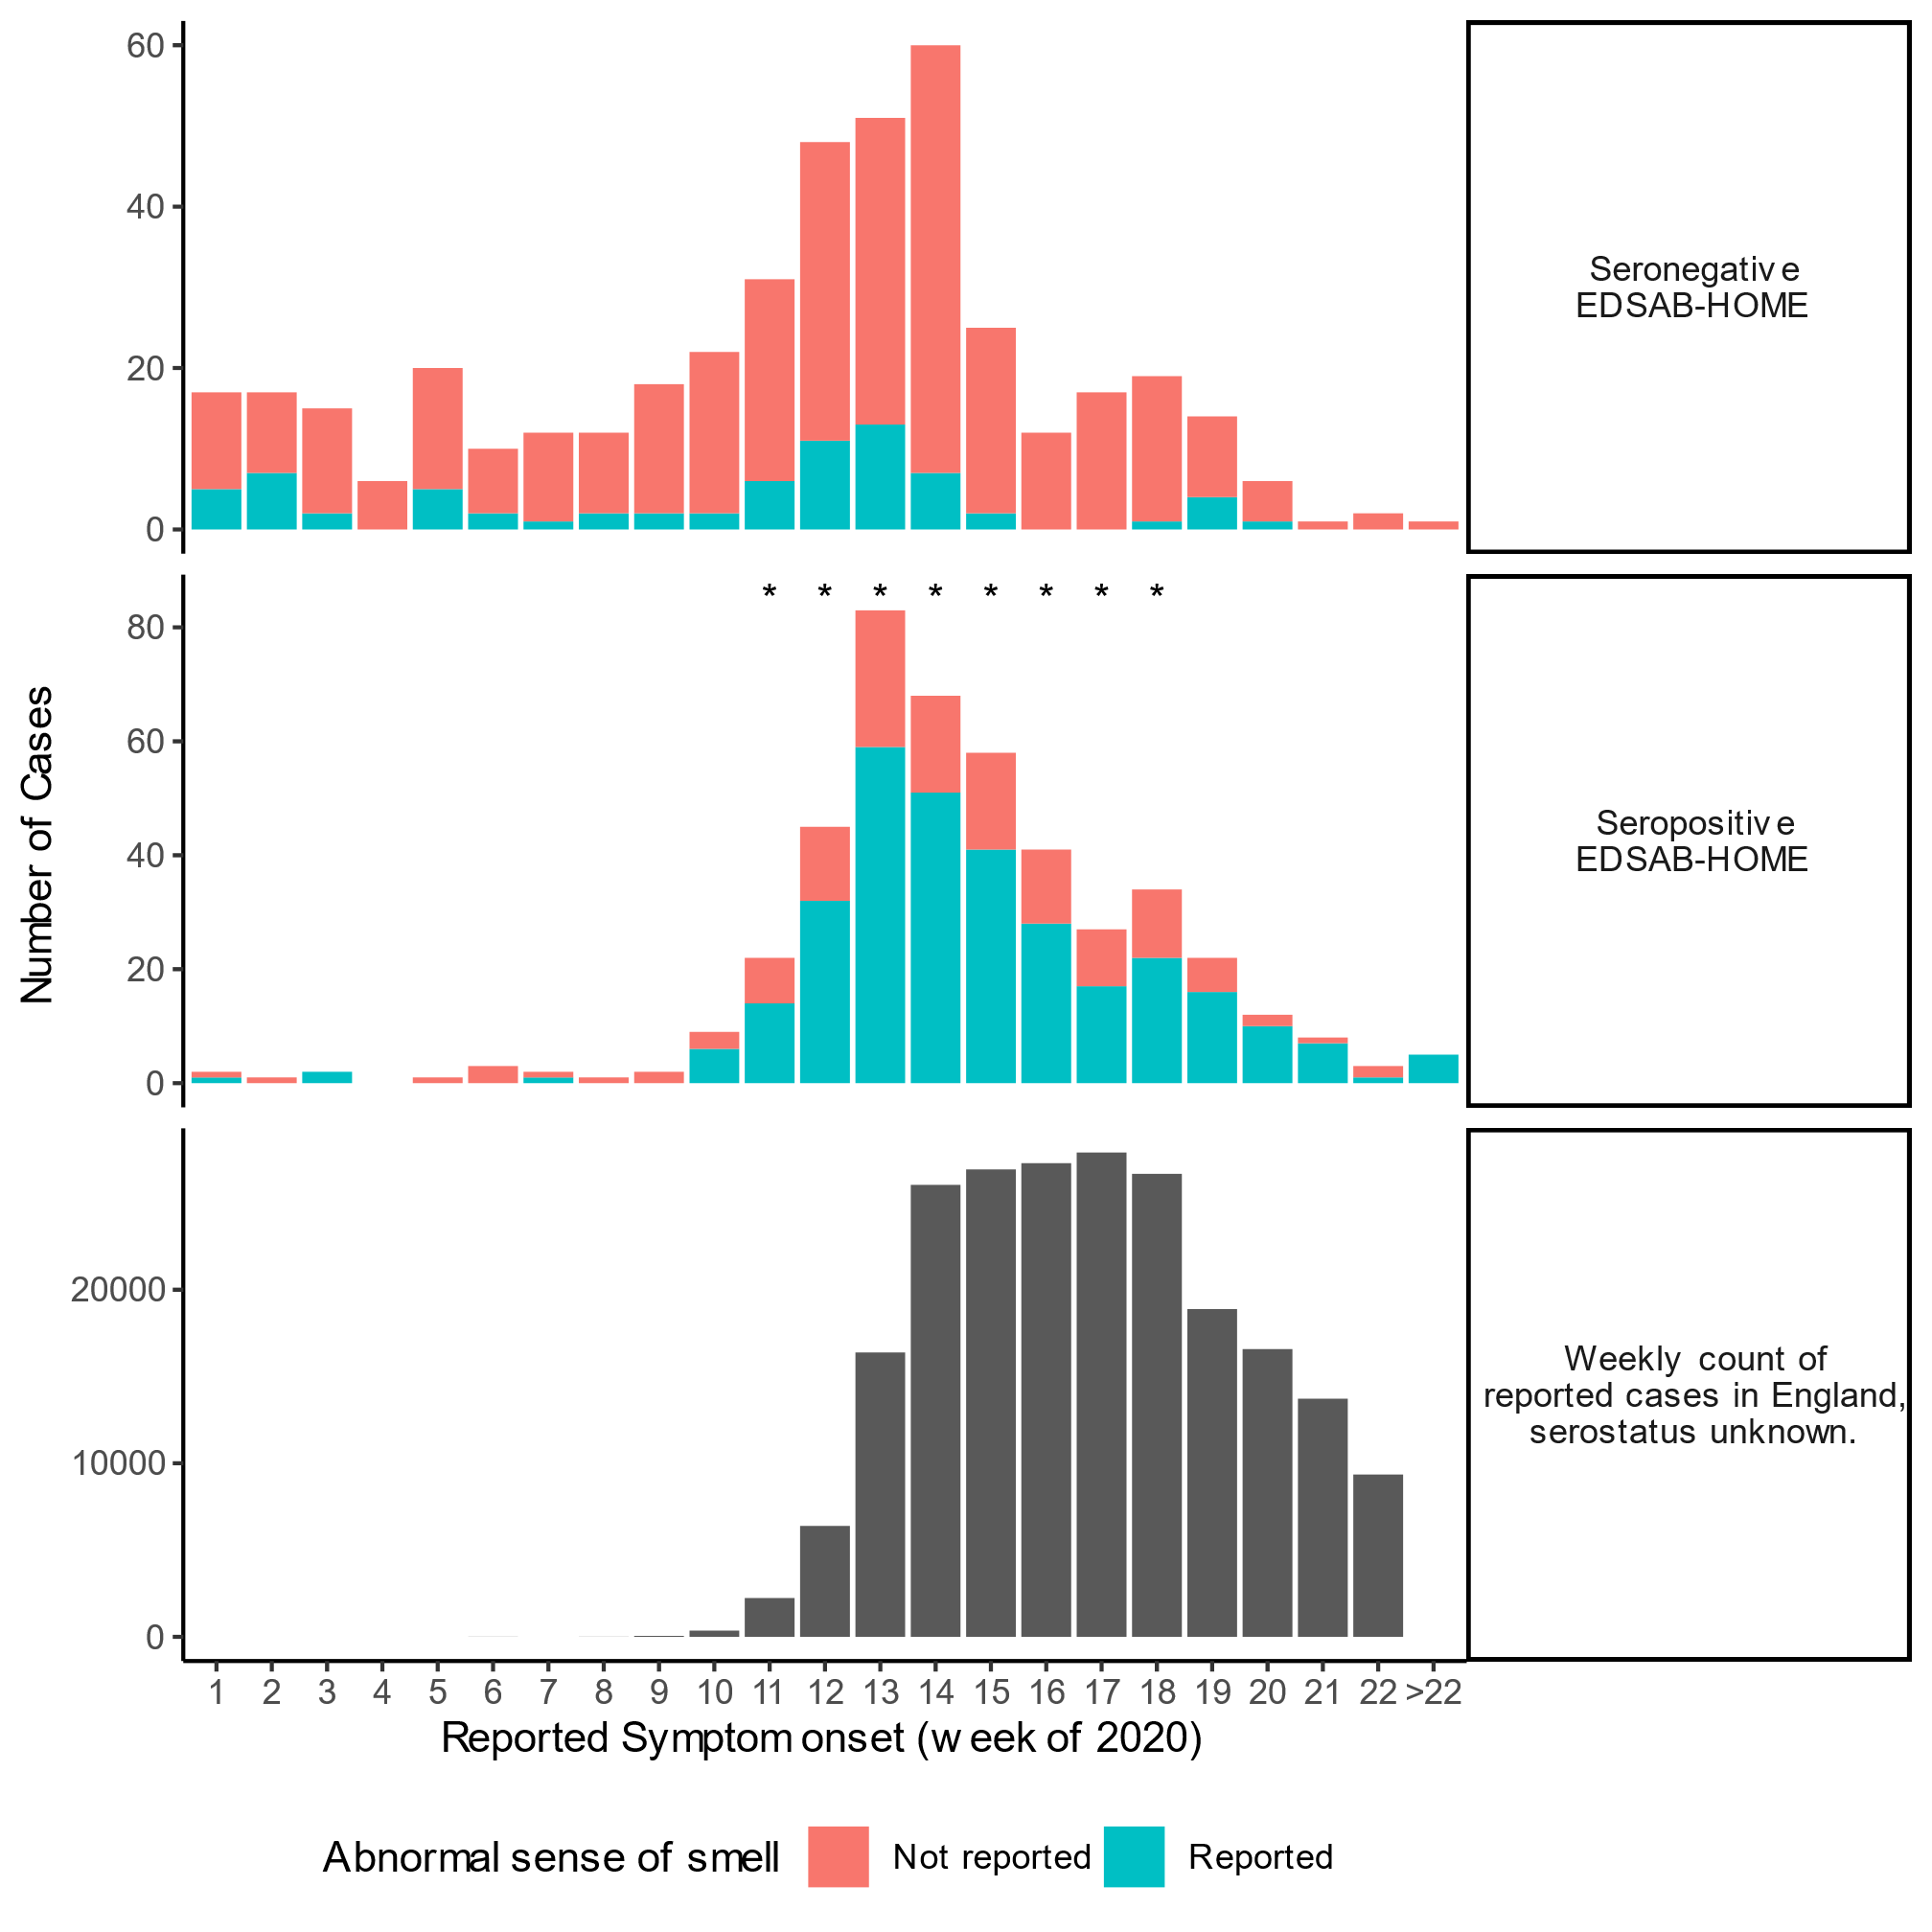

## Table S1: Description of all individuals who had a previous PCR positive result (n=268)

|  |  |
| --- | --- |
|  | **Amongst previous PCR positive** |
| **Recruitment group** |  |
| Stream A: Police and Fire | 24 (9.0%) |
| Stream B: HCW | 90 (33.6%) |
| Stream C: HCW-PP | 154 (57.5%) |
| **Age** |  |
| 18 – 25 | 19 (7.1%) |
| 25 – 40 | 106 (39.6%) |
| 40 – 60 | 126 (47.0%) |
| 60+ | 17 (6.3%) |
| **Sex** |  |
| Female | 188 (70.1%) |
| Male | 80 (29.9%) |
| **Ethnicity** |  |
| White | 212 (79.1%) |
| Asian or British Asian | 43 (16.0%) |
| Black or Black British | 5 (1.9%) |
| Mixed | 4 (1.5%) |
| Other | 4 (1.5%) |
| **Occupation** |  |
| First responder – police | 12 (4.5%) |
| First responder – fire & rescue | 1 (0.4%) |
| First responder – other (e.g. ambulance) | 1 (0.4%) |
| Hospital doctor | 73 (27.2%) |
| Hospital nurse | 80 (29.9%) |
| Hospital medical other | 25 (9.3%) |
| Hospital non-medical | 14 (5.2%) |
| Hospital lab based | 3 (1.1%) |
| GP doctor/nurse/other | 4 (1.5%) |
| Community nurse | 9 (3.4%) |
| NHS staff other | 35 (13.1%) |
| Other | 11 (4.1%) |
| **Interacted face-to-face with patients and/or general public during lockdown (post-23 March)** |  |
| More frequently than before lockdown | 23 (8.6%) |
| Similar to before lockdown | 139 (51.9%) |
| Less frequently than before lockdown | 84 (31.3%) |
| No such interactions | 5 (1.9%) |
| Non-response | 17 (6.3%) |
| **Do you think you have had previous COVID-19?** |  |
| Yes, I had symptoms but was not tested | 256 (95.5%) |
| Yes, I had symptoms but my test(s) were all negative | 0 (0.0%) |
| Yes, I had symptoms, and I had at least one positive test | 0 (0.0%) |
| Yes, I had symptoms, had a test, but it failed | 0 (0.0%) |
| I did not recognise that I had symptoms, but I tested positive when I was screened | 12 (4.5%) |
| No | 0 (0.0%) |
| Unsure | 0 (0.0%) |
| **Length of symptoms\*** |  |
| Less than 7 days | 50 (19.6%) |
| 7 -14 days | 110 (43.1%) |
| 14 – 21 days | 48 (18.8%) |
| More than 21 days | 44 (17.3%) |
| Do not know | 3 (1.2%) |
| **Unable to work (in workplace or at home) due to symptoms\*** |  |
| Yes | 237 (92.9%) |
| No | 18 (7.1%) |
| **Went to hospital due to suspected/confirmed COVID-19\*** |  |
| Yes | 30 (11.8%) |
| No | 225 (88.2%) |
| **Was in contact with a suspected or confirmed case in the 14-day prior to symptom onset\*** |  |
| Yes, confirmed | 139 (54.5%) |
| Yes, suspected | 53 (20.8%) |
| No/Unsure | 63 (24.7%) |
| **Time since symptom onset** |  |
| 0 – 20 days | 4 (1.5%) |
| 21 – 40 days | 28 (10.4%) |
| 41 – 60 days | 79 (29.4%) |
| 61 – 80 days | 106 (39.6%) |
| More than 80 days | 39 (14.6%) |
| Asymptomatic | 12 (4.4%) |
| **Has had a SARS-CoV-2 antibody test, and been informed of the result prior to recruitment** |  |
| Yes | 71 (26.5%) |
| No | 197 (73.5%) |
| **Had a household member who had COVID-19 compatible symptoms** |  |
| Yes | 146 (54.5%) |
| No | 122 (45.5%) |
| **Had a household member who had SARS-CoV-2 positive nasal or throat swab** |  |
| Yes | 52 (19.4%) |
| No | 216 (80.6%) |
| **Total** | **268** |

*based on symptomatic cases (n=256) who responded to the question; one individual was not included in the table as did not answer any symptom specific questions. Total included = 255 individuals.

## Table S2: Test sensitivity by time since symptom onset (A) Roche Elecsys® and (B) EUROIMMUN for individuals with previously PCR positive result (n=268).

(A)

|  |  |  |  |  |
| --- | --- | --- | --- | --- |
| Time since symptom onset |  | Result on Roche Elecsys ® | |  |
|  | Total samples | Positive | Negative | Sensitivity (95% CI) |
| 11 – 34 days | 25 | 23 | 2 | 92.0% (75.0, 97.8) |
| 35 – 70 days | 142 | 140 | 2 | 98.6% (95.0, 99.6) |
| 71 – 145 days | 89 | 88 | 1 | 98.9% (93.9, 99.9) |
| Asymptomatic | 12 | 8 | 4 | - |

(B)

|  |  |  |  |  |
| --- | --- | --- | --- | --- |
| Time since symptom onset |  | Result on EUROIMMUN | |  |
|  | Total samples | Positive | Negative | Sensitivity (95% CI) |
| 11 – 34 days | 25 | 24 | 1 | 96.0% (80.4, 99.8) |
| 35 – 70 days | 142 | 136 | 6 | 95.8% (91.1, 98.0) |
| 71 – 145 days | 89 | 81 | 8 | 91.0% (83.3, 95.4) |
| Asymptomatic | 12 | 9 | 3 | - |