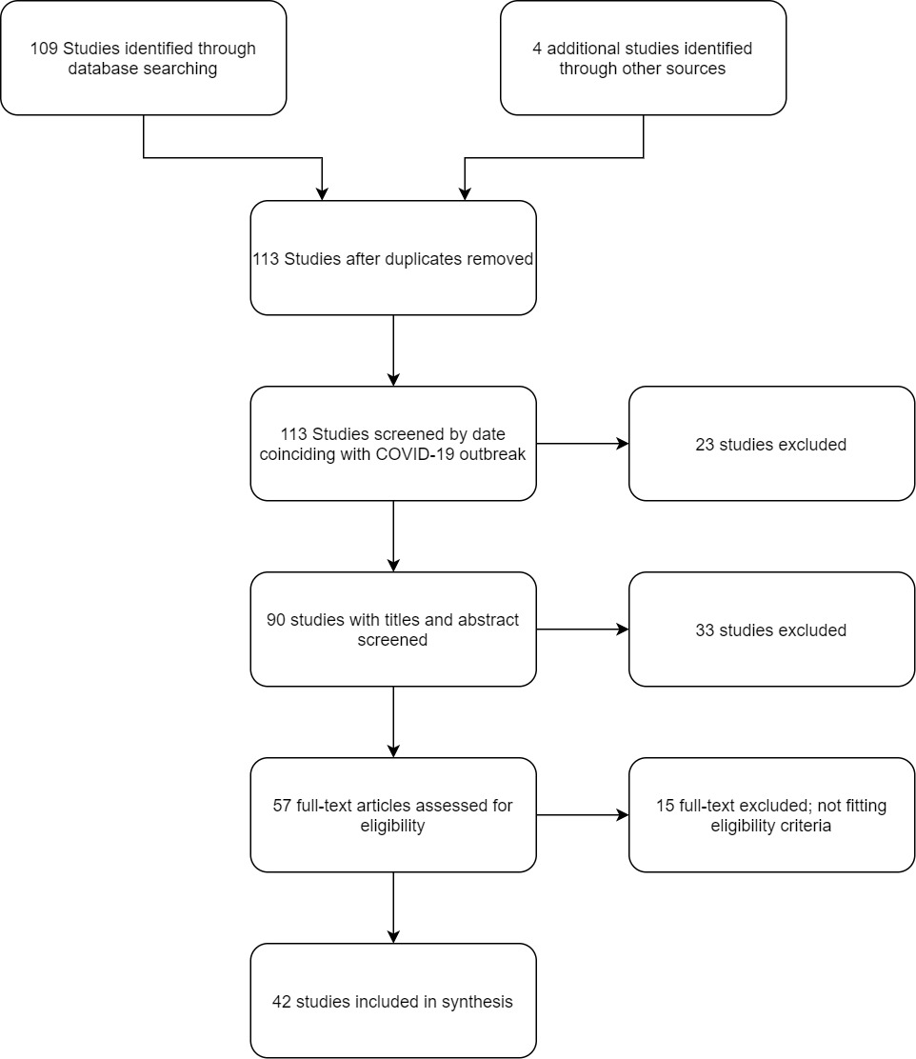

***Figure 1:* Study selection process**

***Table 1:* Distribution of study designs included in the review**

|  |  |  |  |
| --- | --- | --- | --- |
| Design | Country | Count of reports | Count of MIS-C cases |
| Case report (21) | France | 1 | 1 |
|  | India | 2 | 2 |
|  | Israel | 1 | 1 |
|  | Italy | 2 | 3 |
|  | Luxembourg | 1 | 1 |
|  | Switzerland | 2 | 3 |
|  | Turkey | 1 | 1 |
|  | UK | 1 | 1 |
|  | USA | 10 | 11 |
| Case Series (16) | France | 3 | 59 |
|  | UK | 5 | 57 |
|  | USA | 8 | 251 |
| Cohort (5) | France | 2 | 37 |
|  | Italy | 1 | 10 |
|  | UK | 1 | 50 |
|  | USA | 1 | 186 |
| Total |  | 42 | 674 |

***Table 2:* MIS-C population demographics**

|  |  |
| --- | --- |
| ***Demographic*** | ***Value*** |
| Mean age (Range) | 8.9 years (0.2-20) |
| % Males (N/total) | 57% (381/674) |
| % Ethnicity (N/total) |  |
| Afro-Caribbean | 25% (166/674) |
| Hispanic | 21% (141/674) |
| Caucasian | 17% (117/674) |
| Asian | 5% (36/674) |
| % Comorbid conditions (N/total) | 14% (95/674) |

***Table 3:* Results of confirmatory diagnostic tests**

|  |  |  |  |
| --- | --- | --- | --- |
| ***Method of Diagnosis*** | ***Positive result*** | ***Negative result*** | ***% Positive*** |
| RT-PCR | 258 | 407 | 39% |
| Serology | 457 | 76 | 86% |

***Table 4:* Frequency of clinical features among total patient population (N=674)**

|  |  |  |
| --- | --- | --- |
| ***Clinical presentation*** | ***Value*** | |
| ***N*** | ***%*** |
| Fever | 660 | 98% |
| Gastrointestinal symptoms | 557 | 83% |
| Abdominal pain | 215/557 | 39% |
| Vomiting | 197/557 | 35% |
| Diarrhea | 187/557 | 34% |
| Rash | 372 | 55% |
| Mucocutaneous inflammation | 340 | 50% |
| Cardiac symptoms | 330 | 49% |
| Hypotension | 291 | 43% |
| Respiratory symptoms | 227 | 34% |
| Neurological symptoms* | 131 | 19% |
| Acute kidney injury | 110 | 16% |
| Cervical lymphadenopathy | 52 | 8% |

* Neurologic symptoms include irritability, altered mental status, headache, seizures and signs of meningeal irritation.

***Table 5:* Reported laboratory results for total patient population (N=674)**

|  |  |  |  |
| --- | --- | --- | --- |
| ***Laboratory finding*** | ***Value*** | | |
| ***N*** | | ***%*** |
| CBC |  |  | |
| Neutrophilia | 338 | | 50% |
| Lymphopenia | 428 | | 64% |
| Thrombocytopenia | 196 | | 29% |
| Anemia | 154 | | 23% |
| Acute phase reactants |  | |  |
| Elevated CRP | 524 | | 78% |
| Hypoalbuminemia | 349 | | 52% |
| Elevated pro-calcitonin | 214 | | 32% |
| Elevated ferritin | 281 | | 42% |
| Elevated ESR | 224 | | 33% |
| Other laboratory markers |  | |  |
| Elevated troponin | 372 | | 55% |
| Elevated d-dimer | 364 | | 54% |
| Elevated BNP/proBNP | 331 | | 49% |
| Elevated transaminases | 196 | | 29% |

***Table 6:* Imaging studies and their reported findings among MIS-C patients**

|  |  |  |
| --- | --- | --- |
| ***Imaging*** | ***Value*** | |
| ***N/Total*** | ***%*** |
| Chest imaging (CT/X-ray) | 325/674 | 48% |
| Features suggestive of COVID-19 pneumonia | 192/325 | 59% |
| Pleural effusion | 93/325 | 29% |
| Cardiomegaly | 35/325 | 11% |
| Echocardiography | 542/674 | 80% |
| Reduced ejection fraction | 263/542 | 49% |
| Coronary artery abnormality | 100/542 | 18% |
| Pericardial effusion | 157/542 | 29% |
| Valve regurgitation | 26/542 | 5% |
| ECG | 138/674 | 20% |

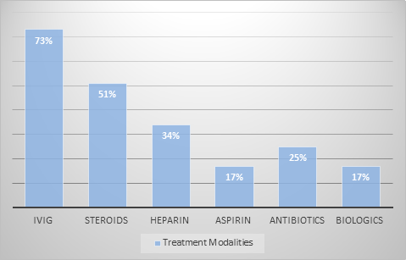

***Figure 2:* Treatment modalities for MIS-C*i***