Vitamin D supplementation to prevent acute respiratory infections: systematic review and meta-analysis of data from randomised controlled trials

Supplementary Material

Methods

Search Strategies

A. Medline

Cochrane Highly Sensitive Search Strategy for identifying randomised controlled trials

#1. randomized controlled trial [pt] OR controlled clinical trial [pt] OR randomized [tiab] OR placebo [tiab] OR drug therapy [sh] OR randomly [tiab] OR trial [tiab] OR groups [tiab]
#2. animals [mh] NOT humans [mh]
#3. #1 NOT #2

Terms specific to vitamin D

#4. Vitamin D OR vitamin D2 OR vitamin D3 OR cholecalciferol OR ergocalciferol OR
alphacalcidol OR alfacalcidol OR calcitriol OR paricalcitol OR doxerocalciferol

Terms specific to acute respiratory infection

#5. Acute Respiratory Infection OR Upper Respiratory Infection OR Lower Respiratory Infection OR Respiratory Tract Infection OR Common Cold OR Sinusitis OR Pharyngitis OR Laryngitis OR Laryngotracheobronchitis OR Tonsillitis OR peritonsillar abscess OR Croup OR Epiglottitis OR supraglottitis OR Otitis Media OR Pneumonia OR Bronchopneumonia OR Bronchitis OR Pleurisy OR Pleuritis

Combination of terms to identify randomised controlled trials of vitamin D for the prevention of acute respiratory infection

#3 AND #4 AND #5

B. EMBASE

Terms for identifying randomised controlled trials

#1 ‘randomized controlled trial’/exp OR ‘single blind procedure’/exp OR ‘double blind procedure’/exp OR ’crossover procedure’/exp
#2 random*:ab,ti OR placebo*:ab,ti OR crossover*:ab,ti OR ’cross over’:ab,ti OR allocat*:ab,ti OR ((singl* OR doubl*) NEXT/1 blind*):ab,ti OR trial:ti
#3. #1 OR #2

Terms specific to vitamin D

#4. vitamin AND d OR vitamin AND d2 OR vitamin AND d3 OR cholecalciferol OR ergocalciferol OR alphacalcidol OR alfacalcidol OR calcitriol OR paricalcitol OR doxerocalciferol

Terms specific to acute respiratory infection

#5. acute AND respiratory AND infection OR upper AND respiratory AND infection OR lower AND respiratory AND infection OR respiratory AND tract AND infection OR common AND cold OR sinusitis OR pharyngitis OR laryngitis OR laryngotracheobronchitis OR tonsillitis OR peritonsillar AND abscess OR croup OR epiglottitis OR supraglottitis OR otitis AND media OR pneumonia OR bronchopneumonia OR bronchitis OR pleurisy OR pleuritis

Combination of terms to identify randomised controlled trials of vitamin D for the prevention of acute respiratory infection

#3 AND #4 AND #5

C. Cochrane Central

Terms specific to vitamin D

#1. Vitamin D OR vitamin D2 OR vitamin D3 OR cholecalciferol OR ergocalciferol OR
alphacalcidol OR alfacalcidol OR calcitriol OR paricalcitol OR doxerocalciferol

Terms specific to acute respiratory infection

#2. Acute Respiratory Infection OR Upper Respiratory Infection OR Lower Respiratory Infection OR Respiratory Tract Infection OR Common Cold OR Sinusitis OR Pharyngitis OR Laryngitis OR Laryngotracheobronchitis OR Tonsillitis OR peritonsillar abscess OR Croup OR Epiglottitis OR supraglottitis OR Otitis Media OR Pneumonia OR Bronchopneumonia OR Bronchitis OR Pleurisy OR Pleuritis

Combination of terms to identify randomised controlled trials of vitamin D for the prevention of acute respiratory infection

#1 AND #2

D. Web of Science

TS =(Vitamin D OR vitamin D2 OR vitamin D3 OR cholecalciferol OR ergocalciferol OR alphacalcidol OR alfacalcidol OR calcitriol OR paricalcitol OR doxerocalciferol) AND TS =(Acute Respiratory Infection OR Upper Respiratory Infection OR Lower Respiratory Infection OR Respiratory Tract Infection OR Common Cold OR Sinusitis OR Pharyngitis OR Laryngitis OR Laryngotracheobronchitis OR Tonsillitis OR peritonsillar abscess OR Croup OR Epiglottitis OR supraglottitis OR Otitis Media OR Pneumonia OR Bronchopneumonia OR Bronchitis OR Pleurisy OR Pleuritis) AND TS =(placebo* or random* or clinical trial* or double blind* or single blind* or rct)

E. ClinicalTrials.gov and ISRCTN Registry

Vitamin D AND respiratory AND infection

Sources of support for participating trials

The trial by Aglipay and colleagues was supported by the competitive grants from the Canadian Institutes of Health Research Institutes of Human Development, Child and Youth Health and Nutrition, Metabolism and Diabetes (grant number MOP-114945) and the Thrasher Research Fund (award number 9113).

The trial by Aloia and colleagues was supported by the National Institute of Aging (grant number R01-AG032440-01A2).

The trial by Arihiro and colleagues was supported by the Ministry of Education, Culture, Sports, Science, and Technology in the Japan-Supported Program for the Strategic Research Foundation at Private Universities and funding from the Department of Gastroenterology and Hepatology, Jikei University of Medicine, Tokyo, Japan.

The trial by Bergman et al was supported by grants from the Swedish Research Council, the Strategic Research Foundation (SSF), the Swedish Heart and Lung foundation, Karolinska Institutet, Stockholm County Council and the Swedish Cancer Society as well as by the Magnus Bergwall and Åke Wiberg foundations.

The trials by Camargo and colleagues were supported by a grant for the Blue Sky Study from an anonymous foundation and the Massachusetts General Hospital; and the Health Research Council of New Zealand (grant number 10/400) and the Accident Compensation Corporation of New Zealand.

The trial by Ganmaa and colleagues was supported by the National Institutes of Health (Grant Number 1R01HL122624-01).

The trial by Ginde and colleagues was supported by NIH/NIA grant K23AG040708, NIH/NCATS Colorado CTSA Grant UL1TR001082, and the American Geriatrics Society Jahnigen Career Development Scholars Award.

The trial by Goodall and colleagues was supported in part by the Canadian Institutes of Health Research [OPP 86940] and with in-kind support from Copan Italia, Bresica Italy.

The trial by Grant and colleagues was supported by the Health Research Council of New Zealand, Grant Number 09/215R.

The trial by Gupta and colleagues was supported by the Indian Council of Medical Research, New Delhi.

The trial by Hauger and colleagues was supported by Lundbeckfonden (grant number R180-2014-3481), by Brødrene Hartmann’s Fund (A26842), and by the European Commission (FP7/2007–2013) under Grant Agreement 613977 for the ODIN Integrated Project (Food-based solutions for optimal vitamin D nutrition and health through the life cycle).

The trial by Hibbs and colleagues was supported by the National Heart, Lung, and Blood Institute and Office of Dietary Supplements (grant number R01HL109293).

The trial by Lee and colleagues was supported by the US Food and Drug Administration Orphan Product Development (grant number R01FD003894).

The trial by Loeb and colleagues was supported by the Institute for Infectious Diseases Research at McMaster University.

The trials by Manaseki-Holland and colleagues were supported by New Zealand Aid (ref: GRA/470/2) and The Wellcome Trust (ref: 082476).

The trial by Mandlik and colleagues was supported by a core grant from the Hirabai Cowasji Jehangir Medical Research Institute.

The trials by Martineau and colleagues were supported by the National Institute for Health Research under its Programme Grants for Applied Research Programme (Reference Number RP-PG-0407-10398).

The trial by Murdoch and colleagues was supported by the Health Research Council of New Zealand, grant number 09/302.

The trial by Rosendahl and colleagues was supported by the Foundation for Pediatric Research, the Finnish Medical Foundation, Governmental Subsidy for Clinical Research, the Päivikki and Sakari Sohlberg Foundation, the Academy of Finland, the Sigrid Jusélius Foundation, the Folkhälsan Research Foundation, the Novo Nordisk Foundation, the Orion Research Foundation, and Barncancerfonden.

The trial by Rake and colleagues was supported by the National Institute for Health Research Health Technology Assessment programme (ref. HTA 08/116/48).

The trial by Rees and colleagues was supported by the National Cancer Institute at the National Institutes of Health (grant numbers CA098286 and CA098286-S).

The trial by Shimizu and colleagues was supported by the FANCL Corporation.

The trial by Simpson and colleagues was supported by the Royal Hobart Hospital Research Foundation.

The trial by Tachimoto and colleagues was supported by the Ministry of Education, Culture, Sports, Science, and Technology in the Japan-Supported Program for the Strategic Research Foundation at Private Universities, JSPH KAKENHI Grant Number 23591553, and funding from Jikei University of Medicine, Tokyo, Japan.

The trial by Tran and colleagues was supported by the National Health and Medical Research Council of Australia, grant 613655.

The trial by Trilok Kumar and colleagues was supported by the Department of Biotechnology, Government of India (ref BT/PR-PR7489/PID/20/285/2006), Nutrition Third World and Sight and Life.

Table S1: Reasons for exclusion of potentially relevant studies

First author, year | Reason for exclusion
Somnath, 2017¹ | Open-label trial
Jung, 2018² | ARI outcome not pre-specified
Ramos-Martínez, 2018³ | Intervention was administration of 1,25-dihydroxyvitamin D
Zhou, 2018⁴ | Open-label trial
Hueniken, 2019⁵ | Primary outcome data reported elsewhere⁶
Singh, 2019⁷ | Study staff not blinded to intervention used

Table S2: Risk of Bias Assessment

 | Sequence generation | Allocation concealment | Blinding of participants and personnel | Blinding of outcome assessment | Incomplete outcome data | Selective reporting | Other bias
Li-Ng 2009⁸
Urashima 2010⁹
Manaseki-Holland 2010¹⁰
Laaksi 2010¹¹ |  |  |  |  | ?
Majak 2011¹²
Trilok-Kumar 2011¹³
Lehouck 2012¹⁴
Manaseki-Holland 2012¹⁵
Camargo 2012¹⁶
Murdoch 2012¹⁷
Bergman 2012¹⁸
Marchisio 2013¹⁹
Rees 2013²⁰
Tran 2014²¹
Goodall 2014²²
Urashima 2014²³
Grant 2014²⁴
Martineau 2015a²⁵ [ViDiCO]
Martineau 2015b²⁶ [ViDiAs]
Martineau 2015c²⁷ [ViDiFlu]
Simpson 2015²⁸
Dubnov-Raz 2015²⁹ |  |  |  |  | ?
Denlinger 2016³⁰
Tachimoto 2016³¹
Ginde 2016³²
Gupta 2016³³
Aglipay 2017 ⁶
Arihiro 2018 ³⁴
Hibbs 2018 ³⁵
Lee 2018 ³⁶
Loeb 2018 ³⁷
Rosendahl 2018 ³⁸
Shimizu 2018 ³⁹
Aloia 2019 ⁴⁰
Camargo 2019 ⁴¹
Hauger 2019 ⁴²
Mandlik 2020 ⁴³
Rake 2020 ⁴⁴
Ganmaa 2020⁴⁵

= low risk of bias; ? = unclear risk of bias
Table S3: Multivariate meta-regression model for proportion of participants experiencing at least one acute respiratory tract infection, by trial-level subgroups.

Variables | No of trials^{[a]} | Proportion with ≥1 ARI, intervention group (%) | Proportion with ≥1 ARI, control group (%) | Odds ratio (95% CI)^{[b]} | I² % | P value for heterogeneity | Adjusted odds ratio (95% CI)^{[c]} | P value for interaction^{[c]}
Dosing frequency
Daily | 18 | 1056/2134 (49.5) | 1020/1871 (54.5) | 0.75 (0.61 to 0.93) | 52.5 | 0.005 | 0.93 (0.73 to 1.19) | 0.56
Not daily | 15 | 7066/11624 (60.8) | 7080/11592 (61.1) | 0.99 (0.92 to 1.05) | 0.0 | 0.50 | Referent
Daily dose equivalent, IU
≤1000 | 12 | 1138/2411 (47.2) | 1138/2202 (51.7) | 0.70 (0.56 to 0.87) | 48.6 | 0.03 | 0.80 (0.62 to 1.03) | 0.08
>1000 | 21 | 6984/11347 (61.5) | 6962/11261 (61.8) | 0.99 (0.90 to 1.08) | 18.5 | 0.22 | Referent
Trial duration, months
≤12 | 27 | 1667/4357 (38.3) | 1711/4110 (41.6) | 0.81 (0.70 to 0.93) | 41.9 | 0.01 | 0.87 (0.68 to 1.11) | 0.24
>12 | 6 | 6455/9401 (68.7) | 6389/9353 (68.3) | 1.03 (0.95 to 1.11) | 0.0 | 0.97 | Referent

[a] Data from one trial that included higher-dose, lower-dose and placebo arms²¹ are excluded, since the higher-dose and lower-dose arms in this study spanned the 1,000 IU/day cut-off, rendering it unclassifiable for the purposes of this analysis. [b] Within-sub-group odds ratios from random effects model adjusting for study weights. [c] adjusted odds ratios and P values for interaction from multivariable meta-regression model including dichotomised variables for dose frequency, size and trial duration.

Table S4: Summary of Findings Table
Vitamin D₃ compared to placebo for prevention of acute respiratory infection (ARI)
Population: children and adults of any age, sex or ethnic origin, with or without co-morbidity
Setting: Eighteen countries on four continents (Asia, Australasia, Europe, North America)
Intervention: oral vitamin D₃ (cholecalciferol) supplementation
Comparison: oral placebo
Outcomes | Anticipated absolute effects* (95% CI) |  | Relative effect  (95% CI) | № of participants  (studies) | Quality of the evidence  (GRADE)
 | Risk with placebo | Risk with Vitamin D
Proportion with at least one ARI, all participants | 600 per 1,000 | 572 per 1,000  (549 to 595) | OR 0.89  (0.81 to 0.98) | 27815  (34 RCTs) | ⨁⨁⨁  MODERATE
Proportion with at least one ARI, participants in placebo-controlled trials with duration ≤12 months investigating daily dosing with 400-1,000 IU vitamin D₃/day | 572 per 1,000 | 436 per 1,000 (375 to 500) | OR 0.58 (0.45 to 0.75) | 1232 (8 RCTs) | ⨁⨁⨁  MODERATE
Proportion with at least one hospital admission or emergency department attendance due to ARI | 13 per 1,000 | 11 per 1,000  (9 to 15) | OR 0.89  (0.68 to 1.15) | 19466  (17 RCTs) | ⨁⨁⨁  MODERATE
Proportion with serious adverse event, any cause | 38 per 1,000 | 36 per 1,000  (31 to 41) | OR 0.94  (0.81 to 1.08) | 22553  (32 RCTs) | ⨁⨁⨁  MODERATE
Proportion of deaths due to ARI or respiratory failure | 1 per 1,000 | 1 per 1,000  (0 to 1) | OR 0.93  (0.50 to 1.73) | 21419  (31 RCTs) | ⨁⨁⨁  MODERATE
*The risk in the intervention group (and its 95% confidence interval) is based on the assumed risk in the comparison group and the relative effect of the intervention (and its 95% CI).
CI: Confidence interval; OR: Odds ratio
GRADE Working Group grades of evidence
High quality: We are very confident that the true effect lies close to that of the estimate of the effect
Moderate quality: We are moderately confident in the effect estimate: The true effect is likely to be close to the estimate of the effect, but there is a possibility that it is substantially different
Low quality: Our confidence in the effect estimate is limited: The true effect may be substantially different from the estimate of the effect
Very low quality: We have very little confidence in the effect estimate: The true effect is likely to be substantially different from the estimate of effect

Table S5: Results of exploratory sensitivity analyses excluding placebo-controlled trials at unclear risk of bias and studies investigating ARI incidence as a secondary outcome.

Reason for exclusion (number of excluded studies) | No. of studies included | Proportion with ≥1 ARI, intervention group (%) | Proportion with ≥1 ARI, control group (%) | Odds ratio (95% CI) | I² % | P value for heterogeneity
Studies at unclear risk of bias (n=2) | 32 | 8258/14061 (58.7) | 8132/13565 (59.9) | 0.91 (0.83 to 0.997) | 38.4 | 0.02
Studies with ARI incidence as secondary outcome (n=17) | 17 | 1030/3718 (27.7) | 1048/3625 (28.9) | 0.89 (0.77 to 1.03) | 18.6 | 0.24

Figure S1: Cates plot illustrating reduction in risk of one or more acute respiratory infections with vitamin D supplementation vs. placebo (primary comparison), A) Overall, and B) in trials with duration ≤12 months where vitamin D₃ was administered using daily doses of 400-1000 IU/day.

A

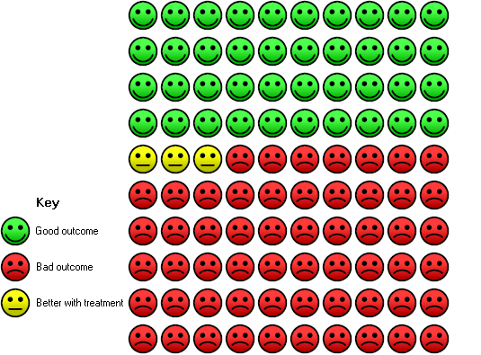

B
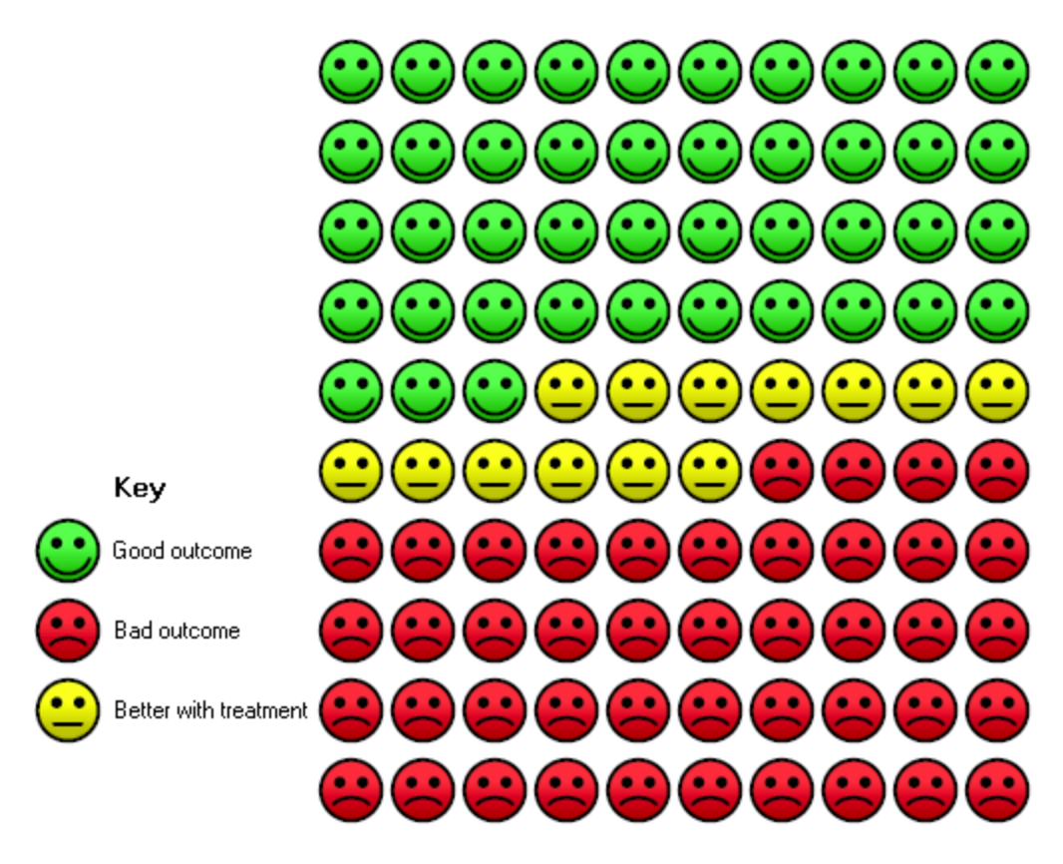

Figure S2: Forest plot of RCTs comparing effects of higher- vs. lower-dose vitamin D, reporting proportion of participants experiencing at least one acute respiratory infection.

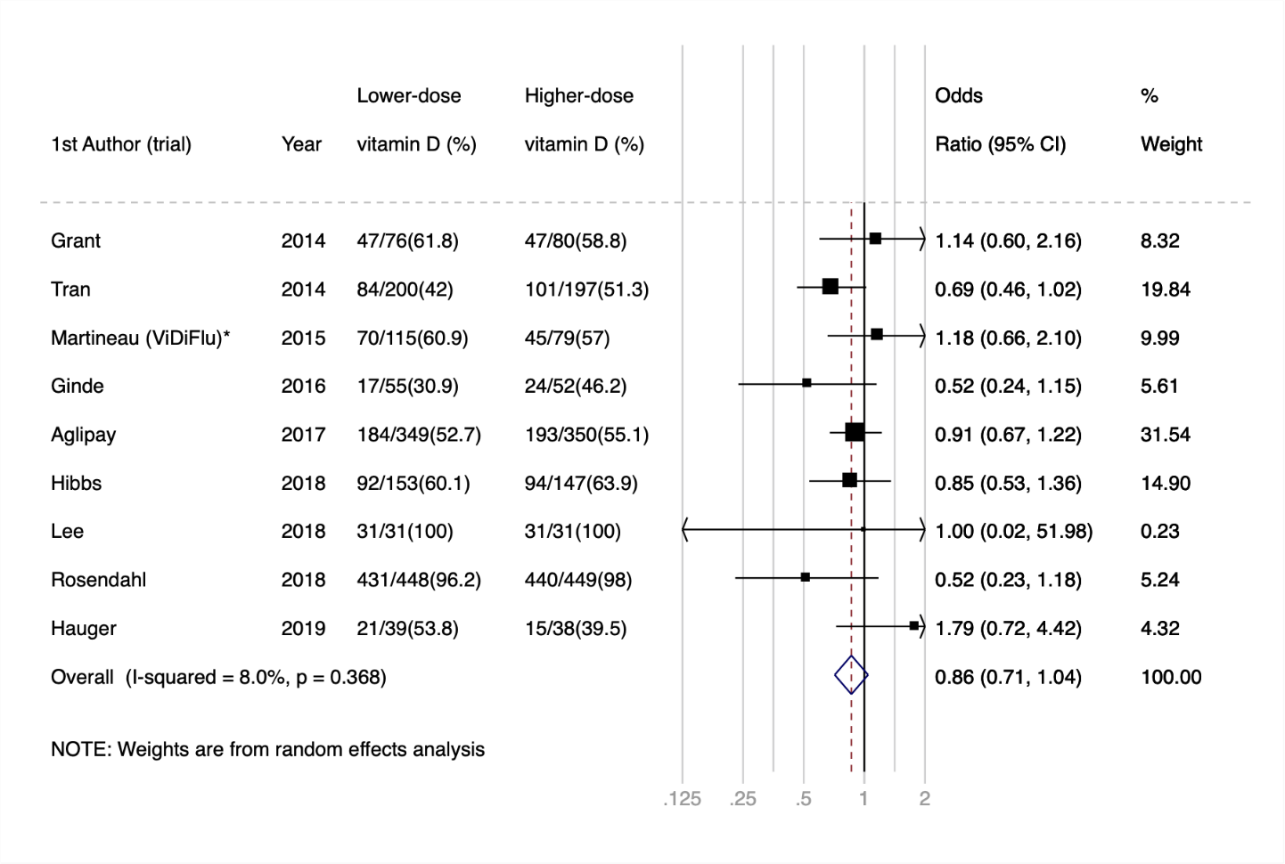

*This analysis includes data from the subset of ViDiFlu trial participants who were randomised to higher- vs. lower-dose vitamin D.
Figure S3: Forest plot of RCTs comparing effects of vitamin D vs. placebo, reporting proportion of participants experiencing at least one acute respiratory infection, by baseline 25-hydroxyvitamin D level. A) <25.0 nmol/L; B) 25.0 to 49.9 nmol/L; C) 50.0 to 74.9 nmol/L, and D) ≥75.0 nmol/L.

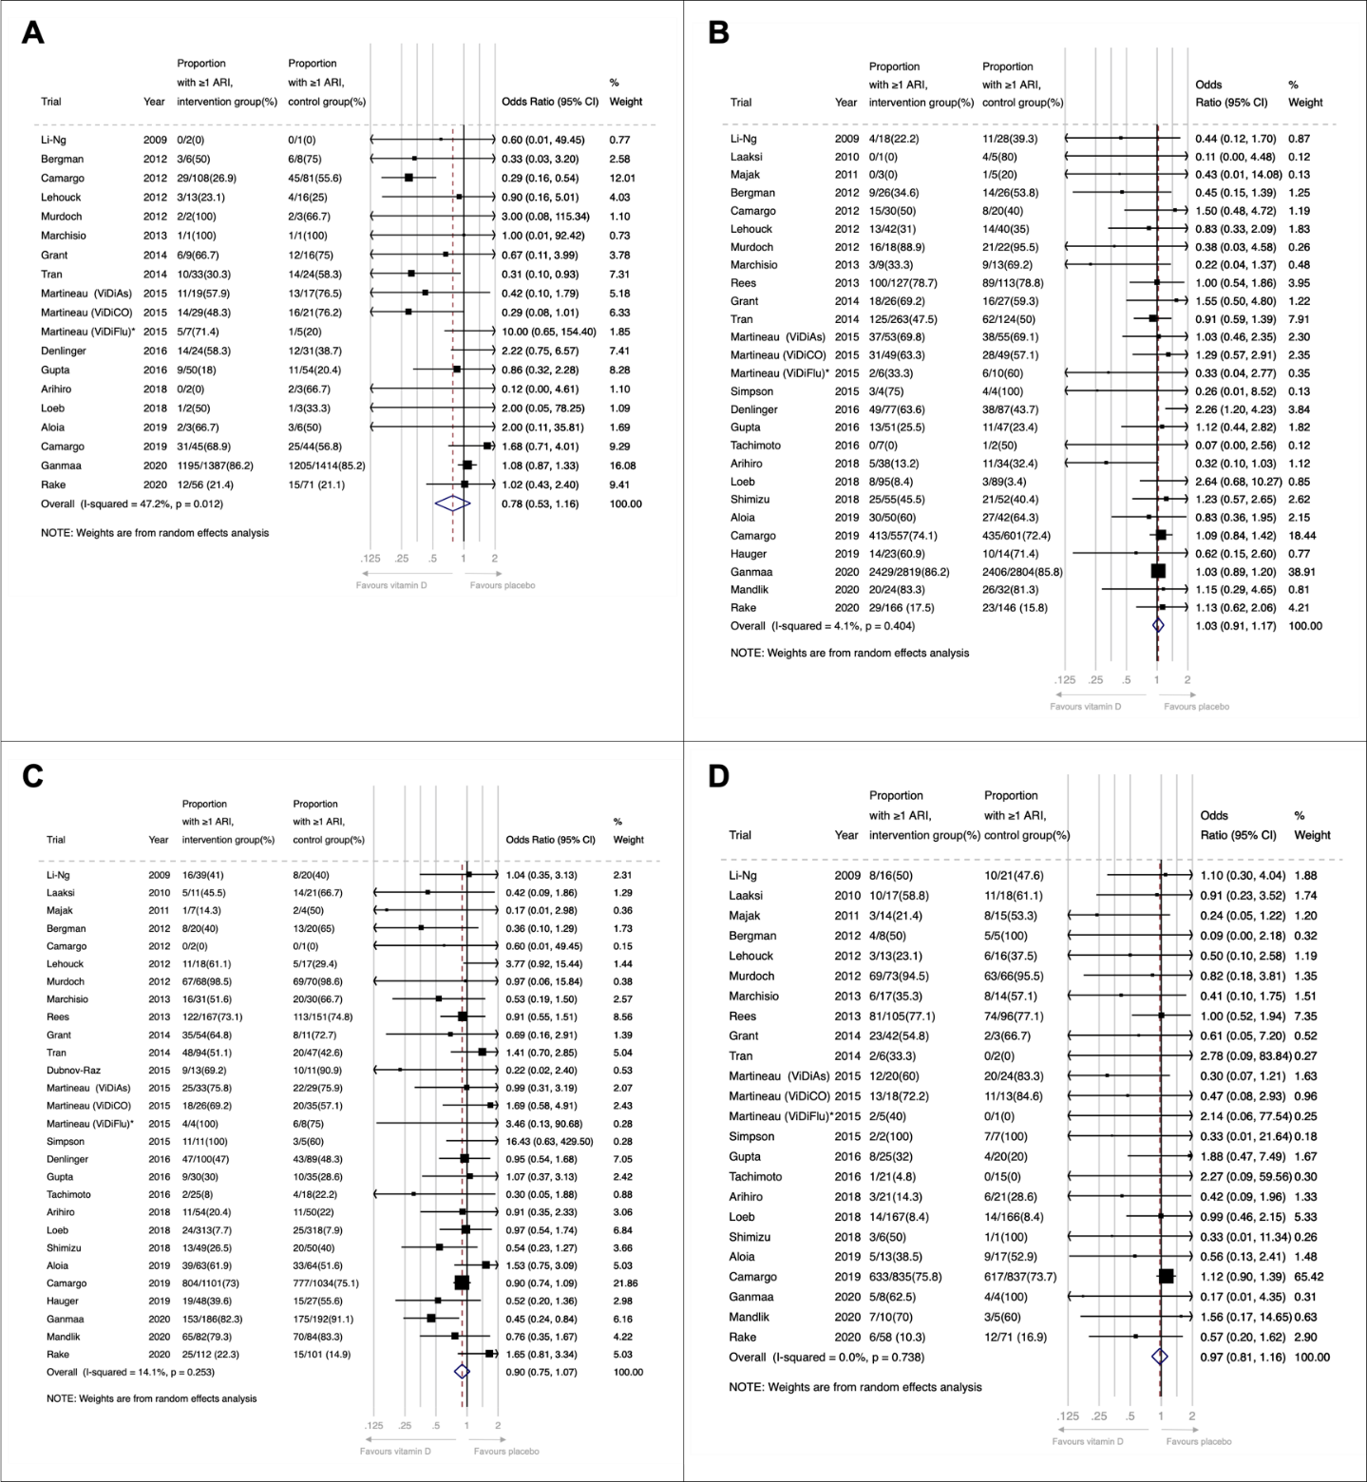

Figure S4: Forest plot of RCTs comparing effects of vitamin D vs. placebo, reporting proportion of participants experiencing at least one acute respiratory infection, by frequency of supplementation (daily vs. weekly vs. monthly to 3-monthly)

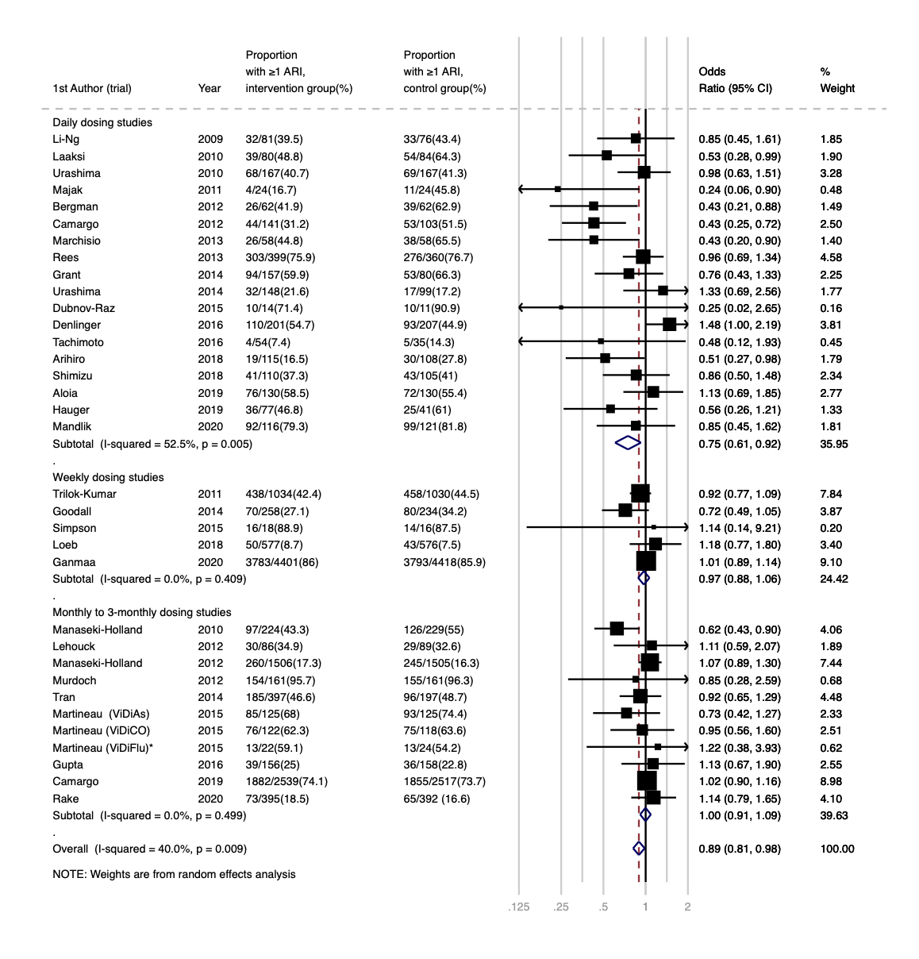
*This analysis includes data from the subset of ViDiFlu trial participants who were randomised to vitamin D vs. placebo control.
Figure S5: Forest plot of RCTs comparing effects of vitamin D vs. placebo, reporting proportion of participants experiencing at least one acute respiratory infection, by daily dose equivalents (<400 IU/day vs. 400-1000 IU/day vs. 1001-2000 IU/day vs. >2000 IU/day).

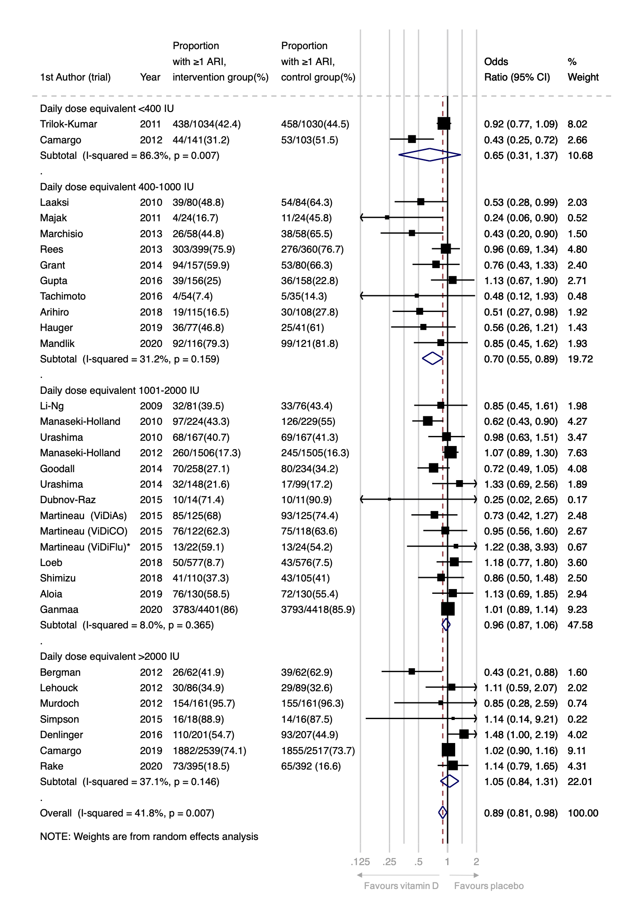
*This analysis includes data from the subset of ViDiFlu trial participants who were randomised to vitamin D vs. placebo control.
Figure S6: Forest plot of RCTs comparing effects of vitamin D vs. placebo, reporting proportion of participants experiencing at least one acute respiratory infection, by trial duration (≤12 months vs. >12 months).

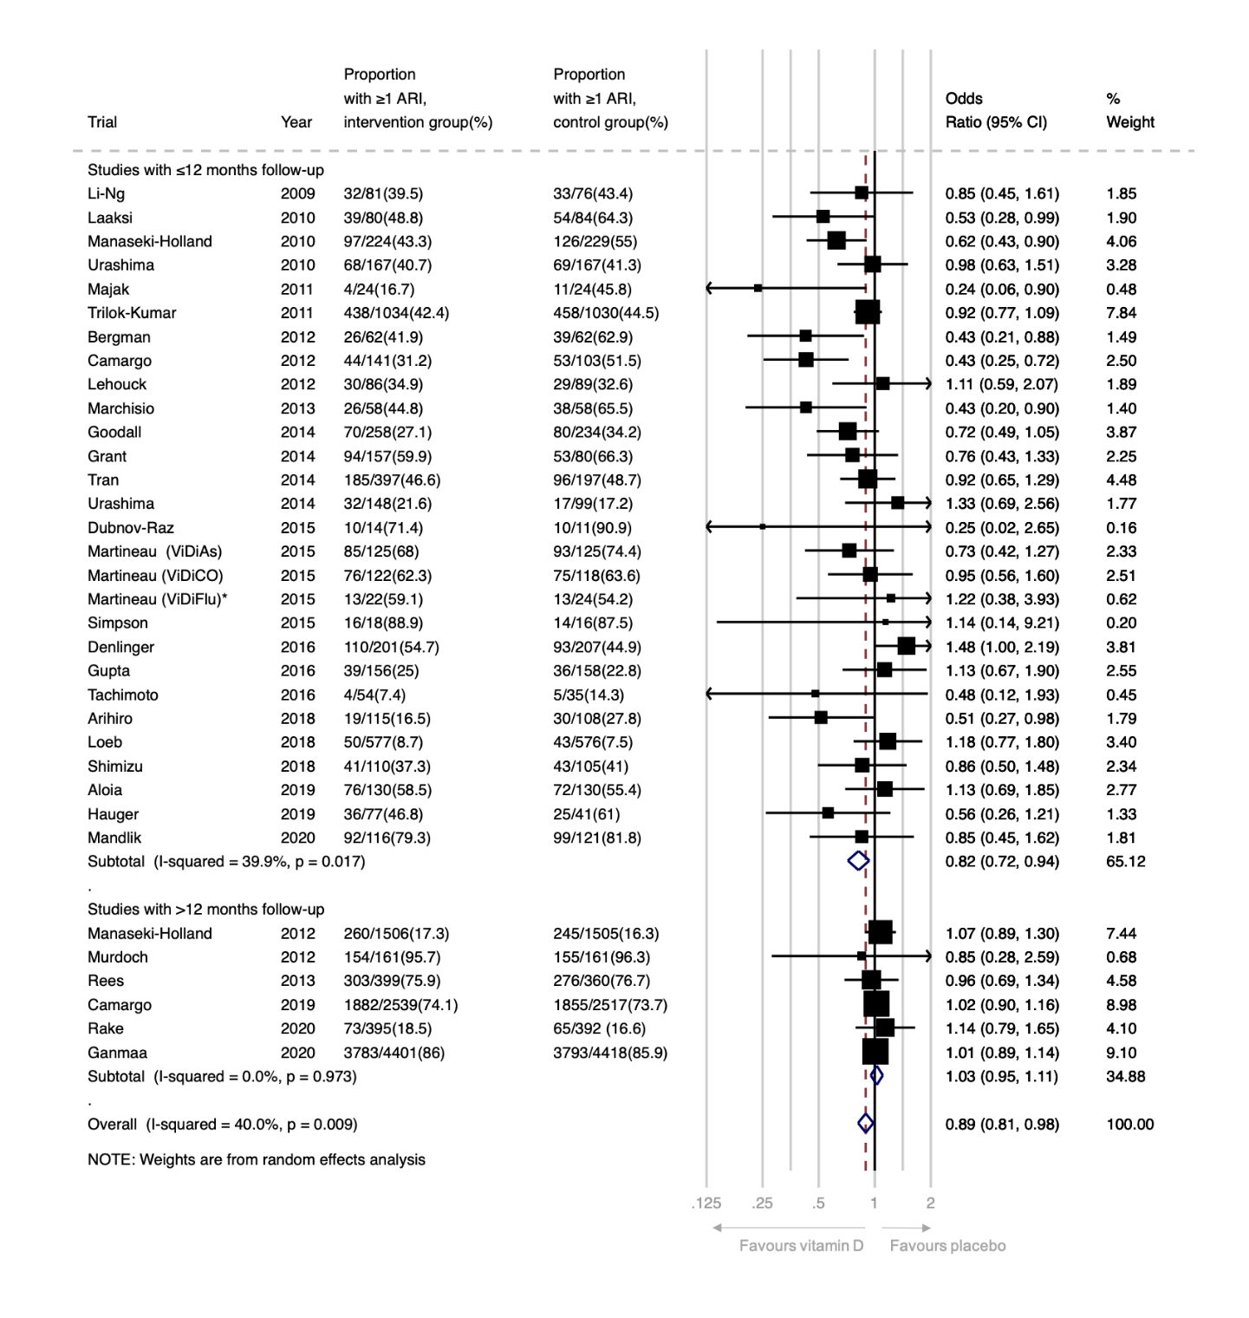
*This analysis includes data from the subset of ViDiFlu trial participants who were randomised to vitamin D vs. placebo control.
Figure S7 Forest plot of sub-set of RCTs with duration ≤12 months comparing effects of daily vitamin D at a dose of 400-1000 IU/day vs. placebo, reporting proportion of participants experiencing at least one acute respiratory infection

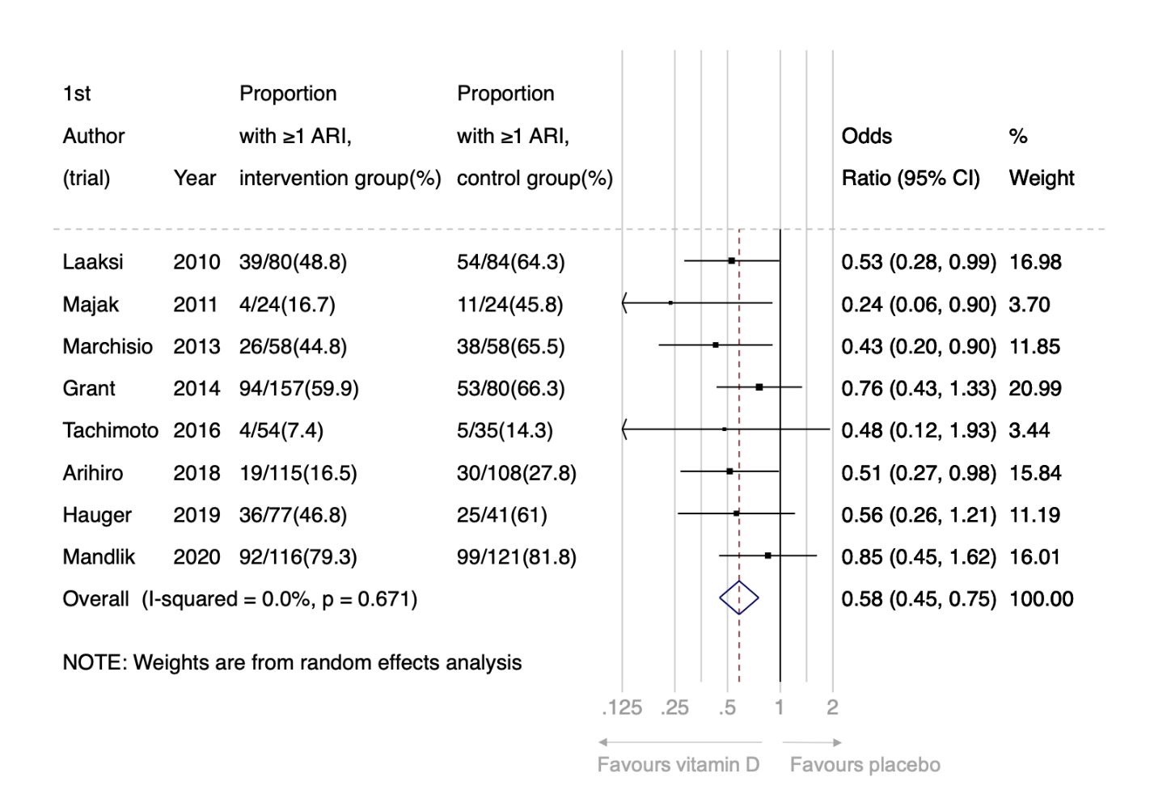

Figure S8: Funnel plot of placebo-controlled RCTs reporting proportion of participants experiencing 1 or more acute respiratory infection.

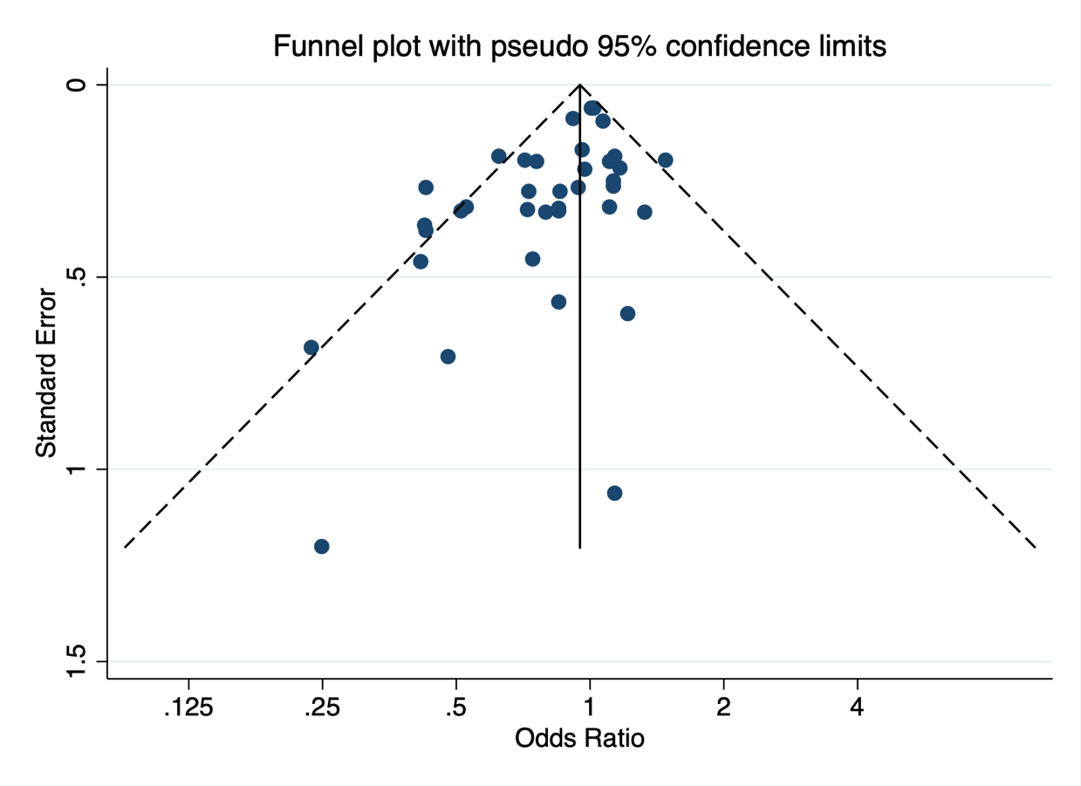

Egger’s test for publication bias: P=0.002

References

1. Somnath SH, Biswal N, Chandrasekaran V, et al. Therapeutic effect of vitamin D in acute lower respiratory infection: A randomized controlled trial. Clin Nutr ESPEN 2017;20:24-28. doi: 10.1016/j.clnesp.2017.02.003 [published Online First: 2017/10/27]
2. Jung HC, Seo M-W, Lee S, et al. Vitamin D₃ Supplementation Reduces the Symptoms of Upper Respiratory Tract Infection during Winter Training in Vitamin D-Insufficient Taekwondo Athletes: A Randomized Controlled Trial. Int J Environ Res Public Health 2018;15(9):2003. doi: 10.3390/ijerph15092003
3. Ramos-Martinez E, Lopez-Vancell MR, Fernandez de Cordova-Aguirre JC, et al. Reduction of respiratory infections in asthma patients supplemented with vitamin D is related to increased serum IL-10 and IFNgamma levels and cathelicidin expression. Cytokine 2018;108:239-46. doi: 10.1016/j.cyto.2018.01.001 [published Online First: 2018/02/07]
4. Zhou J, Du J, Huang L, et al. Preventive Effects of Vitamin D on Seasonal Influenza A in Infants: A Multicenter, Randomized, Open, Controlled Clinical Trial. The Pediatric Infectious Disease Journal 2018;37(8):749-54. doi: 10.1097/INF.0000000000001890 [published Online First: 2018/01/10]
5. Hueniken K, Aglipay M, Birken CS, et al. Effect of High-Dose Vitamin D Supplementation on Upper Respiratory Tract Infection Symptom Severity in Healthy Children. Pediatr Infect Dis J 2019;38(6):564-68. doi: 10.1097/INF.0000000000002225 [published Online First: 2018/11/07]
6. Aglipay M, Birken CS, Parkin PC, et al. Effect of High-Dose vs Standard-Dose Wintertime Vitamin D Supplementation on Viral Upper Respiratory Tract Infections in Young Healthy Children. JAMA 2017;318(3):245-54. doi: 10.1001/jama.2017.8708 [published Online First: 2017/07/19]
7. Singh N, Kamble D, Mahantshetti NS. Effect of Vitamin D Supplementation in the Prevention of Recurrent Pneumonia in Under-Five Children. Indian Journal of Pediatrics 2019;86(12):1105-11. doi: 10.1007/s12098-019-03025-z [published Online First: 2019/07/28]
8. Li-Ng M, Aloia JF, Pollack S, et al. A randomized controlled trial of vitamin D3 supplementation for the prevention of symptomatic upper respiratory tract infections. Epidemiol Infect 2009;137(10):1396-404. doi: 10.1017/S0950268809002404 [published Online First: 2009/03/20]
9. Urashima M, Segawa T, Okazaki M, et al. Randomized trial of vitamin D supplementation to prevent seasonal influenza A in schoolchildren. Am J Clin Nutr 2010;91(5):1255-60.
10. Manaseki-Holland S, Qader G, Isaq Masher M, et al. Effects of vitamin D supplementation to children diagnosed with pneumonia in Kabul: a randomised controlled trial. Trop Med Int Health 2010;15(10):1148-55. doi: TMI2578 [pii]
10.1111/j.1365-3156.2010.02578.x [published Online First: 2010/08/21]
11. Laaksi I, Ruohola JP, Mattila V, et al. Vitamin D supplementation for the prevention of acute respiratory tract infection: a randomized, double-blinded trial among young Finnish men. J Infect Dis 2010;202(5):809-14. doi: 10.1086/654881 [published Online First: 2010/07/17]
12. Majak P, Olszowiec-Chlebna M, Smejda K, et al. Vitamin D supplementation in children may prevent asthma exacerbation triggered by acute respiratory infection. J Allergy Clin Immunol 2011;127(5):1294-6. doi: S0091-6749(10)01957-3 [pii]
10.1016/j.jaci.2010.12.016 [published Online First: 2011/02/15]
13. Kumar GT, Sachdev HS, Chellani H, et al. Effect of weekly vitamin D supplements on mortality, morbidity, and growth of low birthweight term infants in India up to age 6 months: randomised controlled trial. BMJ 2011;342:d2975. doi: 10.1136/bmj.d2975 [published Online First: 2011/06/02]
14. Lehouck A, Mathieu C, Carremans C, et al. High doses of vitamin D to reduce exacerbations in chronic obstructive pulmonary disease: a randomized trial. Ann Intern Med 2012;156(2):105-14. doi: 10.1059/0003-4819-156-2-201201170-00004 [published Online First: 2012/01/18]
15. Manaseki-Holland S, Maroof Z, Bruce J, et al. Effect on the incidence of pneumonia of vitamin D supplementation by quarterly bolus dose to infants in Kabul: a randomised controlled superiority trial. Lancet 2012;379(9824):1419-27. doi: S0140-6736(11)61650-4 [pii]
10.1016/S0140-6736(11)61650-4 [published Online First: 2012/04/13]
16. Camargo CA, Jr., Ganmaa D, Frazier AL, et al. Randomized trial of vitamin D supplementation and risk of acute respiratory infection in Mongolia. Pediatrics 2012;130(3):e561-7. doi: 10.1542/peds.2011-3029
peds.2011-3029 [pii] [published Online First: 2012/08/22]
17. Murdoch DR, Slow S, Chambers ST, et al. Effect of vitamin D3 supplementation on upper respiratory tract infections in healthy adults: the VIDARIS randomized controlled trial. JAMA 2012;308(13):1333-9. doi: 10.1001/jama.2012.12505
1367547 [pii] [published Online First: 2012/10/04]
18. Bergman P, Norlin AC, Hansen S, et al. Vitamin D3 supplementation in patients with frequent respiratory tract infections: a randomised and double-blind intervention study. BMJ Open 2012;2(6):e001663. doi: 10.1136/bmjopen-2012-001663
e001663 [pii]
bmjopen-2012-001663 [pii] [published Online First: 2012/12/18]
19. Marchisio P, Consonni D, Baggi E, et al. Vitamin D supplementation reduces the risk of acute otitis media in otitis-prone children. Pediatr Infect Dis J 2013;32(10):1055-60. doi: 10.1097/INF.0b013e31829be0b0 [published Online First: 2013/05/23]
20. Rees JR, Hendricks K, Barry EL, et al. Vitamin D3 Supplementation and Upper Respiratory Tract Infections in a Randomized, Controlled Trial. Clin Infect Dis 2013 doi: 10.1093/cid/cit549 [published Online First: 2013/09/10]
21. Tran B, Armstrong BK, Ebeling PR, et al. Effect of vitamin D supplementation on antibiotic use: a randomized controlled trial. Am J Clin Nutr 2014;99(1):156-61. doi: 10.3945/ajcn.113.063271 [published Online First: 2013/10/11]
22. Goodall EC, Granados AC, Luinstra K, et al. Vitamin D3 and gargling for the prevention of upper respiratory tract infections: a randomized controlled trial. BMC Infectious Diseases 2014;14:273. doi: 10.1186/1471-2334-14-273 [published Online First: 2014/06/03]
23. Urashima M, Mezawa H, Noya M, et al. Effects of vitamin D supplements on influenza A illness during the 2009 H1N1 pandemic: a randomized controlled trial. Food & Function 2014;5(9):2365-70. doi: 10.1039/c4fo00371c [published Online First: 2014/08/05]
24. Grant CC, Kaur S, Waymouth E, et al. Reduced primary care respiratory infection visits following pregnancy and infancy vitamin D supplementation: a randomised controlled trial. Acta Paediatr 2014 doi: 10.1111/apa.12819 [published Online First: 2014/10/07]
25. Martineau AR, James WY, Hooper RL, et al. Vitamin D3 supplementation in patients with chronic obstructive pulmonary disease (ViDiCO): a multicentre, double-blind, randomised controlled trial. The Lancet Respiratory medicine 2015;3(2):120-30. doi: 10.1016/S2213-2600(14)70255-3 [published Online First: 2014/12/06]
26. Martineau AR, MacLaughlin BD, Hooper RL, et al. Double-blind randomised placebo-controlled trial of bolus-dose vitamin D3 supplementation in adults with asthma (ViDiAs). Thorax 2015;70(5):451-7. doi: 10.1136/thoraxjnl-2014-206449 [published Online First: 2015/03/01]
27. Martineau AR, Hanifa Y, Witt KD, et al. Double-blind randomised controlled trial of vitamin D3 supplementation for the prevention of acute respiratory infection in older adults and their carers (ViDiFlu). Thorax 2015 doi: 10.1136/thoraxjnl-2015-206996 [published Online First: 2015/06/13]
28. Simpson SJ, van der Mei I, Stewart N, et al. Weekly cholecalciferol supplementation results in significant reductions in infection risk among the vitamin D deficient: results from the CIPRIS pilot RCT. BMC Nutrition 2015;1(7)
29. Dubnov-Raz G, Rinat B, Hemila H, et al. Vitamin D supplementation and upper respiratory tract infections in adolescent swimmers: a randomized controlled trial. Pediatric Exercise Science 2015;27(1):113-9. doi: 10.1123/pes.2014-0030 [published Online First: 2014/07/23]
30. Denlinger LC, King TS, Cardet JC, et al. Vitamin D Supplementation and the Risk of Colds in Patients with Asthma. Am J Respir Crit Care Med 2016;193(6):634-41. doi: 10.1164/rccm.201506-1169OC [published Online First: 2015/11/06]
31. Tachimoto H, Mezawa H, Segawa T, et al. Improved Control of Childhood Asthma with Low-Dose, Short-Term Vitamin D Supplementation: A Randomized, Double-Blind, Placebo-Controlled Trial. Allergy 2016 doi: 10.1111/all.12856 [published Online First: 2016/02/04]
32. Ginde AA, Blatchford P, Breese K, et al. High-Dose Monthly Vitamin D for Prevention of Acute Respiratory Infection in Older Long-Term Care Residents: A Randomized Clinical Trial. J Am Geriatr Soc 2017;65(3):496-503. doi: 10.1111/jgs.14679 [published Online First: 2016/11/20]
33. Gupta P, Dewan P, Shah D, et al. Vitamin D Supplementation for Treatment and Prevention of Pneumonia in Under-five Children: A Randomized Double-blind Placebo Controlled Trial. Indian Pediatr 2016;53(11):967-76. doi: 10.1007/s13312-016-0970-5 [published Online First: 2016/11/28]
34. Arihiro S, Nakashima A, Matsuoka M, et al. Randomized Trial of Vitamin D Supplementation to Prevent Seasonal Influenza and Upper Respiratory Infection in Patients With Inflammatory Bowel Disease. Inflamm Bowel Dis 2019;25(6):1088-95. doi: 10.1093/ibd/izy346 [published Online First: 2019/01/03]
35. Hibbs AM, Ross K, Kerns LA, et al. Effect of Vitamin D Supplementation on Recurrent Wheezing in Black Infants Who Were Born Preterm: The D-Wheeze Randomized Clinical Trial. JAMA 2018;319(20):2086-94. doi: 10.1001/jama.2018.5729 [published Online First: 2018/05/26]
36. Lee MT, Kattan M, Fennoy I, et al. Randomized phase 2 trial of monthly vitamin D to prevent respiratory complications in children with sickle cell disease. Blood Adv 2018;2(9):969-78. doi: 10.1182/bloodadvances.2017013979 [published Online First: 2018/05/02]
37. Loeb M, Dang AD, Thiem VD, et al. Effect of Vitamin D supplementation to reduce respiratory infections in children and adolescents in Vietnam: A randomized controlled trial. Influenza Other Respir Viruses 2019;13(2):176-83. doi: 10.1111/irv.12615 [published Online First: 2018/10/18]
38. Rosendahl J, Valkama S, Holmlund-Suila E, et al. Effect of Higher vs Standard Dosage of Vitamin D3 Supplementation on Bone Strength and Infection in Healthy Infants: A Randomized Clinical Trial. JAMA Pediatrics 2018;172(7):646-54. doi: 10.1001/jamapediatrics.2018.0602 [published Online First: 2018/05/31]
39. Shimizu Y, Ito Y, Yui K, et al. Intake of 25-Hydroxyvitamin D3 Reduces Duration and Severity of Upper Respiratory Tract Infection: A Randomized, Double-Blind, Placebo-Controlled, Parallel Group Comparison Study. J Nutr Health Aging 2018;22(4):491-500. doi: 10.1007/s12603-017-0952-x [published Online First: 2018/03/28]
40. Aloia JF, Islam S, Mikhail M. Vitamin D and Acute Respiratory Infections-The PODA Trial. Open Forum Infectious Diseases 2019;6(9):ofz228. doi: 10.1093/ofid/ofz228 [published Online First: 2019/10/30]
41. Camargo CA, Sluyter J, Stewart AW, et al. Effect of monthly high-dose vitamin D supplementation on acute respiratory infections in older adults: A randomized controlled trial. Clin Infect Dis 2020;71:311-17. doi: 10.1093/cid/ciz801 [published Online First: 2019/08/20]
42. Hauger H, Ritz C, Mortensen C, et al. Winter cholecalciferol supplementation at 55°N has little effect on markers of innate immune defense in healthy children aged 4–8 years: a secondary analysis from a randomized controlled trial. European Journal of Nutrition 2019;58(4):1453-62. doi: 10.1007/s00394-018-1671-8
43. Mandlik R, Mughal Z, Khadilkar A, et al. Occurrence of infections in schoolchildren subsequent to supplementation with vitamin D-calcium or zinc: a randomized, double-blind, placebo-controlled trial. Nutr Res Pract 2020;14(2):117-26. doi: 10.4162/nrp.2020.14.2.117 [published Online First: 2020/04/08]
44. Rake C, Gilham C, Bukasa L, et al. High-dose oral vitamin D supplementation and mortality in people aged 65-84 years: the VIDAL cluster feasibility RCT of open versus double-blind individual randomisation. Health Technol Assess 2020;24(10):1-54. doi: 10.3310/hta24100 [published Online First: 2020/02/25]
45. Ganmaa D, Uyanga B, Zhou X, et al. Vitamin D Supplements and Prevention of Tuberculosis Infection and Disease. In press 2020

