Supplemental Appendix

Genetic drift versus climate spreading dynamics of COVID-19

Roberta Di Pietro, MD, Professor ¹, Mariangela Basile, PhD ¹, Laura Antolini, PhD, Professor ² and Saverio Alberti, MD, PhD, Professor ^{3 *}

¹ Department of Medicine and Aging Sciences, Section of Biomorphology, G. d’Annunzio University of Chieti-Pescara, Italy. Email: r.dipietro@morpho.unich.it, mariangelabasile@hotmail.it
² Center for Biostatistics, Department of Clinical Medicine, Prevention and Biotechnology, University of Milano-Bicocca, Monza, Italy. Email: laura.antolini@unimib.it
³ Unit of Medical Genetics, Department of Biomedical Sciences - BIOMORF, University of Messina, via Consolare Valeria, Messina, Italy. Email: salberti@unime.it

⁴ Contributed equally to this article.

* Address reprint requests to Prof. Alberti at the Unit of Medical Genetics, Department of Biomedical Sciences - BIOMORF, University of Messina, via Consolare Valeria, Messina, Italy, or at salberti@unime.it.

Supplemental Figures

Figure S1. Worldwide temperature distributions and climate zones.

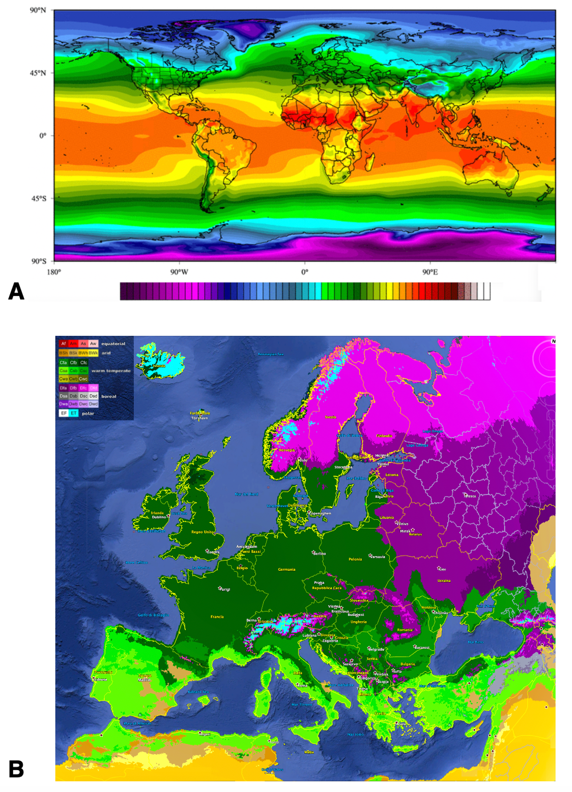

(top) Worldwide temperature averages (pseudocolor) versus geographic areas (April collective data).
(bottom) Köppen–Geiger climate classification map for Europe.

Figure S2. Global accumulation of genomic mutations of SARS-CoV-2.

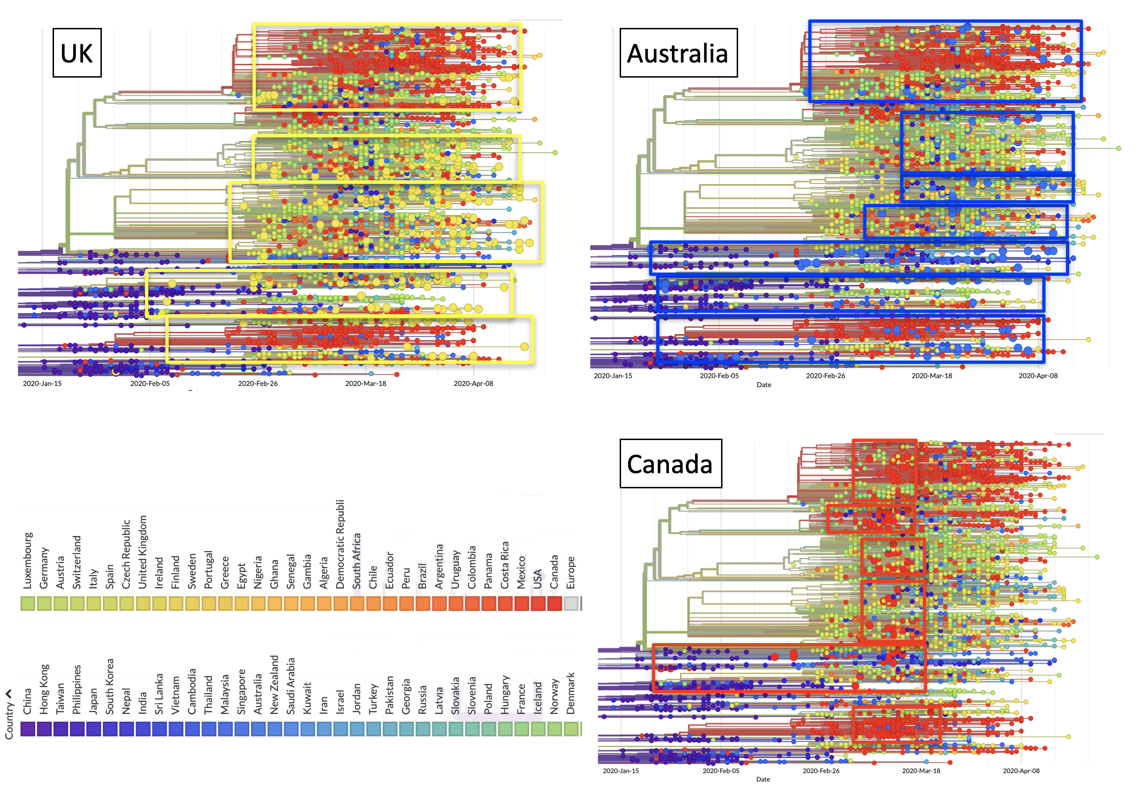

Accumulation of genomic mutations of SARS-CoV-2 over time around the globe is shown as strings-of-beads graphs. Each bead corresponds to a newly-described mutation. Larger beads indicate mutations identified in the indicated country. UK: bright yellow; Australia: blue; Canada: red. Rectangles enclose mutations by country. Color codes by country are shown at the bottom left.

Figure S3. Genomic mutations of SARS-CoV-2 in Europe.

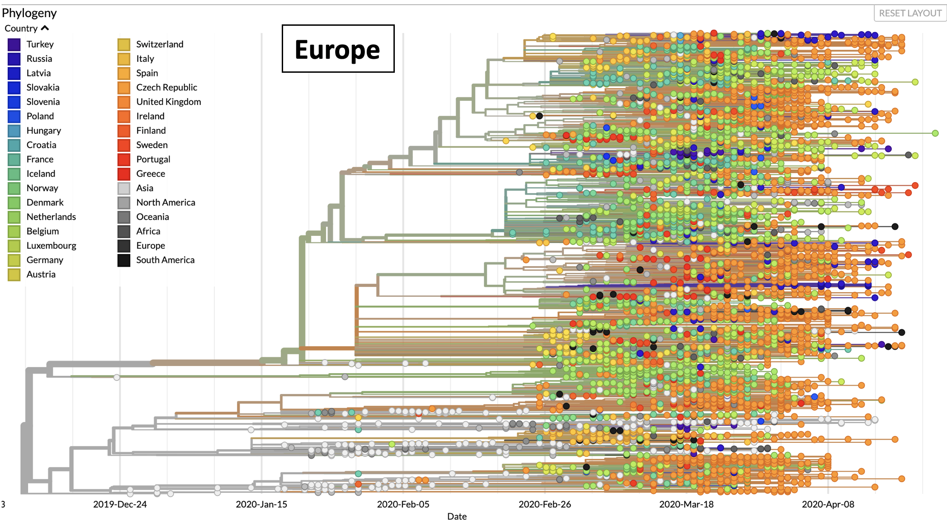

Accumulation of genomic mutations of SARS-CoV-2 over time in Europe is shown as strings-of-beads graphs. Each bead corresponds to a newly-described mutation. Color codes by country are shown on the upper left. Color codes by country are shown in the upper left.

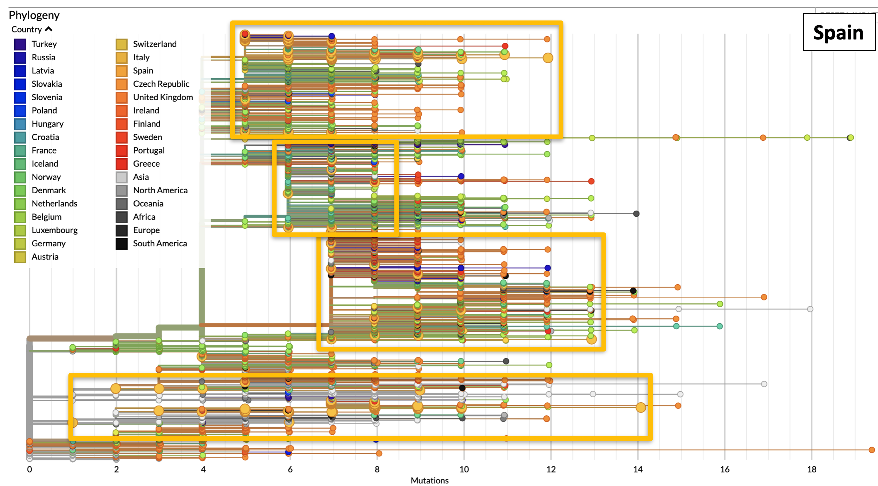
Figure S4. Genomic mutations of SARS-CoV-2 - Spain.

Accumulation of genomic mutations of SARS-CoV-2 over time in Spain is shown as strings of dark-yellow large dots. Rectangles enclose strings of mutations in each phylogenetic branch. The number of accumulated mutations in each viral isolate is indicated at the bottom. Color codes by country are shown in the upper left.

Figure S5. Genomic mutations of SARS-CoV-2 - Italy.
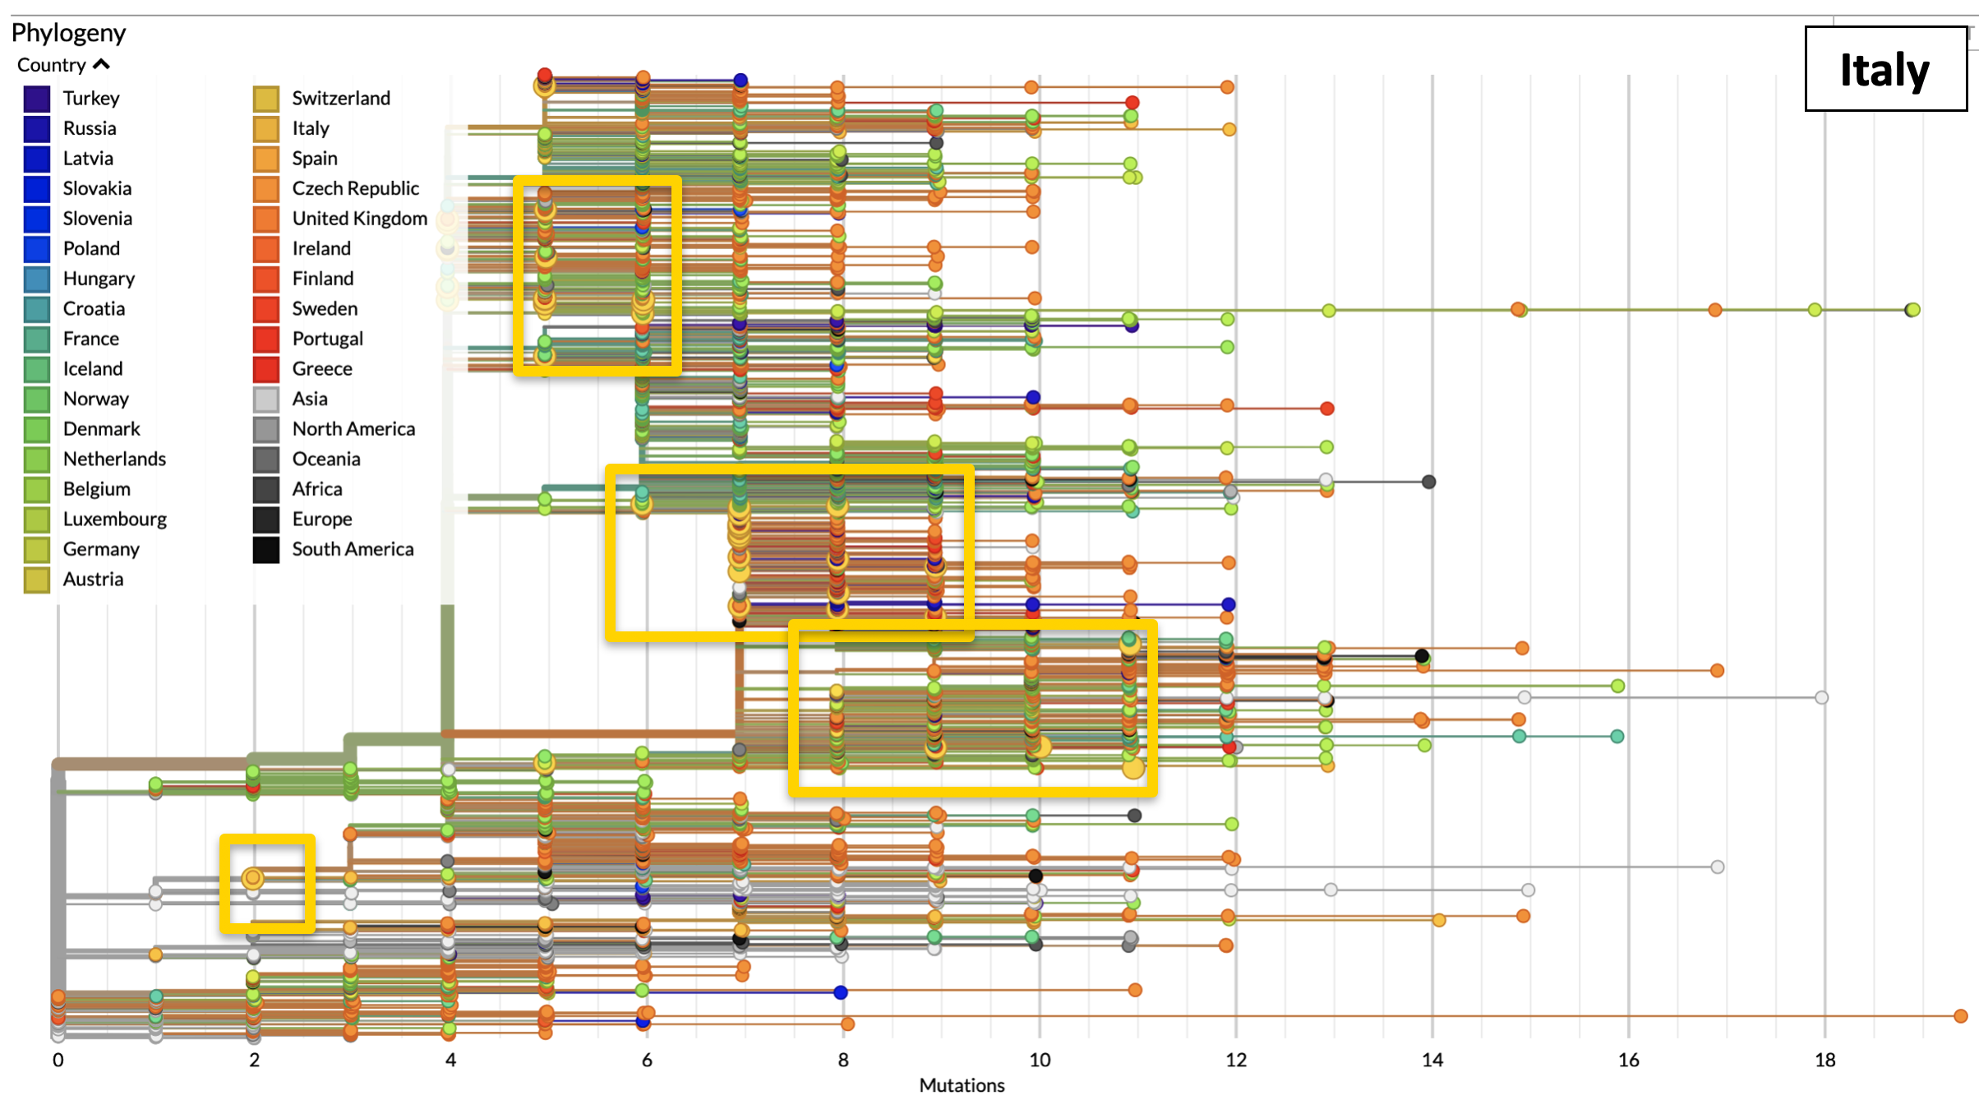

Accumulation of genomic mutations of SARS-CoV-2 over time in Italy is shown as strings of yellow large dots. Rectangles enclose strings of mutations in each phylogenetic branch. The number of accumulated mutations in each viral isolate is indicated at the bottom. Color codes by country are shown in the upper left.

Figure S6. Genomic mutations of SARS-CoV-2 - Sweden.
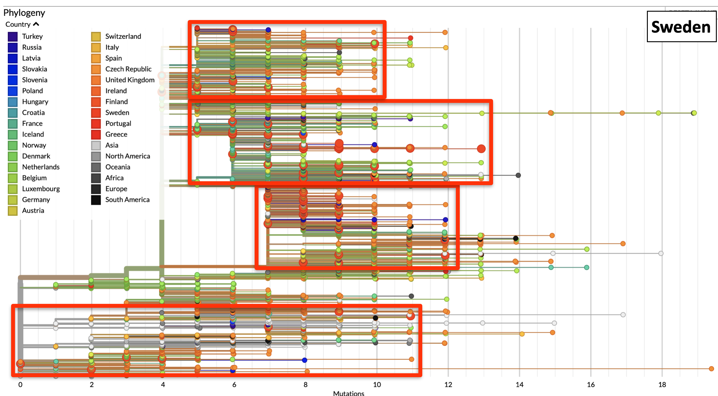

Accumulation of genomic mutations of SARS-CoV-2 over time in Sweden is shown as strings of red large dots. Rectangles enclose strings of mutations in each phylogenetic branch. The number of accumulated mutations in each viral isolate is indicated at the bottom. Color codes by country are shown in the upper left.

Figure S7. Genomic mutations of SARS-CoV-2 - The Netherlands.

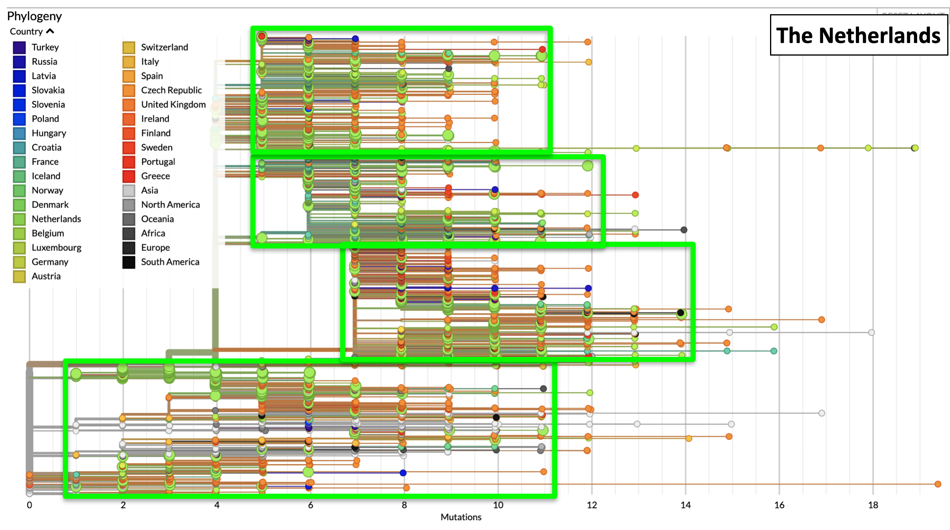

Accumulation of genomic mutations of SARS-CoV-2 over time in The Netherlands is shown as strings of bright-green large dots. Rectangles enclose strings of mutations in each phylogenetic branch. The number of accumulated mutations in each viral isolate is indicated at the bottom. Color codes by country are shown in the upper left.

Figure S8. Genomic mutations of SARS-CoV-2 - Belgium.

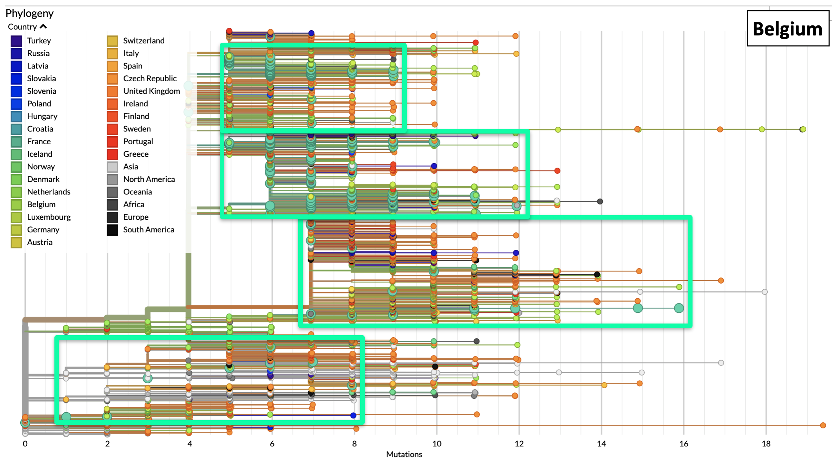
Accumulation of genomic mutations of SARS-CoV-2 over time in Belgium is shown as strings of light-green large dots. Rectangles enclose strings of mutations in each phylogenetic branch. The number of accumulated mutations in each viral isolate is indicated at the bottom. Color codes by country are shown in the upper left.

Figure S9. Genomic mutations of SARS-CoV-2 - France.
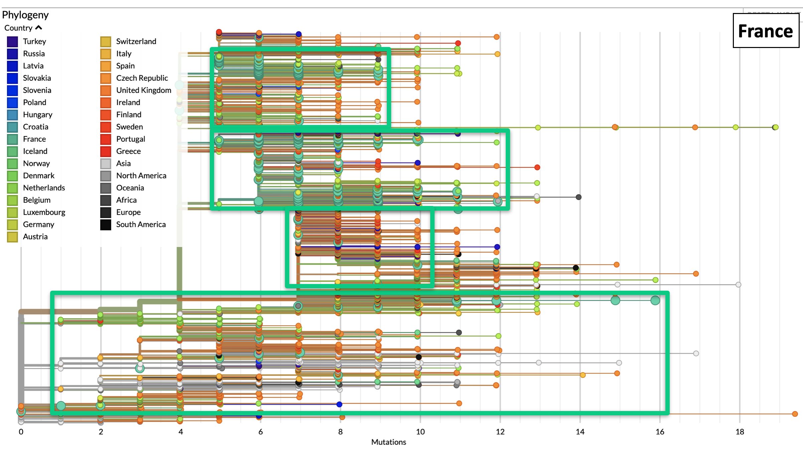

Accumulation of genomic mutations of SARS-CoV-2 over time in France is shown as strings of deep-green large dots. Rectangles enclose strings of mutations in each phylogenetic branch. The number of accumulated mutations in each viral isolate is indicated at the bottom. Color codes by country are shown in the upper left.

Figure S10. Progression of COVID-19 over Italy - Northern Provinces *.

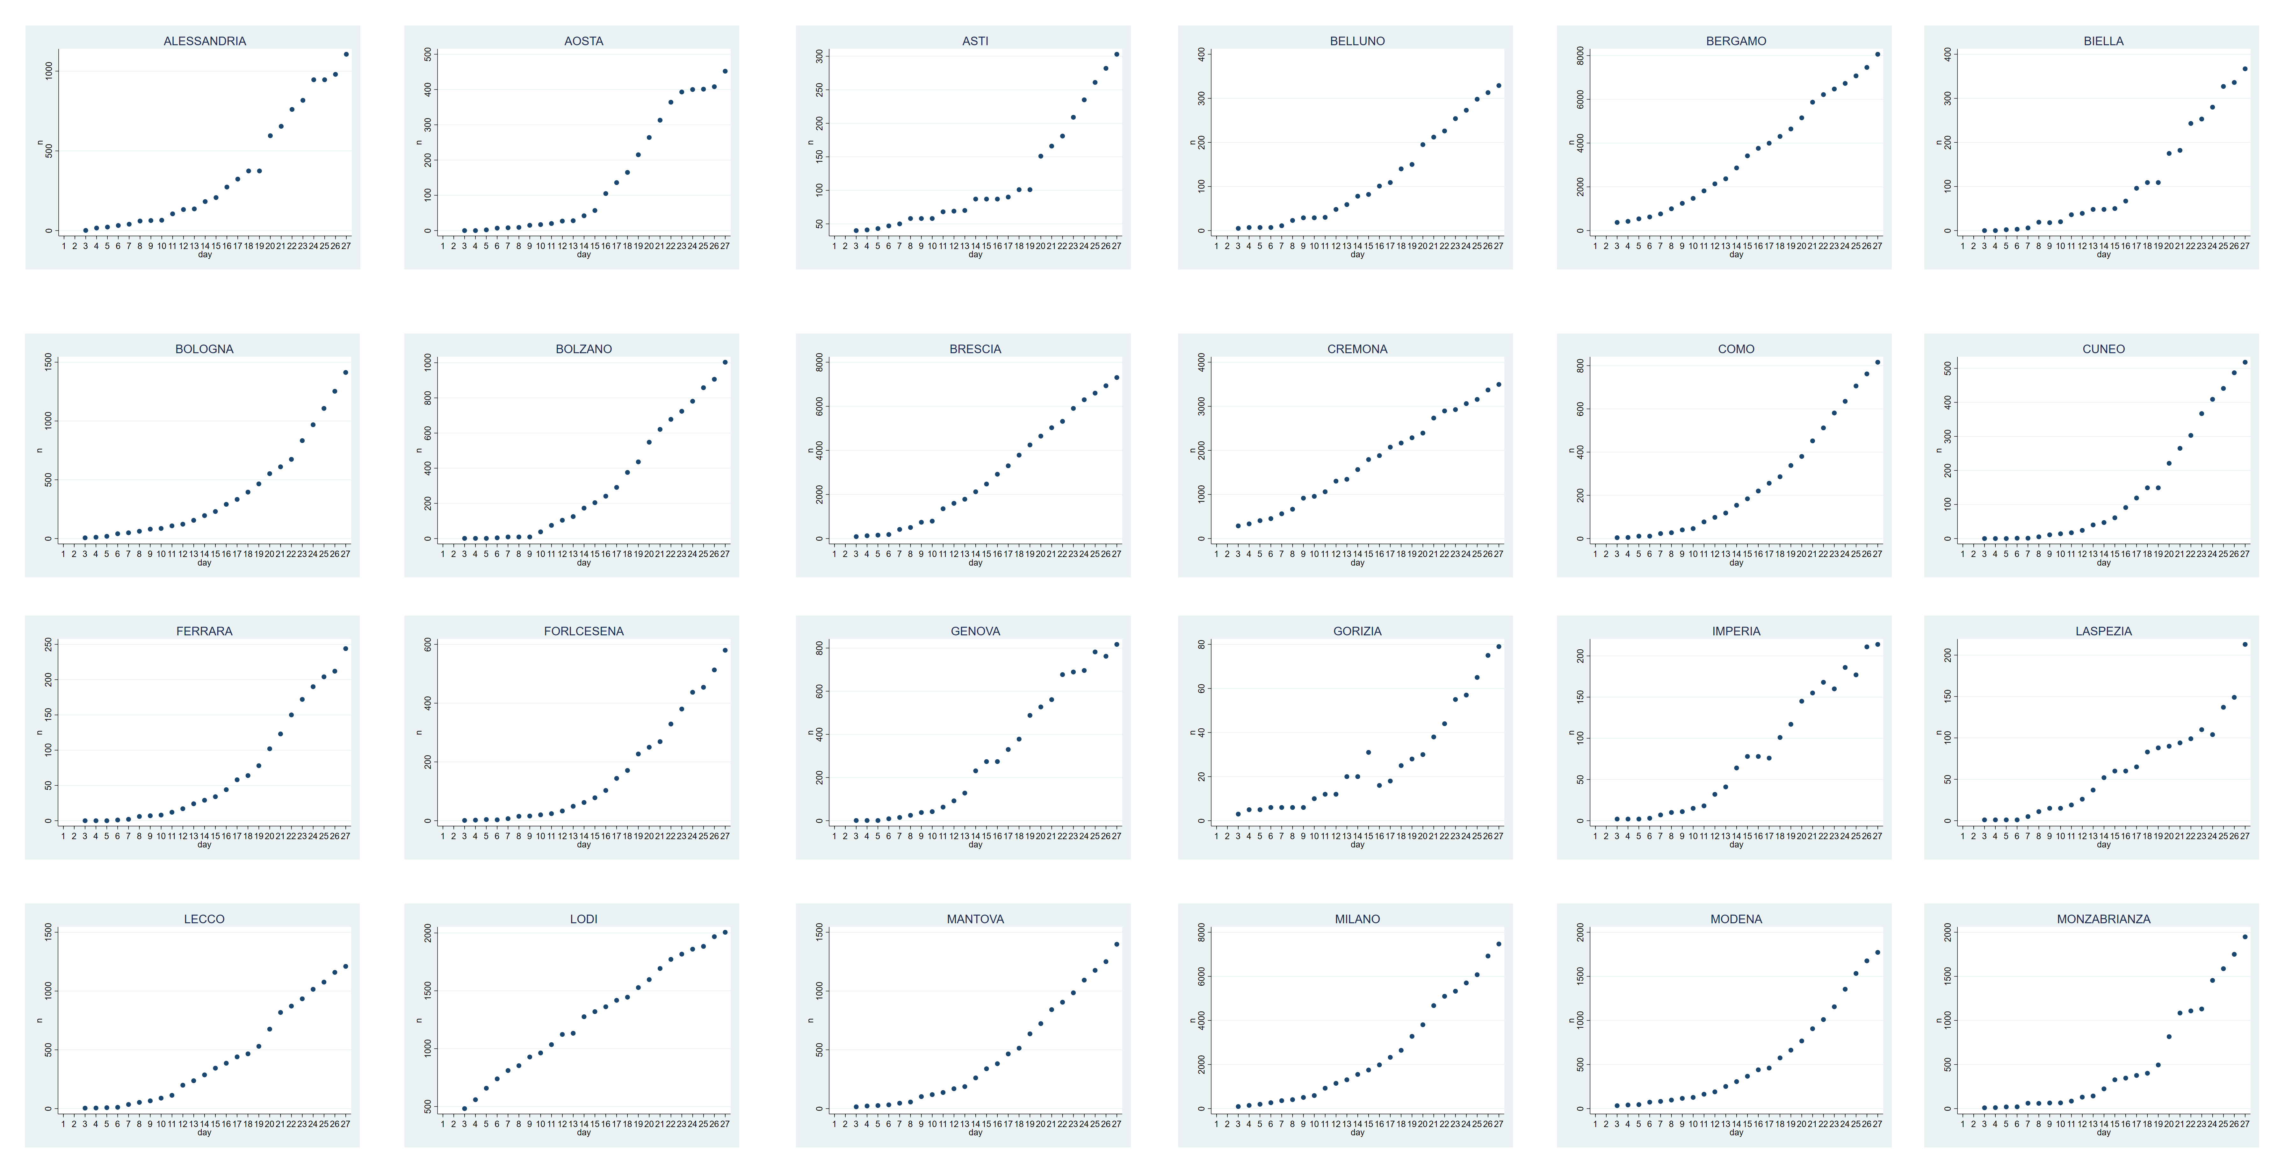
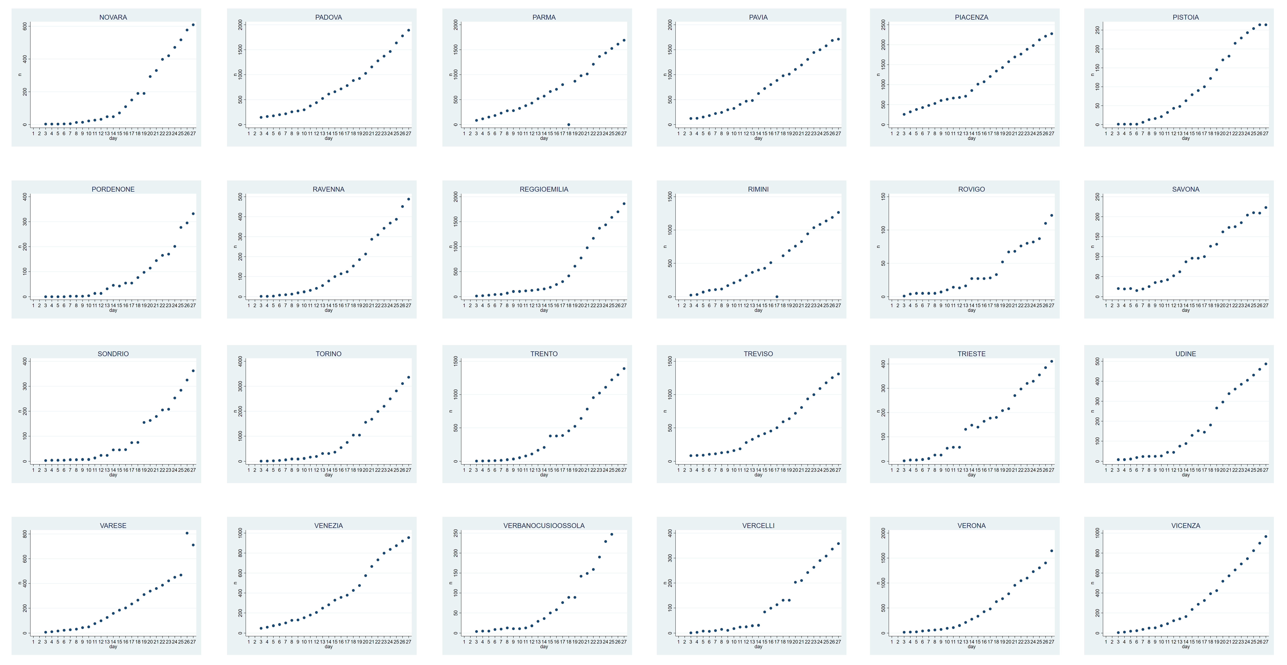

*: Graphs are in alphabetical order. Case incidence in the indicated municipalities is plotted versus time (March 3-27, 2020). For comparison purposes, all graphs were normalized versus the highest number of cases per Province. COVID-19 doubling times were computed on non-normalized, absolute numbers.

Figure S11. Progression of COVID-19 over Italy - Central & Southern Provinces*.

Central
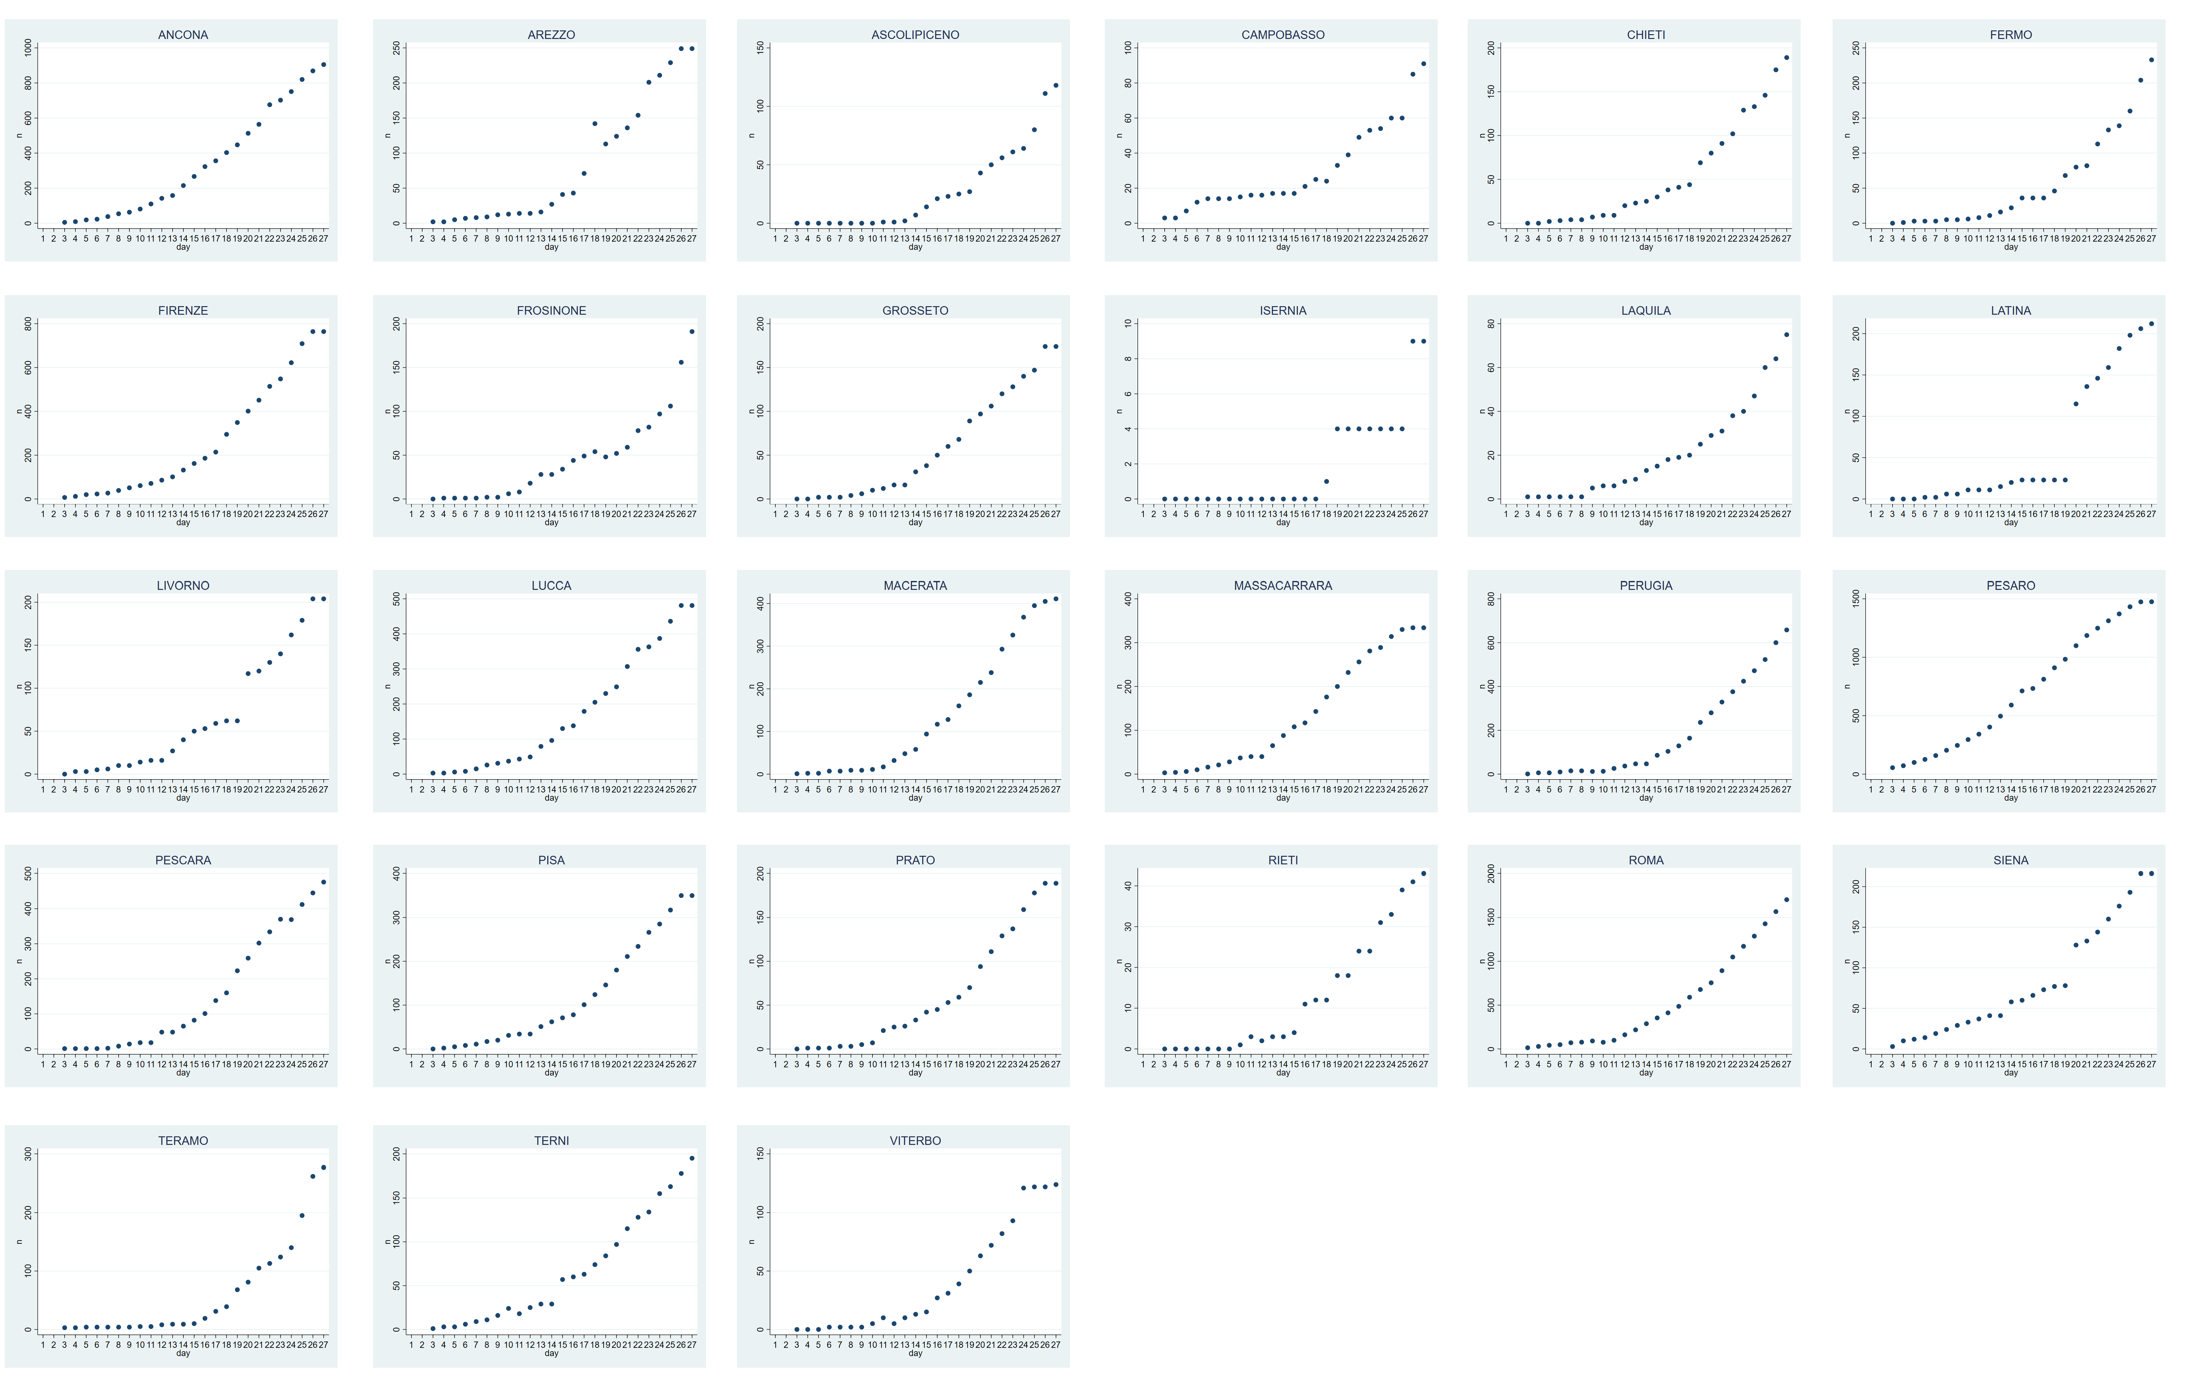

Southern
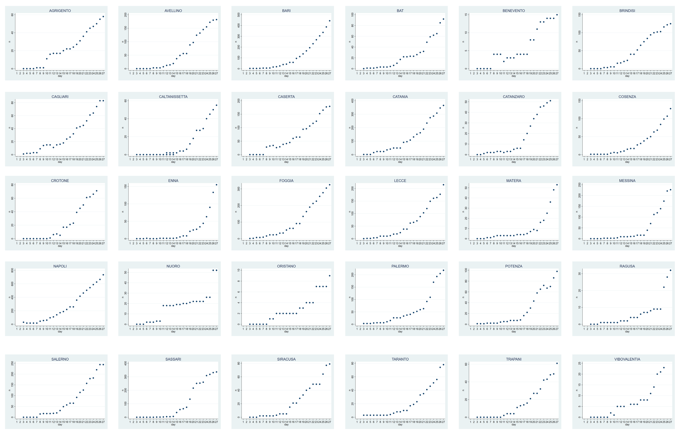

*: Graphs are in alphabetical order. Case incidence in the indicated municipalities is plotted versus time (March 3-27, 2020). For comparison purposes, all graphs were normalized versus the highest number of cases per Province. COVID-19 doubling times were computed on non-normalized, absolute numbers.
Figure S12. Progression of COVID-19 over Italy – global data by region*.

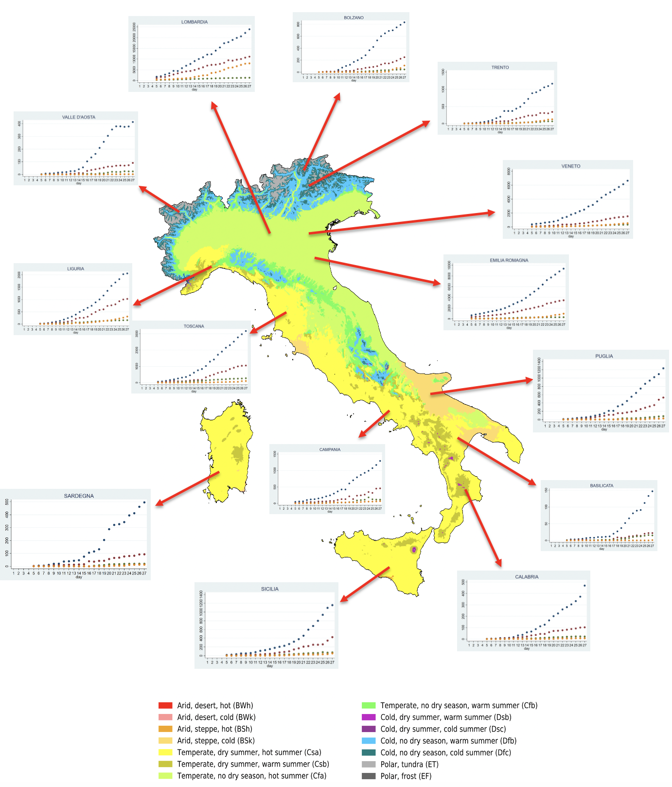

Köppen–Geiger climate classification map. Compounded data of COVID-19 spreading in individual Italy’s regions are overlaid over the country’s climate areas. (insets) Dark gray dots: SARS-CoV-2-positive cases; brown dots: hospitalized cases; green dots: intensive-care unit cases; orange dots: recovered cases. (bottom) color codes for areas classification.

Figure S13. Progression of COVID-19 over Spain*.

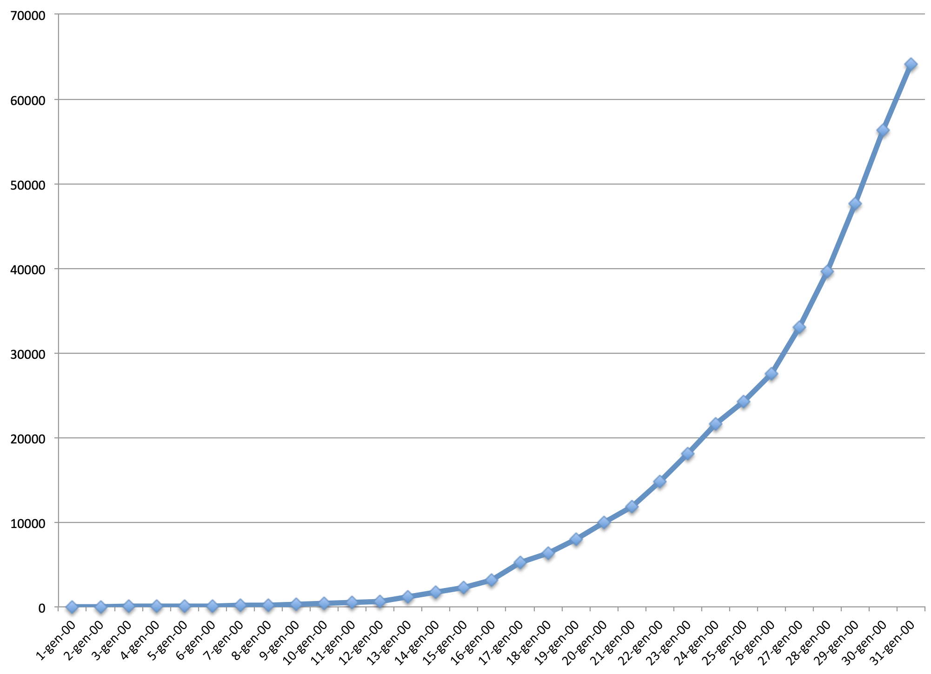

*: case incidence in the country is plotted versus time (March 1-31, 2020).

Figure S14. Progression of COVID-19 over Norway*.

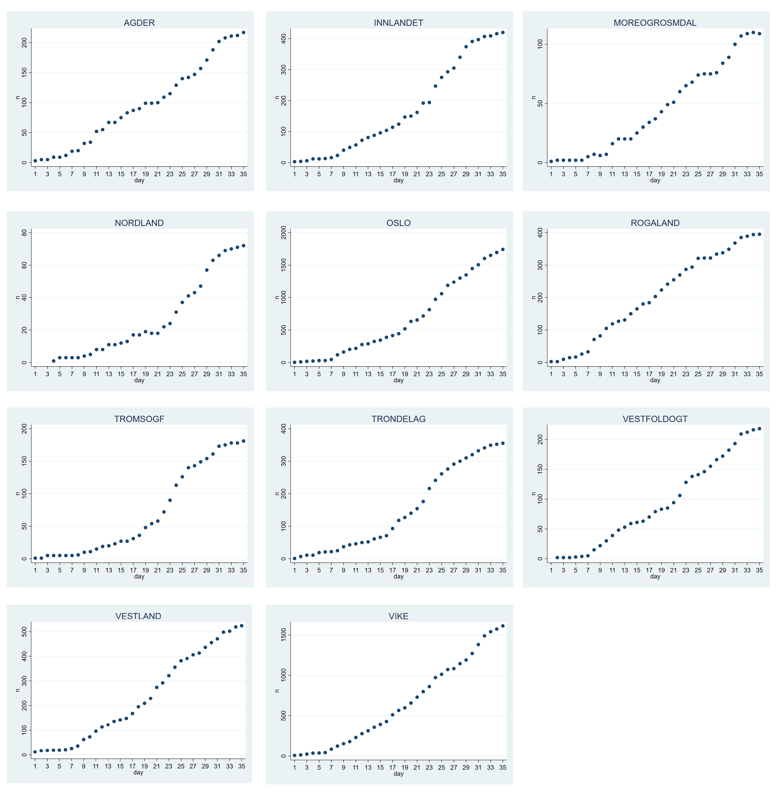

*: case incidence in the indicated municipalities is plotted versus time (March 1-April 7, 2020).

Figure S15. Progression of COVID-19 over Finland*.

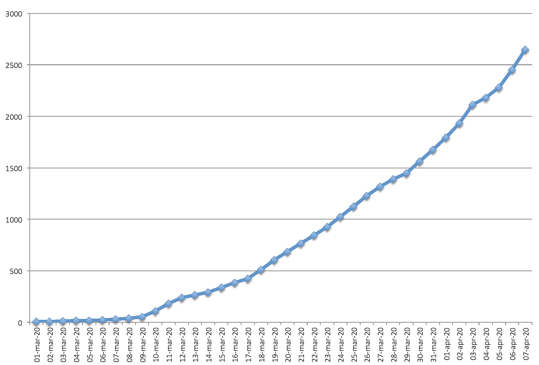

*: case incidence in the indicated municipalities is plotted versus time (March 1-April 7, 2020).

Figure S16. Progression of COVID-19 over Sweden*.

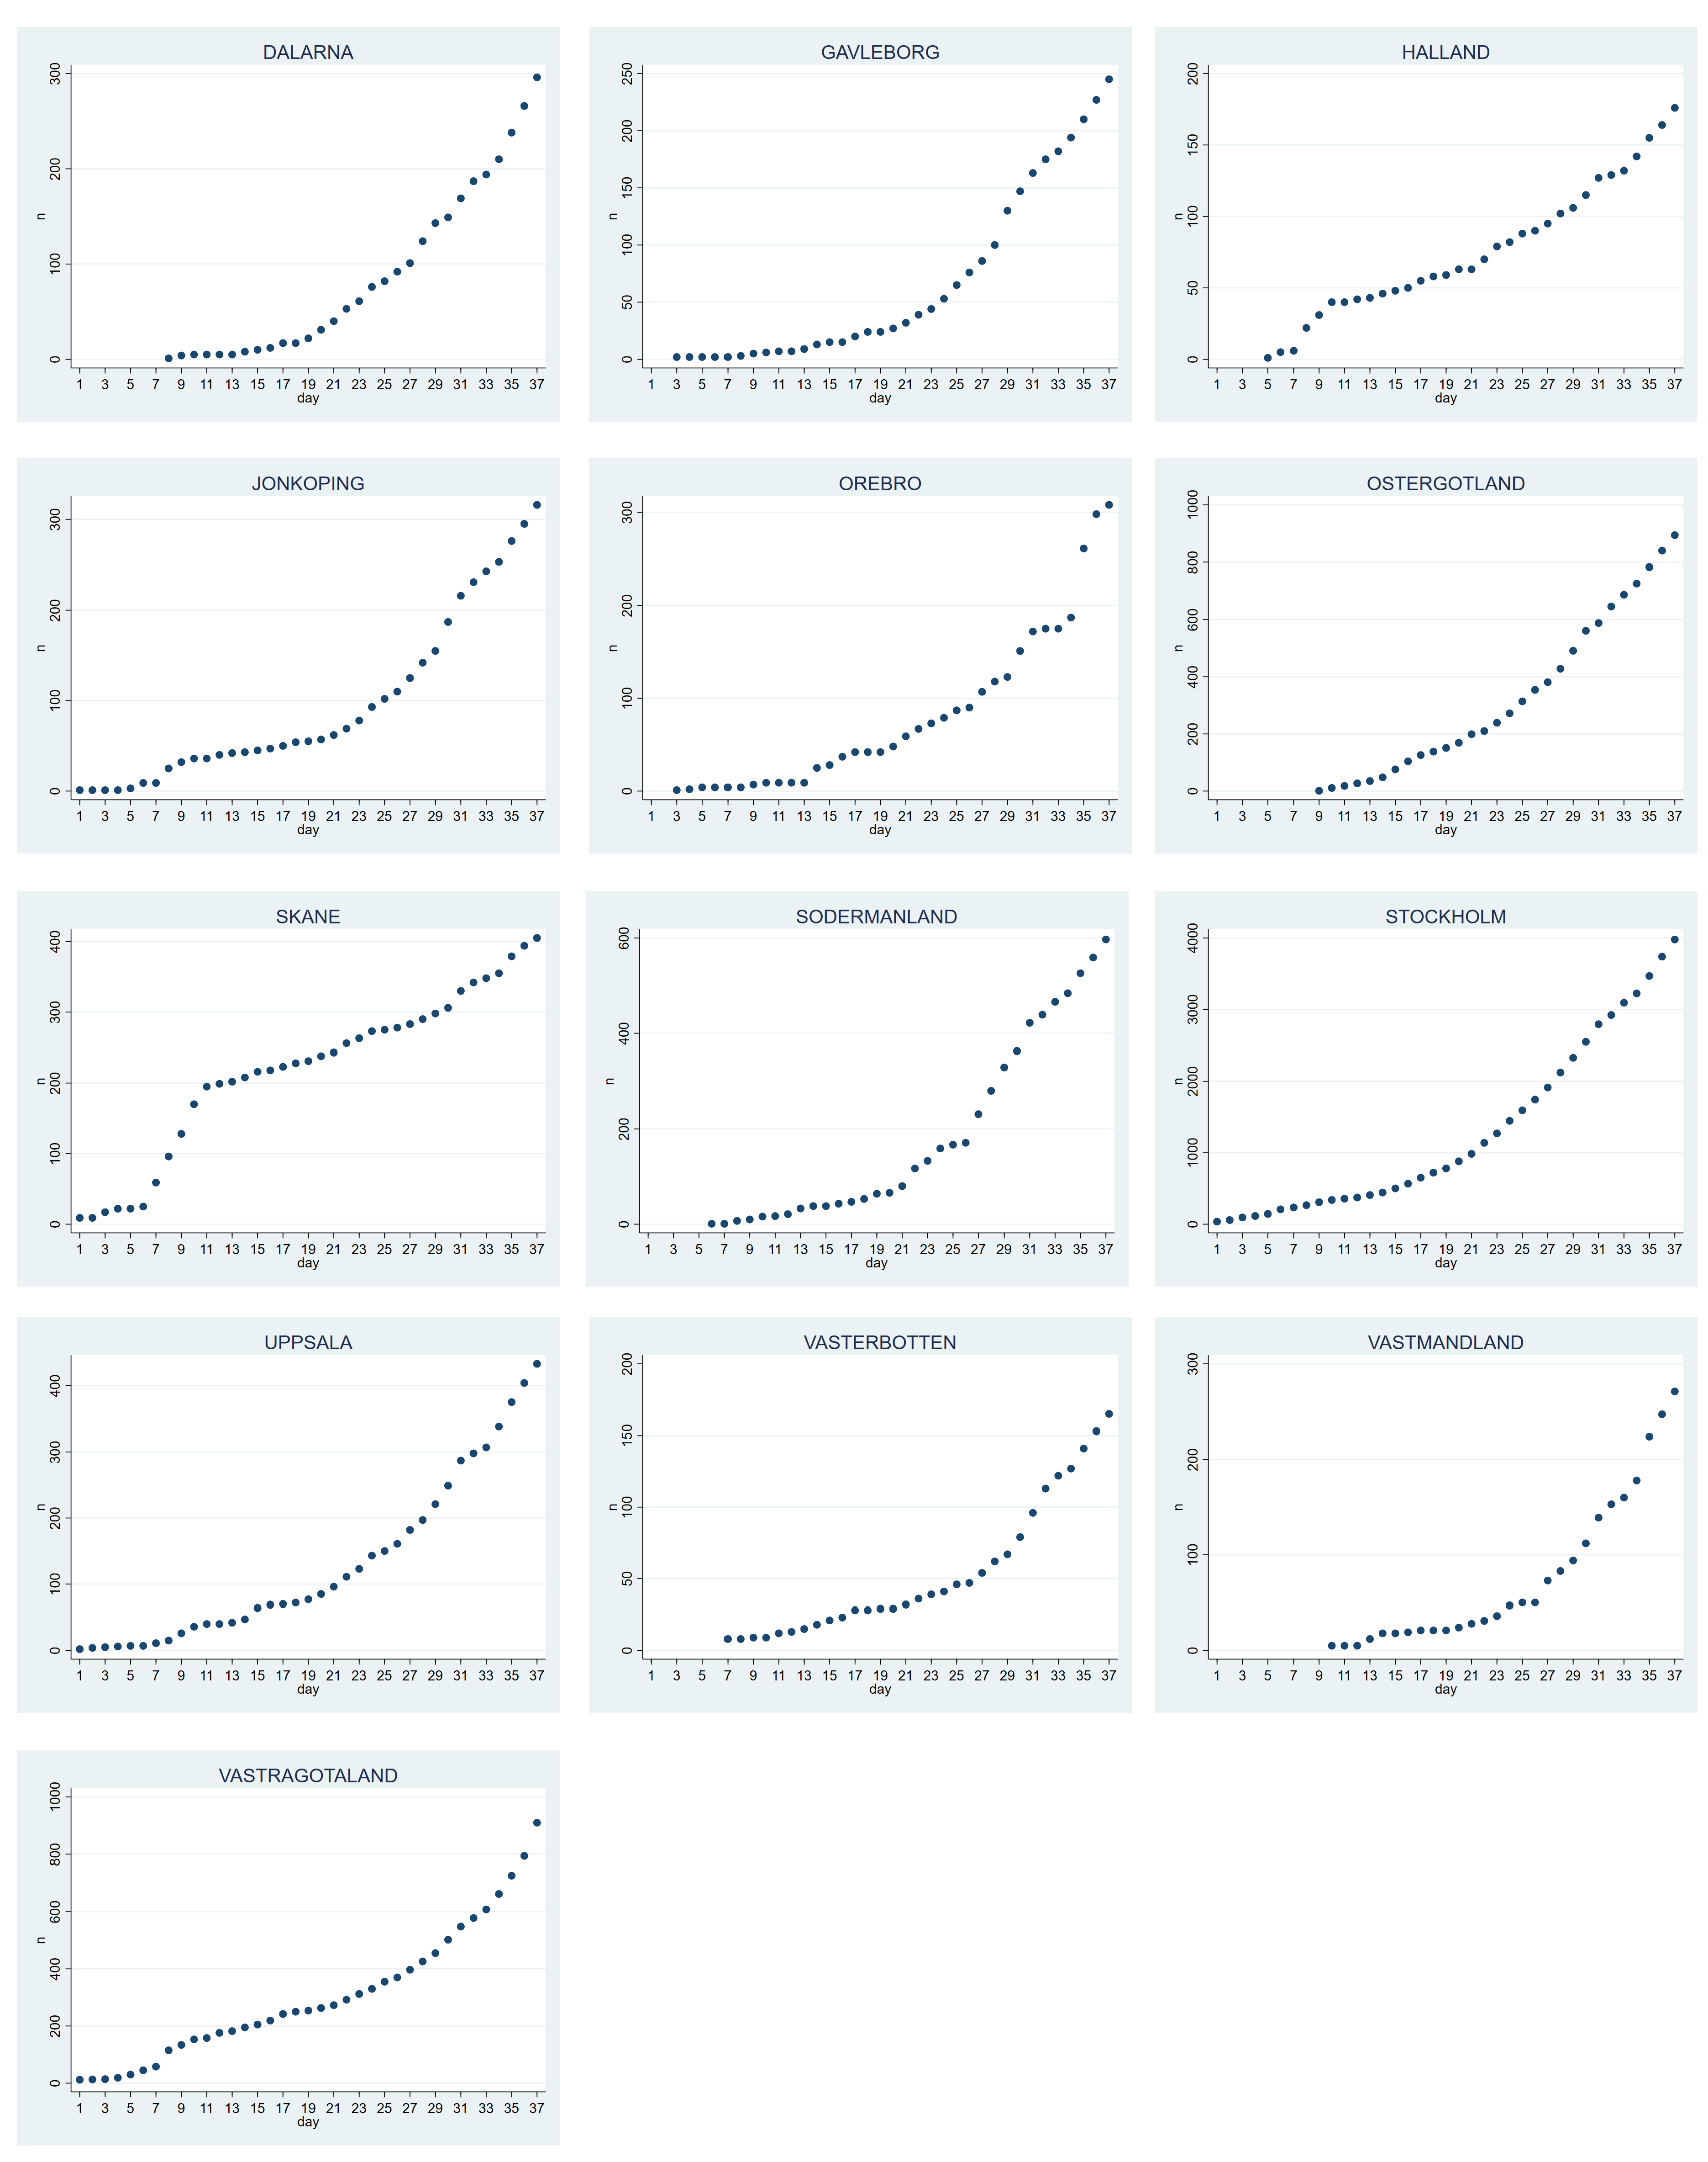

*: case incidence in the indicated municipalities is plotted versus time (March 1-23, 2020).
Figure S17. Progression of COVID-19 over France, Germany and UK*.

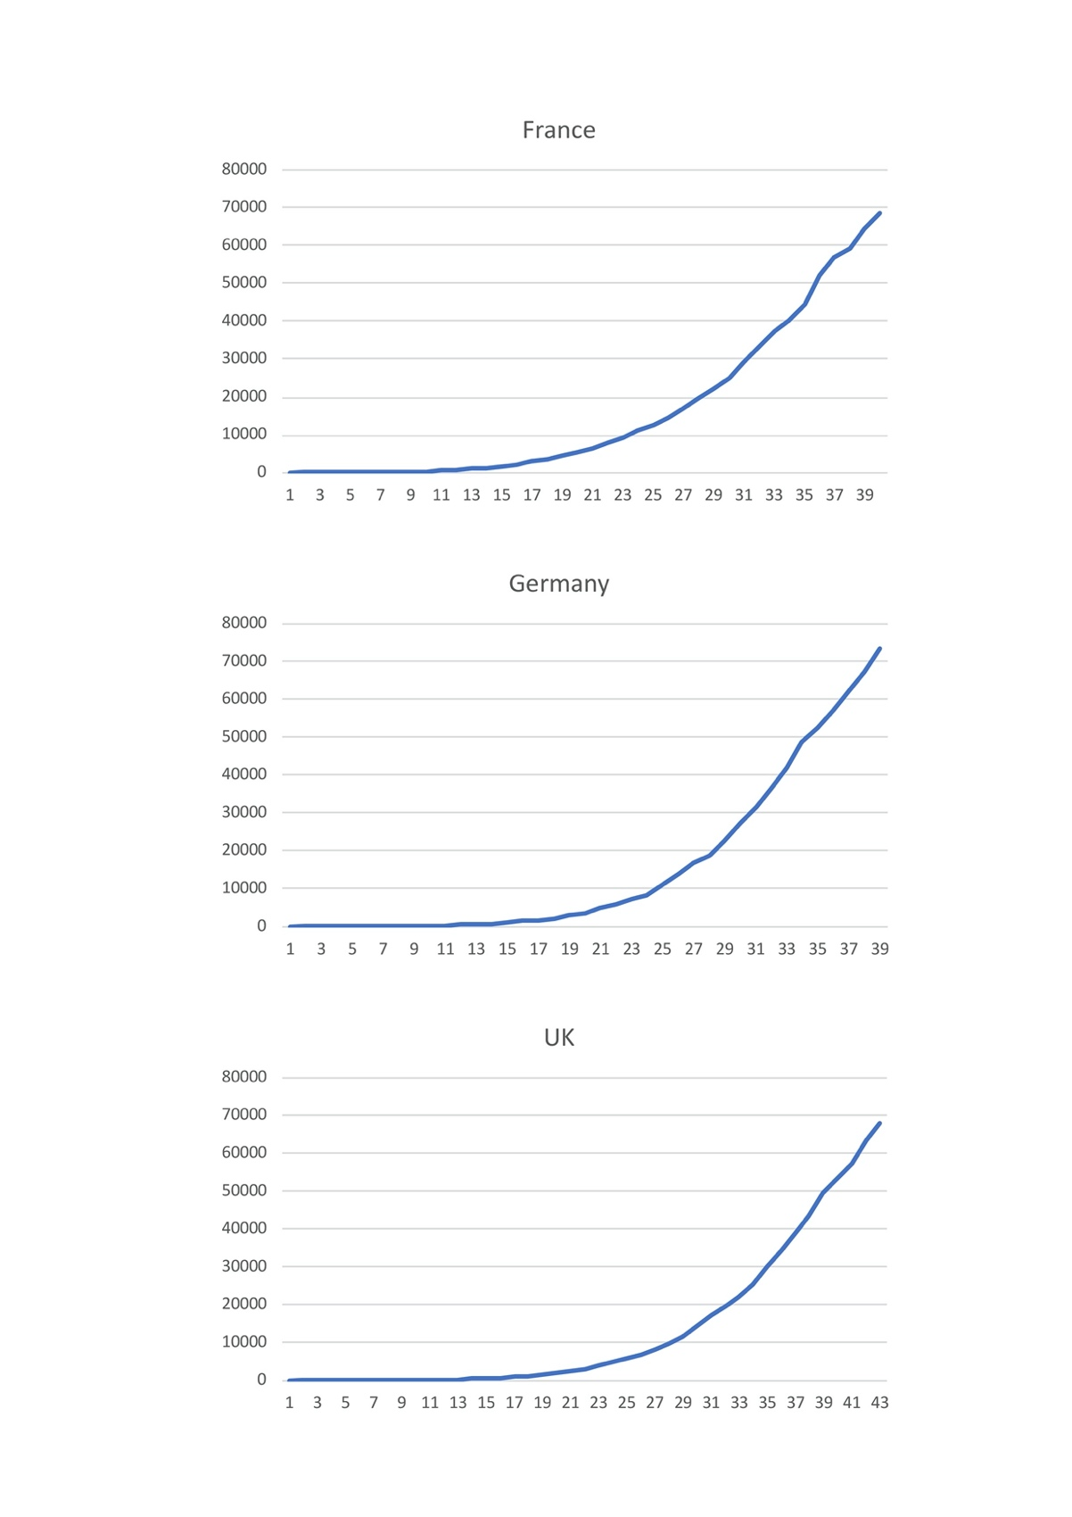

*: Laboratory-confirmed infection cases in Europe cases were retrieved by country at peak diffusion rates, in France (dashboard.covid19.data.gouv.fr/vue-d-ensemble?locatio n=FRA; April 4th 2020), UK (www.nhs.uk/; April 9th 2020), Germany (corona.rki.de; April 2nd 2020).

Supplemental online Table 1. COVID-19 spreading in Central and South America.

 | Argentina | Brazil | Chile | Colombia | Costa Rica | Dominican Republic | Ecuador | Mexico | Panama | Peru | Uruguay | Venezuela | Trinidad and Tobago
March 1* |  | 2 |  |  |  | 1 | 1 | 2
March 2 |  | 2 |  |  |  | 1 | 1 | 5
March 3 |  | 2 | 1 |  |  | 1 | 6 | 5
March 4 | 1 | 2 | 1 |  |  | 1 | 7 | 5
March 5 | 1 | 3 | 1 |  | 1 | 1 | 7 | 5
March 6 | 1 | 7 | 1 | 1 | 1 | 1 | 16 | 5
March 7 | 2 | 13 | 5 | 1 | 1 | 1 | 14 | 5 |  | 1
March 8 | 9 | 19 | 5 | 1 | 5 | 1 | 14 | 7 |  | 6
March 9 | 12 | 25 | 10 | 1 | 9 | 1 | 15 | 7 |  | 6
March 10 | 12 | 25 | 13 | 3 | 9 | 5 | 15 | 7 | 1 | 9
March 11 | 17 | 34 | 17 | 3 | 13 | 5 | 15 | 7 | 8 | 11
March 12 | 19 | 52 | 23 | 9 | 13 | 5 | 17 | 11 | 10 | 17
March 13 | 31 | 77 | 33 | 9 | 22 | 5 | 17 | 12 | 14 | 22
March 14 | 34 | 98 | 43 | 16 | 23 | 5 | 23 | 26 | 27 | 28 |  | 2 | 1
March 15 | 45 | 121 | 61 | 24 | 23 | 5 | 23 | 41 | 27 | 43 |  | 2 | 1
March 16 | 56 | 200 | 75 | 24 | 23 | 5 | 37 | 53 | 43 | 71 | 4 | 2 | 2
March 17 | 65 | 234 | 156 | 45 | 41 | 21 | 58 | 53 | 69 | 86 | 6 | 33 | 5
March 18 | 65 | 234 | 156 | 45 | 41 | 21 | 58 | 82 | 69 | 86 | 6 | 33 | 5
March 19 | 79 | 291 | 238 | 93 | 50 | 21 | 155 | 93 | 86 | 145 | 29 | 36 | 7
March 20 | 97 | 428 | 342 | 108 | 87 | 34 | 199 | 118 | 109 | 234 | 79 | 36 | 9
March 21 | 128 | 621 | 434 | 145 | 113 | 72 | 367 | 164 | 137 | 234 | 94 | 36 | 9
March 22 | 158 | 904 | 434 | 196 | 113 | 72 | 506 | 164 | 137 | 318 | 94 | 36 | 9
March 23 | 225 | 904 | 632 | 196 | 117 | 72 | 532 | 251 | 245 | 318 | 135 | 70 | 50
Supplemental online Table 2: COVID-19 in Middle-East, Africa, and Gulf countries.

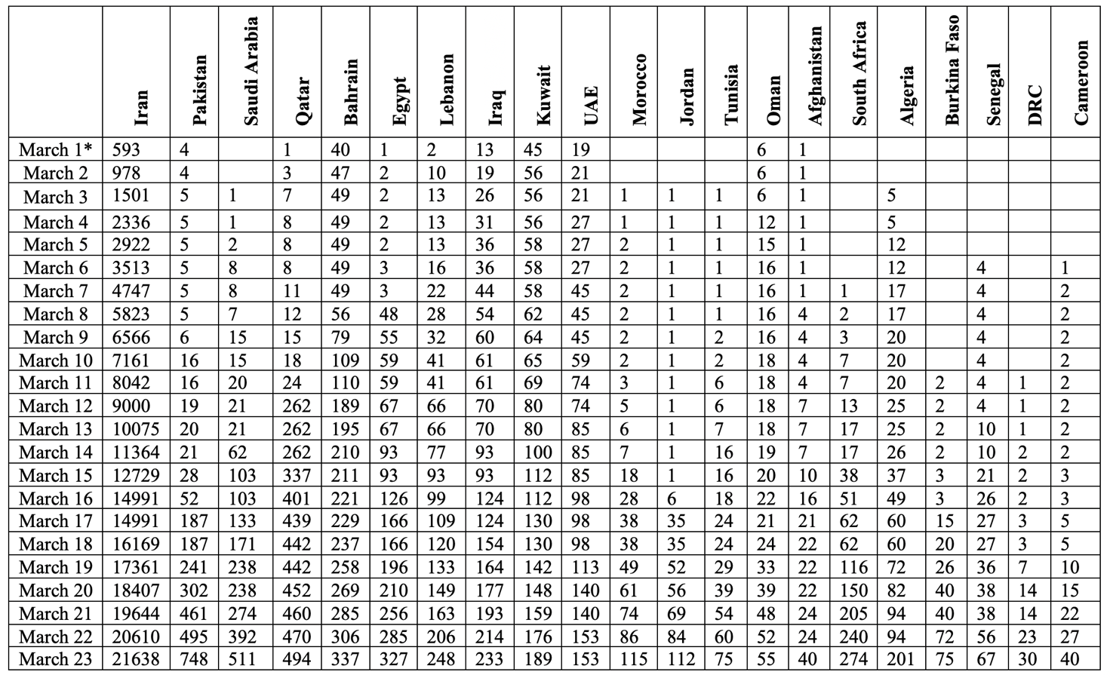

*: cases were recorded from March 1-23, 2020. UAE: United Arab Emirates. DRC: Democratic Republic of the Congo.
Supplemental online Table 3. COVID-19 doubling time by province *.

 | Doubling time | Geographical location
AGRIGENTO | 6,67 | South
ALESSANDRIA | 5,55 | North
ANCONA | 6,84 | Center
AOSTA | 6,29 | North
AREZZO | 5,86 | Center
ASCOLIPICENO | 5,19 | Center
ASTI | 5,41 | North
AVELLINO | 6,06 | South
BARI | 4,90 | South
BAT | 3,97 | South
BELLUNO | 6,10 | North
BENEVENTO | 6,25 | South
BERGAMO | 9,65 | North
BIELLA | 5,17 | North
BOLOGNA | 4,97 | North
BOLZANO | 6,12 | North
BRESCIA | 8,00 | North
BRINDISI | 7,54 | South
CAGLIARI | 6,55 | South
CALTANISSETTA | 4,50 | South
CAMPOBASSO | 6,33 | Center
CASERTA | 6,40 | South
CATANIA | 5,73 | South
CATANZARO | 6,21 | South
CHIETI | 5,64 | Center
COMO | 5,64 | North
COSENZA | 4,10 | South
CREMONA | 10,94 | North
CROTONE | 6,22 | South
CUNEO | 5,01 | North
ENNA | 1,95 | South
FERMO | 5,00 | Center
FERRARA | 5,00 | North
FIRENZE | 5,89 | Center
FOGGIA | 5,84 | South
FORLCESENA | 6,00 | North
FROSINONE | 4,86 | Center
GENOVA | 6,88 | North
GORIZIA | 4,69 | North
GROSSETO | 6,74 | Center
IMPERIA | 7,50 | North
ISERNIA | 6,67 | Center
LAQUILA | 4,50 | Center
LASPEZIA | 7,81 | North
LATINA | 5,17 | Center
LECCE | 5,35 | South
LECCO | 5,95 | North
LIVORNO | 5,50 | Center
LODI | 15,60 | North
LUCCA | 6,48 | Center
MACERATA | 5,60 | Center
MANTOVA | 6,39 | North
MASSACARRARA | 7,33 | Center
MATERA | 2,00 | South
MESSINA | 3,60 | South
MILANO | 6,38 | North
MODENA | 5,00 | North
MONZABRIANZA | 5,07 | North
NAPOLI | 6,45 | South
NOVARA | 5,33 | North
NUORO | 14,33 | South
ORISTANO | 5,50 | South
PADOVA | 7,63 | North
PALERMO | 2,74 | South
PARMA | 6,12 | North
PAVIA | 9,15 | North
PERUGIA | 5,42 | Center
PESARO | 9,81 | Center
PESCARA | 6,27 | Center
PIACENZA | 9,20 | North
PISA | 5,63 | Center
PISTOIA | 6,78 | Center
PORDENONE | 4,18 | North
POTENZA | 5,62 | South
PRATO | 5,21 | Center
RAGUSA | 0,85 | South
RAVENNA | 5,70 | North
REGGIOEMILIA | 4,90 | North
RIETI | 4,75 | Center
RIMINI | 7,07 | North
ROMA | 5,53 | Center
ROVIGO | 6,45 | North
SALERNO | 5,22 | South
SASSARI | 5,70 | South
SAVONA | 7,81 | North
SIENA | 5,63 | Center
SIRACUSA | 6,20 | South
SONDRIO | 6,16 | North
TARANTO | 5,50 | South
TERAMO | 4,31 | Center
TERNI | 6,25 | Center
TORINO | 5,29 | North
TRAPANI | 5,50 | South
TRENTO | 5,26 | North
TREVISO | 7,03 | North
TRIESTE | 7,83 | North
UDINE | 6,59 | North
VARESE | 8,00 | North
VENEZIA | 6,78 | North
VERBANOCUSIOOSSOLA | 5,35 | North
VERCELLI | 5,68 | North
VERONA | 6,57 | North
VIBOVALENTIA | 3,83 | South
VICENZA | 6,39 | North
VITERBO | 5,15 | Center
*: The COVID-19 doubling time was computed on a province-base for the whole country.

Supplemental online Table 4. COVID-19 spreading in Scandinavia by county *.

Sweden |  |  |  | Norway
 | Doubling time |  |  |  | Doubling time
DALARNA | 7,17 |  |  | AGDER | 13,06
GAVLEBORG | 8,25 |  |  | INNLANDET | 11,70
HALLAND | 12,00 |  |  | MOREOGROSMDAL | 13,61
JONKOPING | 7,91 |  |  | NORDLAND | 10,17
OREBRO | 6,86 |  |  | OSLO | 11,64
OSTERGOTLAND | 8,70 |  |  | ROGALAND | 17,29
SKANE | 23,92 |  |  | TROMSOGF | 11,98
SODERMANLAND | 8,62 |  |  | TRONDELAG | 12,96
STOCKHOLM | 9,64 |  |  | VESTFOLDOGT | 12,86
UPPSALA | 8,19 |  |  | VESTLAND | 14,27
VASTERBOTTEN | 6,79 |  |  | VIKE | 12,88
VASTMANDLAND | 6,13
VASTRAGOTALAND | 8,00

*: Landmark dates were the 9th of April for Sweden and the 7th of April for Norway.
Supplemental online Table 5. COVID-19 incidence by date in France.

DATE | TOTAL CASES
25/02/20 | 13
26/02/20 | 18
27/02/20 | 38
28/02/20 | 57
29/02/20 | 100
01/03/20 | 130
02/03/20 | 191
03/03/20 | 212
04/03/20 | 285
05/03/20 | 423
06/03/20 | 613
07/03/20 | 949
08/03/20 | 1126
09/03/20 | 1412
10/03/20 | 1784
11/03/20 | 2281
12/03/20 | 2876
13/03/20 | 3661
14/03/20 | 4499
15/03/20 | 5423
16/03/20 | 6633
17/03/20 | 7730
18/03/20 | 9134
19/03/20 | 10995
20/03/20 | 12612
21/03/20 | 14459
22/03/20 | 16689
23/03/20 | 19856
24/03/20 | 22302
25/03/20 | 25233
26/03/20 | 29155
27/03/20 | 32964
28/03/20 | 37575
29/03/20 | 40174
30/03/20 | 44550
31/03/20 | 52128
01/04/20 | 56989
02/04/20 | 59105
03/04/20 | 64338
04/04/20 | 68605

Supplemental online Table 6. COVID-19 incidence by date in Germany.

DATE | TOTAL CASES
24/02/20 | 16
25/02/20 | 18
26/02/20 | 21
27/02/20 | 26
28/02/20 | 53
29/02/20 | 66
01/03/20 | 117
02/03/20 | 150
03/03/20 | 188
04/03/20 | 240
05/03/20 | 349
06/03/20 | 534
07/03/20 | 684
08/03/20 | 847
09/03/20 | 1112
10/03/20 | 1460
11/03/20 | 1884
12/03/20 | 2369
13/03/20 | 3062
14/03/20 | 3795
15/03/20 | 4838
16/03/20 | 6012
17/03/20 | 7156
18/03/20 | 8198
19/03/20 | 10999
20/03/20 | 13957
21/03/20 | 16662
22/03/20 | 18610
23/03/20 | 22672
24/03/20 | 27436
25/03/20 | 31554
26/03/20 | 36508
27/03/20 | 42288
28/03/20 | 48582
29/03/20 | 52547
30/03/20 | 57298
31/03/20 | 61913
01/04/20 | 67366
02/04/20 | 73522
Supplemental online Table 7. COVID-19 incidence by date in UK.

DATE | TOTAL CASES
01/02/20 | 2
02/02/20 | 2
03/02/20 | 2
04/02/20 | 2
05/02/20 | 2
06/02/20 | 3
07/02/20 | 3
08/02/20 | 3
09/02/20 | 4
10/02/20 | 8
11/02/20 | 8
12/02/20 | 8
13/02/20 | 9
14/02/20 | 9
15/02/20 | 9
16/02/20 | 9
17/02/20 | 9
18/02/20 | 9
19/02/20 | 9
20/02/20 | 9
21/02/20 | 9
22/02/20 | 9
23/02/20 | 9
24/02/20 | 13
25/02/20 | 13
26/02/20 | 13
27/02/20 | 13
28/02/20 | 19
29/02/20 | 23
01/03/20 | 35
02/03/20 | 40
03/03/20 | 51
04/03/20 | 85
05/03/20 | 114
06/03/20 | 160
07/03/20 | 206
08/03/20 | 271
09/03/20 | 321
10/03/20 | 373
11/03/20 | 456
12/03/20 | 590
13/03/20 | 797
14/03/20 | 1061
15/03/20 | 1391
16/03/20 | 1543
17/03/20 | 1950
18/03/20 | 2626
19/03/20 | 3269
20/03/20 | 3983
21/03/20 | 5018
22/03/20 | 5683
23/03/20 | 6650
24/03/20 | 8077
25/03/20 | 9529
26/03/20 | 11658
27/03/20 | 14548
28/03/20 | 17104
29/03/20 | 19606
30/03/20 | 22271
31/03/20 | 25521
01/04/20 | 30088
02/04/20 | 34610
03/04/20 | 39282
04/04/20 | 43282
05/04/20 | 49481
06/04/20 | 53624
07/04/20 | 57512
08/04/20 | 63377
09/04/20 | 68052

