Supplementary Materials for

**Impacts of regional climate on the COVID-19 fatality in 88 countries**

Minneng Wen, Liyuan Chen

Correspondence to: chenliyuan@pku.edu.cn

**This file includes:**

Figures S1 to S4

Tables S1 to S4

Caption for Data S1

**Other Supplementary Materials for this manuscript include the following:**

Data S1. The COVID-19 pandemic and climate data

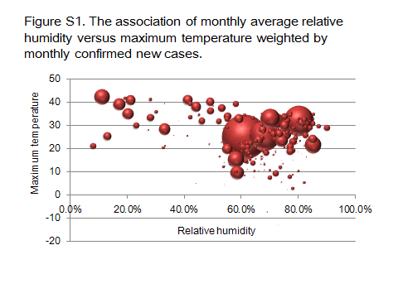

**Figure S1. Bubble chart plotted between the maximum temperature and the relative humidity weighted by the number of monthly confirmed new cases.**

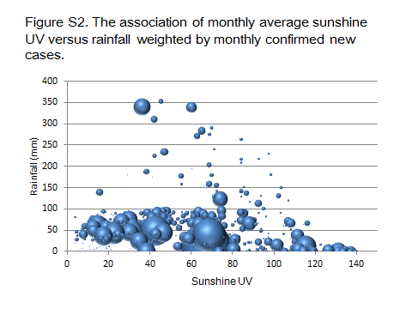

**Figure S2. Bubble chart plotted between the sunshine UV and the rainfall weighted by the number of monthly confirmed new cases.**

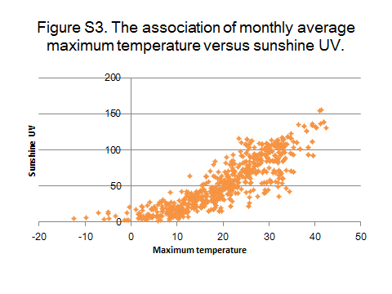

**Figure S3. The association of monthly average maximum temperature versus sunshine UV.**

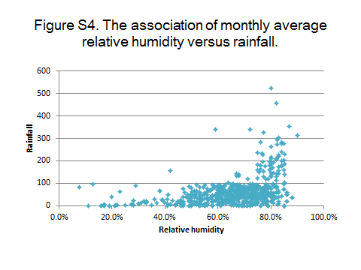

**Figure S4. The association of monthly average relative humidity versus rainfall.**

|  |  |  |  |  |  |
| --- | --- | --- | --- | --- | --- |
|  | **Total**  **cases** | **New**  **cases** | **Total**  **deaths** | **New**  **deaths** | **Monthly**  **case-fatality**  **rate** |
| **World** |  |  |  |  |  |
| Dec 2019 | 27 | 27 | 0 | 0 | 0% |
| Jan 2020 | 11825 | 11798 | 260 | 260 | 2.20% |
| Feb 2020 | 87292 | 75481 | 4263 | 4003 | 5.30% |
| Mar 2020 | 832327 | 745775 | 41690 | 37432 | 5.02% |
| Apr 2020 | 3146793 | 2313711 | 230823 | 189129 | 8.17% |
| May 2020 | 5888006 | 2741213 | 367693 | 136759 | 4.99% |
| Jun 2020 | 10069408 | 4181403 | 502521 | 134828 | 3.22% |
| Subtotal |  | 10069408 |  | 502411 | 4.99% |
| **Northern hemisphere** |  |  |  |  |  |
| Dec 2019-Winter | 27 | 27 | 0 | 0 | 0.00% |
| Jan 2020-Winter | 11813 | 11786 | 260 | 260 | 2.21% |
| Feb 2020-Winter | 87267 | 75468 | 4263 | 4003 | 5.30% |
| Mar 2020-Spring | 819239 | 732712 | 41312 | 37054 | 5.06% |
| Apr 2020-Spring | 3011522 | 2191528 | 223210 | 181893 | 8.30% |
| May 2020-Spring | 5213309 | 2201787 | 332968 | 109647 | 4.98% |
| Jun 2020- Summer | 8278402 | 3065094 | 430104 | 97136 | 3.17% |
| Subtotal |  | 8278402 |  | 429993 | 5.19% |
| **Southern hemisphere** |  |  |  |  |  |
| Dec 2019-Summer | 0 | 0 | 0 | 0 |  |
| Jan 2020-Summer | 12 | 12 | 0 | 0 | 0% |
| Feb 2020-Summer | 25 | 13 | 0 | 0 | 0% |
| Mar 2020-Autumn | 13088 | 13063 | 378 | 378 | 2.89% |
| Apr 2020-Autumn | 135271 | 122183 | 7613 | 7236 | 5.92% |
| May 2020-Autumn | 674697 | 539426 | 34725 | 27112 | 5.03% |
| Jun 2020- Winter | 1791006 | 1116309 | 72417 | 37692 | 3.38% |
| Subtotal |  | 1791006 |  | 72418 | 4.04% |

**Table S1. Monthly distribution of confirmed new cases and deaths in the NH and SH across 90 countries.**

|  |  |  |  |  |
| --- | --- | --- | --- | --- |
| **Climate regions** | **Total cases** | **Proportion** | **Total deaths** | **Fatality** |
| Tropical | 2855416 | 28.36% | 91286 | 3.20% |
| 1. Tropical rainforest | 250617 | 2.49% | 6129 | 2.45% |
| 1. Tropical semiarid/grasslands | 1476539 | 14.66% | 60893 | 4.12% |
| 1. Tropical monsoon/wet and dry | 652198 | 6.48% | 18877 | 2.89% |
| 1. Tropical desert | 476062 | 4.73% | 5387 | 1.13% |
| Subtropical | 3803118 | 37.77% | 218111 | 5.74% |
| 1. Humid subtropical | 2020113 | 20.06% | 122440 | 6.06% |
| 1. Mediterranean climate | 884687 | 8.79% | 47166 | 5.33% |
| 1. Subtropical highland | 520918 | 5.17% | 37036 | 7.11% |
| 1. Subtropical desert | 377400 | 3.75% | 11469 | 3.04% |
| Temperate | 3410874 | 33.87% | 193124 | 5.66% |
| 1. Humid continental | 2029234 | 20.15% | 73974 | 3.65% |
| 1. Temperate marine | 993303 | 9.86% | 110535 | 11.13% |
| 1. Temperate semiarid/grasslands | 387205 | 3.85% | 8603 | 2.22% |
| 1. Subarctic | 1132 | 0.01% | 12 | 1.06% |
| Total | 10069408 | 100% | 502521 | 4.99% |

**Table S2. Total confirmed COVID-19 cases and deaths in different climate regions**.

|  |  |  |  |  |
| --- | --- | --- | --- | --- |
| **Climate regions** | **Total**  **cases** | **Proportion** | **Total**  **deaths** | **Fatality** |
| **Latitude-groups** |  |  |  |  |
| High latitudes (≥30°) | 6301699 | 62.25% | 359990 | **5.71%** |
| Low latitudes (<30°) | 3821187 | 37.75% | 142619 | **3.73%** |
| **Temperature-groups** |  |  |  |  |
| Hot region-months (Tmax≥20°C) | 6348458 | 62.71% | 247528 | 3.90% |
| Cold region-months (Tmax<20°C) | 3774428 | 37.29% | 255081 | 6.76% |
| **Humidity-groups** |  |  |  |  |
| Humid region-months (RH≥60%) | 7473687 | 73.83% | 381838 | 5.11% |
| Arid region-months (RH<60%) | 2649199 | 26.17% | 120771 | 4.56% |
| **Rain-groups** |  |  |  |  |
| Rainy region-months (rainfall≥40mm/month) | 6513365 | 64.34% | 382280 | 5.87% |
| Rainless region-months (rainfall<40mm/month) | 3609521 | 35.66% | 120329 | 3.33% |
| **UV-groups** |  |  |  |  |
| Sunny region-months (sunshine UV≥50/day) | 5990331 | 59.18% | 231160 | 3.86% |
| Cloudy region-months (sunshine UV<50/day) | 4132555 | 40.82% | 271449 | 6.57% |
| **Other groups** |  |  |  |  |
| Hot arid region-months | 1507587 | 14.89% | 45271 | 3.00% |
| Cold humid region-months | 2632816 | 26.01% | 179581 | 6.82% |
| Hot rainless region-months | 3007892 | 29.71% | 96278 | 3.20% |
| Cold rainy region-months | 3172799 | 31.34% | 231030 | 7.28% |
| Hot sunny region-months | 5873078 | 58.02% | 225379 | 3.84% |
| Cold cloudy region-months | 3657175 | 36.13% | 385091 | 10.53% |
| **Total** | 10122886 | 100.00% | 502609 | 4.97% |

**Table S3. Total confirmed COVID-19 cases and deaths in different climate groups.** Tmax: maximum temperature. RH: relative humidity.

|  |  |  |
| --- | --- | --- |
|  | **ln (new cases)** | **ln (new deaths)** |
| **All regions** |  |  |
| Absolute latitude | 0.0557 | 0.1110 |
| Maximum temperature | 0.2296 | 0.1969 |
| Relative humidity | -0.1026 | -0.0634 |
| Rainfall | 0.0505 | 0.0783 |
| Sunshine UV | 0.2479 | 0.1372 |
| **Hot region-months** (Tmax≥20°C) | | |
| Absolute latitude | 0.1005 | 0.2163 |
| Maximum temperature | 0.0923 | -0.0633 |
| Relative humidity | -0.1379 | -0.1016 |
| Rainfall | -0.0538 | 0.0180 |
| Sunshine UV | 0.2451 | -0.0125 |
| **Cold region-months** (Tmax<20°C) | | |
| Absolute latitude | 0.1736 | 0.1904 |
| Maximum temperature | 0.3735 | 0.3788 |
| Relative humidity | 0.0177 | 0.0487 |
| Rainfall | 0.2515 | 0.1673 |
| Sunshine UV | 0.2414 | 0.1846 |
| **Humid region-months** (RH≥60%) | | |
| Absolute latitude | 0.0782 | 0.1231 |
| Maximum temperature | 0.1767 | 0.1804 |
| Relative humidity | -0.1628 | -0.0881 |
| Rainfall | 0.0159 | 0.0575 |
| Sunshine UV | 0.2269 | 0.1213 |
| **Arid region-months** (RH<60%) | | |
| Absolute latitude | -0.0267 | 0.0648 |
| Maximum temperature | 0.3509 | 0.2524 |
| Relative humidity | -0.2119 | -0.1850 |
| Rainfall | 0.1796 | 0.1607 |
| Sunshine UV | 0.3312 | 0.2092 |
| **Rainy region-months (**≥40mm/month**)** | | |
| Absolute latitude | 0.1344 | 0.1911 |
| Maximum temperature | 0.0319 | 0.0687 |
| Relative humidity | -0.1656 | -0.1101 |
| Rainfall | -0.0536 | -0.0356 |
| Sunshine UV | 0.1219 | 0.0481 |
| **Rainless region-months (**<40mm/month**)** | | |
| Absolute latitude | -0.1124 | -0.1041 |
| Maximum temperature | 0.4371 | 0.3915 |
| Relative humidity | -0.1629 | -0.1651 |
| Rainfall | -0.1054 | 0.0406 |
| Sunshine UV | 0.4401 | 0.3469 |
| **Sunny region-months** (Sunshine UV≥50/day) | | |
| Absolute latitude | 0.1091 | 0.1970 |
| Maximum temperature | 0.0858 | -0.0131 |
| Relative humidity | -0.0720 | -0.0906 |
| Rainfall | 0.0181 | 0.0493 |
| Sunshine UV | 0.1932 | -0.0111 |
| **Cloudy region-months** (Sunshine UV<50/day) | | |
| Absolute latitude | 0.1565 | 0.1392 |
| Maximum temperature | 0.2146 | 0.3426 |
| Relative humidity | -0.0543 | 0.0305 |
| Rainfall | 0.0596 | 0.1053 |
| Sunshine UV | 0.2185 | 0.2958 |

**Table S4. Correlation between the COVID-19 pandemic and the climate of epicenters.** The variables including the number of monthly confirmed new cases and deaths, absolute latitude, maximum temperature (Tmax), relative humidity (RH), and sunshine UV. The number of monthly confirmed new cases and deaths were transformed by natural logarithm (ln).

Data S1. (separate file)

**The COVID-19 pandemic and climate data**