**Material and Methods**

**Food consumption:** We tried to verify the relationship between 20 food supply and Total Cases of covid19. The methods include pair-wise correlation with Proc Corr, Stepwise Regression with Proc Reg, LASSO regression with GLMSELECT Proc, Principal Component Analysis with Proc Princomp, and Bayes analysis with Proc Genmod (SAS). Food supply was quantity (kg/capita/yr.). Fourteen foods of animal origin and six foods of plant origin were selected. The primary purpose of the study was to find animal origin foods relationship with TC, but some plant origin foods were chosen to compare.

We started our analyses first time on March 2020. Then we repeated it several times with updated COVID_19 data on April, May, and June. Finally we presented the results of June’ data. Data were taken from:

COVID_19 (36)

<https://www.worldometers.info/coronavirus/> 1 June 2020

Live Animal production data (37):

<http://www.fao.org/faostat/en/#data/QA>

Food Supply - Crops Primary Equivalent (38):

<http://www.fao.org/faostat/en/#data/CC>

Food Supply - Livestock and Fish Primary Equivalent (39): <http://www.fao.org/faostat/en/#data/CL>

We provide the SAS code for an application of the used statistical methods (40). We used base-e logs, also known as natural logs (LOG in SAS) for the transformation of TC and independent variables. In all analyses, the accuracy of the model with non-transformed data was very low. So, all variables has been transformed to normalize the distributions. With transformation of data, the accuracy of the model increased to an acceptable level. In PCA, as a nonparametric method, we utilized non-transformed data, in which the variables are treated equally, i.e., that is, there are no dependent variables.

In comparison of models, Lasso's results are more reliable than stepwise regression and Bayes, because it’s AIC was smaller and had higher accuracy as R-square (Table S1).

Bayesian Analysis: Visual examination of the trace plot displays proper mixing, for all independent variables (fig S8). The P-value in the Geweke Diagnostics table showed that the mean estimate of the Markov chain is stable over time. The positive probability that B1 greater than 0 is estimated.

Although the probability of transmitting the virus through wine is zero, we deliberately kept it in the initial model of our analysis. Results showed wine is eliminated among significant variables of the suited model (Table 2). So we concluded that just the energy content of food should not keep a variable in the fitted model. So, in addition to energy content, there must be something else in food-related COVID-19. The high-fat tissue in the body affects on the pathogenesis of COVID-19 (41). We concentrate FB transmission of COVID-19 rather than the immunity response.

**Animal and crop production:** We utilized the GLMSLECT procedure of SAS 9.2 with the method of least absolute shrinkage and selector operator (LASSO). The dependent variable was TC, and independent variables were beehives, cattle, chicken, pigs, goats, turkeys, horse, rabbit, maize, barley, and apples. Maize, Barley, apples were deliberately kept in a multi-variable model, to test whether plant material production remains in the model compared to livestock production. We used the GENMOD procedure of the SAS using the BAYES statement to obtain Bayesian analysis. Spearman and Pearson correlation between stocks and TC calculated. Analyzes were performed with log-transformed data. Due to the higher accuracy of the transformed data, their results were used.

References that guide us to construct our hypothesis about the essential relationship between COVID-19 and AOF include (42-45)

Table S1 : Adjusted R-square and AIC of fitted models for food consumption.

|  |  |  |  |
| --- | --- | --- | --- |
|  | **Stepwise** | **LASSO** | **BAYES** |
| **R-Square** | 0.48 | 0.52 | - |
| **Adj-R_Square** | 0.47 | 0.48 | - |
| **AIC** | - | 301 | 551 |
| **N#** | 131 | 131 | 131 |

Table S2 Geweke diagnostics from Genmode analysis. Pr > z shows convergence for all variables.

-----------------------------------

Parameter z Pr > |z|

Intercept 0.2734 0.7845

logpig 0.6475 0.5173

logbov -0.2165 0.8286

logche -0.7437 0.4571

logcre -0.9484 0.3429

logegg -1.5173 0.1292

logfreshf 0.4354 0.6633

loghon 0.7984 0.4246

logmilk -0.0434 0.9654

logpoul 0.9524 0.3409

logdemer -0.9509 0.3416

logceph 0.7935 0.4275

logbutg 1.8980 0.0577

logmarf -0.4608 0.6449

logaqp 0.5800 0.5619

logbev -1.1802 0.2379

logrice -0.9809 0.3266

logpotato -1.0137 0.3107

logmaiz -0.3024 0.7624

logwheat 0.5066 0.6124

logwine -0.0076 0.9940

Scale 0.0274 0.9781

--------------------------------------

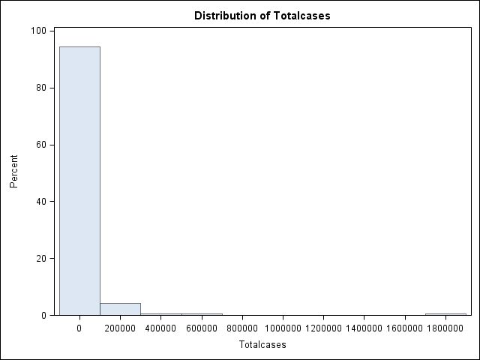 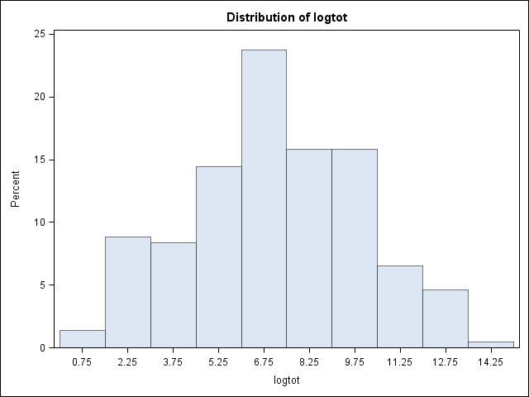

Supplementary Figure. S1 Histogram of variables of Total cases before and after logarithmic transformation

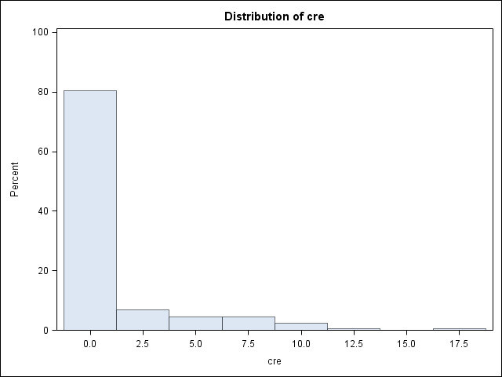 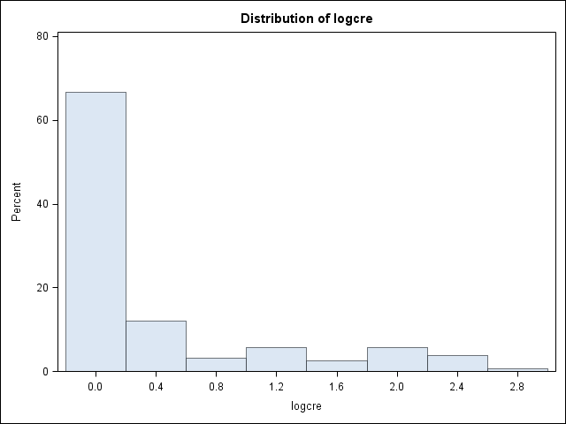 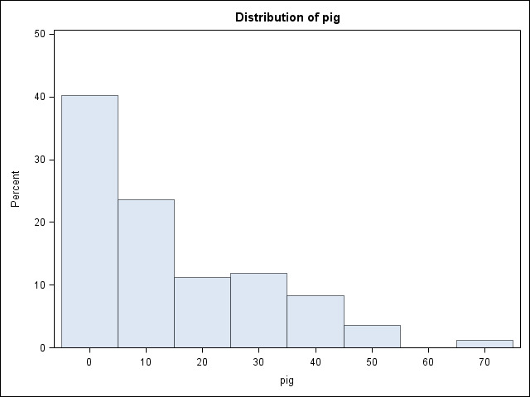 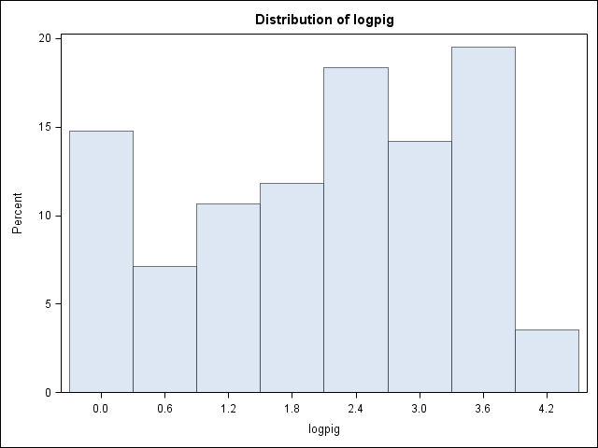

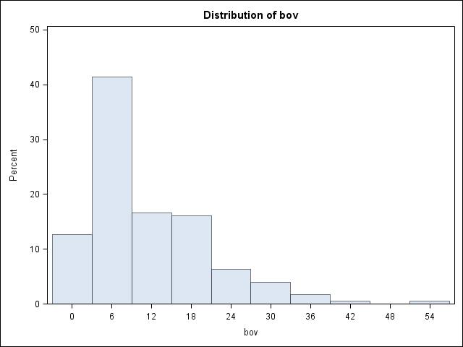 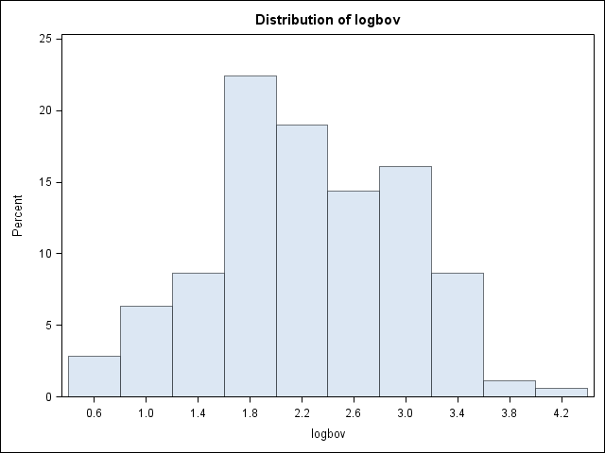 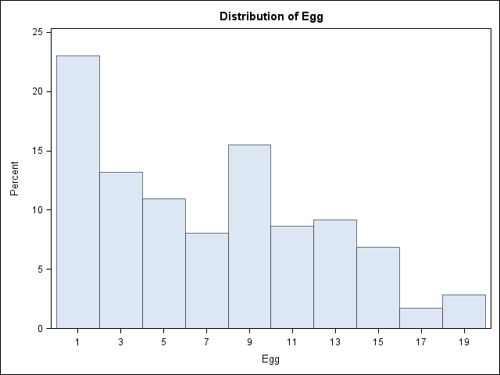 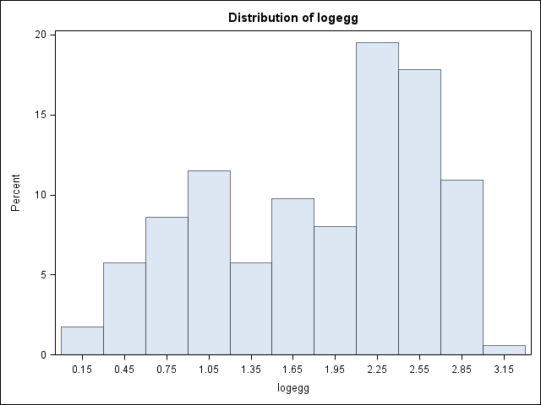

Supplementary Figure S2 Histogram of some independent variables before and after logarithmic transformation. First row, From Left to right: cream, log cream, pigs, logpigs. Second row: Bovine meat, log bovin meat, eggs, log of eggs.

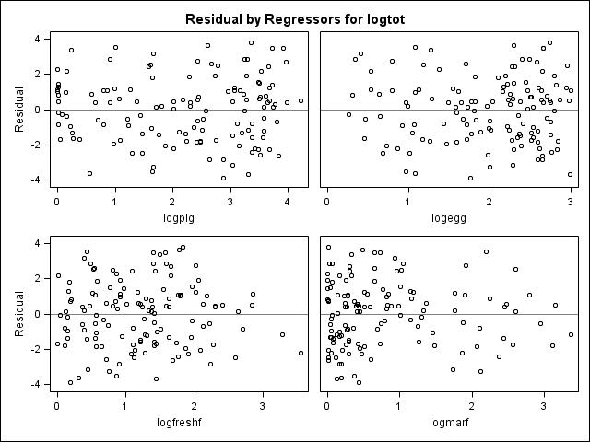 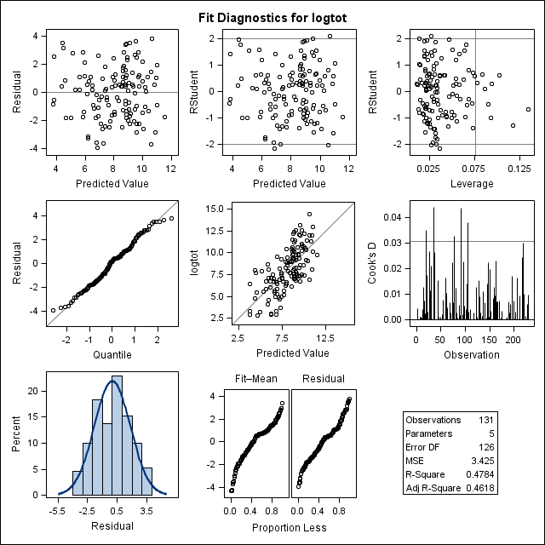

Supplementary Figure. S3 Diagnostics panel : Fit diagnostics and residual by regressors, Multivariate regression with stepwise selection of variables.

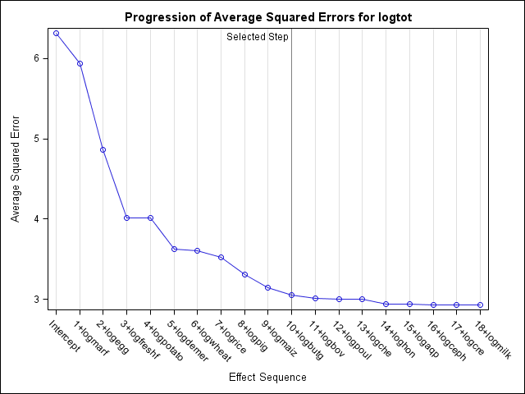 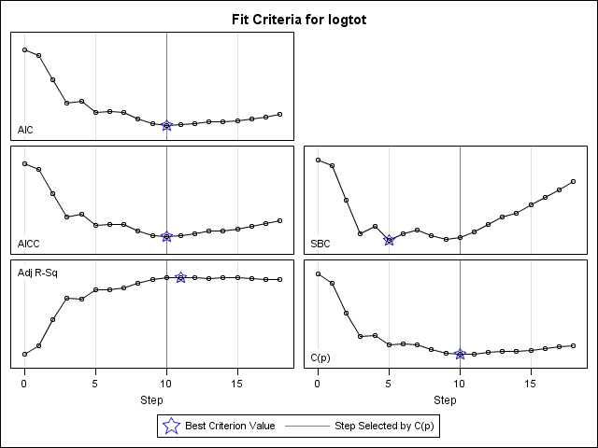

Supplementary Figure S4 Other Criteria Suggest Stopping the Selection (GLMSELECT proc of SAS). Progression of squared errors (left) and Fit criteria of LASSO analysis.

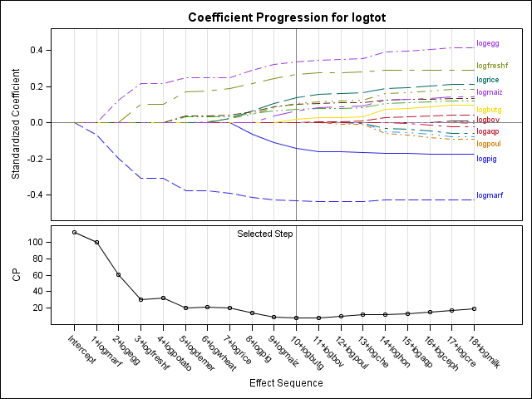

Supplementary Figure S5 shows the standardized coefficients of all the effects that are selected at some step of the elastic net method, plotted as a function of the step number of LASSO analysis. The GLMSELECT Proc of SAS.

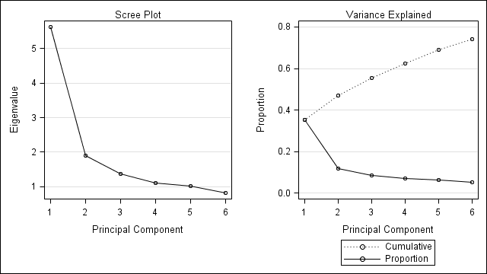

Supplementary Figure. S6 scree plot and percentage of variance explained by principal componentsofPCA analysis.

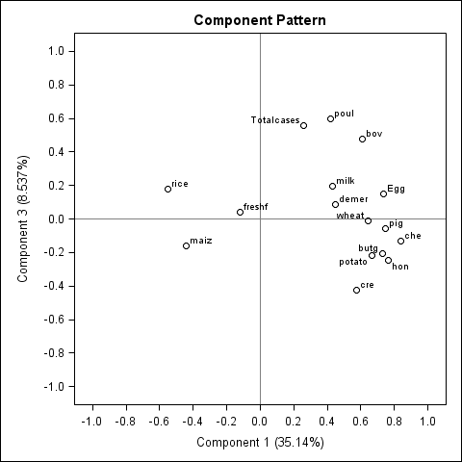 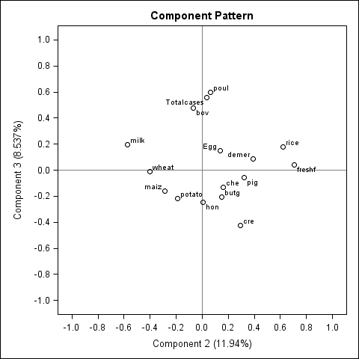

Supplementary Figure. S7 Results of PROC PRINCOMP, includes 1 by 3 and 2 by 3 component pattern plots. Principal component analysis results showed that AOF are generally closer to TC in the comparison with other studied foods.

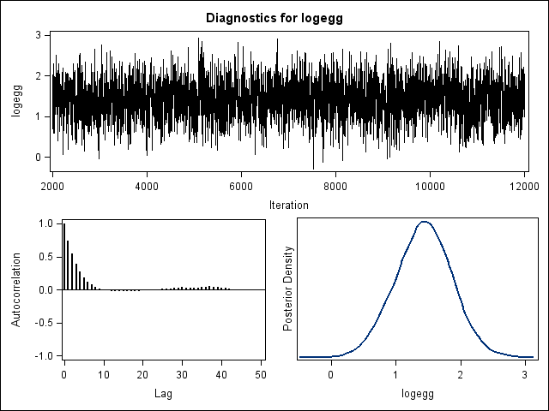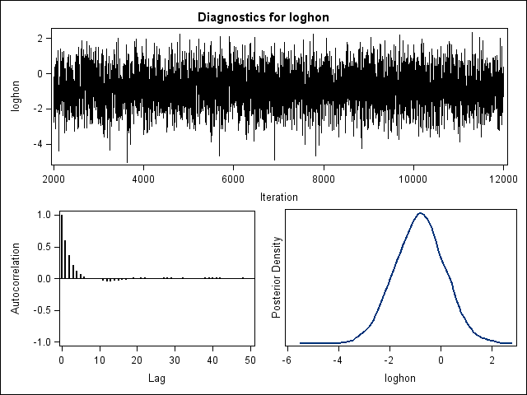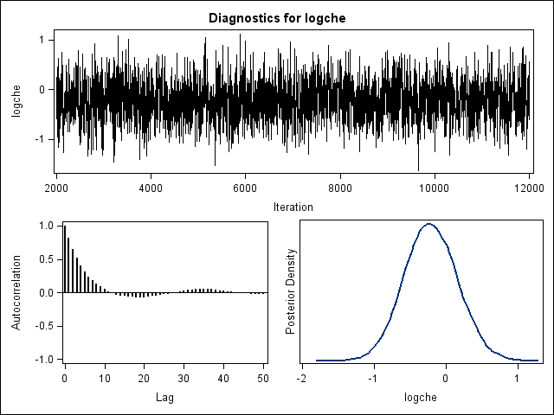 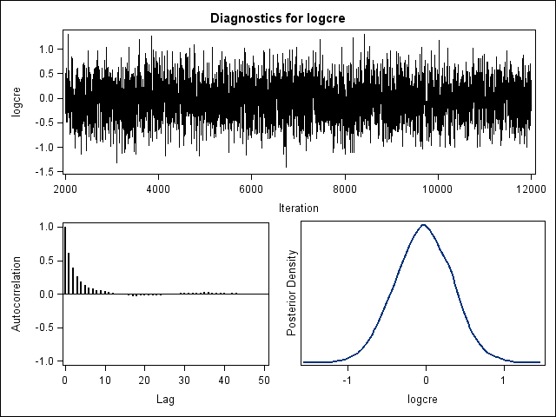

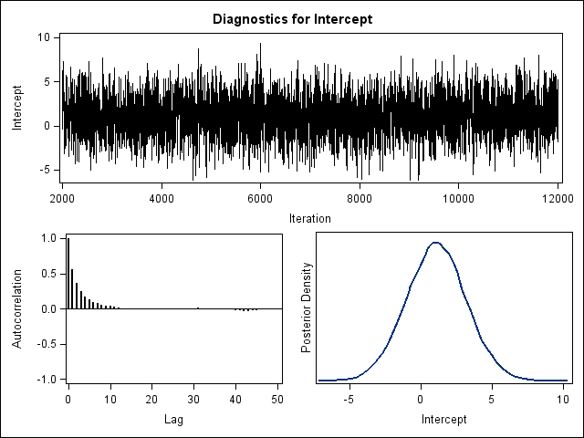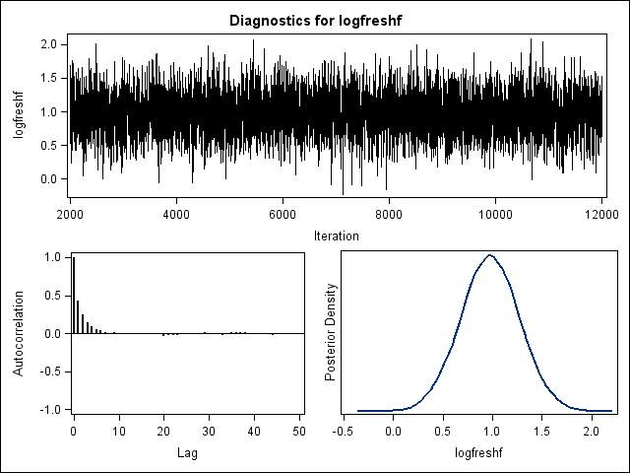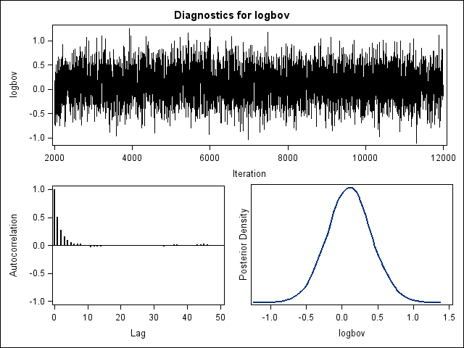 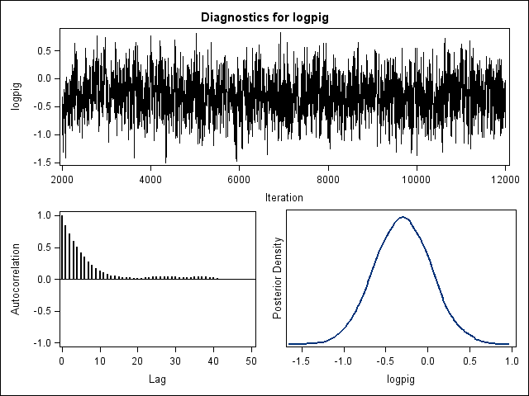

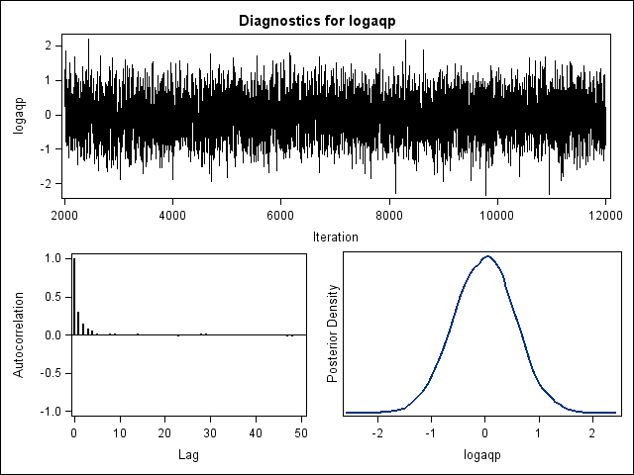 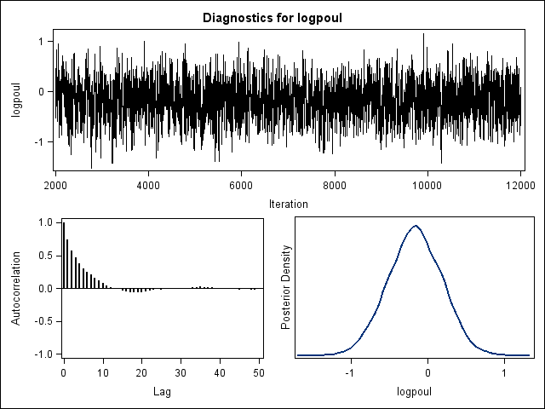 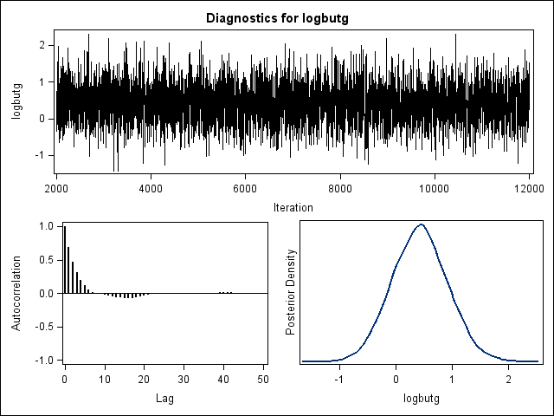 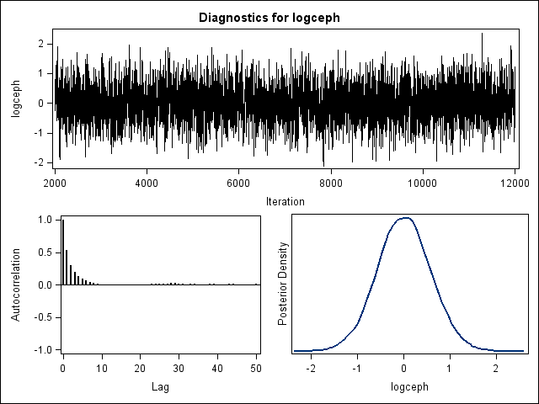

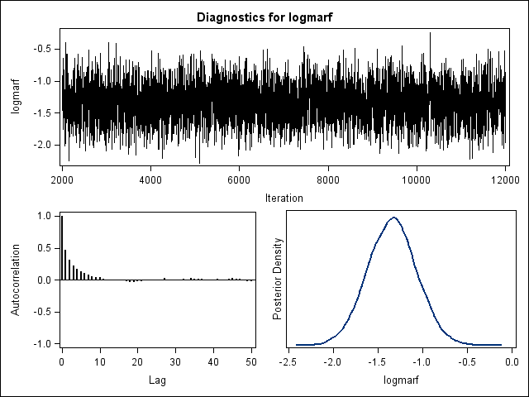 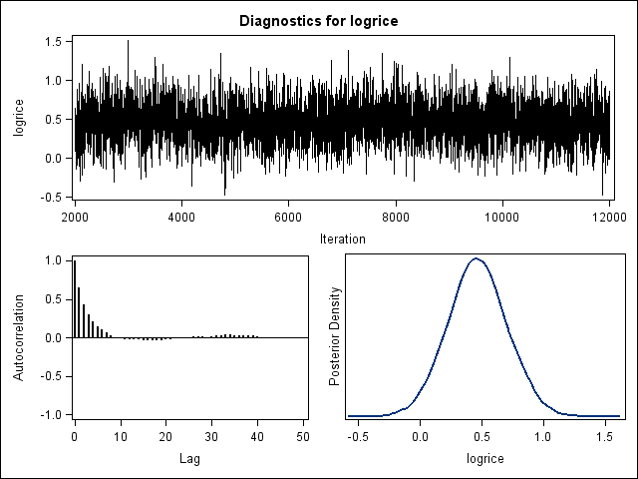 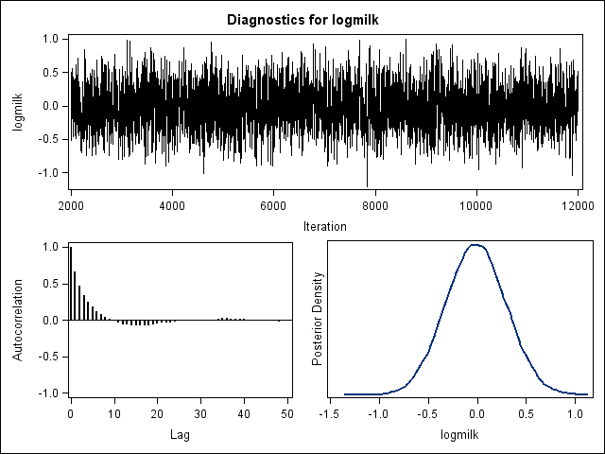 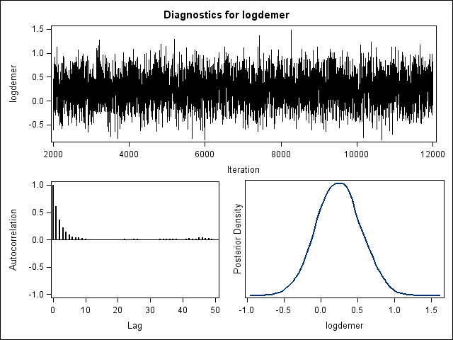

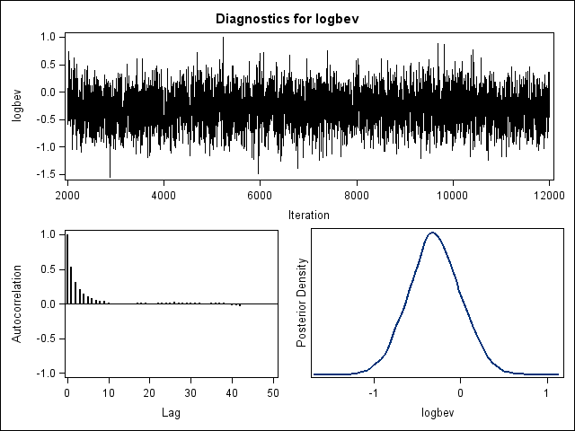 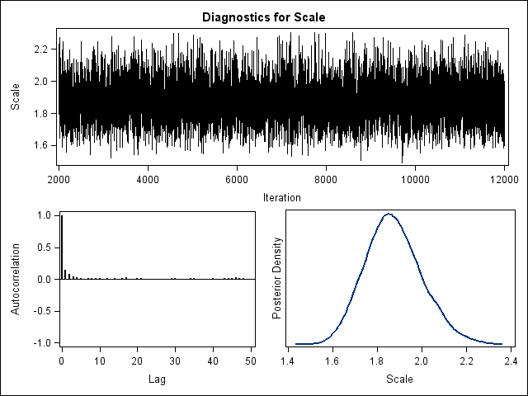 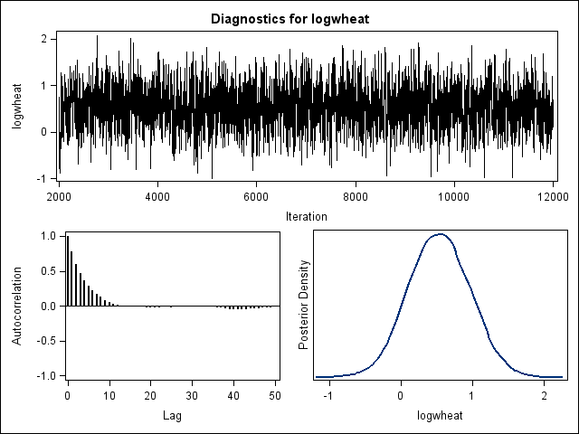 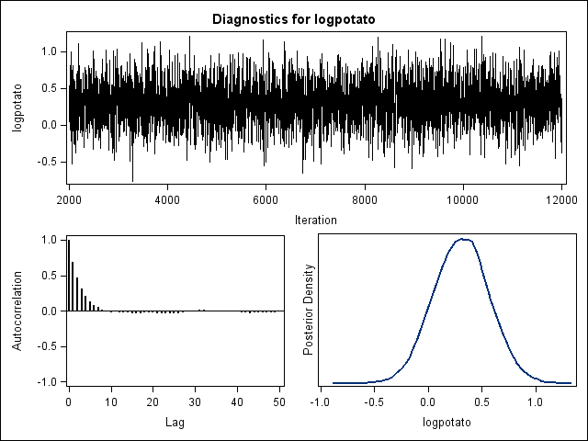

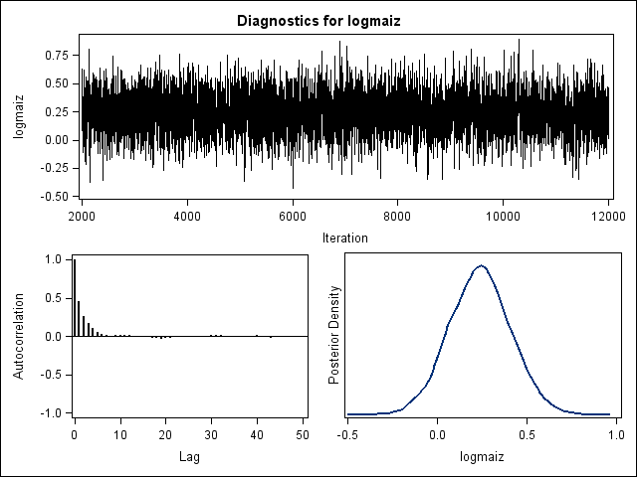 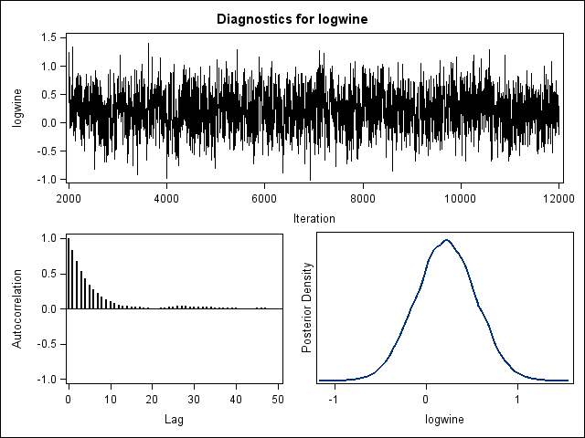

Supplementary Figure. S8 Bayesian Analysis: Visual examination of the trace plot displays proper mixing, for all independent variables.

**REFERENCES:**

1. Matteo Chinazzi, Jessica T. Davis, Marco Ajelli, Corrado Gioannini, Maria Litvinova, Stefano Merler, Ana Pastore y Piontti, Kunpeng Mu, Luca Rossi, Kaiyuan Sun, Cécile Viboud, Xinyue Xiong, Hongjie Yu, M. Elizabeth Halloran, Ira M. Longini Jr., Alessandro Vespignani The effect of travel restrictions on the spread of the 2019 novel coronavirus (COVID-19) outbreak *Science*24 Apr 2020 : 395-400 <https://science.sciencemag.org/content/368/6489/395>
2. EFSA Panel on Biological Hazards (BIOHAZ); Scientific Opinion on An update on the presentknowledge on the occurrence and control of foodborne viruses. EFSA Journal 2011;9(7):2190. [96 pp.]  
   doi:10.2903/j.efsa.2011.2190. Available online: [www.efsa.europa.eu/efsajournal](http://www.efsa.europa.eu/efsajournal)
3. Shao D, Shi Z, Wei J, Ma Z. A brief review of foodborne zoonoses in China. *Epidemiol Infect*. 2011;139(10):1497‐1504. doi:10.1017/S0950268811000872 <https://pubmed.ncbi.nlm.nih.gov/21676353/>
4. Todd E, Grieg J. Viruses of foodborne origin: a review. *Virus Adaptation and Treatment*. 2015;7:25-45 <https://doi.org/10.2147/VAAT.S50108> [https://www.dovepress.com/viruses-of-foodborne-origin-a-review-peer-reviewed-fulltext-article-VAAT#](https://www.dovepress.com/viruses-of-foodborne-origin-a-review-peer-reviewed-fulltext-article-VAAT)
5. Simjee, Shabbir (Ed.) 2007 Foodborne Diseases <https://www.springer.com/gp/book/9781588295187>
6. DG,Newell, Koopmans M, Verhoef L, Duizer E, Aidara-Kane A, Sprong H, Opsteegh M, Langelaar M, Threfall J, Scheutz F, van der Giessen J, Kruse H.2010 Food-borne diseases - the challenges of 20 years ago still persist while new ones continue to emerge. Int J Food Microbiol. 2010 May 30;139 Suppl 1:S3-15. doi:10.1016/j.ijfoodmicro.2010.01.021. Epub 2010 Jan 22.
7. F.Smulders, Birgit Nørrung and Herbert Budka 2013 Foodborne viruses and prions and their significance for public health eISBN: 978-90-8686-780-6 | ISBN: 978-90-8686-226-9 <https://doi.org/10.3920/978-90-8686-780-6>
8. Rob Lake and Joanne Kingsbury 2020 Potential for Foodborne Transmission of COVID-19: Literature Review Update - May 2020 <https://www.unitedfresh.co.nz/technical-advisory-group/covid-19>
9. FAO/WHO [Food and Agriculture Organization of the United Nations/World Health Organization]. 2008. Microbiological hazards in fresh leafy vegetables and herbs: Meeting Report. Microbiological Risk Assessment Series No. 14. Rome. 151pp.
10. Geneviève Panon, Sylviane Tache, C. Labie. Respective stability of rotavirus and coronavirus in bovine milk. Le Lait, INRA Editions, 1988, 68 (1), pp.49-64. ﬀhal-00929118
11. Hamdi A. Mohamed, Adham M. Abdou , Ekbal M. Adela, Sayed Ahmed H. Salemb, Mervat I.M. EL-Hassanine 2013 Detection of bovine rota and corona viruses in raw milk and milk products  **Benha Veterinary Medical Journal** v 24, 79-85<http://www.bvmj.bu.edu.eg/abstract.php?ee=156>
12. EC, Pirtle, Beran GW. Virus survival in the environment. Rev Sci Tech. 1991;10(3):733‐748. doi:10.20506/rst.10.3.570 <https://pubmed.ncbi.nlm.nih.gov/1782426/>
13. G, Moy, 2020 IUFoST/CIFST hold an Extraordinary Scientific Roundtable on COVID-19 and Food Safety. npj Science of Food 4:8 <https://doi.org/10.1038/s41538-020-0068-2>
14. Sarah Williams, C. P. 2012 Kitchen Utensils Transfer Viruses. [https://www.sciencemag.org/news/2012/12/kitchen-utensils-transfer-viruses#](https://www.sciencemag.org/news/2012/12/kitchen-utensils-transfer-viruses)
15. SA, Alger, Burnham PA, Boncristiani HF, Brody AK (2019) RNA virus spillover from managed honeybees (Apis mellifera) to wild bumblebees (Bombus spp.). PLoS ONE 14(6): e0217822. <https://doi.org/10.1371/journal.pone.0217822>
16. E., Maori , Garbian Y, Kunik V, et al. A Transmissible RNA Pathway in Honey Bees. Cell Rep. 2019;27(7):1949‐1959.e6. doi:10.1016/j.celrep.2019.04.073
17. F., Mutinelli. 2011 The spread of pathogens through trade in honey bees and their products (including queen bees and semen): overview and recent developments. Rev Sci Tech.; 30(1):257‐271. doi:10.20506/rst.30.1.2033 <https://pubmed.ncbi.nlm.nih.gov/21809768/>
18. A Bosch , Gkogka E, Le Guyader FS, et al. Foodborne viruses: Detection, risk assessment, and control options in food processing. International Journal of Food Microbiology. 2018 Nov;285:110-128. DOI: 10.1016/j.ijfoodmicro.2018.06.001.
19. SA, Kujawski, Wong, K.K., Collins, J.P. *et al.* Clinical and virologic characteristics of the first 12 patients with coronavirus disease 2019 (COVID-19) in the United States. *Nat Med* (2020). <https://doi.org/10.1038/s41591-020-0877-5>
20. M. Bourgarel,; Noël, V.; Pfukenyi, D.; Michaux, J.; André, A.; Becquart, P.; Cerqueira, F.; Barrachina, C.; Boué, V.; Talignani, L.; Matope, G.; Missé, D.; Morand, S.; Liégeois, F. 2019 Next-Generation Sequencing on Insectivorous Bat Guano: An Accurate Tool to Identify Arthropod Viruses of Potential Agricultural Concern. Viruses , 11, 1102. https://www.ncbi.nlm.nih.gov/pmc/articles/PMC6950063/
21. S. Pillai, Saif, Y., & Lee, C. 2010. Detection of Influenza A Viruses in Eggs Laid by Infected Turkeys. *Avian Diseases,* *54*(2), 830-833. Retrieved May 23, 2020, from www.jstor.org/stable/40801707
22. D. Cavanagh 2005 Coronaviruses in poultry and other birds, Avian Pathology, 34:6, 439-448, DOI: 10.1080/03079450500367682 <https://doi.org/10.1080/03079450500367682>
23. Y.Yamamoto , Nakamura K, Yamada M, Mase M. Persistence of avian influenza virus (H5N1) in feathers detached from bodies of infected domestic ducks. *Appl Environ Microbiol*. 2010;76(16):5496‐5499. doi:10.1128/AEM.00563-10
24. Ye Qiu, Yuan-Bo Zhao, Qiong Wang, Jin-Yan Li, Zhi-Jian Zhou, Ce-Heng Liao, Xing-Yi Ge, Predicting the angiotensin converting enzyme 2 (ACE2) utilizing capability as the receptor of SARS-CoV-2, Microbes and Infection,Volume 22, Issues 4–5,2020, Pages 221-225, <https://doi.org/10.1016/j.micinf.2020.03.003>
25. F.,Wu, Zhao, S., Yu, B. et al. 2020 A new coronavirus associated with human respiratory disease in China. Nature 579, 265–269. <https://doi.org/10.1038/s41586-020-2008-3>
26. A.,Papineau, Berhane, Y., Wylie, T.N. et al. Genome Organization of Canada Goose Coronavirus, A Novel Species Identified in a Mass Die-off of Canada Geese. Sci Rep 9, 5954 (2019). <https://doi.org/10.1038/s41598-019-42355-y>
27. J. C., Leong 2008. Fish Viruses. Encyclopedia of Virology, 227–234. https://doi.org/10.1016/B978-012374410-4.00400-3 https://www.ncbi.nlm.nih.gov/pmc/articles/PMC7149611/
28. Ryan S Miller , Steven J. Sweeney1, Chris Slootmaker, Daniel A. Grear, Paul A. Di Salvo, Deborah Kiser , Stephanie A. Shwif 2017 Cross-species transmission potential between wild pigs, livestock, poultry, wildlife, and humans: implications for disease risk management in North America SCIENtIFIC RePoRTS | 7: 7821 | DOI:10.1038/s41598-017-07336-z
29. Kai Kupferschmidt 2013 New Middle Eastern Virus Found in Camels <https://www.sciencemag.org/news/2013/11/new-middle-eastern-virus-found-camels>
30. Y. Guan, B. J. Zheng, Y. Q. He, X. L. Liu, Z. X. Zhuang, C. L. Cheung, S. W. Luo, P. H. Li, L. J. Zhang, Y. J. Guan, K. M. Butt, K. L. Wong, K. W. Chan, W. Lim, K. F. Shortridge, K. Y. Yuen, J. S. M. Peiris, L. L. M. Poon 2003 Isolation and Characterization of Viruses Related to the SARS Coronavirus from Animals in Southern China Science10: 276-278 <https://science.sciencemag.org/content/302/5643/276>
31. Simon A. Babayan, Richard J. Orton, Daniel G. Streicker 2018 Predicting reservoir hosts and arthropod vectors from evolutionary signatures in RNA virus genomes Science 02 Nov 2018 : 577-580 <https://science.sciencemag.org/content/362/6414/577>
32. Dino P.McMahon, Len Wilfert, Robert J.Paxton, Mark J.F.Brown2018 Emerging Viruses in Bees: From Molecules to Ecology Advances in Virus Research Volume 101, 2018, Pages 251-291 <https://doi.org/10.1016/bs.aivir.2018.02.008>
33. Dyal JW, Grant MP, Broadwater K, et al. COVID-19 Among Workers in Meat and Poultry Processing Facilities - 19 States, April 2020. MMWR Morb Mortal Wkly Rep. 2020;69(18):10.15585/mmwr.mm6918e3. Published 2020 May 8. doi:10.15585/mmwr.mm6918e3 <https://pubmed.ncbi.nlm.nih.gov/32379731/>
34. Geisbert TW, Mire CE, Geisbert JB, et al. Therapeutic treatment of Nipah virus infection in nonhuman primates with a neutralizing human monoclonal antibody. Sci Transl Med. 2014;6(242):242ra82. doi:10.1126/scitranslmed.3008929 <https://pubmed.ncbi.nlm.nih.gov/24964990/>
35. N. T. Grabowski & G. Klein (2017) Microbiology and foodborne pathogens in honey, Critical Reviews in Food Science and Nutrition, 57:9, 1852-1862, DOI: [10.1080/10408398.2015.1029041](https://doi.org/10.1080/10408398.2015.1029041)
36. <https://www.worldometers.info/coronavirus/> 1 June 2020
37. <http://www.fao.org/faostat/en/#data/QA>
38. <http://www.fao.org/faostat/en/#data/CC>
39. <http://www.fao.org/faostat/en/#data/CL>
40. <https://www.researchgate.net/publication/342047913_Corr_food_7>
41. Maffetone Philip B., Laursen Paul B. 2020 The Perfect Storm: Coronavirus (Covid-19) Pandemic Meets Overfat Pandemic Frontiers in Public Health. 8, p 135 , DOI=10.3389/fpubh.2020.0013 URL=https://www.frontiersin.org/article/10.3389/fpubh.2020.00135
42. Katy Askew 2020 German slaughterhouses under fire over 'insufficient precautionary measures' to block COVID-19 spread 14-May-2020 By <https://www.foodnavigator.com/Article/2020/05/14/German-slaughterhouses-under-fire-over-COVID-19-spread>
43. Brazil: Covid-19 cases spike among processing plant workers <https://www.poultryworld.net/Meat/Articles/2020/5/Brazil-Covid-19-cases-spike-among-processing-plant-workers-589566E/>
44. Why Meatpacking Plants Have Become Covid-19 Hot Spots <https://www.wired.com/story/why-meatpacking-plants-have-become-covid-19-hot-spots/>
45. Leah Douglas Charting the spread of Covid-19 in the food system, May 19, 2020 <https://thefern.org/2020/05/charting-the-spread-of-covid-19-in-the-food-system/>