

**Appendix Figure 1. Cross-check amongst different data sources for the following measures in the Greater Toronto Area: (A) Cumulative diagnosed cases overall; (B) Cumulative diagnosed cases for LTCH-residents; (C) Cumulative diagnosed cases for persons using shelters; and (D) cumulative deaths among LTCH-residents diagnosed with COVID-19.** Data sources:iPHIS,the integrated Public Health Information System; OLIS, the Ontario Laboratories Information System; LTCH tracker, the provincial LTCH tracker collects aggregate data at the facility-level on the number of active COVID-19 cases (confirmed and probable, separately), and cumulative deaths (among confirmed COVID-19 cases, and those who were diagnosed with COVID-19 at time of death) at LTCH, among residents and staff, separately; cumulative diagnosed cases in (B) per LTCH tracker was approximated by the sum of active confirmed cases and deaths, thus may not capture resolved cases. The calendar date refers to the date the case was reported to the public health unit in (A)-(C), and date of death in (D). Abbreviations: GTA, Greater Toronto Area; LTCH, long-term care homes.

(A)

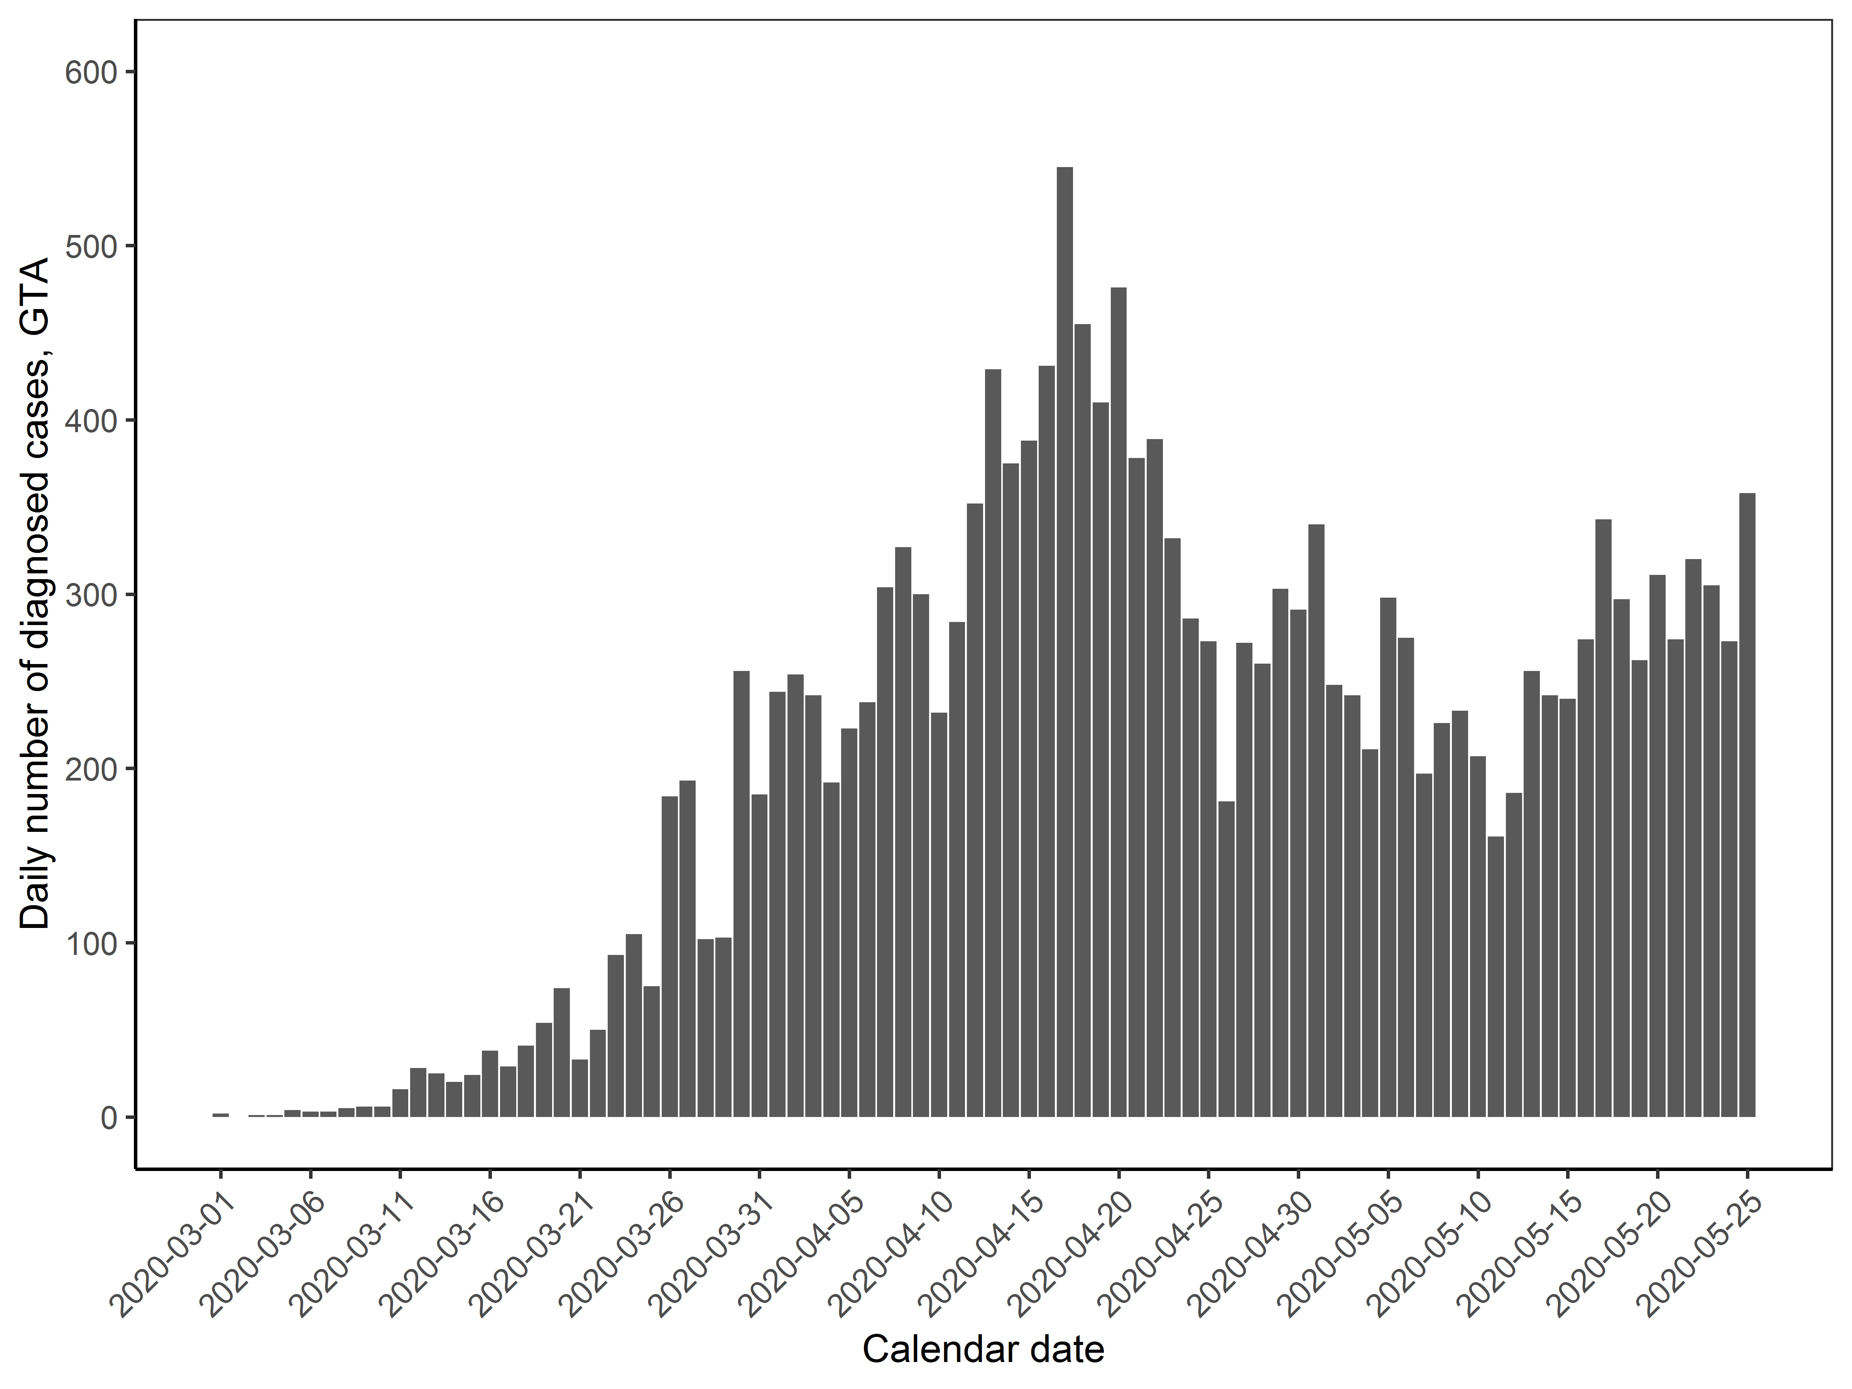

(B)

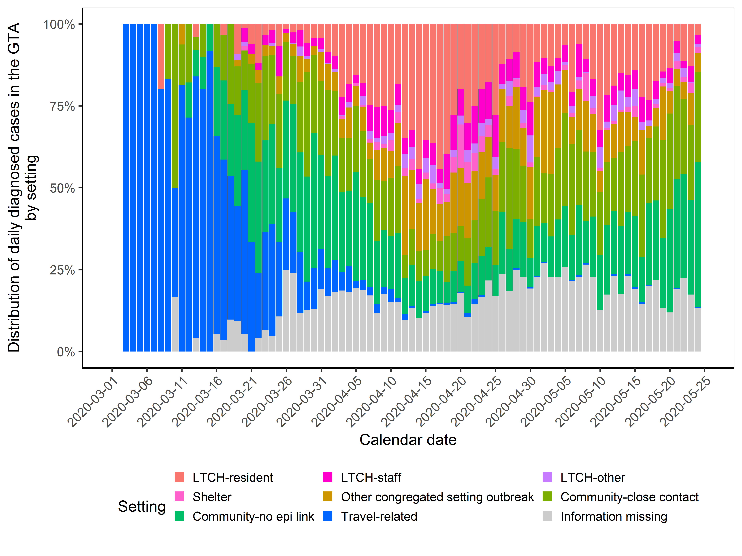

**Appendix Figure 2. The (A) total number and (B) distribution by outbreak setting in the daily number of diagnosed COVID-19 cases in the Greater Toronto Area.** Settings are defined as mutually exclusive categories by the order shown in the graph (from top to bottom) in the event of multiple exposures. LTCH-other may include volunteers; other congregate outbreak settings include hospitals, correctional facilities, retirement homes, group homes, and other not yet classified such as workplaces. Information missing category excludes congregate setting. The calendar date refers to the date the case was reported to the public health unit. Data sources: iPHIS, the integrated Public Health Information System. Abbreviations: GTA, Greater Toronto Area; LTCH, long-term care homes.

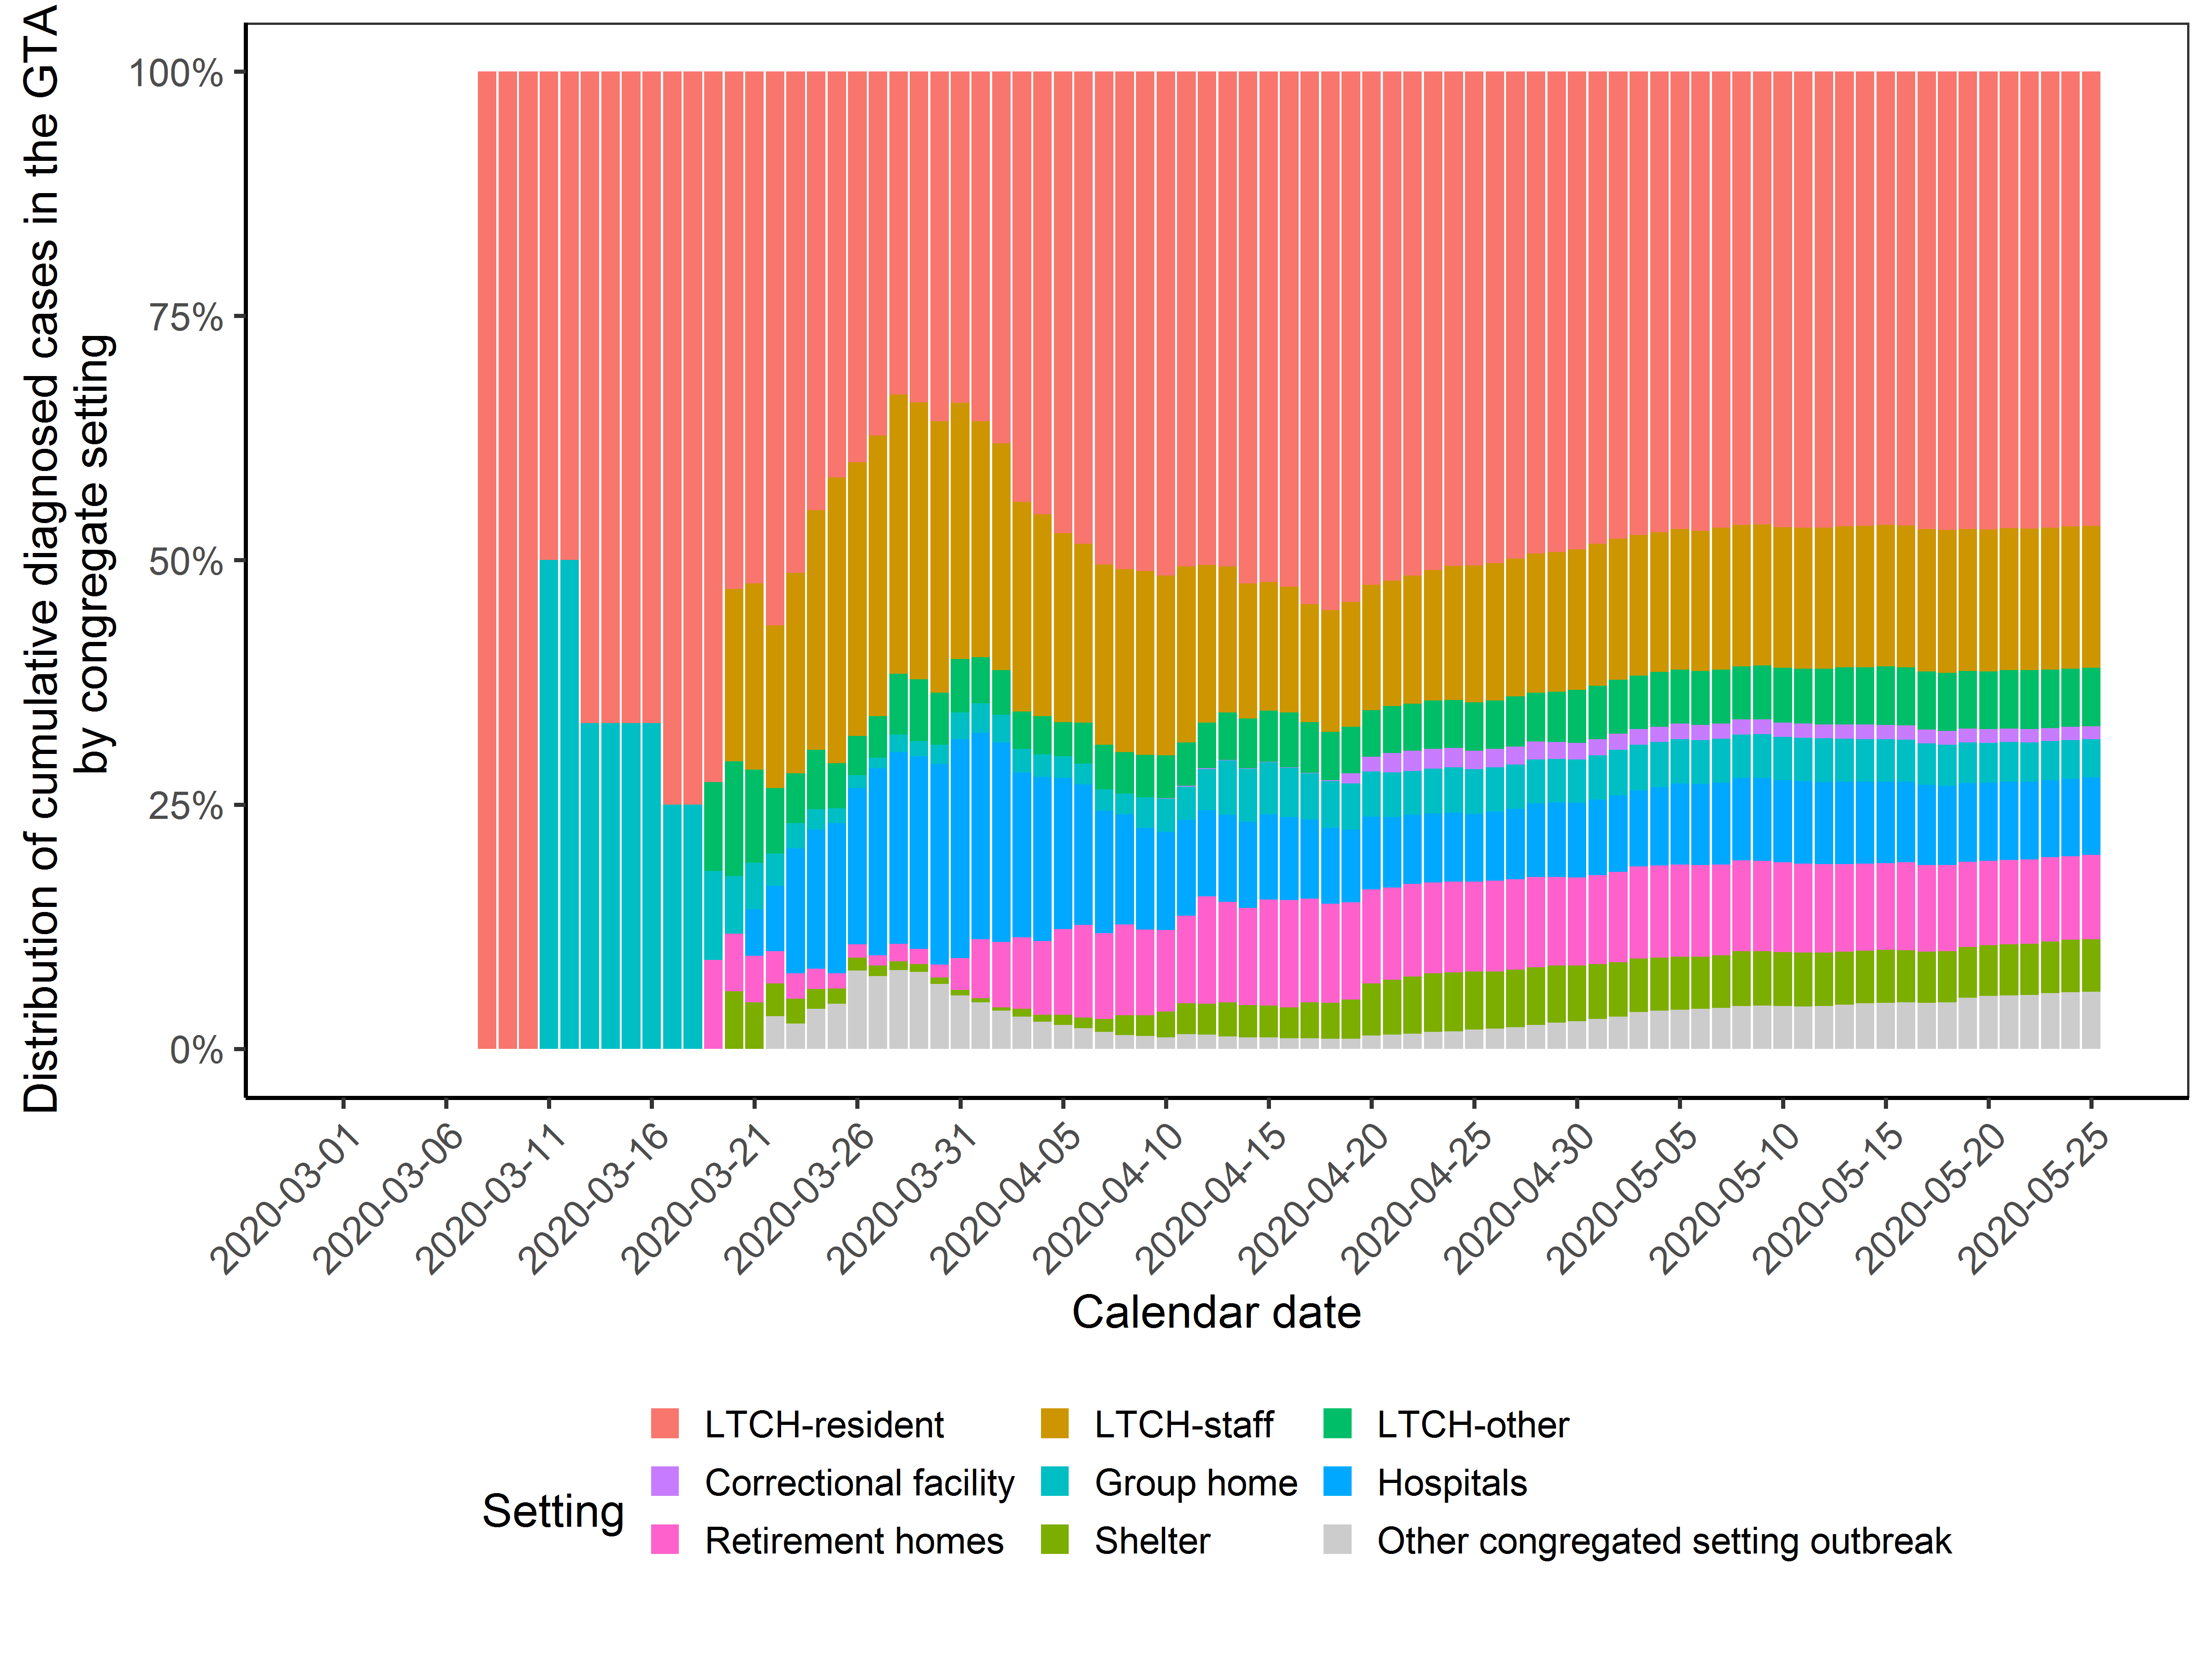**Appendix Figure 3. Distribution of cumulative COVID-19 cases in the Greater Toronto Area (GTA) by setting over time in congregate settings.** LTCH-other may include volunteers; other congregate settings refer to those that have not yet been classified in the data source, and may include other workplace settings where an outbreak has been declared.Data sources: iPHIS: integrated Public Health Information System. Abbreviations: GTA, Greater Toronto Area; LTCH, long-term care homes.

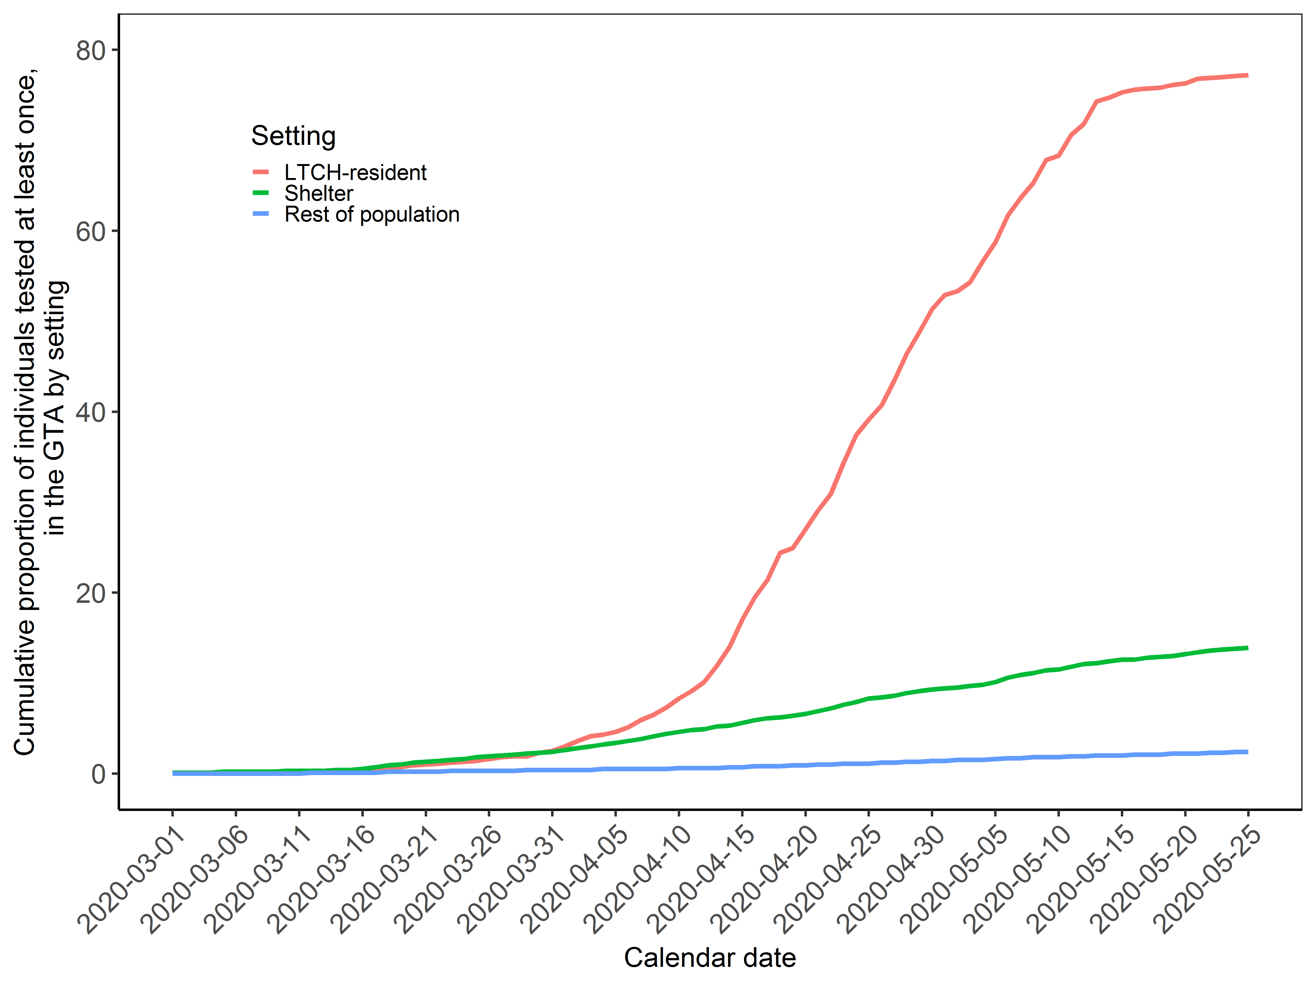

**Appendix Figure 4. Cumulative proportion of population who had at least one COVID-19 test in the Greater Toronto Area by outbreak setting.** The calendar date refers to the date when specimen was collected.Data sources: OLIS: Ontario Laboratories Information System. Abbreviations: GTA, Greater Toronto Area; LTCH, long-term care homes.