Supplementary Materials for

**Impacts of regional climate on the COVID-19 pandemic**

Minneng Wen, Liyuan Chen

Correspondence to: chenliyuan@pku.edu.cn

**This PDF file includes:**

Figure S1 to S3

Tables S1 to S4

Captions for Data S1

**Other Supplementary Materials for this manuscript include the following:**

Data S1. COVID-19 pandemic and climate data for 194 epidemic regions in 116 countries and territories.

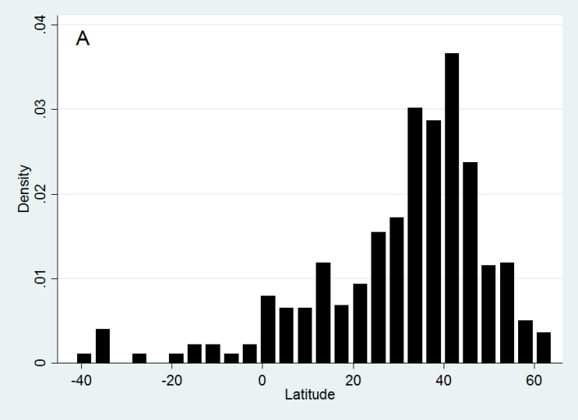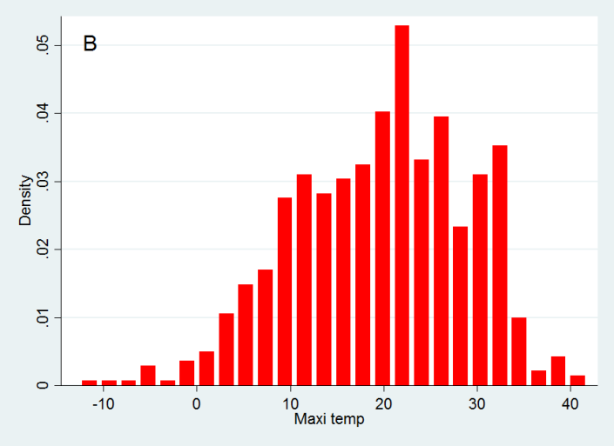

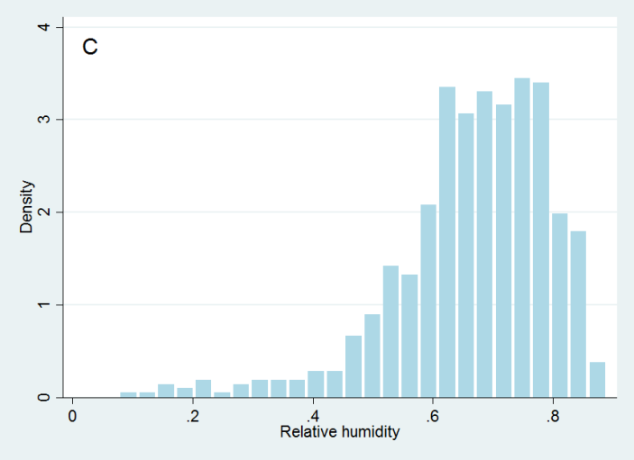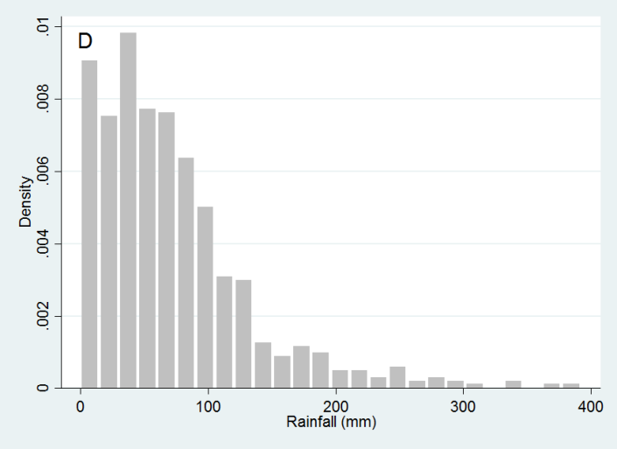

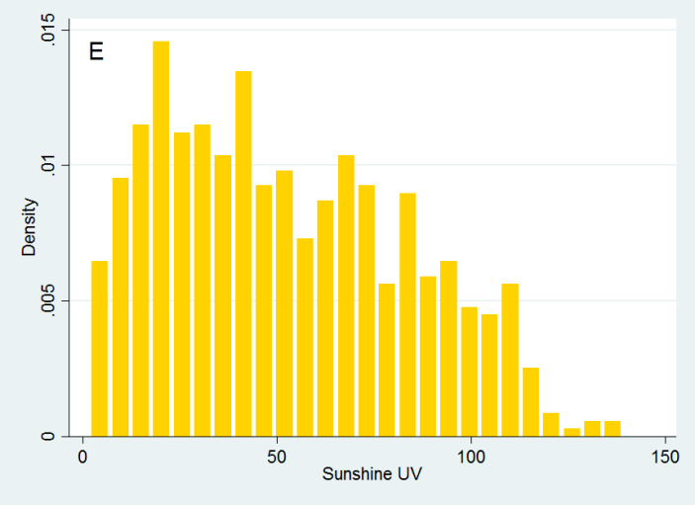

**Figure S1. Histograms of latitude, maximum temperature, relative humidity, rainfall, and sunshine UV.**

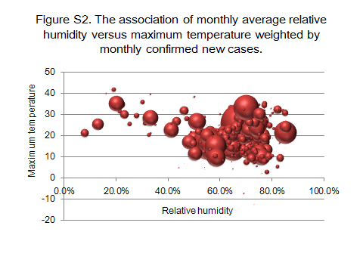

**Figure S2. Bubble chart plotted between the maximum temperature and the relative humidity weighted by the number of monthly confirmed new cases.**

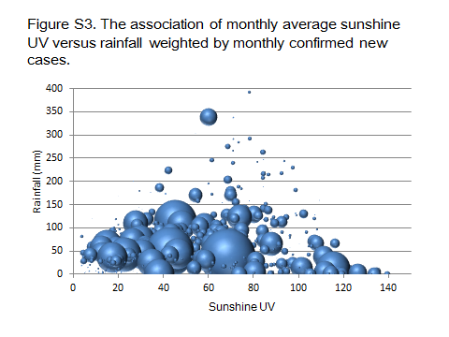

**Figure S3. Bubble chart plotted between the sunshine UV and the rainfall weighted by the number of monthly confirmed new cases.**

|  |  |  |  |
| --- | --- | --- | --- |
|  | **New cases** | **New deaths** | **Case mortality** |
| **Dec 2019** | 27 | 0 | 0% |
| **Jan 2020** | 11814 | 260 | 2.2% |
| **Feb 2020** | 75651 | 4003 | 5.29% |
| **Mar 2020** | 753754 | 37500 | 4.97% |
| **Apr 2020** | 2351179 | 189584 | 8.06% |
| **May 2020** | 2794118 | 138062 | 4.94% |
| **Northern hemisphere** |  |  |  |
| **Dec 2019-Winter** | 27 | 0 | 0% |
| **Jan 2020-Winter** | 11802 | 260 | 2.2% |
| **Feb 2020-Winter** | 75638 | 4003 | 5.29% |
| **Mar 2020-Spring** | 740682 | 37121 | 5.01% |
| **Apr 2020-Spring** | 2227316 | 182323 | 8.19% |
| **May 2020-Spring** | 2252428 | 110926 | 4.92% |
| **Subtotal** | 5307893 | 334633 | 6.30% |
| **Southern hemisphere** |  |  |  |
| **Dec 2019-Summer** | 0 | 0 | 0% |
| **Jan 2020-Summer** | 12 | 0 | 0% |
| **Feb 2020-Summer** | 13 | 0 | 0% |
| **Mar 2020-Autumn** | 13827 | 379 | 2.74% |
| **Apr 2020-Autumn** | 123108 | 7261 | 5.90% |
| **May 2020-Autumn** | 541691 | 27136 | 5.01% |
| **Subtotal** | 678651 | 34776 | 5.12% |

**Table S1. Monthly distribution of confirmed new cases and deaths of the COVID-19 pandemic in the northern hemisphere (NH) and the southern hemisphere (SH).**

|  |  |  |  |  |
| --- | --- | --- | --- | --- |
| **Climate regions** | **Total cases** | **Proportion** | **Total deaths** | **Case**  **mortality** |
| **Tropical** | 1129171 | 18.86% | 40556 | 3.60% |
| 1. Tropical rainforest | 137621 | 2.30% | 3452 | 2.51% |
| 1. Tropical semiarid/grasslands | 518627 | 8.66% | 29132 | 5.62% |
| 1. Tropical monsoon/wet and dry | 238800 | 3.99% | 6451 | 2.70% |
| 1. Tropical desert | 234123 | 3.91% | 1521 | 0.65% |
| **Subtropical** | 2402694 | 40.13% | 164898 | 6.86% |
| 1. Humid subtropical climate | 1462450 | 24.43% | 106662 | 7.29% |
| 1. Mediterranean climate | 645993 | 10.79% | 42865 | 6.64% |
| 1. Subtropical highland | 185537 | 3.10% | 14326 | 7.72% |
| 1. Subtropical desert | 176849 | 2.95% | 5557 | 3.14% |
| **Temperate** | 2454678 | 41.00% | 163821 | 6.67% |
| 1. Humid continental | 1351730 | 22.58% | 54275 | 4.02% |
| 1. Temperate marine | 880173 | 14.70% | 101907 | 11.58% |
| 1. Temperate semiarid/grasslands | 154171 | 2.58% | 3119 | 2.02% |
| 1. Subarctic | 469 | 0.01% | 8 | 1.71% |
| **Temperature-group** |  |  |  |  |
| Hot regions (Tmax≥20°C) | 2757875 | 46.1% | 129094 | 4.68% |
| Cold regions (Tmax<20°C) | 3228669 | 53.9% | 240315 | 7.44% |
| **Humidity-group** |  |  |  |  |
| Humid regions (RH≥60%) | 4195024 | 70.1% | 266225 | 6.35% |
| Arid regions (RH<60%) | 1791519 | 29.9% | 103184 | 5.76% |
| **Rain-group** |  |  |  |  |
| Rainy regions (rainfall≥40mm) | 4217411 | 70.4% | 301044 | 7.14% |
| Rainless regions (rainfall<40mm) | 1769133 | 29.6% | 68365 | 3.86% |
| **UV-group** |  |  |  |  |
| Sunny regions (sunshine UV≥50) | 2669235 | 44.6% | 123777 | 4.64% |
| Cloudy regions (sunshine UV<50) | 3317309 | 55.4% | 245632 | 7.40% |
| **Total** | 5986544 | 100% | 369409 | 6.17% |

**Table S2. Total confirmed COVID-19 cases and deaths in different climate regions.** Tmax: maximum temperature. RH: relative humidity.

|  |  |  |  |  |  |  |
| --- | --- | --- | --- | --- | --- | --- |
|  |  | **Maximum**  **temperature**  (℃) | **Absolute**  **latitude**  **(**°**)** | **Sunshine**  **UV** | **Relative**  **humidity**  (%) | **Rainfall**  (mm) |
| **2019** | **Dec** | 10.8 | 31 | 13.2 | 74 | 26 |
| **2020** | **Jan** | 8.28 | 31 | 14.5 | 74.8 | 20.7 |
| **2020** | **Feb** | 9.8 | 31.9 | 18.9 | 74.1 | 55.1 |
| **2020** | **Mar** | 13.5 | 42.4 | 26.5 | 65.5 | 63.1 |
| **2020** | **Apr** | 18.3 | 39.7 | 46.4 | 62.5 | 68.2 |
| **2020** | **May** | 24.7 | 32.8 | 68.0 | 63.1 | 59.7 |
| **Total** |  | 20.5 | 36.7 | 53.5 | 63.3 | 63.4 |

**Table S3. Case-weighted means of climate data of central cities in COVID-19 epidemic regions.** The means of absolute latitude, maximum temperature, relative humidity, rainfall, and sunshine UV are weighted by the number of monthly confirmed new cases.

|  |  |  |  |  |
| --- | --- | --- | --- | --- |
|  | **R** | | **R2** | |
|  | **ln (new cases)** | **ln (new deaths)** | **ln (new cases)** | **ln (new deaths)** |
| **All regions** |  |  |  |  |
| Latitude | 0.122 | 0.227 | 0.0149 | 0.0515 |
| Temperature | 0.140 | 0.070 | 0.0196 | 0.0049 |
| RH | -0.117 | -0.145 | 0.0137 | 0.0210 |
| Rainfall | 0.050 | -0.012 | 0.0025 | 0.0001 |
| Sunshine UV | 0.146 | 0.038 | 0.0213 | 0.0014 |
| **Hot regions** (T≥20°C) | | | | |
| Latitude | 0.160 | 0.366 | 0.0256 | 0.1340 |
| Temperature | 0.001 | -0.210 | 0.0000 | 0.0441 |
| RH | -0.171 | -0.219 | 0.0292 | 0.0480 |
| Rainfall | -0.046 | -0.106 | 0.0021 | 0.0112 |
| Sunshine UV | 0.142 | -0.092 | 0.0202 | 0.0085 |
| **Cold regions** (T<20°C) | | | | |
| Latitude | 0.230 | 0.243 | 0.0529 | 0.0590 |
| Temperature | 0.341 | 0.355 | 0.1163 | 0.1260 |
| RH | -0.031 | -0.040 | 0.0010 | 0.0016 |
| Rainfall | 0.257 | 0.181 | 0.0660 | 0.0328 |
| Sunshine UV | 0.258 | 0.218 | 0.0666 | 0.0475 |
| **Humid regions** (RH≥60%) | | | | |
| Latitude | 0.160 | 0.252 | 0.0256 | 0.0635 |
| Temperature | 0.080 | 0.020 | 0.0064 | 0.0004 |
| RH | -0.209 | -0.190 | 0.0437 | 0.0361 |
| Rainfall | 0.001 | -0.046 | 0.0000 | 0.0021 |
| Sunshine UV | 0.103 | -0.011 | 0.0106 | 0.0001 |
| **Arid regions** (RH<60%) | | | | |
| Latitude | -0.041 | 0.092 | 0.0017 | 0.0085 |
| Temperature | 0.293 | 0.205 | 0.0858 | 0.0420 |
| RH | -0.126 | -0.096 | 0.0159 | 0.0092 |
| Rainfall | 0.281 | 0.232 | 0.0790 | 0.0538 |
| Sunshine UV | 0.264 | 0.148 | 0.0697 | 0.0219 |
| **Rainy regions (**rainfall≥40mm**)** | | | | |
| Latitude | 0.198 | 0.301 | 0.039 | 0.091 |
| Temperature | -0.032 | -0.073 | 0.001 | 0.005 |
| RH | -0.260 | -0.224 | 0.068 | 0.050 |
| Rainfall | -0.131 | -0.196 | 0.017 | 0.038 |
| Sunshine UV | 0.053 | -0.046 | 0.003 | 0.002 |
| **Rainless regions (**rainfall<40mm**)** | | | | |
| Latitude | 0.004 | 0.060 | 0.000 | 0.004 |
| Temperature | 0.296 | 0.278 | 0.088 | 0.077 |
| RH | -0.116 | -0.193 | 0.013 | 0.037 |
| Rainfall | 0.004 | 0.159 | 0.000 | 0.025 |
| Sunshine UV | 0.292 | 0.228 | 0.085 | 0.052 |
| **Sunny regions** (Sunshine UV≥50) | | | | |
| Latitude | 0.199 | 0.361 | 0.040 | 0.130 |
| Temperature | -0.037 | -0.175 | 0.001 | 0.031 |
| RH | -0.119 | -0.214 | 0.014 | 0.046 |
| Rainfall | 0.022 | -0.077 | 0.000 | 0.006 |
| Sunshine UV | 0.042 | -0.121 | 0.002 | 0.015 |
| **Cloudy regions** (Sunshine UV<50) | | | | |
| Latitude | 0.234 | 0.208 | 0.055 | 0.043 |
| Temperature | 0.194 | 0.304 | 0.038 | 0.092 |
| RH | -0.096 | -0.056 | 0.009 | 0.003 |
| Rainfall | 0.058 | 0.092 | 0.003 | 0.008 |
| Sunshine UV | 0.227 | 0.295 | 0.052 | 0.087 |

**Table S4. Correlation between the climate and the COVID-19 pandemic.** The variables including the number of monthly confirmed new cases and deaths, absolute value of absolute latitude, maximum temperature, relative humidity (RH), and sunshine UV. The number of monthly confirmed new cases and deaths were transformed by natural logarithm.

Data S1. (separate file)

**COVID-19 pandemic and climate data for 194 epidemic regions in 116 countries and territories.**