**Supplementary Appendix**

**: ‘Estimation of global case fatality rate of coronavirus disease 2019 (COVID-19) using meta-analyses: Comparison between calendar date and days since the outbreak of the first confirmed case’**

1. **Supplementary Table 1-2**
2. **Supplementary Figure 1-2**

**Supplementary Table 1. Summary of the 95% Confidence Interval (CI) under the fixed- and random-effect model and heterogeneity (I2) according to calendar date.**

|  |  |  |  |  |  |
| --- | --- | --- | --- | --- | --- |
| **Date** | **Fixed** | **Fixed 95% CI** | **Random** | **Random 95% CI** | **I2%** |
| January 15, 2020 | 4.607 | 0.942 to 12.980 | 4.607 | 0.878 to 11.047 | 0.00% |
| January 16, 2020 | 4.607 | 0.942 to 12.980 | 4.607 | 0.878 to 11.047 | 0.00% |
| January 17, 2020 | 4.28 | 0.876 to 12.089 | 4.28 | 0.815 to 10.279 | 0.00% |
| January 18, 2020 | 3.397 | 0.686 to 9.727 | 3.397 | 0.634 to 8.235 | 0.00% |
| January 19, 2020 | 1.729 | 0.456 to 4.445 | 1.729 | 0.436 to 3.855 | 0.00% |
| January 20, 2020 | 1.643 | 0.449 to 4.156 | 1.643 | 0.431 to 3.619 | 0.00% |
| January 21, 2020 | 1.851 | 0.769 to 3.713 | 1.851 | 0.761 to 3.406 | 0.00% |
| January 22, 2020 | 3.449 | 2.077 to 5.356 | 3.449 | 2.077 to 5.151 | 0.00% |
| January 23, 2020 | 2.915 | 1.752 to 4.537 | 2.915 | 1.751 to 4.361 | 0.00% |
| January 24, 2020 | 3.104 | 2.074 to 4.453 | 3.104 | 2.074 to 4.333 | 0.00% |
| January 25, 2020 | 3.236 | 2.362 to 4.319 | 3.236 | 2.363 to 4.242 | 0.00% |
| January 26, 2020 | 2.913 | 2.226 to 3.739 | 2.913 | 2.227 to 3.687 | 0.00% |
| January 27, 2020 | 2.985 | 2.389 to 3.679 | 2.985 | 2.390 to 3.643 | 0.00% |
| January 28, 2020 | 2.39 | 1.968 to 2.874 | 2.39 | 1.969 to 2.851 | 0.00% |
| January 29, 2020 | 2.237 | 1.880 to 2.641 | 2.237 | 1.881 to 2.624 | 0.00% |
| January 30, 2020 | 2.228 | 1.913 to 2.579 | 2.228 | 1.913 to 2.566 | 0.00% |
| January 31, 2020 | 2.216 | 1.934 to 2.526 | 2.216 | 1.935 to 2.516 | 0.00% |
| February 1, 2020 | 2.212 | 1.956 to 2.492 | 2.212 | 1.956 to 2.483 | 0.00% |
| February 2, 2020 | 2.128 | 1.900 to 2.375 | 2.128 | 1.900 to 2.368 | 0.00% |
| February 3, 2020 | 2.111 | 1.902 to 2.336 | 2.111 | 1.903 to 2.330 | 0.00% |
| February 4, 2020 | 2.095 | 1.904 to 2.300 | 2.095 | 1.904 to 2.295 | 0.00% |
| February 5, 2020 | 2.031 | 1.858 to 2.215 | 2.031 | 1.858 to 2.211 | 0.00% |
| February 6, 2020 | 2.017 | 1.856 to 2.187 | 2.017 | 1.856 to 2.184 | 0.00% |
| February 7, 2020 | 2.045 | 1.892 to 2.208 | 2.045 | 1.892 to 2.204 | 0.00% |
| February 8, 2020 | 2.09 | 1.942 to 2.245 | 2.09 | 1.942 to 2.243 | 0.00% |
| February 9, 2020 | 2.181 | 2.036 to 2.334 | 2.181 | 2.036 to 2.331 | 0.00% |
| February 10, 2020 | 2.26 | 2.117 to 2.409 | 2.26 | 2.117 to 2.407 | 0.00% |
| February 11, 2020 | 2.379 | 2.237 to 2.528 | 2.379 | 2.238 to 2.526 | 0.00% |
| February 12, 2020 | 2.487 | 2.345 to 2.635 | 2.487 | 2.345 to 2.633 | 0.00% |
| February 13, 2020 | 2.285 | 2.167 to 2.408 | 2.285 | 2.167 to 2.406 | 0.00% |
| February 14, 2020 | 2.157 | 2.046 to 2.272 | 2.157 | 2.046 to 2.271 | 0.00% |
| February 15, 2020 | 2.29 | 2.178 to 2.406 | 2.29 | 2.178 to 2.404 | 0.00% |
| February 16, 2020 | 2.428 | 2.314 to 2.546 | 2.428 | 2.315 to 2.544 | 0.00% |
| February 17, 2020 | 2.507 | 2.393 to 2.624 | 2.507 | 2.393 to 2.623 | 0.00% |
| February 18, 2020 | 2.576 | 2.462 to 2.693 | 2.576 | 2.462 to 2.692 | 0.00% |
| February 19, 2020 | 2.7 | 2.585 to 2.819 | 2.7 | 2.585 to 2.818 | 0.00% |
| February 20, 2020 | 2.834 | 2.716 to 2.955 | 2.417 | 1.221 to 4.004 | 22.56% |
| February 21, 2020 | 2.954 | 2.834 to 3.076 | 2.758 | 2.229 to 3.342 | 1.44% |
| February 22, 2020 | 3.054 | 2.934 to 3.178 | 2.28 | 1.261 to 3.589 | 27.31% |
| February 23, 2020 | 3.146 | 3.024 to 3.270 | 2.41 | 1.374 to 3.726 | 38.37% |
| February 24, 2020 | 3.321 | 3.197 to 3.448 | 2.547 | 1.442 to 3.954 | 48.21% |
| February 25, 2020 | 3.384 | 3.259 to 3.512 | 2.794 | 1.627 to 4.264 | 54.01% |
| February 26, 2020 | 3.424 | 3.300 to 3.552 | 2.796 | 1.707 to 4.143 | 53.63% |
| February 27, 2020 | 3.418 | 3.294 to 3.545 | 2.903 | 1.790 to 4.275 | 60.15% |
| February 28, 2020 | 3.427 | 3.304 to 3.553 | 2.602 | 1.603 to 3.835 | 64.76% |
| February 29, 2020 | 3.408 | 3.287 to 3.533 | 2.407 | 1.446 to 3.605 | 73.45% |
| March 1, 2020 | 3.393 | 3.274 to 3.516 | 2.499 | 1.558 to 3.655 | 76.04% |
| March 2, 2020 | 3.381 | 3.263 to 3.502 | 2.292 | 1.448 to 3.324 | 78.13% |
| March 3, 2020 | 3.391 | 3.274 to 3.511 | 2.329 | 1.531 to 3.289 | 76.57% |
| March 4, 2020 | 3.394 | 3.278 to 3.512 | 2.174 | 1.447 to 3.045 | 77.57% |
| March 5, 2020 | 3.388 | 3.273 to 3.505 | 1.973 | 1.319 to 2.754 | 79.32% |
| March 6, 2020 | 3.388 | 3.275 to 3.503 | 1.904 | 1.311 to 2.605 | 79.99% |
| March 7, 2020 | 3.329 | 3.220 to 3.442 | 1.657 | 1.124 to 2.292 | 83.40% |
| March 8, 2020 | 3.291 | 3.184 to 3.401 | 1.56 | 1.064 to 2.149 | 84.21% |
| March 9, 2020 | 3.365 | 3.259 to 3.474 | 1.592 | 1.105 to 2.165 | 85.95% |
| March 10, 2020 | 3.412 | 3.308 to 3.520 | 1.599 | 1.143 to 2.129 | 85.65% |
| March 11, 2020 | 3.474 | 3.370 to 3.580 | 1.512 | 1.066 to 2.035 | 88.63% |
| March 12, 2020 | 3.504 | 3.403 to 3.608 | 1.562 | 1.121 to 2.074 | 90.32% |
| March 13, 2020 | 3.507 | 3.409 to 3.607 | 1.567 | 1.137 to 2.065 | 91.53% |
| March 14, 2020 | 3.519 | 3.424 to 3.615 | 1.537 | 1.112 to 2.029 | 93.22% |
| March 15, 2020 | 3.452 | 3.361 to 3.544 | 1.488 | 1.088 to 1.949 | 93.35% |
| March 16, 2020 | 3.557 | 3.468 to 3.647 | 1.476 | 1.077 to 1.937 | 94.64% |
| March 17, 2020 | 3.579 | 3.493 to 3.665 | 1.376 | 0.998 to 1.814 | 95.31% |
| March 18, 2020 | 3.644 | 3.561 to 3.728 | 1.346 | 0.974 to 1.776 | 95.98% |
| March 19, 2020 | 3.694 | 3.614 to 3.775 | 1.396 | 1.019 to 1.831 | 96.53% |
| March 20, 2020 | 3.573 | 3.499 to 3.648 | 1.416 | 1.039 to 1.850 | 97.02% |
| March 21, 2020 | 3.594 | 3.525 to 3.665 | 1.556 | 1.159 to 2.009 | 97.45% |
| March 22, 2020 | 3.645 | 3.579 to 3.712 | 1.654 | 1.245 to 2.119 | 97.83% |
| March 23, 2020 | 3.69 | 3.626 to 3.754 | 1.701 | 1.288 to 2.170 | 98.10% |
| March 24, 2020 | 3.673 | 3.613 to 3.733 | 1.711 | 1.300 to 2.177 | 98.34% |
| March 25, 2020 | 3.791 | 3.733 to 3.849 | 1.777 | 1.363 to 2.244 | 98.48% |
| March 26, 2020 | 3.81 | 3.755 to 3.865 | 1.77 | 1.361 to 2.231 | 98.65% |
| March 27, 2020 | 3.825 | 3.773 to 3.877 | 1.872 | 1.462 to 2.331 | 98.76% |
| March 28, 2020 | 3.892 | 3.842 to 3.941 | 1.92 | 1.507 to 2.382 | 98.90% |
| March 29, 2020 | 3.97 | 3.922 to 4.017 | 2.026 | 1.606 to 2.493 | 99.01% |
| March 30, 2020 | 4.015 | 3.970 to 4.061 | 2.128 | 1.699 to 2.605 | 99.10% |
| March 31, 2020 | 4.133 | 4.089 to 4.178 | 2.206 | 1.775 to 2.683 | 99.16% |
| April 1, 2020 | 4.28 | 4.237 to 4.324 | 2.351 | 1.914 to 2.831 | 99.19% |
| April 2, 2020 | 4.419 | 4.377 to 4.461 | 2.467 | 2.026 to 2.951 | 99.25% |
| April 3, 2020 | 4.5 | 4.460 to 4.541 | 2.613 | 2.162 to 3.105 | 99.30% |
| April 4, 2020 | 4.685 | 4.645 to 4.725 | 2.678 | 2.213 to 3.186 | 99.38% |
| April 5, 2020 | 4.811 | 4.772 to 4.850 | 2.813 | 2.338 to 3.331 | 99.43% |
| April 6, 2020 | 4.883 | 4.845 to 4.921 | 2.979 | 2.494 to 3.504 | 99.45% |
| April 7, 2020 | 4.975 | 4.938 to 5.013 | 3.063 | 2.573 to 3.593 | 99.48% |
| April 8, 2020 | 5.195 | 5.158 to 5.232 | 3.162 | 2.662 to 3.703 | 99.52% |
| April 9, 2020 | 5.303 | 5.267 to 5.339 | 3.181 | 2.686 to 3.717 | 99.54% |
| April 10, 2020 | 5.427 | 5.392 to 5.463 | 3.247 | 2.745 to 3.790 | 99.57% |
| April 11, 2020 | 5.52 | 5.485 to 5.555 | 3.267 | 2.763 to 3.812 | 99.59% |
| April 12, 2020 | 5.59 | 5.556 to 5.625 | 3.296 | 2.794 to 3.838 | 99.61% |
| April 13, 2020 | 5.636 | 5.603 to 5.670 | 3.34 | 2.836 to 3.883 | 99.62% |
| April 14, 2020 | 5.697 | 5.663 to 5.730 | 3.334 | 2.831 to 3.877 | 99.64% |
| April 15, 2020 | 5.824 | 5.791 to 5.857 | 3.338 | 2.838 to 3.876 | 99.65% |
| April 16, 2020 | 6.083 | 6.051 to 6.116 | 3.344 | 2.848 to 3.878 | 99.66% |
| April 17, 2020 | 6.24 | 6.208 to 6.273 | 3.376 | 2.881 to 3.909 | 99.67% |
| April 18, 2020 | 6.431 | 6.398 to 6.463 | 3.364 | 2.858 to 3.909 | 99.7% |
| April 19, 2020 | 6.459 | 6.427 to 6.491 | 3.376 | 2.867 to 3.926 | 99.7% |
| April 20, 2020 | 6.455 | 6.423 to 6.486 | 3.391 | 2.882 to 3.940 | 99.7% |
| April 21, 2020 | 6.449 | 6.418 to 6.480 | 3.386 | 2.877 to 3.933 | 99.7% |
| April 22, 2020 | 6.487 | 6.457 to 6.518 | 3.393 | 2.883 to 3.944 | 99.8% |
| April 23, 2020 | 6.535 | 6.505 to 6.566 | 3.424 | 2.911 to 3.977 | 99.8% |
| April 24, 2020 | 6.602 | 6.573 to 6.632 | 3.452 | 2.938 to 4.007 | 99.8% |
| April 25, 2020 | 6.601 | 6.572 to 6.630 | 3.454 | 2.939 to 4.009 | 99.8% |
| April 26, 2020 | 6.557 | 6.528 to 6.586 | 3.475 | 2.958 to 4.032 | 99.8% |
| April 27, 2020 | 6.482 | 6.454 to 6.511 | 3.459 | 2.944 to 4.015 | 99.8% |
| April 28, 2020 | 6.484 | 6.457 to 6.513 | 3.449 | 2.934 to 4.004 | 99.8% |
| April 29, 2020 | 6.524 | 6.496 to 6.551 | 3.465 | 2.949 to 4.022 | 99.8% |
| April 30, 2020 | 6.556 | 6.528 to 6.583 | 3.467 | 2.950 to 4.024 | 99.8% |
| May 1, 2020 | 6.538 | 6.511 to 6.565 | 3.504 | 2.986 to 4.061 | 99.8% |
| May 2, 2020 | 6.513 | 6.486 to 6.540 | 3.496 | 2.981 to 4.052 | 99.8% |
| May 3, 2020 | 6.479 | 6.452 to 6.505 | 3.485 | 2.970 to 4.039 | 99.8% |
| May 4, 2020 | 6.419 | 6.393 to 6.445 | 3.492 | 2.976 to 4.046 | 99.8% |
| May 5, 2020 | 6.373 | 6.348 to 6.399 | 3.488 | 2.973 to 4.042 | 99.8% |
| May 6, 2020 | 6.375 | 6.350 to 6.400 | 3.514 | 2.996 to 4.072 | 99.8% |
| May 7, 2020 | 6.37 | 6.345 to 6.395 | 3.524 | 3.005 to 4.081 | 99.8% |
| May 8, 2020 | 6.343 | 6.319 to 6.368 | 3.513 | 2.996 to 4.070 | 99.8% |

**Supplementary Table 2. Summary of the 95% Confidence Interval (CI) under the fixed- and random-effect model and heterogeneity (I2) according to days since the first confirmed case.**

|  |  |  |  |  |  |
| --- | --- | --- | --- | --- | --- |
| **Day** | **Fixed** | **fixed95%CI** | **Random** | **random95%CI** | **I2%** |
| 1 | 7.518 | 5.715 to 9.672 | 7.518 | 5.722 to 9.537 | 0.0% |
| 2 | 6.296 | 4.816 to 8.063 | 6.296 | 4.820 to 7.954 | 0.0% |
| 3 | 4.893 | 3.761 to 6.244 | 4.893 | 3.763 to 6.162 | 0.0% |
| 4 | 3.962 | 3.088 to 4.998 | 3.962 | 3.090 to 4.938 | 0.0% |
| 5 | 3.221 | 2.535 to 4.030 | 3.221 | 2.536 to 3.984 | 0.0% |
| 6 | 2.873 | 2.286 to 3.561 | 2.873 | 2.287 to 3.524 | 0.0% |
| 7 | 2.536 | 2.034 to 3.121 | 2.536 | 2.034 to 3.091 | 0.0% |
| 8 | 2.319 | 1.889 to 2.816 | 2.319 | 1.890 to 2.792 | 0.0% |
| 9 | 2.166 | 1.773 to 2.619 | 2.166 | 1.773 to 2.597 | 0.0% |
| 10 | 1.98 | 1.646 to 2.362 | 1.928 | 1.568 to 2.324 | 4.0% |
| 11 | 1.949 | 1.650 to 2.285 | 1.818 | 1.450 to 2.225 | 15.4% |
| 12 | 1.827 | 1.567 to 2.116 | 1.736 | 1.375 to 2.137 | 25.7% |
| 13 | 1.775 | 1.543 to 2.032 | 1.635 | 1.304 to 2.002 | 29.1% |
| 14 | 1.724 | 1.520 to 1.948 | 1.747 | 1.403 to 2.127 | 40.0% |
| 15 | 1.649 | 1.468 to 1.845 | 1.755 | 1.409 to 2.139 | 50.2% |
| 16 | 1.599 | 1.439 to 1.773 | 1.723 | 1.404 to 2.074 | 51.1% |
| 17 | 1.488 | 1.350 to 1.636 | 1.679 | 1.380 to 2.008 | 55.2% |
| 18 | 1.402 | 1.280 to 1.533 | 1.594 | 1.309 to 1.907 | 60.3% |
| 19 | 1.494 | 1.378 to 1.618 | 1.76 | 1.456 to 2.094 | 67.5% |
| 20 | 1.56 | 1.450 to 1.675 | 1.846 | 1.530 to 2.191 | 73.6% |
| 21 | 1.649 | 1.544 to 1.759 | 1.918 | 1.594 to 2.270 | 77.8% |
| 22 | 1.742 | 1.642 to 1.847 | 2.004 | 1.676 to 2.360 | 80.5% |
| 23 | 1.878 | 1.781 to 1.979 | 2.056 | 1.732 to 2.408 | 82.3% |
| 24 | 1.942 | 1.850 to 2.038 | 2.085 | 1.765 to 2.430 | 84.1% |
| 25 | 2.03 | 1.942 to 2.122 | 2.19 | 1.862 to 2.544 | 86.2% |
| 26 | 2.094 | 2.009 to 2.180 | 2.284 | 1.946 to 2.650 | 88.4% |
| 27 | 2.196 | 2.115 to 2.280 | 2.363 | 2.020 to 2.733 | 89.8% |
| 28 | 2.277 | 2.199 to 2.357 | 2.425 | 2.075 to 2.802 | 91.2% |
| 29 | 2.36 | 2.285 to 2.437 | 2.466 | 2.117 to 2.840 | 92.1% |
| 30 | 2.448 | 2.375 to 2.523 | 2.461 | 2.110 to 2.839 | 93.1% |
| 31 | 2.534 | 2.464 to 2.606 | 2.503 | 2.154 to 2.877 | 93.6% |
| 32 | 2.586 | 2.519 to 2.655 | 2.51 | 2.162 to 2.882 | 94.3% |
| 33 | 2.648 | 2.583 to 2.715 | 2.538 | 2.192 to 2.910 | 94.7% |
| 34 | 2.703 | 2.640 to 2.767 | 2.587 | 2.238 to 2.960 | 95.2% |
| 35 | 2.784 | 2.723 to 2.847 | 2.636 | 2.288 to 3.008 | 95.5% |
| 36 | 2.881 | 2.821 to 2.942 | 2.649 | 2.304 to 3.018 | 95.9% |
| 37 | 2.924 | 2.866 to 2.982 | 2.692 | 2.345 to 3.061 | 96.2% |
| 38 | 2.981 | 2.924 to 3.038 | 2.749 | 2.401 to 3.119 | 96.5% |
| 39 | 3.048 | 2.993 to 3.104 | 2.745 | 2.401 to 3.112 | 96.7% |
| 40 | 3.082 | 3.029 to 3.136 | 2.758 | 2.417 to 3.120 | 96.9% |
| 41 | 3.139 | 3.088 to 3.192 | 2.806 | 2.459 to 3.176 | 97.2% |
| 42 | 3.187 | 3.136 to 3.238 | 2.816 | 2.471 to 3.183 | 97.4% |
| 43 | 3.264 | 3.214 to 3.314 | 2.861 | 2.513 to 3.230 | 97.5% |
| 44 | 3.334 | 3.286 to 3.384 | 2.875 | 2.528 to 3.243 | 97.7% |
| 45 | 3.353 | 3.306 to 3.400 | 2.937 | 2.589 to 3.307 | 97.8% |
| 46 | 3.392 | 3.347 to 3.439 | 2.92 | 2.571 to 3.291 | 98.0% |
| 47 | 3.469 | 3.424 to 3.515 | 2.908 | 2.558 to 3.281 | 98.2% |
| 48 | 3.524 | 3.480 to 3.569 | 2.916 | 2.564 to 3.290 | 98.3% |
| 49 | 3.593 | 3.550 to 3.638 | 2.956 | 2.594 to 3.341 | 98.5% |
| 50 | 3.666 | 3.623 to 3.710 | 2.941 | 2.570 to 3.335 | 98.7% |
| 51 | 3.741 | 3.698 to 3.784 | 2.881 | 2.501 to 3.286 | 98.9% |
| 52 | 3.895 | 3.853 to 3.938 | 2.931 | 2.534 to 3.357 | 99.0% |
| 53 | 3.918 | 3.877 to 3.960 | 2.886 | 2.485 to 3.316 | 99.1% |
| 54 | 3.956 | 3.916 to 3.997 | 2.838 | 2.428 to 3.279 | 99.2% |
| 55 | 4.045 | 4.005 to 4.086 | 2.856 | 2.432 to 3.314 | 99.3% |
| 56 | 4.148 | 4.108 to 4.188 | 2.956 | 2.509 to 3.439 | 99.4% |
| 57 | 4.224 | 4.185 to 4.263 | 2.988 | 2.524 to 3.489 | 99.5% |
| 58 | 4.28 | 4.241 to 4.318 | 2.957 | 2.480 to 3.475 | 99.5% |
| 59 | 4.617 | 4.576 to 4.659 | 2.974 | 2.453 to 3.542 | 99.6% |
| 60 | 4.665 | 4.625 to 4.707 | 2.943 | 2.411 to 3.526 | 99.6% |
| 61 | 4.707 | 4.667 to 4.747 | 3.007 | 2.454 to 3.615 | 99.7% |
| 62 | 4.792 | 4.753 to 4.832 | 3.065 | 2.491 to 3.696 | 99.7% |
| 63 | 4.89 | 4.851 to 4.929 | 3.174 | 2.565 to 3.845 | 99.7% |
| 64 | 5.117 | 5.077 to 5.158 | 3.196 | 2.542 to 3.922 | 99.8% |
| 65 | 5.235 | 5.196 to 5.275 | 3.286 | 2.606 to 4.043 | 99.8% |
| 66 | 5.218 | 5.179 to 5.257 | 3.211 | 2.522 to 3.979 | 99.8% |
| 67 | 5.35 | 5.311 to 5.389 | 3.232 | 2.515 to 4.036 | 99.8% |
| 68 | 5.636 | 5.596 to 5.677 | 3.253 | 2.492 to 4.112 | 99.8% |
| 69 | 5.677 | 5.637 to 5.717 | 3.21 | 2.421 to 4.106 | 99.9% |
| 70 | 5.865 | 5.824 to 5.906 | 3.331 | 2.495 to 4.283 | 99.9% |
| 71 | 5.948 | 5.907 to 5.988 | 3.388 | 2.504 to 4.401 | 99.9% |
| 72 | 5.991 | 5.950 to 6.032 | 3.391 | 2.468 to 4.453 | 99.9% |
| 73 | 6.157 | 6.116 to 6.198 | 3.313 | 2.330 to 4.463 | 99.9% |
| 74 | 6.154 | 6.111 to 6.197 | 3.036 | 1.959 to 4.339 | 99.9% |
| 75 | 6.248 | 6.205 to 6.291 | 3.205 | 2.033 to 4.632 | 99.9% |
| 76 | 6.335 | 6.293 to 6.377 | 3.539 | 2.278 to 5.064 | 99.9% |
| 77 | 6.412 | 6.371 to 6.453 | 3.586 | 2.307 to 5.134 | 99.9% |
| 78 | 6.545 | 6.504 to 6.586 | 3.725 | 2.383 to 5.350 | 100.0% |
| 79 | 6.751 | 6.710 to 6.792 | 3.799 | 2.416 to 5.478 | 100.0% |
| 80 | 6.844 | 6.803 to 6.886 | 3.741 | 2.298 to 5.518 | 100.0% |
| 81 | 6.858 | 6.817 to 6.899 | 3.756 | 2.328 to 5.508 | 100.0% |
| 82 | 6.877 | 6.837 to 6.917 | 3.775 | 2.355 to 5.512 | 100.0% |
| 83 | 6.994 | 6.955 to 7.034 | 3.867 | 2.413 to 5.645 | 100.0% |
| 84 | 7.012 | 6.973 to 7.051 | 3.913 | 2.448 to 5.704 | 100.0% |
| 85 | 7.057 | 7.018 to 7.095 | 3.836 | 2.356 to 5.658 | 100.0% |
| 86 | 7.141 | 7.103 to 7.179 | 3.863 | 2.387 to 5.675 | 100.0% |
| 87 | 7.341 | 7.303 to 7.379 | 3.891 | 2.440 to 5.662 | 100.0% |
| 88 | 7.358 | 7.321 to 7.396 | 3.906 | 2.455 to 5.675 | 100.0% |
| 89 | 7.448 | 7.410 to 7.485 | 3.876 | 2.448 to 5.614 | 100.0% |
| 90 | 7.444 | 7.407 to 7.481 | 3.887 | 2.451 to 5.636 | 100.0% |
| 91 | 7.455 | 7.419 to 7.492 | 3.9 | 2.458 to 5.657 | 100.0% |
| 92 | 7.443 | 7.408 to 7.479 | 3.923 | 2.479 to 5.680 | 100.0% |
| 93 | 7.416 | 7.381 to 7.451 | 3.93 | 2.486 to 5.687 | 100.0% |
| 94 | 7.419 | 7.385 to 7.454 | 3.947 | 2.489 to 5.722 | 100.0% |
| 95 | 7.444 | 7.410 to 7.478 | 3.966 | 2.507 to 5.742 | 100.0% |
| 96 | 7.223 | 7.189 to 7.257 | 3.639 | 2.230 to 5.376 | 100.0% |
| 97 | 7.142 | 7.109 to 7.175 | 3.652 | 2.235 to 5.400 | 100.0% |
| 98 | 7.111 | 7.079 to 7.144 | 3.67 | 2.246 to 5.427 | 100.0% |
| 99 | 7.395 | 7.359 to 7.431 | 3.298 | 1.938 to 5.002 | 100.0% |
| 100 | 5.924 | 5.888 to 5.961 | 2.657 | 1.502 to 4.129 | 99.9% |
| 101 | 6.108 | 6.070 to 6.146 | 2.339 | 1.148 to 3.937 | 100.0% |
| 102 | 6.137 | 6.100 to 6.174 | 2.349 | 1.153 to 3.954 | 100.0% |
| 103 | 6.377 | 6.337 to 6.416 | 2.522 | 1.011 to 4.689 | 100.0% |
| 104 | 6.425 | 6.386 to 6.465 | 2.643 | 1.064 to 4.901 | 100.0% |
| 105 | 6.389 | 6.349 to 6.429 | 2.372 | 0.736 to 4.905 | 100.0% |
| 106 | 5.471 | 5.433 to 5.510 | 1.883 | 0.766 to 3.480 | 99.9% |
| 107 | 5.687 | 5.648 to 5.727 | 3.021 | 1.992 to 4.256 | 99.6% |
| 108 | 5.76 | 5.720 to 5.799 | 3.042 | 1.992 to 4.307 | 99.7% |
| 109 | 5.907 | 5.867 to 5.947 | 3.344 | 2.465 to 4.351 | 99.4% |
| 110 | 4.747 | 4.624 to 4.873 | 3.143 | 1.680 to 5.041 | 99.3% |
| 111 | 5.055 | 4.921 to 5.191 | 3.453 | 1.853 to 5.525 | 99.2% |
| 112 | 5.056 | 4.923 to 5.193 | 3.463 | 1.875 to 5.514 | 99.2% |
| 113 | 5.073 | 4.940 to 5.210 | 3.503 | 1.950 to 5.486 | 99.1% |
| 114 | 5.075 | 4.941 to 5.211 | 3.507 | 1.961 to 5.478 | 99.1% |
| 115 | 5.076 | 4.942 to 5.212 | 3.513 | 1.974 to 5.472 | 99.1% |
| 116 | 5.37 | 5.221 to 5.522 | 3.471 | 0.786 to 7.961 | 99.2% |
| 117 | 5.369 | 5.220 to 5.521 | 3.469 | 0.784 to 7.961 | 99.2% |

**Supplementary Figure 1. Timeline of I2 in worldwide among countries with COVID-19 reports until May 8, 2020: (A) According to date and (B) According to days since 1st confirmed case**

COVID-19: Coronavirus 2019, I2: heterogeneity

**Supplementary Figure 2. Diagrams about different onset of COVID-19 in worldwide among countries reports until May 8, 2020: (A) Africa (B) Asia (C) Europe (D) Oceania (E) South America**

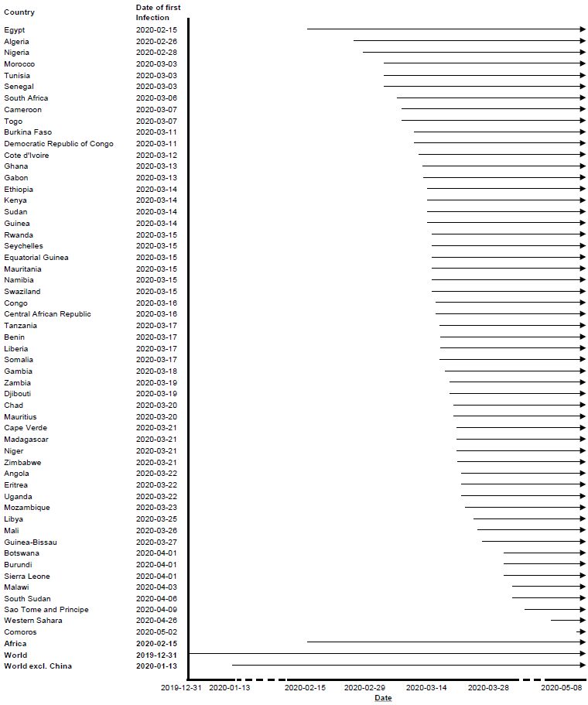

COVID-19: Coronavirus 2019

**(B)**

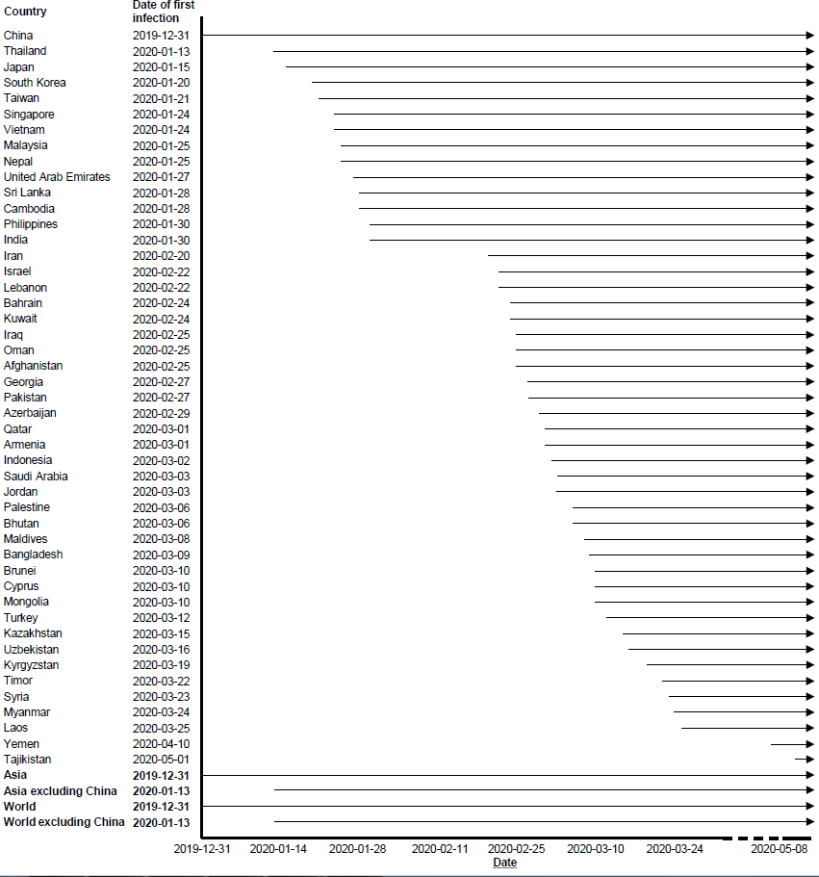

**(C)**

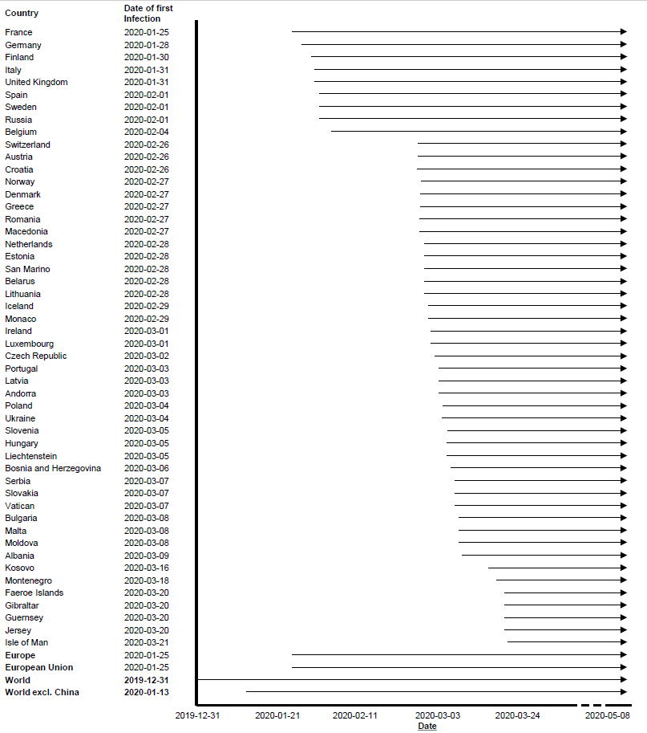

**(D)**

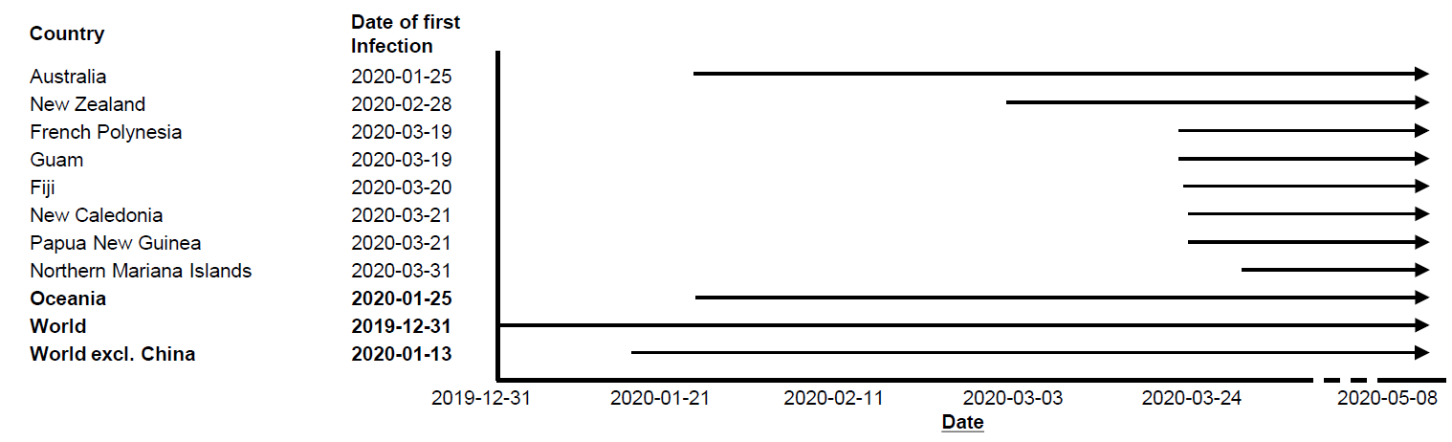

**(E)**

