Box 1. Survey Items and Scoring Scale
COVID-19 Awareness and Concern | Scoring Scale
How serious of a public threat do you think COVID-19 is currently or will become?  Do you think that you will get sick from COVID-19?  How likely do you think it is that you or someone you know will get sick from COVID-19 this year?  Over the past week, how often have you felt nervous or stressed because of COVID-19?  Over the past week, how often have you felt alone or lonely because of COVID-19? | 1 – 10: no threat to a very serious threat  1 – 4: not at all to I definitely will  1 – 4: not at all to very likely  1 – 4: never to all the time  1 – 4: never to all the time
Financial Impact
I worry about the financial problems I will have in the future as a result of the COVID-19 pandemic  I am satisfied with my current financial situation  I am able to meet my weekly expenses  I feel financially stressed  I am concerned about keeping my job and income, including work at home  The COVID-19 pandemic has reduced my satisfaction with my present financial situation | 1 – 5: not at all to very much  1 – 5: not at all to very much  1 – 5: not at all to very much  1 – 5: not at all to very much  1 – 5: not at all to very much  1 – 5: not at all to very much
COVID-19 Knowledge and Information
This question may be difficult to think about or imagine, but what percent of people who get COVID-19 in Australia do you think will die as a result?  What percent of people who get COVID-19 do you think will only have mild symptoms?  Can you name 3 symptoms associated with Covid-19?  Can you name 3 steps people can take to prevent themselves or others from getting COVID-19?  Where have you been getting information about COVID-19?  Which are your top 3 information sources?  How difficult has it been for you to find accurate, understandable information about COVID-19?  Has government advice been difficult to understand?  How long do you spend on average each day getting news or learning about COVID-19?  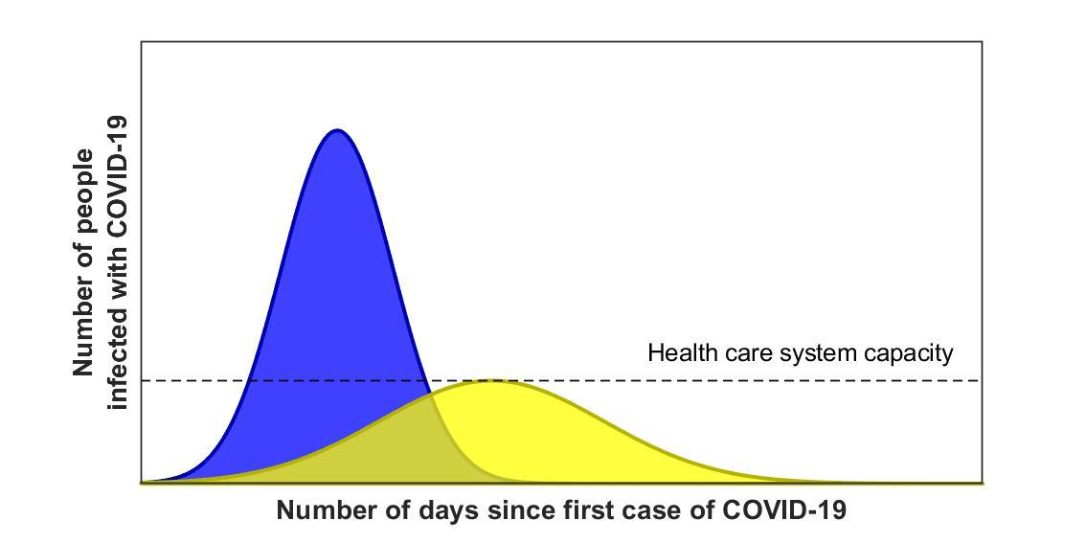  Have you seen a graph like this before?  If everyone practices social distancing, what type of curve do you expect to see?  Which curve would mean a greater strain/stress on healthcare systems?  Which curve represents ‘Flattening the curve? | Percentage  Percentage  Free text  Free text  Public TV; Commercial TV; Public Radio/Podcasts; Social Media; Newspaper/Magazines – online; Newspaper/Magazines – print, Government website; other websites, your Doctor, Pharmacist; Nurse or Health Professional, email notifications (e.g. from employees, services or subscriptions), Family/friends, other  Select from above list  1 – 10: not at all difficult to extremely difficult  1 – 10: not at all difficult to extremely difficult  Frequency, time (hours, minutes)  Yes or No  Yellow, blue, Don’t know  Yellow, blue, Don’t know  Yellow, blue, Don’t know
Preparedness
How confident are you that your state or local government can prevent further outbreak of COVID-19?  How confident are you that the federal government can prevent further outbreak of COVID-19?  I am confident in information about COVID-19 provided by the government  I am satisfied with the amount of information about COVID-19 provided by the government  I follow government advice on social distancing to help protect the wider community  I am concerned that government recommendations about COVID-19 are not safe, or not enough is being done | 1 – 4: not confident at all to very confident  1 – 4: not confident at all to very confident  1 – 7: strongly disagree to strongly agree  1 – 7: strongly disagree to strongly agree  1 – 7: strongly disagree to strongly agree  1 – 7: strongly disagree to strongly agree

Behaviour and impact
COVID-19 has had a huge impact on my daily routine.  Have you changed any plans you have made because of COVID-19? (like holidays, plans with friends)  Do you take any prescription medicines?  What actions have you taken to obtain your prescription medicines because of COVID-19?  Accessing and remembering to take my medications has become more difficult during the COVID-19 outbreak.  My actions will influence whether or not I get COVID-19  It is my responsibility to follow all public health guidance to prevent the spread of COVID-19 to others  Managing my health has become more difficult during the COVID-19 outbreak  Social distancing is important for my family's health  Social distancing is important for the health of others in my community  When everyone else is socially distancing, I don't need to  I socially distance to protect people with a weaker immune system  I will find it very hard to follow social distancing for the next month if this is recommended  I will find it very hard to follow social distancing for the next 3 months if this is recommended  How often are you leaving your home? | 1 – 7: strongly disagree to strongly agree  1 – 3: yes, many plans have changed; yes, I’ve changed my plans a little; no  1 – 3 yes, no, don’t know  none, switched to a longer amount (e.g. a 90 day supply), obtained a new refill, stopped taking it, other  1 –10: do not agree at all to agree very strongly  1 –10: do not agree at all to agree very strongly  1 –10: do not agree at all to agree very strongly  1 –10: do not agree at all to agree very strongly  1 – 7: strongly disagree to strongly agree  1 – 7: strongly disagree to strongly agree  1 – 7: strongly disagree to strongly agree  1 – 7: strongly disagree to strongly agree  1 – 7: strongly disagree to strongly agree  1 – 7: strongly disagree to strongly agree  Less than once per week; once per week; a few times per week; once per day; multiple times per day
COVID-19/ Vaccination Misinformation Beliefs
Data about the effectiveness of vaccines is often made up  The threat of COVID-19 is greatly exaggerated  Herd immunity would be beneficial for COVID-19 and this fact is covered up  The government restrictions are stronger than is needed | 1 – 7: strongly disagree to strongly agree  1 – 7: strongly disagree to strongly agree  1 – 7: strongly disagree to strongly agree  1 – 7: strongly disagree to strongly agree

References
1. Sarich P, Canfell K, Banks E, Paige E, Egger S, Joshy G, et al. A Prospective Study of Health Conditions Related to Alcohol Consumption Cessation Among 97,852 Drinkers Aged 45 and Over in Australia. Alcohol Clin Exp Res. 2019;43(4):710-21.
2. Wallace LS, Rogers ES, Roskos SE, Holiday DB, Weiss BD. Brief report: screening items to identify patients with limited health literacy skills. J Gen Intern Med. 2006;21(8):874-7.
3. Norman CD, Skinner HA. eHEALS: The eHealth Literacy Scale. J Med Internet Res. 2006;8(4):e27.
4. McNaughton CD, Cavanaugh KL, Kripalani S, Rothman RL, Wallston KA. Validation of a Short, 3-Item Version of the Subjective Numeracy Scale. Med Decis Making. 2015;35(8):932-6.
5. Wolf MS, Smith SG, Pandit AU, Condon DM, Curtis LM, Griffith J, et al. Development and Validation of the Consumer Health Activation Index. Med Decis Making. 2018;38(3):334-43.
6. Marteau TM, Bekker H. The development of a six-item short-form of the state scale of the Spielberger State-Trait Anxiety Inventory (STAI). Br J Clin Psychol. 1992;31(3):301-6.
7. Wolf MS, Serper M, Opsasnick L, O'Conor RM, Curtis LM, Benavente JY, et al. Awareness, Attitudes, and Actions Related to COVID-19 Among Adults With Chronic Conditions at the Onset of the U.S. Outbreak: A Cross-sectional Survey. Ann Intern Med. 2020.
8. de Souza JA, Yap BJ, Wroblewski K, Blinder V, Araujo FS, Hlubocky FJ, et al. Measuring financial toxicity as a clinically relevant patient-reported outcome: The validation of the COmprehensive Score for financial Toxicity (COST). Cancer. 2017;123(3):476-84.
9. My C, Danchin M, Willaby HW, Pemberton S, Leask J. Parental attitudes, beliefs, behaviours and concerns towards childhood vaccinations in Australia: A national online survey. Aust Fam Physician. 2017;46(3):145-51.
10. Shapiro GK, Holding A, Perez S, Amsel R, Rosberger Z. Validation of the vaccine conspiracy beliefs scale. Papillomavirus Res. 2016;2:167-72.

