**Supplementary file**

**Alpha globin gene deletions in amelioration clinical severity of beta hemoglobinopathy subjects of β0/β+ genotype**

Dipankar Saha a, Prosanto Kumar Chowdhury b, Amrita Panja c, , Debashis Pal d, Sharmistha Chakraborty e, Kaustav Nayek f, Gispati Chakraborty g, Prashant Sharma h, Reena Das I , Surupa Basu j, Raghunath Chatterjee k, Anupam Basu l *

**Fig-S1**: Chromatograms (A-P) of different beta mutations. A- shows the IVS I-5(G>C) mutation of beta globin gene in heterozygous condition, B shows the CD26(G>A) beta mutation in heterozygous condition, C- shows the CD30(G>C) mutation in heterozygous state, D- shows the CD6(A>T) mutation in heterozygous state, E- shows the CD41/42(-CTTT) mutation in heterozygous state, F- Shows the CD15(G>A) mutation in heterozygous state, G- Shows the -90(C>T) mutations in heterozygous condition, H- shows the CD15(-T) mutation in heterozygous state, I- shows the chromatogram with IVS I-130(G>C) mutation in heterozygous state, J- shows the CD16(-C) mutation in heterozygous condition, K- shows the chromatogram with CD110(T>C) mutation in heterozygous condition, L- shows the CD 8/9(+G) mutations in heterozygous state, M- Chromatogram with IVS II-666(C>T) mutations in heterozygous state, N- chromatogram of -86(G>C) mutation in heterozygous state, O- chromatograms with heterozygous CD30(A>C) mutations, P- Heterozygous IVS I-129(A>C) mutation

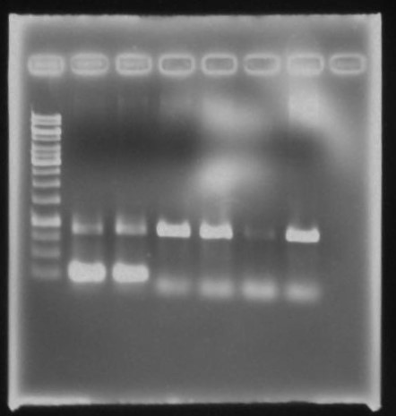

**L1**

**L2**

**L3**

**L4**

**L5**

**L6**

**L7**

**L8**

**Fig-S2:** Gel image of the 619 bp deletion specific PCR. PCR product run in 1% agarose gel. L1 with 1% DNA ladder, L2 and L3 shows the 619bp deletion mutation. Band of 250bp and 900bp confirm the heterozygous state of the mutation. L4-L7 shows the single band of 900 bp, confirms the wild state

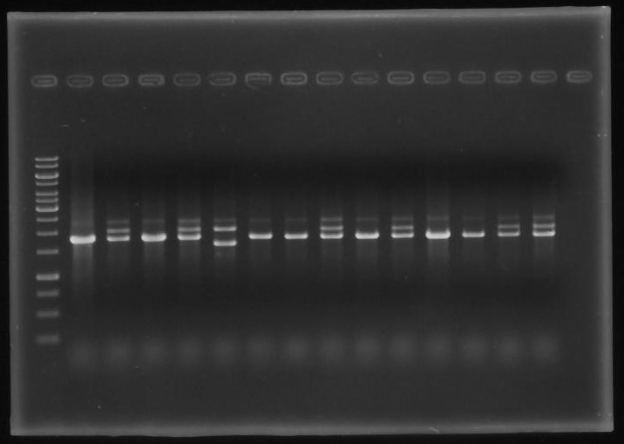

**L1**

**L2**

**L3**

**L4**

**L5**

**L6**

**L7**

**L8**

**L9**

**L10**

**L11**

**L12**

**L13**

**L14**

**L15**

**L16**

**Fig-S3:** 1% Agarose gel image of Multiplex GAP-PCR product. L1 of the gel with 1kb DNA ladder, L2, L4, L7, L8, L10, L12, L13 with band size of 1800bp for the alpha 2 globin gene, confirms the wild state of the alpha globin gene. Also contain the 2400bp of positive control band of LIS1. L3,L5,L9,L11,L14 and L15 contain one band of 1800bp of alpha2 gene and another 2000bp size band of 3.7kb deletion specific mutation, which confirm the alpha 3.7kb deletion in heterozygous state. These lanes are also having the 2400bp positive control of LIS1 band. L6 shows the band of 2000bp, alpha 3.7 kb deletion specific band and 1700 bp, alpha 4.2kb deletion mutation specific band. Which confirms the compound heterozygous state of 3.7kb deletion and 4.2kb deletion.

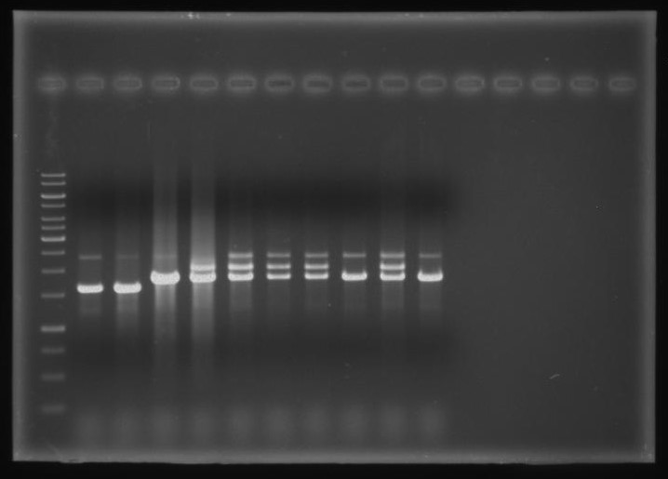

**L**

**L17**

**L18**

**L19**

**L20**

**L21**

**L22**

**L23**

**L24**

**L25**

**L26**

**Fig-S4:** Agarose gel image of alpha deletion multiplex PCR. First lane with 1kb DNA ladder. Second and third lane, L17 and L18 shows single band of 1700bp, confirms alpha 4.2 kb deletion in homozygous condition. L19, L24, L26 with single band of 1800bp with positive control band of 2400bp confirms normal alpha globin state. Rest of the lanes, L20, L21, L22, L23, L25 are showing the two band of 1800bp size and 2000bp size, which confirms the alpha 3.7kb deletion in heterozygous state. All the lane, L17-L26 contain the positive control band of 2400bp of LIS1 gene.