**Supplementary Table 1.** Characteristics of SARS-CoV2 confirmed cases in Mexico according to diabetes status at 18/05/2020. *Abbreviations*: ICU= intense care unit; COPD= chronic obstructive pulmonary disease

|  |  |  |  |
| --- | --- | --- | --- |
| **Parameter** | **With Diabetes  n=9460** | **Without Diabetes  n=41805** | **p-value** |
| Age (mean ± sd) | 57.16±12.83 | 44.23±15.48 | <0.001 |
| Men(%) | 5495 (58.1) | 24070 (57.6) | 0.37 |
| Mortality (%) | 2062 (21.8) | 3223 (7.7) | <0.001 |
| Hospitalization (%) | 6039 (63.8) | 13620 (32.6) | <0.001 |
| Pneumonia (%) | 4601 (48.6) | 10210 (24.4) | <0.001 |
| ICU admission (%) | 647 (6.8) | 1217 (2.9) | <0.001 |
| Invasive ventilation (%) | 690 (7.3) | 1220 (2.9) | <0.001 |
| COPD (%) | 483 (5.1) | 645 (1.5) | <0.001 |
| Asthma (%) | 302 (3.2) | 1297 (3.1) | 0.67 |
| Immunosuppression (%) | 284 (3) | 563 (1.3) | <0.001 |
| Hypertension (%) | 4973 (52.6) | 6168 (14.8) | <0.001 |
| Obesity (%) | 2756 (29.1) | 7924 (19) | <0.001 |
| CVD (%) | 568 (6) | 810 (1.9) | <0.001 |
| CKD (%) | 706 (7.5) | 557 (1.3) | <0.001 |
| Smoking (%) | 911 (9.6) | 3448 (8.2) | <0.001 |

**Supplementary Table 2.**Characteristics of SARS-CoV2 confirmed cases in Mexico according to obesity status at 18/05/2020. *Abbreviations*: ICU= intense care unit; COPD= chronic obstructive pulmonary disease

|  |  |  |  |
| --- | --- | --- | --- |
| **Parameter** | **With Obesity  n=3215** | **Without Obesity  n=12187** | **p-value** |
| Age (mean ± sd) | 47.89 ± 13.79 | 46.28 ± 16.33 | <0.001 |
| Men (%) | 5839 (54.5) | 23696 (58.5) | <0.001 |
| Mortality (%) | 1446 (13.5) | 3823 (9.4) | <0.001 |
| Hospitalization (%) | 4812 (44.9) | 14808 (36.5) | <0.001 |
| Pneumonia (%) | 3789 (35.4) | 10975 (27.1) | <0.001 |
| ICU admission (%) | 537 (5.0) | 1321 (3.3) | <0.001 |
| Invasive ventilation (%) | 552 (5.2) | 1355 (3.3) | <0.001 |
| COPD (%) | 353 (3.3) | 776 (1.9) | <0.001 |
| Asthma (%) | 518 (4.8) | 1082 (2.7) | <0.001 |
| Immunosuppression (%) | 219 (2) | 628 (1.5) | <0.001 |
| Hypertension (%) | 3571 (33.3) | 7557 (18.6) | <0.001 |
| Diabetes (%) | 2756 (25.7) | 6669 (16.5) | <0.001 |
| CVD (%) | 466 (4.4) | 914 (2.3) | <0.001 |
| CKD (%) | 272 (2.5) | 991 (2.4) | 0.6 |
| Smoking (%) | 1310 (12.2) | 3042 (7.5) | <0.001 |

**Supplementary Figure 1.** Logistic regression analysis to estimate probability of SARS-CoV-2 positivity in Mexico, compared to confirmed SARS-CoV2 negative cases for all suspected cases with SARS-CoV2 status available (A) and stratified by diabetes mellitus (B) and obesity (C). *Abbreviations*: ICU= intense care unit; COPD= chronic obstructive pulmonary disease; CKD= chronic kidney disease; CVD= cardiovascular disease

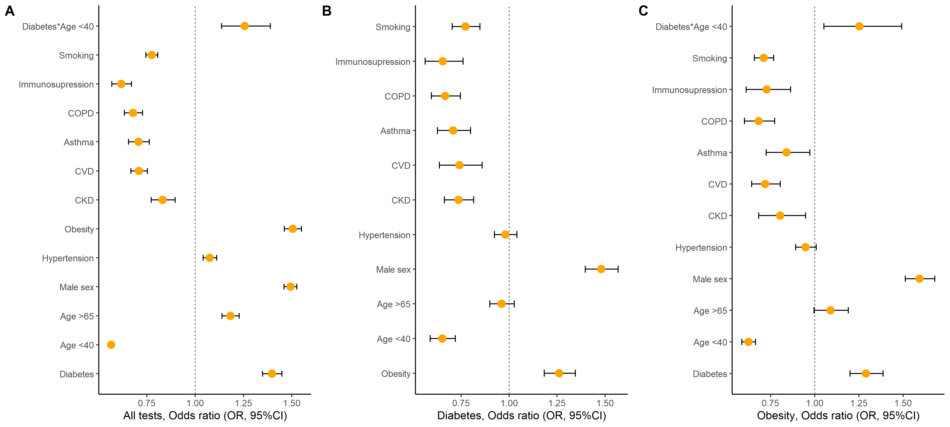

**Supplementary Figure 2.** Cox proportional Hazards regression analysis to estimate risk of COVID-19 and its interaction with comorbidities in patients with A) Diabetes and B) Obesity. *Abbreviations*: COPD= chronic obstructive pulmonary disease; CKD= chronic kidney disease; CVD= cardiovascular disease

