Supplement 1: COVID-19 Questionnaire English Version.
Figure 3: Predictors of burnout in HICs and LMICs.
Table 2: Conversion of ordinal variables into binary.
Table 3: Country of provenience of study participants and GDP information.
Table 4: Additional survey responses.

COVID-19 Questionnaire English Version
Section 1: Demographics
- I am from: (Please write in Country)
- I am a:
  - Medical Student
  - Nursing Student
  - Medical Doctor (MD, DO)
  - Physician Assistant, Nurse Practitioner, Certified Registered Nurse Anesthesiologist
  - Licensed Nurse
  - Pharmacist
  - Administrative Staff
  - Technologist or Technician
  - Therapist
  - I’m not a healthcare professional
- Is your primary work in the Emergency Department (ER/UC), Intensive Care Unit (ICU), or Infectious Diseases (ID)?
  - Yes
  - No
- Have you had any direct experience in working during any of the previous epidemics or pandemics? (SARS 2003, H1N1 2009, MERS 2012)
  - Yes
  - No

Section 2: Personal exposure - since January 2020:
- Were you exposed to at least one person who has been diagnosed or had symptoms suggestive of COVID-19 infection?
  - Yes
  - No
- How many people were you exposed to?
  - 1-10
  - 11-100
  - More than 100
- Have you experienced flu-like symptoms or symptoms suggestive of COVID-19 infection?
  - Yes
  - No
- Did you stop working after experiencing these symptoms?
  - Yes
  - No
- What did you do after you developed symptoms suggestive of COVID-19? (Select all that apply)
  - I voluntarily self-quarantined
  - I voluntarily kept working
  - My institution told me to stay at home
  - My institution told me to keep working
  - I physically distanced myself from my family / loved ones
  - I went to see a doctor
  - I called a doctor
  - I went to the Emergency Room/Hospital
  - I started taking medications
- Were you tested for COVID-19?
  - Yes
  - No
- How easy was it to get tested for COVID-19?
  - Very difficult
  - Difficult
  - Not difficult or easy
  - Easy
  - Very easy
- How many times were you tested for COVID-19?
  - 0
  - 1 - 2
  - 3 - 4
  - 5+
- Did you test positive for COVID-19??
  - Yes
  - No

Section 3: Perception - since January 2020:
- What is your current perception of the COVID-19 disease?
  - Benign disease
  - Mild disease
  - Moderate disease
  - Severe disease
- Has your perception of the COVID-19 virus changed?
  - Yes
  - No
- Do you think that, during the initial days, you underestimated the public health effects of the pandemic?
  - Yes
  - No
- Have you had any specific training related to the COVID-19 pandemic?
  - Yes
  - No
- Do you feel this training was sufficient?
  - Yes
  - No
- Did you receive appropriate guidelines on updated procedures related to personal safety to follow at work?
  - Yes
  - No
- Did your institution provide you adequate PPE? (personal protective equipment)
  - Yes
  - No
- What changes did you apply in your personal protection after COVID-19 affected hit your country? (Select all that apply)
  - I started wearing masks routinely
  - I started using hand sanitizer/washing my hands more frequently
  - I started wearing more scrubs/disposable clothes
  - I started social distancing
  - Other. Please specify __________________________
- Did you decide NOT to wear a mask or other PPE when it was available? (Select all that apply)
  - No, never
  - Yes, for fear of scaring patients
  - Yes, for fear of scaring my colleagues
  - Yes, because none of my colleagues were wearing it
  - Yes, because my colleagues told me not to wear it
  - Yes, because my institution didn’t recommend it
  - Yes, because my institution told me not to wear it
  - Yes, because it is uncomfortable/inconvenient
  - Yes, because I didn’t believe I needed to wear it
  - Yes, for other reasons. Please specify: ___________________________________
- If you are fit and well during the COVID-19 pandemic, how likely are you to continue working?
  - Extremely unlikely
  - Unlikely
  - Neutral
  - Likely
  - Extremely likely
- Some people think that healthcare workers have unconditional obligations to work, even when the risks to themselves are great. To what extent do you agree with this statement?
  - Strongly disagree
  - Disagree
  - Somewhat disagree
  - Neither agree or disagree
  - Somewhat agree
  - Agree
  - Strongly agree
- What worries do you have about working during a pandemic? (Select all that apply)
  - Becoming sick
  - Making my loved ones sick
  - Not having the appropriate skills to care for COVID-19 patients
  - Not having adequate supplies to care for COVID-19 patients
  - Other: (please write in)
- Has your institution made psychological or mental health support available to you?
  - Yes
  - No
- Are patients refusing medical services or missing appointments for fear of being infected?
  - Yes
  - No
- Do you think that telemedicine-based clinical encounters are an effective way to replace in-person clinical encounters?
  - Yes
  - No
- Do you think postponing non-urgent health issues will fasten the resolution of the COVID-19 pandemic?
  - Yes
  - No
- Do you feel you are being pushed beyond your training?
  - Yes
  - No
- Have you been redirected to activities related to COVID-19?
  - Yes
  - No
- How long have you been engaged in COVID-19 related activities?
  - 1-30 days,
  - 31-60 days,
  - 61-90 days
  - 91+ days
- Did you experience a moment whereby you had to make a prioritizing decision about vital issues (ICU admission, intubation, etc.) due to shortage of medical supplies?
  - Yes
  - No
- Which of the following factors would or did influence your decision to prioritize treatment of certain COVID-19 patient groups over others, due to the shortage of medical supplies?
  - age
  - chronic medical conditions
  - presenting symptoms
  - clinical reasoning
  - other (please specify)

Section 4: Workload - compared to your average workweek, in the last 7 days:
- How many additional/fewer hours did you work?
  - 30+ hours per week less than usual
  - 16-30 hours per week less than usual
  - 1-15 hours per week less than usual
  - Same hours per week as usual
  - 1-15 hours per week more than usual
  - 16-30 hours per week more than usual
  - 30+ hours per week more than usual
- Was this change voluntary or mandatory?
  - Voluntary
  - Mandatory
- How have your currently daily duties impacted your quality of life, compared to your duties before the pandemic?
  - Much better quality of life
  - Somewhat better quality of life
  - Same quality of life
  - Somewhat worse quality of life
  - Much worse quality of life
- How has work affected your ability to perform household activities? (Household activities include but are not limited to: childcare, grocery shopping, laundry, cleaning, cooking, etc.)
  - Not at all
  - To a small extent
  - To some extent
  - To a moderate extent
  - To a great extent
  - To a very great extent
- If you have additional free time, how are you spending it? (Select all that apply)
  - Spending time with my family/friends
  - Self-education
  - Cooking
  - Working out
  - Social media
  - Watching movies/TV series
  - I have the same or less free time
- To what extent do you agree with the following statement: I am burned out from my work.
  - Strongly disagree
  - Disagree
  - Somewhat disagree
  - Neither agree or disagree
  - Somewhat agree
  - Agree
  - Strongly agree

Figure 3: Predictors of burnout in HICs (above) and LMICs (below). (PPE) Personal protective equipment.
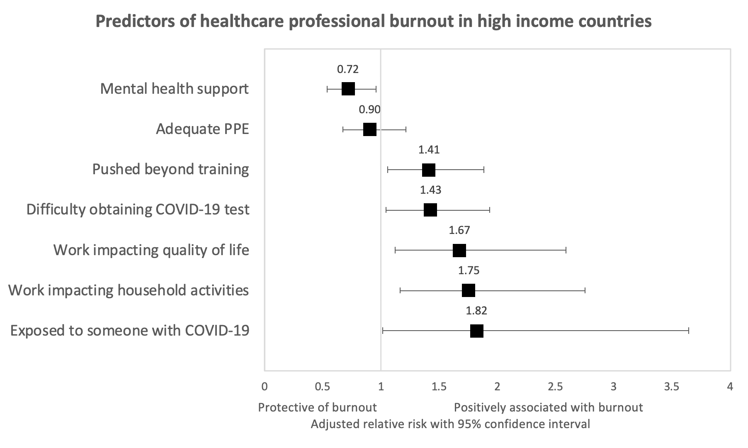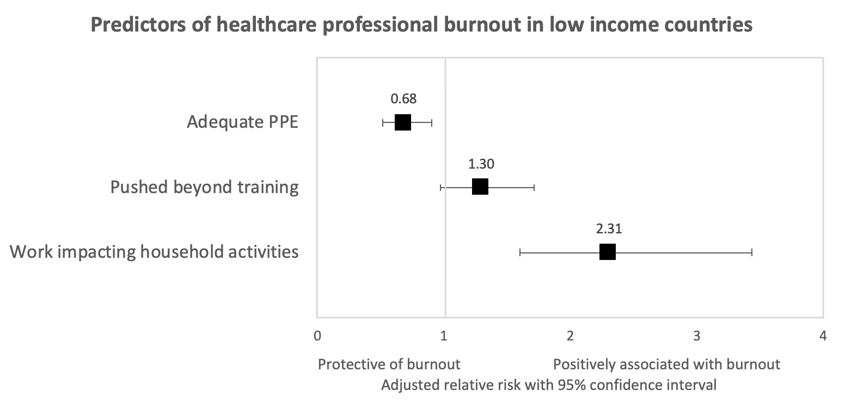

Table 2: Conversion of ordinal variables into binary; (QoL) Quality of life; (PA) Physician assistant; (NP) Nurse practitioner; (CRNA) Certified registered nurse anesthetist; (RN) Registered nurse.

Original ordinal variable | Combined levels to Binary
Burnout | Burnout binary:  Strongly disagree -> Burnout No  Disagree -> Burnout No  Somewhat disagree -> Burnout No  Neither agree nor disagree -> Burnout No  Somewhat agree -> Burnout Yes  Agree -> Burnout Yes  Strongly agree -> Burnout Yes
Work effect on QoL | Much better quality of life -> Lower QoL NO  Somewhat better quality of life -> Lower QoL NO  Same quality of life -> Lower QoL NO  Somewhat worse quality of life -> Lower QoL YES  Much worse quality of life -> Lower QoL YES
Change in workload | 30+ hours per week less than usual -> Larger workload No  16-30 hours per week less than usual -> Larger workload No  1-15 hours per week less than usual -> Larger workload No  Same hours per week as usual -> Larger workload No  1-15 hours per week more than usual -> Larger workload Yes  16-30 hours per week more than usual -> Larger workload Yes  30+ hours per week more than usual -> Larger workload Yes
Work effect on Household activities | Not at all -> NO  To a small extent -> NO  To some extent -> YES  To a moderate extent -> YES  To a great extent -> YES  To a very great extent -> YES
Number of COVID-19 exposures | 0 Exposed NO  1-10 Exposed YES  11-100 Exposed YES  101 or more Exposed YES
Difficulty getting tested for COVID-19 | Very difficult Difficult YES  Difficult Difficult YES  Neutral Difficult NO  Easy Difficult NO  Very easy Difficult NO
Occupation | “Medical Doctors”, “Resident or Fellow” -> ”Medical Doctors”  “PA, NP, CRNA, RN” -> “Nurses”  “Others” -> “Others”
Provenience | US, Italy, Brazil, Sweden, Others

Table 3: Country of provenience of study participants and classification from the World Bank.
Country | Responses | Percentage | World Bank Classification
Afghanistan | 1 | 0.04 % | Low income
Albania | 1 | 0.04 % | Upper Middle income
Algeria | 2 | 0.09 % | Upper Middle income
Argentina | 55 | 2.43 % | Upper Middle income
Australia | 11 | 0.49 % | High income
Bangladesh | 5 | 0.22 % | Low-Middle income
Bhutan | 1 | 0.04 % | Low-Middle income
Bolivia | 1 | 0.04 % | Low-Middle income
Brazil | 188 | 8.29 % | Upper Middle income
Burundi | 1 | 0.04 % | Low income
Canada | 14 | 0.62 % | High income
Chile | 2 | 0.09 % | High income
China | 57 | 2.51 % | Upper Middle income
Colombia | 7 | 0.31 % | Upper Middle income
Denmark | 2 | 0.09 % | High income
Dominica | 1 | 0.04 % | Upper Middle income
Ecuador | 3 | 0.13 % | Upper Middle income
Egypt | 4 | 0.18 % | Low-Middle income
El Salvador | 3 | 0.13 % | Low-Middle income
Ethiopia | 1 | 0.04 % | Low income
Finland | 2 | 0.09 % | High income
France | 16 | 0.71 % | High income
Georgia | 1 | 0.04 % | Upper Middle income
Germany | 12 | 0.53 % | High income
Greece | 4 | 0.18 % | High income
Guatemala | 1 | 0.04 % | Upper Middle income
Hungary | 1 | 0.04 % | High income
Iceland | 1 | 0.04 % | High income
India | 16 | 0.71 % | Low-Middle income
Indonesia | 2 | 0.09 % | Low-Middle income
Iran | 5 | 0.22 % | Upper Middle income
Ireland | 1 | 0.04 % | High income
Israel | 3 | 0.13 % | High income
Italy | 610 | 26.91 % | High income
Japan | 1 | 0.04 % | High income
Latvia | 1 | 0.04 % | High income
Lebanon | 1 | 0.04 % | Upper Middle income
Lithuania | 1 | 0.04 % | High income
Mexico | 10 | 0.44 % | Upper Middle income
New Zealand | 1 | 0.04 % | High income
Norway | 1 | 0.04 % | High income
Peru | 2 | 0.09 % | Upper Middle income
Philippines | 4 | 0.18 % | Low-Middle income
Poland | 15 | 0.66 % | High income
Puerto Rico | 1 | 0.04 % | High income
Romania | 1 | 0.04 % | Upper Middle income
Russia | 1 | 0.04 % | Upper Middle income
Slovakia | 2 | 0.09 % | High income
South Korea | 36 | 1.59 % | High income
Spain | 5 | 0.22 % | High income
Sweden | 149 | 6.57 % | High income
Switzerland | 1 | 0.04 % | High income
Syria | 2 | 0.09 % | Low income
Thailand | 29 | 1.28 % | Upper Middle income
Turkey | 100 | 4.41 % | Upper Middle income
Ukraine | 5 | 0.22 % | Low-Middle income
United Kingdom | 22 | 0.97 % | High income
United Nations | 3 | 0.13 % | High income
United States | 836 | 36.88 % | High income
Venezuela | 1 | 0.04 % | Upper Middle income
Vietnam | 1 | 0.04 % | Low-Middle income

Table 4: Healthcare professionals responses to perception, exposure, and workload during the COVID-19 pandemic. (HCP) Healthcare professional; (PPE) Personal protective equipment; (QoL) Quality of life; (ICU) Intensive care unit; (ER) Emergency room; (ID) Infectious diseases; (CRNA) Certified registered nurse anesthetist.

Occupation specific
Medical student | 47 (2.3%)
Nursing Student | 8 (0.4%)
Resident or Fellow | 160 (8.0%)
Medical Doctor (MD, DO) | 719 (35.9%)
Physician Assistant, Nurse Practitioner, CRNA | 36 (1.8%)
Registered Nurse | 855 (42.7%)
Pharmacist | 22 (1.1%)
Administrative staff | 42 (2.1%)
Technologist or technician | 59 (2.9%)
Not a healthcare professional | 54 (2.7%)
Primary work in the ICU/ER/ID prior to pandemic
No | 1382 (68.8%)
Yes | 628 (31.2%)
Previous experience working during pandemic
No | 1511 (75.0%)
Yes | 504 (25.0%)
Number of COVID-19 exposures
1-10 | 787 (62.8%)
11-100 | 401 (32.0%)
More than 100 | 66 (5.3%)
Difficulty obtaining a test
Very difficult | 20 (7.4%)
Difficult | 42 (15.5%)
Neutral | 75 (27.7%)
Easy | 87 (32.1%)
Very easy | 47 (17.3%)
Number of times tested for COVID-19
0 | 1611 (85.4%)
1-2 | 251 (13.3%)
3-4 | 19 (1.0%)
5+ | 6 (0.3%)
Has perception changed
No | 681 (39.2%)
Yes | 1056 (60.8%)
initial underestimation of severity
No | 597 (34.4%)
Yes | 1137 (65.6%)
Was COVID-19 training sufficient
No | 425 (52.3%)
Yes | 388 (47.7%)
Did you receive guidelines on COVID-19 personnel safety
No | 513 (29.6%)
Yes | 1219 (70.4%)
Will keep working during pandemic if fit enough
Extremely unlikely | 48 (2.8%)
Unlikely | 51 (3.0%)
Neutral | 131 (7.6%)
Likely | 301 (17.5%)
Extremely likely | 1193 (69.2%)
HCP has unconditional obligation to work
Strongly disagree | 323 (18.7%)
Disagree | 292 (16.9%)
Somewhat disagree | 211 (12.2%)
Neither agree nor disagree | 122 (7.1%)
Somewhat agree | 358 (20.7%)
Agree | 280 (16.2%)
Strongly agree | 141 (8.2%)
Patients not getting care out of fear of being infected
No | 332 (19.4%)
Yes | 1379 (80.6%)
Think telemedicine is effective
No | 662 (38.4%)
Yes | 1062 (61.6%)
Postponing non-urgent care will fasten resolution of COVID-19
No | 386 (22.3%)
Yes | 1343 (77.7%)
Redirected to COVID-19 related care
No | 950 (55.2%)
Yes | 772 (44.8%)
Length of COVID-19 care (days)
1-30 days | 507 (65.8%)
31-60 days | 234 (30.4%)
61-90 days | 23 (3.0%)
91+ days | 6 (0.8%)
Rationale for life-prioritizing decision
Age | 276 (18.5%)
Chronic medical conditions | 316 (21.2%)
Presenting symptoms | 238 (16.0%)
Clinical reasoning | 536 (36.0%)
Other | 122 (8.2%)
Mandatory or voluntary COVID-19 work
Voluntary | 801 (52.1%)
Mandatory | 737 (47.9%)

