**Supplementary Information for**

Trauma and posttraumatic stress interact with sex-specific risk loci for suicidality and converge on brain extracellular matrix biology and synaptic plasticity

Frank R Wendt,1,2 Gita A Pathak,1,2 Daniel F Levey,1,2 Yaira Z Nuñez,1,2 Cassie Overstreet,1,2,3 Chelsea Tyrrell,1,2 Keyrun Adhikari,1,2 Flavio De Angelis,1,2 Daniel S Tylee,1,2 Aranyak Goswami,1,2 John H Krystal,1 Chadi G Abdallah,1,2 Murray B Stein,4,5 Henry R Kranzler,6,7 Joel Gelernter,1,2,8 Renato Polimanti1,2

1. Department of Psychiatry, Yale School of Medicine, New Haven, CT, 06510, USA
2. VA CT Healthcare System, West Haven, CT, 06520, USA
3. National Center for Posttraumatic Stress Disorder, Clinical Neurosciences Division, West Haven CT, 06520, USA
4. Psychiatry Service, VA San Diego Healthcare System, San Diego, CA
5. Departments of Psychiatry and Family Medicine & Public Health, University of California San Diego, La Jolla, CA
6. University of Pennsylvania Perelman School of Medicine, Philadelphia, PA, 19104, USA
7. Crescenz Veterans Affairs Medical Center, Philadelphia, PA, 19104, USA
8. Departments of Genetics and Neuroscience, Yale University School of Medicine, New Haven, CT, 06510, USA

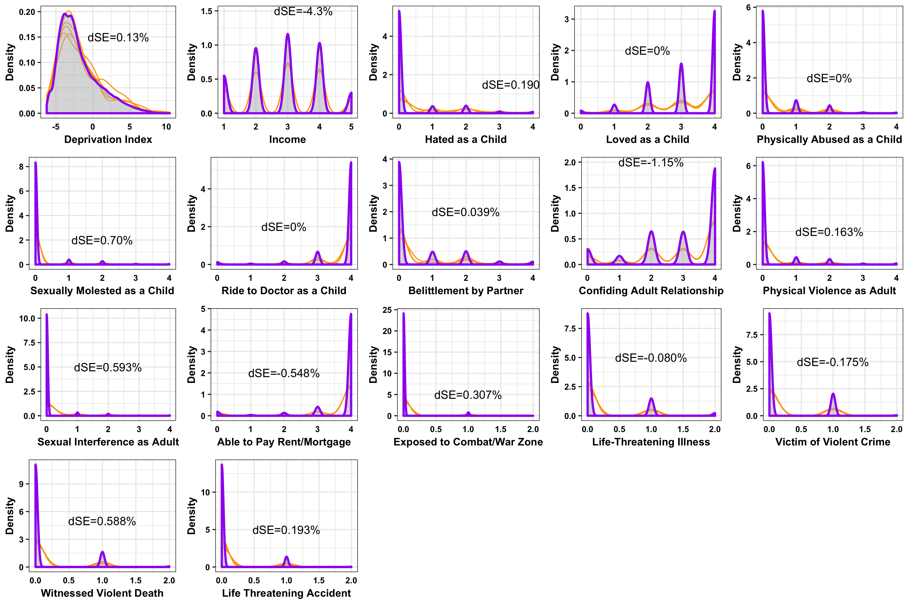

**Figure S1.** Imputation quality control for 17 traumatic event and socioeconomic status phenotypes. Gray shaded regions show the density distribution of the original unimputed phenotype; orange lines indicate the density distribution of ten iterations of five multiple imputations of missing data (see Methods);87 purple lines indicate density distributions after imputation. Each plot is labeled with the relative differences in standard error (dSE) between fully imputed and original unimputed data.16

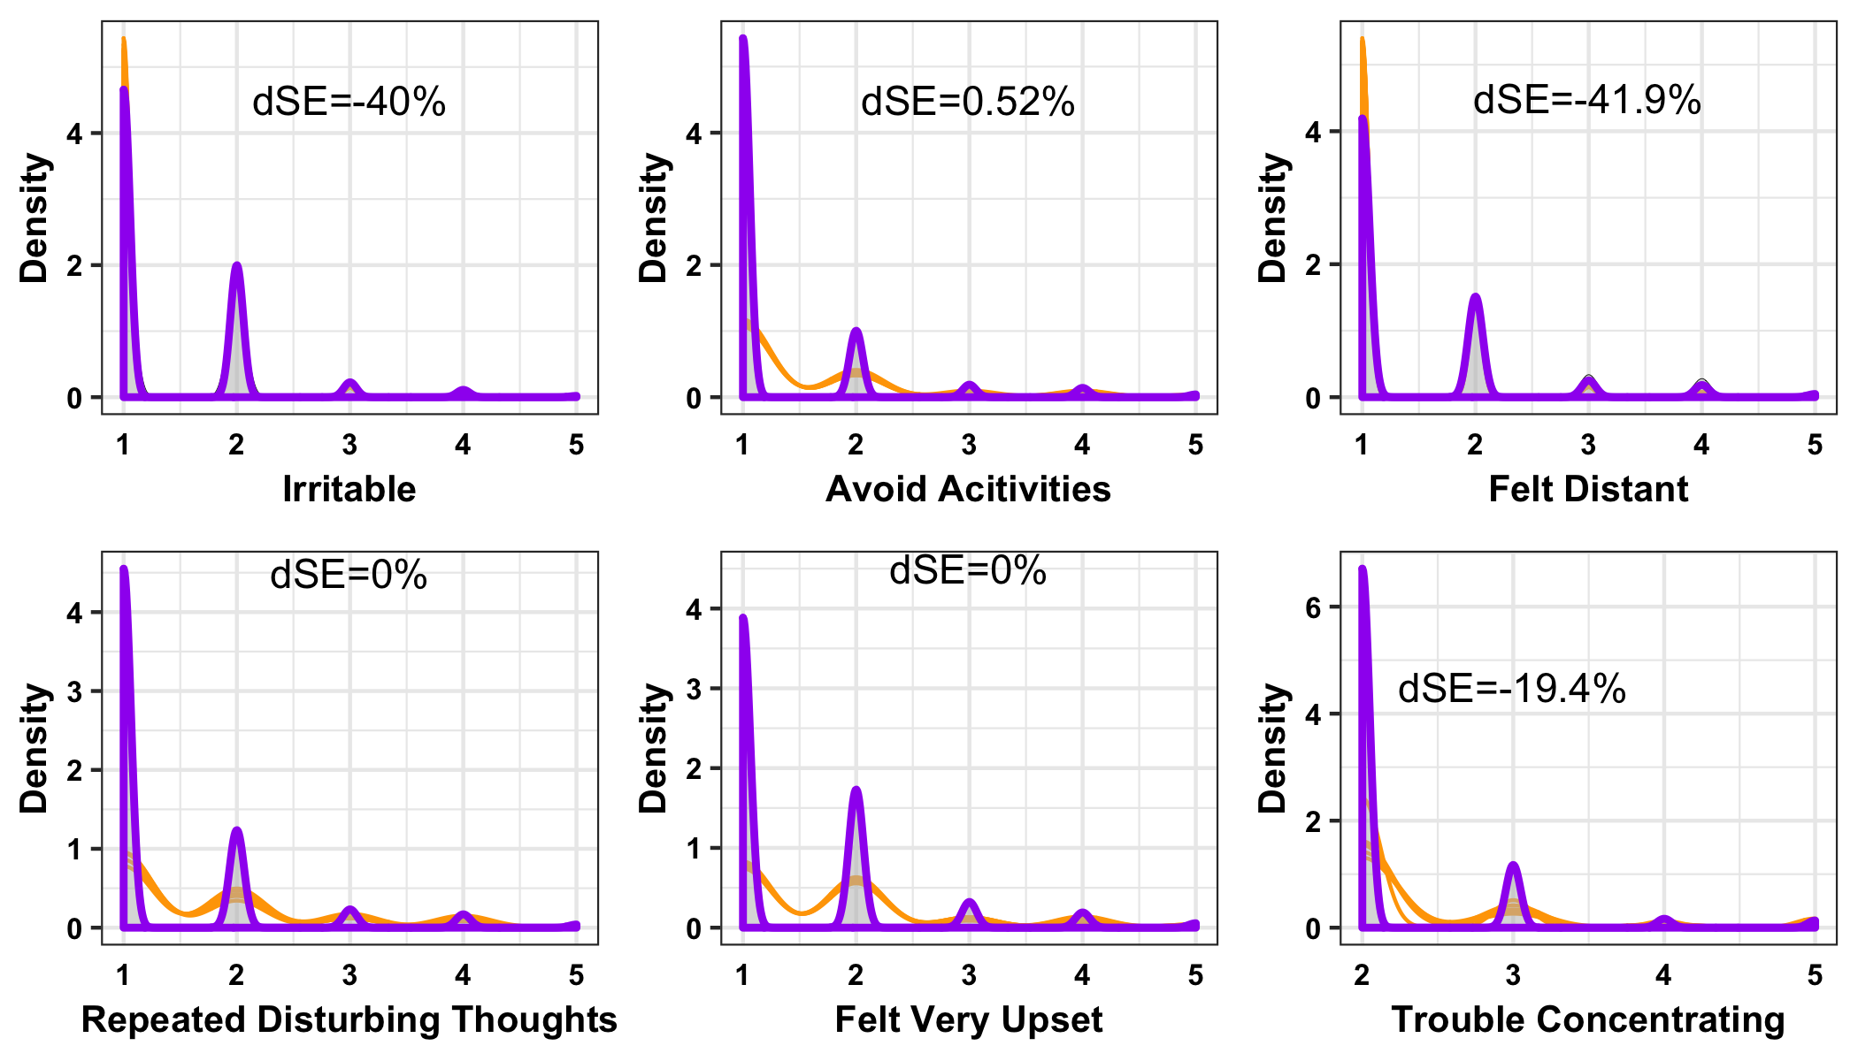

**Figure S2.** Imputation quality control for six trauma response environments. Gray shaded regions show the density distribution of the original unimputed phenotype; orange lines indicate the density distribution of ten iterations of five multiple imputations of missing data (see Methods);87 purple lines indicate density distributions after imputation. Each plot is labeled with the relative differences in standard error (dSE) between fully imputed and original unimputed data. 16

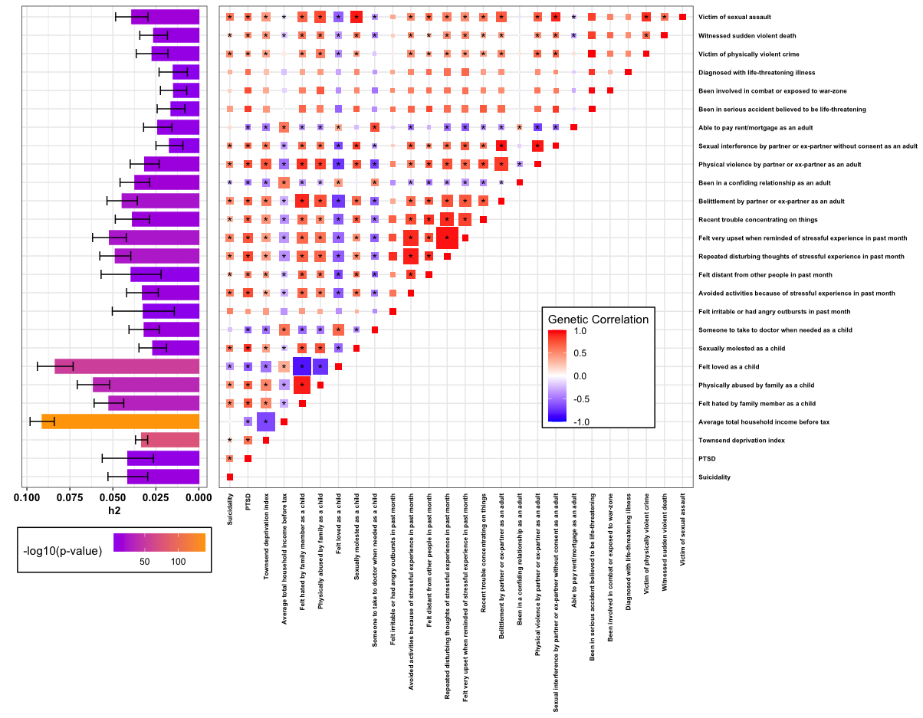

**Figure S3.** Heritability and genetic correlation of suicidality and all environments used in the genome-by-environment genome-wide interaction study of suicidality. Bar graphs show heritability estimates for each phenotype. Each box in the genetic correlation heat map is sized proportionally to significance of the genetic correlation between phenotypes with larger boxes indicating smaller p-values; each box is colored according the magnitude of genetic overlap ranging from -1 to 1.

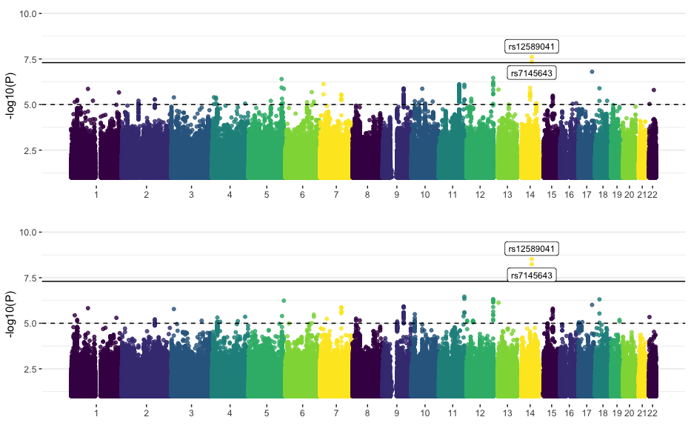

**Figure S4.** Manhattan plots of association (top) and interaction (bottom) test statistics from GEWIS of suicidality in 123,633 subjects from the UK Biobank.

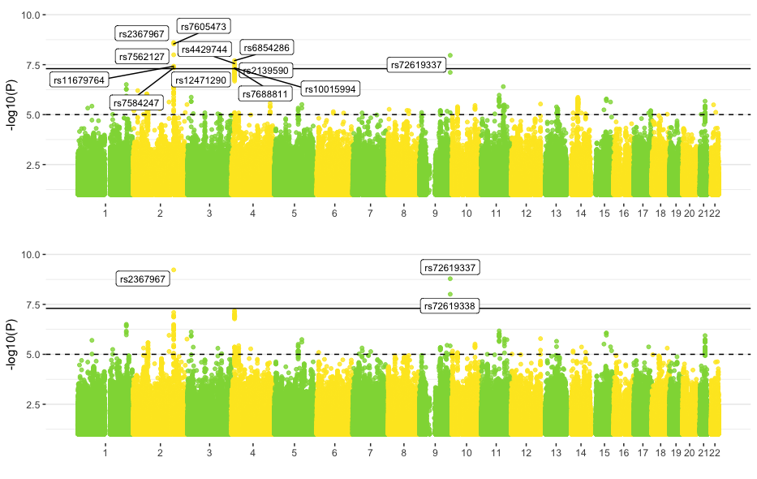

**Figure S5.** Manhattan plots of association (top) and interaction (bottom) test statistics from GEWIS of suicidality in males.

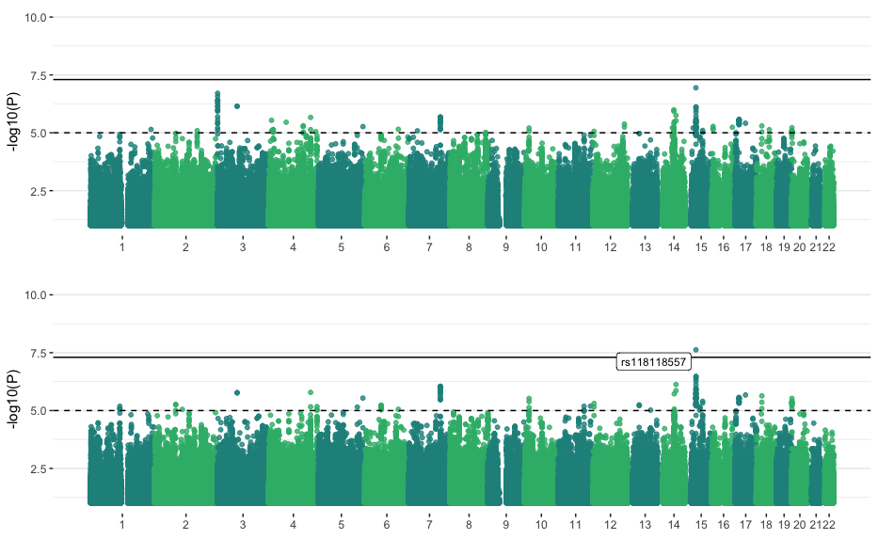

**Figure S6.** Manhattan plots of association (top) and interaction (bottom) test statistics from GEWIS of suicidality in females.

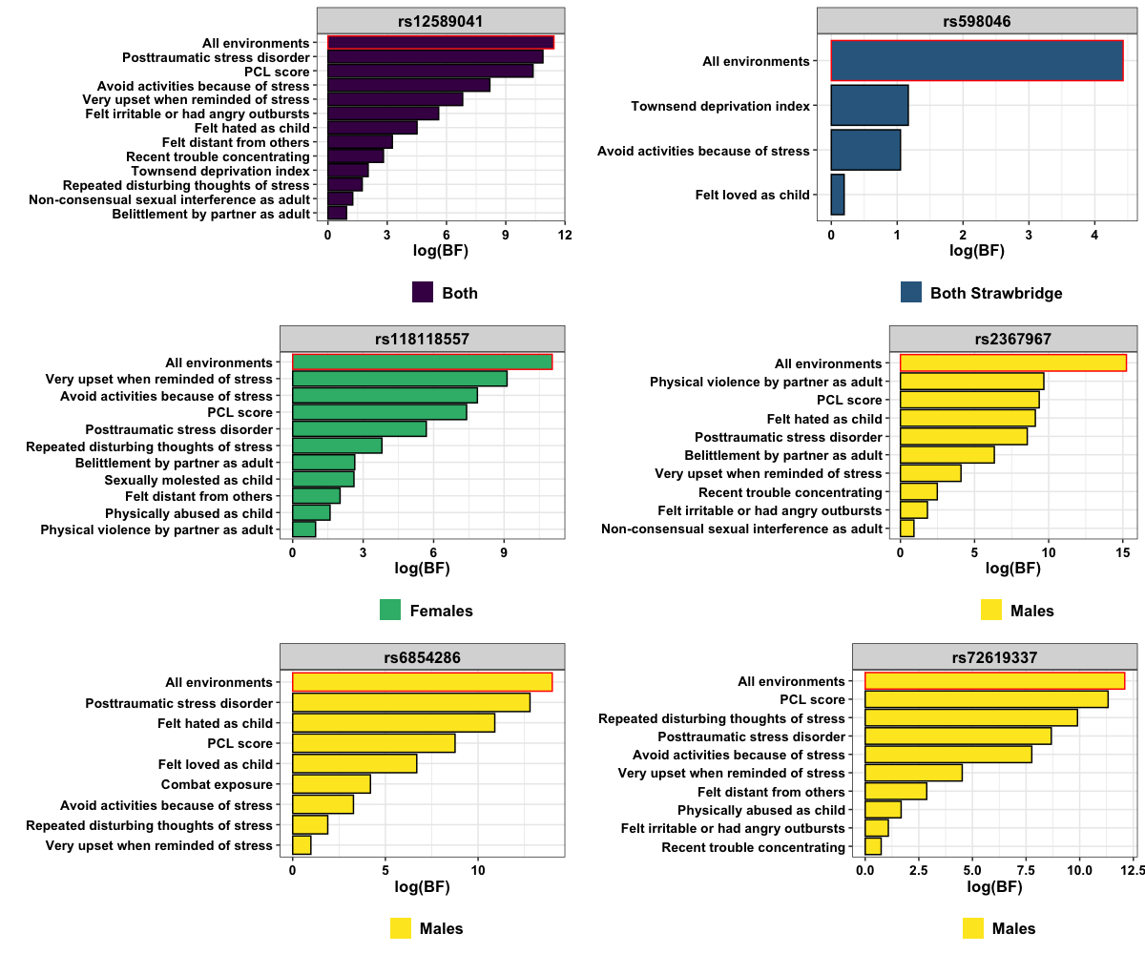

**Figure S7.** Model importance results from backwards elimination for significant GEWIS loci and one locus detected by GWAS7 (blue). The importance of models using all 26 environments is outlined in red. Each bar below that of the “all environments” model indicates model importance after subsequent sequential removal of the indicated environments on the y-axis.

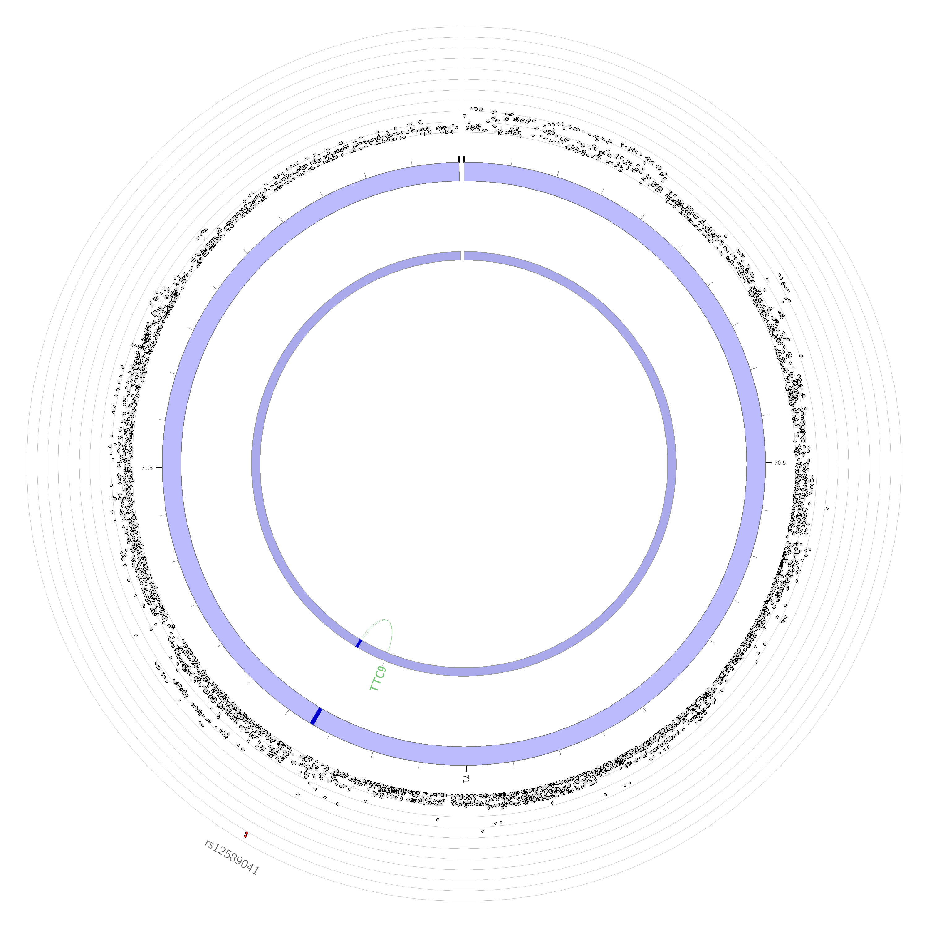

**Figure S8.** Circos plot of chromosome 14 showing the suicidality expression quantitative trait locus (eQTL; green) map for the genomic risk locus containing *rs12589041* (dark blue) using brain expression data in FUMA.30, 31 The outermost layer shows a Manhattan plot containing the –log10(*p-value*) of each GEWIS SNP. Signed eQTL effect estimates are shown in Table S20.

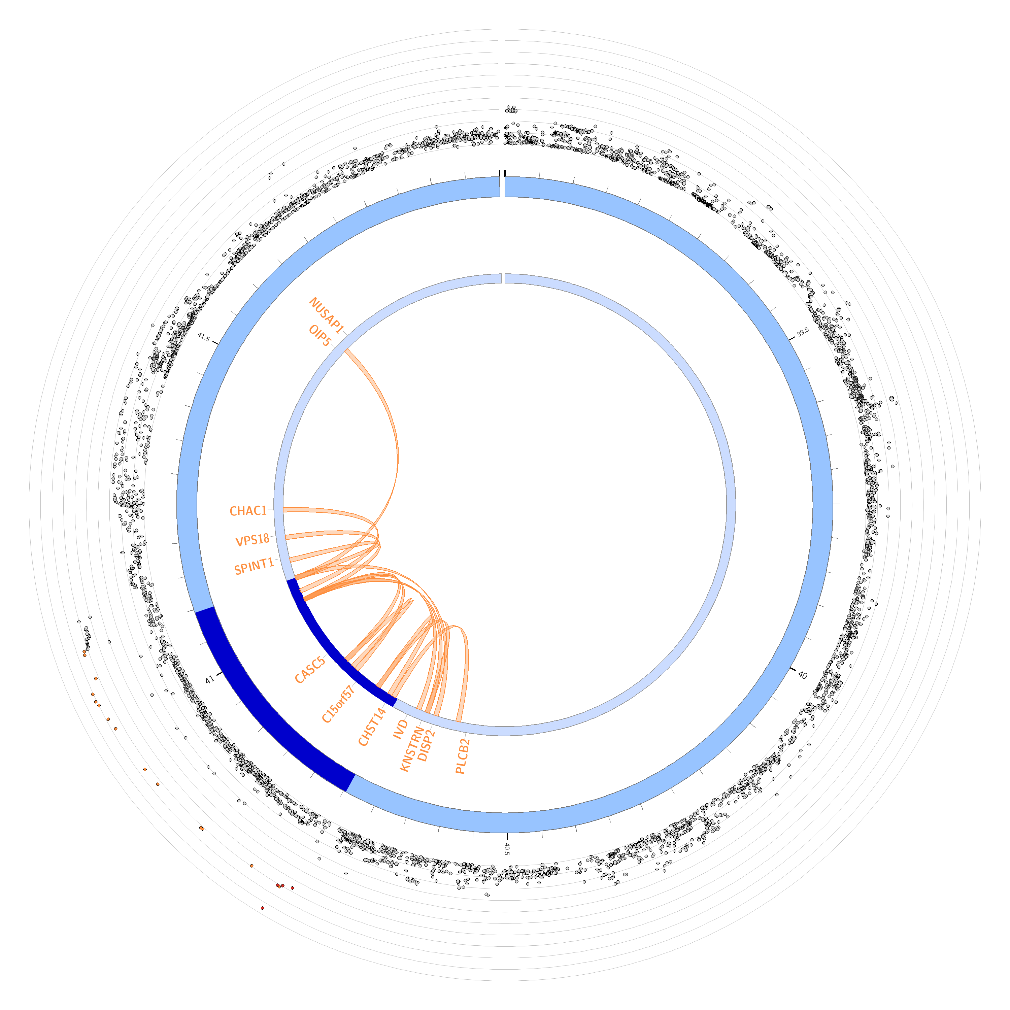

**Figure S9.** Circos plot of chromosome 15 showing the suicidality chromatin interaction (orange) map in females for the genomic risk locus containing *rs118118557* (dark blue) using brain expression data in FUMA.30, 31 The outermost layer shows a Manhattan plot containing the –log10(*p-value*) of each GEWIS SNP. Chromatin interaction *p*-values, genes, and regions are provided in Table S21.

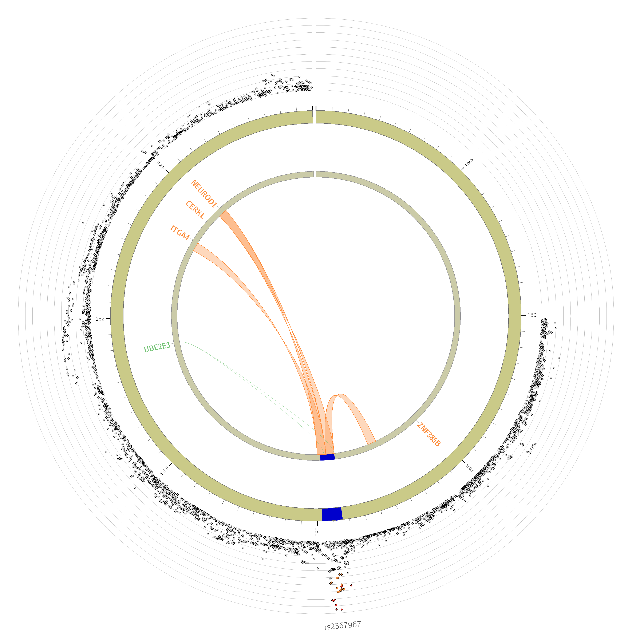

**Figure S10.** Circos plot of chromosome 2 showing the suicidality chromatin interaction (orange) and expression quantitative trait locus (eQTL; green) map in males for the genomic risk locus containing *rs2367967* (dark blue) using brain expression data in FUMA.30, 31 The outermost layer shows a Manhattan plot containing the –log10(*p-value*) of each GEWIS SNP. Signed eQTL effect estimates are shown in Table S22. Chromatin interaction *p*-values, genes, and regions are provided in Table S23.

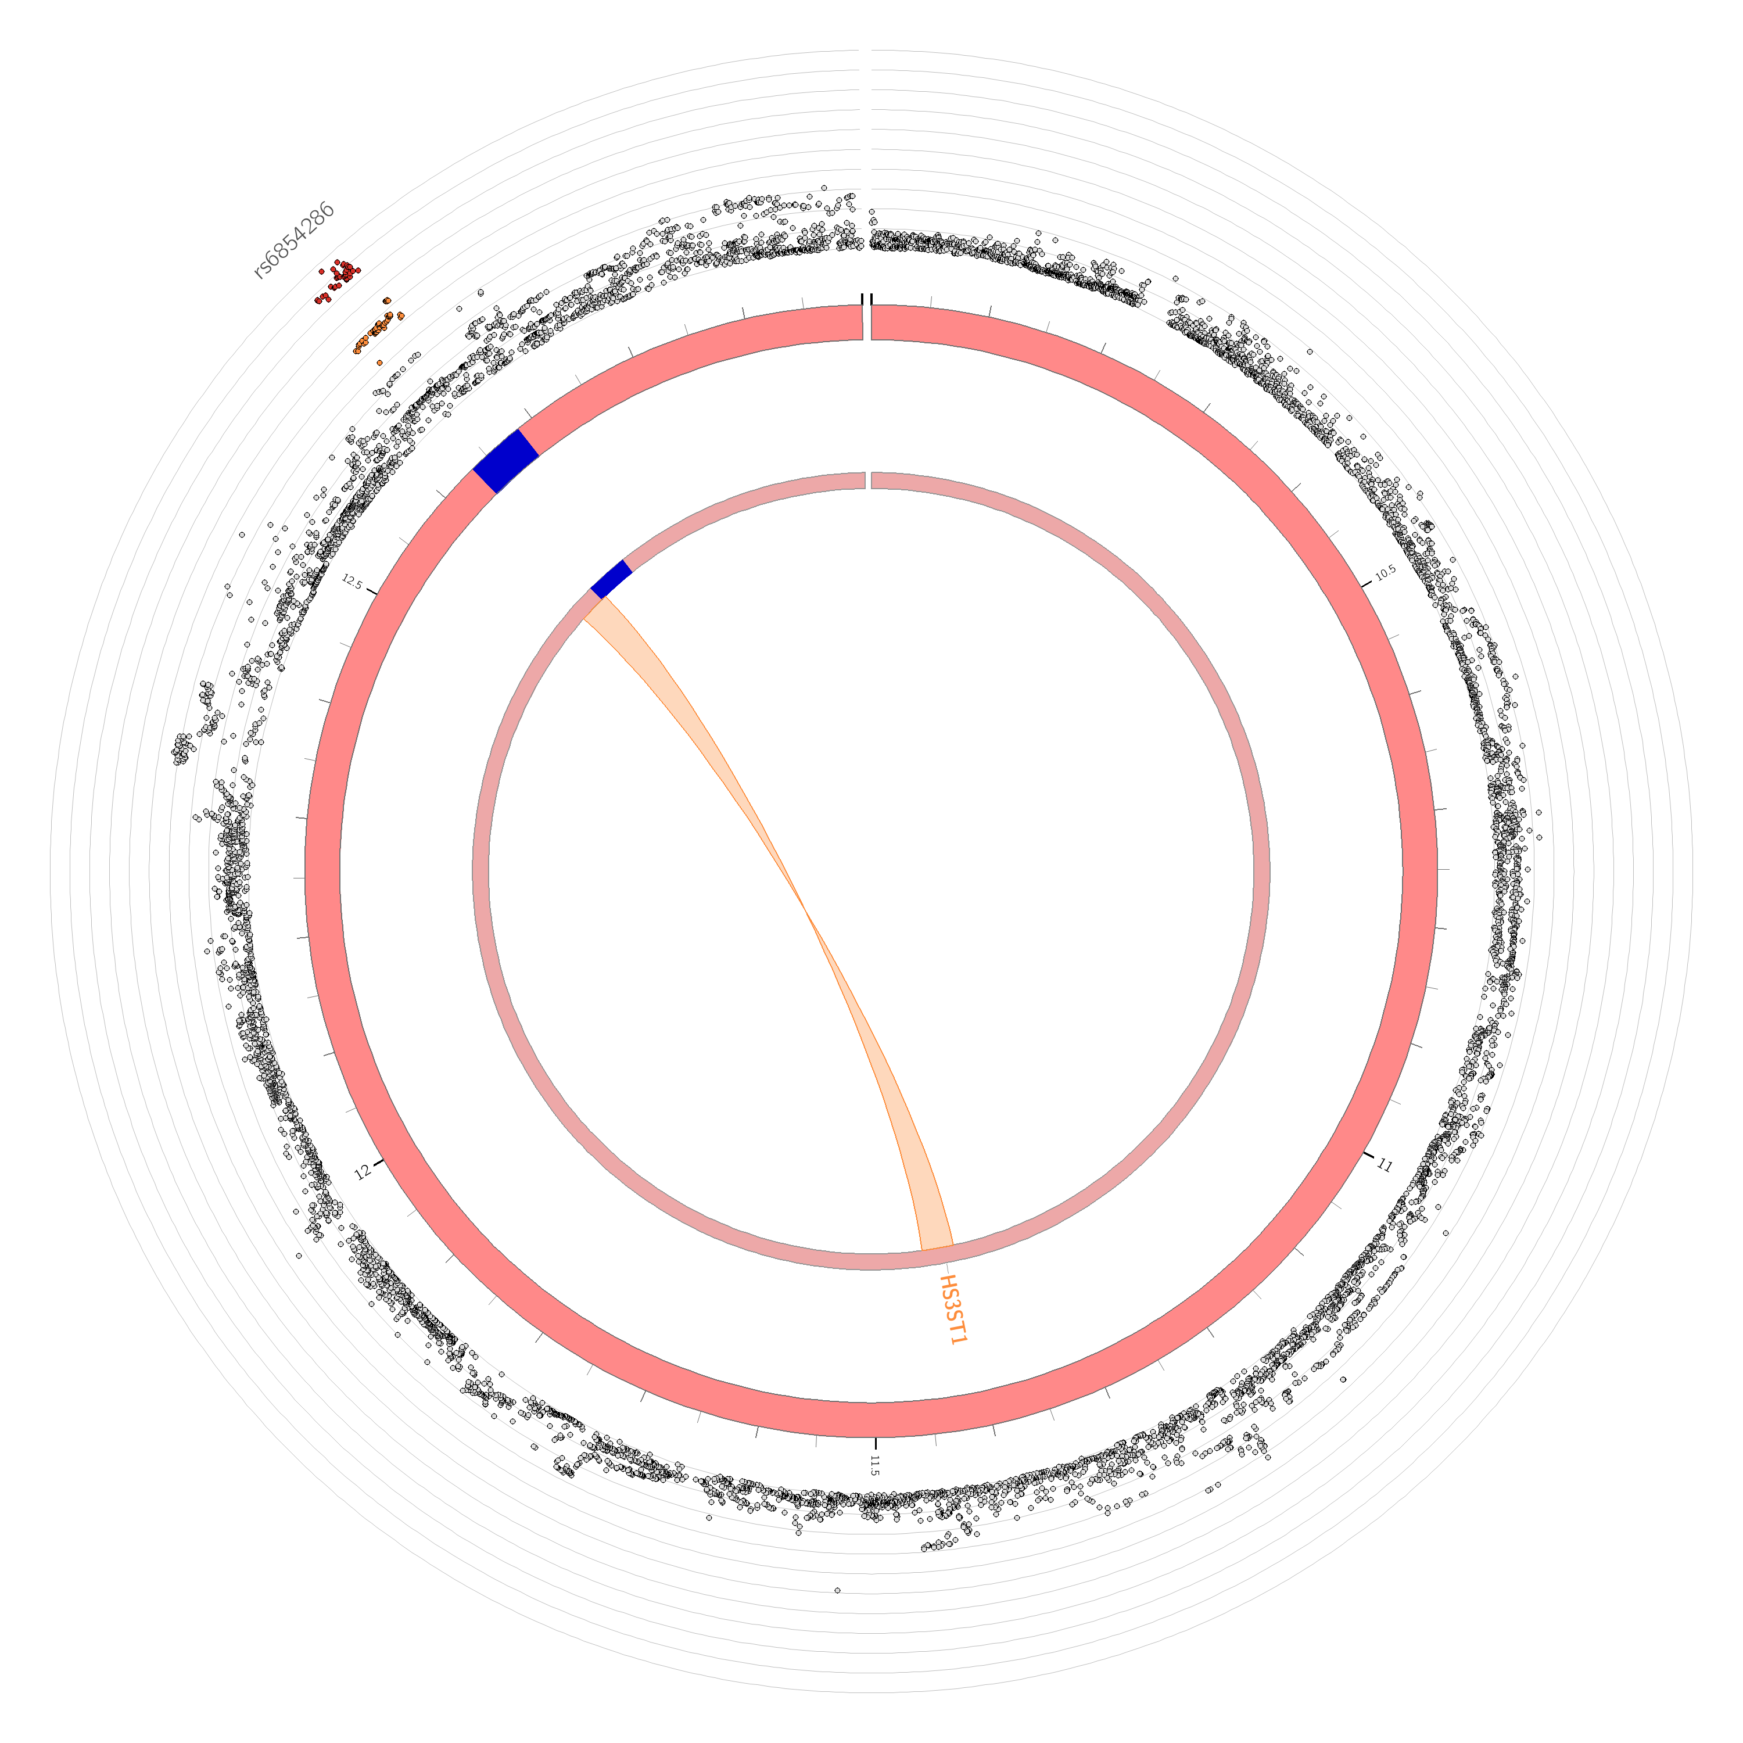

**Figure S11.** Circos plot of chromosome 4 showing the suicidality chromatin interaction (orange) map in males for the genomic risk locus containing *rs6854286* (dark blue) using brain expression data in FUMA.30, 31 The outermost layer shows a Manhattan plot containing the –log10(*p-value*) of each GEWIS SNP. Chromatin interaction *p*-values, genes, and regions are provided in Table S23.

**Table Legends**

**Table S1.** Imputation quality control for 17 traumatic event and socioeconomic status phenotypes in UKB. Two phenotype distributions are described: phenotype distribution in available cases (AC) only and the distribution of all data after ten iterations of 5 multiple imputations. Sample size, standard error (SE), and the change in SE (dSE) after imputation are provided. Data shown graphically in Figure S1.

**Table S2.** Imputation quality control for six trauma response environments in UKB. Two phenotype distributions are described: phenotype distribution in available cases (AC) only and the distribution of all data after ten iterations of 5 multiple imputations. Sample size, standard error (SE), and the change in SE (dSE) after imputation are provided. Data shown graphically in Figure S2.

**Table S3.** Comparison of GWAS-discovered loci with GEWIS association and interaction results for 3 loci from Strawbridge*, et al.*7

**Table S4.** Comparison of GEWIS-discovered loci with Strawbridge*, et al.*7 GWAS association results for 5 loci from this study.

**Table S5.** Replication results for the *rs12589041* genomic risk locus in the independent Yale-Penn cohort of 3,099 individuals of European ancestry.

**Table S6.** Replication results for the *rs118118557* genomic risk locus in the independent Yale-Penn sample of 1,163 European ancestry females.

**Table S7.** Replication results for the *rs2367967* genomic risk locus in the independent Yale-Penn sample of 1,936 European ancestry males.

**Table S8.** Replication results for the *rs6854286* genomic risk locus in the independent Yale-Penn sample of 1,936 European ancestry males.

**Table S9.** Replication results for the *rs72619337* genomic risk locus in the independent Yale-Penn sample of 1,936 European ancestry males.

**Table S10.** Brain imaging phenotypes associated with suicidality in the full UKB cohort using generalized linear models covaried for age, sex, genotype batch, and ten principal components of ancestry.

**Table S11.** Brain imaging phenotypes associated with suicidality in UKB females using generalized linear models covaried for age, sex, genotype batch, and ten principal components of ancestry.

**Table S12.** Brain imaging phenotypes associated with suicidality in UKB males using generalized linear models covaried for age, sex, genotype batch, and ten principal components of ancestry.

**Table S13.** GEWIS of *rs12589041* and brain volumes associated with suicidality in the full UKB cohort. GEWIS test the covariance matrix of 26 environments related to traumatic events, posttraumatic stress, socioeconomic status, and social support.

**Table S14.** GEWIS of *rs118118557* and brain volumes associated with suicidality in UKB females. GEWIS test the covariance matrix of 26 environments related to traumatic events, posttraumatic stress, socioeconomic status, and social support.

**Table S15.** GEWIS of *rs2367967*, *rs6854286*, and *rs72619337* and brain volumes associated with suicidality in UKB males. GEWIS test the covariance matrix of 26 environments related to traumatic events, posttraumatic stress, socioeconomic status, and social support.

**Table S16.** Results of gene-based association and interaction tests of suicidality for the full UKB cohort, UKB males, and UKB females. Multiple testing correction (“fdr” columns) was performed for each sex-test combination only, not across the entire table.

**Table S17.** ShinyGO32 enrichment analysis summary of genes significantly association with suicidality the full UKB cohort, UKB males, and UKB females.

**Table S18.** Gene set enrichment results from MAGMA29 implemented in FUMA30, 31 using the gene-based GWAS results from GEWIS of suicidality in the full UKB cohort, UKB males, and UKB females.

**Table S19.** Cell-type transcriptomic profile enrichments for male suicidality GEWIS. Data shown represent within-dataset cell-type enrichments (FUMA cell-type step 2).30, 31

**Table S20.** Quantitative trait locus results for the genomic risk locus containing *rs12589041* in the full UKB cohort.

**Table S21.** Chromatin interaction results for the genomic risk locus containing *rs118118557* in UKB females.

**Table S22.** Expression quantitative trait locus results for the genomic risk locus containing *rs2367967* in UKB males.

**Table S23.** Chromatin interaction results for the genomic risk loci containing *rs2367967* and *rs6854286* in UKB males.

**Table S24.** Description of environments in the Yale-Penn cohort and their association with suicidality from generalized linear model adjusted for age, sex, genotyping batch, and ten principal components of ancestry.