**SUPPLEMENTAL MATERIALS**

**Contents**

Appendix A – Measurement Model Invariance Testing

Appendix B – Longitudinal Design

Appendix C – Missing Data

Appendix D – Growth Model Fit Statistics

Appendix E – Mixture Model Fit Statistics

Appendix F – Growth Parameters for 1-class and 6-class models

Appendix G – Bar chart of latent class membership across 6 predictor variables

Appendix H – Comparison of 6-class Solutions for GMM versus GMM-SR

**Appendix A**

**Measurement Model and Invariance Testing**

*Item-Level Analyses*

Because the SMFQ included 13 items with a greater range of symptoms, full, item-level invariance analyses were conducted. Factors were modeled with a latent response variable specification (Muthen, 1983), where items were ordinal indicators of an underlying continuous variable. This parameterization was chosen because items had relatively few response points (3 levels of responses; see Rhemtulla, Brosseau-Liard, & Savalei, 2012). The SMFQ consisted of 3 response levels, *not true, sometimes,* and *true.* Thresholds refer to the probability, expressed as a logit, that an item would be endorsed after controlling for the level of the latent variable. Scalar invariance signifies that changes in item endorsement over time are driven entirely by the level of the latent variable. If items measuring a latent variable are treated as scalar invariant when it does not hold, scores of the latent variable are distorted by changes in the items unrelated to the latent variable. If scalar noninvariance was found, results from these item-level models would be used to construct parcels with longitudinally similar patterns of noninvariance.

Although the model demonstrated adequate global fit, the full scalar model was a significantly worse by both the chi-square difference test, c2(74) = 1677.55, *p* < .0001, as well as Cheung & Rensvold’s (2002) more relaxed criterion that changes in the CFI should be < .002.

To conduct partial invariance testing, a minimum of 1 threshold per wave had to be constrained equal to the neighboring wave in order to produce a connected graph and identify the partial scalar model. The initial constraints are depicted by black circles in **Figure A1**. Results of invariance tests are shown in **Table A1** and the constraints for each test are depicted in **Figure A2**.

Parcel #1 consisted of items where scalar invariance held across both levels of responses across all 3 waves. That is, after controlling for the level of the latent depression variable, the response for a particular item was equally likely across all 3 waves. Parcel #1 had full scalar invariance across all waves of items and consisted of items 5, 8, 10, and 12 and broadly reflected negative self-evaluation. Parcel #2 consisted of items 1, 3, 4, 6 and 7, which were mostly emotional symptoms (feeling miserable or unhappy, tired, restless, crying). For these items, *after controlling for the level of depression*, the higher threshold response, *true,* functioned similarly across ages, but the lower threshold response, *sometimes,* was more readily endorsed at 198 months than 140 and 157 months, indicating that after controlling for the latent depression variable*,* mothers reported their children experiencing moderate levels of negative emotions more frequently at 198 months than they did at younger ages. Parcel #3 consisted of items 2, 9, 11, and 13. Scalar invariance held across 140 and 157 months, but average symptom levels, after controlling for the latent depression variable, were higher at 198 months. These items did not appear to have thematic similarity.

Parcels required a minimum of 3 items. Because the SDQ subscales each had only 5 items, each subscale was used to form 1 parcel. Item-level analyses on subscales indicated acceptable fit for scalar invariance models for the SDQ-emotions and SDQ-peer difficulties.

*Construction of the Measurement Model.*

The two SDQ subscales and three SMFQ parcels were included together in the same model and subjected to full invariance testing. Latent means were centered at zero and latent variances were fixed at one in the first wave. A maximum likelihood estimator with robust standard errors was used so that inferences on the measurement model would accommodate nonnormality. The Satorra-Bentler adjustment was used to compare nested models (Satorra & Bentler, 2010).

We could only test metric invariance in the 3 waves where all measures were present (ages 11.7, 13.1 and 16.5). Consistent with the item-level analyses, preliminary models examining just those three waves indicated that a bifactor model provided the best fit to the data. Moreover, given the heterogeneous range of symptoms assessed and desire for one latent construct that unified them, the bifactor model also provided the substantive interpretation that most cleanly mapped to theory. This measurement model consisted of one general factor underlying all the items, referred to as “depression,” and method factors for the SMFQ and each SDQ subscale.

Following metric invariance testing, we constrained factor loadings of the earlier SDQ subscales equal to the later waves. Results indicated full scalar invariance for the SDQ-emotions subscale, and partial scalar invariance for the peer difficulties subscale, where the intercepts of the first 3 waves (3.9 years, 6.8 years, and 8.1 years) were freely estimated. As expected following the item-level analyses, the two SMFQ parcels constructed from noninvariant items were themselves scalar noninvariant. Nested model comparisons for the configural, metric, full scalar, and partial scalar models can be found in the Table A2; for path diagram, see Figure A1). Despite a significant chi-square statistic (2(165) = 657.02, *p* < .0001), which is common in models with large samples and many parameters, the fit of the final model with partial scalar invariance was excellent (CFI = .999, TLI = .998, RMSEA = .015) and superior to the fit of the model with full scalar invariance (2diff(5) = 970.50, *p* < .0001), indicating that some symptoms changed over time in ways that were unrelated to the latent depression variable. Examination of the size and distribution of residuals indicated that local fit was also acceptable.

Factor score distributions had moderate levels of skew and kurtosis. Because mixture models on variables with such skew and kurtosis may extract latent classes that characterize properties of the distribution rather than true population-wide heterogeneity (Bauer & Curran, 2003), log-transformed factor scores were used. The resulting estimated factor score distributions were acceptable, with an approximate normal shape and skew and kurtosis values all < |1.0|.

**Table A1.** Nested Model Comparisons for Item-Level SMFQ Partial Scalar Invariance Models

|  |  |  |  |  |  |  |  |
| --- | --- | --- | --- | --- | --- | --- | --- |
| **Model** | ***df*** | **c2** | **D c2** | **difftest** | **CFI** | **TLI** | **RMSEA** |
| **Full Invariance Models** |  |  |  |  |  |  |  |
| Configural/Metric invariance | 684 | 3001.17 | --- | 0.0003 | 0.983 | 0.982 | 0.020 |
| Threshold Invariance | 734 | 3986.29 | 1677.55 | < .0001 | 0.976 | 0.976 | 0.023 |
|  |  |  |  |  |  |  |  |
| **Partial Scalar Invariance Models** |  |  |  |  |  |  |  |
| Baseline=Model 2-Metric Invariance | 684 | 3001.17 | --- | --- | 0.983 | 0.982 | 0.020 |
| Partial 0 | 686 | 3004.75 | 2.59 | 0.27 | 0.983 | 0.982 | 0.020 |
| Partial 1 | 688 | 3010.76 | 6.64 | 0.036 | 0.983 | 0.982 | 0.020 |
| Partial 2 | 691 | 3017.01 | 5.43 | 0.143 | 0.983 | 0.982 | 0.020 |
| Partial 3 | 692 | 3024.30 | 10.56 | 0.001 | 0.983 | 0.982 | 0.020 |
| Partial 4 | 693 | 3029.76 | 19.13 | 0.0001 | 0.983 | 0.982 | 0.020 |
| Partial 5 | 697 | 3050.20 | 35.58 | < .0001 | 0.983 | 0.982 | 0.020 |
| Partial 6 | 698 | 3053.87 | 5.56 | 0.018 | 0.983 | 0.982 | 0.020 |
| Partial 7 | 700 | 3056.18 | 0.27 | 0.875 | 0.983 | 0.982 | 0.020 |
| Partial 8 | 702 | 3059.05 | 3.47 | 0.176 | 0.983 | 0.982 | 0.020 |
| Partial 9 | 704 | 3062.09 | 1.74 | 0.418 | 0.983 | 0.982 | 0.020 |
| Partial 10 | 708 | 3078.98 | 24.33 | 0.0001 | 0.983 | 0.982 | 0.020 |
| Partial 11 | 710 | 3081.97 | 0.59 | 0.744 | 0.983 | 0.982 | 0.020 |
| Partial 12 | 712 | 3118.91 | 76.7 | < .0001 | 0.982 | 0.982 | 0.020 |
| Partial 13 | 714 | 3124.26 | 6.02 | 0.049 | 0.982 | 0.982 | 0.020 |
| *Note.* This table is interpreted in conjunction with Figure A1, which shows the constraints tested by each model. Chi-square differences between successive models do not equal exact chi-square differences because they were calculated using the Satorra-Bentler adjustment. | | | | | | | |  |

**Table A2.** Fit Statistics for Parcel-Level Partial Scalar Invariance Models

|  |  |  |  |  |  |  |  |  |  |
| --- | --- | --- | --- | --- | --- | --- | --- | --- | --- |
| **Model** | **df** | **2** | **2 p-value** | **Satorra-Bentler 2 diff** | **Adjusted 2 difference p-value** | **CFI** | **TLI** | **RMSEA** | **BIC** |
| *Waves with all three measures (140 months, 157 months, 198 months)* |  |  |  |  |  |  |  |  |  |
| Configural | 60 | 263.38 | < .0001 | **---** | **---** | .994 | .989 | .020 | -4,611 |
| Metric | 68 | 328.94 | < .0001 | 58.52 | < .0001 | .992 | .988 | .021 | -4,567 |
|  |  |  |  |  |  |  |  |  |  |
| *All waves* |  |  |  |  |  |  |  |  |  |
| Metric | 158 | 596.74 | < .0001 | **---** | **---** | .999 | .998 | .015 | 75,441 |
| Partial Scalar | 165 | 657.03 | < .0001 | 71.43 | < .0001 | .998 | .998 | .016 | 75,448 |
| Full Scalar | 170 | 1353.91 | < .0001 | 989.11 | < .0001 | .997 | .995 | .024 | 76,332 |

**Table A3.**  Factor loadings and latent variable correlations for the measurement model

|  |  |  |  |  |  |  |
| --- | --- | --- | --- | --- | --- | --- |
|  | Strengths and Difficulties Questionnaire | | | Short Mood and Feelings Questionnaire | | |
| Age in years | Emotional problems | | Peer Difficulties | Parcel #1 | Parcel #2 | Parcel #3 |
| 3.9 years | | .69 (.02) | .39 (.01) | --- | --- | --- |
| 6.8 years | | .73 (.01) | .48 (.01) | --- | --- | --- |
| 8.1 years | | .73 (.01) | .48 (.01) | --- | --- | --- |
| 9.6 years | | .74 (.01) | .50 (.01) | --- | --- | --- |
| 11.7 years | | .77 (.01) | .49 (.01) | .69 (.01) | .61 (.01) | .66 (.01) |
| 13.1 years | | .80 (.01) | .49 (.01) | .69 (.01) | .61 (.01) | .65 (.01) |
| 16.5 years | | .81 (.01) | .55 (.01) | .72 (.01) | .68 (.01) | .69 (.01) |
| *Note.* Loadings represent standardized values. Standard errors are in parentheses. Parcel #1 consisted of items 5, 8, 10, and 12.  Parcel #2 consisted of items 1, 3, 4, 6, 7.  Parcel #3 consisted of items 2, 9, 11, 13. | | | | | | |

|  |  |  |  |  |  |  |  |
| --- | --- | --- | --- | --- | --- | --- | --- |
| **Table A4.** Latent Variable Correlations | | | |  |  |  |  |
| **Age in years** | 3.9 years | 6.8 years | 8.1 years | 9.6 years | 11.7 years | 13.1 years | 16.5 years |
| 3.9 years | 1.00 |  |  |  |  |  |  |
| 6.8 years | 0.63 | 1.38 |  |  |  |  |  |
| 8.1 years | 0.55 | 0.79 | 1.67 |  |  |  |  |
| 9.6 years | 0.46 | 0.70 | 0.75 | 1.61 |  |  |  |
| 11.7 years | 0.39 | 0.62 | 0.65 | 0.71 | 1.66 |  |  |
| 13.1 years | 0.38 | 0.59 | 0.60 | 0.66 | 0.75 | 1.77 |  |
| 16.5 years | 0.33 | 0.47 | 0.52 | 0.51 | 0.57 | 0.63 | 2.07 |
| *Note.* Variances are on the diagonal. | | | |  |  |  |  |

|  |  |
| --- | --- |
| **Figure A1.** Constraints on Item-Level SMFQ Partial Invariance Models | |
|  |  |
|  |  |
|  |  |
|  |  |
|  |  |
|  |  |
|  | |
| *Note.* Black circles represent constraints that were used to identify the minimal scalar invariant model (i.e., produce the necessary connected graph for further analysis). Solid circles indicate constraints that were accepted and included in subsequent models. Broken circles represent constraints that were rejected and not imposed for subsequent models. | |

**Figure A2.**

Path Diagram for Parcel-Level Confirmatory Factor Model

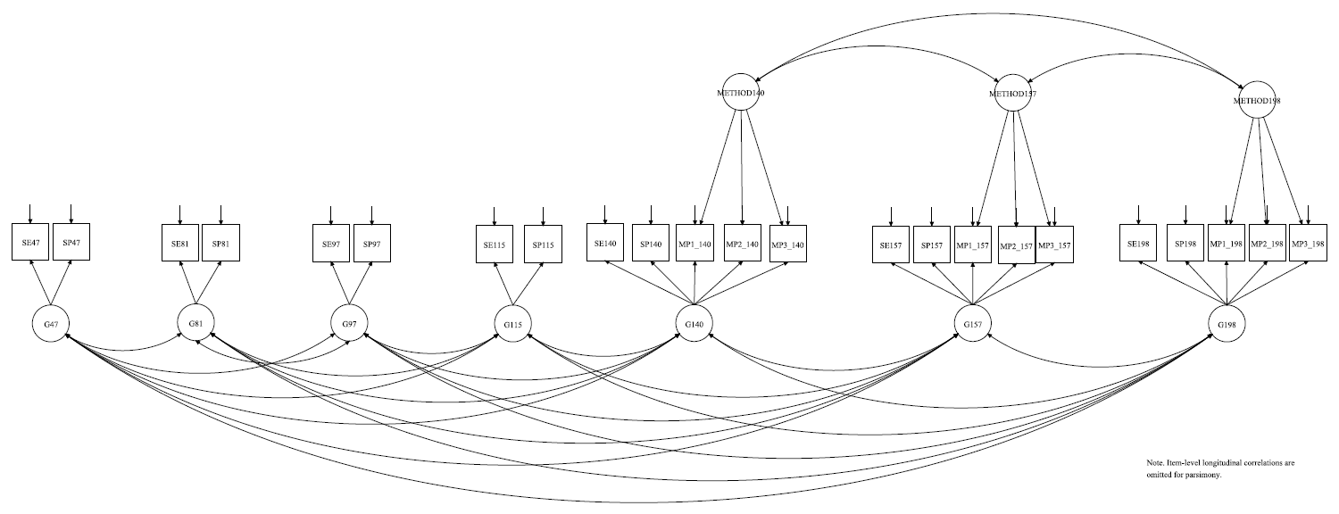

*Note.* SE = Emotional difficulties subscale of the Strengths and Difficulties Questionnaire. SP = peer difficulties subscale of the Strengths and Difficulties Questionnaire. MP1, MP2, and MP3 represent parcels of the Short Mood and Feelings Questionnaire. Factor loadings are constrained equal for each parcel across waves. Factor variances were scaled to 1 for the first time point and freely estimated at subsequent timepoints.

**Appendix B**

Table B1. Longitudinal design showing measures and phantom variables at each wave

|  |  |  |  |
| --- | --- | --- | --- |
| **Age in years* (months)** | **Strengths and Difficulties Questionnaire-Emotional Problems** | **Strengths and Difficulties Questionnaire-Peer Difficulties** | **Short Mood and Feelings Questionnaire** |
| 4 (47) | **X** | **X** |  |
| **NO MEASURES—PHANTOM VARIABLE** | | | |
| 7 (81) | **X** | **X** |  |
| 8 (97) | **X** | **X** |  |
| 9.5 (115) | **X** | **X** |  |
| **NO MEASURES—PHANTOM VARIABLE** | | | |
| 11.5 (140) | **X** | **X** | **X** |
| 13 (157) | **X** | **X** | **X** |
| **NO MEASURES—PHANTOM VARIABLE** | | | |
| 16.5 (198) | **X** | **X** | **X** |

*Note.* *Age is rounded to the nearest half-year.

Phantom variables were used to improve estimation of the autoregression term in the latent growth model with structured residuals. They constrained the autoregression between adjacent waves with wide gaps between observations (e.g., 3.9 and 6.8 years) to be equal to the square of the autoregression between waves with narrower gaps (e.g., 6.8 and 8.1 years).

**APPENDIX C**

**Missing Data**

A number of baseline demographics and variables representing exposure to adversity were examined (see **Table C1** for a complete list) and included as saturated correlates (Collins, Schafer, & Kam, 2001) if they correlated > |0.05| with either (1) any parcel score or, (2) with a dummy variable indicating that a parcel was missing. This procedure resulted in the inclusion of 34 auxiliary variables as saturated correlates.

**Table C1.** List of auxiliary variables examined and included in CFA model used to generate factor scores.

|  |  |  |  |
| --- | --- | --- | --- |
| **Predictor** | **Number of Relations with Outcome Variables (max = 23)** | **Included** | **VariableType** |
| Parent SES | 23 | yes | factor |
| Mother’s education at gestation | 23 | yes | ordered category |
| Parents are home-owners | 23 | yes | binary |
| Marital status | 23 | yes | ordered category |
| Maternal psychopathology (8 months) | 23 | yes | binary |
| Maternal psychopathology (21 months) | 23 | yes | binary |
| Maternal psychopathology (33 months) | 23 | yes | binary |
| One adult in the household (47 months) | 23 | yes | binary |
| Neighborhood housing quality (21 months) | 23 | yes | binary |
| Neighborhood housing quality (33 months) | 23 | yes | binary |
| Financial score (8 months) | 23 | yes | binary |
| Financial score (21 months) | 23 | yes | binary |
| Financial score (33 months) | 23 | yes | binary |
| Partner cruelty (33 months) | 23 | yes | binary |
| ppregnum | 22 | yes | ordered category |
| One adult in the household (21 months) | 22 | yes | binary |
| One adult in the household (33 months) | 22 | yes | binary |
| Partner cruelty (47 months) | 22 | yes | binary |
| Mother's age at birth | 21 | yes | ordered category |
| One adult in the household (8 months) | 21 | yes | binary |
| Partner cruelty (21 months) | 21 | yes | binary |
| Either parent in trouble with law enforcement (21 months) | 20 | yes | binary |
| Male | 14 | yes | binary |
| Partner cruelty (8 months) | 10 | yes | binary |
| Child psychological or emotional abuse (42 months) | 9 | yes | binary |
| Child psychological or emotional abuse (30 months) | 8 | yes | binary |
| Race = White | 7 | yes | binary |
| Family instability (42 months) | 7 | yes | binary |
| Either parent in trouble with law enforcement (33 months) | 5 | yes | binary |
| Either parent in trouble with law enforcement (47 months) | 4 | yes | binary |
| preg_size | 2 | yes | binary |
| Either parent in trouble with law enforcement (8 months) | 2 | yes | binary |
| Family instability (18 months) | 2 | yes | binary |
| Family instability (30 months) | 2 | yes | binary |
| Child psychological or emotional abuse (18 months) | 0 | no | binary |

*Note.* Auxiliary variables were included when correlation with at least 1 *r* > |.05|.

**APPENDIX D**

**Table D1**. *Fit Statistics for Growth Models*

|  |  |  |  |  |  |  |  |  |  |  |
| --- | --- | --- | --- | --- | --- | --- | --- | --- | --- | --- |
| Model | df | 2 | p | Satorra-Bentler Chi-square difference  (k vs. k-1) | chi-square difference test | CFI | TLI | RMSEA | BIC | AIC |
| 1. Linear Growth Model | 28 | 11,334.80 | < .0001 | --- | --- | .815 | .862 | .186 | -16,349 | -16,401 |
| 2. Quadratic Growth Model | 24 | 6196.57 | < .0001 | 5278.72 | < .0001 | .899 | .912 | .149 | -22,883 | -22,964 |
| 3. Cubic Growth Model | 19 | 3582.70 | < .0001 | 2622.75 | < .0001 | .942 | .936 | .127 | -26,214 | -26,331 |
| 4. Quartic Growth Model | 18 | 3543.09 | < .0001 | 13.67 | .0001 | .942 | .933 | .130 | -26,219 | -26,344 |
| **5. Quartic Growth Model with Structured Residuals** | **17** | **3422.53** | **< .0001** | **156.78** | **< .0001** | **.944** | **.931** | **.131** | **-26,482** | **-26,714** |

Note. All quartic models constrained the quartic variance to zero because otherwise, the model was underidentified. The final model is bolded.

**APPENDIX E**

Table E1. *Fit Statistics for Growth Mixture Models*

|  |  |  |  |  |  |  |  |  |  |  |
| --- | --- | --- | --- | --- | --- | --- | --- | --- | --- | --- |
| Model | free parameters | Loglikelihood | BIC | aBIC | AIC | CAIC | AWE | adjusted LRT  (k vs k-1) | cmPk | cmPA |
|  |  |  |  |  |  |  |  |  |  |  |
| Baseline Modela | 18 | 13,375 | -26,581 | -26,638 | -26,713 | -26,563 | -26,358 | --- | --- | --- |
|  |  |  |  |  |  |  |  |  |  |  |
| *Mixture Models* | |  |  |  |  |  |  |  |  |  |
| **all growth factor variances fixed to zero, AR varies across classes** | | | | |  |  |  |  |  |  |
| 2 class | 15 | 11,587 | -23,033 | -23,081 | -23,143 | -23,018 | -22,847 | < .0001 | 0.00 | --- |
| 3 class | 22 | 12,449 | -24,691 | -24,761 | -24,853 | -24,669 | -24,419 | < .0001 | 0.00 | --- |
| 4 class | 29 | 12,819 | -25,367 | -25,459 | -25,580 | -25,338 | -25,008 | < .0001 | 0.00 | --- |
| 5 class | 36 | 13,201 | -26,065 | -26,179 | -26,330 | -26,029 | -25,620 | .0022 | 0.00 | --- |
| 6 class | 43 | 13,568 | -26,734 | -26,871 | -27,051 | -26,691 | -26,203 | < .0001 | 0.00 | --- |
| 7 class | 50 | 13,802 | -27,135 | -27,294 | -27,503 | -27,085 | -26,517 | .0022 | 0.00 | --- |
| 8 class | 57 | 14,031 | -27,528 | -27,709 | -27,947 | -27,471 | -26,823 | .022 | 1.00 | 0.00 |
|  |  |  |  |  |  |  |  |  |  |  |
| **Invariant variances, diagonal covariance, linear slope variance, AR varies across classes** | | | | | | | | |  |  |
| 2 class | 17 | 13,044 | -25,929 | -25,983 | -26,054 | -25,912 | -25,719 | < .0001 | 0.00 | --- |
| 3 class | 24 | 13,461 | -26,697 | -26,773 | -26,874 | -26,673 | -26,400 | .0004 | 0.00 | --- |
| 4 class | 31 | 13,886 | -27,482 | -27,580 | -27,710 | -27,451 | -27,099 | < .0001 | 0.00 | --- |
| 5 class | 38 | 14,293 | -28,231 | -28,351 | -28,510 | -28,193 | -27,761 | .0044 | 0.00 | --- |
| **6 class** | **45** | **14,739** | **-29,056** | **-29,199** | **-29,388** | **-29,011** | **-28,500** | **< .0001** | **0.00** | **1.00** |
| 7 class | 52 | 15,086 | -29,684 | -29,849 | -30,067 | -29,632 | -29,041 | .175 | 0.00 | --- |
| 8 class | 59 | 15,409 | -30,265 | -30,452 | -30,699 | -30,206 | -29,535 | .035 | 1.00 | --- |
|  |  |  |  |  |  |  |  |  |  |  |
| **Invariant variances, non-diagonal covariance, linear slope variance, AR varies across classes** | | | | | | |  |  |  |  |
| 2 class | 18 | 13150 | -26,132 | -26,189 | -26,265 | -26,114 | -25,910 | .0001 | 0.00 | --- |
| 3 class | 25 | 13594 | -26,954 | -27,033 | -27,138 | -26,929 | -26,645 | .0087 | 0.00 | --- |
| 4 class | 32 | 14025 | -27,751 | -27,853 | -27,987 | -27,719 | -27,356 | 0.216 | 0.00 | --- |
| 5 class | 39 | 14497 | -28,629 | -28,753 | -28,916 | -28,590 | -28,147 | 0.002 | 0.00 | 0.00 |
| 6 class | 46 | 14814 | -29,197 | -29,343 | -29,535 | -29,151 | -28,628 | 0.316 | 0.00 | --- |
| 7 class | 53 | 15167 | -29,839 | -30,007 | -30,229 | -29,786 | -29,183 | 0.145 | 0.00 | --- |
| 8 class | 60 | 15487 | -30,412 | -30,603 | -30,854 | -30,352 | -29,671 | 0.006 | 1.00 | --- |
|  |  |  |  |  |  |  |  |  |  |  |
| **Invariant variances, diagonal covariance, linear slope variance, AR invariant across classes** | | | | | | | |  |  |  |
| 2 class | 16 | 13,001 | -25,851 | -25,902 | -25,969 | -25,835 | -25,654 | < .0001 | 0.00 | --- |
| 3 class | 22 | 13,331 | -26,456 | -26,526 | -26,618 | -26,434 | -26,184 | < .0001 | 0.00 | --- |
| 4 class | 28 | 13,660 | -27,059 | -27,148 | -27,265 | -27,031 | -26,713 | .0008 | 0.00 | --- |
| 5 class | 34 | 14,103 | -27,887 | -27,995 | -28,137 | -27,853 | -27,466 | .0028 | 0.00 | --- |
| 6 class | 40 | 14,368 | -28,362 | -28,489 | -28,656 | -28,322 | -27,867 | .127 | 0.00 | 0.00 |
| 7 class | 46 | 14,646 | -28,861 | -29,008 | -29,200 | -28,815 | -28,293 | .036 | 0.00 | --- |
| 8 class | 52 | 14,888 | -29,289 | -29,454 | -29,671 | -29,237 | -28,646 | .004 | 1.00 | --- |

*Note*. The final model selection is bolded. Boxes denote models selected by fit statistics within-class. The Bayes Factor was excluded because it was not informative in model selection (e.g., all values for k vs k+1 class models were 0). Mixture models with variances for quadratic slopes yielded unacceptable models (non-positive definite psi matrices) and were consequently excluded from the table.

a = The baseline model was parameterized in the following way: 1 class, quartic polynomial, with random linear and quadratic variances, higher order variances fixed to zero, 3 phantom variables, time-invariant autoregressive structured residual, residual variances constrained equal within 2 separate pieces: 47-128 months, 140-198 months.

AR = autoregressive parameter for structured residuals.

**APPENDIX F**

|  |  |  |  |  |  |  |  |
| --- | --- | --- | --- | --- | --- | --- | --- |
| **Table F1.** | Growth parameters for the one-class and six-class models | | | |  |  |  |
|  | One-Class Model | Latent Class | | | | | |
|  | Minimal Symptoms | Adolescent Spike | Late Childhood Peak | Childhood Decrease | High and Reversing | High and Renitent |
| Parameter | Estimate (SE) | Estimate (SE) | Estimate (SE) | Estimate (SE) | Estimate (SE) | Estimate (SE) | Estimate (SE) |
| Means |  |  |  |  |  |  |  |
| Intercept | 0.76 (0.003) | 0.62 (0.006) | 0.79 (0.02) | 0.72 (0.03) | 0.99 (0.02) | 0.84 (0.03) | 0.91 (0.02) |
| Slope | 0.18 (0.02) | -0.21 (0.03) | -0.24 (0.15) | 0.95 (0.16) | 0.05 (0.16) | 0.70 (0.13) | 0.63 (0.06) |
| Quadratic | -0.21 (0.06) | 0.59 (0.09) | 1.89 (0.65) | -3.29 (0.66) | -2.08 (0.42) | -0.47 (0.53) | -0.89 (0.15) |
| Cubic | -0.07 (0.06) | -0.70 (0.10) | -3.18 (0.79) | 4.75 (0.79) | 2.05 (0.40) | -0.44 (0.64) | 0.42 (0.015) |
| Quartic | 0.09 (0.02) | 0.26 (0.03) | 1.47 (0.28) | -1.99 (0.28) | -0.53 (0.13) | 0.30 (0.22) | -0.07 (0.05) |
| Structured Residual | 0.30 (0.03) | 0.43 (0.04) | 0.49 (0.10) | -0.48 (0.06) | 0.05 (0.07) | -0.50 (0.03) | 0.90 (0.007) |
|  |  |  |  |  |  |  |  |
| Variances* |  |  |  |  |  |  |  |
| Intercept | 0.07 (0.001) | 0.05 (0.002) | 0.05 (0.002) | 0.05 (0.002) | 0.05 (0.002) | 0.05 (0.002) | 0.05 (0.002) |
| Slope | 0.21 (0.028) | 0.01 (0.001) | 0.01 (0.001) | 0.01 (0.001) | 0.01 (0.001) | 0.01 (0.001) | 0.01 (0.001) |
| Quadratic | 0.21 (0.091) | --- | --- | --- | --- | --- | --- |
| Cubic | 0.04 (0.018) | --- | --- | --- | --- | --- | --- |
| Quartic | --- | --- | --- | --- | --- | --- | --- |
| *Note.* *Variances were constrained equal across latent classes. | | | |  |  |  |  |

**APPENDIX G**

|  |
| --- |
| Figure G1. *Probability of Class Membership by Social Predictor Variables* |
|  |
| *Note.* For each level of each social factor, bars sum to 100%. |

**APPENDIX H**

Figure H1. *Latent class trajectories using a traditional growth mixture model without structured residuals*

1. 6-Class Growth Mixture Model with Structured Residuals B. 6-Class Traditional Growth Mixture Model

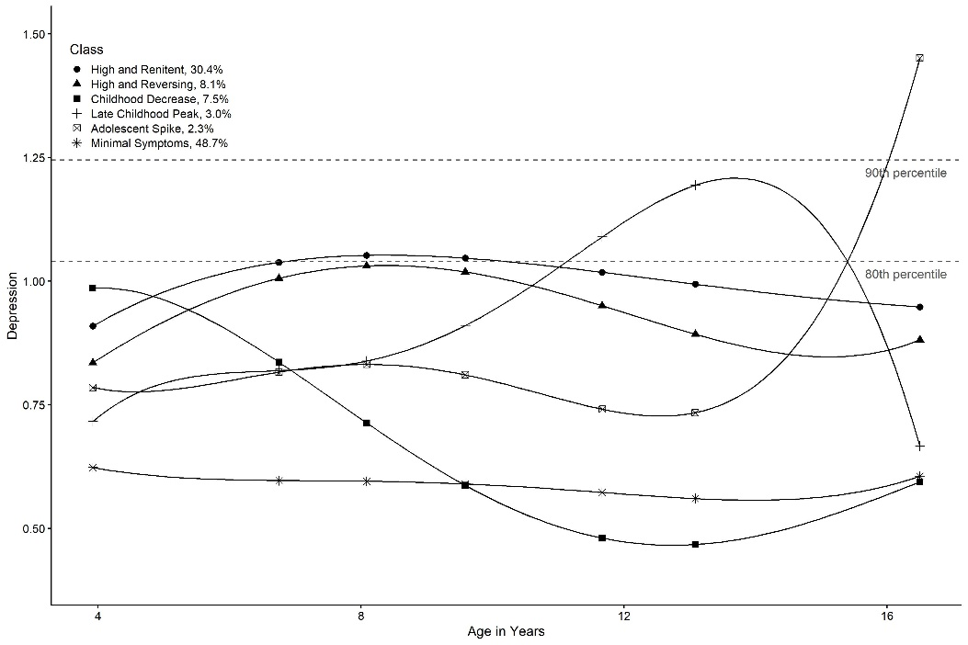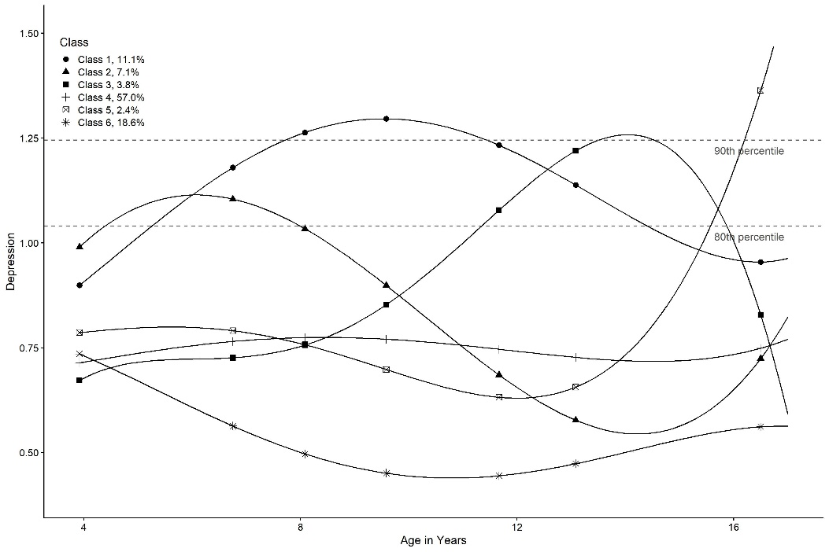

**References for Supplement**

Bauer, D. J., & Curran, P. J. (2003). Distributional assumptions of growth mixture models: implications for overextraction of latent trajectory classes. *Psychological methods*, *8*(3), 338.

Cheung, G. W., & Rensvold, R. B. (2002). Evaluating goodness-of-fit indexes for testing measurement invariance. *Structural equation modeling*, *9*(2), 233-255.

Muthen, B. (1983). Latent variable structural equation modeling with categorical data. *Journal of Econometrics*, *22*(1-2), 43-65.

Rhemtulla, M., Brosseau-Liard, P. É., & Savalei, V. (2012). When can categorical variables be treated as continuous? A comparison of robust continuous and categorical SEM estimation methods under suboptimal conditions. *Psychological methods*, *17*(3), 354.

Satorra, A., & Bentler, P. M. (2010). Ensuring positiveness of the scaled difference chi-square test statistic. *Psychometrika*, *75*(2), 243-248.