Data sources and code used in analyses

Data sources
Data used | Source | url
Numbers of abortions to under-20s in Europe | European Health Information Gateway - Health for all explorer | https://gateway.euro.who.int/en/hfa-explorer/
Populations of countries by age | Human mortality database | https://www.mortality.org
Birth totals of countries by age | Human fertility database | https://www.humanfertility.org
Numbers of births by age, Scotland | NRS Scotland | https://www.nrscotland.gov.uk/statistics-and-data/statistics/stats-at-a-glance/registrar-generals-annual-review/2017
Number of conceptions by age, Scotland 1994-2016 | ISD Scotland | http://www.isdscotland.org/Health-Topics/Sexual-Health/Publications/2018-07-03/mat_tp_table1.xls
Estimates of yearly gross domestic product (GDP), mobile phone ownership, proportion of females in population, proportion of population resident in urban settings | World Bank Open Data | https://data.worldbank.org
Conceptions in England and Wales to under-20s | Office for National Statistics | https://www.ons.gov.uk/peoplepopulationandcommunity/birthsdeathsandmarriages/conceptionandfertilityrates/bulletins/conceptionstatistics/2017
Pregnancy and birth rates to teenagers in the USA | The Guttmacher Institute | https://www.guttmacher.org/report/us-adolescent-pregnancy-trends-2013
New Zealand births by age of mother | Statistics New Zealand | http://stats.govt.nz
New Zealand abortions by age of mother | Statistics New Zealand | http://stats.govt.nz
Public spending on education | OECD Data | https://data.oecd.org/eduresource/public-spending-on-education.htm

Project code repositories
All R code used to run analyses and produce visualisations is available online. The interactive Shiny app is also published online and can be used to repeat ITS analyses without prior installation of R.

Code used to run the analyses and produce the graphs is available online in two Github repositories:
- https://github.com/andrewbaxter439/teen-preg-project - all data importing and tidying and code to run Synthetic Control analyses. (archived version at https://doi.org/10.5281/ZENODO.3519394)
- https://github.com/andrewbaxter439/ITS_shinyapp - code for the Shiny app to run Interrupted Time Series analyses (archived version at https://doi.org/10.5281/ZENODO.3519684)
The ITS Shiny app is also published at https://andybaxter.shinyapps.io/teen_preg_uk_its/ and can be run without installation of R or experience using R.

Packages used in R
- Shiny (Chang, Cheng, Allaire, Xie, & McPherson, 2019)
- nlme (Pinheiro, Bates, DebRoy, Sarkar, & R Core Team, 2019)
- tidyverse (Wickham, 2017)
- svglite (Wickham, Henry, Luciani, Decorde, & Lise, 2019)
- broom (Robinson & Hayes, 2020)
- car (Fox & Weisberg, 2019)
- XLConnect (Mirai Solutions GmbH, 2018)
- officer (Gohel, 2020a)
- rvg (Gohel, 2020b)
- patchwork (Pedersen, 2019)
- export (Wenseleers & Vanderaa, 2018)
- gganimate (Pedersen & Robinson, 2019)
- readxl (Wickham & Bryan, 2019)
- Synth (Abadie, Diamond, & Hainmueller, 2011)
- SPHSUgraphs (Baxter, 2019)
- ggrepel (Slowikowski, 2020)
- ggpubr (Kassambara, 2020)
- gtools (Warnes, Bolker, & Lumley, 2020)
- foreach (Microsoft & Weston, 2020)
- doParallel (Corporation & Weston, 2019)
- plotly (Sievert, 2018)
- magrittr (Bache & Wickham, 2014)
Abadie, A., Diamond, A., & Hainmueller, J. (2011). Synth: An R Package for Synthetic Control Methods in Comparative Case Studies. Journal of Statistical Software, 42(13), 1–17. Retrieved from http://www.jstatsoft.org/v42/i13/
Bache, S. M., & Wickham, H. (2014). magrittr: A Forward-Pipe Operator for R. Retrieved from https://cran.r-project.org/package=magrittr
Baxter, A. J. (2019). SPHSUgraphs: Select SPHSU Brand Colours For ggplot2 Graphs. Retrieved from https://github.com/andrewbaxter439/SPHSUgraphs
Chang, W., Cheng, J., Allaire, J. J., Xie, Y., & McPherson, J. (2019). Shiny: Web Application Framework for R. Retrieved from https://cran.r-project.org/package=shiny
Corporation, M., & Weston, S. (2019). doParallel: Foreach Parallel Adaptor for the “parallel” Package. Retrieved from https://cran.r-project.org/package=doParallel
Fox, J., & Weisberg, S. (2019). car: An R Companion to Applied Regression (Third). Retrieved from https://socialsciences.mcmaster.ca/jfox/Books/Companion/
Gohel, D. (2020a). officer: Manipulation of Microsoft Word and PowerPoint Documents. Retrieved from https://cran.r-project.org/package=officer
Gohel, D. (2020b). rvg: R Graphics Devices for Vector Graphics Output. Retrieved from https://cran.r-project.org/package=rvg
Kassambara, A. (2020). ggpubr: “ggplot2” Based Publication Ready Plots. Retrieved from https://cran.r-project.org/package=ggpubr
Microsoft, & Weston, S. (2020). foreach: Provides Foreach Looping Construct. Retrieved from https://cran.r-project.org/package=foreach
Mirai Solutions GmbH. (2018). XLConnect: Excel Connector for R. Retrieved from https://cran.r-project.org/package=XLConnect
Pedersen, T. L. (2019). patchwork: The Composer of Plots. Retrieved from https://cran.r-project.org/package=patchwork
Pedersen, T. L., & Robinson, D. (2019). gganimate: A Grammar of Animated Graphics. Retrieved from https://cran.r-project.org/package=gganimate
Pinheiro, J., Bates, D., DebRoy, S., Sarkar, D., & R Core Team. (2019). nlme: Linear and Nonlinear Mixed Effects Models. Retrieved from https://cran.r-project.org/package=nlme
Robinson, D., & Hayes, A. (2020). broom: Convert Statistical Analysis Objects into Tidy Tibbles. Retrieved from https://cran.r-project.org/package=broom
Sievert, C. (2018). plotly: Plotly for R. Retrieved from https://plotly-r.com
Slowikowski, K. (2020). ggrepel: Automatically Position Non-Overlapping Text Labels with “ggplot2.” Retrieved from https://cran.r-project.org/package=ggrepel
Warnes, G. R., Bolker, B., & Lumley, T. (2020). gtools: Various R Programming Tools. Retrieved from https://cran.r-project.org/package=gtools
Wenseleers, T., & Vanderaa, C. (2018). export: Streamlined Export of Graphs and Data Tables. Retrieved from https://cran.r-project.org/package=export
Wickham, H. (2017). tidyverse: Easily Install and Load the “Tidyverse.” Retrieved from https://cran.r-project.org/package=tidyverse
Wickham, H., & Bryan, J. (2019). readxl: Read Excel Files. Retrieved from https://cran.r-project.org/package=readxl
Wickham, H., Henry, L., Luciani, T. J., Decorde, M., & Lise, V. (2019). svglite: An “SVG” Graphics Device. Retrieved from https://cran.r-project.org/package=svglite

Interrupted Time Series analysis outputs
Outputted from https://andybaxter.shinyapps.io/teen_preg_uk_its/

All pregnancy rates across England, Scotland and Wales
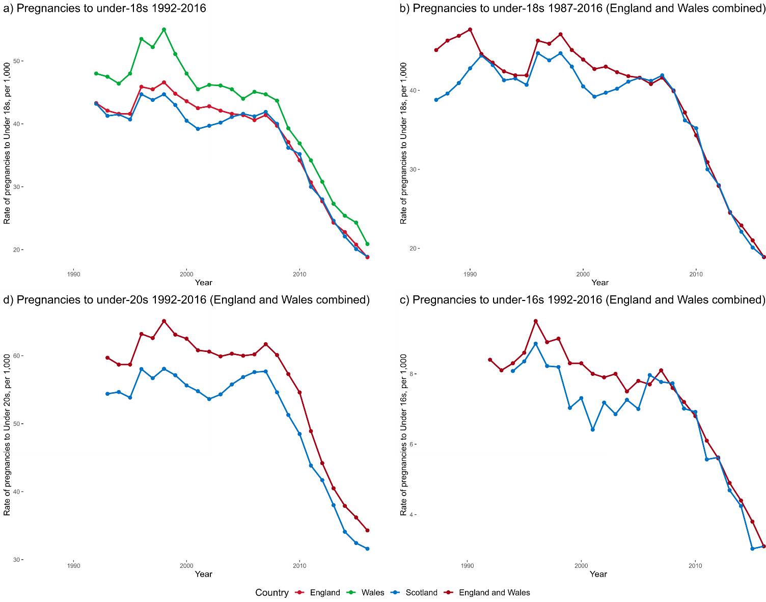
England saw a 60% drop in pregnancies between 1998 and 2016, from 46.6 to 18.8 pregnancies per 1,000 women. Scotland rates fell by 58% (from 44.7 to 18.9 pregnancies per 1,000 women) and Wales by 62% (from 55.0 to 20.9 pregnancies per 1,000 women). England and Wales combined showed decreases in pregnancies amongst under-16 and under-20-year-olds of 66% and 47% respectively, with Scotland seeing similar drops of 62% and 46%. When comparing England under-18 pregnancy rates with aggregated England and Wales rates, we found very little difference between the two, with an average prediction error of 0.25 pregnancies per 1,000 women across all observed years.

England 1992 - 2016
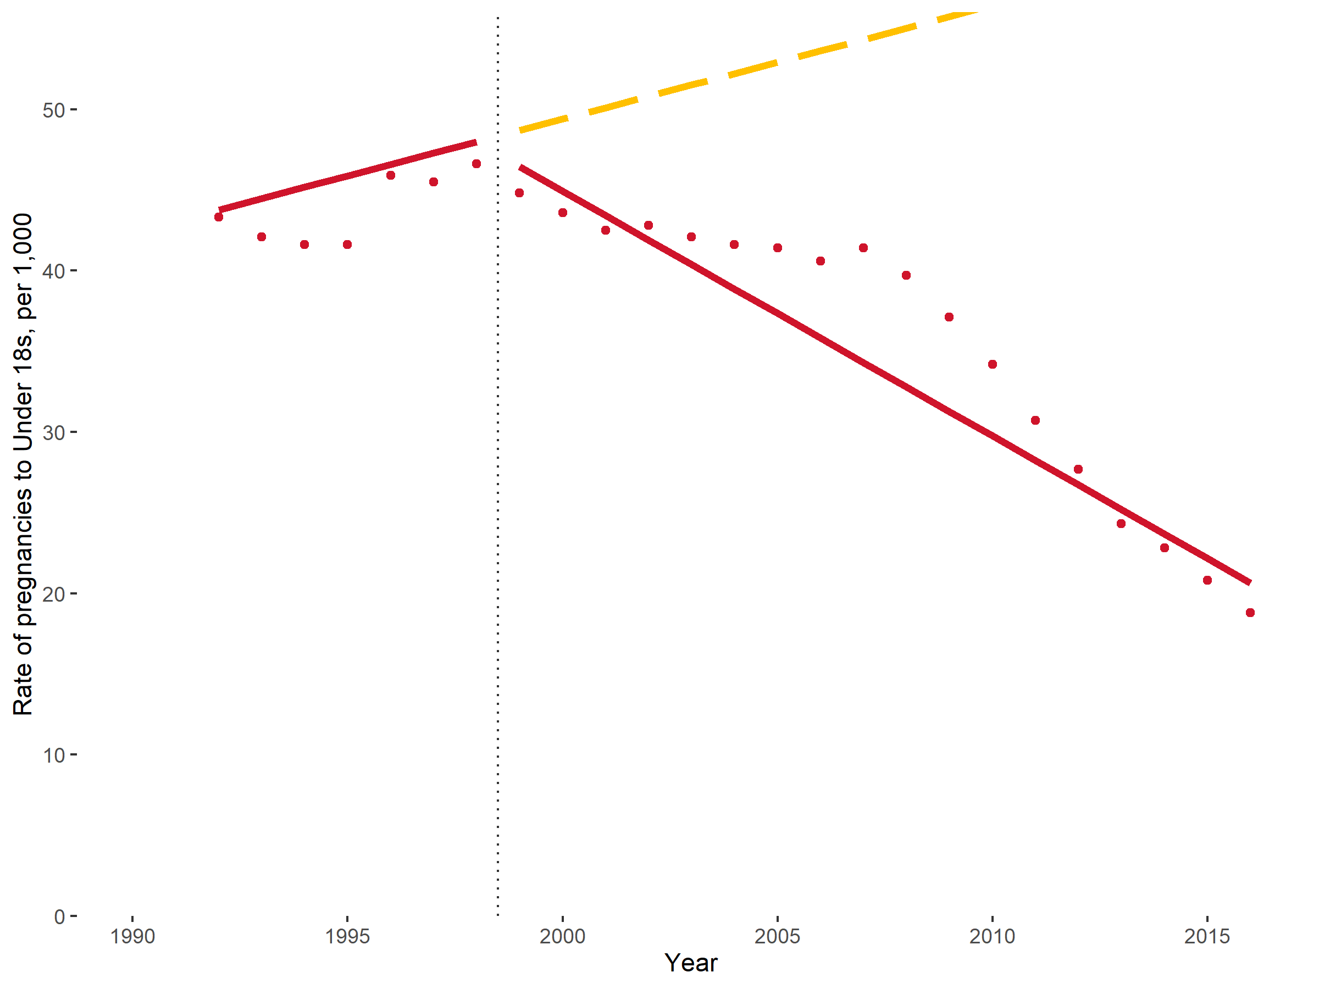
Autocorrelation correction: AR1, MA0
MSPE = 10.6
R² = 0.932
Coefficient | Value | Std.Error | Lower CI | Upper CI
England (est) rate at 1991 | 43.060 | 3.463 | 36.273 | 49.847
England base trend | 0.704 | 0.530 | -0.335 | 1.743
England change in level at intervention | -0.032 | 1.553 | -3.076 | 3.012
England change in trend at intervention | -2.221 | 0.646 | -3.488 | -0.954

England 1992 – 2016 with 1996-1998 ‘pill scare’ corrector
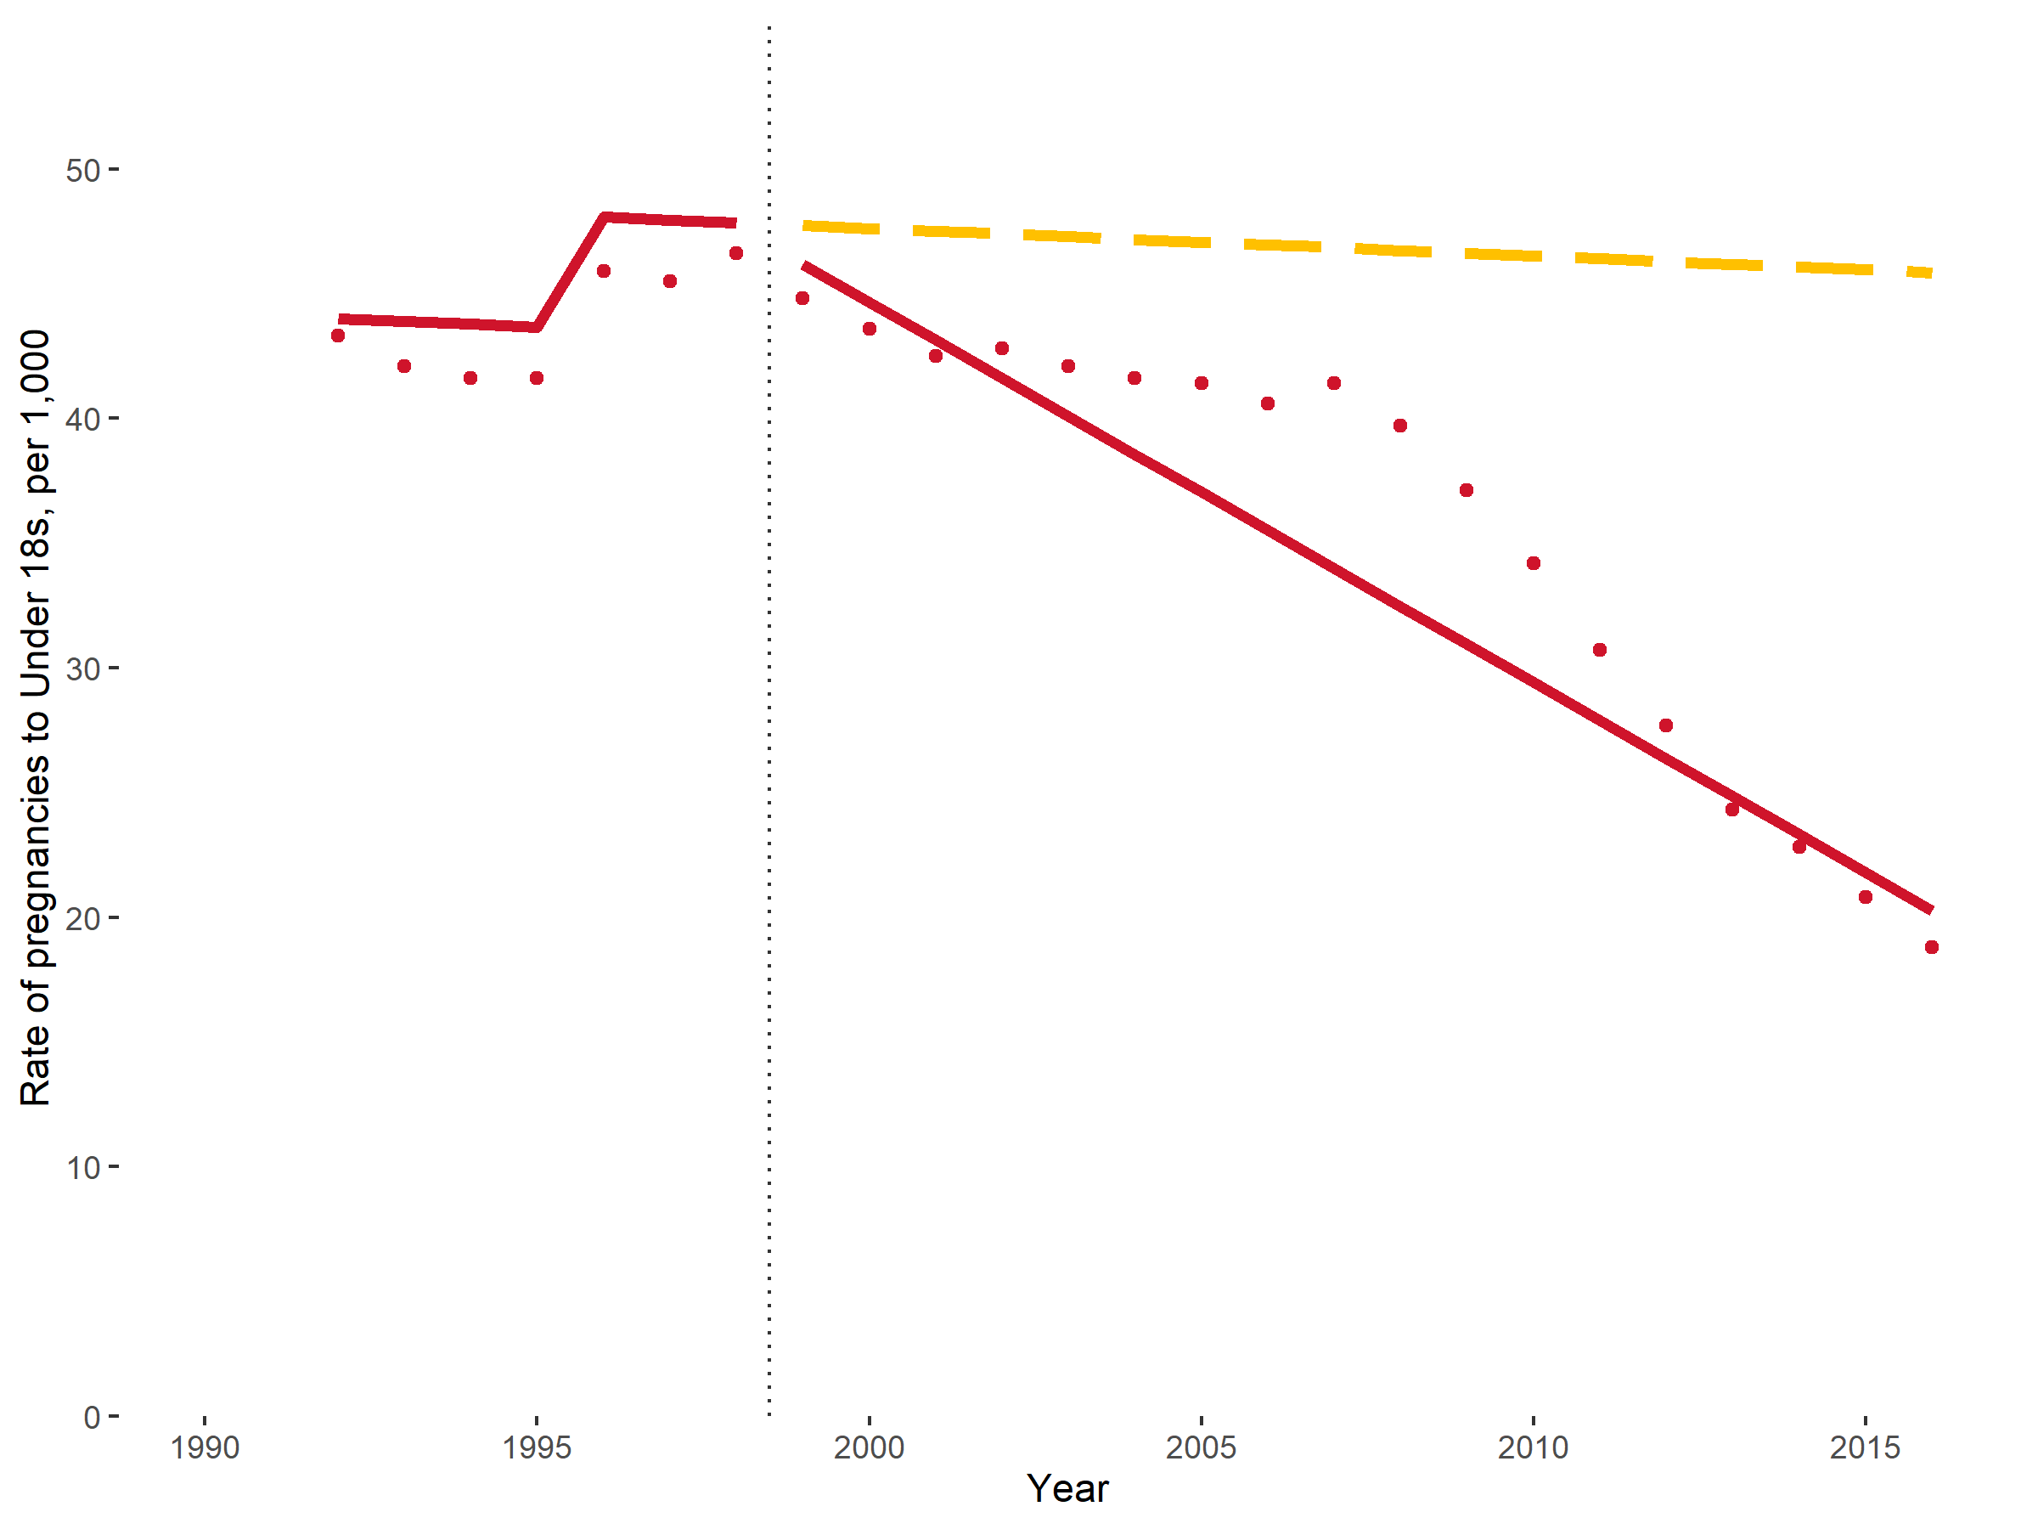
Autocorrelation correction: AR1, MA0
MSPE = 10.8
R² = 0.935
Coefficient | Value | Std.Error | Lower CI | Upper CI
England (est) rate at 1991 | 44.110 | 3.335 | 37.573 | 50.647
England base trend | -0.111 | 0.506 | -1.103 | 0.881
England change in level at intervention | -0.144 | 1.265 | -2.623 | 2.336
England change in trend at intervention | -1.412 | 0.596 | -2.580 | -0.244
‘Pill Scare’ corrector | 4.507 | 1.361 | 1.840 | 7.174

England compared with Scotland 1992 - 2016
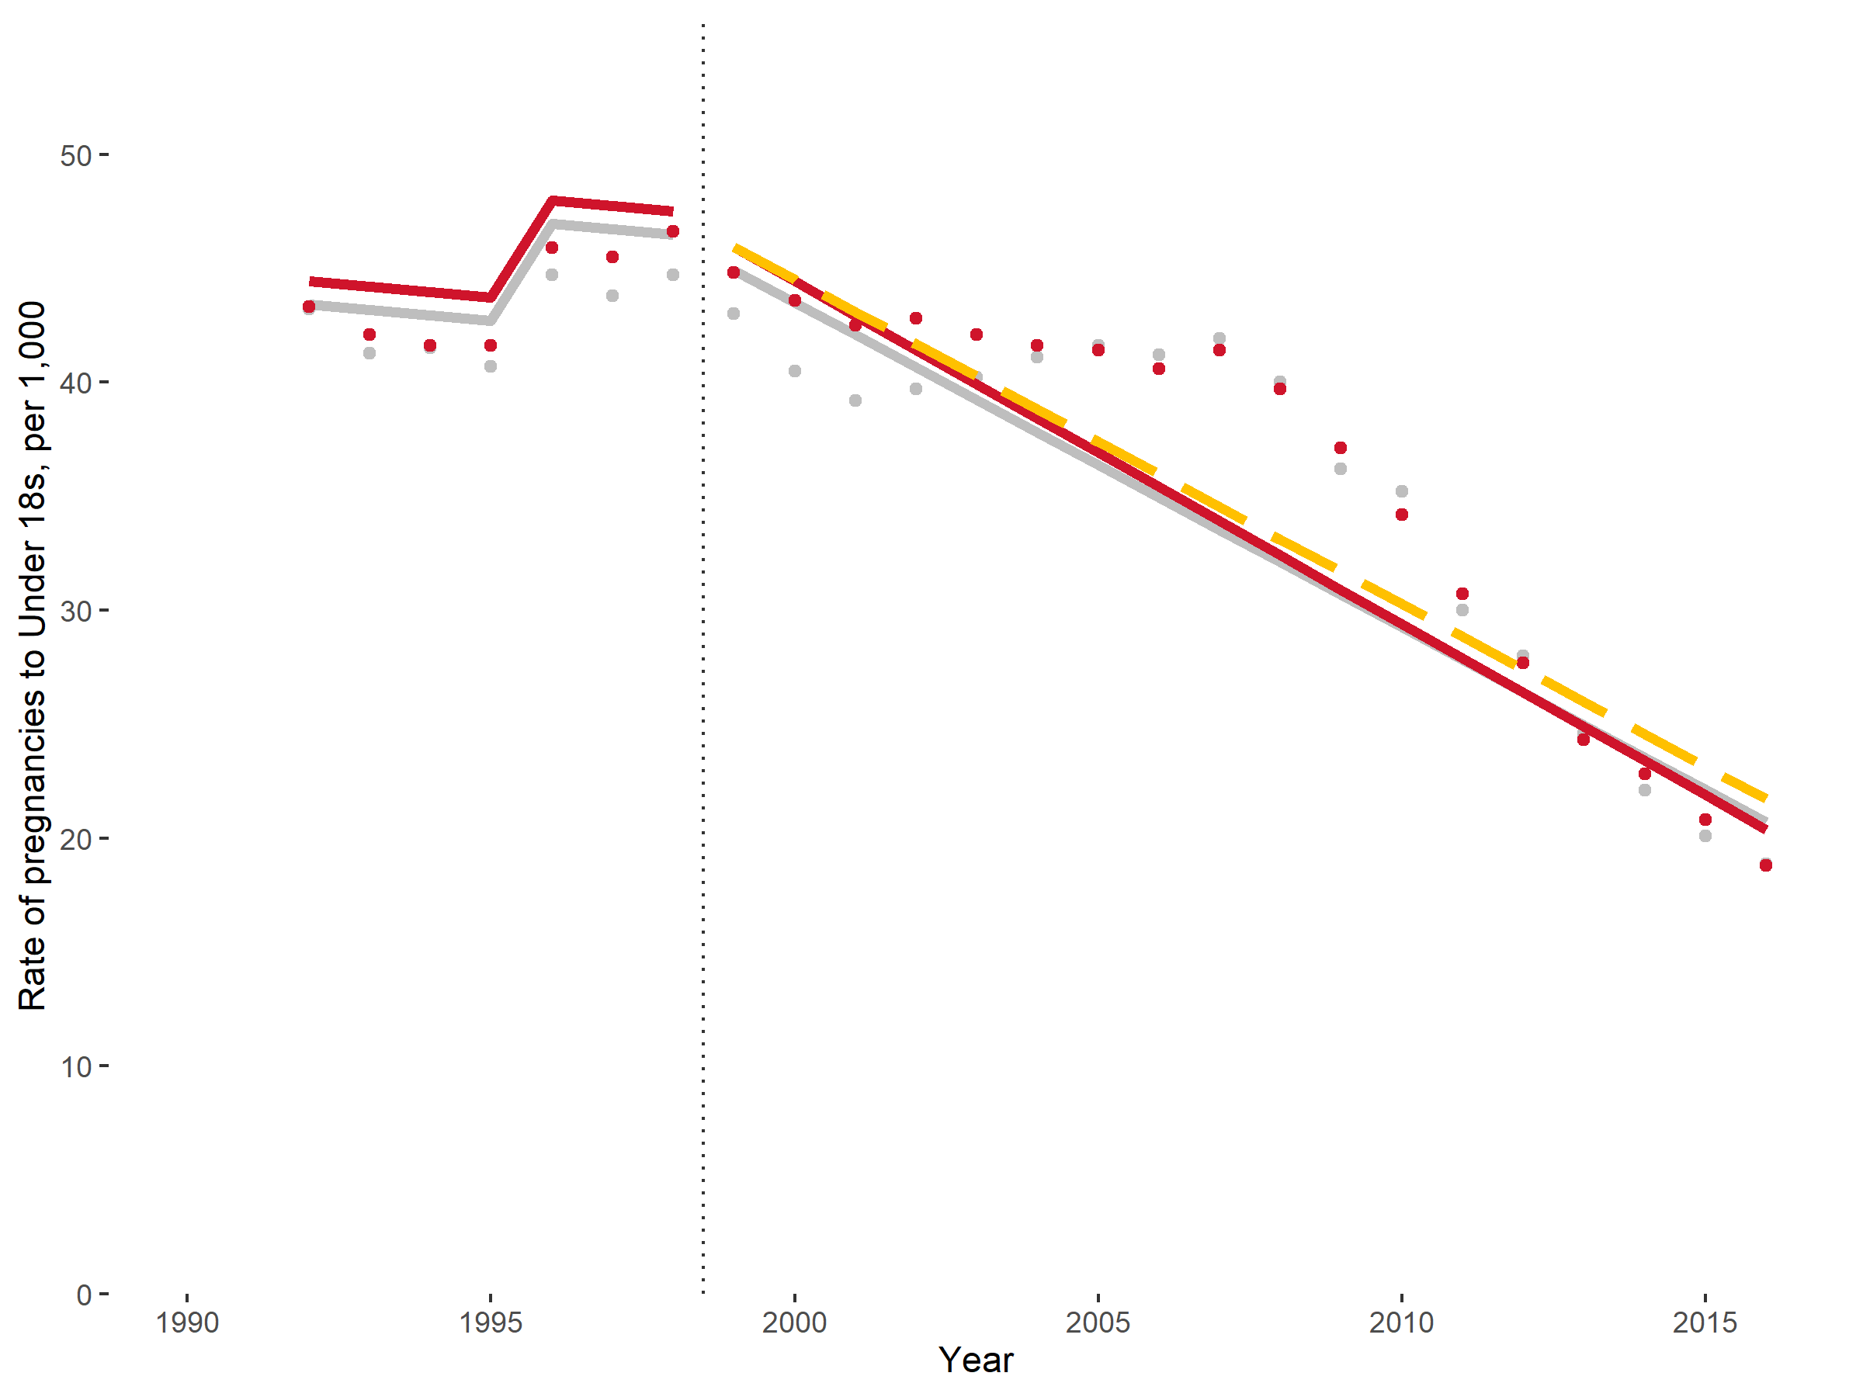
Autocorrelation correction: AR1, MA0
MSPE = 12.4
R² = 0.918
Coefficient | Value | Std.Error | Lower CI | Upper CI
Scotland (est) rate at 1991 | 43.651 | 3.285 | 37.213 | 50.089
Scotland base trend | -0.239 | 0.413 | -1.048 | 0.571
England difference in rate at 1991 | 1.018 | 4.121 | -7.059 | 9.094
Scotland change in level at intervention | -0.143 | 1.479 | -3.041 | 2.755
Scotland change in trend at intervention | -1.187 | 0.515 | -2.195 | -0.178
England difference in level from control at intervention | 0.064 | 2.090 | -4.032 | 4.160
England difference in trend from control at intervention | -0.077 | 0.339 | -0.742 | 0.587
‘Pill Scare’ corrector | 4.509 | 1.129 | 2.295 | 6.723

England compared with Wales 1992 - 2016
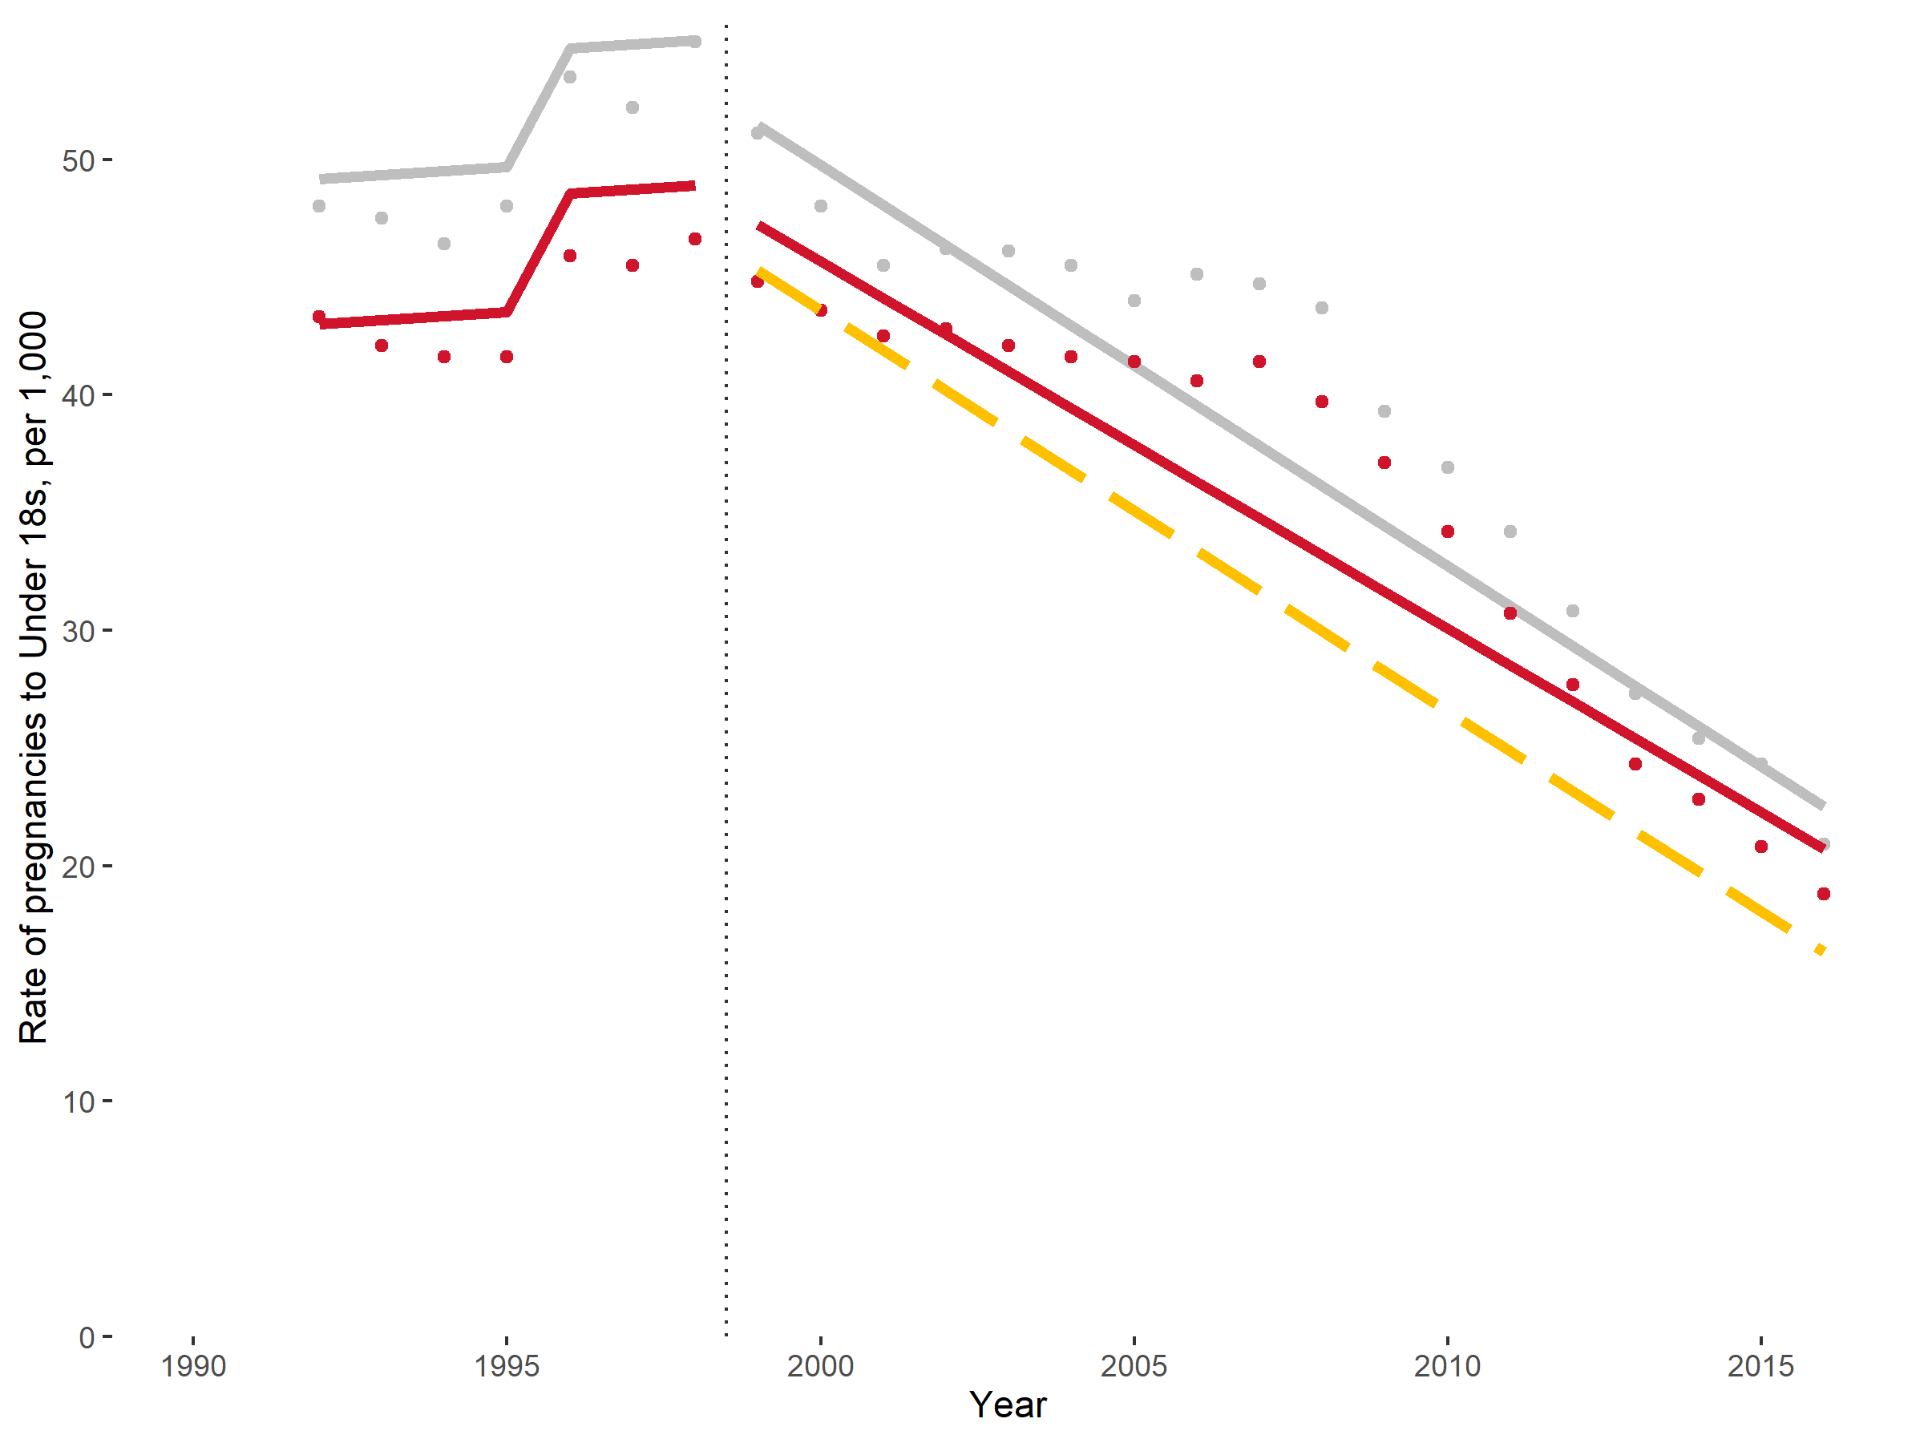
Autocorrelation correction: AR1, MA0
MSPE = 9.42
R² = 0.951
Coefficient | Value | Std.Error | Lower CI | Upper CI
Wales (est) rate at 1991 | 48.988 | 2.950 | 43.206 | 54.769
Wales base trend | 0.170 | 0.406 | -0.626 | 0.966
England difference in rate at 1991 | -6.158 | 3.598 | -13.210 | 0.893
Wales change in level at intervention | -1.903 | 1.482 | -4.808 | 1.001
Wales change in trend at intervention | -1.872 | 0.502 | -2.855 | -0.889
England difference in level from control at intervention | 1.807 | 2.093 | -2.295 | 5.908
England difference in trend from control at intervention | 0.143 | 0.315 | -0.475 | 0.760
‘Pill Scare’ corrector | 4.864 | 1.139 | 2.631 | 7.097

England compared with Scotland 1992 – 2016 with 2008 common shock
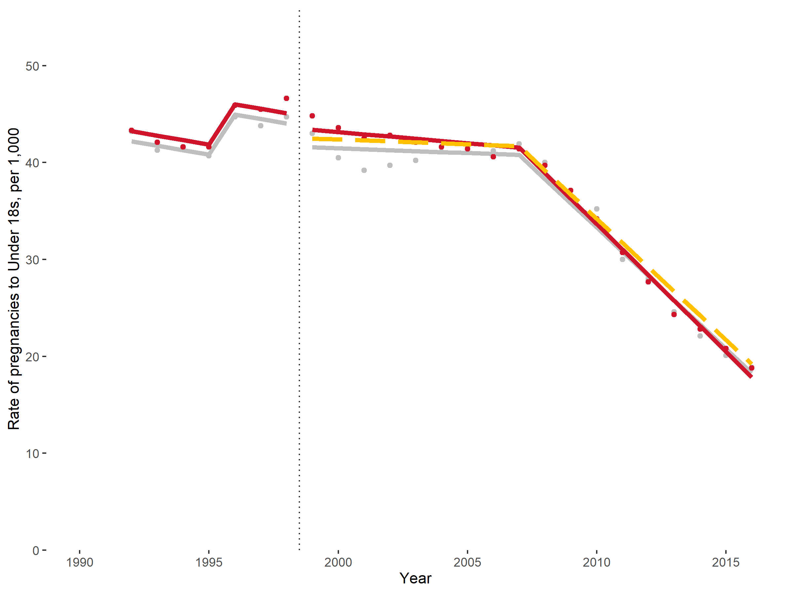
Autocorrelation correction: AR1, MA0
MSPE = 0.793
R² = 0.994
Coefficient | Value | Std.Error | Lower CI | Upper CI
Scotland (est) rate at 1991 | 42.654 | 0.872 | 40.945 | 44.363
Scotland base trend | -0.460 | 0.225 | -0.902 | -0.019
England difference in rate at 1991 | 1.040 | 0.757 | -0.443 | 2.523
Scotland change in level at intervention | -2.376 | 0.897 | -4.134 | -0.619
Scotland change in trend at intervention | 0.363 | 0.265 | -0.157 | 0.883
England difference in level from control at intervention | 0.896 | 1.104 | -1.267 | 3.059
England difference in trend from control at intervention | -0.131 | 0.088 | -0.304 | 0.041
Change in trend at 2008 common shock | -2.403 | 0.172 | -2.740 | -2.065
‘Pill Scare’ corrector | 4.610 | 0.855 | 2.933 | 6.287

England compared with Wales 1992 - 2016 with 2008 common shock
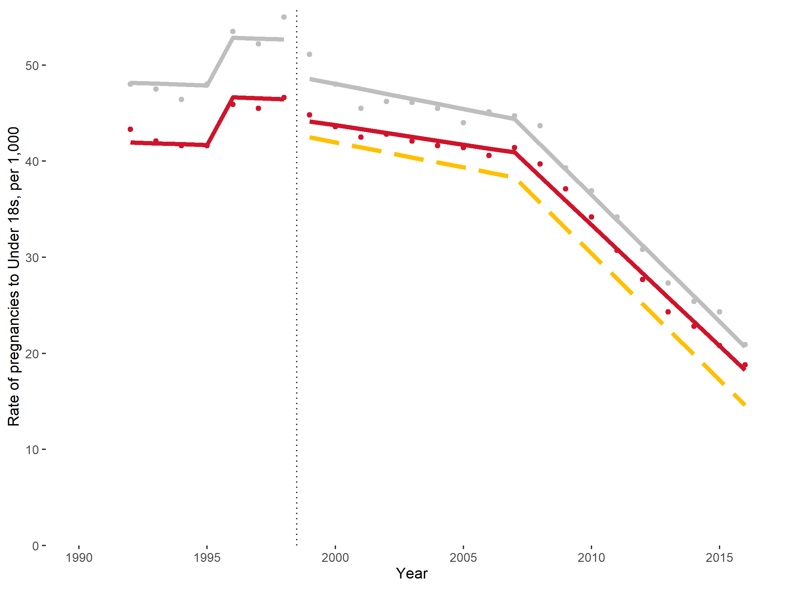
Autocorrelation correction: AR1, MA0
MSPE = 0.863
R² = 0.995
Coefficient | Value | Std.Error | Lower CI | Upper CI
Wales (est) rate at 1991 | 48.244 | 0.894 | 46.492 | 49.995
Wales base trend | -0.091 | 0.246 | -0.573 | 0.391
England difference in rate at 1991 | -6.200 | 0.741 | -7.653 | -4.748
Wales change in level at intervention | -3.575 | 0.944 | -5.425 | -1.726
Wales change in trend at intervention | -0.430 | 0.280 | -0.980 | 0.119
England difference in level from control at intervention | 1.666 | 1.127 | -0.543 | 3.874
England difference in trend from control at intervention | 0.117 | 0.087 | -0.054 | 0.288
Change in trend at 2008 common shock | -2.113 | 0.172 | -2.449 | -1.777
‘Pill Scare’ corrector | 5.050 | 0.957 | 3.175 | 6.925

England and Wales compared with Scotland 1987 - 2016
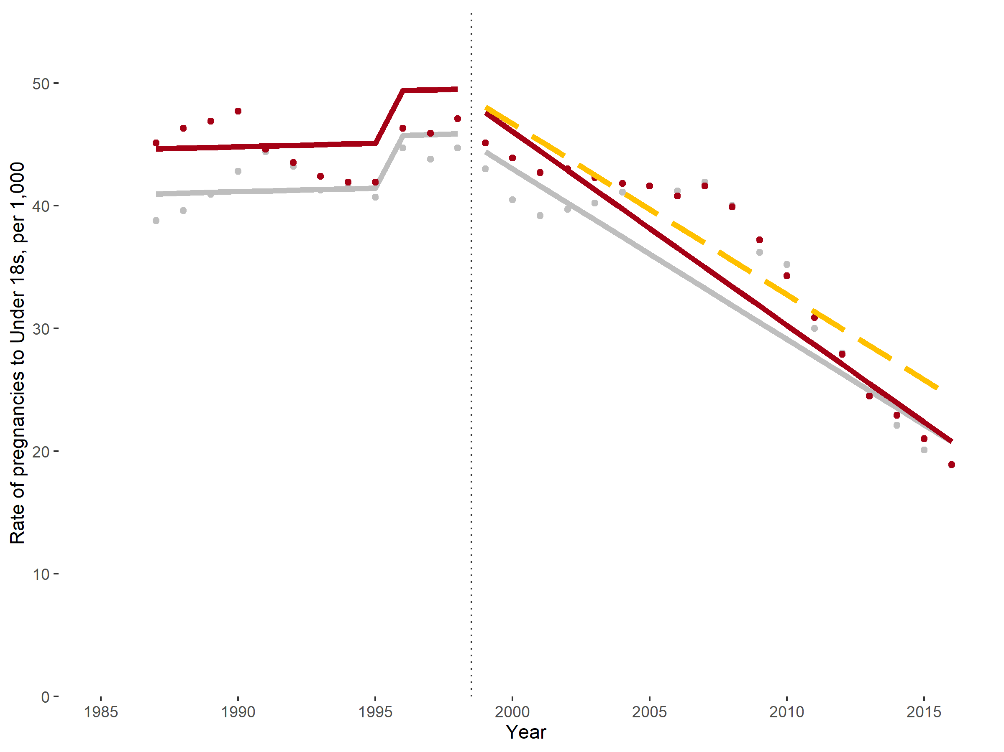
Autocorrelation correction: AR1, MA0
MSPE = 10.5
R² = 0.924
Coefficient | Value | Std.Error | Lower CI | Upper CI
Scotland (est) rate at 1986 | 40.918 | 2.970 | 35.098 | 46.739
Scotland base trend | 0.058 | 0.261 | -0.454 | 0.570
England and Wales difference in rate at 1986 | 3.660 | 3.518 | -3.235 | 10.554
Scotland change in level at intervention | -0.061 | 1.506 | -3.013 | 2.891
Scotland change in trend at intervention | -1.449 | 0.389 | -2.211 | -0.686
England and Wales difference in level from control at intervention | -0.258 | 2.127 | -4.426 | 3.910
England and Wales difference in trend from control at intervention | -0.188 | 0.322 | -0.818 | 0.443
‘Pill Scare’ corrector | 4.238 | 1.100 | 2.081 | 6.395

England and Wales compared with Scotland 1987 - 2016 with 2008 common shock
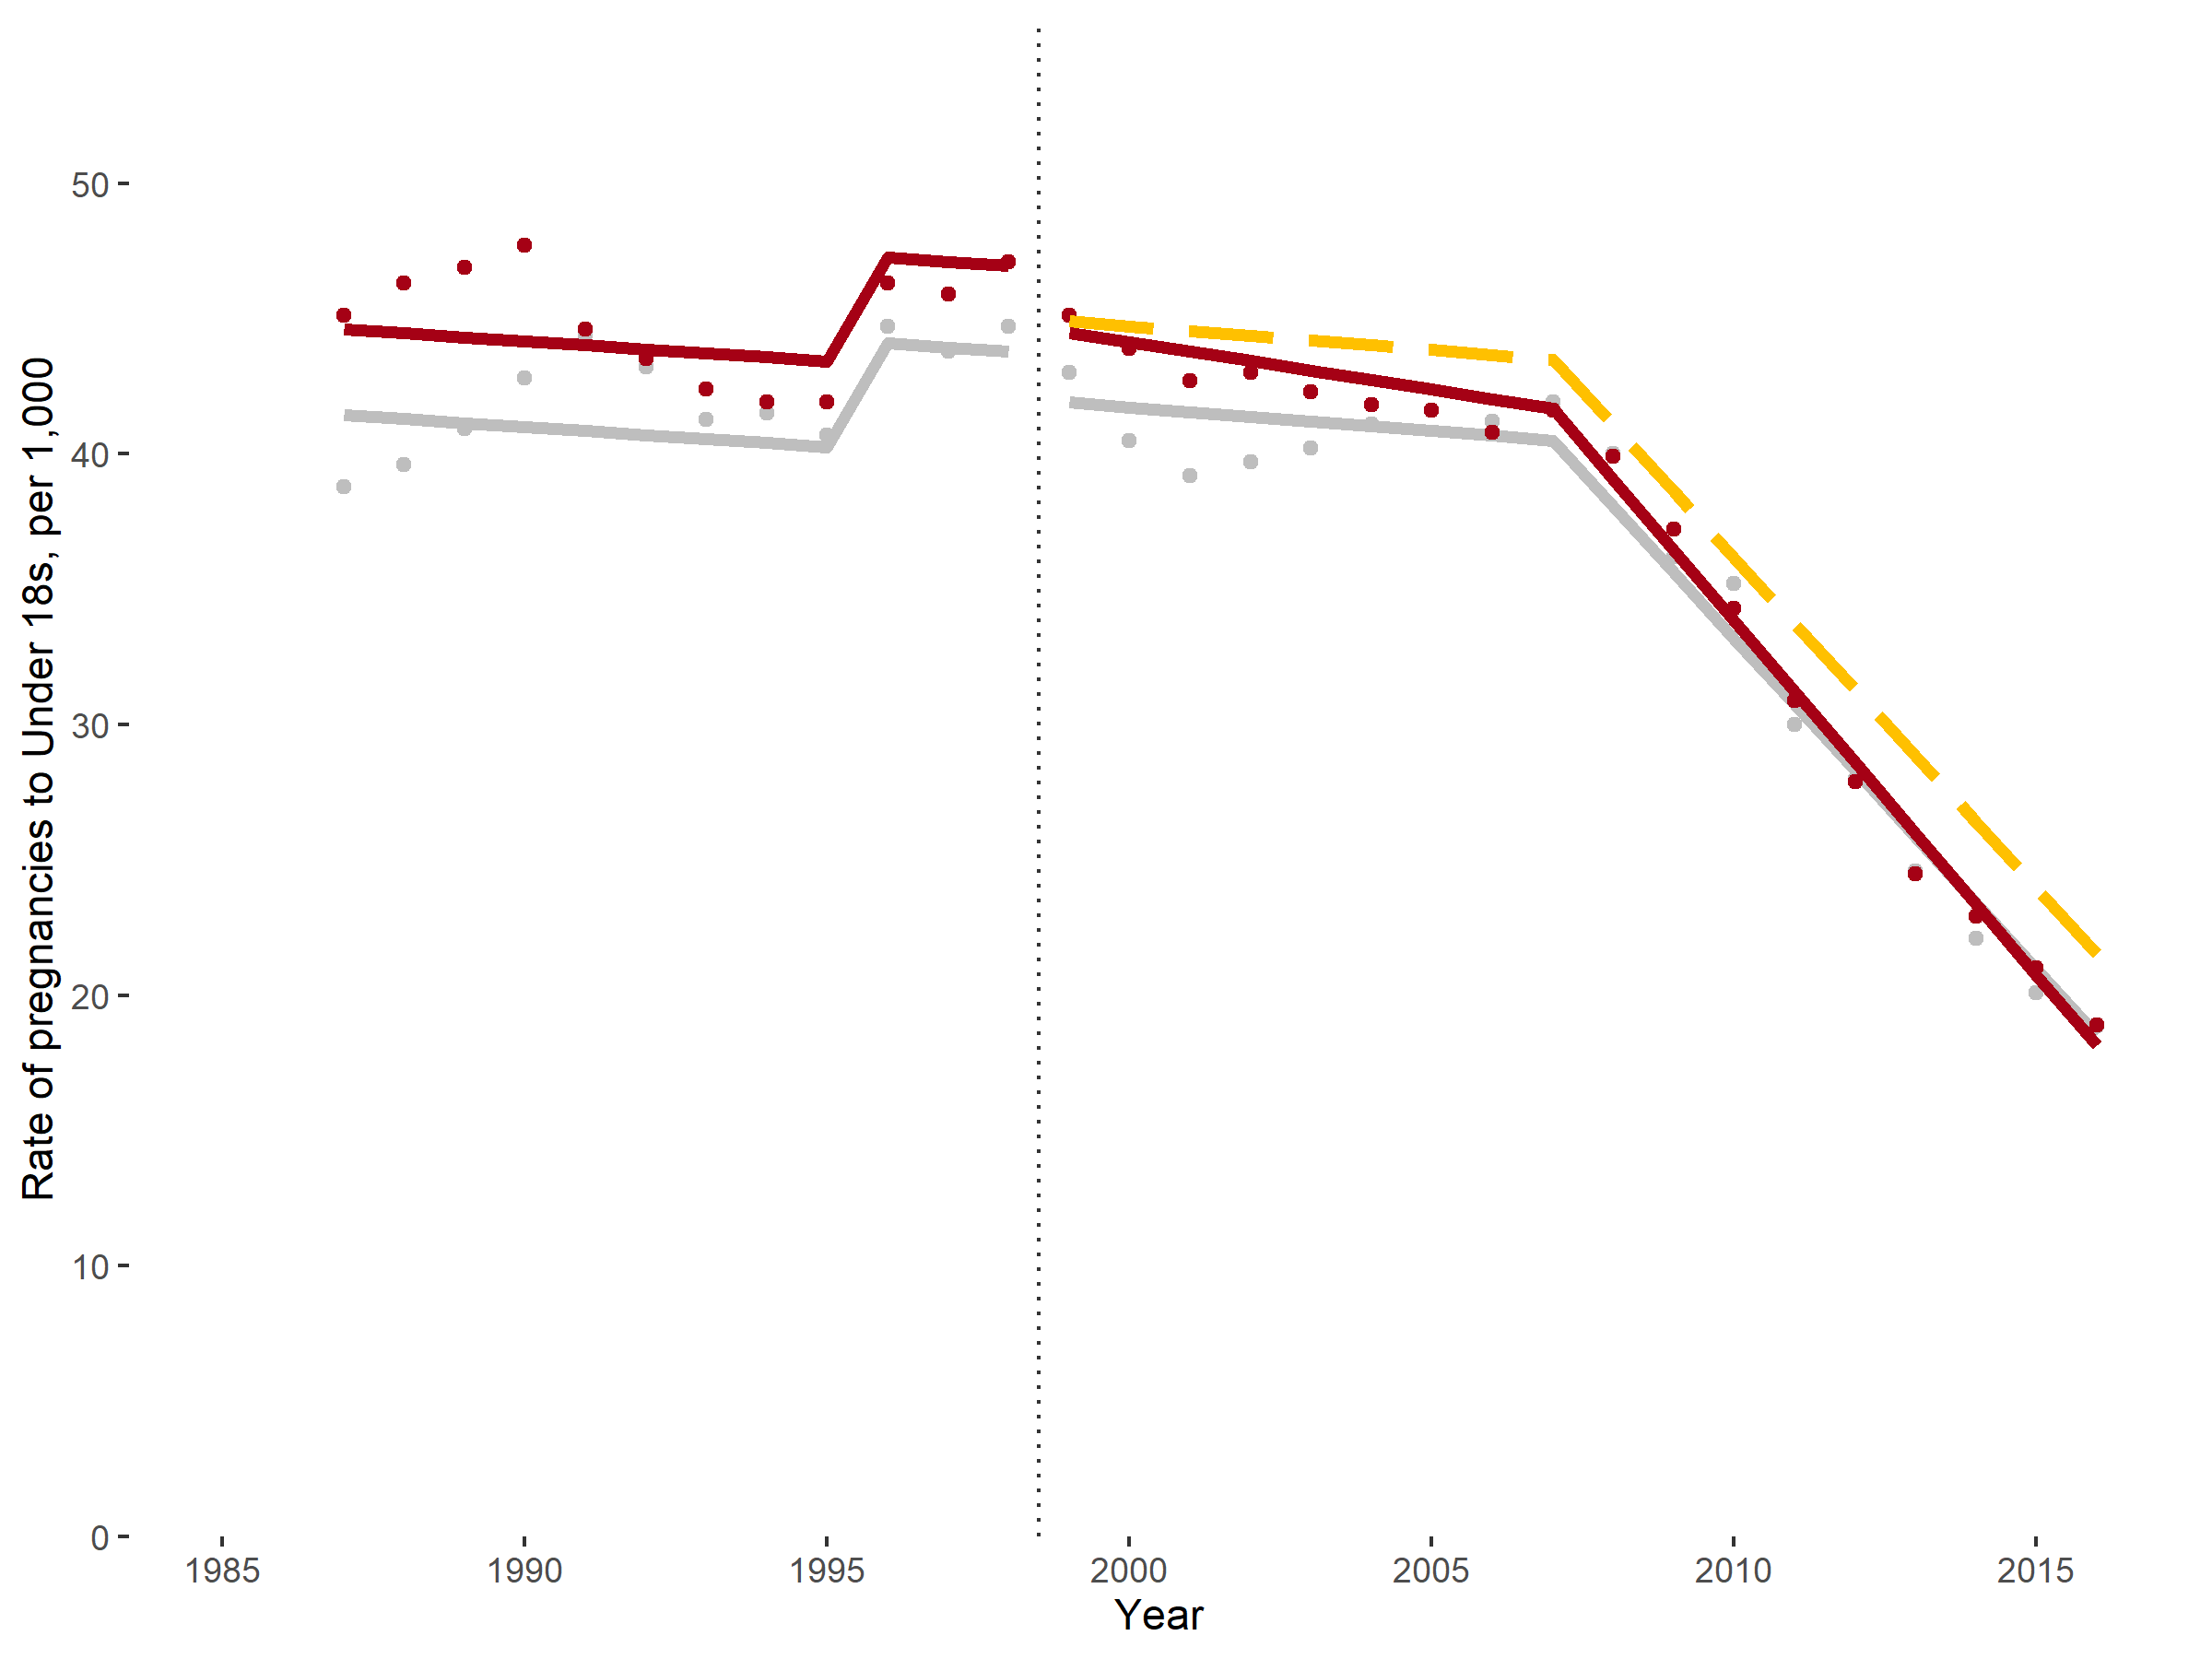
Autocorrelation correction: AR1, MA0
MSPE = 1.77
R² = 0.986
Coefficient | Value | Std.Error | Lower CI | Upper CI
Scotland (est) rate at 1986 | 41.591 | 1.181 | 39.277 | 43.906
Scotland base trend | -0.148 | 0.149 | -0.439 | 0.143
England and Wales difference in rate at 1986 | 3.167 | 1.132 | 0.948 | 5.386
Scotland change in level at intervention | -1.709 | 1.143 | -3.950 | 0.533
Scotland change in trend at intervention | -0.027 | 0.257 | -0.530 | 0.476
England and Wales difference in level from control at intervention | -0.414 | 1.506 | -3.365 | 2.538
England and Wales difference in trend from control at intervention | -0.175 | 0.144 | -0.457 | 0.108
Change in trend at 2008 common shock | -2.266 | 0.273 | -2.802 | -1.730
‘Pill Scare’ corrector | 3.975 | 0.870 | 2.269 | 5.680

England and Wales under-20 pregnancies compared with Scotland 1990 - 2016
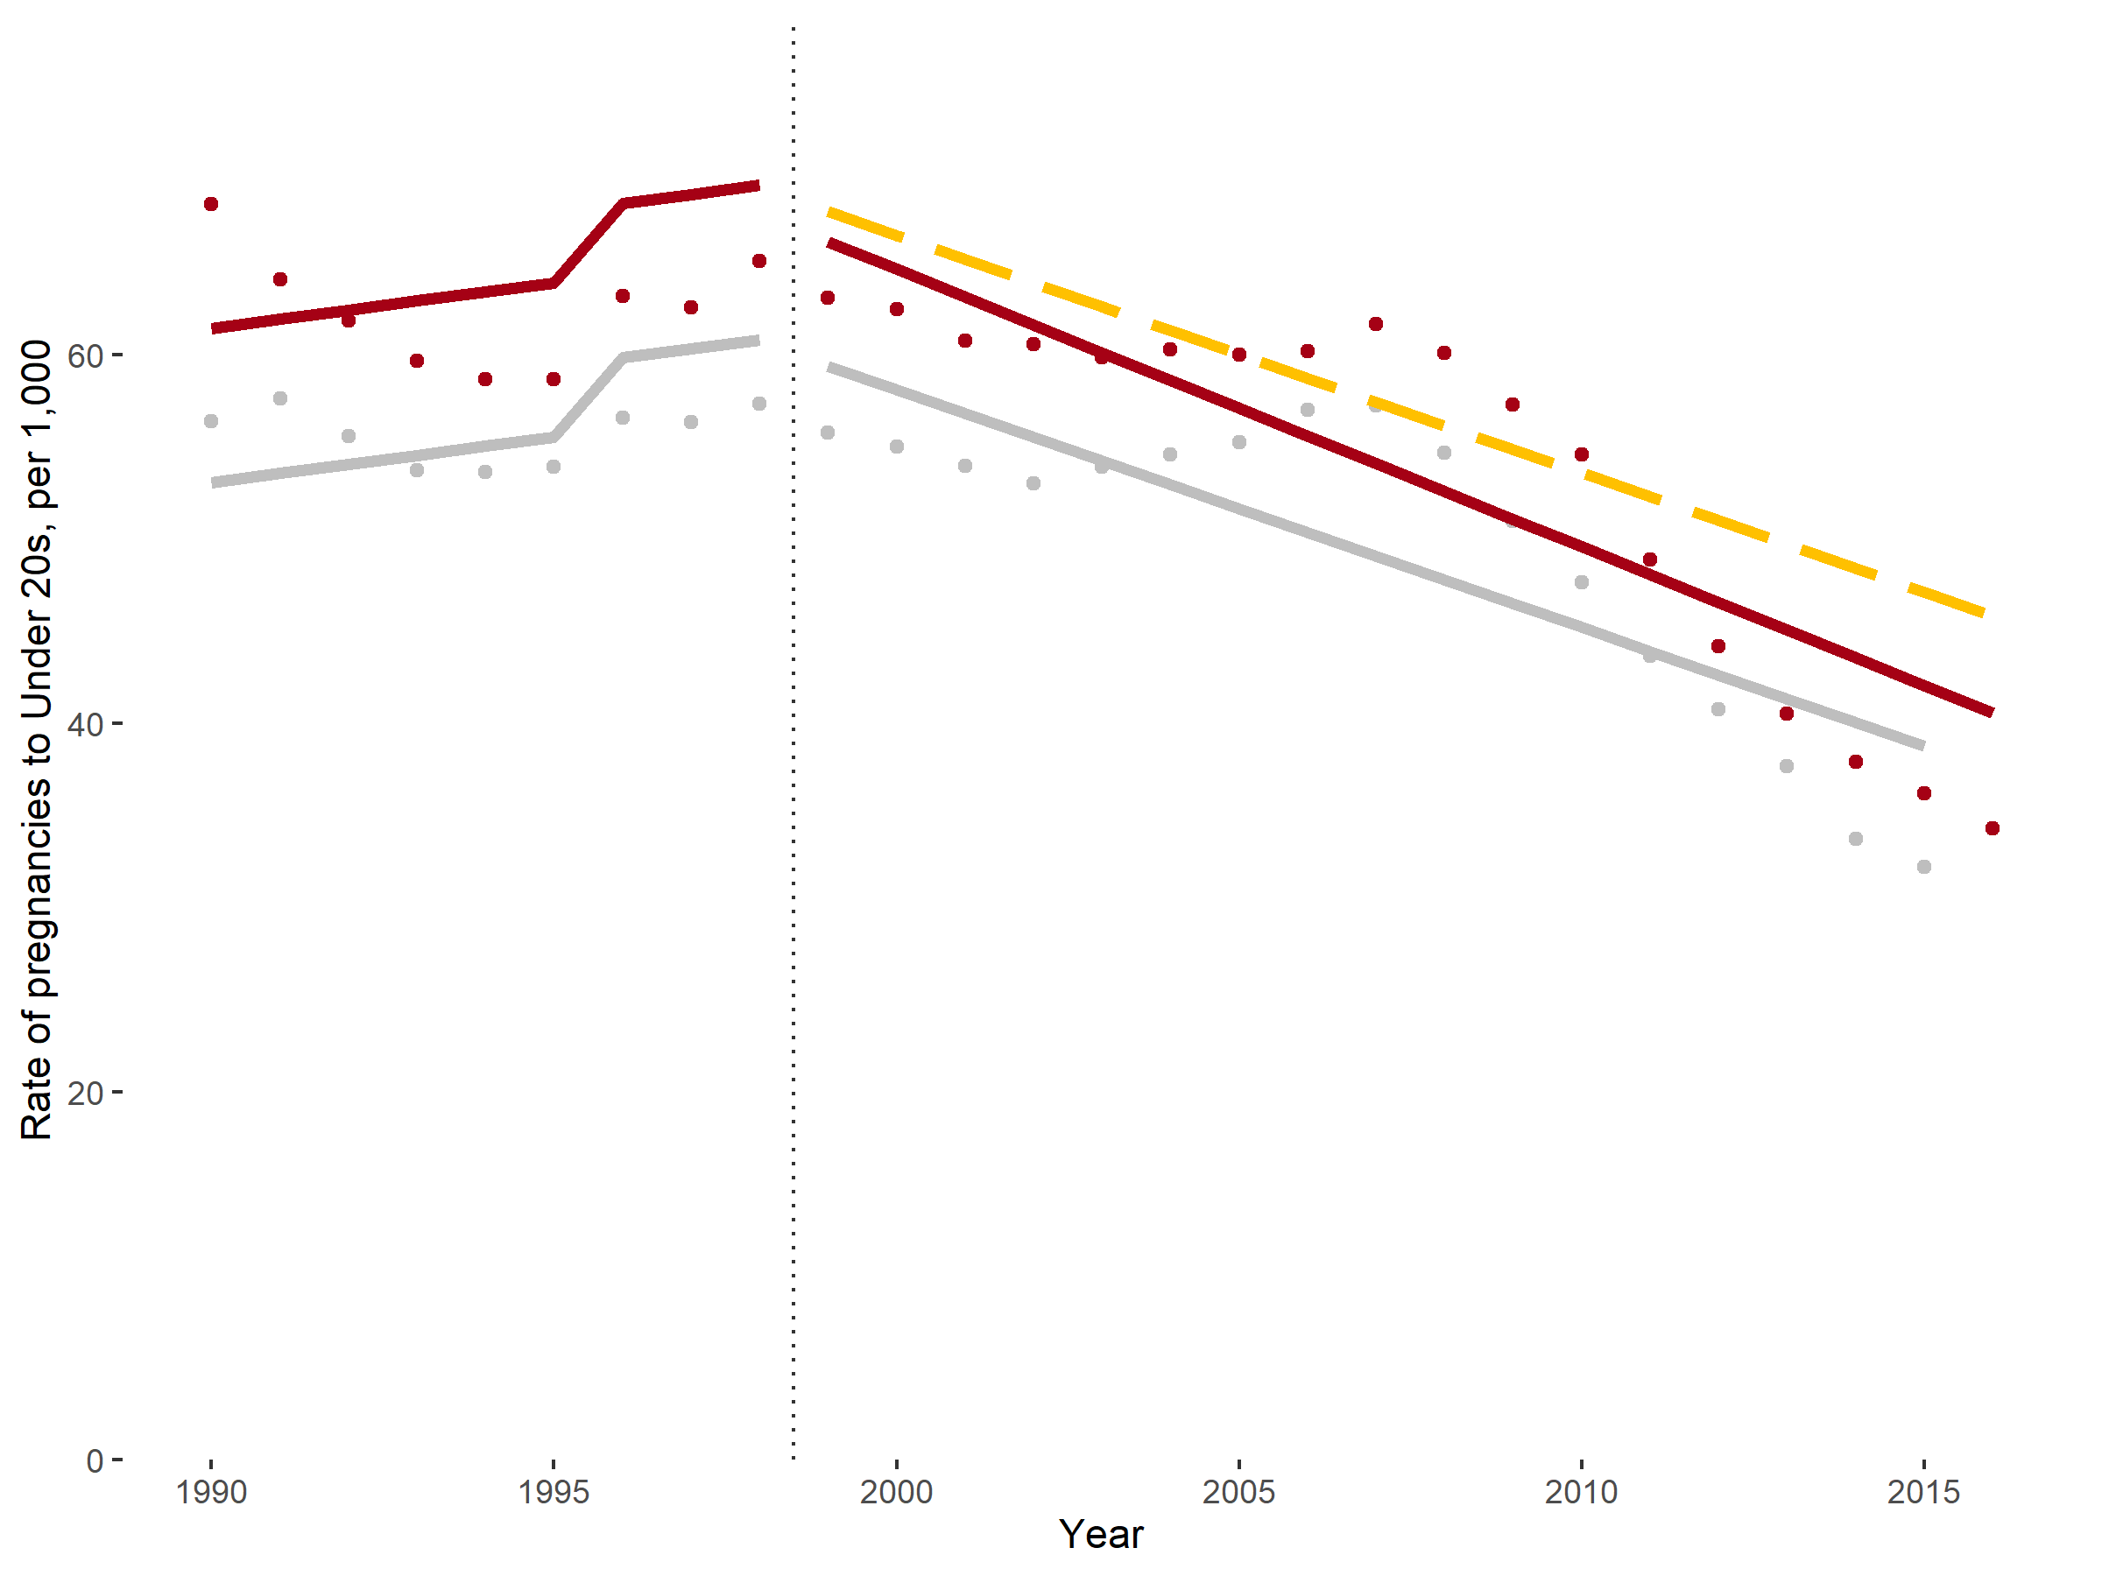
Autocorrelation correction: AR2, MA1
MSPE = 18.2
R² = 0.875
Coefficient | Value | Std.Error | Lower CI | Upper CI
Scotland (est) rate at 1989 | 52.597 | 2.001 | 48.675 | 56.519
Scotland base trend | 0.493 | 0.318 | -0.131 | 1.116
England and Wales difference in rate at 1989 | 8.382 | 0.968 | 6.486 | 10.278
Scotland change in level at intervention | -0.145 | 1.223 | -2.541 | 2.252
Scotland change in trend at intervention | -1.784 | 0.420 | -2.607 | -0.960
England and Wales difference in level from control at intervention | -1.414 | 1.717 | -4.780 | 1.951
England and Wales difference in trend from control at intervention | -0.216 | 0.163 | -0.535 | 0.104
‘Pill Scare’ corrector | 3.822 | 0.873 | 2.110 | 5.533

England and Wales under-20 pregnancies compared with Scotland 1990 - 2016 with 2008 common shock
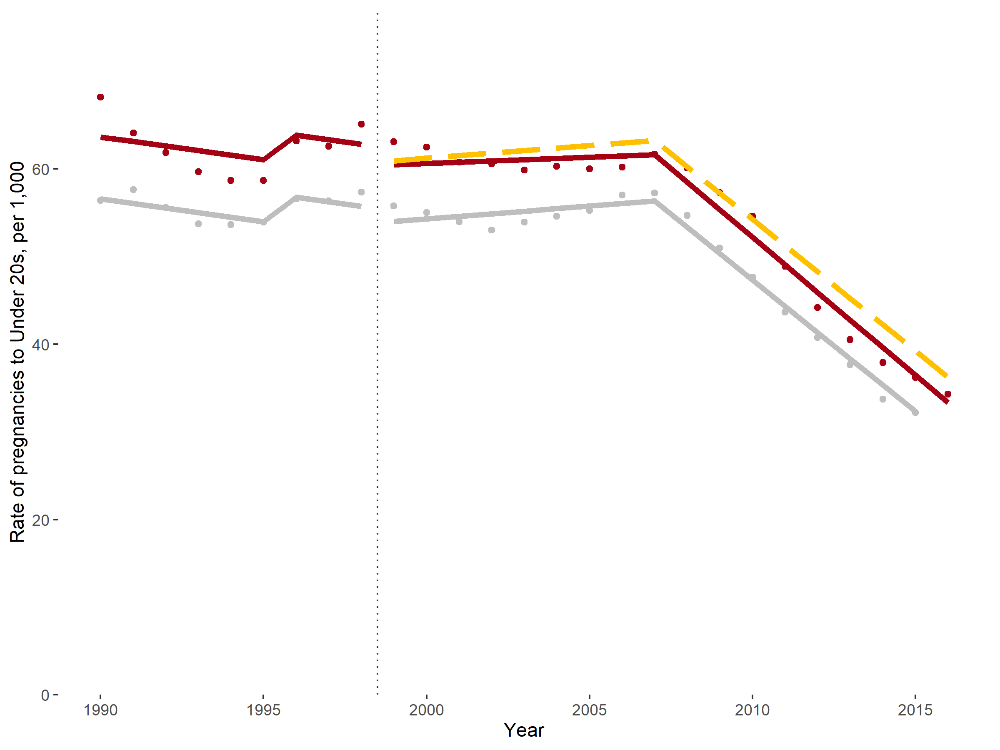
Autocorrelation correction: AR2, MA1
MSPE = 2.14
R² = 0.986
Coefficient | Value | Std.Error | Lower CI | Upper CI
Scotland (est) rate at 1989 | 57.123 | 0.683 | 55.784 | 58.462
Scotland base trend | -0.521 | 0.155 | -0.825 | -0.217
England and Wales difference in rate at 1989 | 7.056 | 0.268 | 6.530 | 7.582
Scotland change in level at intervention | -2.015 | 0.757 | -3.498 | -0.532
Scotland change in trend at intervention | 0.810 | 0.169 | 0.479 | 1.142
England and Wales difference in level from control at intervention | -0.441 | 0.617 | -1.651 | 0.768
England and Wales difference in trend from control at intervention | -0.146 | 0.046 | -0.237 | -0.055
Change in trend at 2008 common shock | -3.291 | 0.141 | -3.568 | -3.015
‘Pill Scare’ corrector | 3.326 | 0.783 | 1.792 | 4.859

England and Wales under-16 pregnancies compared with Scotland 1994 - 2016
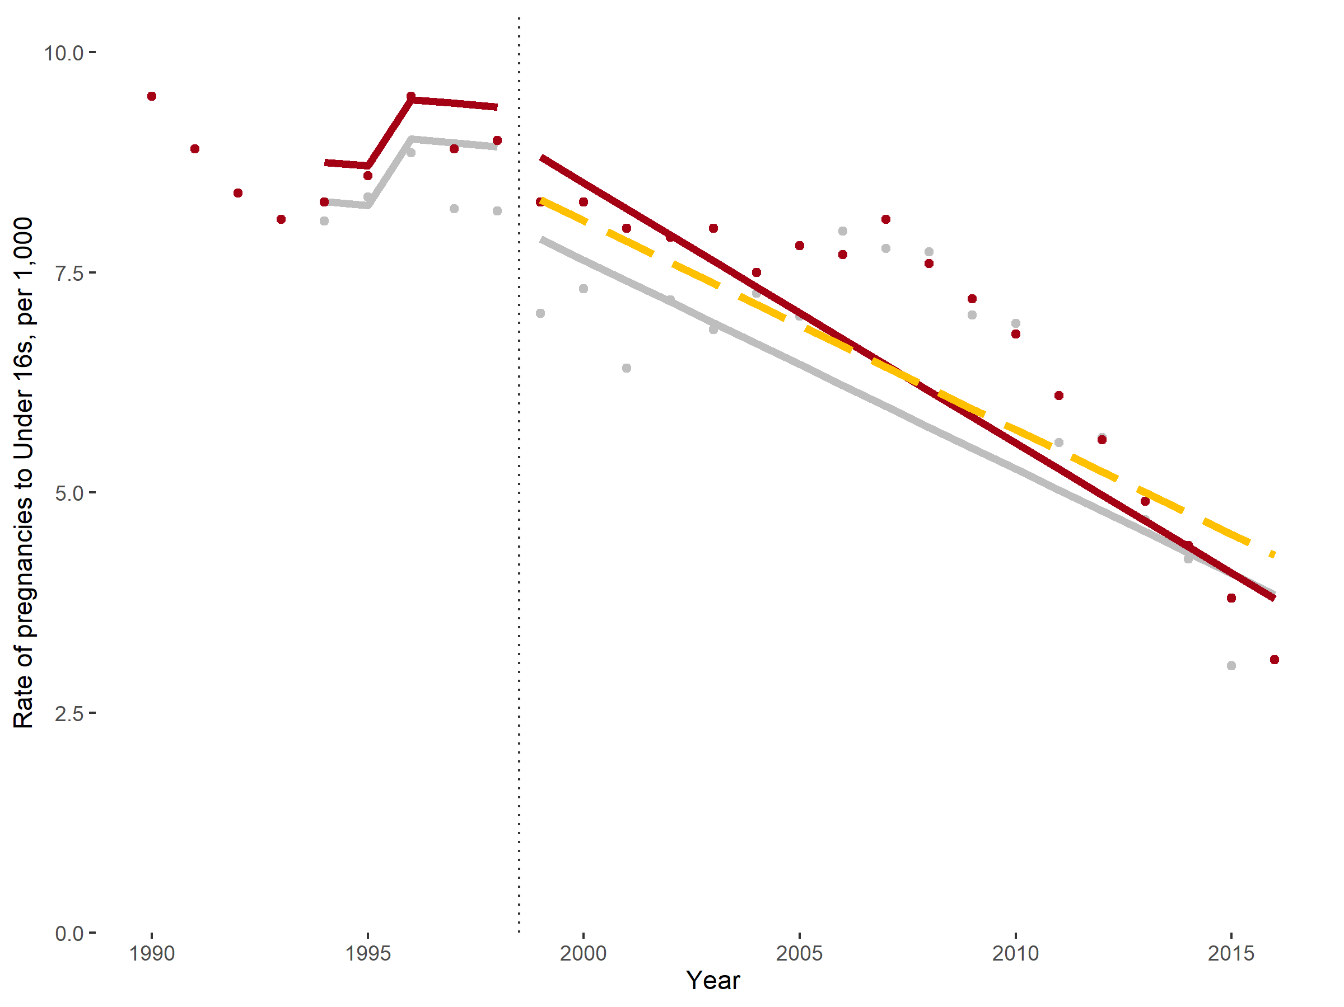
Autocorrelation correction: AR1, MA1
MSPE = 0.74
R² = 0.882
Coefficient | Value | Std.Error | Lower CI | Upper CI
Scotland (est) rate at 1993 | 8.348 | 0.898 | 6.587 | 10.108
Scotland base trend | -0.043 | 0.192 | -0.419 | 0.333
England and Wales difference in rate at 1993 | 0.447 | 1.061 | -1.633 | 2.527
Scotland change in level at intervention | -0.814 | 0.525 | -1.842 | 0.214
Scotland change in trend at intervention | -0.195 | 0.215 | -0.615 | 0.226
England and Wales difference in level from control at intervention | 0.543 | 0.738 | -0.905 | 1.990
England and Wales difference in trend from control at intervention | -0.058 | 0.097 | -0.247 | 0.132
‘Pill Scare’ corrector | 0.796 | 0.442 | -0.070 | 1.661

England and Wales under-16 pregnancies compared with Scotland 1994 - 2016 with 2008 common shock
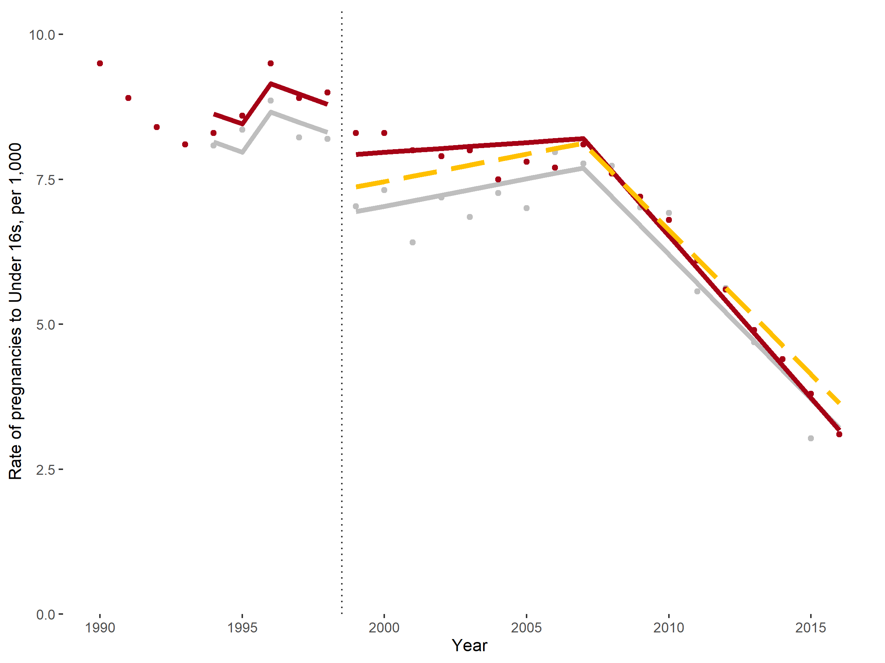
Autocorrelation correction: AR1, MA1
MSPE = 0.0983
R² = 0.982
Coefficient | Value | Std.Error | Lower CI | Upper CI
Scotland (est) rate at 1993 | 8.321 | 0.332 | 7.670 | 8.972
Scotland base trend | -0.176 | 0.140 | -0.450 | 0.097
England and Wales difference in rate at 1993 | 0.486 | 0.279 | -0.060 | 1.033
Scotland change in level at intervention | -1.461 | 0.330 | -2.108 | -0.814
Scotland change in trend at intervention | 0.271 | 0.147 | -0.017 | 0.559
England and Wales difference in level from control at intervention | 0.564 | 0.387 | -0.195 | 1.324
England and Wales difference in trend from control at intervention | -0.061 | 0.029 | -0.117 | -0.004
Change in trend at 2008 common shock | -0.593 | 0.055 | -0.701 | -0.485
‘Pill Scare’ corrector | 0.870 | 0.392 | 0.101 | 1.639

Synthetic Control analyses outputs
Outputted from https://github.com/andrewbaxter439/teen-preg-project/blob/master/Synth-report-updated.Rmd

Setting up data
Data from Human Mortality Database and Human Fertility Database was used to calculate birth rates. This was tidied to give Under-18 rates:
Code | Country | Year | rate | GDPperCap | MF_ratio | MobilePhones | UrbanPop
5 | Denmark | 1990 | 2.94 | 26891.44 | 1.04 | 2.88 | 84.84
5 | Denmark | 1991 | 2.65 | 27011.39 | 1.04 | 3.41 | 84.87
5 | Denmark | 1992 | 3.08 | 29569.65 | 1.04 | 4.08 | 84.90
5 | Denmark | 1993 | 2.90 | 27597.97 | 1.04 | 6.89 | 84.92
5 | Denmark | 1994 | 2.71 | 29995.57 | 1.05 | 9.66 | 84.95
5 | Denmark | 1995 | 2.19 | 35351.38 | 1.05 | 15.71 | 84.98

Abortion estimates were added to give Under-20 rates:
Code | Country | Year | pRate | rate | GDPperCap | MF_ratio | MobilePhones | UrbanPop
4 | Denmark | 1990 | 26.51 | 9.20 | 26891.44 | 1.05 | 2.88 | 84.84
4 | Denmark | 1991 | 25.33 | 9.00 | 27011.39 | 1.04 | 3.41 | 84.87
4 | Denmark | 1992 | 25.43 | 9.70 | 29569.65 | 1.04 | 4.08 | 84.90
4 | Denmark | 1993 | 24.81 | 9.14 | 27597.97 | 1.05 | 6.89 | 84.92
4 | Denmark | 1994 | 24.07 | 9.21 | 29995.57 | 1.05 | 9.66 | 84.95
4 | Denmark | 1995 | 23.08 | 8.72 | 35351.38 | 1.05 | 15.71 | 84.98

Iterating through year combinations
For each comparison, I iterated through all combinations of years as special
Predictors to minimise MSPE (whilst prioritising fewest groupings). For example, for the under-18 basic model with years as special
Predictors:
it_u18_sp <- testSynthIterations(
yrs = 1990:1998,
pred = "rate",
data = synthData_u18[,1:4],
ccodes = u_18_ccodes,
n = 4,
Predictors = NULL,
time.optimise = 1985:1998
) %>%
arrange(groups, mspe)

All countries, no additional Predictors

Model 1: Under-18 birth rates

All Countries graph
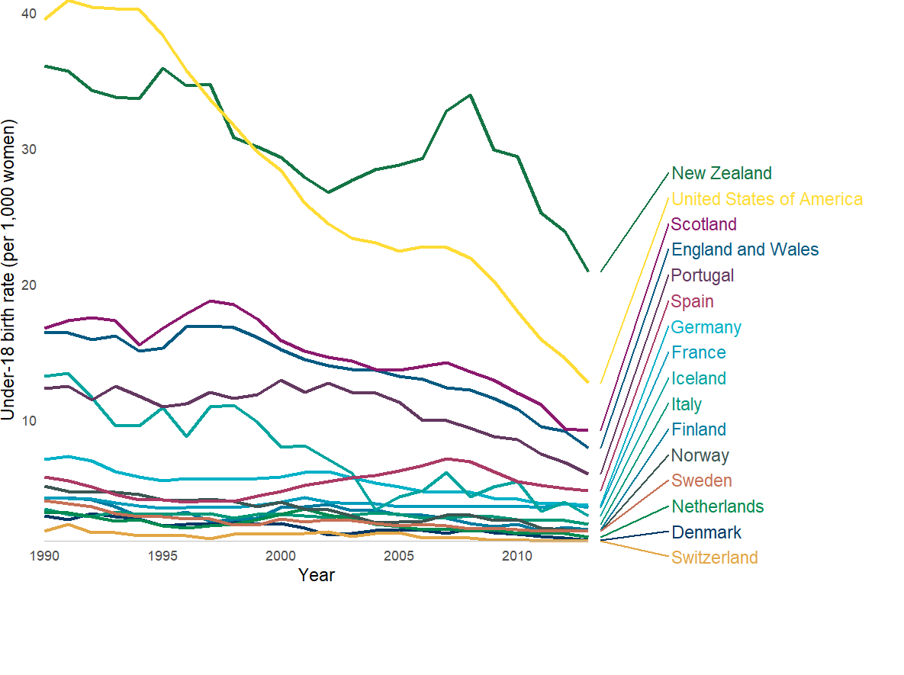

England vs Synthetic Control
Over the period 1999 to 2013, England and Wales saw a difference of -3,744 births (to an average population of 995,340 women).
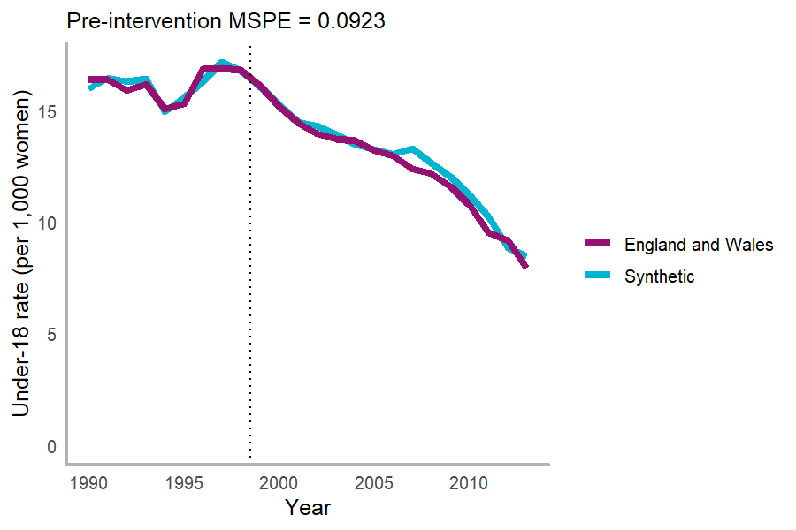

Weights and balance
Country weights
Country | Weight
Scotland | 0.672
Portugal | 0.295
United States of America | 0.016
New Zealand | 0.012
Iceland | 0.001
Sweden | 0.001
Switzerland | 0.000
Germany | 0.000
Denmark | 0.000
Spain | 0.000
Finland | 0.000
France | 0.000
Italy | 0.000
Netherlands | 0.000
Norway | 0.000

Predictor weights
 | v.weights
special.rate.1990.1993 | 0.01
special.rate.1994 | 0.333
special.rate.1995 | 0.295
special.rate.1996.1998 | 0.362

Predictor balance between synthetic and treated units
 | Treated | Synthetic | Sample Mean
special.rate.1990.1993 | 16.214 | 16.275 | 10.415
special.rate.1994 | 15.078 | 14.952 | 9.629
special.rate.1995 | 15.285 | 15.561 | 9.660
special.rate.1996.1998 | 16.836 | 16.728 | 9.257

Placebo testing by country and time
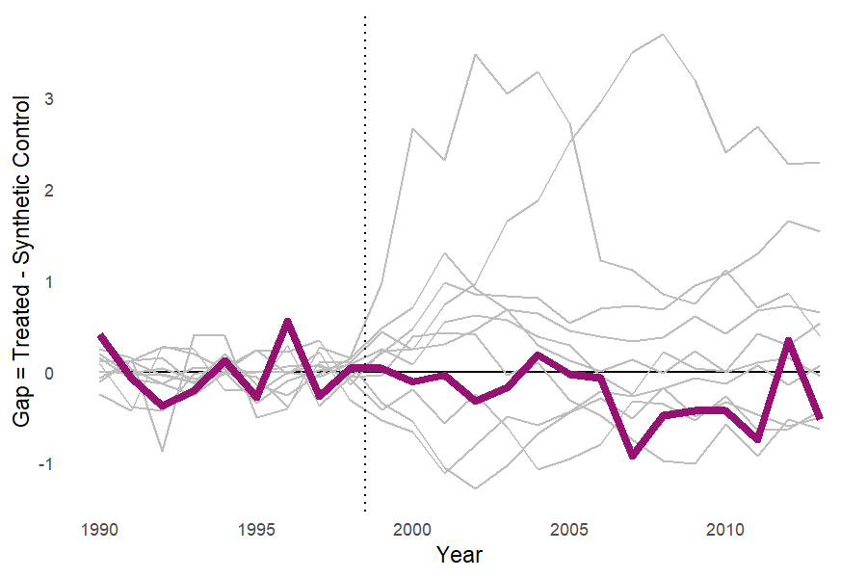
In placebo-country tests, England and Wales ranked 14 out of 16 countries by pre/post-MSPE ratio.
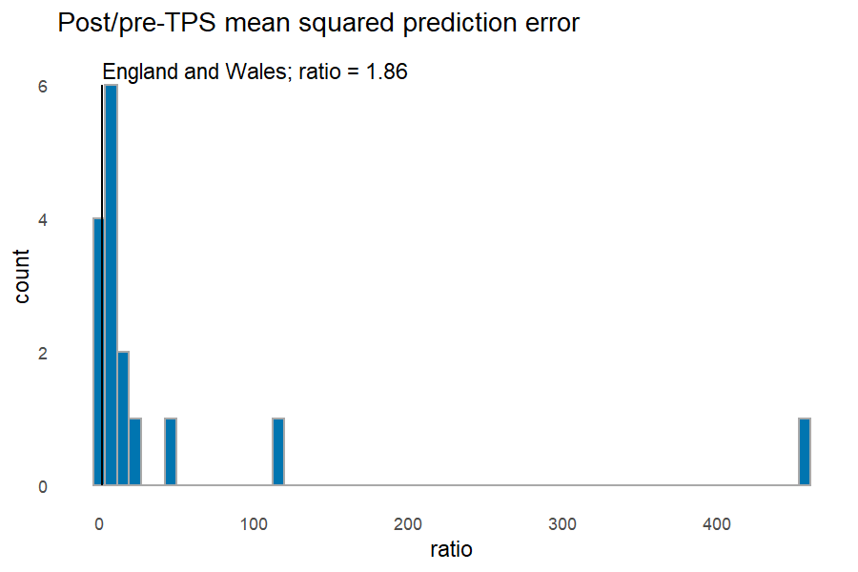

Model 2: Under-20 pregnancy rates

All Countries graph
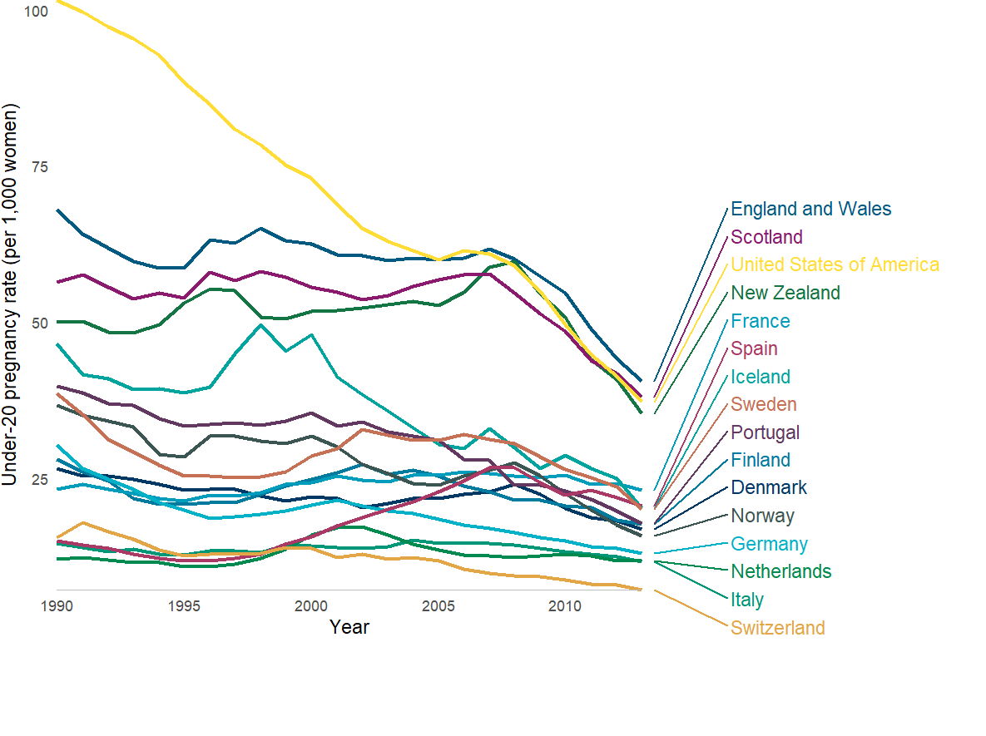

England vs Synthetic Control
Over the period 1999 to 2013, England and Wales saw a difference of 152,471 pregnancies (to an average population of 1,668,190 women).
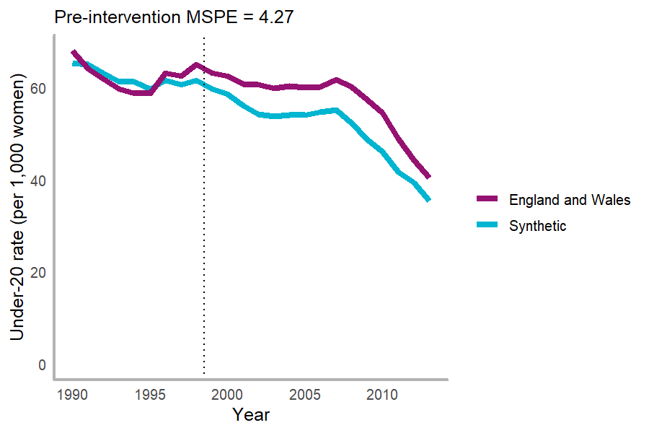

Weights and balance
Country weights
Country | Weight
Scotland | 0.639
United States of America | 0.227
Iceland | 0.134
Switzerland | 0.000
Germany | 0.000
Denmark | 0.000
Spain | 0.000
Finland | 0.000
France | 0.000
Italy | 0.000
Netherlands | 0.000
Norway | 0.000
Portugal | 0.000
New Zealand | 0.000
Sweden | 0.000

Predictor weights
 | v.weights
special.pRate.1990 | 0.152
special.pRate.1991.1995 | 0.578
special.pRate.1996.1998 | 0.271

Predictor balance between synthetic and treated units
 | Treated | Synthetic | Sample Mean
special.pRate.1990 | 68.000 | 65.337 | 35.661
special.pRate.1991.1995 | 60.620 | 62.055 | 32.224
special.pRate.1996.1998 | 63.633 | 61.259 | 30.895

Placebo testing by country and time
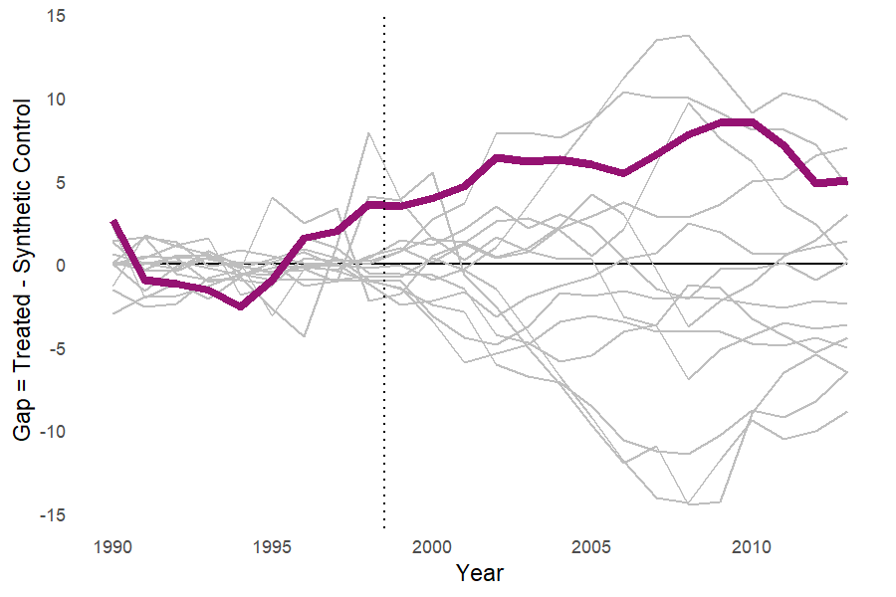
In placebo-country tests, England and Wales ranked 11 out of 16 countries by pre/post-MSPE ratio.
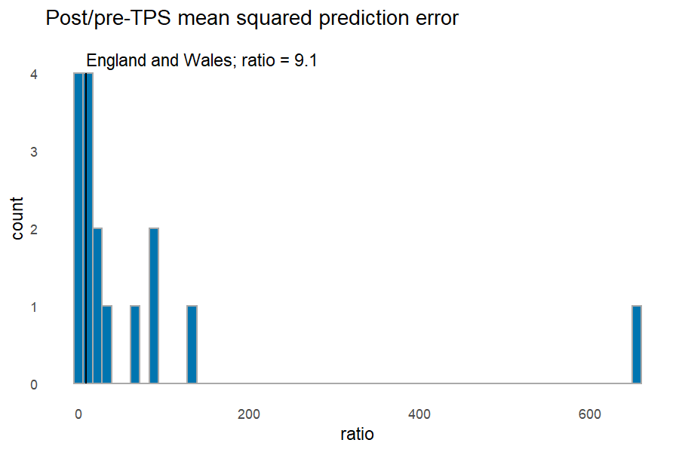

Filtered to remove Scotland, no additional predictors

Model 3: Under-18 birth rates

England vs Synthetic Control
Over the period 1999 to 2013, England and Wales saw a difference of -17,765 births (to an average population of 995,340 women).
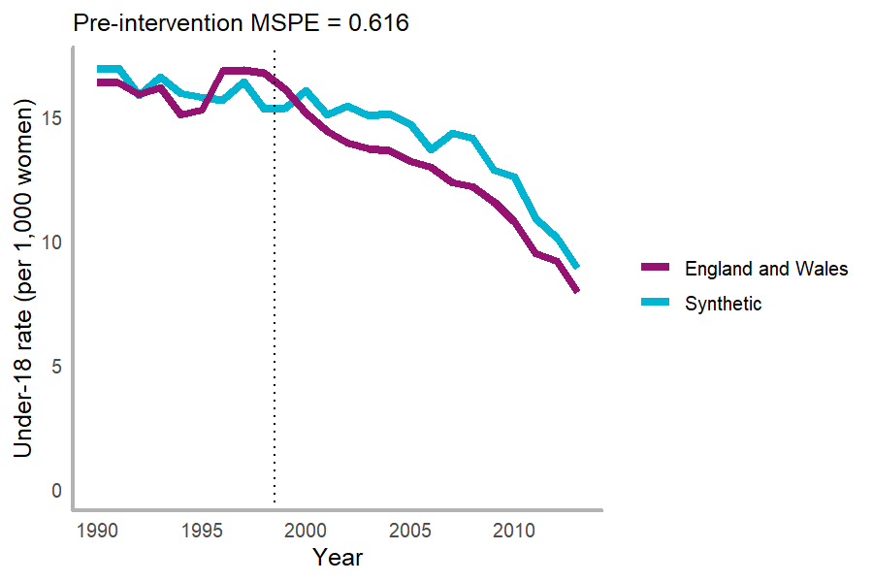
Loss-V (For optimised period) = 0.616, MSPE (for whole pre-intervention observation period) = 0.616.

Weights and balance
Country weights
Country | Weight
Portugal | 0.807
New Zealand | 0.193
Switzerland | 0.000
Germany | 0.000
Denmark | 0.000
Spain | 0.000
Finland | 0.000
France | 0.000
Iceland | 0.000
Italy | 0.000
Netherlands | 0.000
Norway | 0.000
Sweden | 0.000
United States of America | 0.000

Predictor weights
 | v.weights
special.rate.1990.1993 | 0.206
special.rate.1994 | 0.156
special.rate.1995 | 0.318
special.rate.1996.1998 | 0.32

Predictor balance between synthetic and treated units
 | Treated | Synthetic | Sample Mean
special.rate.1990.1993 | 16.214 | 16.587 | 9.928
special.rate.1994 | 15.078 | 15.963 | 9.210
special.rate.1995 | 15.285 | 15.782 | 9.155
special.rate.1996.1998 | 16.836 | 15.803 | 8.607

Placebo testing by country and time
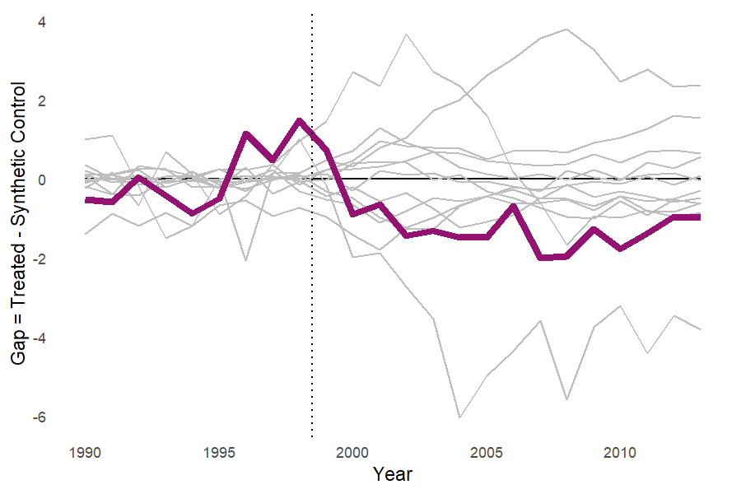
In placebo-country tests, England and Wales ranked 14 out of 16 countries by pre/post-MSPE ratio.
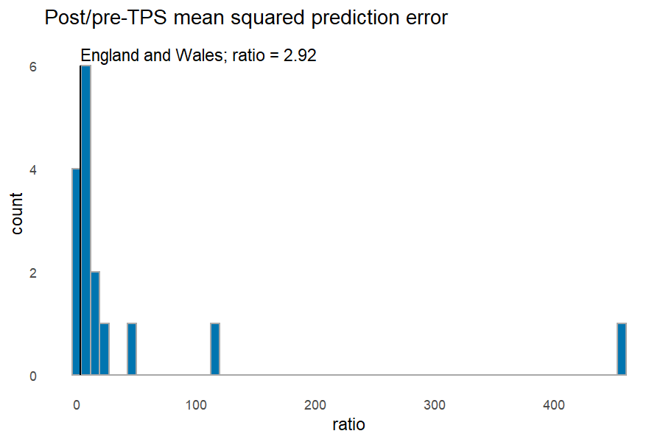

Model 4: Under-20 pregnancy rates

England vs Synthetic Control
Over the period 1999 to 2013, England and Wales saw a difference of 250,707 pregnancies (to an average population of 1,668,190 women).
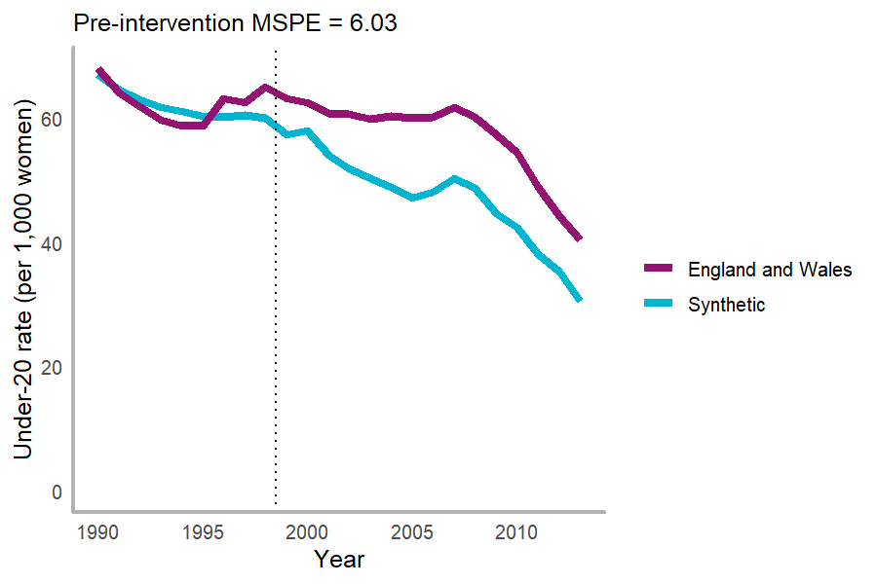
Loss-V (For optimised period) = 6.03, MSPE (for whole pre-intervention observation period) = 6.03.

Weights and balance
Country weights
Country | Weight
Iceland | 0.359
United States of America | 0.353
New Zealand | 0.288
Switzerland | 0.000
Germany | 0.000
Denmark | 0.000
Spain | 0.000
Finland | 0.000
France | 0.000
Italy | 0.000
Netherlands | 0.000
Norway | 0.000
Portugal | 0.000
Sweden | 0.000

Predictor weights
 | v.weights
special.pRate.1990 | 0.309
special.pRate.1991.1995 | 0.498
special.pRate.1996.1998 | 0.193

Predictor balance between synthetic and treated units
 | Treated | Synthetic | Sample Mean
special.pRate.1990 | 68.000 | 67.005 | 34.180
special.pRate.1991.1995 | 60.620 | 62.152 | 30.590
special.pRate.1996.1998 | 63.633 | 60.236 | 28.987

Placebo testing by country and time
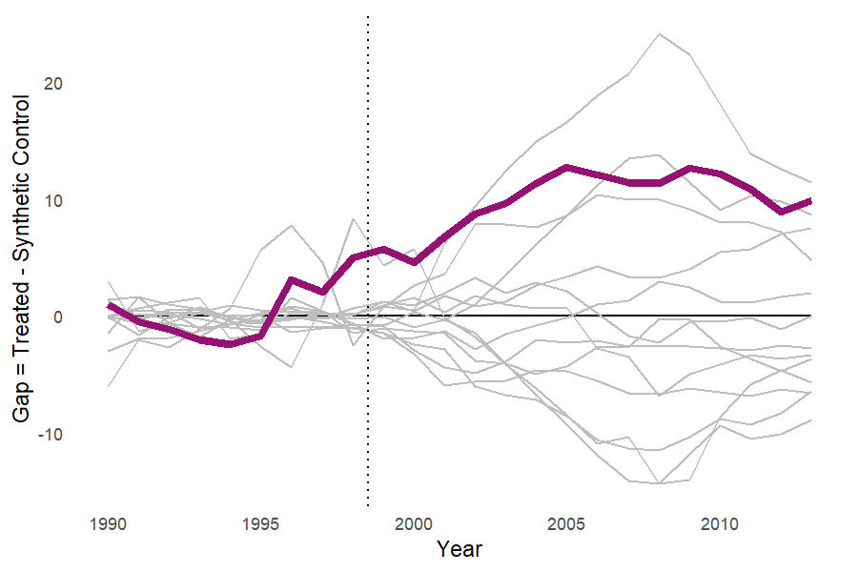
In placebo-country tests, England and Wales ranked 9 out of 15 countries by pre/post-MSPE ratio.
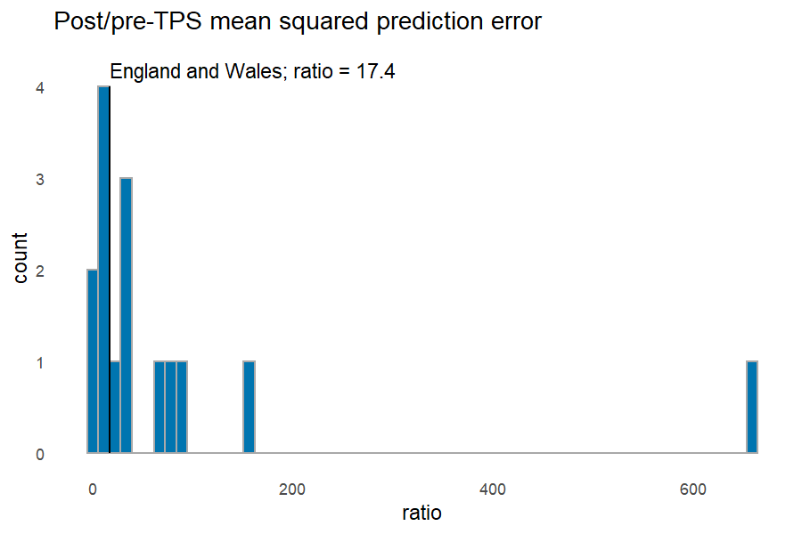

Adding all predictors

Model 5: Under-18 birth rates

England vs Synthetic Control
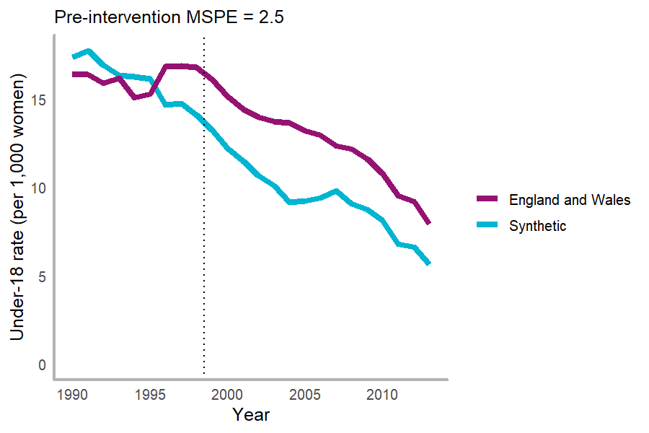
Loss-V (For optimised period) = 2.5, MSPE (for whole pre-intervention observation period) = 2.5.

Weights and balance
Country weights
Country | Weight
Italy | 0.374
Iceland | 0.328
United States of America | 0.298
Switzerland | 0.000
Germany | 0.000
Denmark | 0.000
Spain | 0.000
Finland | 0.000
France | 0.000
Netherlands | 0.000
Norway | 0.000
Portugal | 0.000
Sweden | 0.000

Predictor weights
 | v.weights
special.rate.1990.1993 | 0.028
special.rate.1994 | 0.023
special.rate.1995 | 0.034
special.rate.1996.1998 | 0.15
special.GDPperCap.1990.2003 | 0.014
special.GDPperCap.2004 | 0.078
special.GDPperCap.2005.2010 | 0.014
special.GDPperCap.2011.2013 | 0.002
special.edu_spend.1995.1998 | 0.003
special.edu_spend.1999.2007 | 0
special.edu_spend.2008.2013 | 0.13
special.MobilePhones.1990.1992 | 0
special.MobilePhones.1993.1995 | 0.022
special.MobilePhones.1996.1997 | 0.011
special.MobilePhones.1998.2013 | 0.126
special.UrbanPop.1990 | 0.092
special.UrbanPop.1991 | 0.088
special.UrbanPop.1992 | 0.087
special.UrbanPop.1993.2013 | 0.098

Predictor balance between synthetic and treated units
 | Treated | Synthetic | Sample Mean
special.rate.1990.1993 | 16.214 | 17.099 | 8.005
special.rate.1994 | 15.078 | 16.268 | 7.329
special.rate.1995 | 15.285 | 16.157 | 7.099
special.rate.1996.1998 | 16.836 | 14.511 | 6.703
special.GDPperCap.1990.2003 | 24800.333 | 26808.216 | 26870.008
special.GDPperCap.2004 | 39983.985 | 39557.010 | 39108.220
special.GDPperCap.2005.2010 | 43340.344 | 44960.799 | 47573.339
special.GDPperCap.2011.2013 | 41975.732 | 43998.534 | 52420.115
special.edu_spend.1995.1998 | 4.223 | 5.330 | 5.616
special.edu_spend.1999.2007 | 5.296 | 5.885 | 5.627
special.edu_spend.2008.2013 | 5.794 | 5.884 | 5.691
special.MobilePhones.1990.1992 | 2.256 | 2.896 | 2.778
special.MobilePhones.1993.1995 | 6.881 | 7.278 | 7.214
special.MobilePhones.1996.1997 | 13.808 | 18.177 | 18.310
special.MobilePhones.1998.2013 | 98.113 | 95.733 | 93.736
special.UrbanPop.1990 | 78.140 | 77.151 | 74.238
special.UrbanPop.1991 | 78.112 | 77.323 | 74.478
special.UrbanPop.1992 | 78.172 | 77.514 | 74.734
special.UrbanPop.1993.2013 | 79.690 | 79.327 | 77.582

Placebo testing by country
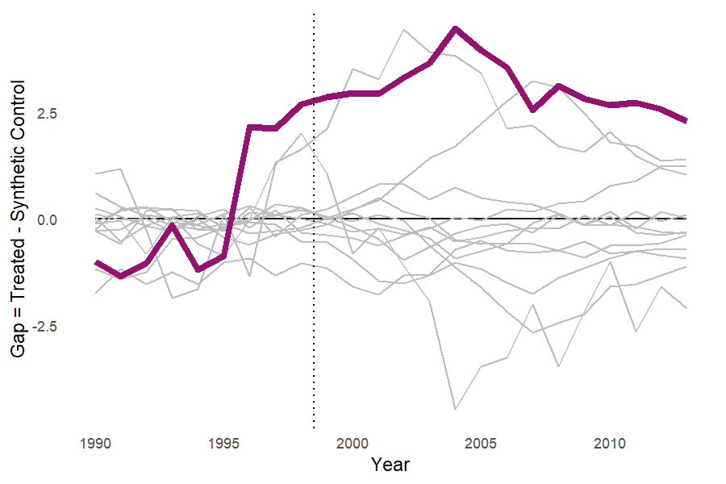
In placebo-country tests, England and Wales ranked 5 out of 14 countries by pre/post-MSPE ratio.
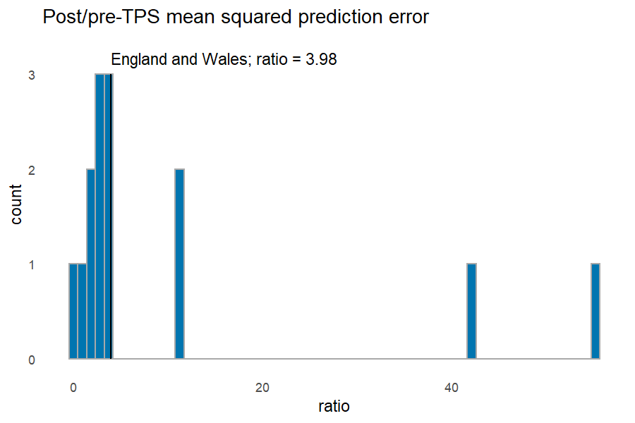

Model 6: Under-20 pregnancy rates

England vs Synthetic Control
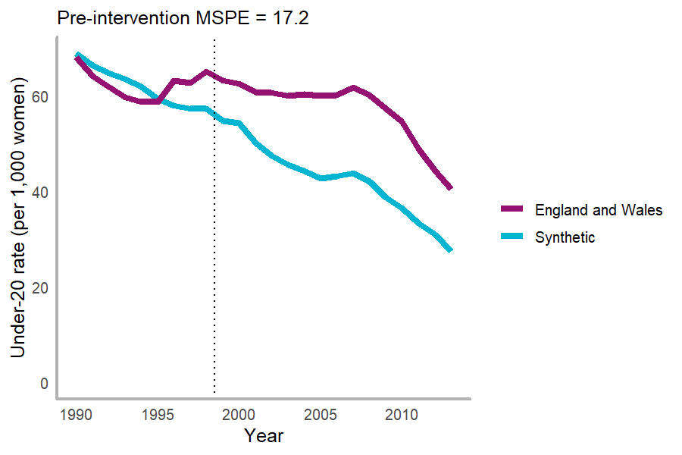
Loss-V (For optimised period) = 17.2, MSPE (for whole pre-intervention observation period) = 17.2.

Weights and balance
Country weights
Country | Weight
United States of America | 0.522
Iceland | 0.278
Italy | 0.201
Switzerland | 0.000
Germany | 0.000
Denmark | 0.000
Spain | 0.000
Finland | 0.000
France | 0.000
Netherlands | 0.000
Norway | 0.000
Portugal | 0.000
Sweden | 0.000

Predictor weights
 | v.weights
special.pRate.1990 | 0.175
special.pRate.1991.1995 | 0.156
special.pRate.1996.1998 | 0.315
special.MobilePhones.1990.1992 | 0
special.MobilePhones.1993.1995 | 0.001
special.MobilePhones.1996.1997 | 0.004
special.MobilePhones.1998.2013 | 0.054
special.edu_spend.1995.1998 | 0
special.edu_spend.1999.2007 | 0
special.edu_spend.2008.2013 | 0.001
special.GDPperCap.1990.2003 | 0
special.GDPperCap.2004 | 0.014
special.GDPperCap.2005.2010 | 0
special.GDPperCap.2011.2013 | 0.006
special.UrbanPop.1990 | 0.11
special.UrbanPop.1991 | 0.087
special.UrbanPop.1992 | 0.071
special.UrbanPop.1993.2013 | 0.004

Predictor balance between synthetic and treated units
 | Treated | Synthetic | Sample Mean
special.pRate.1990 | 68.000 | 68.849 | 32.961
special.pRate.1991.1995 | 60.620 | 63.155 | 29.104
special.pRate.1996.1998 | 63.633 | 57.510 | 27.083
special.MobilePhones.1990.1992 | 2.256 | 3.182 | 2.778
special.MobilePhones.1993.1995 | 6.881 | 8.184 | 7.214
special.MobilePhones.1996.1997 | 13.808 | 18.494 | 18.310
special.MobilePhones.1998.2013 | 98.113 | 85.702 | 93.736
special.edu_spend.1995.1998 | 4.223 | 5.570 | 5.616
special.edu_spend.1999.2007 | 5.296 | 6.133 | 5.627
special.edu_spend.2008.2013 | 5.794 | 6.239 | 5.691
special.GDPperCap.1990.2003 | 24800.333 | 28604.113 | 26870.008
special.GDPperCap.2004 | 39983.985 | 41170.217 | 39108.220
special.GDPperCap.2005.2010 | 43340.344 | 46569.676 | 47573.339
special.GDPperCap.2011.2013 | 41975.732 | 46884.569 | 52420.115
special.UrbanPop.1990 | 78.140 | 77.870 | 74.238
special.UrbanPop.1991 | 78.112 | 78.125 | 74.478
special.UrbanPop.1992 | 78.172 | 78.389 | 74.734
special.UrbanPop.1993.2013 | 79.690 | 80.692 | 77.582

Placebo testing by country
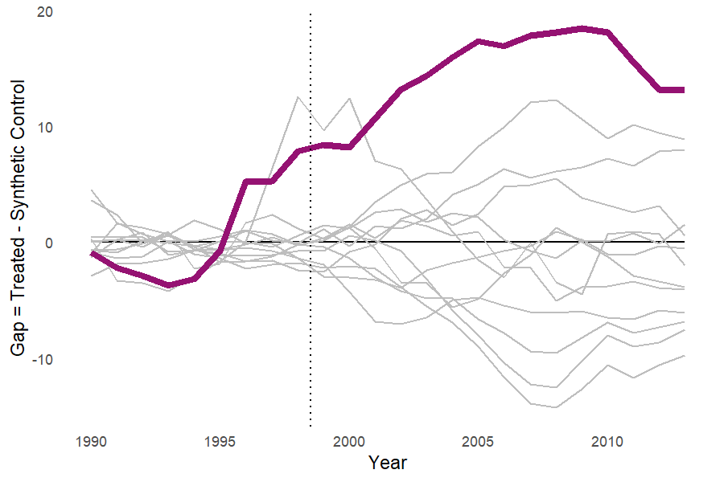
In placebo-country tests, England and Wales ranked 8 out of 14 countries by pre/post-MSPE ratio.
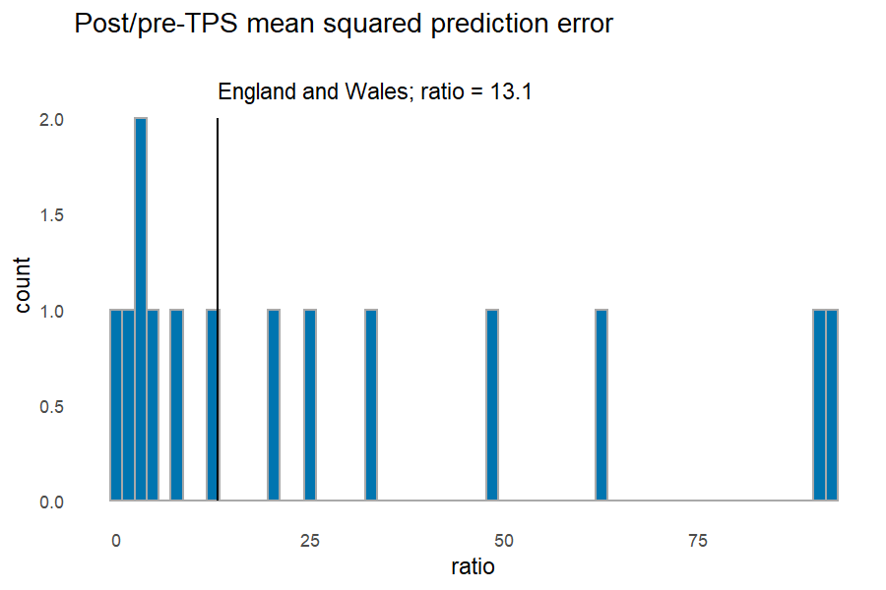

Model-testing iterations

Under-18 pregnancy - no added predictors
Plotting MSPEs by iteration and gaps for all iterations.
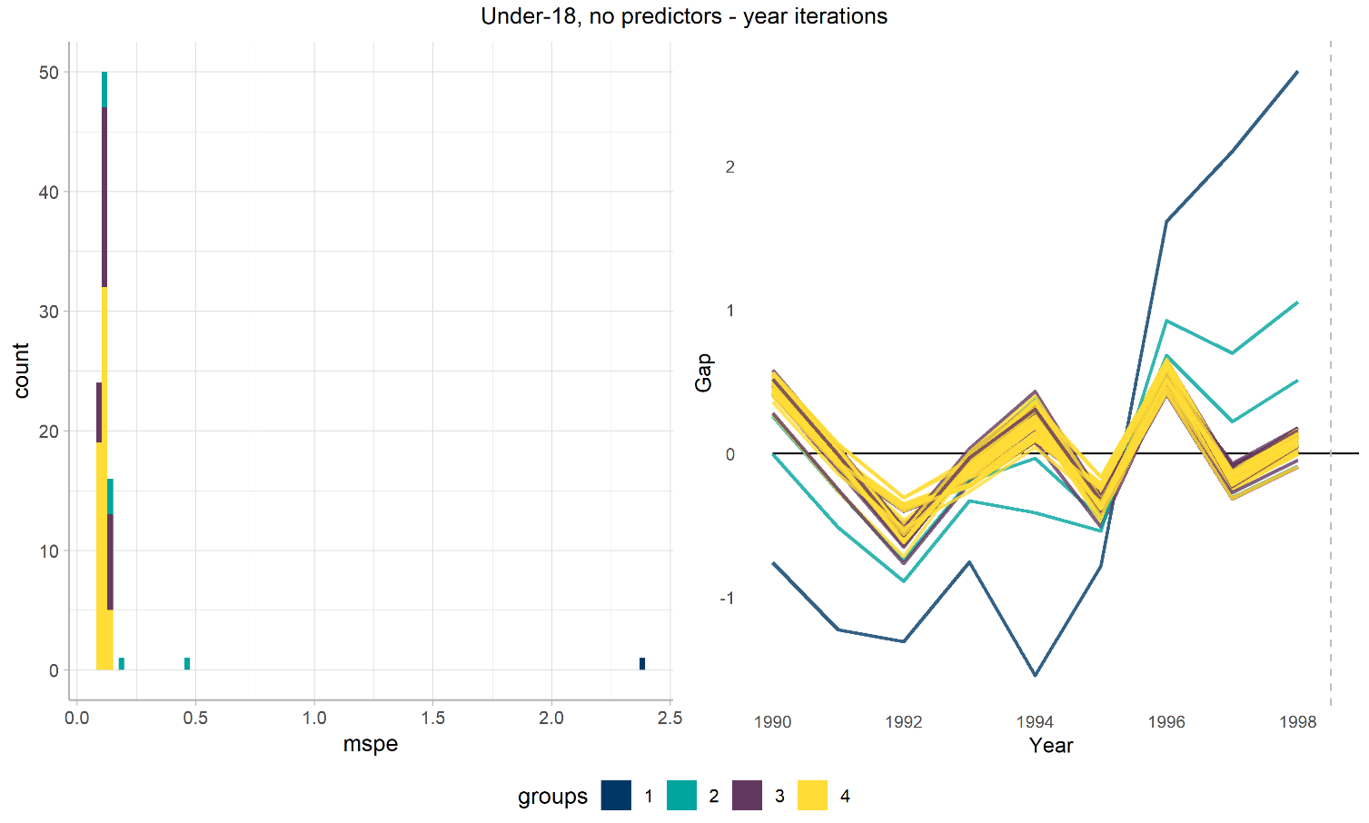

Top countries
Differing iterations produced different country weightings. I exctracted the top country for each iteration and plotted the lowest MSPE for the top four countries:
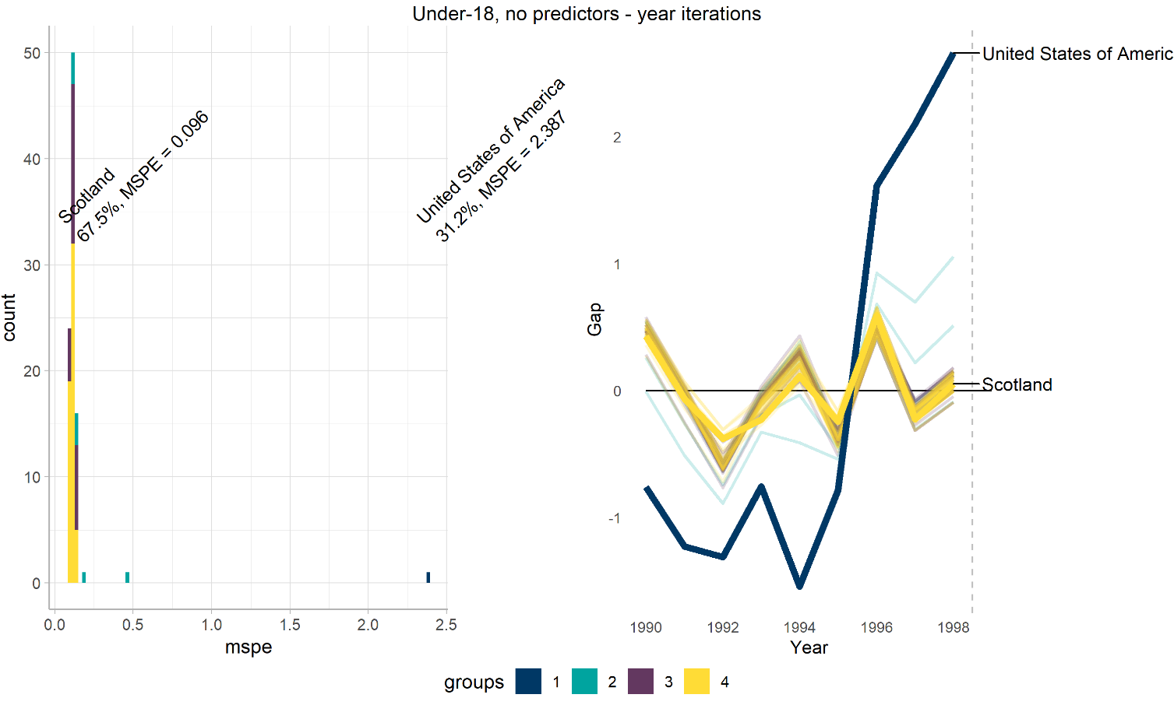

Removing top countries
A further iterative cycle constructed sequential synthetic controls, removing the previous top-weighted country to test for over-reliance on very few abnormal countries. Labels represent the top-weighted country in each analysis by weight and pre-intervention MSPE:
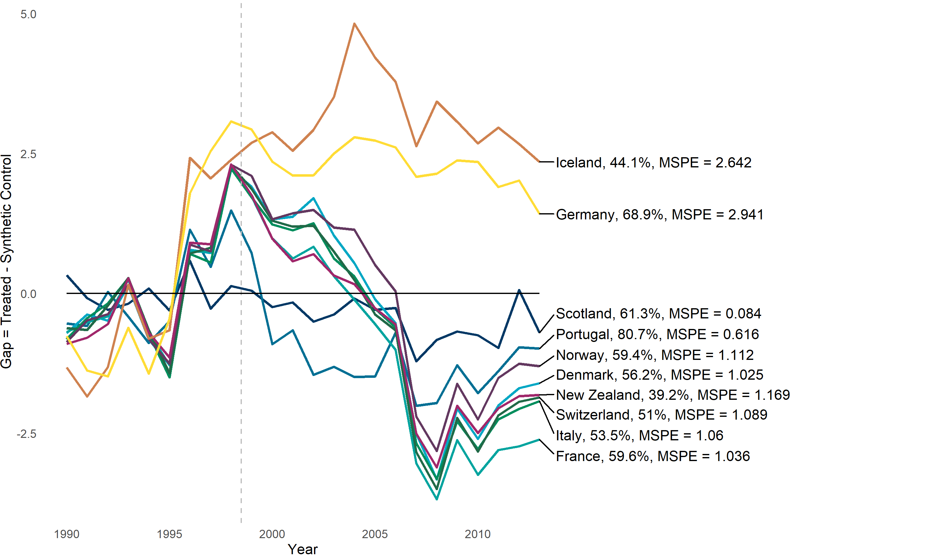

Under-20 - no added predictors
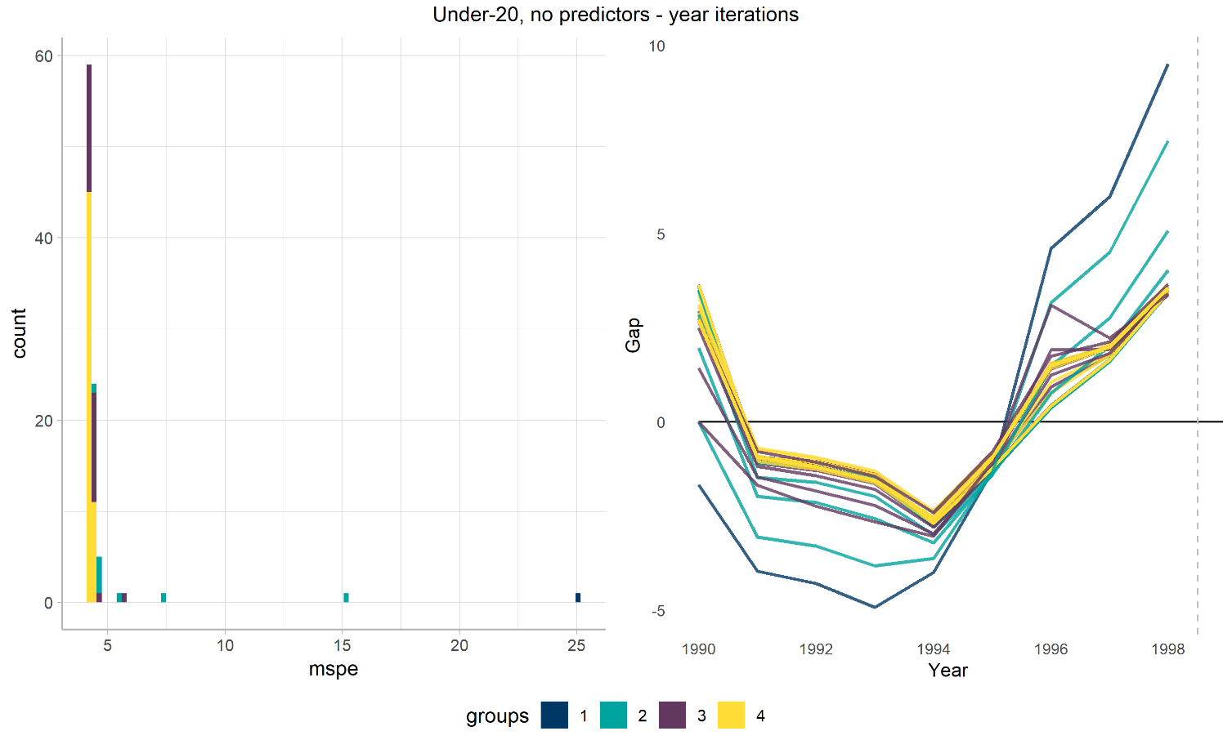

Top Countries
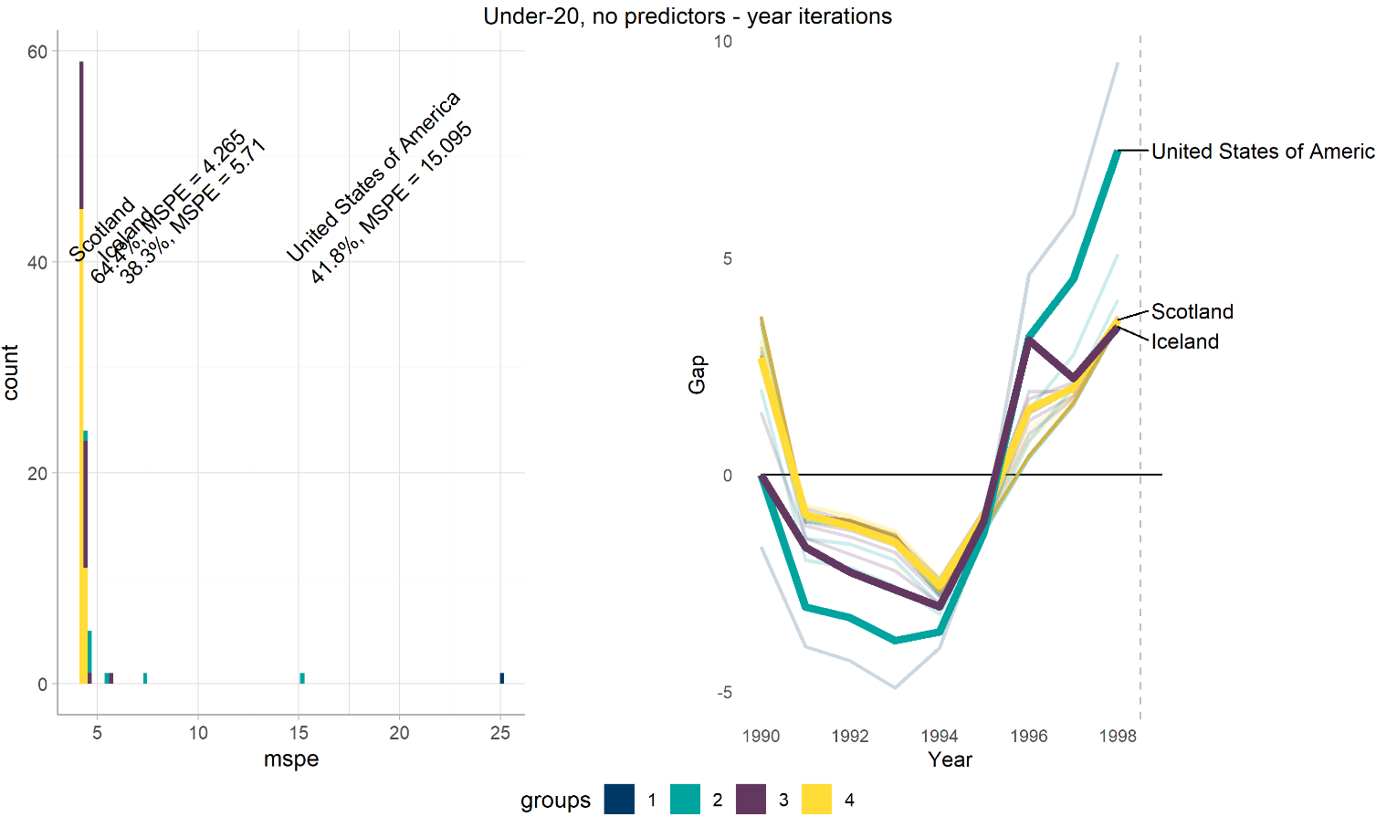

Removing Top Countries
