Supplementary Appendix

COVID-19 in Ecuador

Supplementary Appendix 1
COVID-19 in Ecuador 1
Appendix 1 3
Complete methodology 3
Study design 3
Setting 3
Data 3
Study size and sample size calculation 4
Descriptive statistics 5
Statistical analysis 5
Burden of Disease 6
Ethical considerations 6
Additional results 6
Education attainment and marital status 6
Symptoms assessment 7
Occupation and work-related risk 7
Contact Tracing 7
Result by region and elevation 7
Attack rate (confirmed cases per 100,000 people) 8
Mortality Rates (confirmed deaths per 100,000 people) 8
Daily new cases and deaths by province 9
Tests performed 9
Additional Conclusions 10
Acknowledgement 10
Authors' Contributions 10
Disclosure Statement 11
Funding Sources 11
Supplementary figures 12
Figure S1. Timeline of important landmarks during the early phase of the COVID-19 Ecuadorian pandemic in Ecuador. 12
Figure S2. Reported symptoms by frequency of presentation among mild to moderate patients with a RT-PCR positive COVID-19 test. 13
Figure S3. Relative risk calculation by occupation compared with white-collar workers 14
Figure S4. Attack rate and Crude mortality rate by canton in Ecuador during the COVID-19 pandemic (February-April 2020). 15
Figure S5. Confirmed cases of and deaths linked to suspected and confirmed COVID-19, during the first 58 days of the outbreak. 16
Figure S6. Daily number of new confirmed cases and deaths per province due to COVID-19, Ecuador February-April 2020. 17
Figure S7. Confirmed cases and deaths due to COVID-19 in Ecuador. Cumulative number of confirmed cases and deaths per province, log-transformed since the first day of reporting (27th February 2020). 18
Figure S8. Testing for COVID-19 in Ecuador. Number of RT-PCR tests performed since the day of first reporting (February 27th 2020) that were suspected (red), positive (blue), negative (black) and tests not processed (grey). 19
Figure S9. COVID-19 cases, deaths and case fatality rate (CFR) by ethnicity in Ecuador. A) Percentage (bar) and number (text) of cases, B) percentage (bar) and number (text) of deaths and C) case fatality rate (%) by ethnicity and gender. 20
Supplementary Tables 21
Supplementary Table 1. 21
Supplementary Table 2. 22
Supplementary Table 3 22
References 23

Appendix 1

Complete methodology

Study design
We conducted a country-wide population-based analysis of the epidemiology of COVID-19, using case data reported in Ecuador between 27 February and 18 April 2020. The database comprised men, women and children from 0 to 100 years old with a positive RT-PCR COVID-19 diagnosis, using a reverse transcription polymerase chain reaction (RT-PCR) technique, during the first 54 days of the outbreak, including the first imported and the subsequent community-acquired cases.

Setting
The study was conducted in Ecuador, a country located in South America, bordering with Colombia to the North, Peru to the South/East and the Pacific Ocean to the West. The country is divided into four geographical regions: 1) the coastal region, 2) the highlands or sierra region, 3) the Amazon region and 4) the insular region (Galapagos Islands). The population of Ecuador was estimated to be 17,510,643 inhabitants based on the latest available projections for 2020 ¹.

Data
We obtained socio-demographic variables, such as age, sex, marital status and place of residence from the Ministry of Health (MoH) registries. Clinical data including date of onset of symptoms, date of diagnosis and date of death, as well as the presence of comorbidities, pregnancy and influenza vaccination history were also obtained. Epidemiological information including city and province of registration, elevation, occupation, travel history and institution of diagnosis were analyzed. We also obtained the results of tests performed nationwide up until 18th April, 2020 and developed testing trends per days, including positive, negative, suspicious and not processed tests. The information was transferred to our research team after presenting a formal petition and signing a confidentiality agreement with the MoH to protect patient’s rights.
From the online self-reporting tool delivered through the MoH surveillance department, clinical information about signs and symptoms, as well as civil status and educational attainment were obtained from the 856 outpatients (COVID-19 positive) that fulfill the voluntary self-reporting tool.
The number of deaths used in this analysis were officially reported as COVID-19 using the 10th revision of the International Statistical Classification of Diseases and Related Health Problems (ICD) code: U07.1 COVID-19, virus identified, U07.2 COVID-19, virus not identified.
In order to estimate the number of additional deaths that were not diagnosed as COVID-19 during March and April 2020, we compared the COVID-19 database with the National Death Registry, including fatalities registered as Acute Respiratory Distress Syndrome (ICD J80).

Study size and sample size calculation
This study included 9,468 RT-PCR confirmed COVID-19 patients and the first 474 officially reported deaths.
In terms of the number of patients required (x) to complete the self-reported symptoms tool distributed by the MoH, the sample size (n) and margin of error (E) were given by the following formula:
x | = | Z(^{c}/₁₀₀)²r(100-r)
n | = | ^{N x}/_{((N-1)E}² _{+ x)}
E | = | Sqrt[^{(N - n)x}/_{n(N-1)}]
Where N is the population size (9,468), (r) is the fraction of expected responses (50%), and Z(c/100) is the critical value for the confidence level (c).
The total number of completed answers required according to the calculations was 621 in order to achieve a 99% confidence level. Through a convenience-based sampling technique 856 patients were included. The self-reporting tool was sent to all patients not hospitalized who were under epidemiological surveillance by the MoH and we included only those who voluntarily agree to provide information on educational attainment, symptomatology and civil status.

Descriptive statistics
The overall incidence (attack rate), mortality rate, and case fatality rate were computed according to the entire population at risk living in a canton or a province. Information from the first 9,468 COVID-19 confirmed patients in Ecuador were compared with the population at risk, obtained from the publicly available canton- and province-level sex-specific projections. Measurements of frequency (counts, absolute and relative percentages), central tendency (median), dispersion (interquartile range) and absolute differences were calculated for all categorical and continuous variables. Case fatality rates (CFR%) were computed using the number of cases officially reported while the dichotomized variable (alive or died) was used as an outcome of the confirmed cases. CFR% were adjusted to mitigate the effect in crude CFR% estimation. We computed the time distribution from hospital admission to the time of using the methodology reported by Russel 2020.
Positive test rates (PTR%) were calculated using the number of positive test results divided by the total number of tests conducted. The attack and crude mortality rates per canton and province were computed per 100,000 inhabitants. Important landmark dates are included in Supplementary Figure 1.

Statistical analysis
To examine associations, relative risks (RR) and 95% confidence intervals were computed for all age groups using female cases as the reference level. We performed a relative risk (RR) analysis of the total number of expected cases by the population at risk in all the groups to obtain the likelihood of dying due to COVID-19. In order to control for the effects of sex, age and comorbidities, an adjusted logistic regression was performed using the final outcome (alive or died) as a response variable. The geographical distribution of residence was divided into high (>= 2,500 m) and low altitude (< 2,500), in order to analyze the differences within these populations using a t-test with a 0.05 significance level.

Burden of Disease
The number of years of healthy life lost due to COVID-19 among the reported cases were calculated using Disability-Adjusted Life Years (DALY). DALYs are the sum of the Years of Life Lost (YLL) due to premature mortality in the population and the Years Lost due to Disability (YLD) caused by the consequences of the disease ². YLL were calculated from the number of deaths per age group multiplied by the standard life expectancy at the age of death. We used the life expectancy table developed by the 2010 Global Burden of Disease study, with a life expectancy at birth of 86 for both males and females ³. To estimate YLD, the total number of cases in the study period was multiplied by the average duration of the disease reported by the International Severe Acute Respiratory and Emerging Infections Consortium (ISARIC) COVID-19 database and the disability weights corresponding to the different degrees of severity of infectious diseases included in the 2013 Global Burden of Disease study ^{4,5}.

Ethical considerations
This secondary data analysis of anonymized, un-identifiable information received ethical approval from the Universidad de las Americas Ethics Committee CEISH on March 10th, 2020. The phone calls and the information retrieved during the follow-up period was obtained by health professionals not linked to this project as part of their standard of care treatment for patients with COVID-19. The information from those reports were posteriorly anonymized ensuring no sensitive information was shared with any member of our research project. According to the international good clinical and research practices and in accordance with Ecuadorian law, observational studies that do not jeopardize the rights of patients are exempt from obtaining full ethical approval.

Additional results

Education attainment and marital status
In Ecuador, the results of the demographic survey (n = 856) show that 0.7% (n = 6) of COVID-19 patients had not completed their elementary school, 1.9% (n = 16) reported a complete elementary school education, 5.8% (n = 50) had not completed their high school education and 22.5% (n = 193) had completed their entire high school cycle. At least 6.8% (n = 58) are technicians, 46.3% (n = 396) have completed their undergraduate degree and 16.0% (n = 137) have formal postgraduate training. In terms of civil status 39.3% (n = 336) are single, 38% (n = 327) are married, 13% (n = 114) are cohabitating with their partners, 5.4% are divorced (n = 46), 1.3% widows (n = 11) and other responses 3% (n =22).

Symptoms assessment
The patients who were under epidemiological surveillance by the MoH (n = 856) self-reported their symptoms experienced during the preceding 14 days using an online self-reporting tool. The most common symptom described was fatigue or general tiredness (53.2%), followed by headaches (43%), and dry cough (41.7%). 37.1% of the patients reported loss of taste (ageusia), 36.1% reported loss of smell (anosmia) and 35 % reported muscle and join pain (Figure S2).

Occupation and work-related risk
The results of COVID-19 mortality by occupation showed that 19% of infected people (n = 1800) are health professionals (Supplementary Table 2). From this group medical doctors (n = 876) were the most affected professionals in Ecuador, representing at least 9.3% of all reported cases (Supplementary Figure 3 and Supplementary table 2).

Contact Tracing
The results from the self-reporting tool (n = 856) suggested that 42.6% (n = 365) of patients did not have contact with anyone after COVID-19 diagnosis, 11.8% (n = 101) reported that they might have been in contact with 1 to 5 people, 4.9% (n = 42) might have contacted 6 to 10 people, and 5.8% (n = 50) might have contacted more than 10 people after diagnosis. The other 34.9% (n = 299) of the cohort did not recall such information.

Result by region and elevation

In Ecuador, the coastal region had a higher attack rate of 36.1 per 100,000 [CI 95%: 24.1 - 48.2], than the highlands 21.2 per 100,000 [CI 95%: 16.5 – 25.9]. The Amazon region had an attack rate of 22.7 per 100,000 [CI 95%: 9.9 – 35.5] and the Galapagos Islands 139.7 per 100,000 [CI 95%: 27.9 – 251.5]. The coastal region had a crude mortality rate of 2.84 per 100,000 [CI 95%: 1.8 – 3.8], the highlands 2.60 per 100,000 [CI 95%: 1.6 – 3.5] and the Amazon region 1 per 100,000 [CI 95%: -0.42 – 2.3]. When considering altitude (< 2,500 meters versus >= 2,500 meters) per canton, we found that cantons located at higher altitudes had lower attack rates (20.3 per 100,000 [CI 95%: 14.4 – 26.3]) than those located below 2,500 m (33.3 per 100,000 [CI 95%: 25.1 – 41.5]). This difference is statistically significant according to a t-test at 0.05% significance level (mean difference 12.95 ± 5.08 p value: 0.018 [CI95% 22.9 - 2.90]). In terms of mortality, cantons at higher altitudes had a lower crude mortality rate with 4.8 per 100,000 [2.7 – 6.9] versus those located at lower altitudes with 5.14 per 100,000 [CI 95% 3.9 – 6.3] although the difference was not statistically significant according to a t-test at 0.05% significance level (mean difference 0.16± 0.76 p value: 0.82 [CI95% -1.36 - 1.69]).

Attack rate (confirmed cases per 100,000 people)
The overall attack rate was 51.1 per 100,000 people. Sex-specific attack rates of COVID-19 was 60.5 per 100,000 for men and 47.2 per 100,000 for women. In terms of age-adjusted attack rates per 100,000, the lowest attack rate was amongst children from 0-4 years old (2.86 per 100,000), while the highest attack rate was found in patients aged between 55 and 59 years (111 per 100,000) (Supplementary Figure 4).

Mortality Rates (confirmed deaths per 100,000 people)
The overall confirmed mortality rate was 2.7 per 100,000 people. This value ranged from 0.1 to 20.1 per 100,000 people at risk, with 90-95 years of age being the most affected group with a crude age specific mortality rate of 20 per 100,000 people. From the official reports, 474 deaths were recorded due to COVID-19 (RT-PCR confirmed).
During March and April 2020, Ecuador experienced a sharp increase in its overall mortality. In 2018, at least 23,973 deaths were officially reported between January to April, in the following year, 25,061 and during January to April 15th, 2020, 29,392 were registered, indicating an increase of more than 15% compared with the previous year. The increase over the same period from 2018 to 2019 was just 4.4% (Supplementary Figure 4).
We analyzed the total number of deaths included in the National Registry. From March 1st to April 18th, 2020, 4,780 reported deaths were related to acute respiratory distress syndrome (ARDS) in Ecuador (37%). From the total of ARDS-related deaths, 1,283 were probable COVID-19 (U07.2 clinically-epidemiologically diagnosed), 809 were registered as suspected COVID-19 (U07.2) and 474 confirmed COVID-19 cases (U07.1) (Supplementary figure 5).

Daily new cases and deaths by province
Galapagos (157.3/100,000), Guayas (146.9/100,000), Cañar (49.1/100,000), Santa Elena (37.8/100,000) and El Oro (35.6/100,000) provinces had the greatest attack rates per 100,000. In terms of the crude mortality rate, the provinces of El Oro (7.82/100,000), Chimborazo (4.7/100,000), Guayas (4.44/100,000), Santo Domingo de los Tsachilas (4.14/100,000) and Bolivar (2.85/100,000) provinces had the greatest mortality crude rate per 100,000 (Figure S6-7).

Tests performed

Since the start of the outbreak in Ecuador, a total of 19,875 tests have been carried out nationwide, resulting in 1,126 tests per million inhabitants. Of the accumulated total number of tests, 48% of these were positive and less than 0.5% were inconclusive or suspected. Up until April 18th 2020 12,751 tests were unprocessed, even though nasopharyngeal swab samples were taken. On average, 67% (n = 13,362) of tests were performed by the National Institute for Public Health Research (INSPI), 4% (n = 709) by public hospitals, 26% (n = 5,222) by privately owned laboratories and 3% (n = 582) by a university-based (UDLA) laboratory. In terms of positive testing rates (PTR%), 69% of the results coming from INPSI were positive, followed by 47% from private labs, 37% from hospital-based laboratories and 7% from university-based labs (Supplementary Table 3, Figure S8). The highest testing rates were in cantons from the Galapagos Islands. Isabela has the highest testing rate per 100,000 (4,393 per 100,000), followed by San Cristobal (1,841 per 100,000) and Santa Cruz (1,462 per 100,000). On the Ecuadorian mainland, Samborondon canton has the highest testing rate, with 765 tests per 100,000 people, followed by the Amazonian canton of Palora (285 per 100,000), Guayaquil (278 per 100,000) and Daule (278 per 100,000)

Additional Conclusions
We found that there were a high number of COVID-19 infections among medical personnel, which likely occurred during the first weeks of the outbreak in the Ecuador. Although the attack rate was high, mortality in this group was very low, which could be due to greater access to healthcare. We also found that the occupations of patients and whether they were unemployed was strongly associated with overall mortality due to COVID-19 in Ecuador, suggesting that poverty is an important driver of the final outcome for this disease. Lastly, strengthening of community-based surveillance and case tracing response capacities is essential to prevent further advance of the disease within the community.

Acknowledgement
The authors thank Rebeca Bravo who was very keen in editing our maps for this publication as well as the staff from the National Direction of Epidemiology for sharing the official database after fulfilling their requirements.
We greatly appreciate the work carried out by Dr. Ignacia Paez and her team of Community Mental Health professionals from the Ministry of Public Health, for their role of distributing the self-reporting symptomology tool among the entire cohort of patients who were under constant monitoring from the official epidemiological department of the MoH.

Authors' Contributions
Esteban Ortiz-Prado conceptualized the project and the methodological approach, acquired the data, performed the statistical analysis and interpreted of the results. He drafted the main manuscript and created some of the figures for this publication.
Lenin Gómez-Barreno, Katherine Simbaña-Rivera were responsible for the conceptualization of the manuscript. They contributed to analysis of the data while providing critical revisions of the rest of the manuscript and elaboration of the discussion section.
Aquiles R. Henriquez was fully responsible for the DALY and burden of disease analysis. Andrés López Cortés was responsible for the creation of figures. Ana Maria Diaz, Alejandra Barreto, Carla Moyano, Vannesa Arcos, Eduardo Vásconez-González and Clara Paz contributed to data analysis of the self-reporting symptomatology tool.
Fernanda Simbaña acquired the regional data and contributed to the literature review. Martin Molestina-Luzuriaga and Raul Fernandez collaborated on the statistical analysis and the methodological approach as well as the creation of some of the figures for the analysis.
Lila Adana improved the discussion in terms of the social impact of COVID-19 among workers and contributed to the final draft of this manuscript.
Finally, Rachel Lowe and Isabel Fletcher critically reviewed the document and helped us improve the final version of this manuscript, enhancing the quality of the analysis and the approach.

Disclosure Statement
Esteban Ortiz-Prado was invited to advise the government during the first week of the pandemic, nevertheless, this invitation was carried out to many others scientists whom did not receive any economic retribution for their work and this temporary role did not interfere with the analysis of the results in any way. The other authors have no conflict of interest to declare.

Funding Sources
This work was funded by the Universidad de Las Américas through their annual general research projects funds.

Supplementary figures

Figure S1. Timeline of important landmarks during the early phase of the COVID-19 Ecuadorian pandemic in Ecuador.

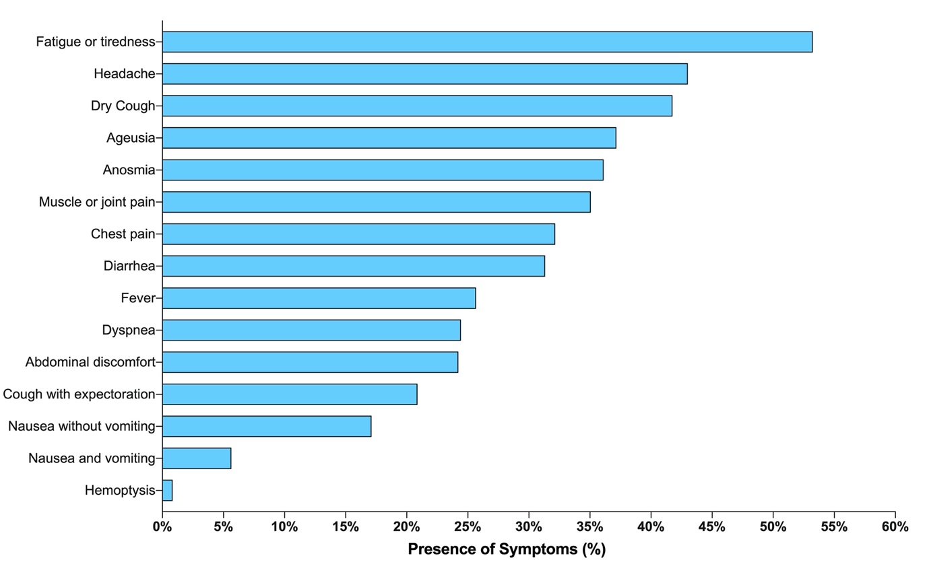

Figure S2. Reported symptoms by frequency of presentation among mild to moderate patients with a RT-PCR positive COVID-19 test.

Figure S3. Relative risk calculation by occupation compared with white-collar workers

(Engineers, lawyer, auditors, psychologists, chefs, architects, communicator, teachers, managers, chief executive officers, entrepreneurs, analysts, administrator). *Diplomatic, City Mayor, political advisor and city/provincial councilors, ** Hospital and Minister of Public Health administrative personnel, Medical Student nursing assistant, hospital cellars, Medical Assistant, Therapists, Laboratory, X-ray and Pharmacy Technician, Diagnostic Medical Sonographer, primary health care technicians (TAPS), physiotherapist, obstetricians and paramedics. °Military soldiers and army staff, Navy personal, Transit agents, Policemen, Security guards, Jail security agents. †Informal merchants, kitchen staff, Housework, Domestic Services employees, informal driver, Farmers, Craftsman, Machine operators, Cleaning Services employees, mechanics, carpenters and construction workers.

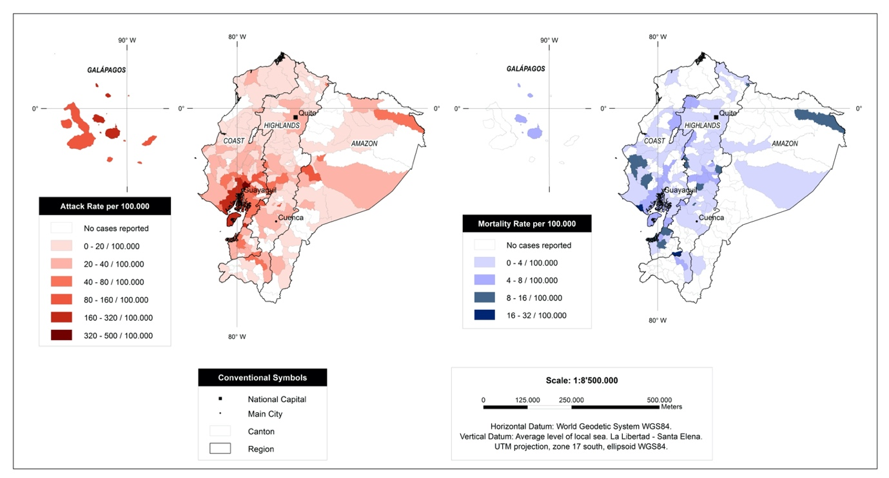

Figure S4. Attack rate and Crude mortality rate by canton in Ecuador during the COVID-19 pandemic (February-April 2020).

Figure S5. Confirmed cases of and deaths linked to suspected and confirmed COVID-19, during the first 58 days of the outbreak.
The first case was reported on day 1 based on the onset of symptomatology (February 15th ) and day 16th based on the date of medical attention (February 27th).

Figure S6. Daily number of new confirmed cases and deaths per province due to COVID-19, Ecuador February-April 2020.

Figure S7. Confirmed cases and deaths due to COVID-19 in Ecuador. Cumulative number of confirmed cases and deaths per province, log-transformed since the first day of reporting (27th February 2020).

Figure S8. Testing for COVID-19 in Ecuador. Number of RT-PCR tests performed since the day of first reporting (February 27th 2020) that were suspected (red), positive (blue), negative (black) and tests not processed (grey).

Figure S9. COVID-19 cases, deaths and case fatality rate (CFR) by ethnicity in Ecuador. A) Percentage (bar) and number (text) of cases, B) percentage (bar) and number (text) of deaths and C) case fatality rate (%) by ethnicity and gender.

Supplementary Tables
Supplementary Table 1. Case fatality rate (CFR%) due to COVID-19 and relative risk (RR) in Ecuador among women and men from different age groups (N=9,468). *P-values below or equal to 0.05 were considered significant.

 | Female |  |  | Male
Age | Alive | Death | CFR% | Alive | Death | CFR% | RR | Lower limit (CI 95%) | Upper limit (CI 95%) | P Value | Risk
0 to 4 | 13 | 1 | 7.14% | 24 | 0 | 0.00% | 0.2 | 0.0087 | 4.6023 | 0.3145 | -80%
5 to 9 | 29 | 1 | 3.33% | 37 | 0 | 0.00% | 0.27 | 0.0115 | 6.4437 | 0.806 | -73%
10 to 14 | 26 | 0 | 0.00% | 37 | 0 | 0.00% | 0.71 | 0.0145 | 4.7119 | 0.8632 | -29%
15 to 19 | 55 | 0 | 0.00% | 60 | 0 | 0.00% | 0.92 | 0.0185 | 5.4976 | 0.9657 | -8%
20 to 24 | 175 | 0 | 0.00% | 134 | 0 | 0.00% | 1.3 | 0.026 | 9.2868 | 0.8943 | 30%
25 to 29 | 482 | 2 | 0.41% | 471 | 2 | 0.42% | 1.02 | 0.1447 | 7.2347 | 0.9816 | 2%
30 to 34 | 627 | 3 | 0.48% | 717 | 6 | 0.83% | 1.7427 | 0.4376 | 6.9397 | 0.4308 | 74%
35 to 39 | 474 | 3 | 0.63% | 627 | 14 | 2.18% | 3.47 | 1.0036 | 8.0162 | 0.0493* | 247%
40 to 44 | 428 | 5 | 1.15% | 567 | 24 | 4.06% | 3.516 | 1.3526 | 9.1436 | 0.0099* | 252%
45 to 49 | 372 | 4 | 1.06% | 476 | 26 | 5.18% | 4.86 | 1.7136 | 11.8316 | 0.003* | 386%
50 to 54 | 350 | 12 | 3.31% | 451 | 33 | 6.82% | 2.05 | 1.0775 | 3.9263 | 0.0288* | 105%
55 to 59 | 368 | 9 | 2.39% | 410 | 41 | 9.09% | 3.80 | 1.8752 | 7.7332 | 0.0002* | 280%
60 to 64 | 250 | 21 | 7.75% | 339 | 58 | 14.61% | 1.88 | 1.1728 | 3.0307 | 0.0088* | 88%
65 to 69 | 173 | 25 | 14.45% | 227 | 41 | 15.30% | 1.21 | 0.7632 | 1.9235 | 0.4156 | 21%
70 to 74 | 112 | 18 | 16.07% | 145 | 38 | 20.77% | 1.49 | 0.8972 | 2.5069 | 0.1221 | 49%
75 to 79 | 71 | 13 | 18.31% | 104 | 25 | 19.38% | 1.25 | 0.6795 | 2.3076 | 0.4708 | 25%
80 to 84 | 46 | 9 | 19.57% | 51 | 16 | 23.88% | 1.45 | 0.7 | 3.0425 | 0.3132 | 45%
85 to 89 | 21 | 7 | 33.33% | 21 | 8 | 27.59% | 1.10 | 0.4616 | 2.6375 | 0.8248 | 10%
90 to 94 | 7 | 4 | 57.14% | 10 | 3 | 23.08% | 0.6346 | 0.1794 | 2.2449 | 0.4805 | -37%
95 to 99 | 5 | 0 | 0.00% | 2 | 2 | 50.00% | 6.00 | 0.3667 | 11.1622 | 0.2089 | 500%
Total | 4,084 | 137 | 3.35% | 4,910 | 337 | 6.42% | 1.9789 | 1.6292 | 2.4035 | 0.0001 | 98%

Supplementary Table 2. Case fatality rate (%), relative risk and risk likelihood due to COVID-19 in Ecuador by occupation. Relative risk was estimated using White-Collar jobs as a reference group. P-values below or equal to 0.05 were considered significant.
Occupation | Deaths | Cases | CFR% | Relative  Risk | p-value | Lower limit (CI 95%) | Upper limit (CI 95%) | Likelihood  of outcome
Politicians* | 0 | 18 | 0.0% | 0.016 | 0.004 | 0.001 | 0.273 | -98%
Registered Nurses | 1 | 309 | 0.3% | 0.1 | 0.023 | 0.013 | 0.732 | -90%
Health Care professionals no physicians** | 4 | 583 | 0.7% | 0.211 | 0.003 | 0.074 | 0.600 | -79%
Medical doctors | 14 | 876 | 1.6% | 0.487 | 0.027 | 0.257 | 0.923 | -51%
Dentists | 1 | 32 | 3.1% | 0.939 | 0.062 | 0.131 | 6.705 | -6%
White Collar Jobs*** | 27 | 810 | 3.3% | Ref. | Ref. | Ref. | Ref. | Ref.
Civil Services° | 16 | 324 | 4.9% | 1.458 | 0.221 | 0.796 | 2.672 | 46%
Others | 26 | 405 | 6.4% | 1.870 | 0.019 | 1.10 | 3.164 | 87%
Blue Collar† | 186 | 1,390 | 13.4% | 3.658 | <0.001 | 2.465 | 5.433 | 266%
Unemployed | 53 | 314 | 16.9% | 4.476 | <0.001 | 2.863 | 6.999 | 348%
Retired | 39 | 175 | 22.3% | 5.649 | <0.001 | 3.541 | 9.013 | 465%
Prisoners | 1 | 3 | 33.3% | 7.75 | 0.020 | 1.363 | 44.04 | 675%
No Information | 106 | 4,229 | 2.5% | N/A | N/A | N/A | N/A | N/A
Total | 474 | 9,468 | 5.0% | N/A | N/A | N/A | N/A | N/A
N/A= Not applied; *Diplomatic, City Mayor, political advisor and city/provincial councilors, ** Hospital and Minister of Public Health administrative personnel, Medical Student nursing assistant, hospital cellars, Medical Assistant, Therapists, Laboratory, X-ray and Pharmacy Technician, Diagnostic Medical Sonographer, primary health care technicians (TAPS), physiotherapist, obstetricians and paramedics. ***Engineers, lawyer, auditors, psychologist, chefs, architect, communicator, teachers, managers, Chief executive Officers, entrepreneurs, analysts, administrator. °Military soldiers and army staff, Navy personal, Transit agents, Policemen, Security guards, Jail security agents. †Informal merchants, kitchen staff, Housework, Domestic Services employees, informal driver, Farmers, Craftsman, Machine operators, Cleaning Services employees, mechanics, carpenters and construction workers.

Supplementary Table 3. RT-PCR testing capabilities in Ecuador. Number of suspected, negative and positive tests performed, and positive testing rates (PTR%).
Laboratory | Suspected | Negative | Positive | Total | PTR%
INSPI Cuenca | 0 | 1,548 | 548 | 2,096 | 26%
INSPI Guaranda | 0 | 14 | 17 | 31 | 55%
INSPI Guayaquil | 0 | 2,858 | 5,073 | 7,931 | 64%
INSPI Loja | 0 | 59 | 53 | 112 | 47%
INSPI Portoviejo | 0 | 0 | 1 | 1 | 100%
INSPI Quevedo | 0 | 0 | 2 | 2 | 100%
INSPI Quito | 9 | 2,149 | 1,028 | 3,186 | 32%
INSPI Santa Elena | 0 | 0 | 2 | 2 | 100%
INSPI Babahoyo | 0 | 0 | 1 | 1 | 100%
Public Hospitals | 8 | 440 | 261 | 709 | 37%
Private Laboratories | 86 | 2,695 | 2,441 | 5,222 | 47%
ABG/UDLA Lab | 0 | 541 | 41 | 582 | 7%
Total | 103 | 10,304 | 9,468 | 19,875 | 48%

References
1. INEC. Censo de Población y Vivienda. 2010.
2. Devleesschauwer B, McDonald S, Haagsma J, Praet N, Havelaar A, Speybroeck N. The DALY Calculator–A GUI for stochastic DALY calculation in R. 2014;
3. Murray CJ, Ezzati M, Flaxman AD, et al. GBD 2010: design, definitions, and metrics. The Lancet 2012;380(9859):2063–2066.
4. ISARIC. International Severe Acute Respiratory and Emerging Infections Consortium [Internet]. 2020 [cited 2020 Apr 25];Available from: https://isaric.tghn.org/covid-19-clinical-research-resources/
5. Salomon JA, Haagsma JA, Davis A, et al. Disability weights for the Global Burden of Disease 2013 study. Lancet Glob Health 2015;3(11):e712–e723.

