**Supplementary materials**

**Supplementary method**

**The highest-level emergency response of Guangdong**

On January 23, 2020, Guangdong initiated the highest provincial emergency response, including 16 control measures:

1. Sounding prevention and control mechanisms. The main leaders of the government are responsible for the overall responsibility and the leaders in charge are specifically responsible for setting up special teams to follow up and deal with the situation, formulation a plan of action in an integrated manner, reporting and releasing information on the “Four Ones” mechanism for dealing with emergencies of a unified caliber, and organizing the response and disposal work in an orderly manner.
2. Strengthening joint prevention and control, including strengthening the exchange of information and interaction of measures among departments, quickly forming cooperative forces for prevention and control, holding regular meetings to study and assess the development trend of the epidemic, agreeing on prevention and control policies, response plans and major measures, coordinating and guiding local departments in implementing measures for prevention and control of the epidemic, medical treatment, scientific research, foreign affairs communication, propaganda campaigns and material security, and organizing supervision and inspection of local implementation.
3. Prevention of the spread of the epidemic. Implement control measures to minimize public gatherings and immediately stop public gatherings where there is a clear risk of cross-infection. Temporary expropriation of houses, transport and related facilities and equipment, depending on the needs of epidemic prevention and control.
4. Strengthening case management. In-situ isolation, in-situ observation and in-situ treatment of patients with infectious diseases and suspected patients. Effective isolation of close contacts and medical observation.
5. Implement traffic quarantine. Civil aviation, railway and transportation departments and health and public security departments shall establish joint quarantine stations at airports, docks, railway stations and interprovincial long-distance bus and passenger terminals, conduct temperature tests on all incoming and outgoing passengers, temporarily isolate and detain patients, suspected patients and their close contacts for testing, and transfer them to designated bodies of local health and health administration departments. Strengthen inspection and quarantine at ports of entry and exit.
6. Full rescue of the patient. Strengthen capacity building of designated hospitals and reserve hospitals. In accordance with the principle of "concentrating cases, experts, resources and treatment", establishing and perfecting the operational mechanism for medical treatment, concentrating confirmed cases in designated medical institutions, making every effort to save and treat patients and ensuring that the death rate is reduced to a minimum.
7. Protection of medical personnel. To protect the health and safety of medical personnel by implementing the most thorough safety precautions for medical personnel. Measures to prevent infections in the hospital are strictly implemented and all medical staff and persons entering the hospital are required to wear masks. Relevant departments strengthen the standardized management of medical waste throughout the process to prevent secondary contamination and transmission.
8. Focus on key populations. Strengthen the management of patients, suspected patients, and close contacts. Monitoring and screening of persons coming to Guangdong from highly affected areas. Pay close attention to the elderly population, and make good preparations for the prevention and control of epidemics in the homes for aged people. Provide health tips and health management for returning teachers, students and returning staff.
9. Strengthening the scientific research, including the emergency technical research, tracing the source of the disease, mapping the epidemiological characteristics of pneumonia in new coronavirus infections, determining the pathogen and its biological characteristics, proposing effective prevention and control measures, and rapidly applying the research results to the clinic.
10. Focus on humanistic care. Implementing humane care for patients and isolated people and providing timely mental health guidance.
11. Intensify environmental remediation. To carry out an in-depth patriotic health campaign to clean up the environmental health of key areas, zones and places, and to eliminate vector breeding grounds.
12. Conducting group guard and control. To mobilize the masses in depth, the streets, townships (townships), neighborhood committees and village committees will do their utmost to assist the health administration in coordinating the relevant units and medical institutions, and to do a good job of collecting information on the epidemic, reporting it, isolating people and implementing public health measures.
13. Regulation of information dissemination. Implementing strict epidemic reporting, information dissemination and public opinion control, strengthening public opinion guidance, releasing timely and transparent information on the epidemic and prevention and control work, resolving doubts and confusion scientifically and responding objectively to social concerns.
14. To strengthen the dissemination of information on science. To carry out comprehensive publicity and guidance on prevention and control knowledge to raise the nation's awareness of protection and the health literacy of the population.  
     15. To provide material security. Implementation of negative pressure ambulances, negative pressure wards, therapeutic drugs, sterilization drugs, testing reagents, medical equipment, protective supplies and other guarantees.
15. Maintaining social stability. To strengthen the production and deployment of urgently needed supplies, ensure the supply of commodities, suppress prices and prevent looting. Strictly crack down on illegal crimes such as rumour-mongering, inflated prices, hoarding, counterfeiting and selling and disturbing social order.

**“Five 100%, ten must” policy**

“Five 100%”

100% enclosed management of community plots

100% residential isolation of people with a history of travel to key outbreak areas for the recent 14 days

100% centralized isolation of people with a history of close contact with the cases

100% two-way body temperature testing in and out of the community

100% publicity, registration and fulfilling responsibility for the landlords and tenants of the rental properties

“Ten must”

1. All communities and villages in the city are provided with inspection and registration cards at all entrances and exits; minimizing the number of entrances and exits

2. Communities, together with relevant units, will notify all residents in Hubei that they will not return to the city for the time being, and those who have already returned to the city will strictly enforce household isolation measures.

3. All fever patients are reported to the community in the first instance, registered with identity information and contact numbers, and sent to hospitals for treatment in a timely manner

4. Externals and vehicles are not allowed to enter the community, and special cases with the consent of the residents to enter must be registered for the record

5. All households returning to Shenzhen from out-of-town trips, visits to relatives, etc. will be screened and asked about their residence history, travel history, contact history within the last 14 days

6. A 14-day hard quarantine will be imposed on all units in residential buildings with confirmed cases, and a notice entitled "Quarantine management in this building due to epidemic prevention and control" will be posted in a prominent place

7. All takeaway, courier, delivery, etc. will be delivered without contact and will be accessible at the entrances and exits of the community

8. All residents in communities do not visit each other, do not gather for meals, and strictly implement the requirement to wear masks in public places

9. Daily disinfection of buildings, elevators and small enclosed areas so that no dead space is left

10. Closure of all public places in the community that are not essential to the life of the population and cessation of all mass events.

**Table S1. The daily rate for the COVID-19 cases stratified by age and sex across the four periods**

|  |  |  |  |  |  |
| --- | --- | --- | --- | --- | --- |
| Characteristics | Jan 1-15 | Jan 16-22 | Jan 23-Feb 5 | Feb 6-14 | Total |
| All cases | 9.3 (5.7 to 14.3) | 98.2 (79.3 to 100) | 154.4 (100 to 200) | 25.7 (17.7 to 36.2) | 71.5 (64.9 to 78.7) |
| Male | 12.3 (6.9 to 20.5) | 85.5 (62.5 to 100) | 134.3 (100 to 200) | 15.8 (8.1 to 28.1) | 62.4 (54.1 to 71.5) |
| Female | 5.6 (2.1 to 12.3) | 113.2 (84.2 to 160) | 178.2 (168 to 200) | 37.5 (23.6 to 56.7) | 82.4 (72.1 to 94) |
| Age groups |  |  |  |  |  |
| 0-19y | 3.0 (0.3 to 13.9) | 0 (0 to 0) | 95.4 (65.7 to 100) | 9.9 (2.1 to 31.7) | 32.7 (22.9 to 45.3) |
| 20-39y | 1.7 (0.4 to 5.4) | 45.2 (30.0 to 65.6) | 81.3 (65.8 to 99.5) | 16.9 (9.2 to 28.6) | 36.3 (30.4 to 42.9) |
| 40-59y | 11.0 (3.7 to 26.2) | 194.5 (100 to 300) | 291.8 (200 to 400) | 45.9 (23.6 to 81.3) | 133.9 (100 to 200) |
| 60-86y | 194 (100 to 300) | 1170.9 (800 to 1600) | 1152 (900 to 1500) | 176.3 (73.6 to 400) | 640.4 (500 to 800) |

Data were shown as number of confirmed cases per day per 100 million people and its 95% confidence interval.

**Table S2. Parameter values of the SEIAR model**

|  |  |  |  |
| --- | --- | --- | --- |
| Parameters | Meanings | Before January 22 | January 23~ |
| β | Transmission rate of ascertained cases | 2.28 × 10-8 | 1.21× 10-9 |
| *p* | Proportion of asymptomatic infections | 0.17 | 0.17 |
| *k* | Ratio of transmission rate between  asymptomatic and symptomatic cases | 0.5 | 0.5 |
| ω | Incubation period relative rate | 0.2 | 0.2 |
| ω' | Latent period relative rate | 0.2 | 0.2 |
| *r* | Removal rate of symptomatic cases | 1/6 | 0.25 |
| *r’* | Removal rate of asymptomatic cases | 1/6 | 0.25 |
| *f* | case fatality rate | 0.00718 | 0.00718 |
| *n* | Population size | 12,000,000 | 12,000,000 |

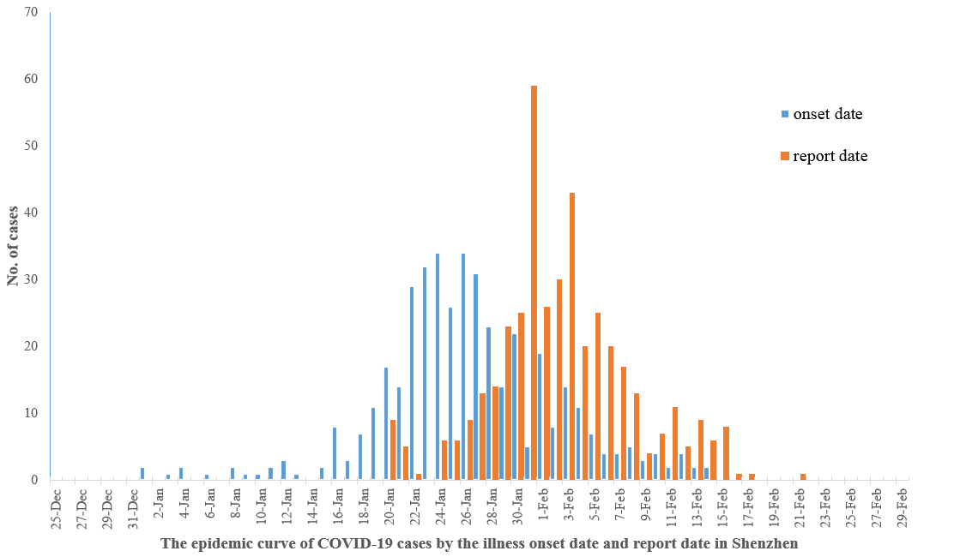

**Figure S1. The epidemic curve of COVID-19 cases by the illness onset date and report date in Shenzhen.**

**Figure S2. The geographic distribution of COVID-19 cases across 4 time periods in the 10 districts of Shenzhen, China.**

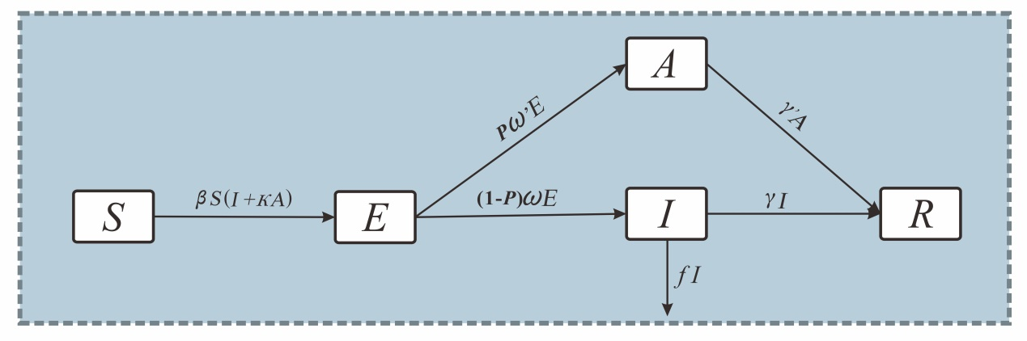

**Figure S3. Illustration of the susceptible-exposed-infectious-asymptomatic-recovered model.** We divided the population into five compartments: S (susceptible), E (latent), I (reported infectious), A (unreported infections) and R (removed). The dynamics of five compartments and the key parameters of the model across time were demonstrated by ordinary differential equations.

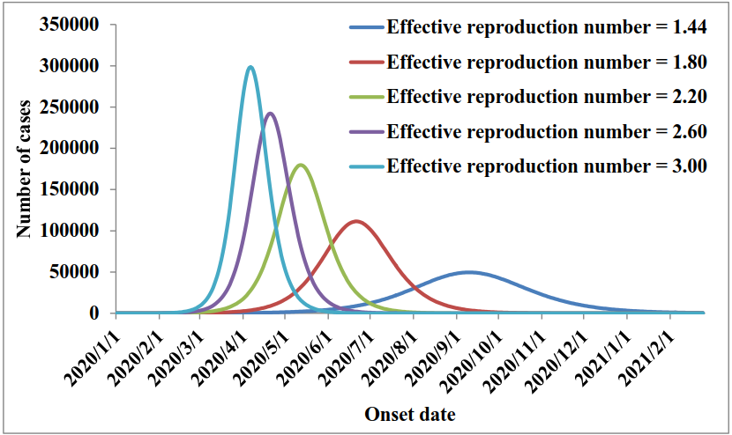

**Figure S4. The predicted number of cases in five scenarios with different effective reproduction number in condition of no intervention was initiated.**