Supplemental Appendix

Genetic drift and environmental spreading dynamics of COVID-19

Roberta Di Pietro, MD, Professor ¹, Mariangela Basile, PhD ¹, Laura Antolini, PhD, Professor ² and Saverio Alberti, MD, PhD, Professor ^{3 *}

¹ Department of Medicine and Aging Sciences, Section of Biomorphology, G. d’Annunzio University of Chieti-Pescara, Italy. Email: r.dipietro@morpho.unich.it, mariangelabasile@hotmail.it
² Center for Biostatistics, Department of Clinical Medicine, Prevention and Biotechnology, University of Milano-Bicocca, Monza, Italy. Email: laura.antolini@unimib.it
³ Unit of Medical Genetics, Department of Biomedical Sciences - BIOMORF, University of Messina, via Consolare Valeria, Messina, Italy. Email: salberti@unime.it

⁴ Contributed equally to this article.

* Address reprint requests to Prof. Alberti at the Unit of Medical Genetics, Department of Biomedical Sciences - BIOMORF, University of Messina, via Consolare Valeria, Messina, Italy, or at salberti@unime.it.

Supplemental Figures

Figure S1. Global accumulation of genomic mutations of SARS-CoV-2.

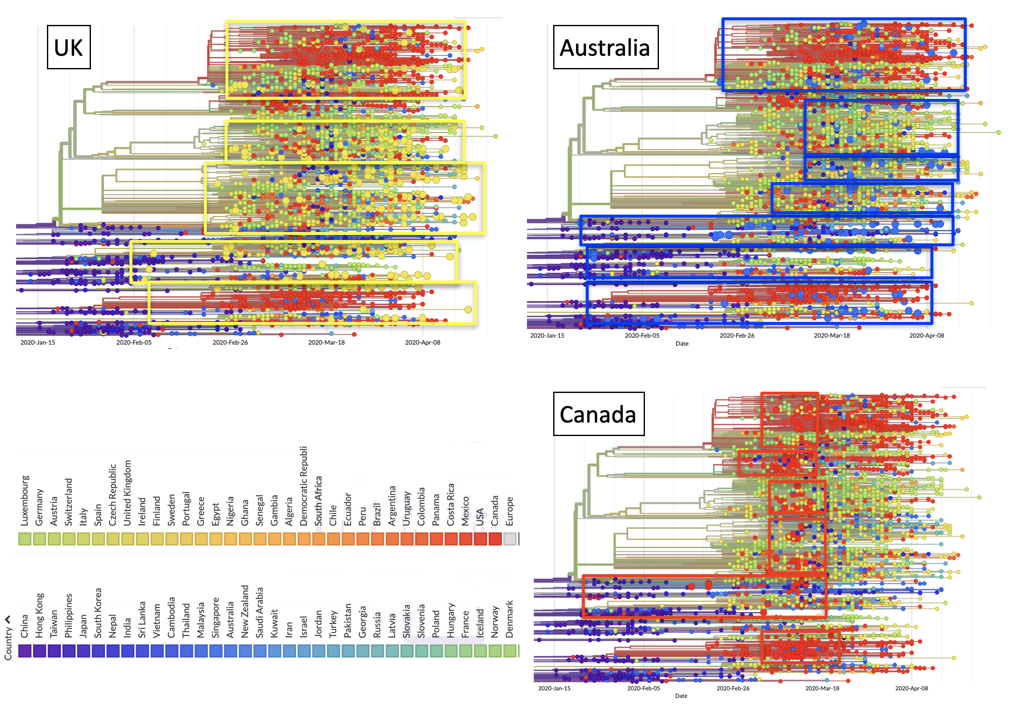

Accumulation of genomic mutations of SARS-CoV-2 over time around the globe is shown as strings-of-beads graphs. Each bead corresponds to a newly-described mutation. Larger beads indicate mutations identified in the indicated country. UK: bright yellow; Australia: blue; Canada: red. Rectangles enclose mutations by country. Color codes by country are shown at the bottom left.

Figure S2. Genomic mutations of SARS-CoV-2 in Europe.

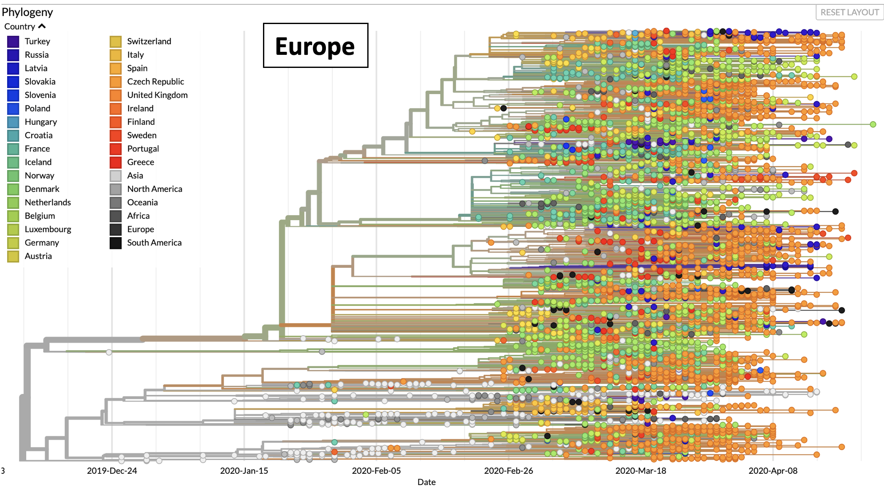

Accumulation of genomic mutations of SARS-CoV-2 over time in Europe is shown as strings-of-beads graphs. Each bead corresponds to a newly-described mutation. Color codes by country are shown on the upper left. Color codes by country are shown in the upper left.

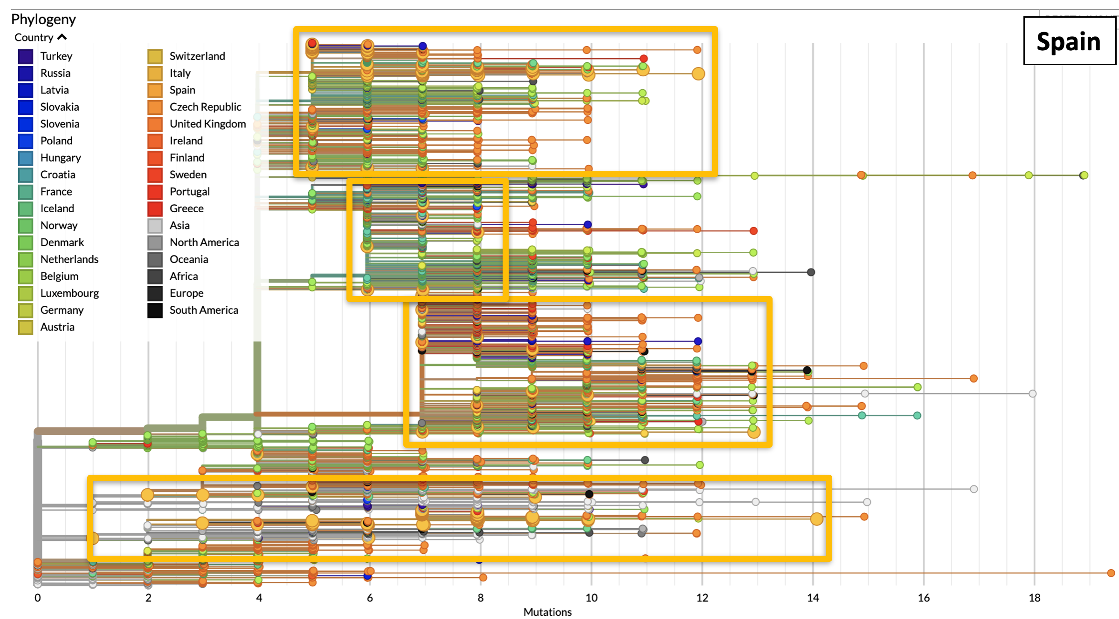
Figure S3. Genomic mutations of SARS-CoV-2 - Spain.

Accumulation of genomic mutations of SARS-CoV-2 over time in Spain is shown as strings of dark-yellow large dots. Rectangles enclose strings of mutations in each phylogenetic branch. The number of accumulated mutations in each viral isolate is indicated at the bottom. Color codes by country are shown in the upper left.

Figure S4. Genomic mutations of SARS-CoV-2 - Italy.
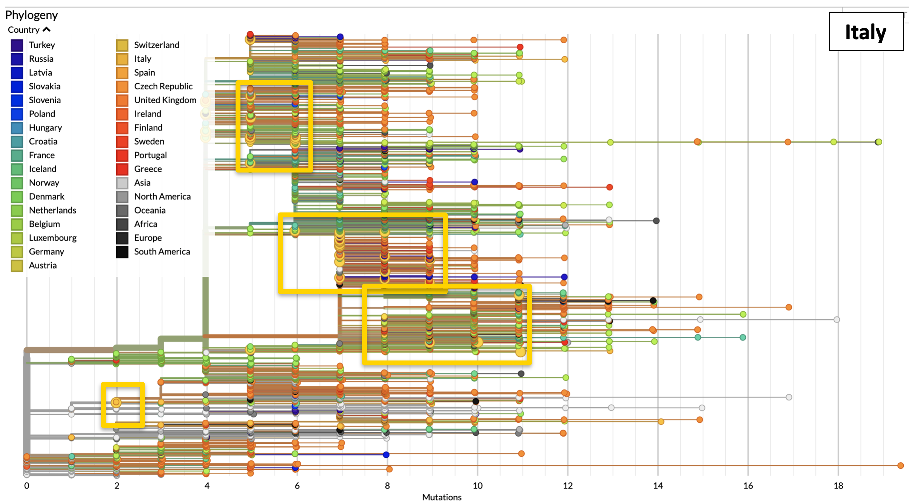

Accumulation of genomic mutations of SARS-CoV-2 over time in Italy is shown as strings of yellow large dots. Rectangles enclose strings of mutations in each phylogenetic branch. The number of accumulated mutations in each viral isolate is indicated at the bottom. Color codes by country are shown in the upper left.

Figure S5. Genomic mutations of SARS-CoV-2 - Sweden.
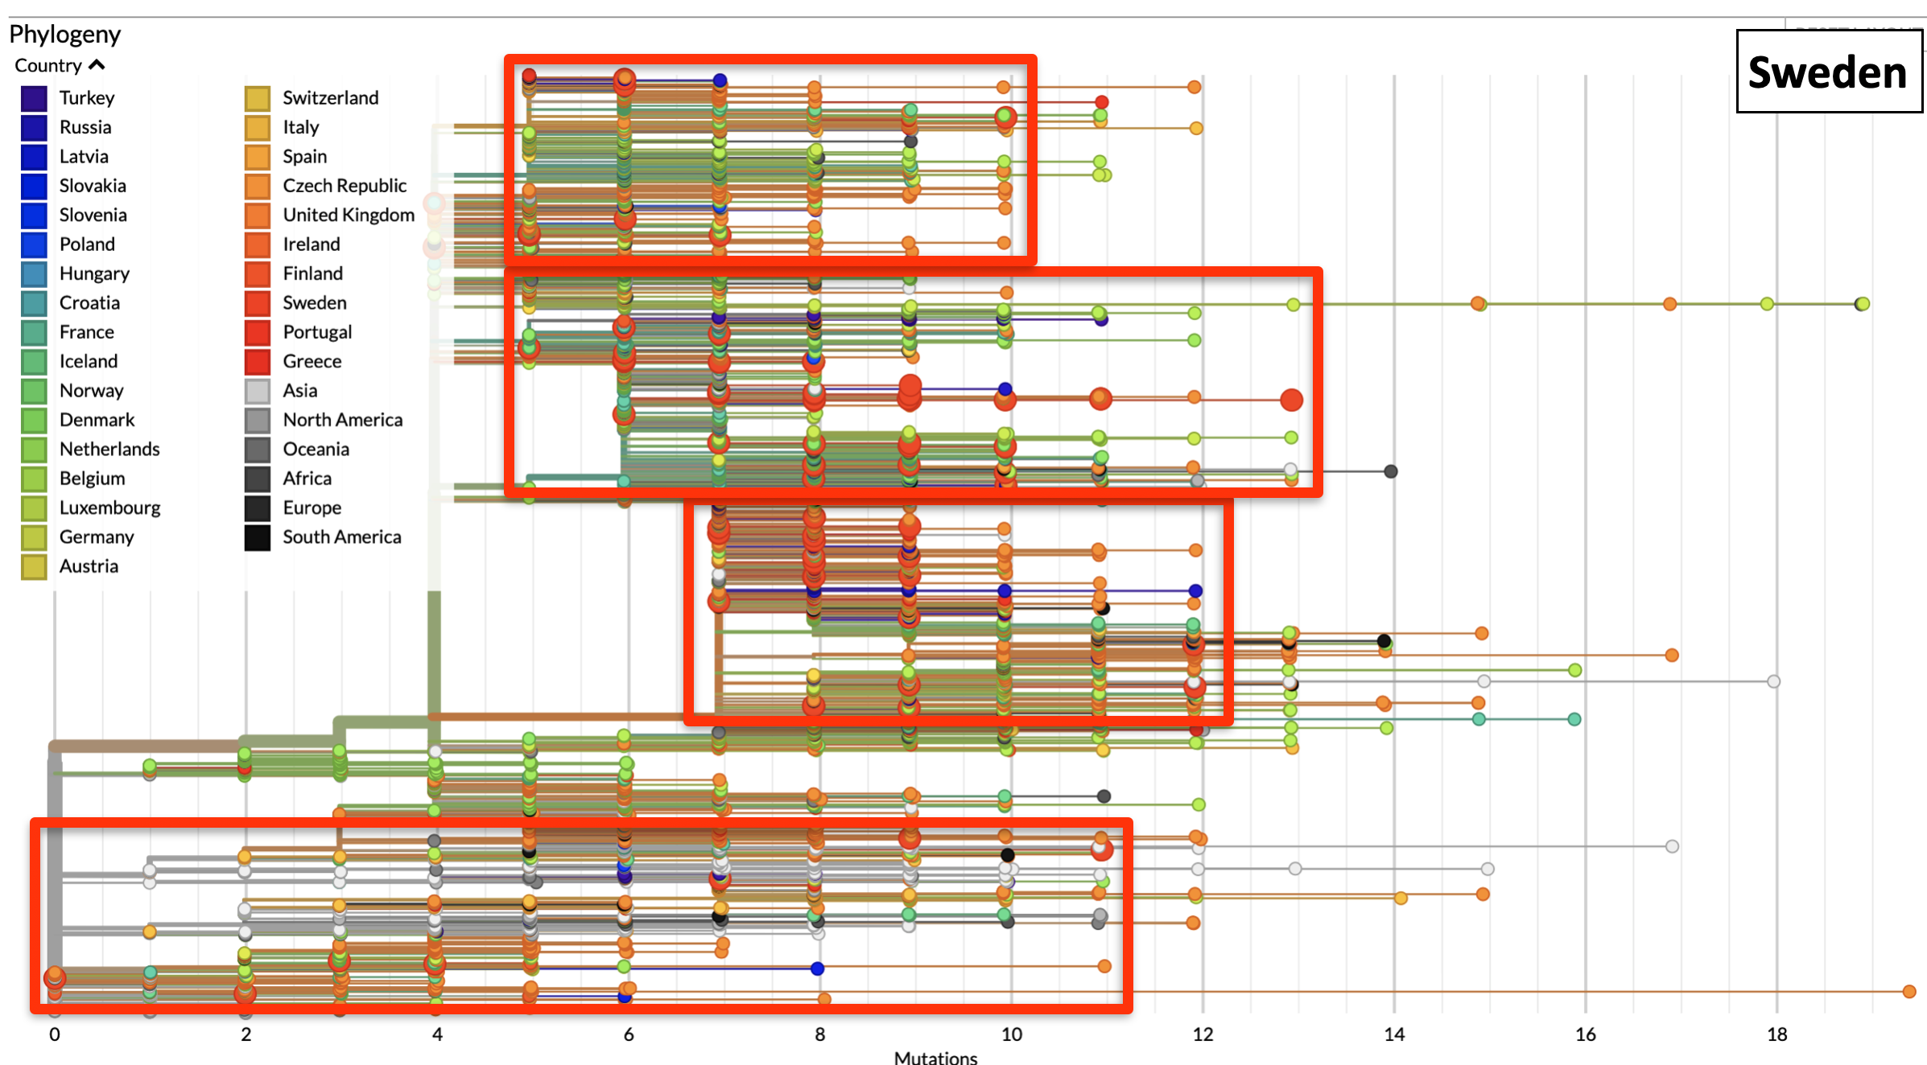

Accumulation of genomic mutations of SARS-CoV-2 over time in Sweden is shown as strings of red large dots. Rectangles enclose strings of mutations in each phylogenetic branch. The number of accumulated mutations in each viral isolate is indicated at the bottom. Color codes by country are shown in the upper left.

Figure S6. Genomic mutations of SARS-CoV-2 - The Netherlands.

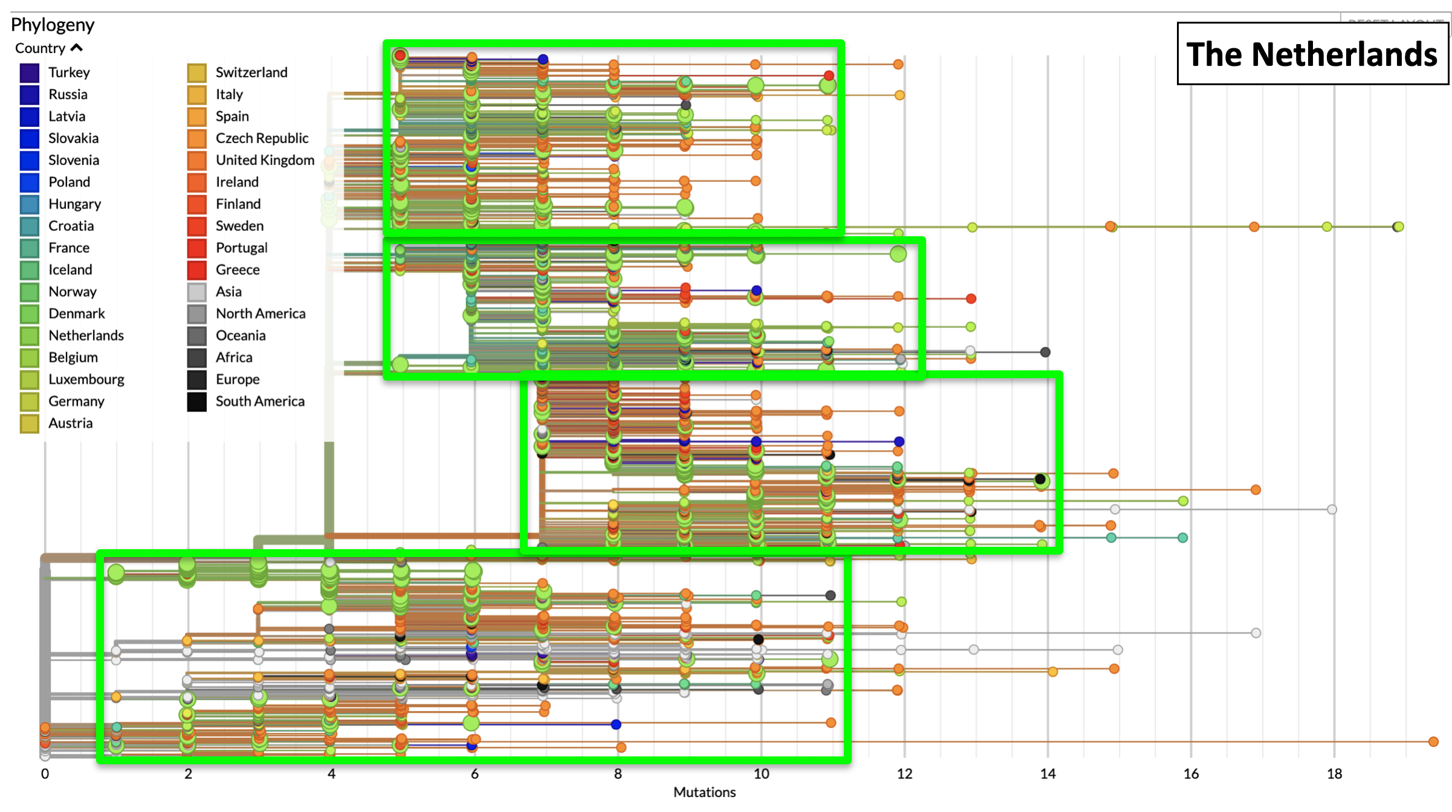

Accumulation of genomic mutations of SARS-CoV-2 over time in The Netherlands is shown as strings of bright-green large dots. Rectangles enclose strings of mutations in each phylogenetic branch. The number of accumulated mutations in each viral isolate is indicated at the bottom. Color codes by country are shown in the upper left.

Figure S7. Genomic mutations of SARS-CoV-2 - Belgium.

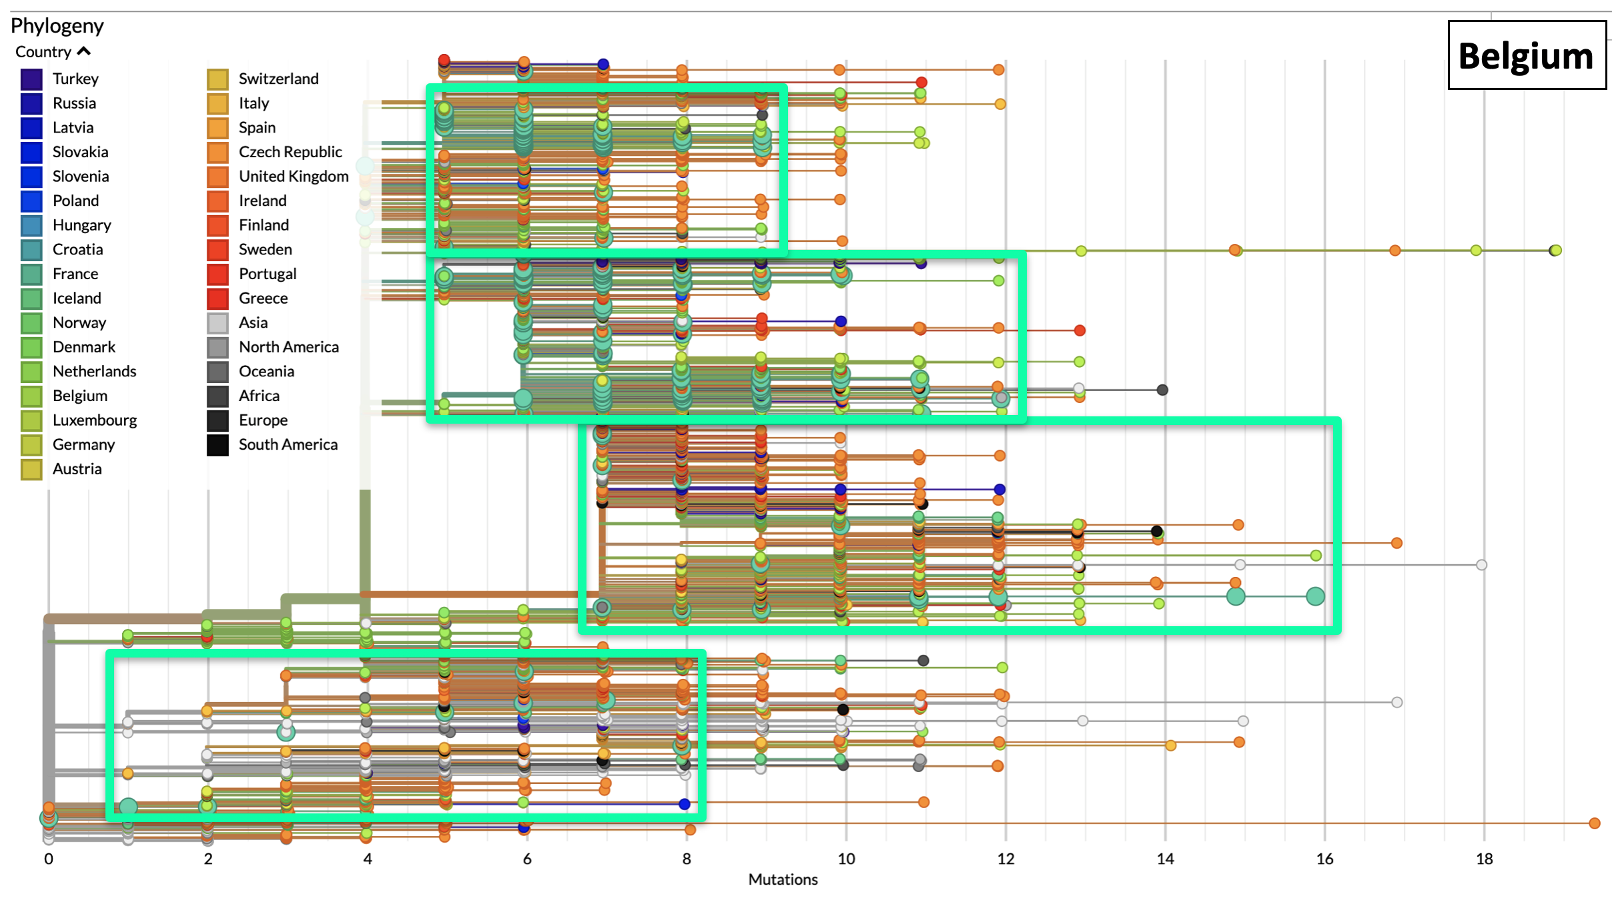
Accumulation of genomic mutations of SARS-CoV-2 over time in Belgium is shown as strings of light-green large dots. Rectangles enclose strings of mutations in each phylogenetic branch. The number of accumulated mutations in each viral isolate is indicated at the bottom. Color codes by country are shown in the upper left.

Figure S8. Genomic mutations of SARS-CoV-2 - France.
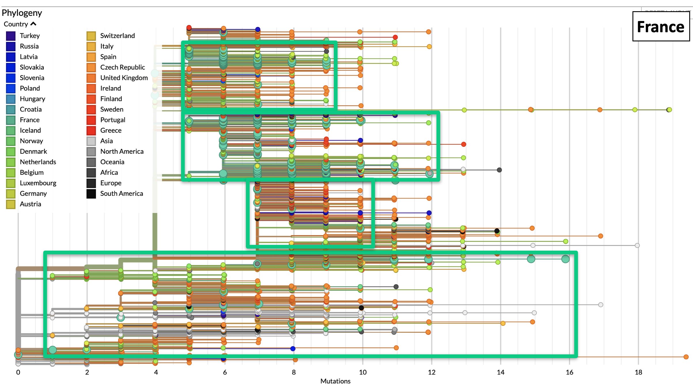

Accumulation of genomic mutations of SARS-CoV-2 over time in France is shown as strings of deep-green large dots. Rectangles enclose strings of mutations in each phylogenetic branch. The number of accumulated mutations in each viral isolate is indicated at the bottom. Color codes by country are shown in the upper left.

Figure S9. Progression of COVID-19 over Italy - Northern Provinces *.

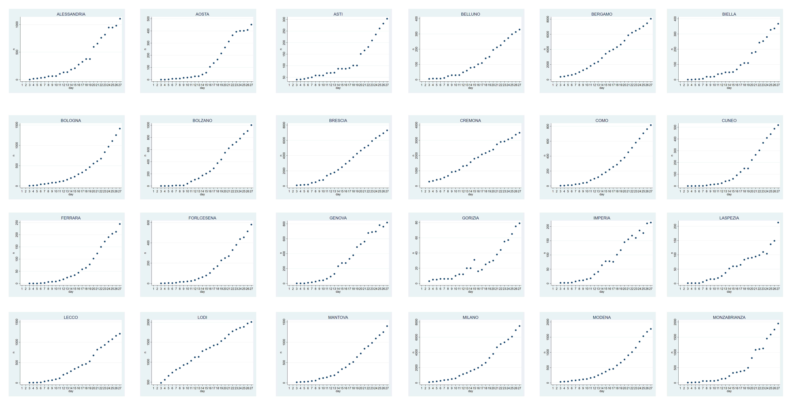
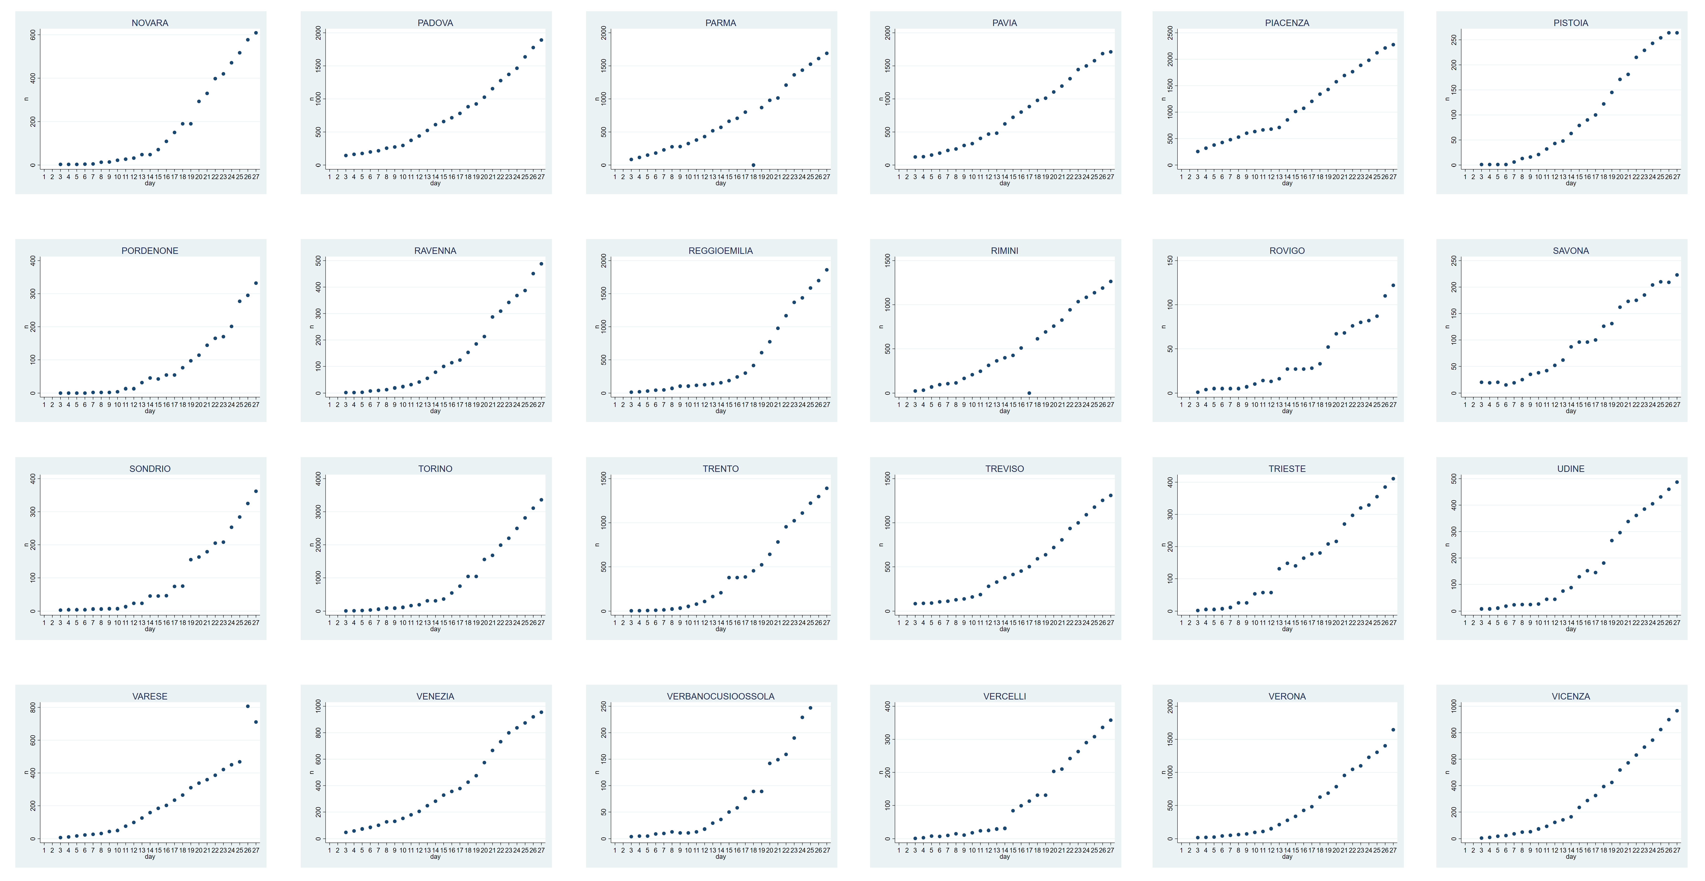

*: Graphs are in alphabetical order. Case incidence in the indicated municipalities is plotted versus time (March 3-27, 2020). For comparison purposes, all graphs were normalized versus the highest number of cases per Province. COVID-19 doubling times were computed on non-normalized, absolute numbers.

Figure S10. Progression of COVID-19 over Italy - Central & Southern Provinces*.

Central
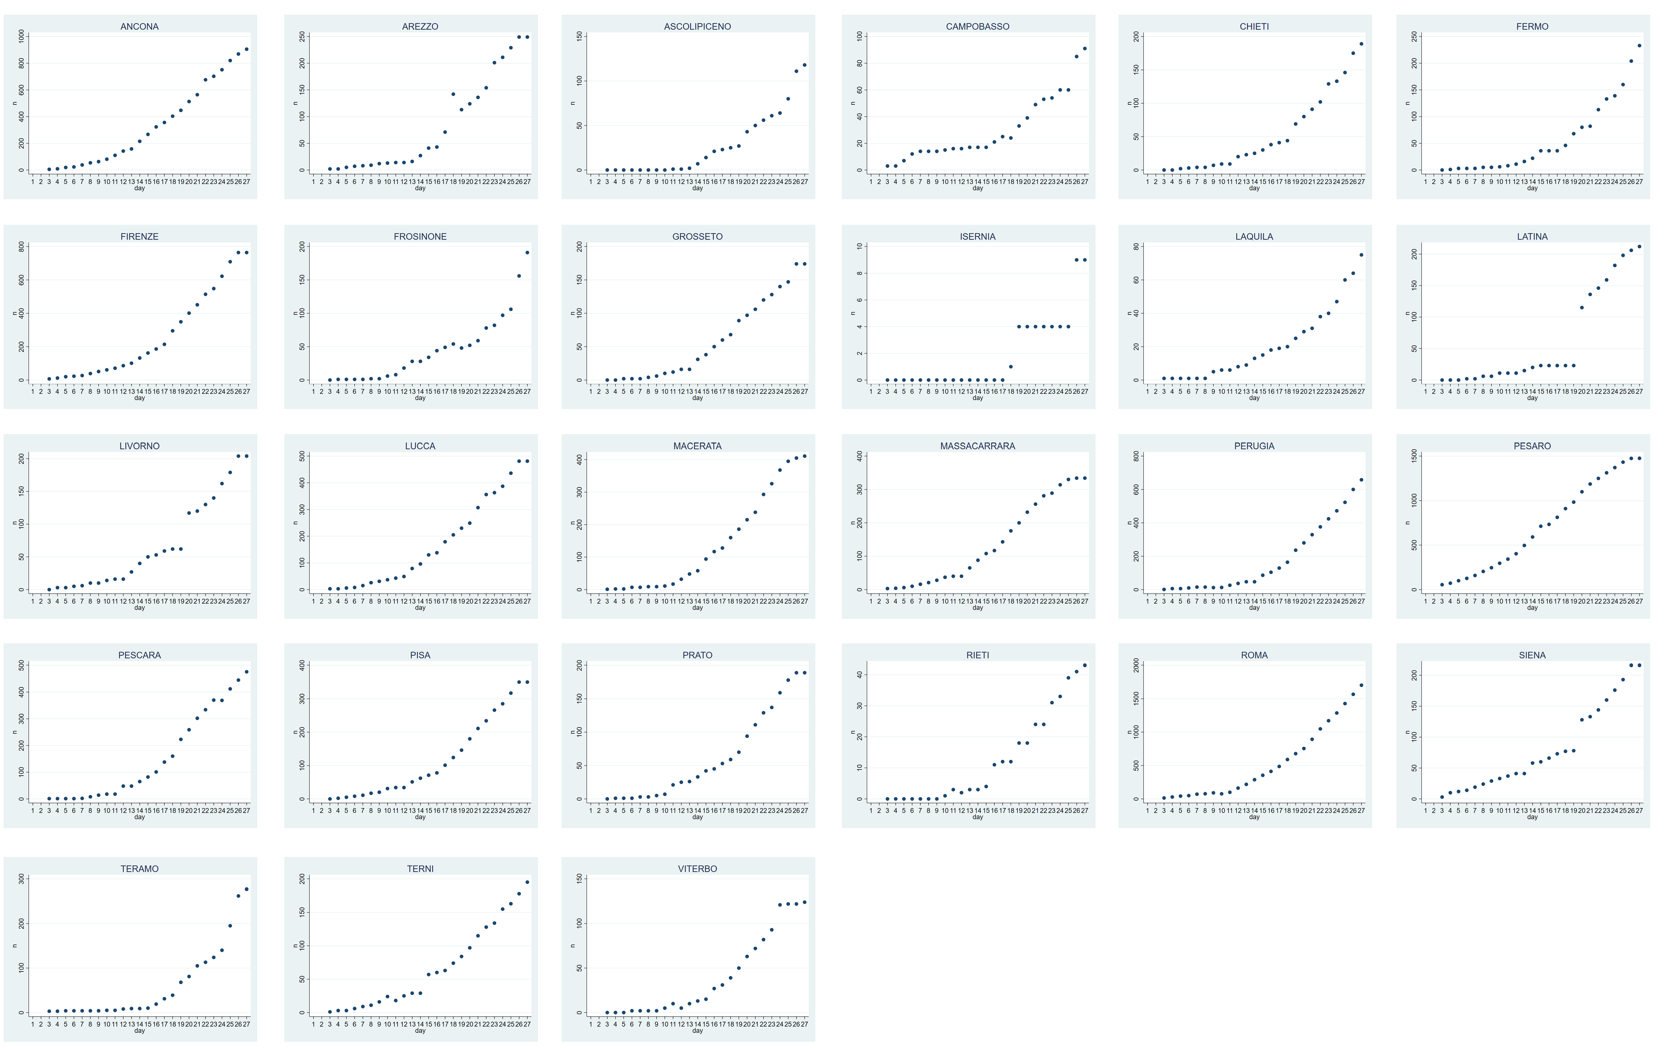

Southern
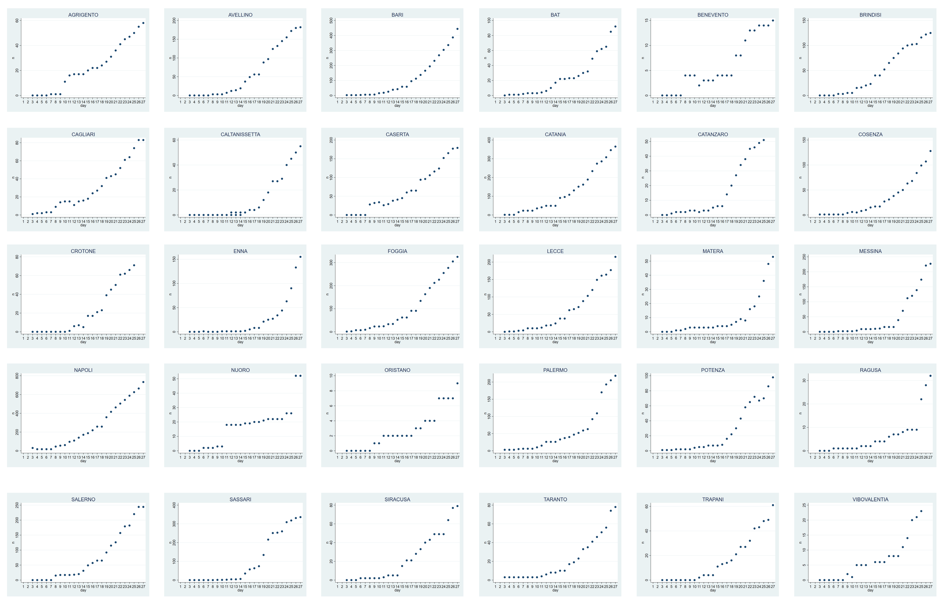

*: Graphs are in alphabetical order. Case incidence in the indicated municipalities is plotted versus time (March 3-27, 2020). For comparison purposes, all graphs were normalized versus the highest number of cases per Province. COVID-19 doubling times were computed on non-normalized, absolute numbers.
Figure S11. Progression of COVID-19 over Spain*.

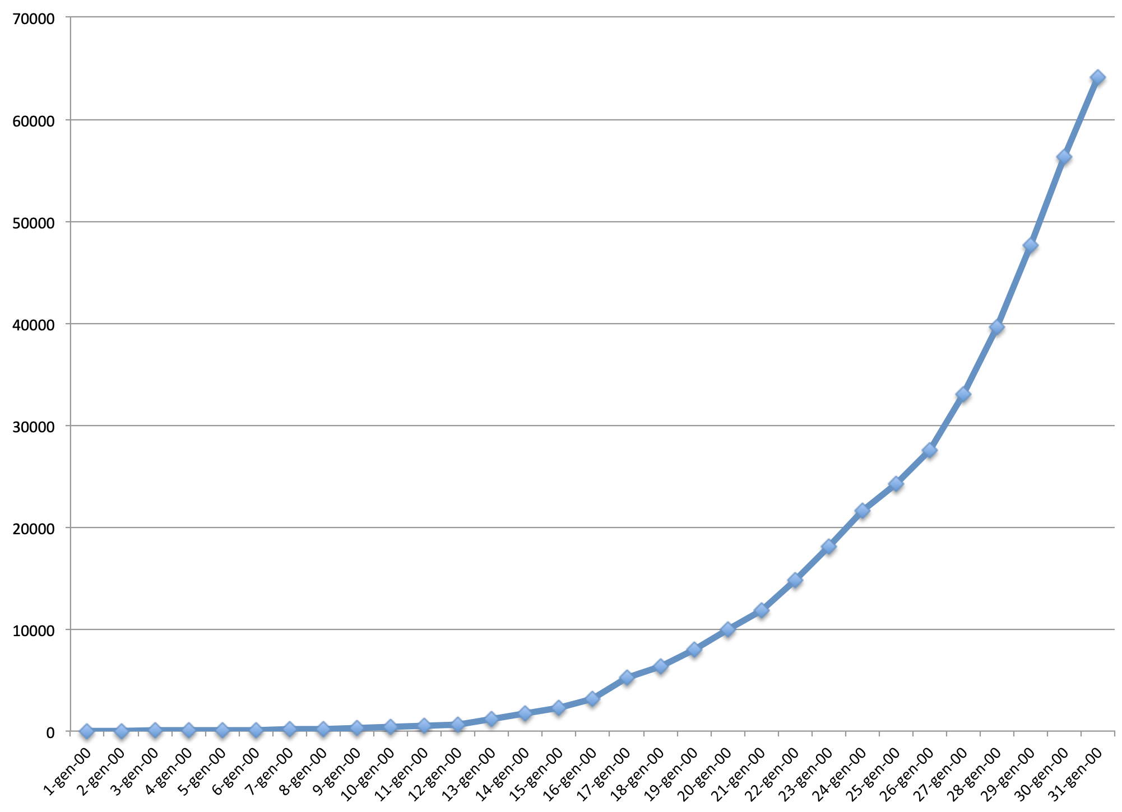

*: case incidence in the country is plotted versus time (March 1-31, 2020).

Figure S12. Progression of COVID-19 over Norway*.

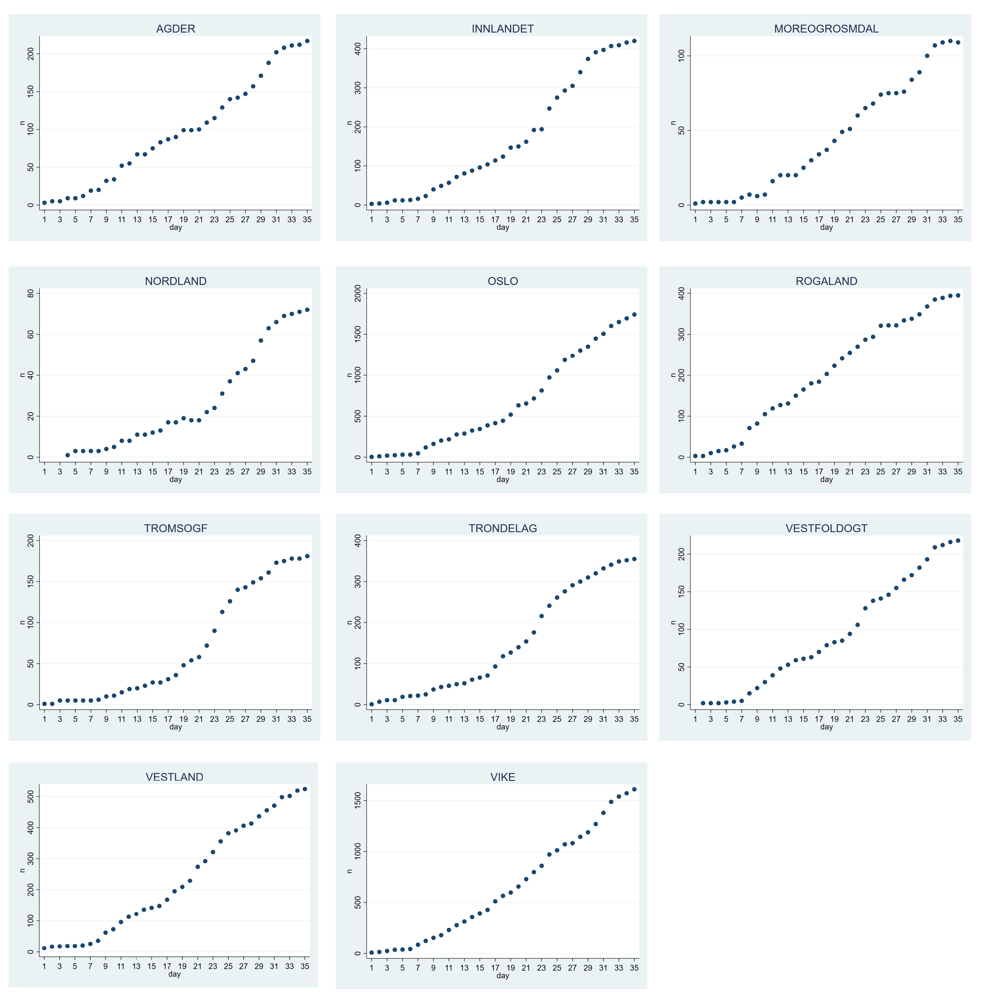

*: case incidence in the indicated municipalities is plotted versus time (March 1-April 7, 2020).

Figure S13. Progression of COVID-19 over Finland*.

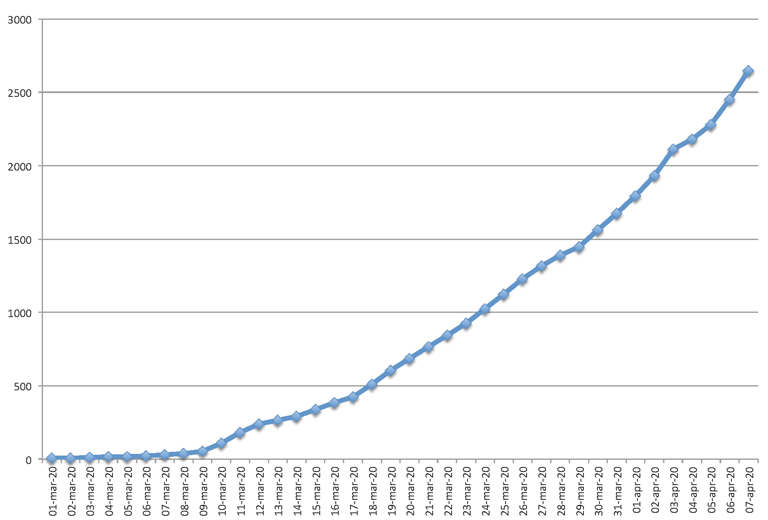

*: case incidence in the indicated municipalities is plotted versus time (March 1-April 7, 2020).

Figure S14. Progression of COVID-19 over Sweden*.

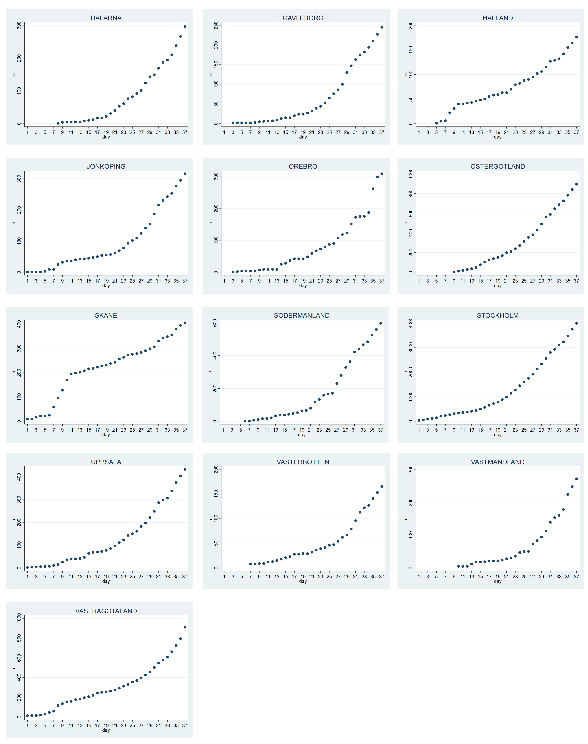

*: case incidence in the indicated municipalities is plotted versus time (March 1-23, 2020).

