Supplementary material for

Social distancing and movement constraint as the most likely factors for COVID-19 outbreak control in Brazil

Matheus Tenório Baumgartnera*¶, Fernando Miranda Lansac-Tôhaa*¶, Marco Túlio& Pacheco Coelhob&, Ricardo Dobrovolski c& & José Alexandre Felizola Diniz-Filhob&

aDepartamento de Biologia, Centro de Ciências Biológicas, Universidade Estadual de Maringá, Maringá, PR, Brasil

bDepartamento de Ecologia, Universidade Federal de Goiás, Goiânia, GO, Brazil

cInstituto de Biologia, Universidade Federal da Bahia, Salvador, BA, Brazil

* Corresponding author

E-mail address:

matheustbs@gmail.com (M.T.S Baumgartner)

fernando_toha@hotmail.com (F.M. Lansac-Tôha)

¶These authors contributed equally to this paper

&These authors contributed equally to this paper

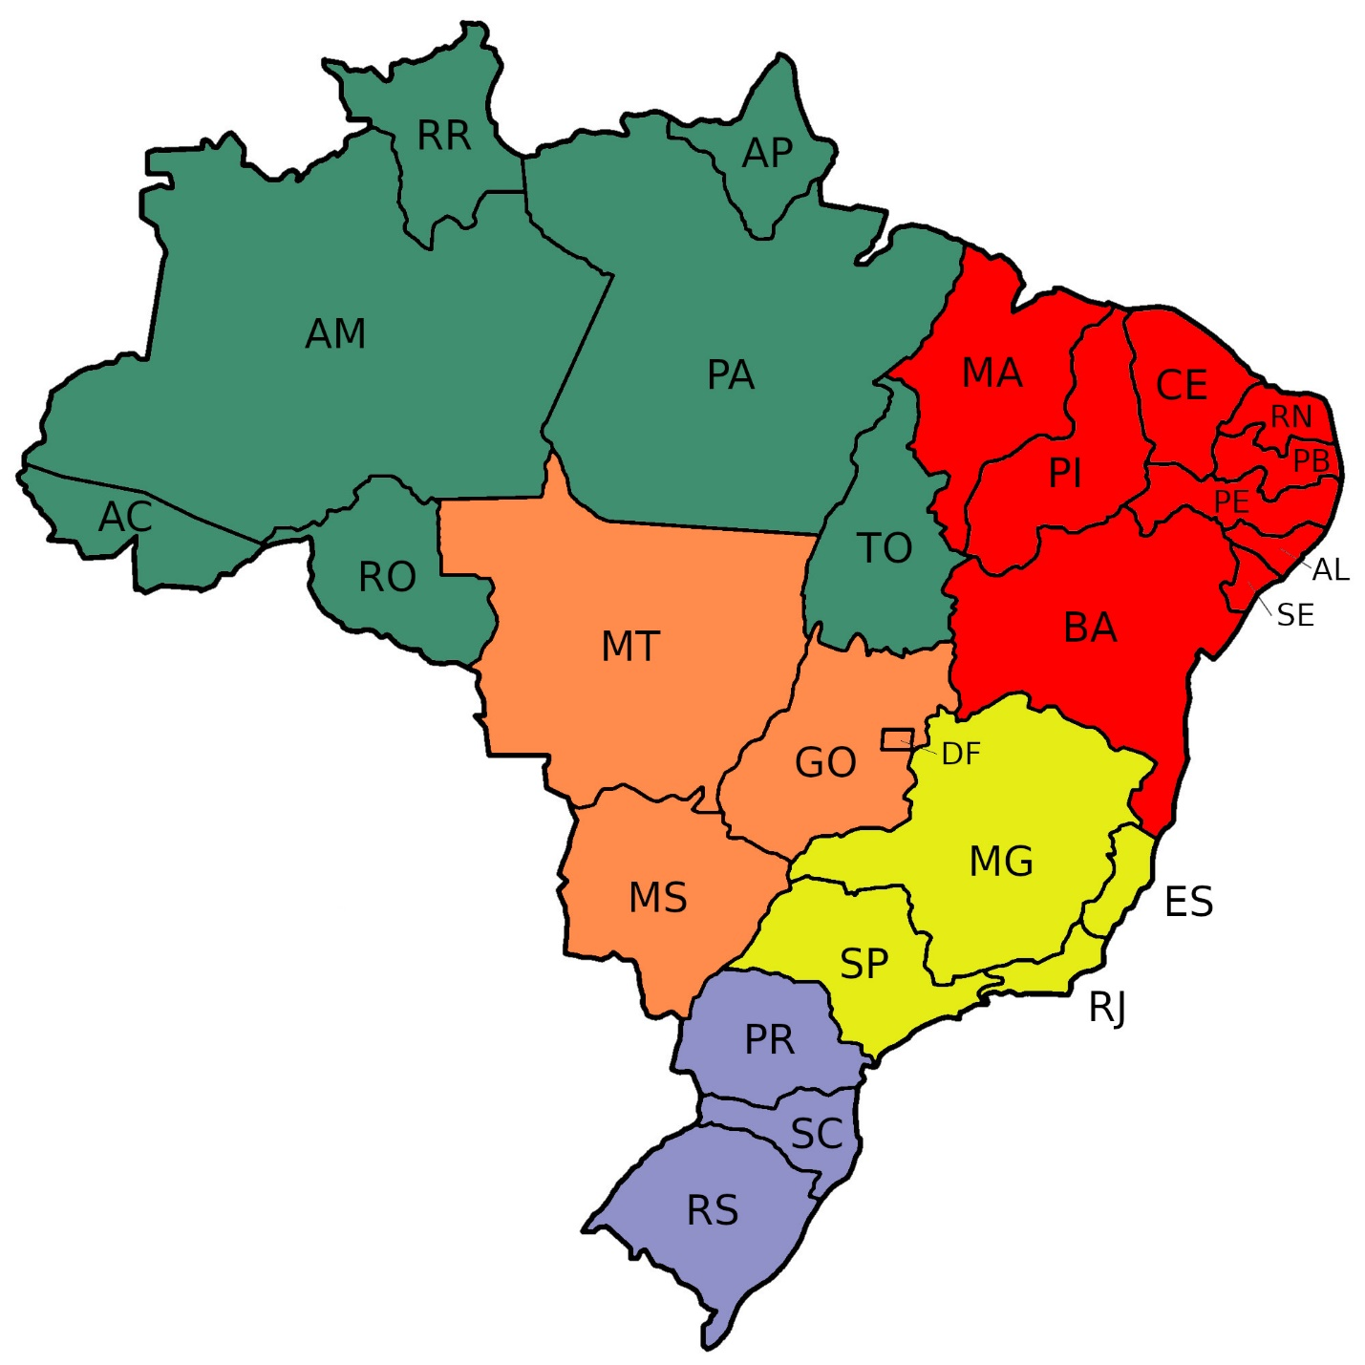

**Fig. S1:** Map of Brazil showing major regions and states. North region (green): AC = Acre, AP = Amapá, AM = Amazonas, PA = Pará, RO = Rondônia, RR = Roraima, TO = Tocantins; Northeast region (red): AL = Alagoas, BA = Bahia, CE = Ceará, MA = Maranhão, PB = Paraíba, PE = Pernambuco, PI = Piauí, RN = Rio Grande do Norte, SE = Sergipe; Central-West region (Orange): GO = Goiás, MT = Mato Grosso, MS = Mato Grosso do Sul; Southeast (yellow): ES = Espírito Santo, MG = Minas Gerais, RJ = Rio de Janeiro, SP = São Paulo; South region (blue): PR = Paraná, RS = Rio Grande do Sul, SC = Santa Catarina.

C:\Users\Asus\Documents\Laboratorio protoplankton\Coronga\STOTEN\S2 Fig.tiff

**Fig. S2:** Time series of percentages of people respecting social distancing protocols. Social distancing was quantified using monitoring data on the relative movement of electronic devices (e.g., cellphones and tablets), provided by telephone companies. See Methods for details.