Supplementary Appendix

A possible role of immunopathogenesis in COVID-19 progression

# Table of Contents

[Authors 3](#_Toc38892499)

[Detailed Methods 4](#_Toc38892500)

[Preparation of PBMCs 4](#_Toc38892501)

[Stimulation with SARS-Cov-2 overlapping peptide pools 4](#_Toc38892502)

[Antibodies 4](#_Toc38892503)

[Flow cytometry 5](#_Toc38892504)

[SARS-CoV-2 IgG Antibody titers 5](#_Toc38892505)

[Statistical analysis 6](#_Toc38892506)

[Supplement tables 7](#_Toc38892507)

[Table S1. COVID-19 severity according to the Robert Koch Institute, Germany, published 17 April, 20203 7](#_Toc38892508)

[Table S2. Clinical characteristics of the study patients according to disease severity 8](#_Toc38892509)

[Table S3. Association of gender with the potential markers of COVID-19 severity 9](#_Toc38892510)

[Table S4. Frequency of patients with detectable antigen specific T-cell subpopulations 10](#_Toc38892511)

[Supplement figures 11](#_Toc38892512)

[Figure S1. COVID-19 severity is not reflected in composition of the major immune cell populations. 11](#_Toc38892513)

[Figure S2. COVID-19 severity is not reflected in composition of the major immune cell populations at the follow-up visit 12](#_Toc38892514)

[Figure S3. Decrease of lymphocyte frequencies with differentiated and activated cytotoxic phenotype in patients with severe or critical COVID-19 at the follow-up visit 13](#_Toc38892515)

[Figure S4. Increased number and functional activity of SARS-CoV-2-reactive T-cells in patients with critical COVID-19. 14](#_Toc38892516)

[Figure S5. Gating strategy for detection of cytokine producing CD4+ and CD8+ antigen specific T-cells. 16](#_Toc38892517)

[Figure S6. Gating strategy for identification of main immune cell populations. 17](#_Toc38892518)

[Figure S7. Gating strategy for identification of activated T-cells. 18](#_Toc38892519)

[Figure S8. Gating strategy for identification of memory and regulatory T-cells. 19](#_Toc38892520)

[Figure S9.Gating strategy for identification of B-cell subpopulations. 20](#_Toc38892521)

[References 20](#_Toc38892522)

# Authors

Moritz Anft, Center for Translational Medicine; Krystallenia Paniskaki, Department of Infectious Diseases; Arturo Blazquez-Navarro, Center for Translational Medicine and Charité – Universitätsmedizin Berlin; Adrian Doeverlaar, Center for Translational Medicine; Felix S. Seibert, Center for Translational Medicine; Bodo Hoelzer, Center for Translational Medicine; Sarah Skrzypczyk, Center for Translational Medicine; Eva Kohut, Center for Translational Medicine; Julia Kurek, Center for Translational Medicine; Jan Zapka, Center for Translational Medicine; Patrizia Wehler, Center for Translational Medicine and Charité – Universitätsmedizin Berlin; Sviatlana Kaliszczyk, Center for Translational Medicine; Sharon Bajda, Charité – Universitätsmedizin Berlin; Constantin J. Thieme, Charité – Universitätsmedizin Berlin; Toralf Roch, Center for Translational Medicine and Charité – Universitätsmedizin Berlin; Margarethe Justine Konik, Department of Infectious Diseases; Thorsten Brenner, Department of Anesthesiology; Clemens Tempfer, Department of Gynecology and Obstetrics; Carsten Watzl, Department of Immunology; Sebastian Dolff, Department of Infectious Diseases; Ulf Dittmer, Germany Institute for Virology; Timm H. Westhoff, Center for Translational Medicine; Oliver Witzke, Department of Infectious Diseases; Ulrik Stervbo, Center for Translational Medicine; Nina Babel, Center for Translational Medicine and Charité – Universitätsmedizin Berlin

# Detailed Methods

## Preparation of PBMCs

Peripheral blood was collected in S-Monovette K3 EDTA blood collection tubes (Sarstedt). Collected blood was pre-diluted in PBS/BSA (Gibco) at a 1:1 ratio and underlaid with 15 mL Ficoll-Paque Plus (GE Healthcare). Tubes were centrifuged at 800 g for 20 minutes at room temperature. Isolated PBMCs were washed twice with PBS/BSA.

## Stimulation with SARS-Cov-2 overlapping peptide pools

Isolated PBMCs were stimulated with 15mer overlapping peptides pools (OPP) from SARS-Cov2 Proteins with an overlap of 11 amino acids. SARS-CoV-2 PepTivator peptide pools (Miltenyi Biotec) were used containing overlapping peptides spanning the whole surface glycoprotein (GenBank MN908947.3, Protein QHD43416.1, including the sequence domains aa 304-338, 421-475, 492-519, 683-707, 741-770, 785-802 and 885-1273). Peptide pools were dissolved per manufacturer’s directions and used at a concentration of 1 µg/ml. 2.5x106 PBMCs were plated for each condition in 96-UWell Plates in RPMI media (Life Technologies, supplemented with 1% Penicillin-Streptomycin-Glutamine (Sigma Aldrich) and 10% FCS (PAN-Biotech)) and were stimulated or left untreated as a control for 16 h. After 2 h Brefeldin A (1µg/ml, Sigma Aldrich) was added. Antigen specific responses were considered as positive after non-specific background was subtracted and more than 0.001% cells were positive. Negative values were set to zero.

## Antibodies

General phenotyping (all antibodies are from BioLegend unless otherwise noted): CD45-A488; clone: 2D1, CD56-PerCP-Cy5.5; clone: NCAM, CD14-PE-Vio770; clone: TÜK4 (Miltenyi Biotec), CD4-A700; clone: OKT4, CD16-APC-Vio770; clone: REA423 (Miltenyi Biotec), CD8-V500; clone: RPA-T8 (BD), CD19-BV605; clone: HIB19, HLA-DR-BV650; clone: L243, CD3-BV785; clone: OKT3.

T-cell subsets (all antibodies are from Beckman-Coulter unless otherwise noted): CCR7-PE; clone: G043H7, CD127-PC7; clone: R34.34, CD25-FITC; clone: B1.49.9, CD3-APC-750; clone: UCHT1, CD45RA-Pacific Blue; clone: 2H4, CD4-ECD; clone: SCF4I12T4D11, CD8-APC; clone: B9.11, TCR α/β- PerCP-Cy5.5; clone: IP26 (BioLegend), TCR γ/δ-BV510; clone: B1 (BioLegend).

T-cell activation state ex vivo (all antibodies are from Beckman-Coulter): CD11a-FITC; clone: 25.3, CD28- PerCP-Cy5.5; clone: CD28.2, CD57-Pacific Blue; clone: NC1, CD3-APC-750; clone: UCHT1, HLA-DR-PE; clone: Immu-357, CD4-ECD; clone: SCF4I12T4D11, CD8-APC; clone: B9.11.

B-cell subsets (all antibodies are from Beckman-Coulter unless otherwise noted): CD19-ECD; clone: J3-119, CD21-APC; clone: B-ly4 (BD Biosciences), CD24- PerCP-Cy5.5; clone: ALB9, CD27-PC7; clone: 1A4CD27, CD38-APC-750; clone: LS198-4-3, CD45-KrOrange; clone: J33, HLA-DR-PE; clone: Immu357, IgD-FITC; clone: IA6-2, IgM-Pacific Blue; clone: SA-DA4.

SARS-Cov-2 specific T-cells (all antibodies are from BioLegend unless otherwise noted): Surface staining: CCR7 (CD197)-PerCP-Cy5.5; clone: G043H7, CD4-A700; clone: OKT4, LD eFluor780 (eBioscience), CD8-V500; clone: RPA-T8 (BD Biosciences), CD45RA-BV605; clone: HI100. Intracellular staining: Granzyme B-FITC; clone: GB11, IL-2-PE; clone: MQ1-17H12, IL-4-PE-Dazzle594; clone: MP4-25D2, CD137 (4-1BB)-PE-Cy7; clone: 4B4-1, CD154 (CD40L)-A647; clone: 24-31, TNFa-eFluor450; clone: MAb11 (eBioscience), IFNg-BV650; clone: 4S.B3, CD3-BV785; clone: OKT3. Fixable Viability Dye eFluor 780 (eBioscience) was used for live/dead discrimination.

## Flow cytometry

EDTA treated whole blood was stained with optimal concentrations of each antibody for 10 minutes at room temperature in the dark. Erythrocytes were lysed using VersaLyse (Beckman-Coulter) with 2.5% IOTest 3 Fixative Solution (Beckman-Coulter) for 30 minutes at room temperature in the dark. Samples for general phenotyping were immediately acquired, while samples for T- and B-cell subsets were washed twice with PBS/BSA. Samples for the B-cell subset were washed twice with PBS prior to staining with antibodies.

T-cells stimulated with SARS-Cov-2 OPP were stained with optimal concentrations of antibodies for 10 minutes at room temperature in the dark. Stained cells were washed twice with PBS/BSA before preparation for intracellular staining using the Intracellular Fixation & Permeabilization Buffer Set (Thermo Fisher Scientific) as per manufacturer’s instructions. Fixed and permeable cells were stained for 30 minutes at room temperature in the dark with optimal dilution of antibodies against intracellular antigen.

All samples were immediately acquired on a CytoFlex flow cytometer (Beckman Coulter). Quality control was performed daily using the recommended CytoFLEX Daily QC Fluorospheres (Beckman Coulter). No modification to the compensation matrices was required throughout the study.

## SARS-CoV-2 IgG Antibody titers

Peripheral blood was collected in S-Monovette Z-Gel (Sarstedt). SARS-CoV-2 IgG titers were analyzed in purified serum using a SARS-CoV-2 IgG kit (EUROIMMUN, Lübeck, Germany). The test was performed according to the manufacturer’s instructions. Briefly, serum samples were diluted 1:100 and added to plates coated with recombinant SARS-CoV-2 antigen. Bound SARS-Cov-2 S1 protein specific IgG was detected by a HRP-conjugated anti-human IgG. The absorbance was read on a microplate reader at 450 nm with reference at 620 nm and evaluated as the ratio the absorbance of the sample to the absorbance of the internal standard.

## Statistical analysis

Flow cytometry data was analyzed using FlowJo version 10.6.2 (BD Biosciences); gating strategies are presented in Fig. S5-S9. Statistical analysis was performed using R, version 3.6.21. Categorical variables are summarised as numbers and frequencies; quantitative variables are reported as median and range. Box plots depict the median, first and third quartile of a variable; the maximum length of the whiskers corresponds to 1.5 times the interquartile range. Unless otherwise stated, differences between groups for categorical variables were calculated using Fisher’s exact test. Differences in quantitative variables between groups are analysed using the two-tailed Mann-Whitney U test unless otherwise stated; correlation size and significance were calculated using Spearman’s correlation coefficient. Bivariate regression analysis was performed to exclude potential bias in the analysis due to the unbalanced gender distribution of the groups. Thus, for factors significantly associated with illness severity, regression analysis was performed with gender and COVID-19 severity as independent variables, without interactions. P values below 0.050 were considered significant; only significant P values are reported. P values were not corrected for multiple testing, as this study was of exploratory nature2.

# Supplement tables

## Table S1. COVID-19 severity according to the Robert Koch Institute, Germany, published 17 April, 20203

|  |  |
| --- | --- |
| Severity level | Symptom |
| Light and uncomplicated | Slight symptoms |
| Moderate | Light pneumonia |
| Severe pneumonia | Fever or respiratory tract infection and either respiratory rate > 30/min, severe dyspnea, or SpO2 <90% room air |
| Critical | ARDS, sepsis, or septic shock |

## Table S2. Clinical characteristics of the study patients according to disease severity

|  |  |  |  |
| --- | --- | --- | --- |
|  | Disease Severity | | |
|  | Moderate | Severe | Critical |
| Number of Patients | 21 | 18 | 14 |
| Chest CT abnormalities |  |  |  |
| Bilateral ground-glass opacity | 16 | 15 | 14 |
| Pleural effusion | 0 | 2 | 1 |
|  |  |  |  |
|  |  |  |  |
| Median laboratory findings |  |  |  |
| pO2/FiO2 mmHg | na | na | 138 (58-280) |
| Laucocyte (cells/nL) | 5.17 (2.07-11) | 6.48 (0.85-33.9) | 12.74 (6.08-22.14) |
| Lymphocyte (cells/nL) | 0.81 (0.14-1.82) | 0.65 (0.16-1.36) | 1.11 (0.22-2.82) |
| Neutrophile (cells/nL) | 4.15 (0.72-9.61) | 5.05 (1.68-22.84) | 10.3 (5.23-12.82) |
| Platelet (cells/nL) | 178 (120-380) | 209 (115-377) | 190 (26-598) |
| Hemoglobin (g/dL) | 12.7 (8.4-15.4) | 12.1 (6.1-16.9) | 9.2 (7.9-12.6) |
| C-reactive protein (mg/dL) | 5.1 (0.4-17.9) | 13.3 (6-24) | 14.15 (5-32) |
| Procalcitonin (ng/mL) | 0.09 (0.01-0.75) | 0.135 (0.01-2.35) | 2.08 (0.06-29.64) |
| Lactat dehydrogenase (U/L) | 305 (194-615) | 301 (198-685) | 433.5 (141-1300) |
| Aspartate aminotransferase (U/L) | 35 (12-110) | 35.5 (10-151) | 110.5 (25-625) |
| Alanine aminotranserase (U/L) | 27 (10-143) | 21.5 (10-220) | 59 (22-393) |
| Total Bilirubin (mg/dL) | 0.55 (0.1-1.6) | 0.7 (0.2-1.8) | 1.3 (0.2-20.5) |
| GFR\* (mL/min/1.73m2) | 70 (22-99) | 41.4 (50-99) | 46 (6-82) |
|  |  |  |  |
| Therapy |  |  |  |
| Oxygen | 6 | 15 | 14 |
| Intravenous antibiotics | 11 | 18 | 14 |
| Admission to intensive care unit | 0 | 0 | 12 |
| Mechanical Ventilation | 0 | 0 | 12 |
|  |  |  |  |
| Length of hospitalization (days) | 7 (2-20) | 16 (5-29) | 23 (10-35) |
| Currently hospitalized | 6 | 13 | 8 |
| Death | 0 | 0 | 5 |
| Discharge | 14 | 5 | 1 |

\*Estimated by MDRD. Values are given as median (range). Na indicate not applicable

## Table S3. Association of gender with the potential markers of COVID-19 severity

|  |  |
| --- | --- |
| Cell population | P value |
| NK-cells | 0.853 |
| Eosinophiles | 0.272 |
| % CD4+ among CD3+ | 0.366 |
| % CD8+ among CD3+ | 0.301 |
| Ratio CD4+/CD8+ | 0.409 |
| % CM among CD4+ | 0.574 |
| % TEMRA among CD8+ | 0.596 |
| % CD4+HLA-DR+ among CD4+ | 0.798 |
| % CD8+HLA-DR+ among CD8+ | 0.743 |
| % CD4+CD57+ among CD4+ | 0.110 |
| % CD8+CD57+ among CD8+ | 0.066 |
| % CD4+CD11a+ among CD4+ | 0.826 |
| % CD8+CD11a+ among CD8+ | 0.196 |
| % CD4+CD28+ among CD4+ | 0.336 |
| % Transitional among CD19+ | 0.646 |
| % MZ among CD19+ | 0.112 |
| % CD4+CD154+ among CD4+ | 0.394 |
| % CD4+CD154+IL2+ among CD4+ | 0.569 |
| % CD8+CD137+IL2+ among CD8+ | 0.964 |

Association of gender with markers of COVID-19 severity was assessed by bivariate regression.

## Table S4. Frequency of patients with detectable antigen specific T-cell subpopulations

|  |  |  |  |  |  |  |
| --- | --- | --- | --- | --- | --- | --- |
|  |  |  | Disease Severity | | |  |
| T-cell subpopulation | Visit | All patients | Moderate | Severe | Critical | p value |
| CD4+CD154+ | Initial | 66.7% | 44.4% | 75.0% | 80.0% | 0.269 |
| Follow-up | 81.5% | 76.9% | 100.0% | 80.0% | 0.826 |
| CD4+CD154+GrB+ | Initial | 40.7% | 55.6% | 37.5% | 30.0% | 0.551 |
| Follow-up | 29.6% | 30.8% | 25.0% | 30.0% | 1 |
| CD4+CD154+IFNγ+ | Initial | 63.0% | 55.6% | 62.5% | 70.0% | 0.883 |
| Follow-up | 59.3% | 53.8% | 50.0% | 70.0% | 0.666 |
| CD4+CD154+IL2+ | Initial | 66.7% | 44.4% | 62.5% | 90.0% | 0.116 |
| Follow-up | 77.8% | 61.5% | 100.0% | 90.0% | 0.194 |
| CD4+CD154+TNF+ | Initial | 66.7% | 44.4% | 75.0% | 80.0% | 0.269 |
| Follow-up | 70.4% | 61.5% | 75.0% | 80.0% | 0.737 |
| CD8+CD137+ | Initial | 59.3% | 44.4% | 50.0% | 80.0% | 0.235 |
| Follow-up | 59.3% | 38.5% | 75.0% | 80.0% | 0.095 |
| CD8+CD137+GrB+ | Initial | 59.3% | 55.6% | 50.0% | 70.0% | 0.701 |
| Follow-up | 55.6% | 46.2% | 50.0% | 70.0% | 0.581 |
| CD8+CD137+IFNγ+ | Initial | 37.0% | 22.2% | 25.0% | 60.0% | 0.224 |
| Follow-up | 48.1% | 38.5% | 50.0% | 60.0% | 0.677 |
| CD8+CD137+IL2+ | Initial | 29.6% | 11.1% | 12.5% | 60.0% | 0.054 |
| Follow-up | 37.0% | 15.4% | 50.0% | 60.0% | 0.069 |
| CD8+CD137+TNF+ | Initial | 29.6% | 22.2% | 12.5% | 50.0% | 0.251 |
| Follow-up | 33.3% | 23.1% | 25.0% | 50.0% | 0.413 |

Differences between patient groups for first and follow-up for each T-cell subpopulation are calculated by Fisher’s exact test. For critical patients, only a single time point was available. To ensure the comparability of the data with respect to the longer disease duration in critical COVID-19 patients, we performed the comparison of the available data of critically ill patients also with the follow up visits in moderate and severe cases.

# Supplement figures

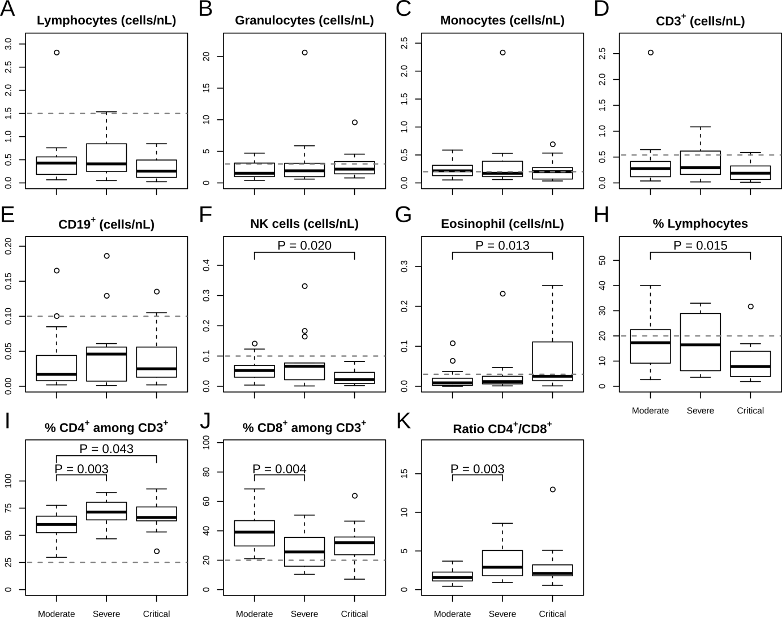

## Figure S1. COVID-19 severity is not reflected in composition of the major immune cell populations.

Circulating immune cell subsets were characterized in patients confirmed COVID-19 at the initial visit using multiparametric flow cytometry. In total 53 patients were analyzed divided in sub groups with moderate, severe, and critical COVID-19 manifestation. Immune cell subsets in peripheral blood were evaluated according to the gating strategy in Fig. S6. Cells/nL were evaluated for (A) Lymphocytes, defined as CD45+SSClow, (B) Granulocytes, defined as CD45+SSChigh, and (C) Monocytes, defined as CD45+SSCintermediate. Within the lymphocytes the cells/nL were assessed for (D) T-cells, defined as CD3+ lymphocytes, (E) B-cells, defined as CD19+CD3–, (F) natural killer cells (NK), defined as CD56+CD3–. (G) The cell count/nL of the Granulocyte subpopulation Eosinophils, defined as CD45+SSChighCD16–. The frequency of (H) lymphocytes in whole blood, (I) T helper cells, defined as CD3+CD4+CD8– and (J) cytotoxic T-cells identified as CD3+CD8+CD4– among CD3+ T-cells. (K) Ratio of CD4+ and CD8+ T-cells in I and J. The horizontal dashed line indicates the lower limit of the expected ranges in healthy individuals.

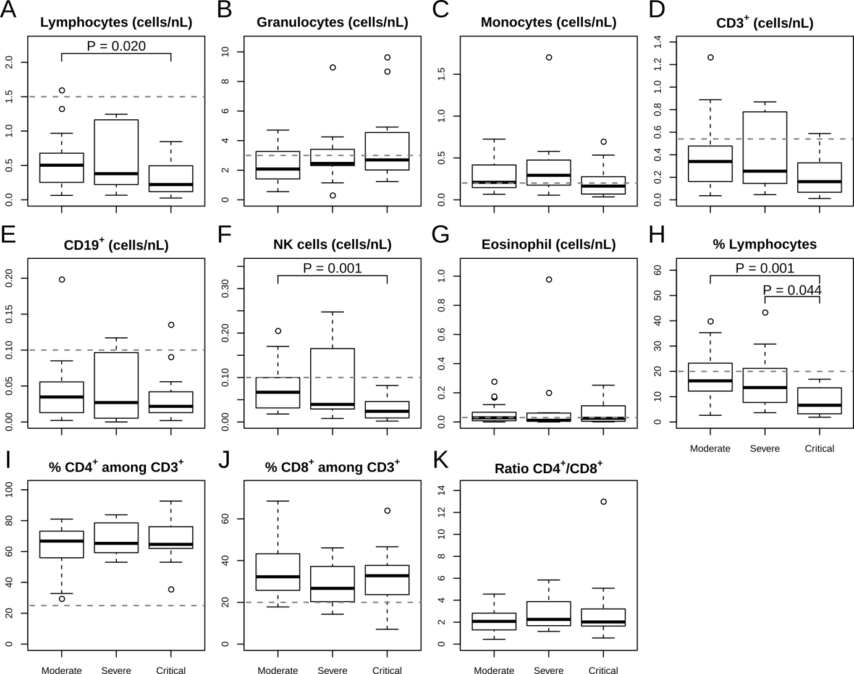

## Figure S2. COVID-19 severity is not reflected in composition of the major immune cell populations at the follow-up visit

Circulating immune cell subsets were characterized in patients confirmed COVID-19 at the follow-up visit using multiparametric flow cytometry. In total 53 patients were analyzed divided in sub groups with moderate, severe, and critical COVID-19 manifestation. Immune cell subsets in peripheral blood were evaluated according to the gating strategy in Fig. S6. Cells/nL were evaluated for (A) Lymphocytes, defined as CD45+SSClow, (B) Granulocytes, defined as CD45+SSChigh, and (C) Monocytes, defined as CD45+SSCintermediate. Within the lymphocytes the cells/nL were assessed for (D) T-cells, defined as CD3+ lymphocytes, (E) B-cells, defined as CD19+CD3­–, (F) natural killer cells (NK), defined as CD56+CD3–. (G) The cell count/nL of the Granulocyte subpopulation Eosinophils, defined as CD45+SSChighCD16–. The frequency of (H) lymphocytes in whole blood, (I) T-helper cells, defined as CD3+CD4+CD8– and (J) cytotoxic T-cells identified as CD3+CD8+CD4– among CD3+ T-cells. (K) Ratio of CD4+ and CD8+ T-cells in I and J. The horizontal dashed line indicates the lower limit of the expected ranges in healthy individuals.

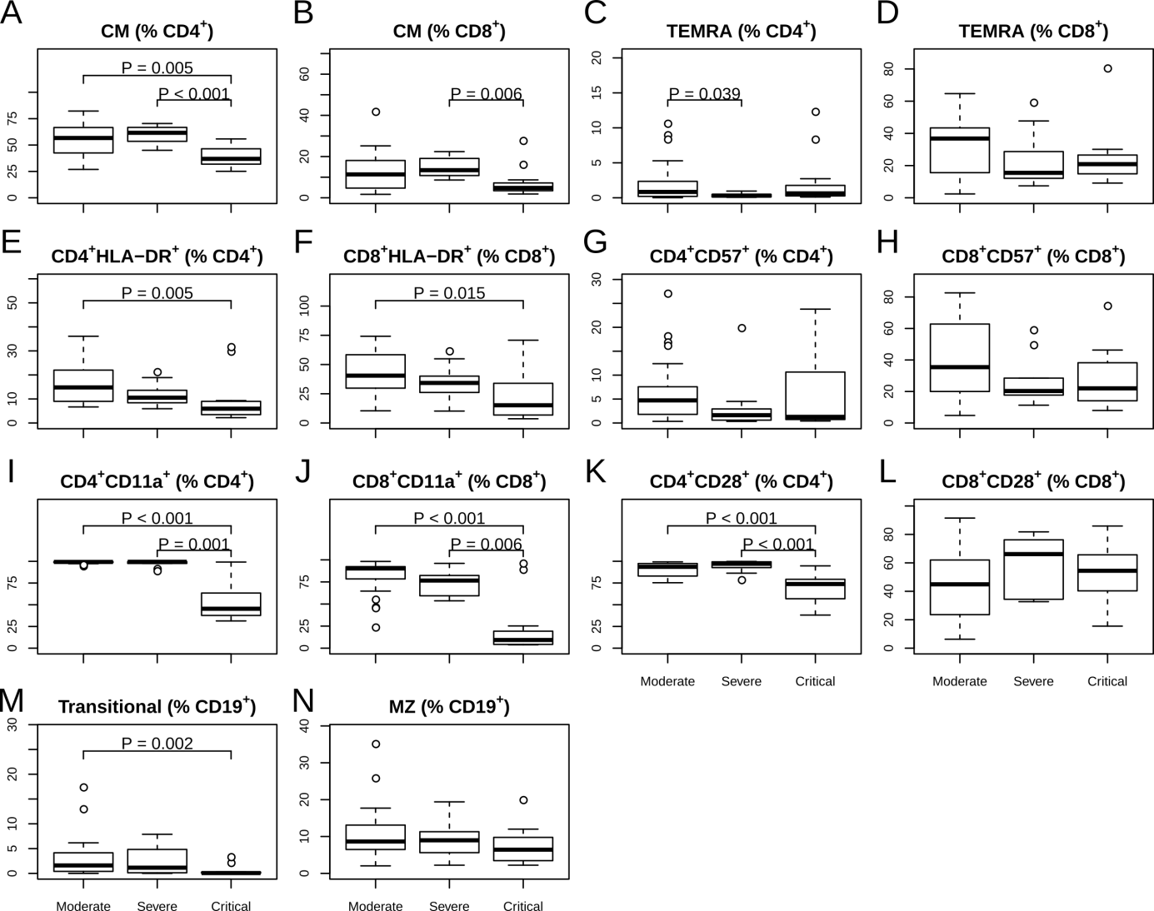

## Figure S3. Decrease of lymphocyte frequencies with differentiated and activated cytotoxic phenotype in patients with severe or critical COVID-19 at the follow-up visit

Peripheral blood from patients with moderate, severe or critical COVID-19 manifestations was subjected to evaluation for differentiation and activation state of T- and B-cell subsets at the follow-up visit using multiparametric flow cytometry. The subsets of the CD3+ T-cells and the CD19+ B lymphocyte were identified according to the gating strategy Fig. S7-S9. (A-B) Frequency of central memory, defined as CCR7+CD45RA–, among CD4+ (A) and CD8+ (B) CD3+ T-cells. (C-D) Frequency of terminally differentiated effector T-cells (TEMRA), defined as CCR7–CD45RA+, among CD4+ (C) and CD8+ (D) CD3+ T-cells. (E-F) The frequency of HLA-DR expressing cells among CD4+ (E) and CD8+ (F) CD3+ T-cells. (G-H) The frequency of CD57 positive cells among CD4+ (G) and CD8+ (H) CD3+ T-cells. (I-J) The frequency of CD11a expressing cells among CD4+ (I) and CD8+ (J) CD3+ T-cells. (K-L) The frequency of CD28expressing cells among CD4+ (K) and CD8+ (L) CD3+ T-cells. (M) The frequency of transitional B-cells defined as CD27–CD38highCD24high, among all CD19+IgM+IgD+ B-cells, and (N) the frequency of marginal zone (MZ) B-cells, defined as IgD+CD27+, among all CD19+ B-cells.



## Figure S4. Increased number and functional activity of SARS-CoV-2-reactive T-cells in patients with critical COVID-19.

The presence and functional status of SARS-CoV-2 specific T-cells was evaluated using PBMCs, isolated from the peripheral blood of patients with moderate, severe, or critical COVID-19 manifestations. Defrosted PBMCs rested for 24 hours before treatment with overlapping peptide pools covering the SARS-CoV-2 S protein. The cells were stimulated for a total of 16 hours and in the presence of Brefeldin A for the last 14 hours. SARS-CoV-2 reactive CD4+ T-cells and CD8+ T-cells were evaluated using multiparametric flow cytometry, using the expression of CD154 and CD137 to identify the activated CD4+ and CD8+ T-cell, respectively. The complete gating strategy is presented in Fig. S5. For critical COVID-19 patients, only a single time point was available. To ensure the comparability of the data with respect to the longer disease duration in critical COVID-19 patients, the comparison of the data in critically ill patients was performed also with the follow-up visit data in moderate and severe cases. (A) Number of CD4+CD154+ T-cells (first row) to the initial visit (left column) and follow-up visit (right column), and number of CD4+CD154+ cells expressing granzyme B (GrB), INF-γ, IL-2, and TNF-α (row two to four). (B) Number of CD8+CD137+ T-cells (first row) to the initial visit (left column) and follow-up visit (right column), and number of CD8+CD137+ cells expressing granzyme B (GrB), INF-γ, IL-2, and TNF-α (row two to four). (C) The number of SARS-CoV-2 specific CD4+ T-cells (left) and SARS-CoV-2 specific CD8+ T-cells (right) against relative titers of SARS-CoV-2 S protein specific IgG antibodies, measured by ELISA and evaluated as ratio to an internal control.

C:\Users\manft\Desktop\fig S5.tiff

## Figure S5. Gating strategy for detection of cytokine producing CD4+ and CD8+ antigen specific T-cells.

Isolated PBMCs were stimulated with SARS-CoV-2 spike protein OPPs or left untreated for 16h. (A) Lymphocytes were gated based on side and forward scatter profile, doublets were excluded and living T-cells were identified as CD3+ and Live/Dead-Markernegative cells, expressing either CD4 or CD8. Antigen specific T-cells were identified as CD4+CD154+CD137+ T-helper cells (B) or CD8+CD137+ cytotoxic T-cells (C). Within the antigen specific T-cells, intracellular staining of cytokines and granzyme B was used to identify effector cells.

K:\Forschung\Medizinische Klinik 1\Mitarbeiter\Ulrik\_Laptop\Documents\Papers\01-Working\02_By_colleagues\babel - COVID immunity\Figure S6.tiff

## Figure S6. Gating strategy for identification of main immune cell populations.

Whole blood was diluted 1:1 in staining solution prior to erythrocytes lysis. Livecells were identified as negative for Propidium iodide and doublets were excluded. Granulocytes, Monocytes and Lymphocytes were distinguished by CD45 and side scatter profile. Granulocytes were separated by CD16 in Eosinophiles (CD16–) and Neutrophiles (CD16+). Monocytes were divided by the expression of CD14 and CD16 into classical-(CD14++CD16–), intermediate- (CD14++CD16+) and non-classical Monocytes (CD14+CD16+). Lymphocytes were separated by CD3 and CD56 in NK (CD3–CD56+), NKT (CD3+CD56+) and T-cells (CD3+CD56–) and T-cells were further distinguished into CD4+ helper T-cells and CD8+ cytotoxic T-cells. B-cells were identified as CD3/CD56 double negative and CD19 positive cells.

K:\Forschung\Medizinische Klinik 1\Mitarbeiter\Ulrik\_Laptop\Documents\Papers\01-Working\02_By_colleagues\babel - COVID immunity\Figure S7.tiff

## Figure S7. Gating strategy for identification of activated T-cells.

Whole blood was diluted 1:1 in staining solution prior to erythrocytes lysis. Living lymphocytes were identified by their forward and sideward scatter profile and doublets were excluded. T-cells were identified as CD3+ and separated by expression of CD4 and/or CD8 into double negative (CD4–CD8–), double positive (CD4+CD8+), T-helper cells (CD4+CD8–) and cytotoxic T-cells (CD4–CD8+). The expression of activation marker CD11a, HLA-DR, CD28 and CD57 was assessed on CD4+ and CD8+ single positive T-cells.

K:\Forschung\Medizinische Klinik 1\Mitarbeiter\Ulrik\_Laptop\Documents\Papers\01-Working\02_By_colleagues\babel - COVID immunity\Figure S8.tiff

## Figure S8. Gating strategy for identification of memory and regulatory T-cells.

Whole blood was diluted 1:1 in staining solution prior to erythrocytes lysis. Living lymphocytes were identified by their forward and sideward scatter profile and doublets were excluded. T-cells were identified by the expression of CD3 and separated into αβ-T-cells and γδ-T-cells by staining with TCR antibodies against TCRαβ and TCRγδ antibodies. Additionally, CD3+ T-cells were divided into T-helper cells (CD4+CD8–) and cytotoxic T-cells (CD4–CD8+). Both T-cell subsets were further divided by the expression of CD45RA and CCR7 into Naïve (CD45RA+CCR7+), central memory (CM, CD45RA–CCR7+), effector memory (EM, CD45RA–CCR7–) and T effector RA (TEMRA, CD45RA+CCR7–) T-cells. Additionally, regulatory T-cells (Tregs) were identified as CD4+CD25+CD127+ and further separated by their expression of CD45RA into Naïve (CD45RA+) and effector Tregs (CD45RA–).

K:\Forschung\Medizinische Klinik 1\Mitarbeiter\Ulrik\_Laptop\Documents\Papers\01-Working\02_By_colleagues\babel - COVID immunity\Figure S9.tiff

## Figure S9.Gating strategy for identification of B-cell subpopulations.

Whole blood was diluted 1:1 in staining solution and afterwards erythrocytes were lysed. Living lymphocytes were identified by their forward and sideward scatter profile and doublets were excluded. B-cells were identified by the expression of CD19 and separated into Naïve (IgD+CD27–), marginal zone B-cells (IgD+CD27+) and CD21lowCD38low B-cells. Additionally, B-cells were separated by expression of IgM and IgD into double negative (IgM–IgD–) and double positive (IgM+IgD+) cells. Double negative cells could be separated by CD38 and CD27 into class-switch memory B-cells and Plasmablasts (CD27highCD38high). IgM/IgD double positive B-cells were further divided into class-unswitched memory B-cells (CD27+CD38–) and CD38highCD24high transitional B-cells.

# References

1. R Core Team. R: A Language and Environment for Statistical Computing [Internet]. Vienna, Austria: R Foundation for Statistical Computing; 2020. Available from: http://www.R-project.org/

2. Li G, Taljaard M, Van den Heuvel ER, et al. An introduction to multiplicity issues in clinical trials: the what, why, when and how. International Journal of Epidemiology 2016;dyw320.

3. Ständiger Arbeitskreis der Kompetenz- und Behandlungszentren fürKrankheiten durch hochpathogene Erregeram Robert Koch-Institut. Hinweise zu Erkennung, Diagnostik und Therapie von Patienten mit COVID-19 [Internet]. 2020;Available from: https://www.rki.de/DE/Content/Kommissionen/Stakob/Stellungnahmen/Stellungnahme-Covid-19\_Therapie\_Diagnose.pdf?\_\_blob=publicationFile