Supplemental materials

Epidemiological and clinical characteristics of COVID-19 in Shenzhen, the largest migrant city of China

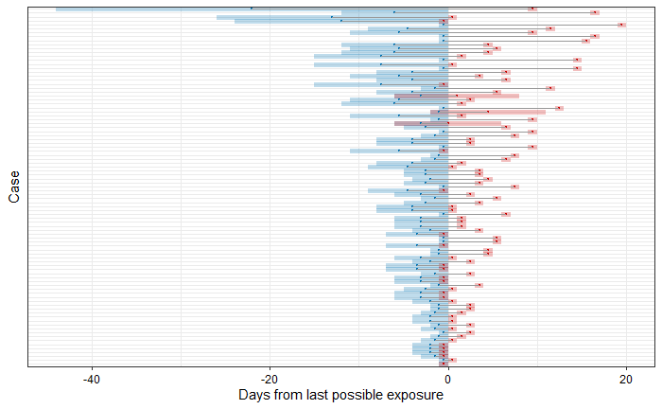
Figure S1 The exposure and symptom onset windows for 92 cases, relative to the right-bound of the exposure window.
(The blue bars indicate the exposure windows and the red bars indicate the symptom onset windows for each case. Purple areas are where those two bars overlap.)

Table S1. Incubation period estimates by Lognormal, Gamma, and Weibull distribution using MCMC methods, at 2.5th, 25th, 50th, 75th and 97.5th quantiles.
Quantiles | Lognormal | Gamma | Weibull
2.5th | 1.212 | 0.784 | 0.569
25th | 3.084 | 3.080 | 2.997
50th | 5.021 | 5.358 | 5.463
75th | 8.170 | 8.564 | 8.761
97.5th | 20.726 | 17.524 | 17.192

