**Supplementary Material**

**Detection of new *Mycobacterium leprae* subtype in Bangladesh by genomic characterization** **to explore transmission patterns**

**Maria Tió-Coma, Charlotte Avanzi,** **Els M. Verhard, Louise Pierneef, Anouk van Hooij,**

**Andrej Benjak, Johan Chandra Roy, Marufa Khatun, Khorshed Alam, Paul Corstjens,**

**Stewart T. Cole, Jan Hendrik Richardus,and Annemieke Geluk**

# Supplementary Tables

**Table S1. Cohort characterization.**

|  |  |  |  |  |  |
| --- | --- | --- | --- | --- | --- |
| **Group** | **Subjects** | **Gender** | **Age** | **RJ Classification** | **BI** |
| MB patients BI 2-6* | 33 | 18% Female  82% Male | 34 | 17 LL  14 BL  2 BT | 1 BI-2  4 BI-4  9 BI-5  19 BI-6 |
| PB/MB patients BI 0 | 27 | 63% Female  37% Male | 31 | 24 BT  2 TT | 27 BI-neg |
| HHC | 250 | 52% Female  48% Male | 30 | - | - |

Group, number of subjects, percentage of female and male, median of age, Ridley-Jopling classifications and BI of patients are shown. *31 were index cases of the study.

Table S2. WGS results.

|  |  |  |  |  |  |  |  |  |
| --- | --- | --- | --- | --- | --- | --- | --- | --- |
| **Subject ID** | **Sample ID** | **Sample type** | **RLEP Ct** | **Overall alignment rate** | **Input reads** | **Mean Coverage** | **Standard deviation Coverage** | **Genotype** |
| H09I | RB001 | SSS | 17.90 | 88.70 | 37876264 | 118.8 | 18.1 | 1B-Bangladesh |
| H24I | RB074 | SSS | 16.81 | 0.93 | 13530098 | 102.6 | 27.4 | 1B-Bangladesh |
| H07I | RB188 | SSS | 19.17 | 88.27 | 10622218 | 92.0 | 26.5 | 1D-*esxA* |
| H20I | RB069 | SSS | 18.94 | 0.75 | 21851287 | 89.6 | 21.7 | 1B-Bangladesh |
| H23I | RB073 | SSS | 16.25 | 0.89 | 9286514 | 86.1 | 29.0 | 1A |
| H08I | RB180 | SSS | 21.65 | 90.22 | 13937851 | 84.3 | 20.1 | 1D |
| H09C02 | RB003 | SSS | 21.63 | 0.56 | 23437425 | 46.6 | 13.6 | 1B-Bangladesh |
| H27I | RB182 | SSS | 19.04 | 52.87 | 5466606 | 45.8 | 19.3 | 1A |
| H26I | RB181 | SSS | 22.55 | 66.86 | 7136091 | 41.5 | 13.4 | 1D |
| H05I | RB186 | SSS | 23.19 | 96.15 | 3886798 | 33.8 | 11.0 | 1D |
| H23I | RN084 | Nasal swab | 20.06 | 0.10 | 21244851 | 30.8 | 15.5 | 1A |
| H29I | RB184 | SSS | 18.40 | 87.61 | 1812203 | 29.7 | 14.7 | 1D |
| H15I | RN059 | Nasal swab | 21.15 | 0.18 | 8947418 | 23.8 | 12.8 | 1D-*esxA* |
| H09I | RN001 | Nasal swab | 21.21 | 0.27 | 10293926 | 22.9 | 10.9 | 1B-Bangladesh |
| H10I | RN022 | Nasal swab | 23.86 | 0.09 | 58961720 | 19.1 | 10.5 | 1D |
| H14I | RB063 | SSS | 23.05 | 0.60 | 6035989 | 18.3 | 8.0 | 1A |
| H15I | RB048 | SSS | 23.25 | 0.69 | 14209772 | 16.4 | 10.0 | 1D-*esxA* |
| H24I | RN095 | Nasal swab | 21.24 | 0.02 | 86248391 | 16.4 | 9.6 | 1B-Bangladesh |
| H11I | RB041 | SSS | 23.13 | 74.65 | 1583694 | 15.4 | 7.1 | 1D |
| H10I | RB053 | SSS | 20.73 | 0.64 | 42419599 | 14.8 | 10.7 | 1D |
| H04I | RB066 | SSS | 23.71 | 0.92 | 45440398 | 14.4 | 11.2 | 1D |
| H12I | RB022 | SSS | 21.76 | 71.59 | 1023739 | 12.3 | 6.8 | 1A |
| H20I | RN165 | Nasal swab | 24.20 | 0.04 | 49770933 | 12.3 | 8.1 | 1B-Bangladesh |
| H06I | RB187 | SSS | 25.35 | 95.65 | 5938249 | 12.1 | 7.4 | 1D |
| H17I | RB067 | SSS | 22.96 | 93.36 | 5924859 | 11.3 | 6.5 | 1D |
| H30I | RB185 | SSS | 26.21 | 36.75 | 4508785 | 7.6 | 5.1 | 1A |
| H18I | RB065 | SSS | 21.21 | 78.72 | 8185166 | 6.1 | 5.9 | 1D-*esxA* |
| H16I | RN048 | Nasal swab | 23.27 | 5.42 | 3922066 | 4.2 | 3.3 |  |
| H22I | RN070 | Nasal swab | 26.70 | 0.02 | 25558536 | 1.9 | 4.2 |  |
| H21I | RB071 | SSS | 22.67 | 41.12 | 225851 | 1.8 | 1.6 |  |
| H13I | RB062 | SSS | 27.84 | 1.42 | 7741019 | 1.1 | 1.4 |  |
| H09C02 | RN003 | Nasal swab | 28.44 | 0.03 | 45483192 | 0.8 | 4.0 |  |
| H04I | RN180 | Nasal swab | 26.27 | 0.01 | 20827629 | 0.8 | 3.7 |  |
| H15C01 | RN060 | Nasal swab | 31.90 | 0.04 | 50724722 | 0.4 | 4.6 |  |
| H03I | RN131 | Nasal swab | 28.58 | 0.00 | 38908767 | 0.3 | 2.9 |  |
| H15C02 | RN061 | Nasal swab | 31.51 | 0.02 | 38484288 | 0.3 | 4.1 |  |
| H25I | RN190 | Nasal swab | 29.25 | 2.33 | 5882069 | 0.3 | 3.8 |  |
| H13C03 | RN085 | Nasal swab | 33.84 | 0.08 | 9083592 | 0.2 | 4.0 |  |
| H31I | RN186 | Nasal swab | 20.70 | 0.27 | 5374729 | 0.2 | 1.4 |  |
| H24C06 | RN098 | Nasal swab | 37.08 | 0.00 | 7876102 | 0.2 | 2.2 |  |
| H23C02 | RN089 | Nasal swab | 35.57 | 0.02 | 7052993 | 0.2 | 3.8 |  |
| H15C04 | RN062 | Nasal swab | 35.69 | 0.13 | 9975494 | 0.2 | 3.9 |  |
| H24C01 | RN091 | Nasal swab | 34.02 | 0.02 | 8358917 | 0.2 | 4.0 |  |
| H22C04 | RN080 | Nasal swab | 35.97 | 0.01 | 7236189 | 0.2 | 3.7 |  |
| H19I | RN182 | Nasal swab | 33.66 | 0.71 | 6722761 | 0.1 | 3.3 |  |
| H14I | RN065 | Nasal swab | 35.83 | 0.01 | 7248820 | 0.1 | 3.3 |  |
| H04C04 | RN155 | Nasal swab | 36.45 | 0.03 | 11927998 | 0.1 | 2.8 |  |
| H24C02 | RN093 | Nasal swab | 32.57 | 0.00 | 5643286 | 0.1 | 2.5 |  |
| H24C05 | RB108 | SSS | 37.14 | 0.02 | 9180110 | 0.1 | 1.5 |  |
| H22C03 | RN079 | Nasal swab | 36.74 | 0.00 | 10138274 | 0.1 | 2.4 |  |
| H14C01 | RB076 | SSS | 35.46 | 0.00 | 5344261 | 0.0 | 0.8 |  |

Data for the 51 samples sequenced according to the Ct obtained by qPCR. Coverage ≥5 was considered successful and data was used for further analysis.

**Table S3. *M. leprae* strain-specific SNPs.**

|  |  |  |  |  |  |  |
| --- | --- | --- | --- | --- | --- | --- |
| **Subject ID** | **Position in the genome** | **Wild type** | **Mutation** | **Gene** | **Codon change** | **Amino acid change** |
| H04I | 1081085 | C | T | *murD* | 865C>T | Leu289Phe |
|  | 1890100 | C | T | *cobB\*\*\** | 416C>T | - |
| H09I | 1693181 | A | G | *argR* | 82A>G | Thr28Ala |
|  | 5351 | C | T | *gyrB* | 123C>T | Leu41Leu |
| H10I | 1898238 | T | C | *ML1572* | 115T>C | Tyr39His |
|  | 1964656 | C | T | *ML1632* | 1253C>T | Pro418Leu |
| H15I | 34563 | G | A | *ML0029* | 76G>A | Val26Ile |
|  | 157111 | C | G | *ML0116* | 819C>G | His273Gln |
| H20I | 2391490 | A | G | *ctpB* | 2080A>G | Ile694Val |
|  | 2861093 | G | T | *ML2389\*\*\** | 221G>T | - |
| H23I | 160576 | T | C | *lipE* | 1155T>C | Ser385Ser |
|  | 354948 | C | G | *ML0271* | 273C>G | Val91Val |
| H24I | 1024176 | G | A | *ML0861* | 538G>A | Asp180Asn |
|  | 2022304 | C | A | *ddlA* | 670C>A | Leu224Met |
| H11I | 1157640 | A | G | *ML0990* | 360A>G | Ile120Met |
|  | 1802381 | C | G | *ML1495* | 434C>G | Pro145Arg |
| H18I | 3109974 | C | T | *bglS* | 211C>T | pseudogene |
|  | 1020650 | G | A | *lipA* | 764G>A | Arg255His |
| H17I | 856547 | G | T | *lhr* | 3267G>T | pseudogene |
|  | 2029182 | G | A | *ML1683* | 138G>A | Gly46Gly |
| H08I | 1182540 | A | G | *ML1012* | 429A>G | pseudogene |
|  | 1944088 | G | A | *ffh* | 1279G>A | Ala427Thr |
| H26I | 2094131 | C | T | *ML1733* | 147C>T | Arg49Arg |
|  | 3102710 | C | T | *ML2597* | 384C>T | Ala128Ala |
| H27I | 404990 | G | A | *ML0316* | 284G>A | Gly95Glu |
|  | 1368618 | C | T | *ML1171* | 127C>T | Leu43Phe |
| H29I | 2691282 | C | G | *ML2267* | 1097C>G | pseudogene |
|  | 3004830 | G | A | *ML2522* | 417G>A | Val139Val |
| H30I | 1140222 | C | T | *ML0971* | 170C>T | pseudogene |
|  | 3048182 | C | T | *nirB* | 406C>T | pseudogene |
| H05I | 52981 | C | T | *ML0042* | 989C>T | Ala330Val |
|  | 679359 | C | A | *uvrC* | 490C>A | His164Asn |
| H06I | 179474 | G | T | *ML0133* | 219G>T | Leu73Phe |
|  | 3109073 | G | A | *ML2604* | 628G>A | Ala210Thr |
| H07I | 1288026 | C | T | *ML1113* | 1601C>T | Ala534Val |
|  | 2625366 | C | G | *cpsY* | 1043C>G | Ala348Gly |
| H12I | 1747440 | T | C | *ML1452* | 122T>C | Val41Ala |
|  | 3254510 | A | G | *ML2700* | 1454A>G | His485Arg |
| H14I | 961300 | C | T | *rhlE* | 452G>A | Arg151Gln |
|  | 1417446 | C | G | *lspA* | 418C>G | Leu140Val |

List of mutated genes used to build strain specific primers (two SNPs per strain). Each mutation is unique to the strain analyzed compared to 259 other *M. leprae* genomes. *** indicate pseudogenes.

**Table S4**. **PCR primers for *M. leprae* strain-specific SNPs*.***

|  |  |  |  |  |  |
| --- | --- | --- | --- | --- | --- |
| **Subject ID** | **Position in the genome** | **Genes** | **Primer F (5’-3’)** | **Primer R (5’-3’)** | **Amplicon size (bp)** |
| H04I | 1081085 | *murD* | aatgccggttacgtcgatac | cagcaacggctaccacct | 164 |
| 1890100 | *cobB* | gtccactgcacacgtaatcg | acaccgacctgctcagatg | 207 |
| H09I | 1693181 | *argR* | cgcttcgaagaccacacc | gagctcttcgaggtctcgtg | 166 |
| 5351 | *gyrB* | gaaggcccaagacgaatatg | tcgaataaccgcacatcaac | 195 |
| H10I | 1898238 | *ml1572* | ttgacctacgcagcatatcg | agtcaggtgggtcagcaatc | 216 |
| 1964656 | *ml1632* | cactacaccaacgaccagga | gtggagaccacgacaacctt | 242 |
| H15I | 34563 | *ml0029* | gcggccatcgtcatacttta | atggtcaacaccgaggacat | 168 |
| 157111 | *ml0116* | attcacctcggtcccctatg | gaaaaggctgacgacgatcc | 193 |
| H20I | 2391490 | *ctpB* | ttgtagttccgacgacgatg | agcgcaaaacgtcgataact | 169 |
| 2861093 | *ml2389* | gccataatcgatcactggtgt | ggtcgatgtagggatgtgct | 172 |
| H23I | 160576 | *lipE* | ggattcatcttgggaacgaa | gcggtgatggtgttcattag | 197 |
| 354948 | *ml0271* | tcttaccggaacggctattg | agatcagctcaacgacagca | 218 |
| H24I | 1024176 | *ml0861* | tggctcgtctatcggtatca | gcgtcgtcgagatatttggt | 249 |
| 2022304 | *ddlA* | agatcggagactcggttcag | acctatccgtgccaactcac | 158 |
| H11I | 1157640 | *ml0990* | ctggtattcggtgtcggttt | agccatccagcagtgtcttt | 307 |
| 1802381 | *ml1495* | gtcagcgcacccatttatct | cgttcatcccagcttcaaat | 358 |
| H18I | 3109974 | *bglS* | gcgacgatgttgttgatgac | tgatgctgtatgccgttgat | 365 |
| 1020650 | *lipA* | gcctgctttcacctaccaac | gatacgatgaccgcaccag | 305 |
| H17I | 856547 | *lhr* | cagcgttcctgtcatcttca | cactcgacggattacctcgt | 466 |
| 2029182 | *ml1683* | caaagcagagctcattgacg | gcctttttagccggaacttt | 465 |
| H08I | 1182540 | *ml1012* | cgattctcggtgaagaccat | ggtgactttctcgtcgaagc | 358 |
| 1944088 | *ffh* | tcgatgacaaacagctcgac | cctgggaacttcagtttgga | 442 |
| H26I | 2094131 | *ml1733* | ggtatttgacgtggggagaa | ccgagtcggtagctaagtcg | 317 |
| 3102710 | *ml2597* | gcgagggattactgcttgtc | acctggaggaggatctcgtt | 316 |
| H27I | 404990 | *ml0316* | ccgaatactgggtgttgctt | aatgccgagttgtacgcttc | 468 |
| 1368618 | *ml1171* | cggagaaaaacctgggctat | cgccaaagatccataccatc | 327 |
| H29I | 2691282 | *ml2267* | ggccactaacctgccattta | tgttgctcagtggttcttcg | 347 |
| 3004830 | *ml2522* | tgggccaccttaatacttgc | tttgcaggttctcgctttct | 424 |
| H30I | 1140222 | *ml0971* | tggtcttcggtatcctcgtc | ttcgcgttactgcatagtcg | 454 |
| 3048182 | *nirB* | ctggtgttgcctagcaatga | gtgggtttgcaaccaaaact | 358 |
| H05I | 52981 | *ml0042* | tctgtggacacagcttcgag | cactgtctcgccaacgagta | 356 |
| 679359 | *uvrC* | aggtcgagtggacagtggtc | gttccaagtcacgggcatac | 450 |
| H06I | 179474 | *ML0133* | gggaagaaatccgaaagctc | ccataatctcgccgatagga | 321 |
| 3109073 | *ml2604* | tgcggacgtatgtacagctc | gcagctcagtgctgttgtct | 498 |
| H07I | 1288026 | *ml1113* | aaacattgcctacggacgac | tggaagatggtgtgcgataa | 313 |
| 2625366 | *cpsY* | ggcattgccaacctacaact | tgaggcctgtgtacgaagtg | 500 |
| H12I | 1747440 | *ml1452* | ggcagacggacttcaacct | tcatgacagtcaccccactc | 412 |
| 3254510 | *ml2700* | cgatcgtgatcattgtcgtc | atctggcacagtcgctttct | 482 |
| H14I | 961300 | *rhlE* | aaaatacctgaccgctgacg | atgggttggtccatgaatgt | 342 |
|  | 1417446 | *lspA* | gacacggtgacctggacttt | atgtcgaactcggctttacg | 377 |

Index case (Subject ID) with the *M. leprae* strain where the mutation was identified*.*

**Table S5**. **Primers and probes used in the study.**

|  |  |  |  |
| --- | --- | --- | --- |
| **Primer** | **Test** | **Sequence 5**'**-3'** | **Amplicon size (bp)** |
| RLEP LP1 F | PCR | tgcatgtcatggccttgagg | 129 |
| RLEP LP2 R | PCR | caccgataccagcggcagaa |
| RLEP qPCR F | qPCR | gcagcagtatcgtgttagtgaa | 73 |
| RLEP qPCR R | qPCR | cgctagaaggttgccgtat |
| RLEP Probe FAM | qPCR | cgccgacggccggatcatcga |
| SNP 14676 F (Locus 1) | PCR+seq | aatggaatgctggtgagagc | 194 |
| SNP 14676 R (Locus 1) | PCR+seq | caatgcatgctagccttaatga |
| SNP 1642879 F (Locus 2) | PCR+seq | ttgaatgcgaccaaacgtactttctg | 122 |
| SNP 1642879 R (Locus 2) | PCR+seq | taccaccggatcatggaaccgtc |
| SNP 2935685 F (Locus 3) | PCR+seq | atctggtccgggtaggaatc | 180 |
| SNP 2935685 R (Locus 3) | PCR+seq | accggtgagcgcactaag |
| SNP 8453 F (SNP1A) | PCR+seq | ggtctgcggacaagttggta | 211 |
| SNP 8453 R (SNP1A) | PCR+seq | caatagcgctcagacacgac |
| SNP 313361 F (SNP1B) | PCR+seq | caccggagacaaagctgat | 200 |
| SNP 313361 R (SNP1B) | PCR+seq | ctcggagaccaaacttctcg |
| SNP 61425 F (SNP1C) | PCR+seq | tcgtcaagccgaaagagttt | 243 |
| SNP 61425 R (SNP1C) | PCR+seq | ccagaacaccgagggaataa |
| SNP 889499 F (SNP1B-Bangladesh) | PCR+seq | cagctcggaaatccactctc | 199 |
| SNP 889499 F (SNP1B-Bangladesh) | PCR+seq | cgtcttcgacaccttgacct |
| *rpoB* F | PCR+seq | gtcgaggcgatcacgccgca | 279 |
| *rpoB* R | PCR+seq | cgacaatgaaccgatcagac |
| *folP1* F2 | PCR+seq | aactgatgctgcttctcgtg | 287 |
| *folP1* R2 | PCR+seq | ccctgtgctgcaagttcttt |
| *gyrA* F | PCR+seq | atggtctcaaaccggtacatc | 225 |
| *gyrA* R | PCR+seq | tacccggcgaaccgaaattg |

Forward (F) and reverse (R) primers and probes with dye used for RLEP PCR (1) and qPCR (2), genotyping (3, 4) and antimicrobial resistance (5). Test column indicates if the primers were used for PCR, qPCR or PCR and Sanger sequencing (PCR+seq). SNP 889499 to define new genotype 1B-Bangladesh changes from C to T in subtype 1B-Bangladesh.

# Supplementary figures

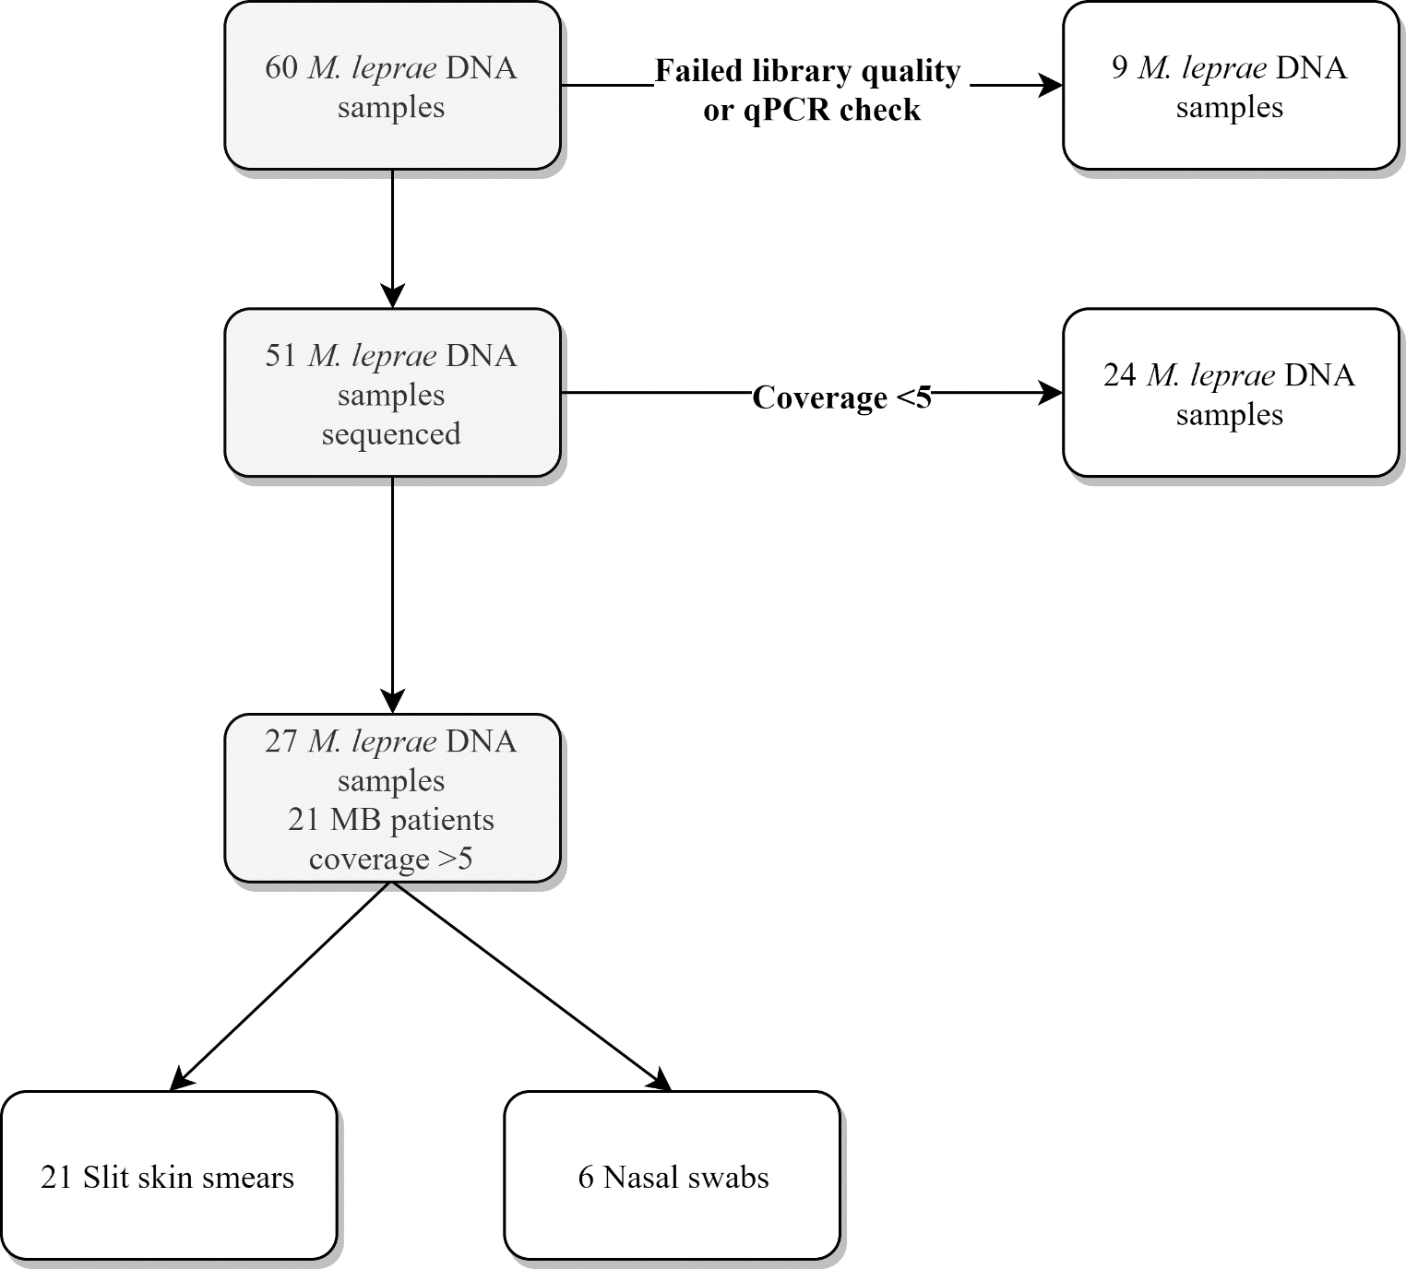

**Figure S1. Samples analysed by whole genome sequencing.** Number of DNA samples isolated from slit skin smears (SSS) or nasal swabs (NS) analysed by whole genome sequencing, samples that failed quality checks and samples with a query coverage higher or lower than 5 for *Mycobacterium leprae*. Origin of DNA samples sequenced with a coverage>5 is shown. All samples sequenced were collected from multibacillary (MB) patients. For all samples obtained from NS a sample of the same subject from SSS was also successfully sequenced.

**References**

1. Donoghue HD, Holton J, Spigelman M. PCR primers that can detect low levels of *Mycobacterium leprae* DNA. Journal of medical microbiology. 2001;50(2):177-82.

2. Martinez AN, Lahiri R, Pittman TL, Scollard D, Truman R, Moraes MO, et al. Molecular determination of *Mycobacterium leprae* viability by use of real-time PCR. Journal of clinical microbiology. 2009;47(7):2124-30.

3. Monot M, Honore N, Garnier T, Zidane N, Sherafi D, Paniz-Mondolfi A, et al. Comparative genomic and phylogeographic analysis of *Mycobacterium leprae*. Nature genetics. 2009;41(12):1282-9.

4. Truman RW, Singh P, Sharma R, Busso P, Rougemont J, Paniz-Mondolfi A, et al. Probable zoonotic leprosy in the Southern United States. The New England journal of medicine. 2011;364(17):1626-33.

5. A guide for surveillance of antimicrobial resistance in leprosy. New Delhi: World Health Organization, Region Office for South-East Asia; 2017.