**Supplement 5 – Funnel plots and outlier-sensitivity analyses**

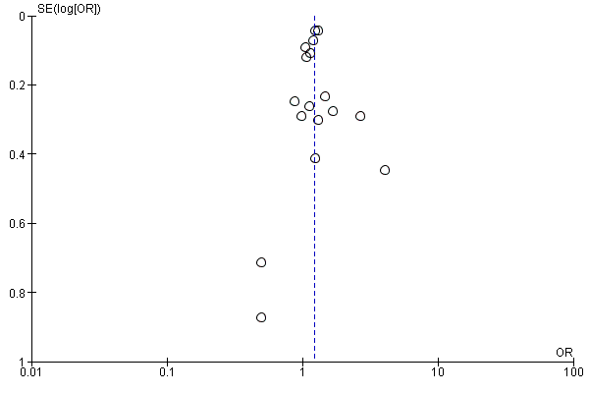

4

5

6

3

2

1

14

**LEGEND**

**Number First Author, Year**

1 Huybrechts 2014

2 Furu 2015

3 Louik 2014

4 Jordan 2016

5 Ban 2014

6 Berard 2015

7 Oberlander 2008

8 Davis 2007a

9 Alwan 2010

10 De Jonge 2013

11 Marguilis 2013

12 Polen 2013

13 Vasilakis Scaramozza 2013

14 Nordeng 2012

15 Diav-Citrin 2008

16 Davis 2007b

17 Kulin 1998

17

16

15

13

12

11

7

8

9

10

**Figure 1** Funnel plot of any antidepressant use, with all studies included

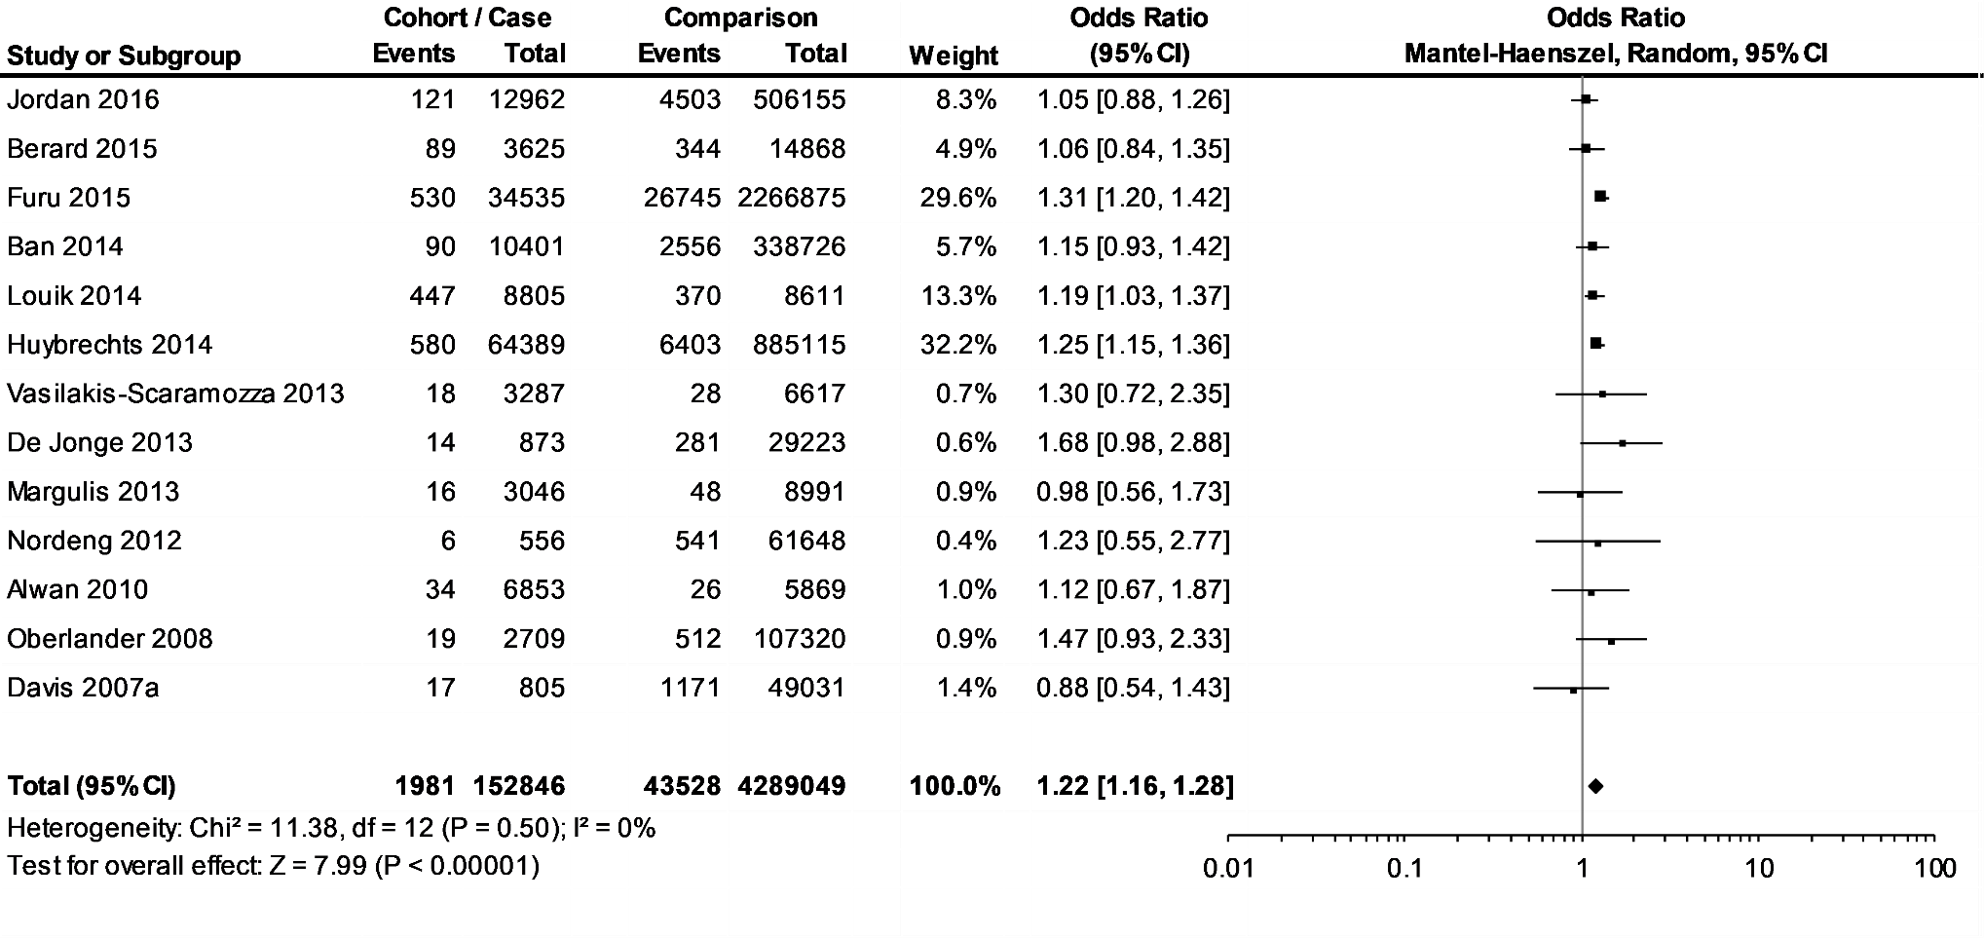

**Figure 2** Mixed-effect forest plot of any antidepressant usage during the first trimester of pregnancy and congenital heart defects, with outlying studies removed

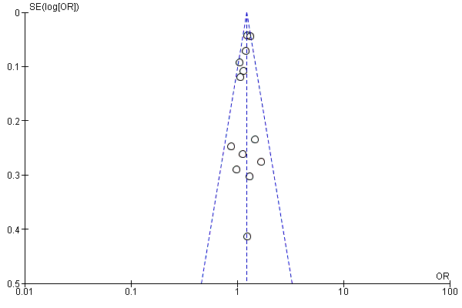

**LEGEND**

**Number First Author, Year**

1 Huybrechts 2014

2 Furu 2015

3 Louik 2014

4 Jordan 2016

5 Ban 2014

6 Berard 2015

7 Oberlander 2008

8 Davis 2007a

9 Alwan 2010

10 De Jonge 2013

11 Marguilis 2013

12 Vasilakis Scaramozza 2013

13 Nordeng 2012

13

12

11

10

9

8

7

6

5

4

3

2

1

**Figure 3** Funnel plot of any antidepressant use, with outliers removed

Outlier removal did not change the significance of the results (Figure 2), but it produced a more symmetrical funnel plot (Figure 3). The funnel plot of the outlier-adjusted primary meta-analyses data indicates that reporting or publication biases may be present as the bottom of the graph is mostly empty.1 2

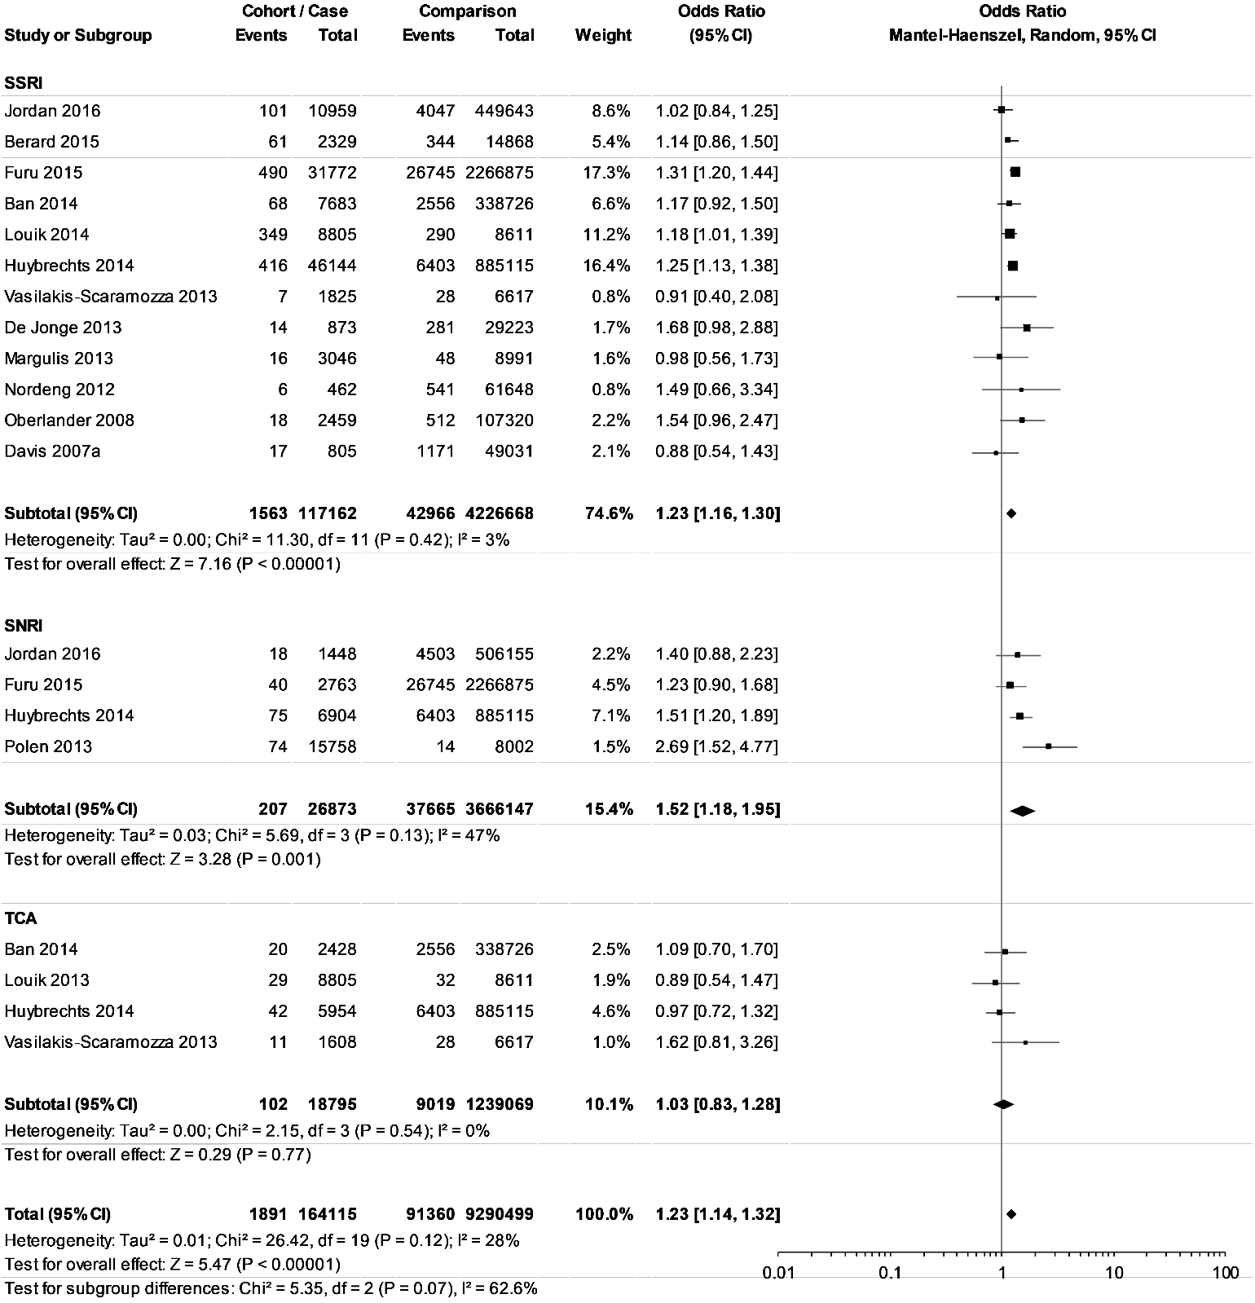

**Figure 4** Mixed-effect forest plot of SSRI, SNRI and TCA usage during the first trimester of pregnancy and congenital heart defects, with outlying studies removed

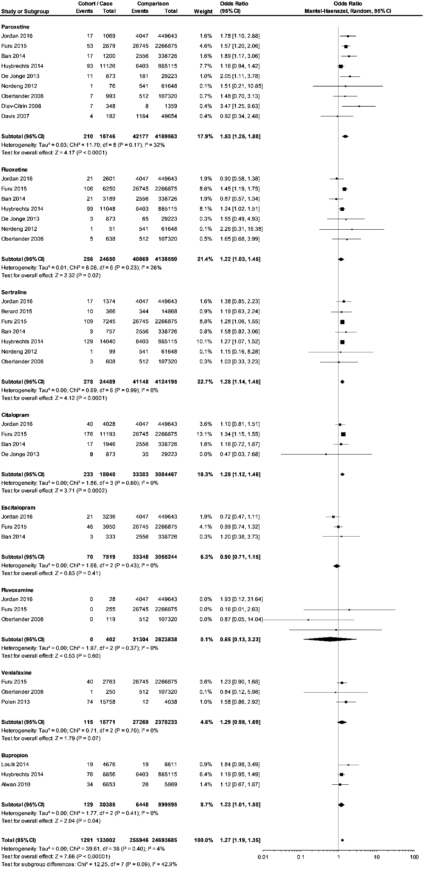

**Figure 5** Mixed-effect forest plot of individual antidepressant usage during the first trimester of pregnancy and congenital heart defects, with outlying studies removed

**References**

1. Sedgwick P, Marston L. How to read a funnel plot in a meta-analysis. *Bmj* 2015;351

2. Higgins JPT, Green S. Cochrane handbook for systematic reviews of interventions. Chichester, England: Wiley-Blackwell, John Wiley & Sons, 2008.