# Supplementary Information

|  |  |  |
| --- | --- | --- |
| Head mean framewise displacement in mm | | |
| **Placebo** | **First tf-fMRI scan** | **Second tf-fMRI scan** |
| 1 | 0.09 | 0.08 |
| 2 | 0.12 | 0.16 |
| 3 | 0.11 | 0.15 |
| 4 | 0.10 | 0.08 |
| 5 | 0.17 | 0.24 |
| 6 | 0.11 | 0.12 |
| 7 | 0.14 | 0.13 |
| 8 | 0.11 | 0.10 |
| 9 | 0.23 | 0.28 |
| 10 | 0.08 | 0.09 |
| 11 | 0.08 | 0.10 |
| 12 | 0.10 | 0.09 |
| 13 | 0.14 | 0.18 |
| 14 | 0.20 | 0.17 |
| 15 | 0.25 | 0.20 |
| 16 | 0.19 | 0.14 |
| 17 | 0.06 | 0.06 |
| 18 | 0.12 | 0.11 |
| 19 | 0.11 | 0.10 |
| 20 | 0.15 | 0.12 |
| 21 | 0.13 | 0.17 |
| **Ayahuasca** | **First tf-fMRI scan** | **Second tf-fMRI scan** |
| 1 | 0.20 | 0.17 |
| 2 | 0.12 | 0.14 |
| 3 | 0.13 | 0.14 |
| 4 | 0.15 | 0.11 |
| 5 | 0.13 | 0.11 |
| 6 | 0.16 | 0.18 |
| 7 | 0.18 | 0.15 |
| 8 | 0.10 | 0.10 |
| 9 | 0.14 | 0.16 |
| 10 | 0.07 | 0.06 |
| 11 | 0.15 | 0.20 |
| 12 | 0.12 | 0.11 |
| 13 | 0.14 | 0.18 |
| 14 | 0.10 | 0.12 |
| 15 | 0.18 | 0.16 |
| 16 | 0.19 | 0.17 |
| 17 | 0.17 | 0.29 |
| 18 | 0.11 | 0.14 |
| 19 | 0.18 | 0.14 |
| 20 | 0.12 | 0.15 |
| 21 | 0.13 | 0.15 |
| 22 | 0.15 | 0.21 |

**Supplementary Table S1.** Individual motion parameters. Head mean framewise displacement (in mm) before and after the session for all participants included in the analyses.

|  |  |  |  |  |  |
| --- | --- | --- | --- | --- | --- |
|  | **Coordinates**  **(x, y, z)** | **Anatomical label** | **Cluster size (voxels)** | **t** | **p** |
| **Salience network** | | | | | |
| **One-sample t-test baseline maps** | -4, 30, 26 | Left Anterior Cingulate Cortex | 6465 | 31.78 | < 0.0001 |
|  | 36, 12, -6 | Right Insula | 957 | 13.47 | < 0.0001 |
|  | 26, 48, 30 | Right Middle Frontal Gyrus | 895 | 12.77 | < 0.0001 |
|  | -40, 14, -6 | Left Insula | 624 | 12.03 | < 0.0001 |
|  | -4, -18, 38 | Left Middle Cingulate Cortex | 654 | 11.63 | < 0.0001 |
| **Default mode network** | | | | | |
| **One-sample t-test baseline maps** | -2, -40, 34 | Left Precuneus | 6187 | 37.37 | < 0.0001 |
|  | -44, -64, 34 | Left Angular Gyrus | 1485 | 15.56 | < 0.0001 |
|  | 44, -62, 40 | Right Angular Gyrus | 1582 | 14.86 | < 0.0001 |
|  | 4, 46, 18 | Right Frontal Superior Gyrus | 3395 | 14.83 | < 0.0001 |
|  | -18, 42, 42 | Left Frontal Superior Gyrus | 307 | 12.13 | < 0.0001 |
| **Visual network** | | | | | |
| **One-sample t-test baseline maps** | -16, -100, 0 | Left Middle Occipital | 14559 | 25.88 | < 0.0001 |
|  | 16, -60, -2 | Right Lingual Gyrus | 56 | 8.00 | < 0.0001 |
| **Sensorimotor network** | | | | | |
| **One-sample t-test baseline maps** | 20, -24, 72 | Right Precentral Gyrus | 9490 | 26.71 | < 0.0001 |
|  | -56, -4, 20 | Left Postcentral Gyrus | 77 | 8.20 | < 0.0001 |
|  | 40, -24, 18 | Right Rolandic Operculum | 69 | 7.82 | < 0.0001 |

**Supplementary Table S2. Related to brain network maps in Figures 1; one-sample t-tests using the seed-based connectivity maps.** Voxel-wise statistics. If not specified otherwise, extent probability threshold of p < 0.01 FWE corrected, voxel-wise threshold of p < 0.001 FWE corrected for multiple comparisons, only the first five major clusters are reported. Anatomical labels derived from the AAL atlas (<http://www.gin.cnrs.fr/en/tools/aal-aal2/>) [(Tzourio-Mazoyer et al., 2002)](https://paperpile.com/c/BxQUFh/XBc5).

|  |  |  |  |  |  |
| --- | --- | --- | --- | --- | --- |
|  | **Coordinates**  **(x, y, z)** | **Anatomical label** | **Cluster size (voxels)** | **t** | **p** |
|  | **Salience network** | | | | |
| **Two-sample t-test**  **change maps ayahuasca > placebo** | 0, 50,24 | Left Frontal Superior Gyrus | 248 | 4.14 | < 0.0001 |
|  | **Default mode network** | | | | |
| **Two-sample t-test**  **change maps ayahuasca < placebo** | 0, -68, 20 | Left Precuneus | 262 | 3.73 | < 0.0001 |

**Supplementary Table S3. Related to brain network maps in Figures 2; two-sample t-tests using the seed-based connectivity change maps.** Voxel-wise statistics. Joint extent and cluster probability thresholds of p < 0.01 for the salience network and p < 0.05 for the default mode network. Anatomical labels derived from the AAL atlas (<http://www.gin.cnrs.fr/en/tools/aal-aal2/>) [(Tzourio-Mazoyer et al., 2002)](https://paperpile.com/c/BxQUFh/XBc5).

|  |  |  |  |  |  |
| --- | --- | --- | --- | --- | --- |
|  | Coordinates  (x, y, z) | Anatomical label | Cluster size (voxels) | t | p |
|  | Salience network | | | | |
| Two-sample t-test  change maps ayahuasca > placebo | -2, 52, 24 | Left Frontal Superior Gyrus | 288 | 4.65 | < 0.0001 |
|  | Default mode network | | | | |
| Two-sample t-test  change maps ayahuasca < placebo | 0, -68, 20 | Left Precuneus | 206 | 3.62 | < 0.0001 |

**Supplementary Table S4. Related to brain network maps in Supplementary Figures S2; two-sample t-tests using the seed-based connectivity change maps corrected for the difference in head mean framewise displacement between scans.** Voxel-wise statistics. Joint extent and cluster probability thresholds of p < 0.01 for the salience network and p < 0.05 for the default mode network. Anatomical labels derived from the AAL atlas (<http://www.gin.cnrs.fr/en/tools/aal-aal2/>) [(Tzourio-Mazoyer et al., 2002)](https://paperpile.com/c/BxQUFh/XBc5).

|  |  |  |  |  |  |
| --- | --- | --- | --- | --- | --- |
|  | **Coordinates**  **(x, y, z)** | **Anatomical label** | **Cluster size (voxels)** | **t** | **p** |
|  | **Salience network** | | | | |
| **Change maps ayahuasca > placebo** | 0, 50,24 | Left Frontal Superior Gyrus | 90 | 4.21 | 0.009 |
|  | **Default mode network** | | | | |
| **Change maps ayahuasca < placebo** | 0, -68, 20 | Left Precuneus | 582 | 3.78 | 0.003 |

**Supplementary Table S5. Related to brain network maps in Figures S3; nonparametric permutation-based statistical inference.** Voxel-wise statistics, p < 0.05 threshold-free cluster enhancement. Anatomical labels derived from the AAL atlas (<http://www.gin.cnrs.fr/en/tools/aal-aal2/>) [(Tzourio-Mazoyer et al., 2002)](https://paperpile.com/c/BxQUFh/XBc5).

|  |  |  |  |  |  |
| --- | --- | --- | --- | --- | --- |
|  | **Coordinates**  **(x, y, z)** | **Anatomical label** | **Cluster size (voxels)** | **t** | **p** |
| **Salience network** | | | | | |
| **One-sample t-test baseline mapsA** | -36, 8,-2 | Left Insula | 1868 | 16.47 | < 0.0001 |
|  | -30, 42, 22 | Left Middle Frontal Gyrus | 1796 | 16.10 | < 0.0001 |
|  | -4,14,40 | Left Anterior Cingulate Cortex | 2994 | 15.55 | < 0.0001 |
|  | 32, 44, 18 | Right Middle Frontal Gyrus | 1428 | 15.31 | < 0.0001 |
|  | 56, 14, -4 | Right Insula | 1194 | 13.25 | < 0.0001 |
| **Two-sample t-test**  **change maps ayahuasca > placebo** | 0, 50, 12 | Left Anterior Cingulate Cortex | 291 | 3.40 | < 0.0001 |
| **Default mode network** | | | | | |
| **One-sample t-test baseline mapsA** | 2, -42, 24 | Left Precuneus | 5714 | 18.64 | < 0.0001 |
|  | 46, -58, 40 | Right Angular Gyrus | 872 | 15.62 | < 0.0001 |
|  | -44, -62, 44 | Left Angular Gyrus | 995 | 12.84 | < 0.0001 |
| **Two-sample t-test**  **change maps ayahuasca < placebo** | -10, -52, 18 | Left Precuneus | 234 | 3.16 | 0.001 |

**Supplementary Table S6. Related to Supplementary Figures S4; findings using independent component analysis (ICA).** Voxel-wise statistics. **A**Extent probability threshold of p < 0.01 FWE corrected, voxel-wise threshold of p < 0.001 FWE corrected for multiple comparisons, only the first five major clusters are reported. For two-sample t-tests, joint and cluster extent probability thresholds of p < 0.05 for the salience network and p < 0.1 for the default mode network are reported. Anatomical labels derived from the AAL atlas (<http://www.gin.cnrs.fr/en/tools/aal-aal2/>) [(Tzourio-Mazoyer et al., 2002)](https://paperpile.com/c/BxQUFh/XBc5).

|  |  |  |  |  |  |  |
| --- | --- | --- | --- | --- | --- | --- |
|  | **Within salience network conectivity** | | **Within default mode network connectivity** | | **Between salience and default mode network**  **connectivity** | |
| **HRS subscales** | **Ayahuasca** | **Placebo** | **Ayahuasca** | **Placebo** | **Ayahuasca** | **Placebo** |
| **Somesthesia** | **0.54\*** | 0.01 | -0.06 | -0.01 | 0.21 | 0.24 |
| **Affect** | 0.39+ | 0.27 | -0.02 | -0.18 | **0.47^** | -0.06 |
| **Perception** | 0.31 | 0.20 | -0.01 | -0.30 | 0.10 | 0.40+ |
| **Cognition** | 0.29 | 0.09 | -0.20 | -0.26 | 0.42+ | 0.13 |
| **Volition** | 0.33 | 0.41+ | **-0.59\*\*** | -0.43+ | 0.35 | -0.05 |
| **Intensity** | 0.27 | 0.03 | -0.29 | -0.17 | 0.02 | 0.13 |

**Supplementary Table S7.** Partial correlation coefficients associating subacute functional connectivity changes with subscales of the HRS, corrected for the difference in head mean framewise displacement between the second and first scan. Significant findings are highlighted in bold. **p < 0.005; *p < 0.01; **^**p < 0.03; +p < 0.1

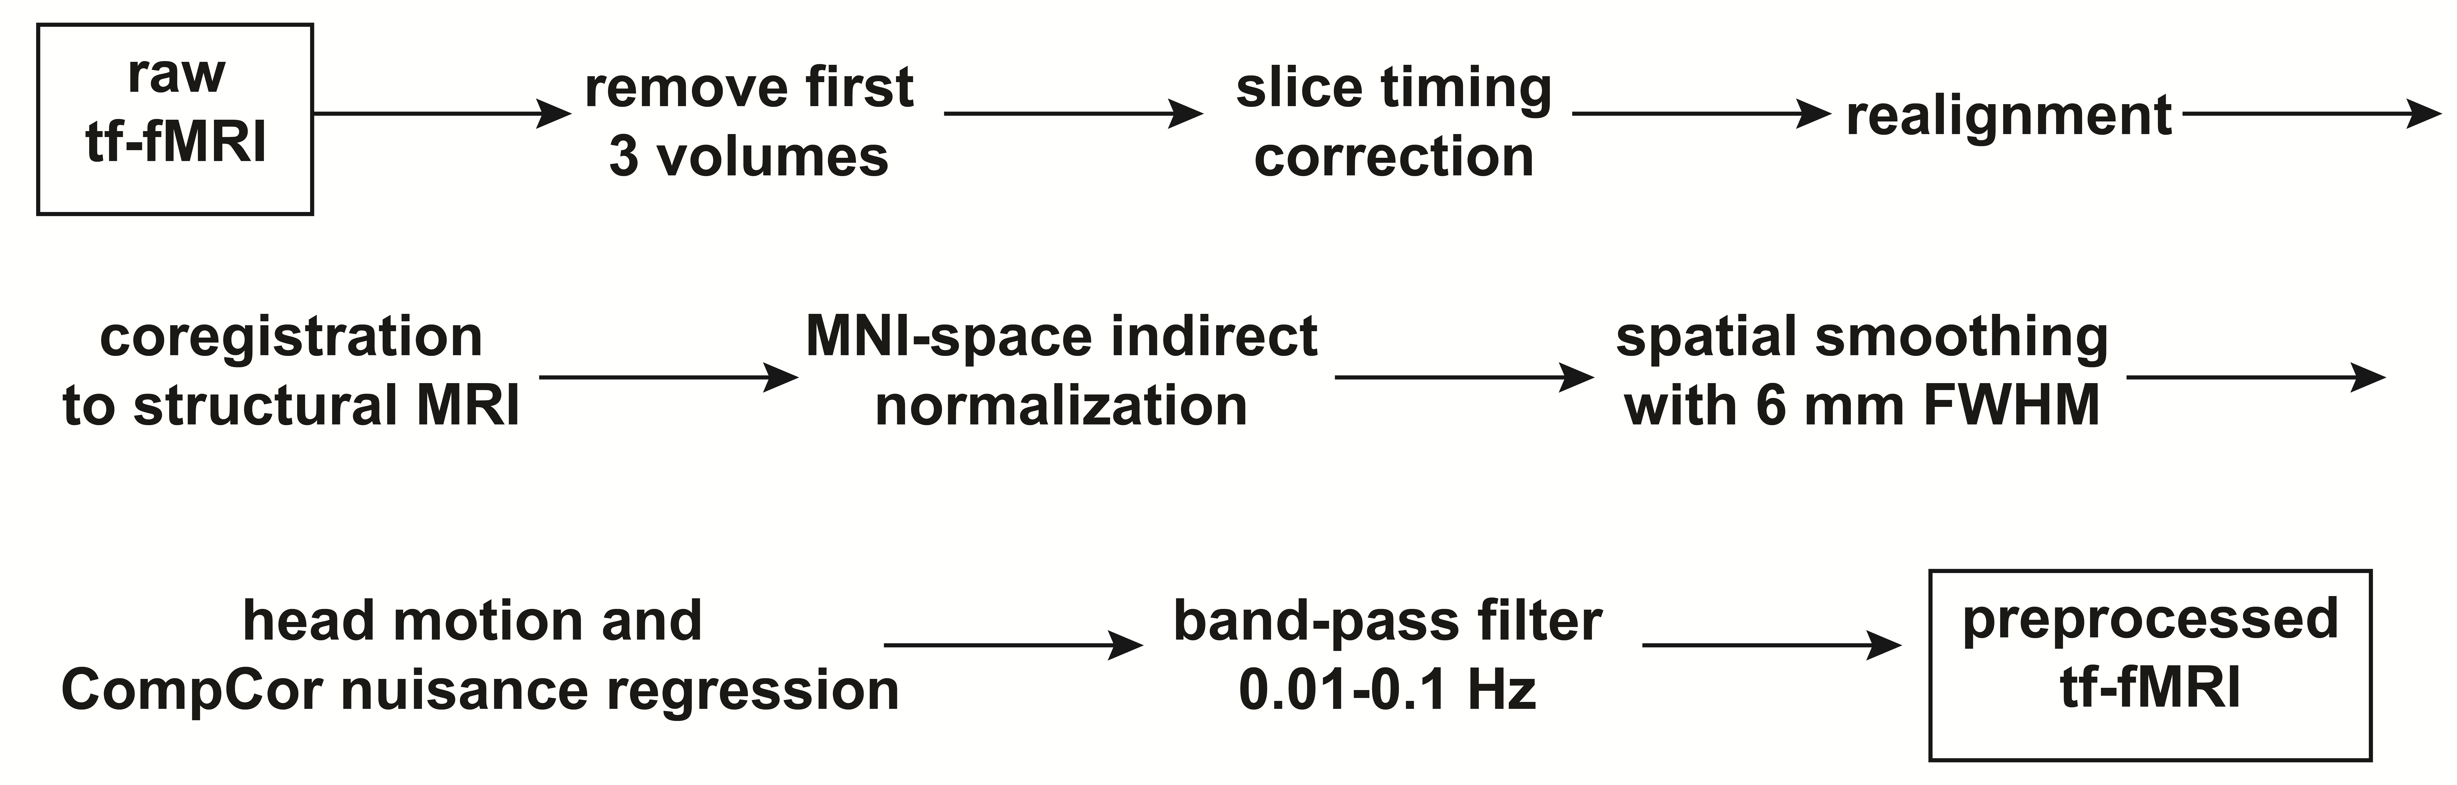

**Supplementary Figure S1. Preprocessing pipeline of tf-fMRI data.** tf-fMRI = task-free fMRI data.



**Supplementary Figure S2.** **Intra-network functional connectivity changes corrected for head movement.** **(A)** Significant salience network functional connectivity increases within the anterior cingulate cortex for the ayahuasca compared to the placebo group. Joint extent and cluster probability thresholds of p < 0.05 (red) and p < 0.01 (yellow). Left is on the left. **(B)** Significant default mode network functional connectivity decreases within the posterior cingulate cortex for the ayahuasca compared to the placebo group. Joint cluster and extent probability thresholds of p < 0.05 (red). Left is on the left. Voxel-wise two-sample t-tests corrected for the difference in head mean framewise displacement between scans. Legend for SPM matrix: Aya = ayahuasca group; Pla = placebo group; ΔMFD = difference in head mean framewise displacement between scans.



**Supplementary Figure S3.** **Non-parametric permutation inference.** **(A)** Significant salience network functional connectivity increases in the anterior cingulate cortex for the ayahuasca compared to the placebo group. **(B)** Significant default mode network functional connectivity decreases in the posterior cingulate cortex for the ayahuasca compared to the placebo group. FWE = family wise error corrected for multiple comparisons, TFCE = threshold-free cluster enhancement.

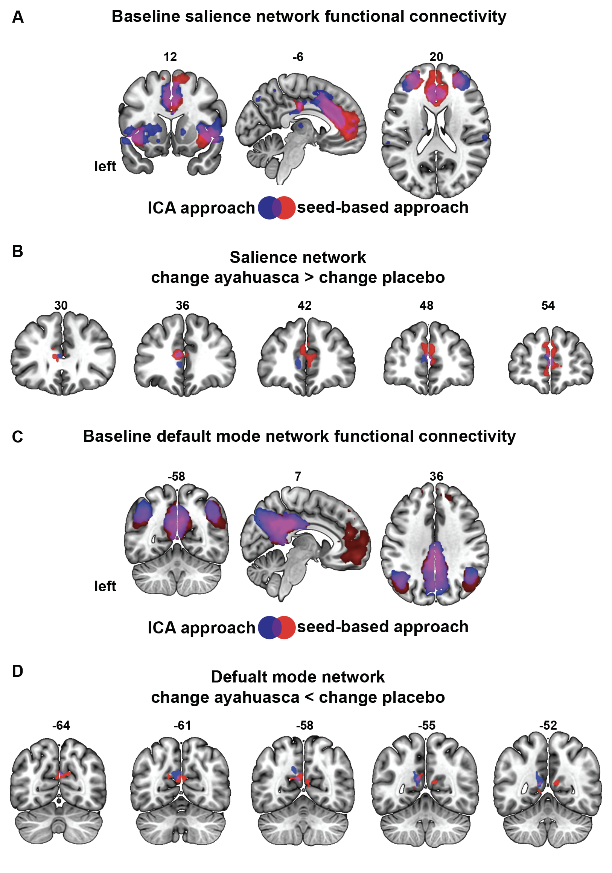

**Supplementary Figure S4. ICA-based analyses. (A)** Overlap (purple) of salience network maps derived with the ICA-based (in blue) and seed-based (in red) approaches. One-sample t-test over all participants at baseline (t = 6.5; extent probability threshold of p < 0.01 FWE corrected, voxel-wise threshold of p < 0.001 FWE corrected for multiple comparisons). **(B)** Significant salience network functional connectivity increases in the ayahuasca compared to the placebo group, overlap (purple) of ICA-based (blue) and seed-based (red) approaches. t = 1.3; joint cluster and extent probability thresholds of p < 0.05 for both seed-based and ICA-based two-sample t-test. **(C)** Overlap (purple) of default mode network maps derived with the ICA-based (in blue) and seed-based approach (in red). One-sample t-test over all participants at baseline (t = 6.5; extent probability threshold of p < 0.01 FWE corrected, voxel-wise threshold of p < 0.001 FWE corrected for multiple comparisons). **(D)** Significant default mode network functional connectivity decreases in the ayahuasca compared to the placebo group, overlap (purple) of ICA-based (blue) and seed-based (red) approaches. t = 1.3, joint cluster and extent probability thresholds of p < 0.05 for seed-based two-sample t-test; t = 1.3, joint cluster and extent probability thresholds and p < 0.1 for ICA-based two-sample t-test. Left is on the left. ICA = independent component analysis.