**Supplementary Appendix**

This appendix has been provided by the authors to give readers additional information about their work.

**Supplementary Appendices**

**Evidence and characteristics of human-to-human transmission of 2019-nCoV**

Min Kang, Ph.D., Jie Wu, Ph.D., Wenjun Ma, Ph.D., Jianfeng He, M.D., Jing Lu, Ph.D., Tao Liu, Ph.D., Baisheng Li, Ph.D., Shujiang Mei, M.D., Feng Ruan, M.D., Lifeng Lin, Ph.D., Lirong Zou, M.D., Changwen Ke, M.D., Haojie Zhong, M.D., Yingtao Zhang, M.D., Xuguang Chen, M.D., Zhe Liu, Ph.D., Qi Zhu, M.D., Jianpeng Xiao, Ph.D., Jianxiang Yu, M.D., Jianxiong Hu, M.D., Weilin Zeng, M.D., Xing Li, M.D., Yuhuang Liao, M.D., Xiujuan Tang, M.D., Songjian Xiao, M.D., Ying Wang, M.D., Yingchao Song, M.D., Xue Zhuang, M.D., Lijun Liang, M.D., Siqing Zeng M.D., Guanhao He, Ph.D., Peng Lin, M.D., Huihong Deng, M.D., Tie Song, M.P.H.

Guangdong Provincial Center for Disease Control and Prevention (M.K., J.W., J.H., B.L., L.L., L.Z., C.K., H.Z., Y.Z., X.C., Q.Z., J.Y., Y.L., Y.S., X.Z., L.L., P.L., H.D., T.S.)

Guangdong Provincial Institute of Public Health, Guangdong Provincial Center for Disease Control and Prevention (W.M., J.L., T.L., Z.L., J.X., J.H., W.Z., X.L., G.H., S.Z., W.M.)

Shenzhen Center for Disease Control and Prevention (S.M., X.T.,)

Zhuhai Center for Disease Control and Prevention (F.R., S.X.)

Shenzhen Nanshan Center for Disease Control and Prevention (Y.W.)

Drs. M. Kang, J. Wu, W. Ma., J. He, J. Lu, T. Liu and B. Li contributed equally to this article.

Address reprint requests to Dr. Song at the Guangdong Provincial Center for Disease Control and Prevention, Guangzhou 511430, China, or at tsong@cdcp.org.cn

**Table of contents**

Definition and identification of 2019-nCoV case 3

Epidemiological information of family cluster infections 4

Figure S1. Chronology of symptom onset and treatment of family cluster infections with 2019-nCoV in Guangdong, China 8

Table S1. Characteristics of 37 cases in 13 family cluster infections 10

**Definition and identification of 2019-nCoV case**

A suspected case was diagnosed if he/she met one of the following epidemic history and two of the following clinical symptoms. Epidemic history included: (1) a history of travel to or a person who lived in Wuhan or other region where sustained local transmission exists in the 14 days prior to symptom onset; (2) contact with patient with fever/respiratory symptoms from Wuhan or other region where sustained local transmission exists in the 14 days prior to symptom onset; (3) came from a cluster of 2019-nCoV cases or have epidemic relationship with 2019-nCoV cases. Clinical symptoms included: (1) fever; (2) chest radiologic changes (multiple mottling and interstitial change at early phase, bilateral pulmonary multiple ground-glass opacity, infiltrates at advanced phase, lung consolidation at the phase of severe illness); (3) total white blood cell count is normal/low or total lymphocyte count is low. A confirmed case was defined if a suspected case was verified 2019-nCoV by real-time reverse transcriptase polymerase chain reaction assay (RT-PCR) or genetic sequencing.

**Epidemiological information of family cluster infections**

**Family cluster F**

There were 2 cases in family cluster F, and they were a couple and resided in Wuhan. Case 1(husband) had symptoms of fever, cough with sputum and fatigue on January 11,2020. He took medicine without going to hospital, and his symptoms were relieved. On the afternoon of January 14, the couple went to Shenzhen by train and arrived in the morning of January 15 . Case 1 had fever again on the train. Their daughter picked up them on the train station. Then they went daughter’s home and then to hospital by taxi. Case 1 had chest radiologic changes and was identified negative infection of influenza virus, and then transferred by ambulance to the hospital ecspecially for treatment of cases with 2019-nCoV at night of January 15 . His throat swab and blood samples were tested by local CDC on January 16 and identified positive of 2019-nCoV. Case 2(wife) was isolated in daughter’s home since January 16. She had fever(37.8℃) and cough on January 20 and was sent to hospital on January 21. Her CT test showed multiple lobar lesions in both lungs. Her throat swab sample was tested by GDCDC on January 23 and identified positive of 2019-nCoV.

**Family cluster G**

There were 2 cases in family cluster G, and they were a couple in Huanggang, Hubei Province. Case 1(husband) had symptom of dry cough on January 5,2020. His cough became severe on January 9 and took medicine by himself. On January 10 and 11, he went to a clinic for intravenous antibiotic therapy, and his cough was relieved. On January 12, the couple went to Guangzhou by high-speed rail and transfered to Zhuhai, Guangdong. They arrived at their son’s home in Zhuhai in the afternoon of January 12. Case 1 still had slight cough. Case 2(wife) had cough on January 13. She took medicine for cough by herself for two days, but cough did not relieve. From January 16 to 18, she went to a outpatient clinic in Zhuhai for treatment because she still had cough. She was sent to a hospital on January 19. Her nose swab, throat swab, blood and urine samples were identified positive of 2019-nCoV on January 20. He was been transferred to the hospital for treastment of 2019-nCoV cases by ambulance on January 20. His CT test showed there were infectious lesions in the right lung and the lower lobes of left lung. His nose swab, throat swab, blood samples were identified positive of 2019-nCoV on January 22.

**Family cluster H**

There were 2 cases in family cluster H. Case 1 worked and resided in Hebei Province. She visited her parents in Wuhan on January 16. She went to Guangzhou from Wuhan with her family (her parents, brother and son) by high-speed rail on January 20. Then they went to their apartment in Foshan by taxi. Case 1 had fever on January 21 and the family (5 persons) went to hospital. Case 1 had fever(37.6℃) and CT test showed there was inflammation in the lower lobes of left lung. Her throat swabs and blood samples were testedidentified positive of 2019-nCoV by Foshan CDC on January 22. Case (brother of Case 1) felt uncomfortable on January 21 and visited hospital. He had symptoms of pneumonia on January 23 and was identified positive infection of 2019-nCoV on January 24. Case 1 and Case 2 were transferred to the hospital for treatment and isolation on January 23 and 24 ,respectively.

**Family cluster I**

There were 2 cases in family cluster I, and they were a couple and resided in Wuhan. Case 1 (wife) she had symptom of sore throat on January 4, and follwed by cough with a little sputum, fatigue . She visited an outpatient, and was treated byantibiotics as the routine blood tests showed increased white blood cell(WBC) . Her symptoms were improved in 3 days and WBC returned to normal. Case 2(husband) had cough on January 12, but he didn’t go to hospital for treatment. The couple had a flight to Shenzhen to visit their son on January 15. At night, Case 2 had symptoms of fever, [muscular](javascript:;) [soreness](javascript:;) and chest tightness. On January 17, Case 1 felt uncomfortable. On January 18, their son sent his parents to hospital. Case 1 had low fever and was given some medicine nad Case 2 was treated for antibiotic treatment. As Case 2 did not relieve, the son sent him to another hospital in the evenin of January 19 . The couple were isolated and treated in hospital, and then transferred to special hospital for treatment of 2019-nCoV cases on January 20. They were identified positive infection of 2019-nCoV on January 21.

**Family cluster J**

There were 2 cases in family cluster J. Case 1 (wife) and Case 2 (husband) are a couple residing in Wuhan. They took a train to Shenzhen from January 12 to January 13. Case 1 had a cough on the train on January 12 and developed symptoms of fever on January 14. Case 2 also developed fever on January 15. This couple visited a community clinic for treatment on January 17, and another private clinic on January 18. Since their symptoms did not improve, they visited a hospital on January 19. Their throat swabs were collected and sent to Shenzhen CDC for pathogen detection, and were identified positive of 2019-nCoV. They were transferred to special hospital for treatment and isolation on January 20. None of them had exposure to wild animals or patients with respiratory infection in the past 14 days.

**Family cluster K**

There were 2 cases in family cluster K, and they were a couple residing in Wuhan. Case 1(wife ) had respiratory symptoms on January 13. She was treated in a local private clinic. Her husband accompanied her to a hospital for treatment on January 16, and visited another hospital on January 18. Her sample was identified positive with 2019-nCoV in the second hospital. Case 2(husband) had respiratory symptoms on January 19. Case 1 and Case 2 went to Guangzhou for further treatment in the same day and arrived at a hospital in Guangzhou on January 20, and then were transferred by ambulance to a special hospital for treatment of 2019-nCoV cases. Case 1 had chest radiologic changes with multiple infections in both lungs and blood routine test as 3.73 WBC. Case 2 had fever(38.3) and chest radiologic changes. Their sample were tested on January 22 and identified positive of 2019-nCoV.

**Family cluster L**

There were 2 cases in family cluster L, and they were a couple residing in Wuhan. They went to Guangzhou by high-speed rail, and to their apartment in Foshan by taxi on January 20.. Case 1(wife) had fever in the morning of January 21. She went to a local hospital by walk with her husband in the afternoon. Case 1 had fever(38.5) without chest radiologic change, but CT test showed she was mildly infected in both lungs. The couple were isolated in the hospital in the same day. Case 2(husband) had fever(39℃) in the afternoon of January 22 with radiologic changes of bronchitis. Their endotracheal aspirates and blood samples were tested and identified positive of 2019-nCoV by Foshan CDC at night of January 22 .

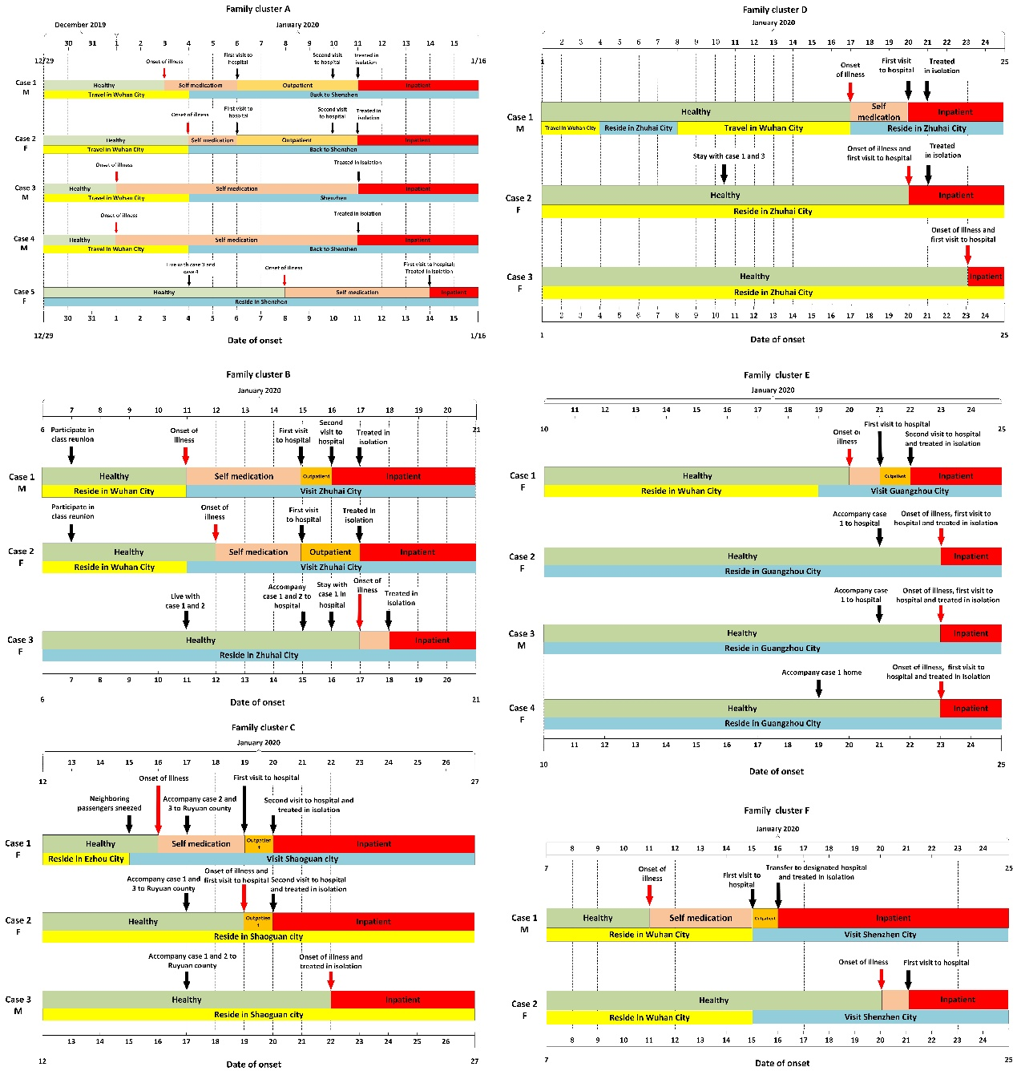

Figure S1. Chronology of symptom onset and treatment of family cluster infections with 2019-nCoV in Guangdong, China

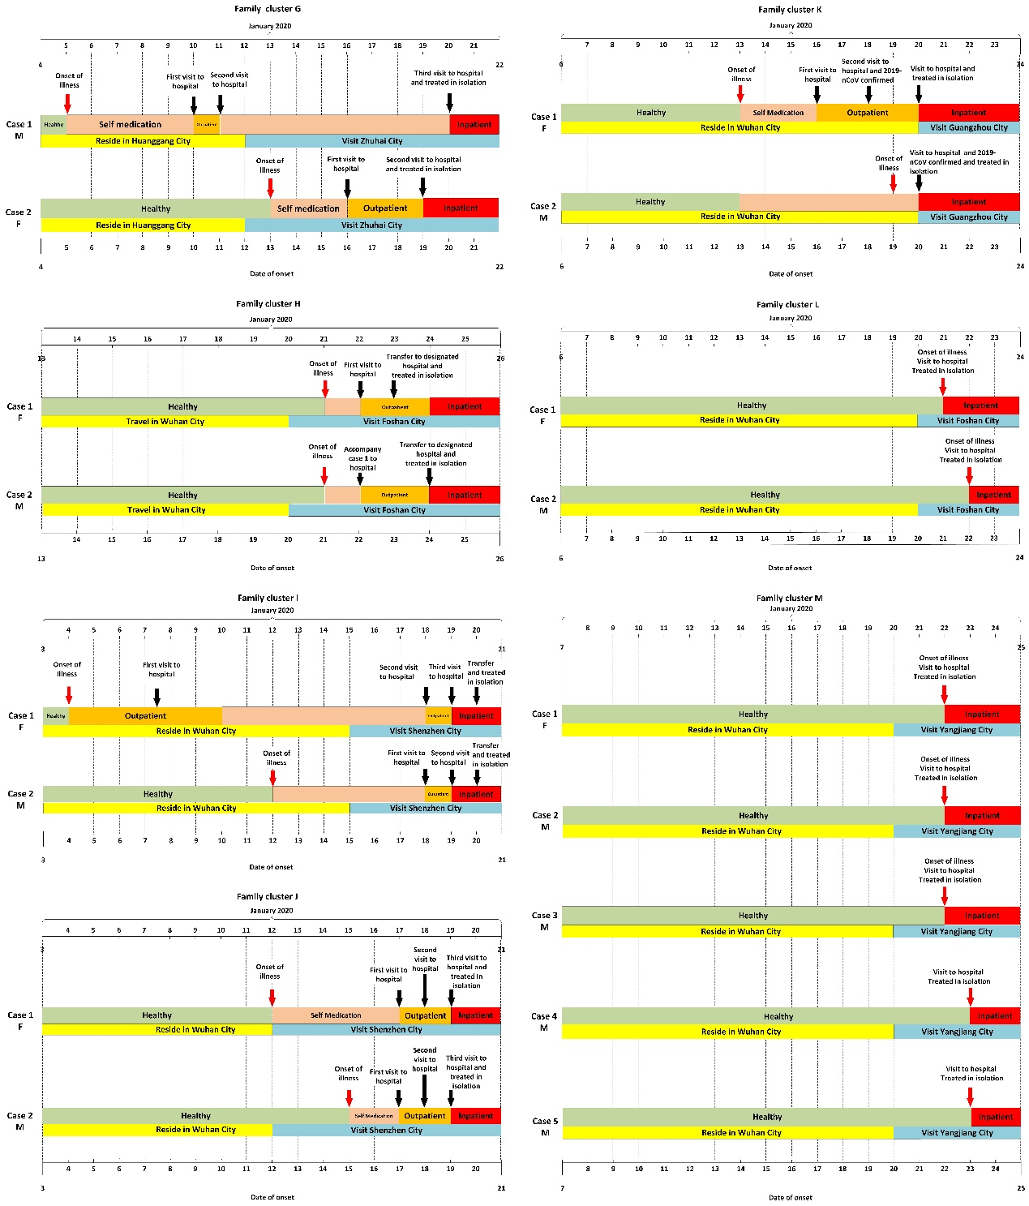

Figure S1. Chronology of symptom onset and treatment of family cluster infections with 2019-nCoV in Guangdong, China (continue)

Table S1. Characteristics of 37 cases in 13 family cluster infections

|  |  |  |  |  |  |  |  |  |  |  |  |  |  |  |  |
| --- | --- | --- | --- | --- | --- | --- | --- | --- | --- | --- | --- | --- | --- | --- | --- |
| Family cluster | City | Case number | Age | Sex | Date of onset of illness | Clinical symptoms | | | | Exposure to wild animals | Index cases | Secondary cases | History of travel to Wuhan | Severe cases | Death |
| Fever | Cough | Fatigue | Others a |
| A | Shenzhen | Case 1 | 66 | Male | 2020-01-03 | + | + | + | + | × | √ | × | √ | Critical | × |
| Case 2 | 65 | Female | 2020-01-04 | + | - | + | - | × | √ | × | √ | Severe | × |
| Case 3 | 36 | Male | 2020-01-01 | + | - | - | + | × | √ | × | √ | Mild | × |
| Case 4 | 10 | Male | 2020-01-01 | + | - | - | + | × | √ | × | √ | Recovered | × |
| Case 5 | 63 | Female | 2020-01-08 | + | - | - | + | × | × | √ | × | Mild | × |
| B | Zhuhai | Case 1 | 78 | Male | 2020-01-11 | - | + | + | + | × | √ | × | √ | Critical | × |
| Case 2 | 75 | Female | 2020-01-12 | - | + | + | + | × | √ | × | √ | Severe | × |
| Case 3 | 48 | Female | 2020-01-17 | + | + | - | + | × | × | √ | × | Mild | × |
| C | Shaoguan | Case 1 | 58 | Female | 2020-01-16 | + | - | - | + | × | √ | × | √ | Severe | × |
| Case 2 | 62 | Female | 2020-01-19 | + | + | - | + | × | × | √ | × | Mild | × |
| Case 3 | 64 | Male | 2020-01-22 | + | - | - | + | × | × | √ | × | Mild | × |
| D | Zhuhai | Case 1 | 36 | Male | 2020-01-17 | - | - | - | + | × | √ | × | √ | Mild | × |
| Case 2 | 38 | Female | 2020-01-20 | - | + | - | - | × | × | √ | × | Mild | × |
| Case 3 | 63 | Female | 2020-01-23 | + | - | + | - | × | × | √ | × | Mild | × |
| E | Guangzhou | Case 1 | 73 | Female | 2020-01-20 | + | + | - | + | × | √ | × | √ | Mild | × |
| Case 2 | 50 | Female | 2020-01-23 | - | + | - | - | × | × | √ | × | Mild | × |
| Case 3 | 51 | Male | 2020-01-23 | - | + | - | - | × | × | √ | × | Mild | × |
| Case 4 | 22 | Female | 2020-01-23 | - | + | - | - | × | × | √ | × | Mild | × |
| F | Shenzhen | Case 1 | 62 | Male | 2020-01-11 | + | + | + | + | / | √ | × | √ | Severe | × |
| Case 2 | 62 | Female | 2020-01-20 | + | + | - | - | / | √ | × | √ | Mild | × |

a Others refer to the other clinical symptoms, including headache, muscular soreness, breathless, chills, sore throat, Dizziness, sputum, diarrhea, stomachache, etc.

/: Unclear

Table S1 Characteristics of 37 cases in 13 family cluster infections(continued)

|  |  |  |  |  |  |  |  |  |  |  |  |  |  |  |  |
| --- | --- | --- | --- | --- | --- | --- | --- | --- | --- | --- | --- | --- | --- | --- | --- |
| Family cluster | City | Case number | Age | Sex | Date of onset of illness | Clinical symptoms | | | | Exposure to wild animals | Index cases | Secondary cases | History of travel to Wuhan | Severe cases | Death |
| Fever | Cough | Fatigue | Others a |
| G | Zhuhai | Case 1 | 65 | Male | 2020-01-05 | - | + | - | - | × | √ | × | √ | Mild | × |
| Case 2 | 66 | Female | 2020-01-13 | - | + | - | - | × | √ | × | √ | Mild | × |
| H | Foshan | Case 1 | 31 | Female | 2020-01-21 | + | - | - | - | × | √ | × | √ | Mild | × |
| Case 2 | 21 | Male | 2020-01-21 | - | - | - | + | / | √ | × | √ | Mild | × |
| I | Shenzhen | Case1 | 64 | Female | 2020-01-04 | - | + | + | + | × | √ | × | √ | Severe | × |
| Case2 | 69 | Male | 2020-01-12 | - | + | - | - | × | √ | × | √ | Severe | × |
| J | Shenzhen | Case1 | 64 | Female | 2020-01-12 | + | + | - | - | × | √ | × | √ | Critical | × |
| Case2 | 71 | Male | 2020-01-15 | + | - | - | - | × | √ | × | √ | Severe | × |
| K | Guangzhou | Case1 | 51 | Female | 2020-01-13 | / | / | / | / | × | √ | × | √ | Severe | × |
| Case2 | 53 | Male | 2020-01-19 | / | / | / | / | × | √ | × | √ | Severe | × |
| L | Foshan | Case1 | 57 | Female | 2020-01-21 | + | - | - | - | × | √ | × | √ | Mild | × |
| Case2 | 56 | Male | 2020-01-22 | + | - | - | - | × | √ | × | √ | Mild | × |
| M | Yangjiang | Case1 | 56 | Female | 2020-01-22 | + | - | - | + | × | √ | × | √ | Severe | × |
| Case2 | 35 | Male | 2020-01-22 | + | - | - | + | × | √ | × | √ | Mild | × |
| Case3 | 48 | Male | 2020-01-22 | + | - | - | + | × | √ | × | √ | Mild | × |
| Case4 | 56 | Male | 2020-01-23 | - | - | - | - | × | √ | × | √ | Mild | × |
| Case5 | 77 | Male | 2020-01-23 | - | - | - | - | × | √ | × | √ | Mild | × |

a Others refer to the other clinical symptoms, including headache, muscular soreness, breathless, chills, sore throat, Dizziness, sputum, diarrhea, stomachache, etc.

/: Unclear