**Supplemental Material**

Use of viral load to improve survey estimates of known HIV-positive status and antiretroviral treatment coverage

Peter W. Young, Emily Zielinski-Gutierrez, Joyce Wamicwe, Irene Mukui, Andrea A. Kim, Anthony Waruru, Clement Zeh, Mirjam E. Kretzschmar, Kevin M. De Cock

**Table S1.** Self-reported HIV status and antiretroviral treatment (ART) use, KAIS 2012

|  |  |  |  |  |
| --- | --- | --- | --- | --- |
| Characteristic | Unaware  n (%) | Aware, not on ART  n (%) | Aware, on ART  n (%) | N |
| **Gender** |  |  |  |  |
| Male | 120 (62.0) | 22 (11.0) | 51 (27.0) | 193 |
| Female | 223 (47.8) | 78 (17.5) | 154 (34.7) | 455 |
| **Age** |  |  |  |  |
| 15-24 yrs | 59 (82.0) | 10 (10.9) | 6 ( 7.1) | 75 |
| 25-34 yrs | 121 (58.9) | 40 (20.0) | 48 (21.1) | 209 |
| 35-49 yrs | 120 (44.1) | 40 (14.8) | 104 (41.1) | 264 |
| 50-64 yrs | 43 (43.1) | 10 ( 8.9) | 47 (48.0) | 100 |
| **Marital** **status** |  |  |  |  |
| Single/never married | 67 (73.5) | 10 ( 9.8) | 16 (16.7) | 93 |
| Married / cohabitating | 210 (54.2) | 57 (14.4) | 118 (31.4) | 385 |
| Divorced / sep / widowed | 66 (38.9) | 33 (19.7) | 71 (41.5) | 170 |
| **Highest educational attainment** |  |  |  |  |
| None | 49 (53.9) | 12 (12.9) | 28 (33.2) | 89 |
| Primary | 192 (55.8) | 60 (17.5) | 94 (26.7) | 346 |
| Secondary | 18 (57.4) | 3 (11.2) | 10 (31.4) | 31 |
| Higher | 83 (47.4) | 25 (11.9) | 73 (40.8) | 181 |
| **Employment** |  |  |  |  |
| Unemployed | 124 (49.1) | 33 (14.7) | 82 (36.2) | 239 |
| Employed | 218 (55.1) | 67 (15.3) | 123 (29.6) | 408 |
| **Mobility** |  |  |  |  |
| Not away for >1 month in last year | 196 (54.6) | 52 (14.2) | 112 (31.2) | 360 |
| Away >1 month in last year | 131 (51.4) | 45 (16.6) | 87 (32.1) | 263 |
| **ARV biomarker** |  |  |  |  |
| Present | 55 (25.2) | 12 (4.5) | 168 (70.4) | 235 |
| Absent | 233 (72.3) | 73 (22.3) | 18 (5.4) | 324 |
| **UVL biomarker** |  |  |  |  |
| Present | 65 (28.7) | 25 (9.9) | 145 (61.3) | 235 |
| Absent | 253 (66.5) | 74 (19.2) | 55 (14.3) | 382 |
| **Total** | 343 (53.1) | 100 (15.1) | 205 (31.8) | 648 |

Note: ARV biomarker: test for presence of antiretrovirals in blood, UVL biomarker: present if respondent had undetectable viral load (<550 copies/mL) in blood. Missing values: one respondent was missing education and employment status, respectively, while 89 respondents were missing the ARV biomarker and 31 were missing viral load measure. Percentages are weighted to account for survey design.

**Table S2.** Comparison of antiretroviral (ARV) detection and undetectable viral load (UVL) by self-reported HIV status, KAIS 2012

|  |  |  |  |  |  |
| --- | --- | --- | --- | --- | --- |
|  |  | **UVL biomarker** | | | |
| Status | **ARV biomarker** | Present | Absent | Missing | Total |
| **Unaware of HIV-positive status** | present | 40 | 15 | 0 | 55 |
| absent | 14 | 209 | 10 | 233 |
| missing | 11 | 29 | 15 | 55 |
| total | 65 | 253 | 25 | 343 |
| **Aware of HIV-positive status, not on ART** | present | 8 | 3 | 1 | 12 |
| absent | 12 | 61 | 0 | 73 |
| missing | 5 | 10 | 0 | 15 |
| total | 25 | 74 | 1 | 100 |
| **Aware of HIV-positive status, on ART** | present | 132 | 35 | 1 | 168 |
| absent | 3 | 15 | 0 | 18 |
| missing | 10 | 5 | 4 | 19 |
| total | 145 | 55 | 5 | 205 |
| Self-reported adherent last 30 days | present | 116 | 3 | 9 | 128 |
| absent | 27 | 11 | 4 | 42 |
| missing | 1 | 0 | 14 | 15 |
| total | 144 | 14 | 27 | 185 |
| Self-reported non-adherent last 30 days | present | 16 | 0 | 1 | 17 |
| absent | 8 | 3 | 1 | 12 |
| missing | 0 | 0 | 5 | 5 |
| total | 24 | 3 | 7 | 34 |
|  | N | 235 | 382 | 31 | 648 |

Note: ARV biomarker is present if ARVs detected in blood, UVL biomarker present if viral load undetectable (<550 copies/mL). Self-reported adherence is based on response to question among those who self-reported aware of HIV-positive status and on ART: ‘In the last 30 days, have you missed taking any of your ARV pills?’ One respondent who reported ‘don’t know’ to this question was excluded from the self-reported adherence analysis.

**Figure S1. Absolute and relative changes in ART coverage and HIV cascade indicators due to adjustment, by covariates, KAIS 2012**

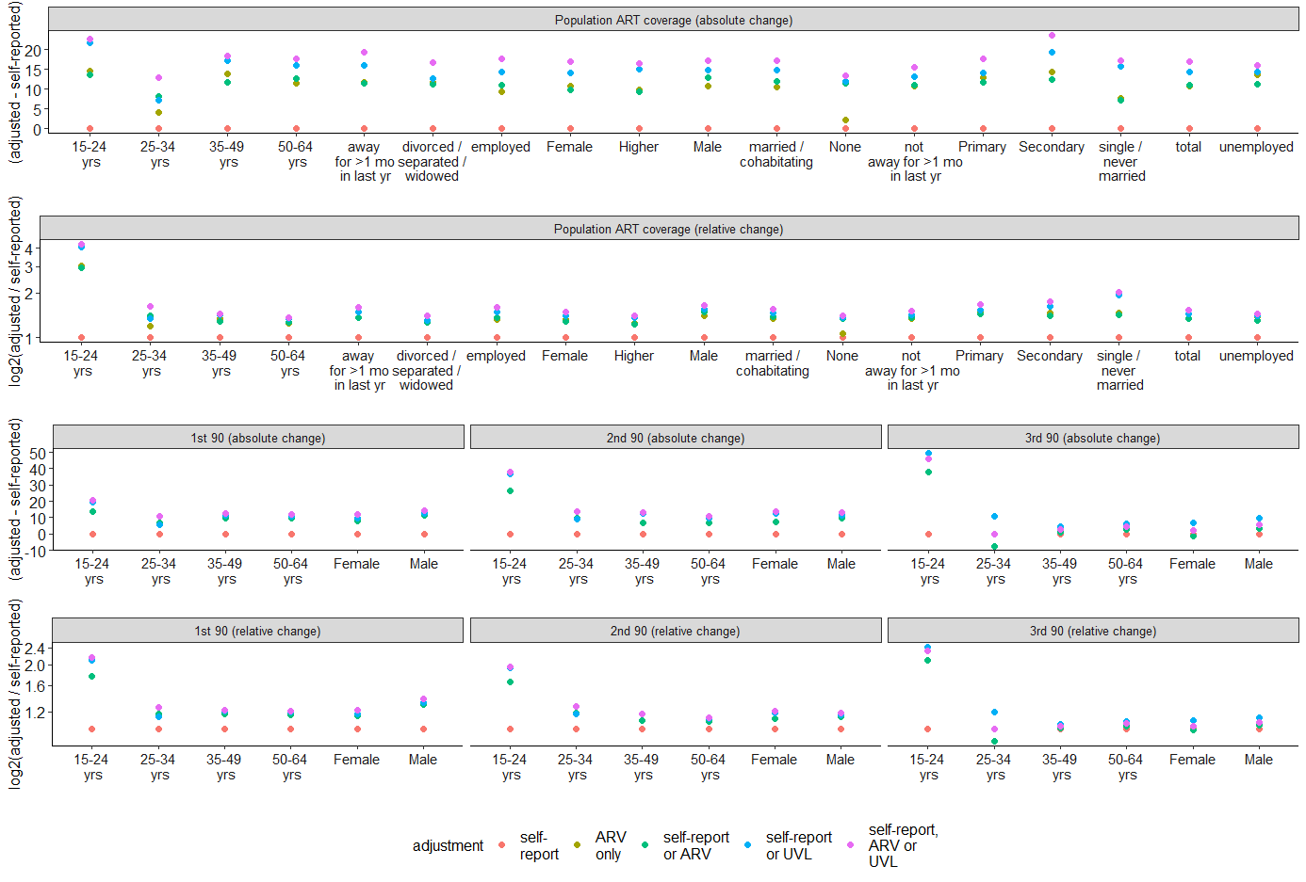

Note: relative differences are shown on log (2) scale, All differences are shown versus self-report. self-report: self-report only, self-report or ARV: either self-reported known-positive/on ART or ARVs detected, self-report or UVL: either self-reported known-positive/on ART or viral load was undetectable.

**Table S3.** Sensitivity analysis of self-reported and adjusted estimates of HIV care cascade restricted to participants with ARV and UVL biomarkers present, KAIS 2012

|  |  |  |  |  |  |  |  |  |  |  |  |  |  |
| --- | --- | --- | --- | --- | --- | --- | --- | --- | --- | --- | --- | --- | --- |
| Characteristic | | Self-report | | | Self-report or ARV | | | Self-report or UVL | | | Self-report, ARV or UVL | | |
| Variable | level | n | % | se | n | % | se | n | % | se | n | % | se |
| **Awareness of HIV infection (1st 90)** | | | | | | | | | | |  |  |  |
| Gender | Male | 62 | 37.1 | 4.5 | 81 | 50.0 | 5.3 | 82 | 50.3 | 5.3 | 86 | 52.4 | 5.4 |
| Female | 207 | 55.8 | 3.0 | 243 | 65.5 | 2.7 | 241 | 64.9 | 2.7 | 252 | 67.9 | 2.7 |
| Age group | 15–24 yrs | 15 | 21.7 | 6.0 | 23 | 39.2 | 7.9 | 25 | 44.8 | 8.4 | 26 | 46.2 | 8.3 |
| 25–34 yrs | 76 | 42.0 | 4.6 | 90 | 50.3 | 4.7 | 86 | 46.9 | 4.7 | 95 | 53.0 | 4.7 |
| 35–49 yrs | 126 | 56.5 | 4.0 | 149 | 67.7 | 3.6 | 148 | 67.5 | 3.6 | 152 | 68.5 | 3.6 |
| 50–64 yrs | 52 | 58.5 | 5.8 | 62 | 69.4 | 5.5 | 64 | 71.2 | 5.3 | 65 | 72.0 | 5.3 |
| Total |  | 269 | 48.5 | 3.0 | 324 | 59.4 | 3.0 | 323 | 59.2 | 3.1 | 338 | 61.8 | 3.1 |
| **ART coverage among previously-diagnosed (2nd 90)** | | | | | | | | | | |  |  |  |
| Gender | Male | 44 | 71.8 | 6.4 | 66 | 81.8 | 5.0 | 68 | 82.9 | 4.6 | 73 | 84.3 | 4.4 |
| Female | 141 | 68.0 | 3.4 | 185 | 76.0 | 3.0 | 191 | 79.3 | 2.9 | 204 | 80.8 | 2.8 |
| Age group | 15–24 yrs | 6 | 41.8 | 10.8 | 14 | 67.8 | 10.0 | 18 | 77.5 | 7.4 | 19 | 78.2 | 7.2 |
| 25–34 yrs | 42 | 51.8 | 6.4 | 58 | 61.8 | 5.7 | 55 | 60.5 | 5.9 | 65 | 65.5 | 5.6 |
| 35–49 yrs | 94 | 75.4 | 4.5 | 123 | 82.8 | 3.7 | 127 | 86.1 | 3.0 | 132 | 86.9 | 2.9 |
| 50–64 yrs | 43 | 84.9 | 5.4 | 56 | 92.4 | 3.7 | 59 | 93.6 | 2.9 | 61 | 95.0 | 2.6 |
| Total |  | 185 | 69.2 | 3.5 | 251 | 77.9 | 3.0 | 259 | 80.5 | 2.7 | 277 | 81.9 | 2.6 |
| **Viral suppression among those on ART (3rd 90)** | | | | | | | | | | |  |  |  |
| Gender | Male | 32 | 75.5 | 6.4 | 49 | 78.0 | 5.1 | 56 | 84.3 | 4.4 | 56 | 79.6 | 4.8 |
| Female | 108 | 76.5 | 4.0 | 139 | 75.3 | 3.6 | 158 | 82.7 | 3.0 | 158 | 77.6 | 3.3 |
| Age group | 15–24 yrs | 2 | 34.6 | 19.8 | 9 | 72.4 | 11.3 | 14 | 82.9 | 7.8 | 14 | 79.7 | 8.4 |
| 25–34 yrs | 27 | 58.4 | 8.6 | 33 | 50.3 | 7.5 | 40 | 68.1 | 7.2 | 40 | 55.5 | 7.0 |
| 35–49 yrs | 77 | 83.3 | 4.2 | 101 | 84.8 | 3.6 | 110 | 87.8 | 3.1 | 110 | 85.7 | 3.3 |
| 50–64 yrs | 34 | 80.6 | 6.4 | 45 | 82.2 | 5.4 | 50 | 85.6 | 5.0 | 50 | 83.3 | 5.1 |
| Total |  | 140 | 76.2 | 3.4 | 188 | 76.2 | 3.0 | 214 | 83.2 | 2.5 | 214 | 78.2 | 2.7 |

Note: self-reported: self-report only, self-report or ARV: either self-reported known-positive/on ART or ARVs detected, self-report or UVL: either self-reported known-positive/on ART or viral load was undetectable, n: unweighted numerator, se: standard error, viral suppression defined as <1000 copies/mL. Percentages and standard errors are weighted and adjusted to account for the survey design.