**Supplemental Figure 1**. US Census Divisions. The US Territories (American Samoa, Guam, Puerto Rico, Virgin Islands) are not shown. Image from: https://yourfreetemplates.com/us-region-map-template/

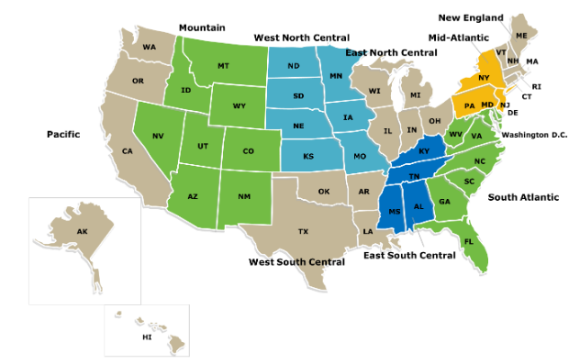

**Supplemental Figure 2**. Percent of Medicaid prescriptions (A, B, C) or total amount reimbursed (D, E, F) by buprenorphine formulation (i.e. the product name) in 2008, 2013, and 2018 (<https://www.medicaid.gov/medicaid/prescription-drugs/state-drug-utilization-data/index.html> ).

