|  |  |  |
| --- | --- | --- |
| **Supplemental table 1- Search strategy in different databases** | | |
| Pubmed | Medline | Embase |
| (puberty OR pubertal OR menarche OR Tanner[Text Word] OR (voice (break OR breaking)) OR sexual maturation) AND (diabetes OR diabetic OR insulin OR blood sugar OR glucose OR ((glycated OR glycosylated) AND (haemoglobin OR haemoglobin))) AND (“Epidemiologic studies”[Mesh] OR “case control studies”[Mesh] OR “cohort studies”[Mesh] OR Case control[Text Word] OR cohort stud*[Text Word] OR Cohort analy*[Text Word] OR Follow up stud*[Text Word] OR observational stud*[Text Word] OR (observ*[Text Word] association*[Text Word]) OR Longitudinal[Text Word] OR Retrospective[Text Word] OR Recall*[Text Word] OR Cross sectional[Text Word] OR “Cross-sectional studies”[Mesh] OR (nation*[Text Word] stud*[Text Word]) OR (nation*[Text Word] survey*[Text Word]) OR mendelian randomi*[Text Word]) | 1. puberty.mp. or exp puberty/  2. pubertal.mp.  3. menarche.mp. or exp menarche/  4. Tanner.tw.  5. (voice adj (break or breaking)).mp.  6. sexual maturation.mp. or exp sexual maturation/  7. 1 or 2 or 3 or 4 or 6  8. diabetes.mp. or exp diabetes mellitus/  9. diabetic.mp.  10. exp insulin sensitivity/ or insulin.mp. or exp insulin resistance/  11. blood sugar.mp. or exp glucose blood level/  12. glucose.mp.  13. exp glycosylated hemoglobin/  14. or/8-13  15. 7 and 14  16. Epidemiologic studies/  17. exp case control studies/  18. exp cohort studies/  19. Case control.tw.  20. (cohort adj (study or studies)).tw.  21. Cohort analy$.tw.  22. (Follow up adj (study or studies)).tw.  23. (observational adj (study or studies)).tw.  24. Longitudinal.tw.  25. Retrospective.tw.  26. Cross sectional.tw.  27. Cross-sectional studies/  28. (observ* adj (association or associations)).tw.  29. (nation$ adj (study or studies or survey or surveys)).tw.  30. recall*.tw.  31. exp Mendelian Randomization Analysis/ or mendelian randomi*.mp.  32. or/16-31  33. 15 and 32 | 1. puberty.mp. or exp puberty/  2. pubertal.mp.  3. menarche.mp. or exp menarche/  4. Tanner.tw.  5. (voice adj (break or breaking)).mp.  6. sexual maturation.mp. or exp sexual maturation/  7. 1 or 2 or 3 or 4 or 6  8. diabetes.mp. or exp diabetes mellitus/  9. diabetic.mp.  10. exp insulin sensitivity/ or insulin.mp. or exp insulin resistance/  11. blood sugar.mp. or exp glucose blood level/  12. glucose.mp.  13. exp glycosylated hemoglobin/  14. 8 or 9 or 10 or 11 or 12 or 13  15. 7 and 14  16. clinical study/  17. Case control study/  18. Family study/  19. Longitudinal study/  20. Retrospective study/  21. Prospective study/  22. Cohort analysis/  23. (Cohort adj (study or studies)).mp.  24. (Case control adj (study or studies)).tw.  25. (follow up adj (study or studies)).tw.  26. (observational adj (study or studies)).tw.  27. (epidemiologic$ adj (study or studies)).tw.  28. (cross sectional adj (study or studies)).tw.  29. (observ* adj (association or associations)).tw.  30. (nation$ adj (study or studies or survey or surveys)).tw.  31. recall*.tw.  32. exp Mendelian randomization analysis/ or mendelian randomi*.mp. or exp Mendelian randomization/  33. or/16-32  34. 15 and 33 |

|  |  |  |  |  |  |  |
| --- | --- | --- | --- | --- | --- | --- |
| **Supplemental Table 2- Summary of eligible studies for prevalent diabetes and/or impaired glucose tolerance** | | | | | | |
| First author,  year | Year at  enrolment | Outcome, definition | Controlled variables without anthropometric adiposity measures | | Controlled variables with anthropometric adiposity measures | |
| OR (95% CI) | Adjustment | OR (95% CI) | Adjustment |
| Cooper,  2000 (25) | 1934-1939 | Diabetes: Self-reported physician diagnosis |  |  | 1.1 (0.9, 1.3) per year later | Age and BMI at age 30 |
| Saquib,  2005 (18) | 1984-1987 | Diabetes: fasting glucose≥7.0 mmol/L (≥126 mg/dL), 2-hour glucose≥11.1 mmol/L (≥200 mg/dl), a previous physician diagnosis or use of anti-diabetic medication |  |  | <12 vs. ≥16 (Ref): 2.27 (0.62, 9.09)a | Age, number of pregnancies, exercise≥3 times/week, cigarette smoking, estrogen use, family history of diabetes and BMI |
|  |  | Impaired glucose tolerance: fasting glucose=6.1 mmol/L (110 mg/dL) - 7.0 mmol/L or 2-hour glucose=7.8 mmol/L (140 mg/dL) - 11.1 mmol/L |  |  | <12 vs. ≥16 (Ref): : 0.93 (0.47, 1.85)a | Age, number of pregnancies, exercise≥3 times/week, cigarette smoking, estrogen use, family history of diabetes and BMI |
| Heys,  2007 (30) | 2003-2004 | Impaired glucose tolerance: fasting glucose>5.6 mmol/L or use of anti-diabetic medication | <12.5 vs. ≥14.5 (Ref): 1.40 (1.15, 1.71) | Age, education and number of pregnancies | <12.5 vs. ≥14.5 (Ref): 1.33 (1.08, 1.63) | Previous model + waist circumference |
| Lakshman,  2008 (19) | 1993-1997 | Diabetes: Self-reported physician diagnosis or use of diabetes-specific medication | 0.91 (0.87, 0.96) per year later | Age at baseline, smoking, occupational social class, educational level, physical activity, family history of diabetes, reproductive factors parity, oral contraceptive and use hormone replacement therapy | 0.98 (0.93, 1.03) per year later | Previous model + BMI |
|  |  |  | 8-11 vs. 15-18 (Ref): 1.52 (1.18, 1.96)a | Age at baseline, smoking, occupational social class, educational level, physical activity and family history of diabetes |  |  |
| Akter,  2012 (31) | 2009-2010 | Diabetes: physician diagnosis or anti-diabetic medication and impaired glucose tolerance: fasting glucose≥6.1 mmol/L (≥110 mg/dL) | <12 vs. >13-16 (Ref)  : 0.65 (0.46, 0.93) | Age, education, marital status, use of tobacco products, ever use of contraceptives, and number of pregnancies |  |  |
| Dreyfus,  2012 (40) | 1987-1989 | Diabetes: fasting glucose≥7.0 mmol/L (126 mg/dL), non-fasting glucose>11.1 mmol/L (200 mg/dl), self-reported physician-diagnosis or use of hypoglycemic medication at 30 years or older | 8-11 vs. 13 (Ref)  : 1.37 (1.12, 1.68) | Age at baseline, race, center, family history of diabetes, smoking status, use of oral contraceptives and education | 8-11 vs. 13 (Ref): 1.20 (0.97, 1.48) | Previous model + baseline BMI, height and waist circumference |
| Pierce,  2012 (24) | 1946 | Diabetes: Ever treated with diet or oral hypoglycemic agents, or who had insulin added more than 2 years after diagnosis at 30 years or older | 0.72 (0.52, 0.99) per year later | No | 0.86 (0.63, 1.18) per year later | Adult BMI |
| Stockl,  2012 (26) | 2006-2008 | Diabetes: use of glucose-lowering medication, self-reported physician diagnosis, fasting glucose≥7.0 mmol/L (≥126 mg/dL) or 2-hour glucose≥11.1 mmol/L (≥200 mg/dL) | 0.83 (0.73, 0.95) per year later | Year of birth, physical activity, education, marital status, smoking, alcohol consumption and menopausal status | 0.84 (0.73, 0.98) per year later | Previous model + current BMI |
|  |  | Prediabetes: fasting glucose=6.1 mmol/L - 6.9mmol/L or 2-hour glucose=7.8 mmol/L (140 mg/dL) - 11.1 mmol/L | 0.91 (0.85, 0.98) per year later |  | 0.92 (0.85, 0.99) per year later |  |
|  |  | Diabetes and prediabetes | 0.88 (0.83, 0.94) per year later |  | 0.89 (0.83, 0.95) per year later |  |
| aResults were computed with the reciprocal of risk estimates at highest category  BMI, Body mass index; OR, odds ratio; CI, confidence interval | | | | | | |

|  |  |  |  |  |  |  |
| --- | --- | --- | --- | --- | --- | --- |
| **Supplemental Table 2- Summary of eligible studies for prevalent diabetes and/or impaired glucose tolerance (continued)** | | | | | | |
| First author,  year | Year at  enrolment | Outcome, definition | Controlled variables without anthropometric adiposity measures | | Controlled variables with anthropometric adiposity measures | |
| OR (95% CI) | Adjustment | OR (95% CI) | Adjustment |
| Qiu,  2013 (32) | 2011-2012 | Diabetes: fasting glucose≥7.0 mmol/L (≥126 mg/dL) or 2-hour glucose≥11.1 mmol/L (≥200 mg/dL), a previous physician diagnosis or use of anti-diabetic medication | 9-14 vs. 16 (Ref): 0.94 (0.70, 1.26) | Age at enrollment, physical activity, parity, smoking, alcohol consumption, family history of diabetes, age at menopause and type of menopause | 9-14 vs. 16 (Ref): 0.90 (0.66, 1.21) | Previous model + BMI and waist circumference |
| Mueller,  2014 (41) | 2008-2010 | Diabetes: self-report diagnosis, use of medication for diabetes, fasting glucose≥126 mg/dL, 2-hour glucose≥200 mg/dL or HbA1c≥6.5% | <11 vs. 13-14 (Ref): 1.34 (1.14, 1.57) | Age at enrollment, study center, race, maternal education, maternal diabetes, paternal diabetes and birth weight | <11 vs. 13-14 (Ref): 1.26 (1.07, 1.49) | Previous model + BMI at age 20 years |
| Baek,  2015 (33) | 2012-2013 | Diabetes: self-report physician diagnosis, use of insulin or hypoglycemic medication, fasting glucose≥126 mg/dL (7.0 mmol/L) or HbA1c≥6.5% (48 mmol/mol) | <13 vs. 13-16 (Ref): 2.43 (1.04, 5.69) | Age at enrollment, education, spouse, income, parity, menopause status, smoking, alcohol and physical activity | <13 vs. 13-16 (Ref): 2.10 (0.86, 5.14) | Previous model + BMI |
|  |  | Prediabetes: fasting glucose=100-125 mg/dL (5.6mmol/L-6.9 mmol/L) or HbA1c=5.7%-6.4% (39-46 mmol/mol) | <13 vs. 13-16 (Ref): 1.80 (1.24, 2.61) |  | <13 vs. 13-16 (Ref): 1.63 (1.11, 2.39) |  |
|  |  | Diabetes + Prediabetes | 13-16 (Ref),  <13: 1.85 (1.28, 2.66) |  | 13-16 (Ref),  <13: 1.66 (1.14, 2.41) |  |
| Day,  2015 (22) | 2006-2010 | Diabetes: Self-report physician diagnosis, excluding possible type 1 diabetes (based on age at diagnosis≤35, use of insulin within 1 year of diagnosis or diagnosis less than 1 year before enrollment) | 0.87 (0.85, 0.88) per year later;  8-11 vs. 13-14 (Ref): 1.76 (1.62, 1.91) | Birth year, age and age-squared | 0.94 (0.92, 0.96) per year later; 8-11 vs. 13-14 (Ref): 1.25 (1.15, 1.36) | Previous model + socioeconomic position (11 principle components) and adiposity/body composition (5 principle components) |
|  |  |  | relatively younger vs. about average (Ref): 1.44 (1.30, 1.59) |  | relatively younger vs. about average (Ref): 1.24 (1.11, 1.37) |  |
| Hwang,  2015 (34) | 2007-2009 | Diabetes: Self-report physician diagnosis | 10-12 vs. 13-15 (Ref): 1.86 (1.07, 3.23) | Age, education, income, use of hormonal medication, smoking status, alcohol use, exercise status and diagnosis of hypertension, dyslipidemia and cardiac disease | 10-12 vs. 13-15 (Ref): 1.82 (1.03, 3.23) | Previous model + BMI and waist circumference |
| Lim,  2015 (35) | 2007-2009 | Diabetes: use of a glucose-lowering medication, self-report physician diagnosis, fasting glucose≥126 mg/dL | <12 vs. ≥12 (Ref): 3.61 (1.90, 6.88) | Age | <12 vs. ≥12 (Ref): 2.52 (1.29, 4.94) | Previous model + BMI |
| Cao,  2016 (21) | 2011-2014 | Impaired glucose tolerance: fasting glucose≥5.6 mmol/L |  |  | 11-13vs. 16-20 (Ref): 0.83 (0.62, 1.10)a | Age, education level, physical activity and BMI |
| Won,  2016 (36) | 2010-2013 | Diabetes: Self-reported physician diagnosis | <11 vs. ≥17 (Ref): 1.72 (0.94, 3.15) | Age, current smoking, college graduation and menstruation |  |  |
| aResults were computed with the reciprocal of risk estimates at highest category  BMI, Body mass index; OR, odds ratio; CI, confidence interval | | | | | | |

|  |  |  |  |  |  |  |
| --- | --- | --- | --- | --- | --- | --- |
| **Supplemental Table 2- Summary of eligible studies for prevalent diabetes and/or impaired glucose tolerance (continued)** | | | | | | |
| First author,  year | Year at  enrolment | Outcome, definition | Controlled variables without anthropometric adiposity measures | | Controlled variables with anthropometric adiposity measures | |
| OR (95% CI) | Adjustment | OR (95% CI) | Adjustment |
| Yang,  2016 (37) | 2011-2013 | Diabetes: use of anti-diabetic medication, fasting glucose ≥7.0 mmol/L (126 mg/dl.) | ≤12 vs. 15-16 (Ref): 1.60 (1.16, 2.22) | Age | ≤12 vs. 15-16 (Ref): 1.44 (1.02, 2.03) | Age, education, marital status, occupation, smoking status, drinking, hypertension, abnormal lipid, family history of diabetes, age at menopause and BMI |
| Au Yeung, 2017 (13) | 2003-2008 | Diabetes: use of anti-diabetic medication, fasting glucose ≥7.0 mmol/L (126 mg/dl.) | 0.65 (0.32, 1.33) per year later | Mendelian Randomization |  |  |
|  |  |  | 0.92 (0.89, 0.95) per year later | Education, recruitment phase, age, smoking, alcohol use, physical activity, job type, corresponding medications such as antihypertensive for blood pressure |  |  |
| Farahmand, 2017 (28) | 1998 | Diabetes: fasting glucose≥7.0 mmol/L (126mg/dL), 2-hour glucose≥11.1 mmol/L (200 mg/dL) | <11 vs. 13-14 (Ref): 2.70 (1.40, 5.20) | Family history of diabetes, parity, education and age | <11 vs. 13-14 (Ref): 3.28 (1.50, 7.10) | Previous model + BMI |
|  |  | Prediabetes: fasting glucose=100 mg/dL (5.6 mmol/L) -125 mg/dL (6.9 mmol/L) or 2-hour glucose=140 mg/dL (7.8 mmol/L) -199 mg/dL (11.0 mmol/L) | <11 vs. 13-14 (Ref): 3.74 (1.60, 8.60) |  | <11 vs. 13-14 (Ref): 3.56 (1.20, 10.20) |  |
| Petersohn, 2019 (43) | 1999-2000 | Diabetes: self-report physician diagnosis or random blood glucose>200 mg/dL |  |  | 0.95 (0.83, 0.98) per year later | BMI, age BMI-age interaction, family history of diabetes |
| aResults were computed with the reciprocal of risk estimates at highest category  BMI, Body mass index; OR, odds ratio; CI, confidence interval | | | | | | |

|  |  |  |  |  |  |  |
| --- | --- | --- | --- | --- | --- | --- |
| **Supplemental Table 3- Summary of eligible studies for incident diabetes and/or impaired glucose tolerance** | | | | | | |
| First author,  year | Year at  enrolment | Outcome, definition | Controlled variables without anthropometric adiposity measures | | Controlled variables with anthropometric adiposity measures | |
| OR (95% CI) | Adjustment | OR (95% CI) | Adjustment |
| He,  2010 (39) | 1980 | Diabetes: fasting glucose≥7.8 mmol/L (≥140 mg/dL) or ≥7.0 mmol/L (≥126 mg/dL) (after 1997), 2-hour/ random glucose≥ 11.1mmol/L (≥200 mg/dL), at least one symptom related to diabetes (excessive thirst, polyuria, weight loss, hunger) or treatment with insulin/ oral hypoglycemic medication | 0.94 (0.92, 0.95) per year later;  ≤11 vs. 13 (Ref): 1.21 (1.13, 1.31) | Age groups, birth weight, having been breastfed, childhood socioeconomic status, ethnicity, family history of diabetes, perceived body figure at age 10 years, the baseline factors physical activity, quintile of dietary score, alcohol consumption, smoking status, hypertension, hypercholesterolemia, menopause status, use of hormone replacement therapy, adult socioeconomic status, reproductive factors (parity, oral contraceptive use, and regularity of menstrual cycles at ages 18–22 years) | 0.99 (0.97, 1.01) per year later;  13 (Ref),  ≤11 vs. 13 (Ref): 1.02 (0.95, 1.10) | Previous model + BMI over the course of follow-up |
|  | 1991 |  | 0.88 (0.86, 0.91) per year later;  ≤11 vs. 13 (Ref): 1.50 (1.34, 1.69) |  | 0.97 (0.94, 1.00) per year later;  ≤11 vs. 13 (Ref): (1.02, 1.29) |  |
| Conway,  2012 (20) | 1997-2000 | Diabetes: fasting glucose≥7 mmol/L, oral glucose tolerance test≥11.1 mmol/L and/or use of a hypoglycemic agent | 0.95 (0.92, 0.98) per year later;  8-13 vs. 17-26 (Ref): 1.35 (1.14, 1.59)a | Birth cohort, education and income | 0.98 (0.95, 1.01) per year later; 8-13 vs. 17-26 (Ref): 1.14 (0.95, 1.33)a | Previous model + participation in team sports during adolescence, BMI at baseline and BMI at age 20 |
| Dreyfus,  2012 (40) | 1987-1989 |  | 8-13 vs. 17-26 (Ref): 1.27 (1.02, 1.58) |  | 8-13 vs. 17-26 (Ref): 1.18 (0.95, 1.47) |  |
| Elks,  2013 (27) | 1991 | Diabetes: self-report physician diagnosis, confirmed by medical records, or local and national diabetes and pharmaceutical registers | 0.89 (0.86, 0.93) per year later;  8-11 vs. 13 (Ref): 1.70 (1.48, 1.94) | Age at recruitment, date of birth, center, age at first full-term pregnancy, parity, menopausal status, use of oral contraceptive pill, use of hormone replacement therapy | 0.96 (0.91, 1.01) per year later;  8-11 vs. 13 (Ref): 1.42 (1.18, 1.71) | Previous model + adult BMI |
| Dreyfus,  2015 (17) | 1985 | Diabetes: fasting glucose≥7.0 mmol/L (126 mg/dL), HbA1c≥6.5%, 2-hour glucose≥11.1 mmol/L (200 mg/dL), or use of diabetes medication | 0.93 (0.86, 1.00) per year laterb,  8-11 vs. 14-17 (Ref): 1.61 (1.09, 2.37) | Age, center, race, parental history of diabetes, education, pre-high school physical activity, high school physical activity, smoking status, oral contraceptive use, physical activity and alcohol intake | 0.90 (0.86, 0.94) per year laterb, 14-17 (Ref),  8-11 vs. 14-17 (Ref): 1.33 (0.90, 1.96) | Previous model + baseline BMI |
|  |  | Impaired glucose tolerance: fasting glucose=5.6 (100 mg/dL) -6.9 mmol/L, not taking diabetes medication | 0.96 (0.89, 1.05) per year laterb,  8-11 vs. 14-17 (Ref): 1.50 (1.17, 1.94) |  | 0.93 (0.88, 0.98) per year laterb,  8-11 vs. 14-17 (Ref): 1.28 (0.99, 1.62) |  |
| aResults were computed with the reciprocal of risk estimates at highest category  bResults were computed with the reciprocal of risk estimates per year early age at menarche  BMI, Body mass index; OR, odds ratio; CI, confidence interval | | | | | | |

|  |  |  |  |  |  |  |
| --- | --- | --- | --- | --- | --- | --- |
| **Supplemental Table 3- Summary of eligible studies for incident diabetes and/or impaired glucose tolerance (continued)** | | | | | | |
| First author,  year | Year at  enrolment | Outcome, definition | Controlled variables without anthropometric adiposity measures | | Controlled variables with anthropometric adiposity measures | |
| OR (95% CI) | Adjustment | OR (95% CI) | Adjustment |
| LeBlanc,  2017 (42) | 1993-1998 | Diabetes: self-report diagnosis, use of diabetes medications | <12 vs. 12 (Ref): 1.14 (1.08, 1.20) | Age | <12 vs. 12 (Ref): 1.01 (0.95, 1.06) | Age, race, hormone therapy intervention arm membership, baseline physical activity, baseline alcohol consumption, baseline smoking history, education, baseline marital status, number of term pregnancies, family history of diabetes, years since menopause at baseline, baseline waist circumference, history of oral contraceptive use at baseline, baseline metformin use and baseline BMI |
| Yang,  2018 (12) | 2004-2008 | Diabetes: Data linkage with the nationwide health insurance system | 0.96 (0.94, 0.97) per year later;  13 vs. ≥18 (Ref): 1.33 (1.24, 1.44)a | Education, household income, smoking status, alcohol intake, blood pressure, physical activity, menopause status, parity, age at first birth, breastfeeding duration per child, and oral contraceptive use | 0.98 (0.97, 1.00) per year later | Previous model + baseline BMI and waist circumference |
| Pandeya,  2018 (29) | 1985-2009 | Diabetes: self-report physician diagnosis or information from hospital patient registry data | ≤10 vs. 13 (Ref): 1.63 (1.40, 1.89) | Women's year of birth, age at baseline, education,  smoking status at baseline, number of children, age at first birth, menopausal status/timing and hormone therapy at baseline | ≤10 vs. 13 (Ref): 1.18 (1.02, 1.37) | Previous model + baseline BMI |
| Nanri,  2019 (38) | 1990, 1993 | Diabetes: self-reported physician diagnosis by examining medical records | ≤13 vs. ≥16 (Ref): 1.09 (0.83, 1.43)a | Age, study area, smoking status , alcohol consumption , family history of diabetes mellitus, total physical activity, history of hypertension, total energy intake, coffee consumption, energy-adjusted daily intake of foods or nutrients | ≤13 vs. ≥16 (Ref): 1.01 (0.76, 1.33)a | Previous model + BMI |
| aResults were computed with the reciprocal of risk estimates at highest category  BMI, Body mass index; OR, odds ratio; CI, confidence interval | | | | | | |

|  |  |  |  |  |  |  |  |  |  |  |  |  |  |  |  |  |  |  |  |  |  |
| --- | --- | --- | --- | --- | --- | --- | --- | --- | --- | --- | --- | --- | --- | --- | --- | --- | --- | --- | --- | --- | --- |
| **Supplemental Table 4- Quality of eligible studies for prevalent diabetes/ impaired glucose tolerance assessed by The Newcastle-Ottawa Quality Assessment Scale for cohort studies** | | | | | | | | | | | | | | | | | | | | | |
| First author, year | Cooper,  2000  (25) | Pierce,  2012  (24) | Saquib, 2015 (18) | Heys,  2007  (30) | Lakshman,  2008  (19) | Akter,  2012  (31) | Dreyfus,  2012  (40) | Stockl,  2012  (26) | Qiu,  2012  (32) | Mueller,  2014  (41) | Baek,  2015  (33) | Day,  2015  (22) | Hwang,  2015  (34) | Lim,  2015  (35) | Cao,  2016  (21) | Won,  2016  (36) | Yang,  2016  (37) | Au Yeung,  2017  (13) | Farahmand,  2017  (28) | Petersohn,  2019  (43) |
| 1. Truly or somewhat representative of the general population | 0 | 1 | 1 | 1 | 1 | 1 | 1 | 1 | 1 | 1 | 1 | 1 | 1 | 1 | 1 | 1 | 0 | 1 | 1 | 1 |
| 1. Selection of the non-exposed cohort from the same community as the exposed cohort | 1 | 1 | 1 | 1 | 1 | 1 | 1 | 1 | 1 | 1 | 1 | 1 | 1 | 1 | 1 | 1 | 1 | 1 | 1 | 1 |
| 1. At least some description of assessment | 1 | 1 | 1 | 1 | 1 | 1 | 1 | 1 | 1 | 1 | 1 | 1 | 1 | 1 | 0 | 1 | 1 | 1 | 1 | 1 |
| 1. Demonstration that the outcome was not present at the start of study | 1 | 1 | NA | NA | NA | NA | NA | NA | NA | NA | NA | NA | NA | NA | NA | NA | NA | NA | NA | NA |
| 5a) Controls for age | 1 | 0 | 1 | 1 | 1 | 1 | 1 | 1 | 1 | 1 | 1 | 1 | 1 | 1 | 1 | 1 | 1 | 1 | 1 | 1 |
| 5b) Controls for additional factors (ethnicity, diet, physical activity) | 0 | 0 | 1 | 0 | 1 | 0 | 0 | 1 | 1 | 0 | 1 | 0 | 1 | 0 | 1 | 0 | 0 | 1 | 0 | 0 |
| 1. Assessment of outcome – oral glucose tolerance test or record linkage | 0 | 0 | 1 | 1 | 0 | 1 | 1 | 1 | 1 | 1 | 1 | 0 | 0 | 1 | 1 | 0 | 1 | 1 | 1 | 1 |
| 1. At least 5 years follow-up for outcomes to occur | 1 | 1 | NA | NA | NA | NA | NA | NA | NA | NA | NA | NA | NA | NA | NA | NA | NA | NA | NA | NA |
| 1. Adequate ≥70% of original cohort | 0 | 0 | 0 | 1 | 0 | 1 | 1 | 0 | 1 | 1 | 1 | 1 | 1 | 1 | 1 | 1 | 1 | 1 | 1 | 1 |
| Total (max 7 or 9) | 5 | 5 | 6 | 6 | 5 | 6 | 6 | 6 | 7 | 6 | 7 | 5 | 6 | 6 | 6 | 5 | 5 | 7 | 6 | 6 |

|  |  |  |  |  |  |  |  |  |  |
| --- | --- | --- | --- | --- | --- | --- | --- | --- | --- |
| **Supplemental Table 5- Quality of eligible studies for incident diabetes/ impaired glucose tolerance assessed by The Newcastle-Ottawa Quality Assessment Scale for cohort studies** | | | | | | | | | |
| First author, year | He  2010  (39) | Conway,  2012  (20) | Dreyfus,  2012  (40) | Elks,  2013  (27) | Dreyfus,  2015  (17) | LeBlanc,  2017  (42) | Yang,  2018  (12) | Pandeya,  2018  (29) | Nanri,  2019  (38) |
| 1. Truly or somewhat representative of the general population | 1 | 1 | 1 | 1 | 1 | 1 | 1 | 1 | 1 |
| 1. Selection of the non-exposed cohort from the same community as the exposed cohort | 1 | 1 | 1 | 1 | 1 | 1 | 1 | 1 | 1 |
| 1. At least some description of assessment | 1 | 1 | 1 | 1 | 1 | 1 | 1 | 1 | 1 |
| 1. Demonstration that the outcome was not present at the start of study | 1 | 1 | 1 | 1 | 1 | 1 | 1 | 1 | 1 |
| 5a) Controls for age | 1 | 1 | 1 | 1 | 1 | 1 | 1 | 1 | 1 |
| 5b) Controls for additional factors (ethnicity, diet, physical activity) | 1 | 1 | 0 | 0 | 1 | 1 | 1 | 0 | 1 |
| 6) Assessment of outcome – oral glucose tolerance test or record linkage | 1 | 1 | 1 | 1 | 1 | 0 | 1 | 1 | 1 |
| 1. At least 5 years follow-up for outcomes to occur | 1 | 1 | 1 | 1 | 1 | 1 | 1 | 1 | 1 |
| 1. Adequate ≥70% of original cohort | 1 | 1 | 1 | 1 | 1 | 1 | 1 | 1 | 0 |
| Total (max 9) | 9 | 9 | 8 | 8 | 9 | 8 | 9 | 8 | 8 |

**Supplemental figure 1**- Forest plots of the association of AAM (a continuous variable) with T2D or IGT, (a) without and (b) with adjustment for adiposity.

(a)

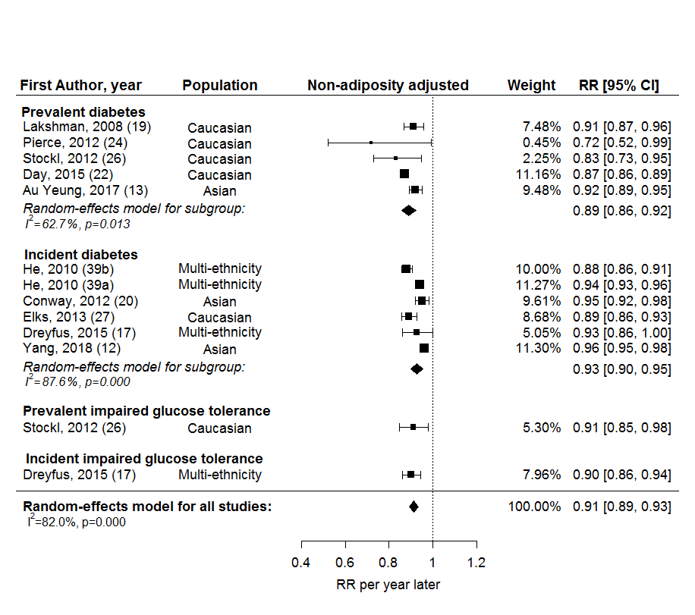

(b)

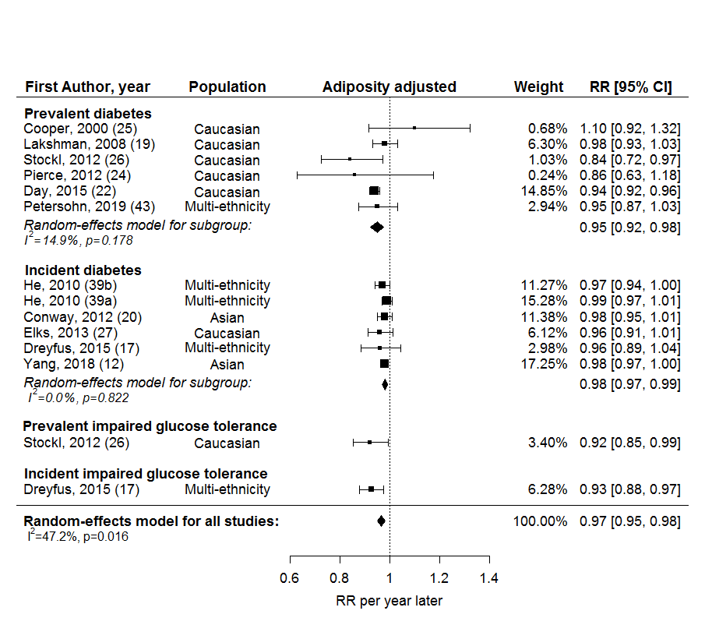

**Supplemental figure 2**- Forest plots of the association of early vs. later menarche with T2D or IGT, (a) without and (b) with adjustment for adiposity.

(a)

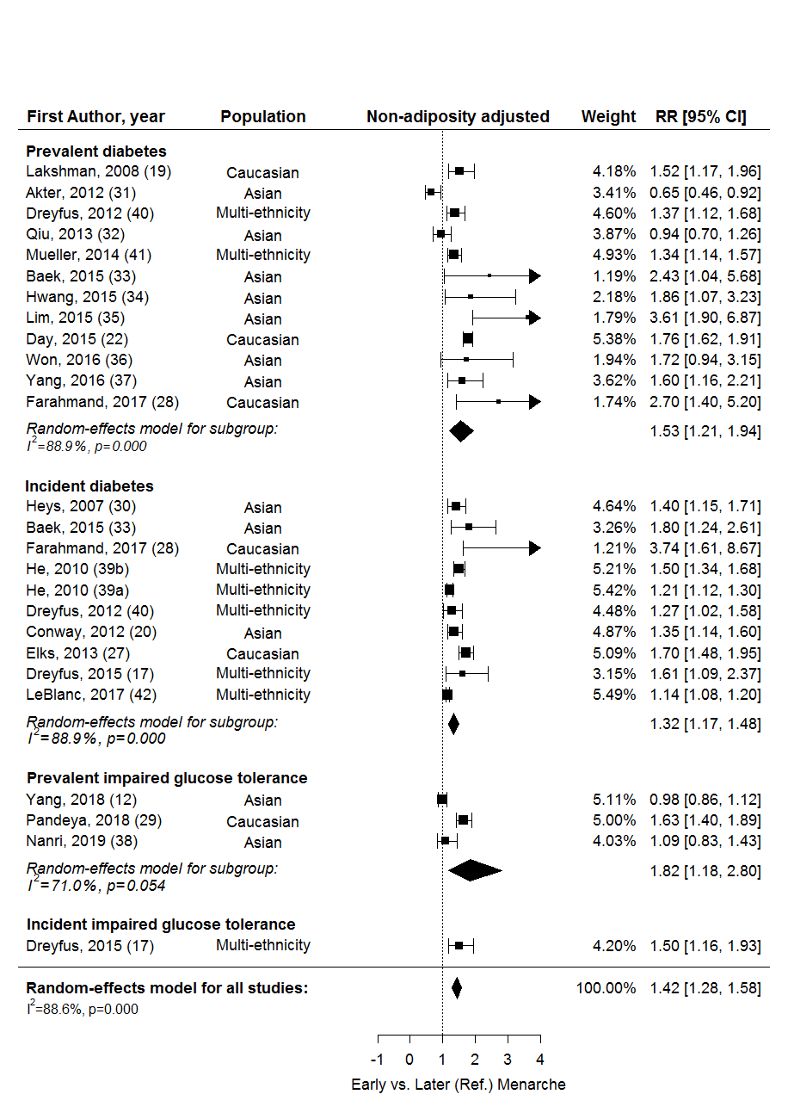

(b)

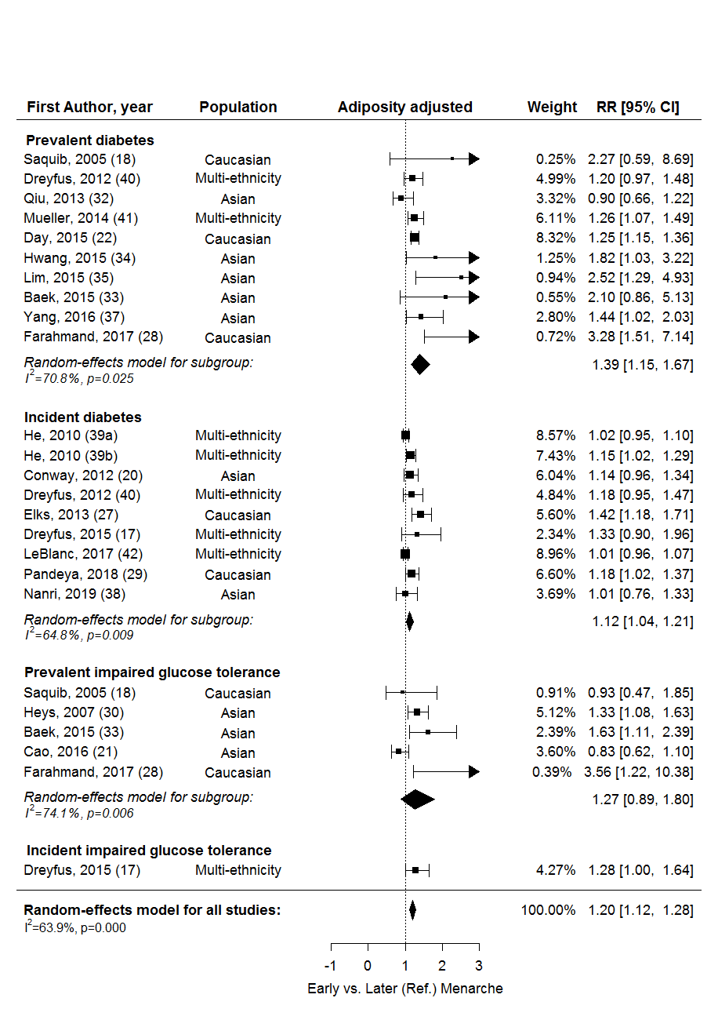

|  |  |  |  |  |  |  |  |  |  |  |  |  |  |  |  |
| --- | --- | --- | --- | --- | --- | --- | --- | --- | --- | --- | --- | --- | --- | --- | --- |
| **Supplemental table 3**- Univariable meta-regression and pooled RR for diabetes and glucose intolerance in subgroups | | | | | | | | | | | | | | | |
| Factors | RR per year later age at menarche | | | | | | |  | Early versus later (Ref.) menarche | | | | | | |
| Non-adiposity adjusted | | |  | Adiposity adjusted | | |  | Non-adiposity adjusted | | |  | Adiposity adjusted | | |
| N | RR (95% CI) | R2 (%) |  | N | RR (95% CI) | R2 (%) |  | N | RR (95% CI) | R2 (%) |  | N | RR (95% CI) | R2 (%) |
| Year of enrolment |  |  | 0 |  |  |  | 1.3 |  |  |  | 0 |  |  |  | 11.8 |
| until 2000 | 7 | 0.91 (0.89, 0.94) |  |  | 9 | 0.98 (0.97, 0.99) |  |  | 12 | 1.39 (1.26, 1.53) |  |  | 12 | 1.14 (1.06, 1.23) |  |
| after 2000 | 4 | 0.91 (0.87, 0.95) |  |  | 3 | 0.94 (0.90, 0.99) |  |  | 11 | 1.45 (1.16, 1.80) |  |  | 9 | 1.28 (1.08, 1.51) |  |
|  |  |  |  |  |  |  |  |  |  |  |  |  |  |  |  |
| Age at outcome assessment, years |  |  |  |  |  |  |  |  |  |  |  |  |  |  |  |
| <50 | 1 | 0.88 (0.86, 0.91) |  |  | 2 | 0.97 (0.94, 1.00) |  |  | 7 | 1.66 (1.13, 2.45) |  |  | 5 | 1.65 (1.18. 2.29) |  |
| ≥50 | 10 | 0.92 (0.89, 0.94) |  |  | 10 | 0.97 (0.95, 0.99) |  |  | 16 | 1.37 (1.26, 1.50) |  |  | 16 | 1.15 (1.07, 1.24) |  |
|  |  |  |  |  |  |  |  |  |  |  |  |  |  |  |  |
| Number of variables adjusted |  |  | 0 |  |  |  | 0 |  |  |  | 0 |  |  |  | 0 |
| <5 | 3 | 0.99 (0.82, 0.98) |  |  | 3 | 0.98 (0.88, 1.08) |  |  | 8 | 1.59 (1.30, 1.95) |  |  | 3 | 1.32 (0.74, 2.35) |  |
| ≥5 | 8 | 0.92 (0.89, 0.94) |  |  | 9 | 0.97 (0.95, 0.98) |  |  | 15 | 1.35 (1.20, 1.51) |  |  | 18 | 1.18 (1.10, 1.27) |  |
|  |  |  |  |  |  |  |  |  |  |  |  |  |  |  |  |
| Early menarche, years |  |  |  |  |  |  |  |  |  |  | 21.99 |  |  |  | 0 |
| <12 |  | - |  |  |  | - |  |  | 12 | 1.50 (1.37, 1.64) |  |  | 10 | 1.20 (1.11, 1.30) |  |
| <14 |  | - |  |  |  | - |  |  | 11 | 1.32 (1.08, 1.62) |  |  | 11 | 1.20 (1.02, 1.41) |  |
|  |  |  |  |  |  |  |  |  |  |  |  |  |  |  |  |
| Reference AAM category, years |  |  |  |  |  |  |  |  |  |  | 0 |  |  |  | 0 |
| ≥12 |  | - |  |  |  | - |  |  | 14 | 1.47 (1.26, 1.72) |  |  | 13 | 1.22 (1.12, 1.34) |  |
| ≥14 |  | - |  |  |  | - |  |  | 9 | 1.34 (1.26, 1.41) |  |  | 8 | 1.12 (0.97, 1.30) |  |
| N, number of estimates, R2 (%), % heterogeneity explained | | | | | | | | | | | | | | | |

**Supplemental figure 3**- Funnel plots and Egger’s tests for studies using (a) AAM (continuous variable) and (b) early menarche, with and without adjustment for adiposity

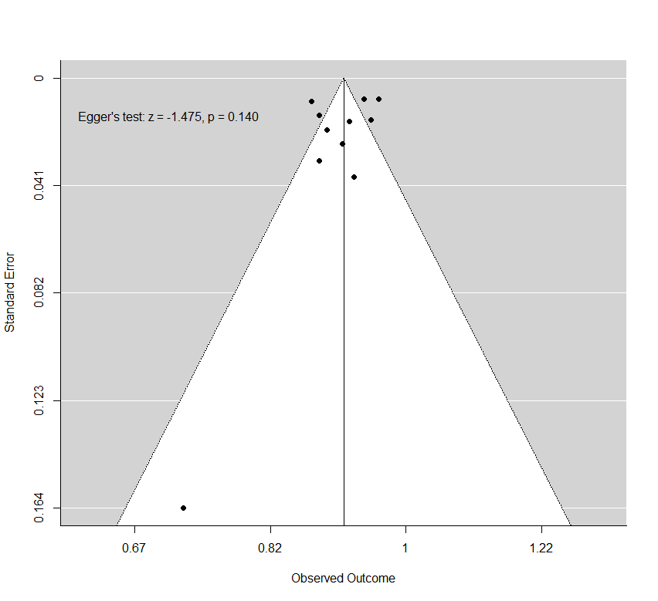Non-adiposity adjusted

(a)

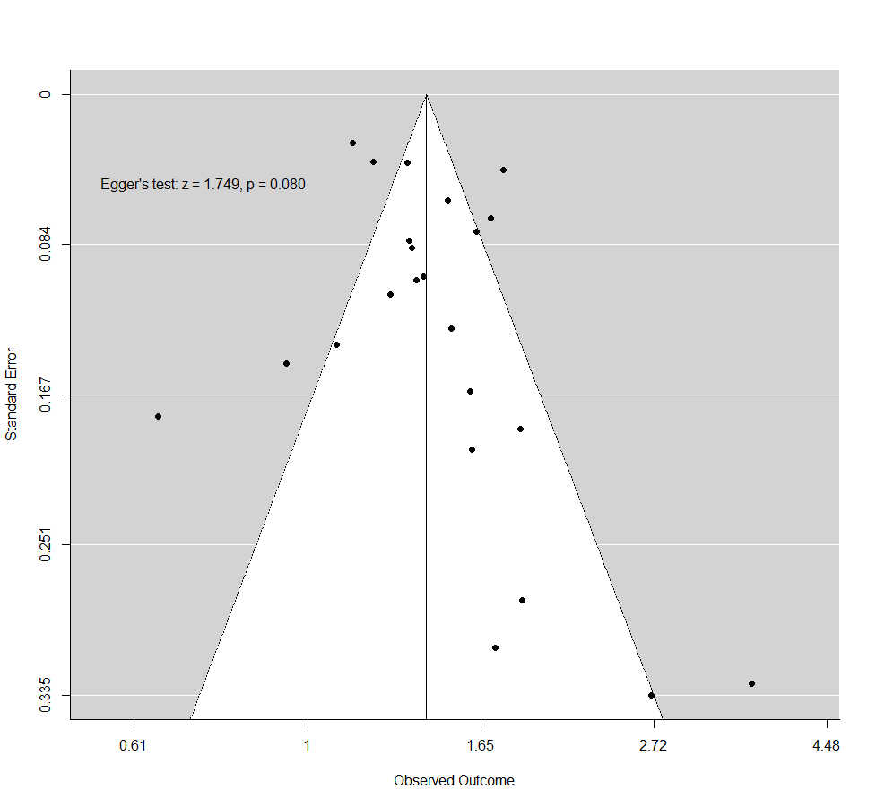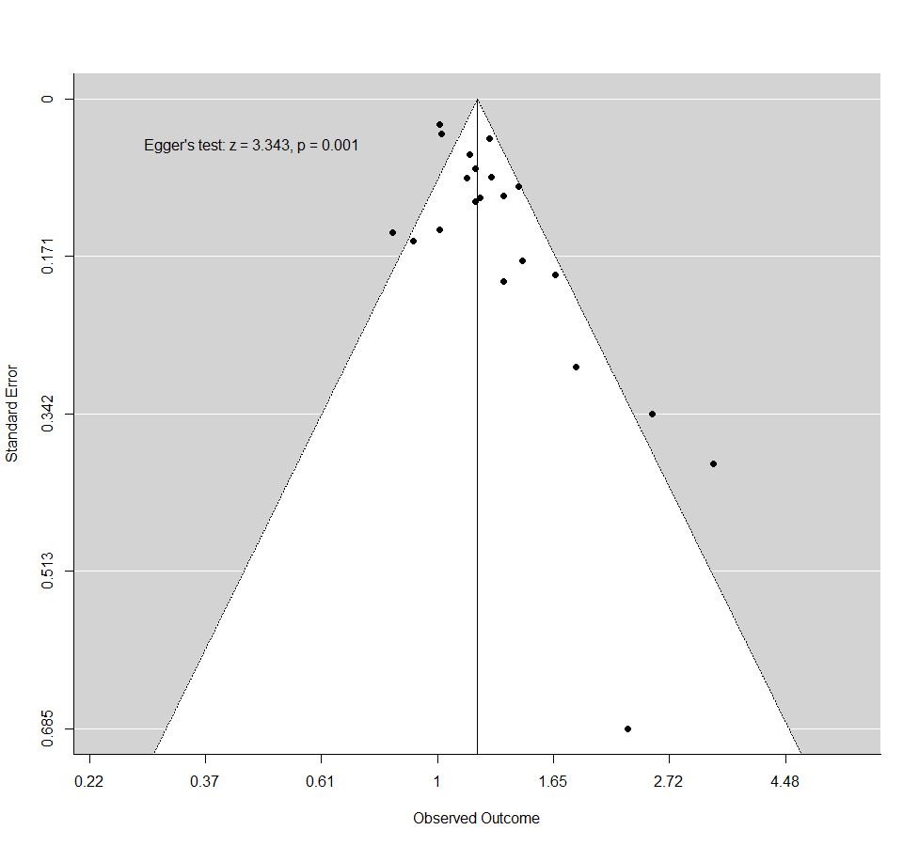

(b)

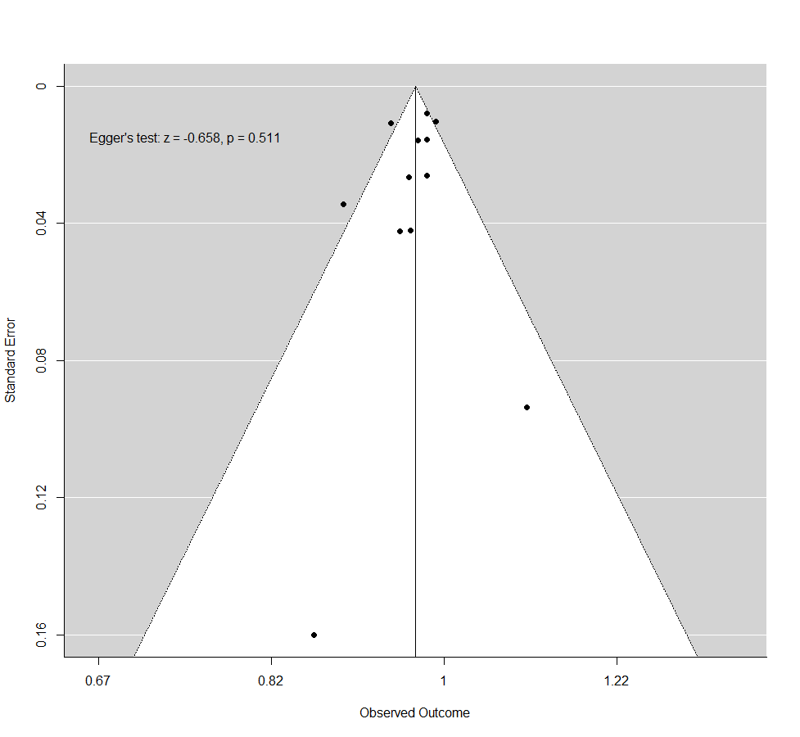Adiposity adjusted

**Supplemental figure 4**- Funnel plots with missing studies using (a) AAM (continuous variable) and (b) early menarche, with and without adjustment for adiposity, identified by the trim-and-fill method. Open circles indicate filled missing studies.

Non-adiposity adjusted

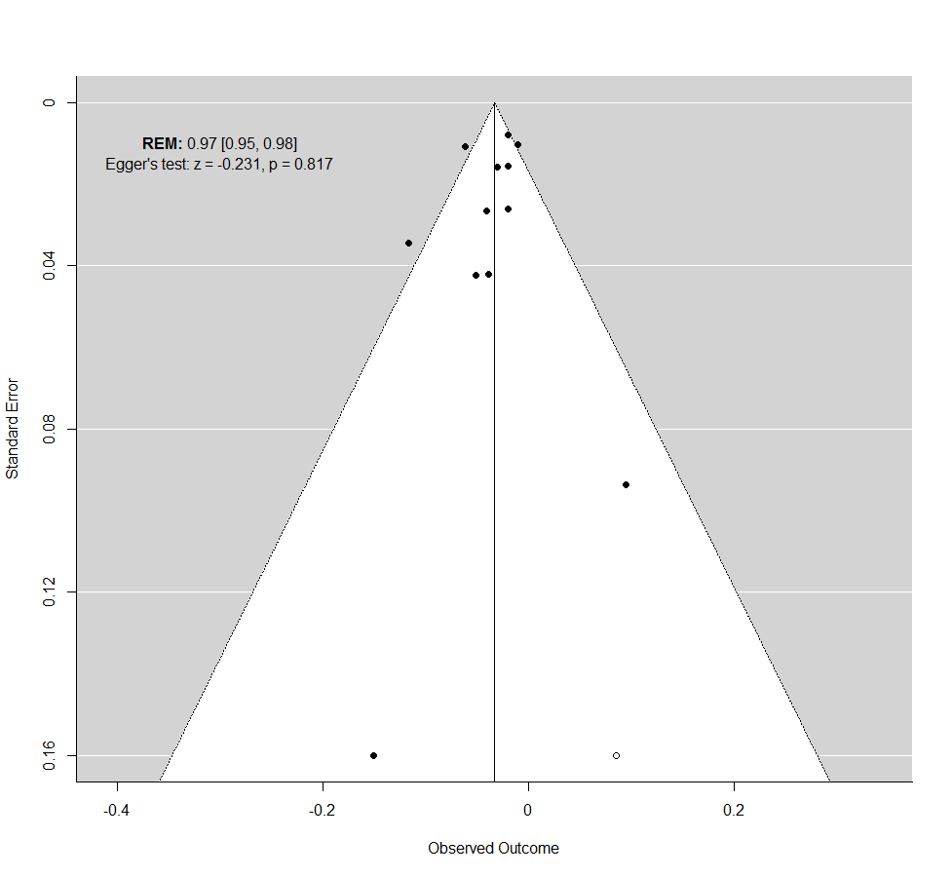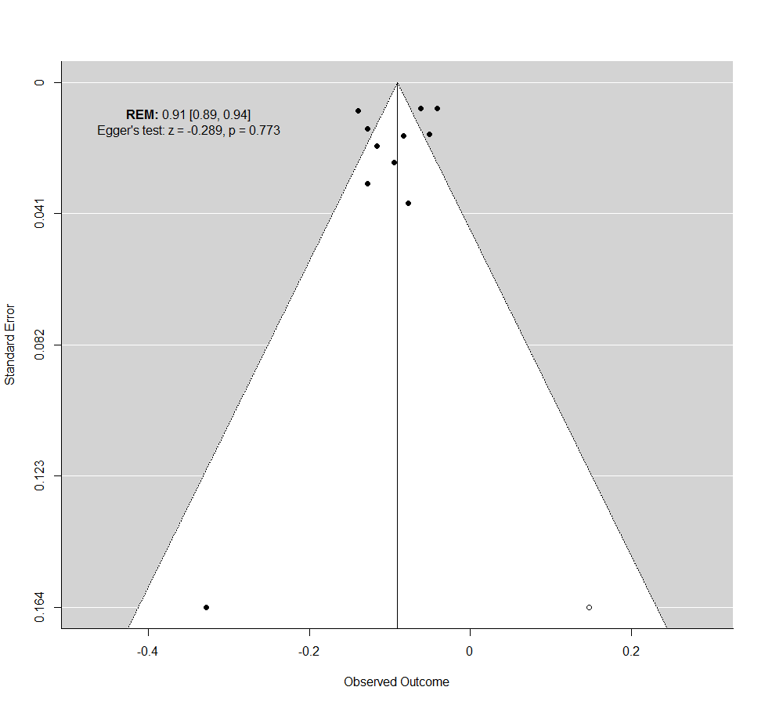 (a)

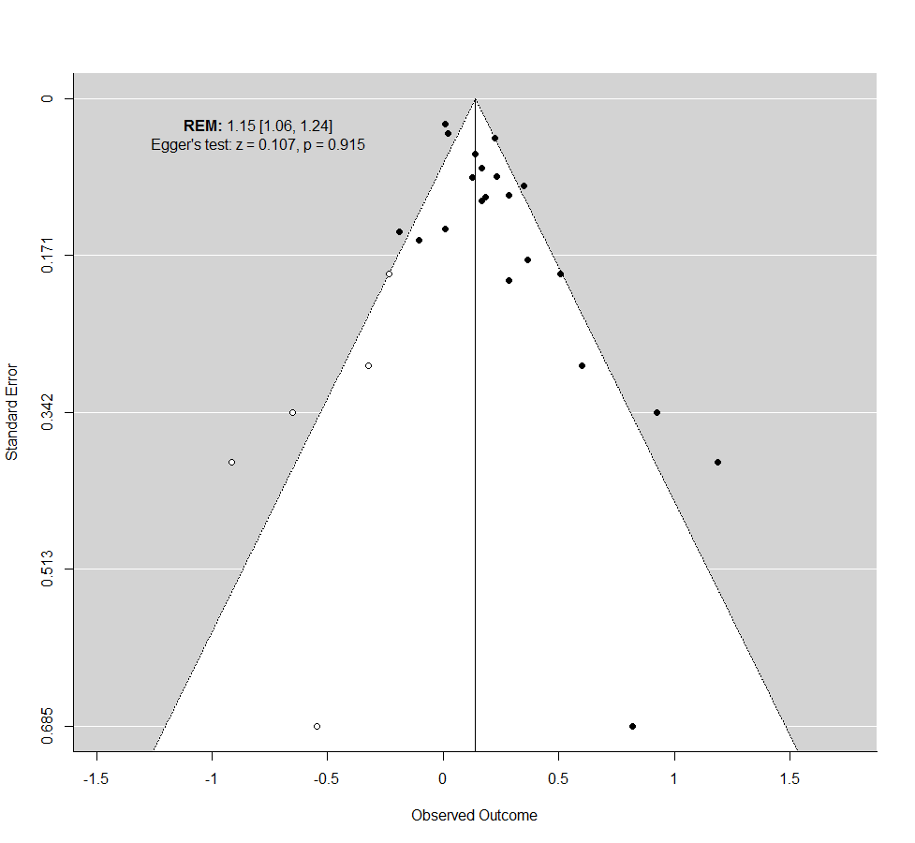

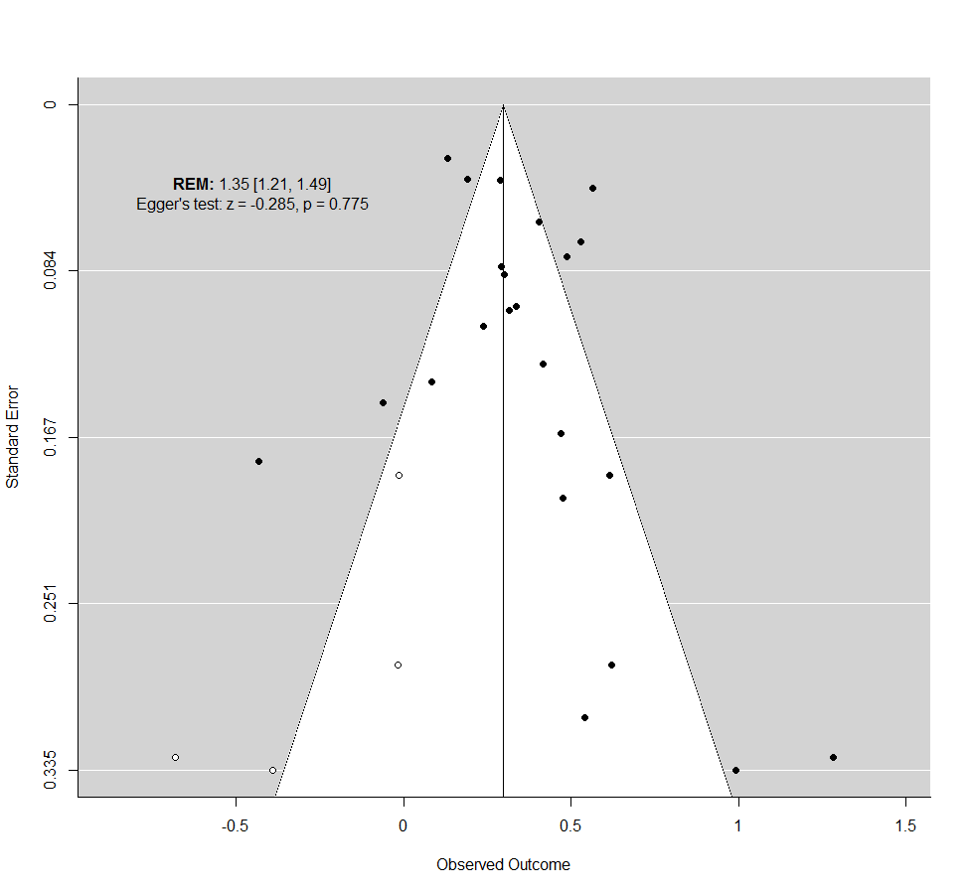(b)

Adiposity adjusted

**Supplemental figure 5**- Forest plots of leave-one-out analysis, where each estimate in studies using (a) AAM (continuous variable) and (b) early menarche, with and without adjustment for adiposity, was iteratively removed.

Non- adiposity adjusted

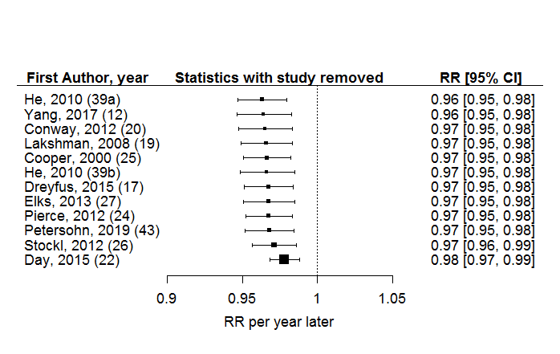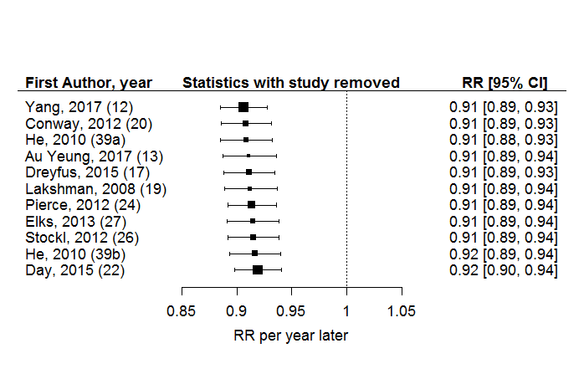(a)

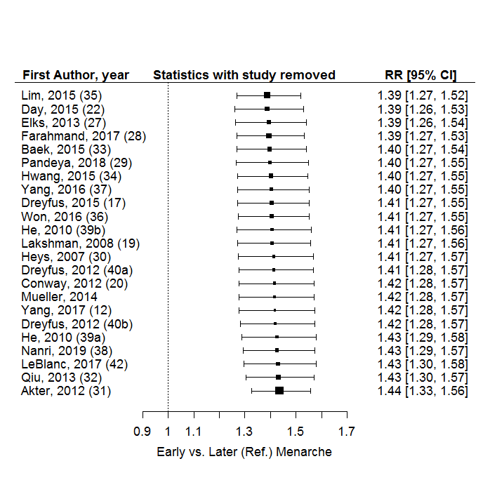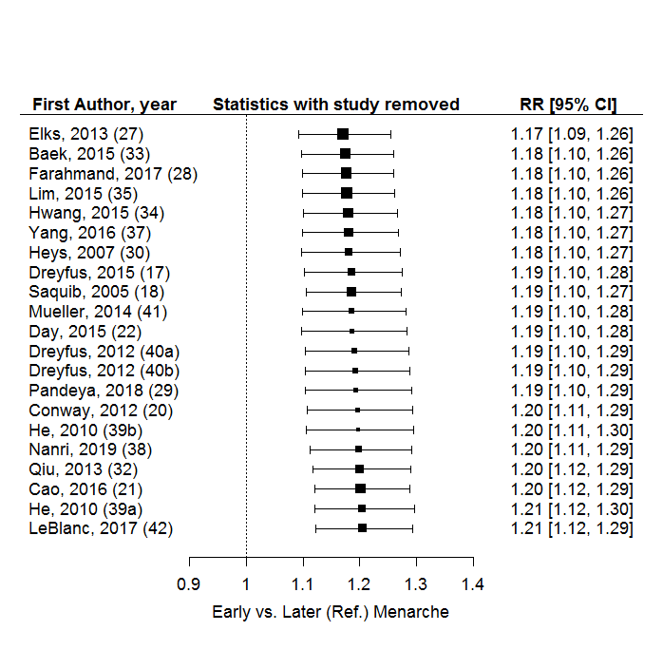

(b)

Adiposity adjusted