**Table S1: Summary statistics for the probability of H5N1 infection per pasteurized or raw milk serving**. Two purchasing pathways (via farmstore and via retail) for raw milk are differentiated. *Note: 0 logTCID50 = 1 TCID50 (“log” indicates log10 transformation)

|  |  |  |  |  |  |  |  |  |  |  |  |  |
| --- | --- | --- | --- | --- | --- | --- | --- | --- | --- | --- | --- | --- |
|  | Pasteurized Milk Model | | | | Raw Milk Model | | | | | | | |
|  |  | | | | Farmstore Purchasing Pathway | | | | Retail Purchasing Pathway | | | |
|  | Probability of Infection per Serving (unitless) | Quantity of Virus per Contaminated Serving (logTCID50) | Prevalence of Contaminated Servings (unitless) | Probability of Infection per Serving (unitless) | | Quantity of Virus per Contaminated Serving (logTCID50) | Prevalence of Contaminated Servings (unitless) | Probability of Infection per Serving (unitless) | | Quantity of Virus per Contaminated Serving (logTCID50) | Prevalence of Contaminated Servings (unitless) |
| Minimum | 1.12E-17 | 0* | 1.58E-09 | 7.03E-12 | | 2.98 | 8.03E-04 | 1.44E-11 | | 3.04 | 8.03E-04 |
| 5 %ile | 1.77E-16 | 0 | 2.43E-08 | 5.16E-06 | | 5.22 | 3.21E-03 | 5.20E-06 | | 5.18 | 3.21E-03 |
| Median | 5.68E-15 | 0 | 7.67E-07 | 1.13E-03 | | 6.88 | 3.13E-02 | 1.02E-03 | | 6.84 | 3.13E-02 |
| Mean | 6.45E-14 | 0.019 | 8.66E-06 | 7.36E-03 | | 6.87 | 4.00E-02 | 6.90E-03 | | 6.83 | 4.00E-02 |
| Interquartile Range | 1.04E-15 - 3.25E-14 | 0 -  0 | 1.41E-07 - 4.41E-06 | 1.53E-04 - 6.52E-03 | | 6.15 - 7.60 | 1.40E-02 - 5.78E-02 | 1.39E-04 - 5.81E-03 | | 6.12 - 7.55 | 1.40E-02 - 5.78E-02 |
| 95 %ile | 2.98E-13 | 0.30 | 4.03E-05 | 3.82E-02 | | 8.49 | 1.07E-01 | 3.64E-02 | | 8.44 | 1.07E-01 |
| Maximum | 9.27E-12 | 0.30 | 1.32E-03 | 1.85E-01 | | 9.77 | 2.14E-01 | 1.84E-01 | | 9.89 | 2.14E-01 |

**Table S2: Summary statistics for the scenario analysis of varying pasteurization log (base-10) reductions on the probability of H5N1 infection per pasteurized milk serving.**

|  |  |  |  |  |  |
| --- | --- | --- | --- | --- | --- |
|  | 6-log | 8-log | 10-log | 12-log (Baseline) | 14-log |
| Minimum | 1.14E-12 | 1.16E-14 | 1.05E-16 | 1.12E-17 | 8.85E-18 |
| 5 %ile | 5.61E-11 | 9.62E-13 | 9.50E-15 | 1.77E-16 | 7.68E-17 |
| Median | 3.71E-10 | 4.95E-11 | 5.84E-13 | 5.68E-15 | 3.49E-16 |
| Mean | 1.22E-09 | 1.13E-10 | 5.58E-12 | 6.45E-14 | 9.30E-16 |
| Interquartile Range | 2.25E-10 - 4.32E-10 | 9.82E-12 - 1.78E-10 | 1.02E-13 - 3.26E-12 | 1.04E-15 - 3.25E-14 | 1.78E-16 - 7.98E-16 |
| 95 %ile | 2.63E-09 | 3.86E-10 | 2.80E-11 | 2.98E-13 | 3.31E-15 |
| Maximum | 1.53E-06 | 1.90E-08 | 3.05E-10 | 9.27E-12 | 9.45E-14 |

**Table S3: Summary statistics for the scenario analysis of varying dose-response parameter *r* on the probability of H5N1 infection per pasteurized or raw milk serving**. Two purchasing pathways (via farmstore and via retail) for raw milk are differentiated.

|  |  |  |  |  |  |  |  |  |  |
| --- | --- | --- | --- | --- | --- | --- | --- | --- | --- |
|  | Pasteurized Milk Model | | | Raw Milk Model | | | | | |
|  |  |  |  | Farmstore Purchasing Pathway | | | Retail Purchasing Pathway | | |
|  | *r*=*1E*-6 | *r*=1E-8 (Baseline) | *r*=1E-10 | *r*=1E-6 | *r*=1E-8 (Baseline) | *r*=1E-10 | *r*=1E-6 | *r*=1E-8 (Baseline) | *r*=1E-10 |
| Minimum | 1.12E-15 | 1.12E-17 | 1.12E-19 | 7.03E-10 | 7.03E-12 | 7.03E-14 | 1.43E-09 | 1.44E-11 | 1.44E-13 |
| 5 %ile | 1.77E-14 | 1.77E-16 | 1.77E-18 | 3.28E-04 | 5.16E-06 | 5.17E-08 | 3.29E-04 | 5.20E-06 | 5.22E-08 |
| Median | 5.68E-13 | 5.68E-15 | 5.68E-17 | 1.42E-02 | 1.13E-03 | 1.21E-05 | 1.39E-02 | 1.02E-03 | 1.09E-05 |
| Mean | 6.45E-12 | 6.45E-14 | 6.45E-16 | 2.42E-02 | 7.36E-03 | 2.24E-04 | 2.39E-02 | 6.90E-03 | 1.99E-04 |
| Interquartile Range | 1.04E-13 - 3.25E-12 | 1.04E-15 - 3.25E-14 | 1.04E-17 - 3.25E-16 | 4.14E-03 - 3.52E-02 | 1.53E-04 - 6.52E-03 | 1.56E-06 - 8.49E-05 | 4.06E-03 - 3.46E-02 | 1.39E-04 - 5.81E-03 | 1.42E-06 - 7.34E-05 |
| 95 %ile | 2.98E-11 | 2.98E-13 | 2.98E-15 | 8.22E-02 | 3.82E-02 | 9.73E-04 | 8.09E-02 | 3.64E-02 | 8.68E-04 |
| Maximum | 9.27E-10 | 9.27E-12 | 9.27E-14 | 1.89E-01 | 1.85E-01 | 4.26E-02 | 2.01E-01 | 1.84E-01 | 2.95E-02 |

**Table S4: Summary statistics for the probability of H5N1 infection per raw milk serving obtained through farmstore purchase in the scenario analysis of bulk tank PCR testing and improved infected cow diversion.**

|  |  |  |  |  |  |  |
| --- | --- | --- | --- | --- | --- | --- |
|  | No PCR Testing | | | PCR Testing | | |
|  | 25% Diversion (Baseline) | 50% Diversion | 75% Diversion | 25% Diversion | 50% Diversion | 75% Diversion |
| Minimum | 7.03E-12 | 3.55E-12 | 3.55E-12 | 1.13E-13 | 5.69E-14 | 5.69E-14 |
| 5 %ile | 5.16E-06 | 3.54E-06 | 2.41E-06 | 8.25E-08 | 5.67E-08 | 3.88E-08 |
| Median | 1.13E-03 | 7.90E-04 | 5.51E-04 | 1.81E-05 | 1.26E-05 | 8.82E-06 |
| Mean | 7.36E-03 | 6.09E-03 | 4.95E-03 | 1.18E-04 | 9.74E-05 | 7.93E-05 |
| Interquartile Range | 1.53E-04 - 6.52E-03 | 1.04E-04 - 4.79E-03 | 7.22E-05 - 3.50E-03 | 2.45E-06 - 1.04E-04 | 1.66E-06 - 7.66E-05 | 1.16E-06 - 5.60E-05 |
| 95 %ile | 3.82E-02 | 3.24E-02 | 2.67E-02 | 6.12E-04 | 5.18E-04 | 4.27E-04 |
| Maximum | 1.85E-01 | 1.84E-01 | 1.82E-01 | 2.95E-03 | 2.95E-03 | 2.91E-03 |

**Table S5: Summary statistics for the probability of H5N1 infection per raw milk serving obtained through retail purchase in the scenario analysis of bulk tank PCR testing and improved infected cow diversion.**

|  |  |  |  |  |  |  |
| --- | --- | --- | --- | --- | --- | --- |
|  | No PCR Testing | | | PCR Testing | | |
|  | 25% Diversion (Baseline) | 50% Diversion | 75% Diversion | 25% Diversion | 50% Diversion | 75% Diversion |
| Minimum | 1.44E-11 | 7.47E-12 | 7.47E-12 | 2.30E-13 | 1.20E-13 | 1.20E-13 |
| 5 %ile | 5.20E-06 | 3.48E-06 | 2.41E-06 | 8.33E-08 | 5.57E-08 | 3.86E-08 |
| Median | 1.02E-03 | 7.10E-04 | 4.93E-04 | 1.64E-05 | 1.14E-05 | 7.89E-06 |
| Mean | 6.90E-03 | 5.68E-03 | 4.60E-03 | 1.10E-04 | 9.09E-05 | 7.35E-05 |
| Interquartile Range | 1.39E-04 - 5.81E-03 | 9.50E-05 - 4.26E-03 | 6.49E-05 - 3.11E-03 | 2.23E-06 - 9.30E-05 | 1.52E-06 - 6.82E-05 | 1.04E-06 - 4.97E-05 |
| 95 %ile | 3.64E-02 | 3.07E-02 | 2.49E-02 | 5.83E-04 | 4.91E-04 | 3.98E-04 |
| Maximum | 1.84E-01 | 1.84E-01 | 1.81E-01 | 2.95E-03 | 2.94E-03 | 2.90E-03 |

**Figure S1: Violin plots for the scenario analysis of varying dose-response parameter *r* on the probability of H5N1 infection per raw milk serving obtained via farmstore or retail pathway.** For the purposes of visualization, a logarithmic (base-10) Y-axis is employed.

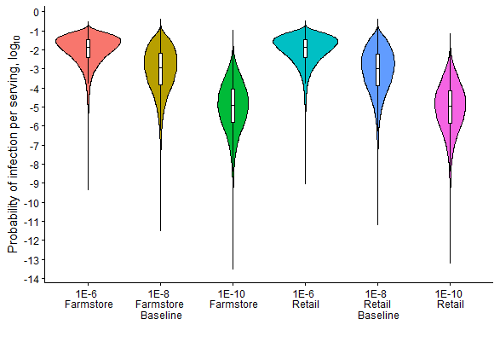

**Figure S2**: **Violin plots for the scenario analysis of bulk tank PCR testing and improved infected cow diversion on probability of infection per raw milk serving.** For the purposes of visualization, a logarithmic (base-10) Y-axis is employed. The retail purchase pathway is represented here.

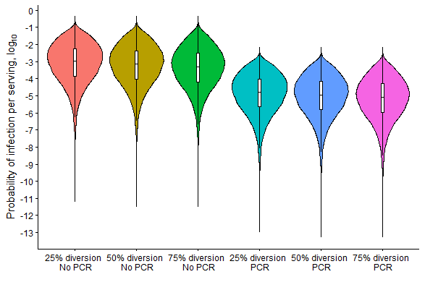

**Calculation of herd-level prevalence and the number of H5N1-affected herds shipping milk to a processing plant (Eqs. S1-3)**

**Eq. S1**:

Where *N* is the number of dairy herds in the United States (23,153)(*21*), *n*=100, and *K*, the hypergeometric distribution parameter for the success (i.e. affected herds) in the population, is represented by:

**Eq. S2**:

Using APHIS detection data obtained 2025 Nov 5 and the USDA 2022 Ag Census.(*21*) *pnat’l* is a PERT distribution to represent the following calculation:

**Eq. S3**:

For example, K=26 was used in validation to replicate infection prevalence in April 2024, the number of detected infected farms in the month during which the dairy food surveillance of Spackman *et al* was performed.(*29*)

**Time- and temperature-dependent logarithmic decay (logTCID50/d) of H5N1 in fluid milk:**

**Eq. S4**:

Where *T* is the temperature parameter and *VD* is the log (base-10) decay rate during the cold chain step. This regression model was fit using empirical data from Nooruzzaman *et al*.(*16*)

**Exponential dose-response curve for infection risk per contaminated serving:**

**Eq. S5**:

Where *x* is the count of TCID50 present in a contaminated serving, *r* is the dose-response parameter, and *pinf* is the resultant probability of infection from the contaminated serving. Parameter *r* was determined using dose-response data from a ferret H5N1 ingestion model by determining the median infectious dose (ID50) and calibrating the curve to this value.(*27*) Parameter *r* was further evaluated in scenario analysis.

**Temperature of raw milk during transport from farmstore or retail to consumer residence:**

**Eq. S6**:

Where *TF* and *TSR-W* are the temperatures of storage at the farmstore or retail, respectively, *TH* is the temperature of home arrival, and *TTC-W* is the temperature during transport to the consumer residence.(*30*)

**Time- and temperature-dependent probability of spoilage for raw milk:**

**Eq. S7**:

Where *T* is the temperature parameter, *h* is the duration parameter, and *pi* is the probability of spoilage and subsequent discard of a gallon (*PDisc-Gal-W*) or serving (*PDisc-Serv-W*). Adapted from Crotta *et al*.(*31*)