**Supplemental data for**

**Tracking Immunity: A University Serosurvey Reveals Antibody Prevalence After Multiple Waves of COVID-19**

Ching-Wen Hou 1, Stacy Williams 1, Veronica Boyle 1, Alexa Roeder 2, Bradley Bobbett 1, Izamar Garcia1, Giavanna Caruth1, Mitch Magee 1, Yunro Chung 1,3, Douglas Lake 2, Joshua LaBaer 1,4, and Vel Murugan 1*

1 Virginia G. Piper Center for Personalized Diagnostics, Biodesign Institute, Arizona State University, Tempe, AZ, USA.

2 School of Life Sciences, Arizona State University, Phoenix, AZ, USA.

3 College of Health Solutions, Arizona State University, Phoenix, AZ, USA.

4 School of Molecular Sciences, Arizona State University, Phoenix, AZ, USA.

* Correspondence: vel.murugan@asu.edu; Tel.: +1(480)727-0402

**Table S1:** Seroconversion by race, age, gender, employment status, and the types of vaccines

|  |  |  |  |  |  |  |  |  |  |
| --- | --- | --- | --- | --- | --- | --- | --- | --- | --- |
| **Variable** | **Comparison** | **Anti-RBD Antibody**  **(Access SARS-CoV-2 IgG II)** | | | | **Anti-NC antibody**  **(Platelia NC total Ab)** | | | |
| **n** | **PR** | **95% CI** | **P-value** | **n** | **PR** | **95% CI** | **P-value** |
| Race | White vs Other | 368 vs 172 | 1.00 | (0.93, 1.08) | 0.93 | 229 vs 114 | 0.95 | (0.83, 1.09) | 0.50 |
| Asian vs Other | 268 vs 172 | 0.96 | (0.84, 1.09) | 0.53 | 134 vs 114 | 0.94 | (0.81, 1.08) | 0.35 |
| White vs Asian | 368 vs 268 | 1.05 | (0.92, 1.19) | 0.50 | 229 vs 134 | 1.02 | (0.90, 1.15) | 0.74 |
| Age | 26-40 vs 18-25 | 224 vs 373 | 1.02 | (0.91, 1.14) | 0.72 | 130 vs 191 | 0.91 | (0.79, 1.04) | 0.16 |
| 41+ vs 18-25 | 161 vs 373 | 1.00 | (0.85, 1.18) | 0.99 | 84 vs 191 | 1.07 | (0.89, 1.29) | 0.47 |
| 41+ vs 26-40 | 161 vs 224 | 0.98 | (0.86, 1.12) | 0.75 | 84 vs 130 | 1.18 | (0.99, 1.41) | 0.06 |
| Gender | Male vs Female | 366 vs 442 | 0.99 | (0.94, 1.05) | 0.84 | 211 vs 266 | 0.97 | (0.87, 1.07) | 0.52 |
| Employment Status | Student vs Employee | 487 vs 321 | 0.99 | (0.85, 1.14) | 0.85 | 278 vs 199 | 1.12 | (0.95, 1.31) | 0.17 |
| Vaccine Group# | mRNA vaccine vs Other vaccine | 482 vs 326 | 0.99 | (0.88, 1.12) | 0.92 | 270 vs 157 | 0.91 | (0.82, 1.01) | 0.07 |
| Unvaccinated vs Other vaccine | N/A | N/A | N/A | N/A | 50 vs 157 | 1.06 | (0.72, 1.55) | 0.78 |
| mRNA vaccine vs Unvaccinated | N/A | N/A | N/A | N/A | 270 vs 50 | 0.86 | (0.58, 1.26) | 0.44 |

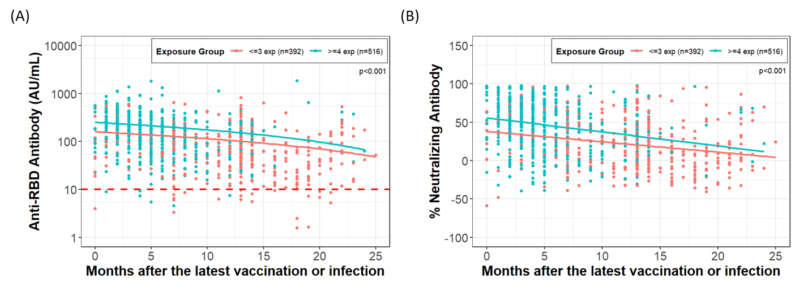

**Figure S1.** Anti-RBD antibody levels and neutralizing antibody percentages in participants exposed to SARS-CoV-2 antigens through infection or vaccination. (A) Anti-RBD antibody decay (B) Neutralizing antibody decay.