Supplemental Material: Windows of Susceptibility to Air Pollution During and Surrounding Pregnancy in Relation to Longitudinal Maternal Measures of Adiposity and Lipid Profiles

Supplemental Methods 1.
Our model was evaluated with leave-one-station-out cross-validation (CV), and exhibited good performance, with an overall cross-validated mean absolute error of 3.68 μg/m³ and an annual R² ranging from 0.64 to 0.86. We estimated residential exposure to PM_{2.5} at each participant's address, accounting for any moves, as follows. Participants’ addresses were collected at recruitment and updated at each follow-up if they had moved, as well as through an address history questionnaire administered between 2018-2020. Residential addresses were geocoded and crosschecked against actual geographic coordinates collected by our fieldwork team at each study visit. PM_{2.5} exposure estimates were assigned to study participants based on the geographic coordinates of their homes, using the corresponding 1 × 1 km PM_{2.5} grid cells from our satellite-based models.¹

Supplemental Methods 2.
We flagged self-reported medications to treat cardiometabolic disease² at baseline and at each follow-up visit. These included self-report of a drug treatment for abnormal levels of either glucose, triglycerides, high-density lipoprotein (HDL), or blood pressure. Given that participants self-reported their specific medications at the visit by filling out a questionnaire with blank spaces with the name of the medication, only a list of self-reported names of medications are provided by the participants and limited information exists on whether healthy individuals without reported medications are non-respondents. The list of medications self-reported by participants across all visits were the following (in alphabetical order):
- Acarbose
- Alpha-methyldopa
- Amlodipine
- Atorvastatin
- Bezafibrate
- Captopril
- Chlortalidone
- Enalapril
- Farxiga
- Glibenclamide
- Hydrochlorothiazide
- Insulin
- Januvia
- Kombiglyze
- Losartan
- Pravastatin
- Propranolol
- Methyldopa
- Metformin
- Metoprolol
- Norvasc
- Telmisartan
- Verapamil

Supplemental Methods 3.
The distributed lag interaction model (DLIM) estimates a linear exposure-time-response function that varies continuously by time after delivery and by outcome assessment time. The DLIM is
$$y_{ij}=\sum_{t=-2}^{22}{x_{it}β_{t}(m_{ij})}+z_{ij}^{'}γ+b_{i}+ε_{ij},$$
where $y_{ij}$is the $j$th outcome for individual $i$, $x_{it}$ is the exposure level for individual $i$ in month $t$, $β_{t}(m_{i})$ is the coefficient for the linear effect of exposure at time $t$ for an individual with outcome assessed at time $m_{ij}$. The outcome time $m_{ij}$ is in months since delivery rounded to the first decimal place of the $j$th post-delivery visit and, therefore, accounts for deviations in visit time from the 4, 6, and 8-year targets and allow for estimation of the lagged effects at any time during the observed outcome time span. In addition, the term $z_{ij}^{'}γ$ controls for covariates, $b_{i}$ is an individual random intercept to account for correlation between repeated measures for an individual, and $ε_{ij}$ is a residual error term. To construct the cross-basis for the DLIM, we used penalized B-splines³ with 20 basis functions to smooth in both the exposure-time and post-delivery-time dimensions. We estimated the model parameters with restricted maximum likelihood as previously described.⁴ We performed bootstrap likelihood ratio tests to choose the basis construction, linear modification, non-linear modification, or no modification.⁴

Supplemental Figure 1. Study Participation Flowchart.

Supplemental Figure 2. Directed Acyclic Graph (DAG) between PM_{2.5} and Cardiometabolic Health. ª
Age
Pre-pregnancy BMI
Socio-economic Status (SES)
Marital Status
Parity at Enrollment

(-)
ª Includes potential confounders (seasonality, SES) and additional clinically relevant predictors (alcohol, smoking, cardiometabolic medications, parity, age, pre-pregnancy BMI, marital status, additional pregnancies during follow-up, and stage).
(-)
(-)
(+)
(+)
(-)
(+)
(-)
Season (Dry/Warm)
Cardiometabolic Medications
Alcohol Intake
Smoking during Pregnancy
Multiple Pregnancies
Follow-Up Visit (Stage)

(+)
(-)
(-)
(+)
(+)
PM_{2.5}

Cardiometabolic Health

Supplemental Figure 3. PM_{2.5} Exposure Levels during and around Pregnancy from 2 Months Prior to Last Menstrual Period (LMP) to 22 Months after LMP.
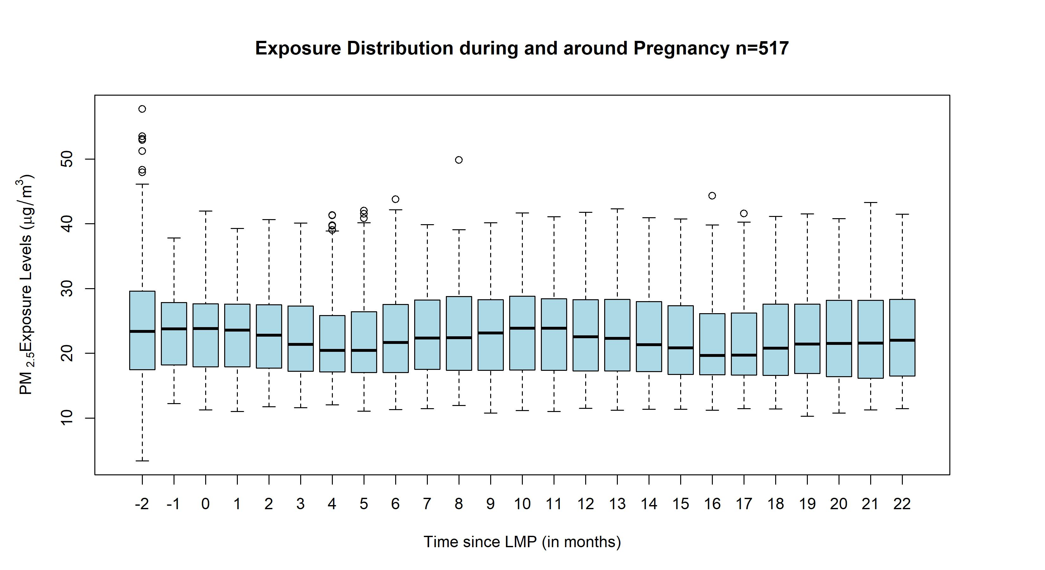

Supplemental Figure 4. Sensitivity analyses for anthropometric measures showing overlaying plots with original distributed lag interaction models (DLIMs) controlling for pre-pregnancy body mass index (BMI) in gray color and DLIMs not controlling for BMI as a covariate in blue color. All models were additionally adjusted for age, socio-economic status, smoking during pregnancy, marital status, parity at enrollment, meteorological season, cardiometabolic medications, alcohol intake, multiple pregnancies throughout follow-up, stage, and follow-up time in months squared to allow for a nonlinear effect. Estimates of the association and 95% confidence interval (95% CI) between monthly PM_{2.5} exposure and anthropometric measures Body Mass Index (BMI), Waist Circumference (WC), body fat percentage at 48, 72, and 96 months after parturition using DLIMs with penalization and non-linear modification. Negative and positive values on the x-axis indicate months before and after last menstrual period (LMP), respectively. Month 0 indicates the LMP month (month 0). Sample sizes for analyses with BMI were n=516 and sample sizes for analyses with WC and body fat were n=515.
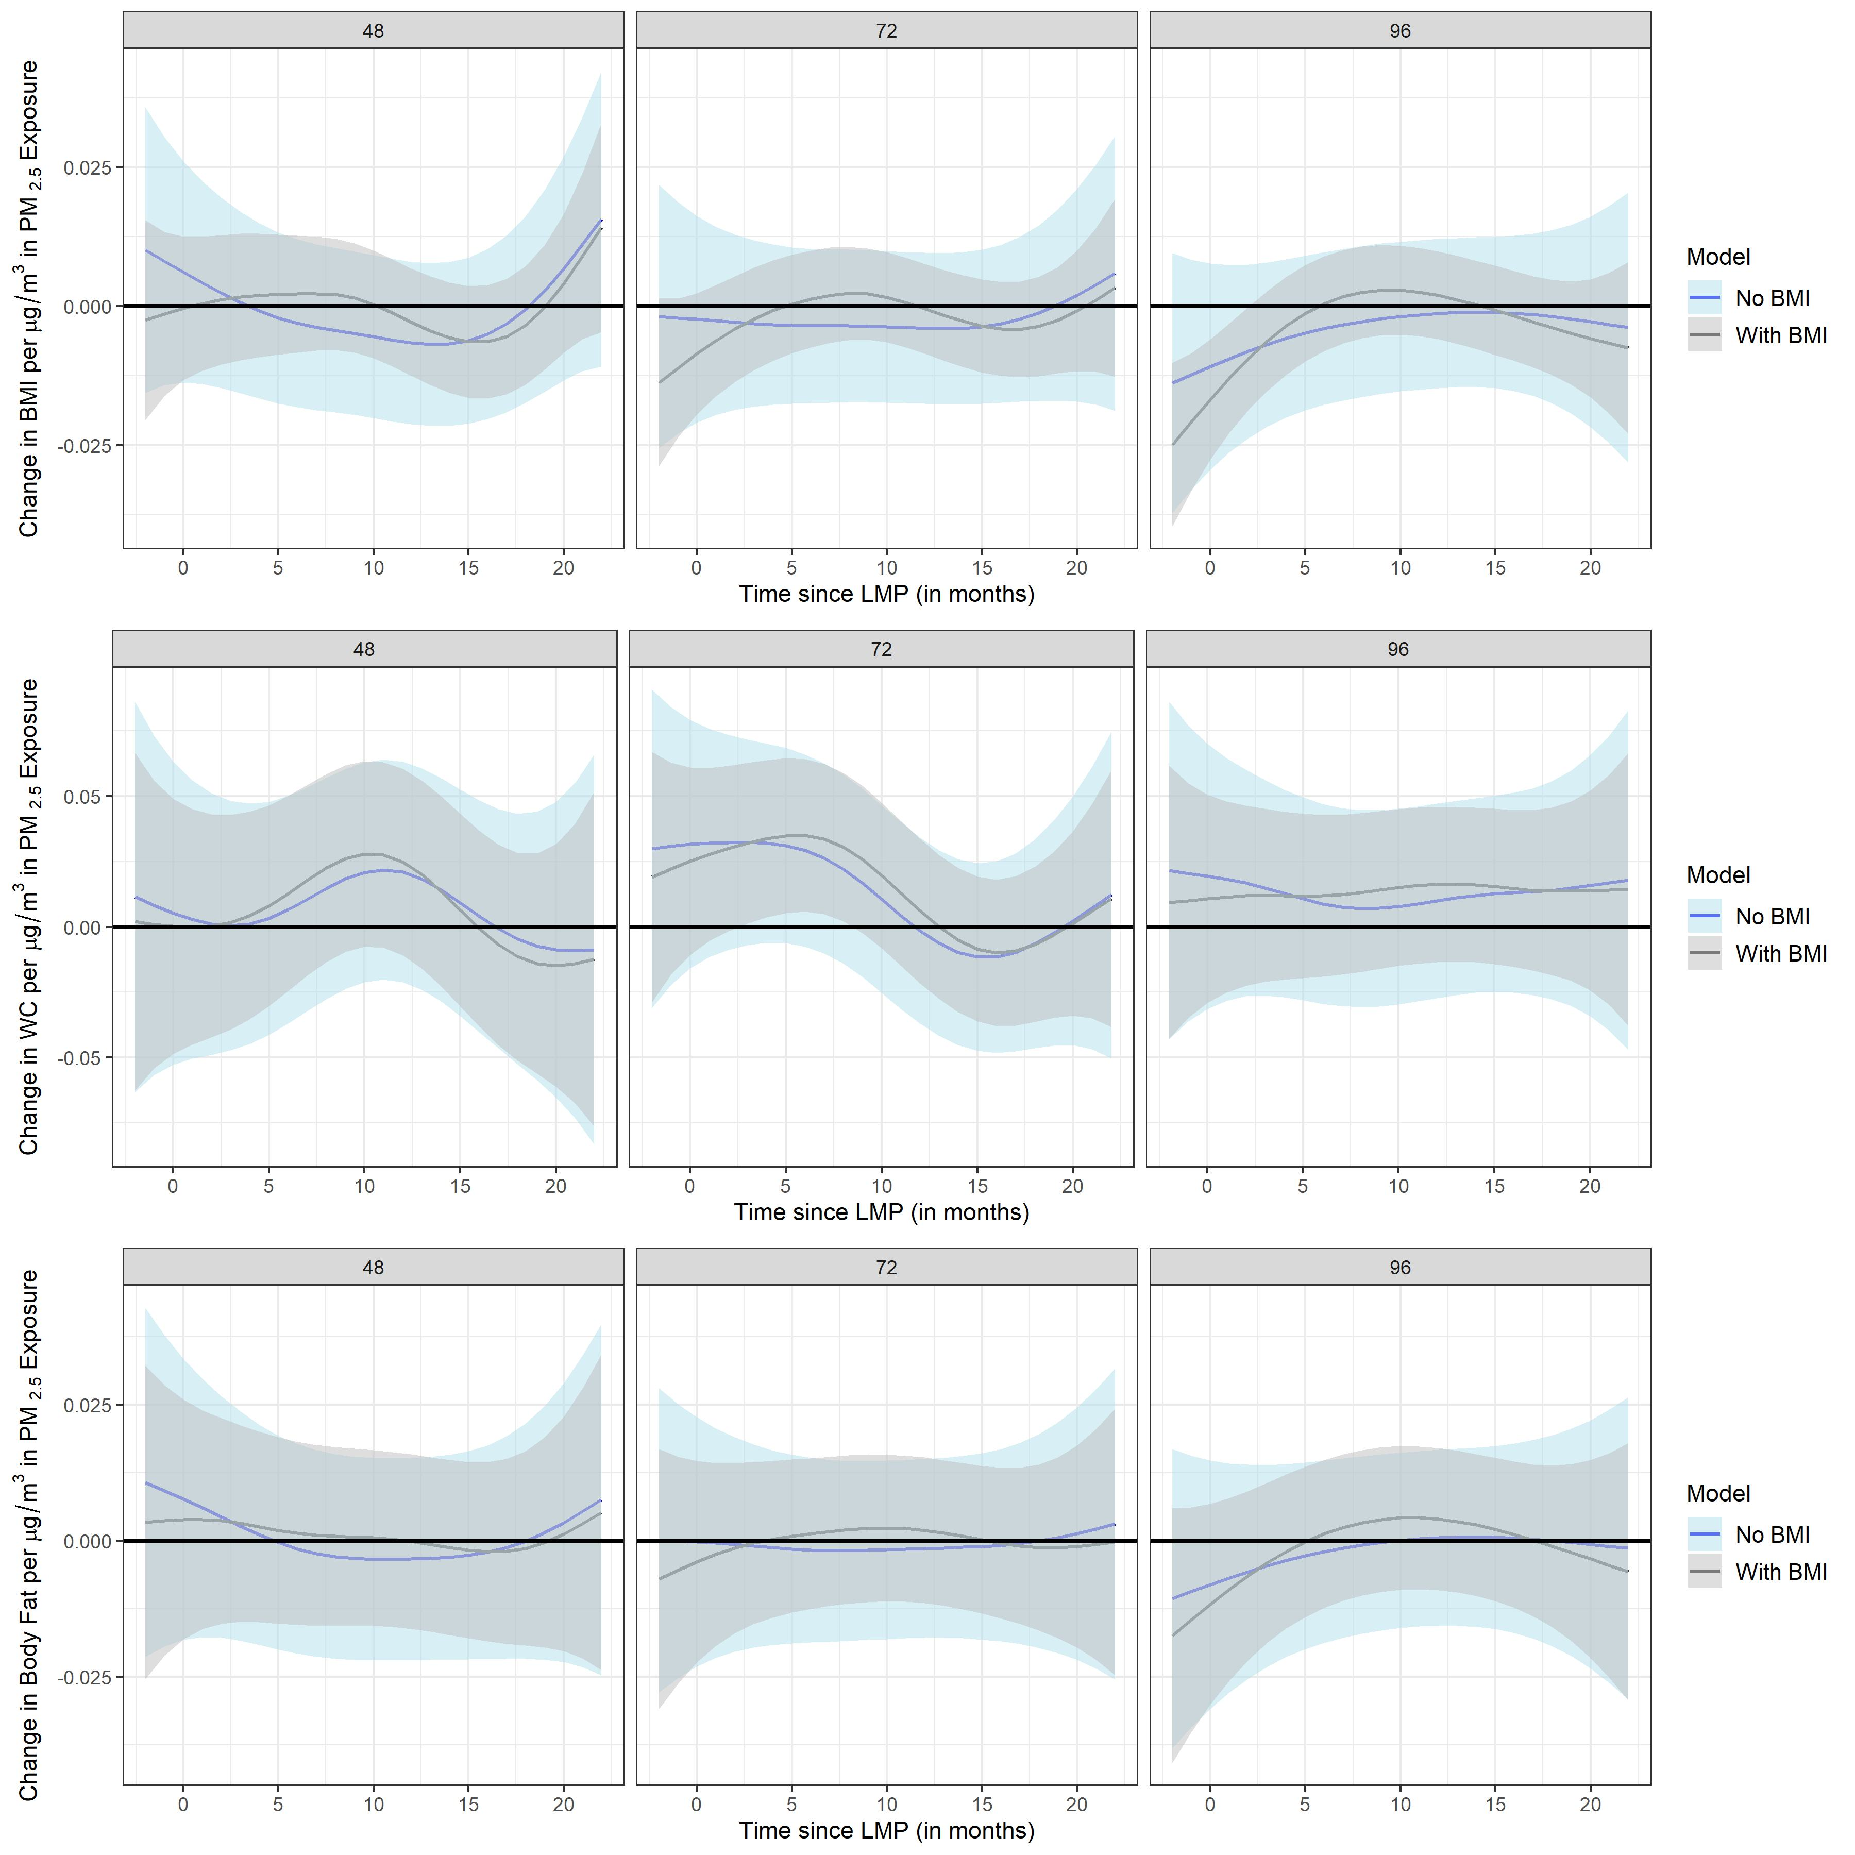
Supplemental Figure 5. Sensitivity analyses for cholesterol biomarkers showing overlaying plots with original distributed lag interaction models (DLIMs) controlling for pre-pregnancy body mass index (BMI) in gray color and DLIMs not controlling for BMI as a covariate in blue color. All models were additionally adjusted for age, socio-economic status, smoking during pregnancy, marital status, parity at enrollment, meteorological season, cardiometabolic medications, alcohol intake, multiple pregnancies throughout follow-up, stage, and follow-up time in months squared to allow for a nonlinear effect. Estimates of the association and 95% confidence interval (95% CI) between monthly PM_{2.5} exposure and total cholesterol, high-density lipoprotein (HDL), low-density lipoprotein (LDL) at 48, 72, and 96 months after parturition using DLIMs with penalization and non-linear modification. Negative and positive values on the x-axis indicate months before and after last menstrual period (LMP), respectively. Month 0 indicates the LMP month (month 0). Sample sizes for analyses with total cholesterol, HDL, and LDL were n=517.
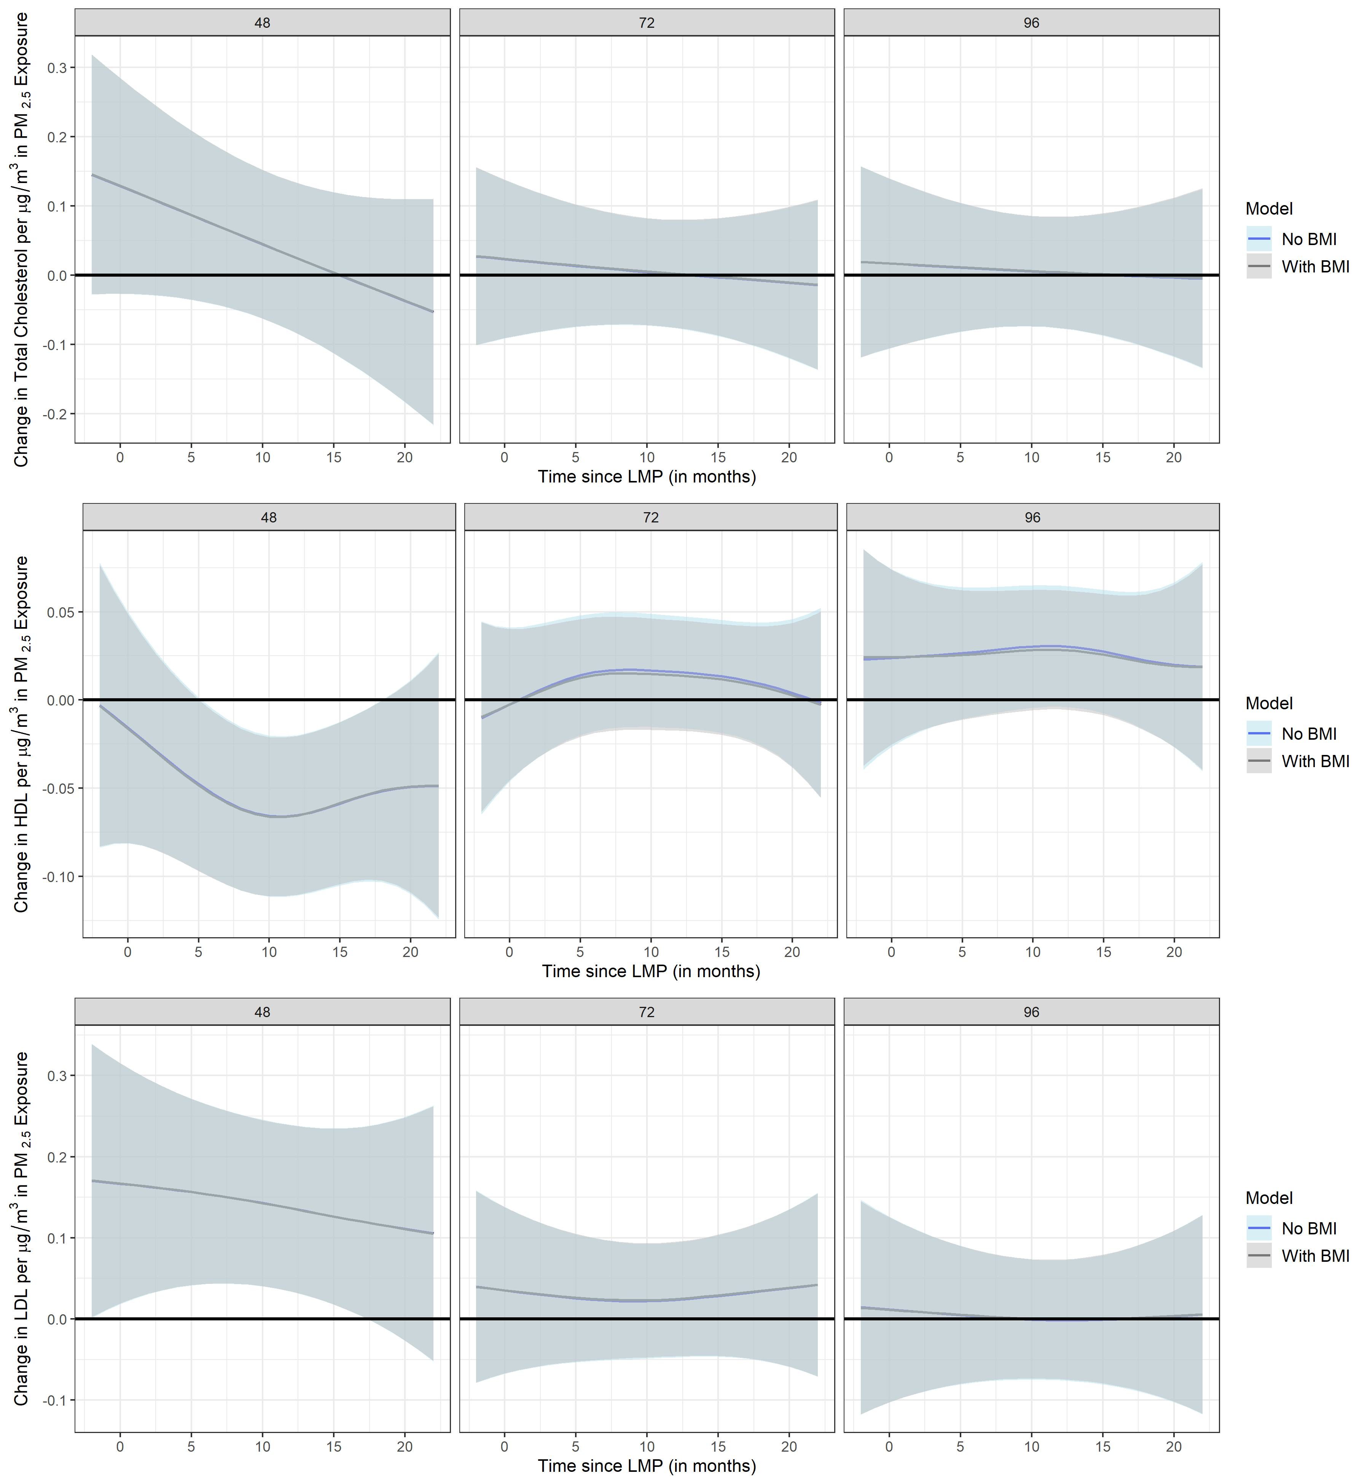
Supplemental Figure 6. Sensitivity analyses for anthropometric measures showing overlaying plots with original distributed lag interaction models (DLIMs) not controlling for time-varying 1-year average PM_{2.5} (prior to each follow-up visit) in gray color and DLIMs controlling for time-varying 1-year average PM_{2.5} as a covariate in blue color. All models were additionally adjusted for age, pre-pregnancy BMI, socio-economic status, smoking during pregnancy, marital status, parity at enrollment, meteorological season, cardiometabolic medications, alcohol intake, multiple pregnancies throughout follow-up, stage, and follow-up time in months squared to allow for a nonlinear effect. Estimates of the association and 95% confidence interval (95% CI) between monthly PM_{2.5} exposure and anthropometric measures Body Mass Index (BMI), Waist Circumference (WC), body fat percentage at 48, 72, and 96 months after parturition using DLIMs with penalization and non-linear modification. Negative and positive values on the x-axis indicate months before and after last menstrual period (LMP), respectively. Month 0 indicates the LMP month (month 0). Sample sizes for analyses with BMI were n=516 and sample sizes for analyses with WC and body fat were n=515.
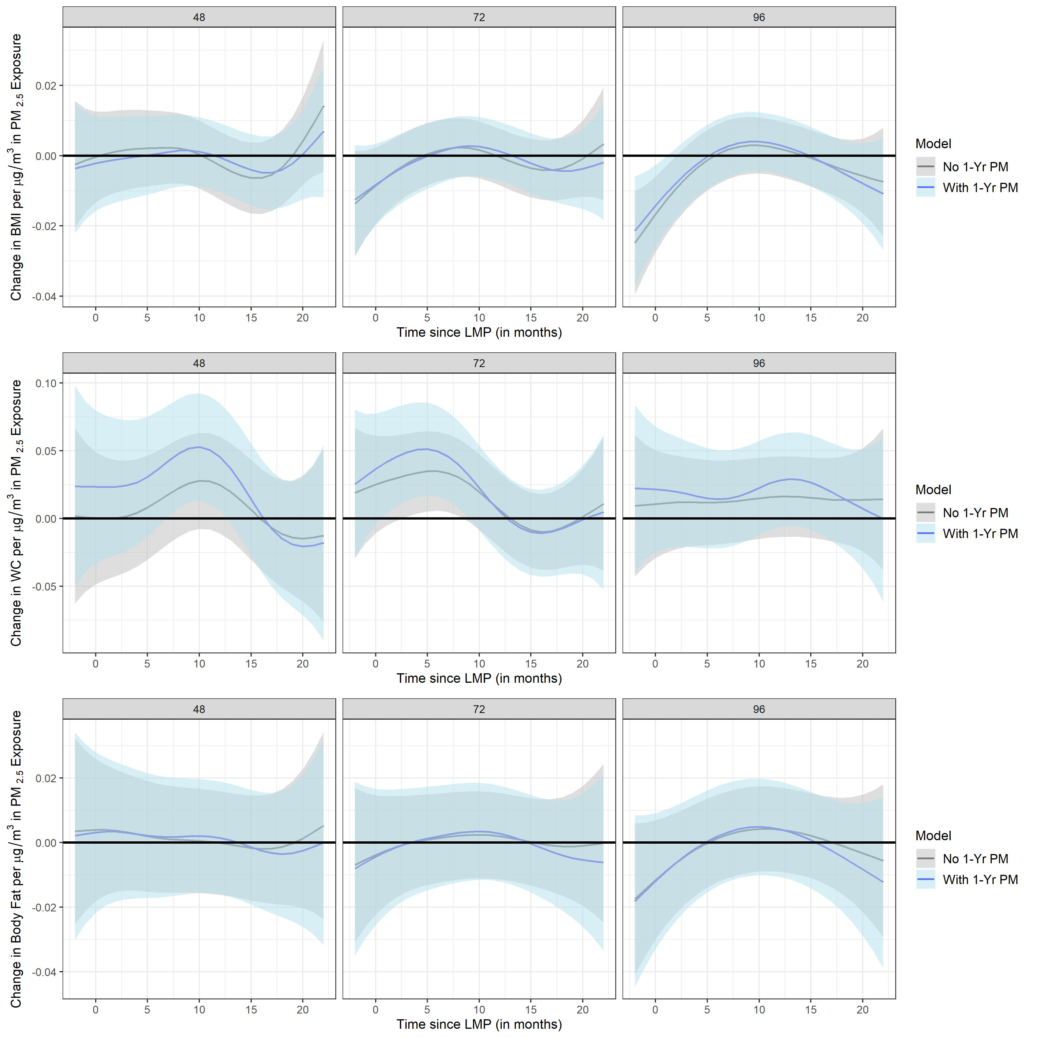
Supplemental Figure 7. Sensitivity analyses for cholesterol biomarkers showing overlaying plots with original distributed lag interaction models (DLIMs) not controlling for time-varying 1-year average PM_{2.5} (prior to each follow-up visit) in gray color and DLIMs controlling for time-varying 1-year average PM_{2.5} as a covariate in blue color. All models were additionally adjusted for age, pre-pregnancy BMI, socio-economic status, smoking during pregnancy, marital status, parity at enrollment, meteorological season, cardiometabolic medications, alcohol intake, multiple pregnancies throughout follow-up, stage, and follow-up time in months squared to allow for a nonlinear effect. Estimates of the association and 95% confidence interval (95% CI) between monthly PM_{2.5} exposure and total cholesterol, high-density lipoprotein (HDL), low-density lipoprotein (LDL) at 48, 72, and 96 months after parturition using DLIMs with penalization and non-linear modification. Negative and positive values on the x-axis indicate months before and after last menstrual period (LMP), respectively. Month 0 indicates the LMP month (month 0). Sample sizes for analyses with total cholesterol, HDL, and LDL were n=517.
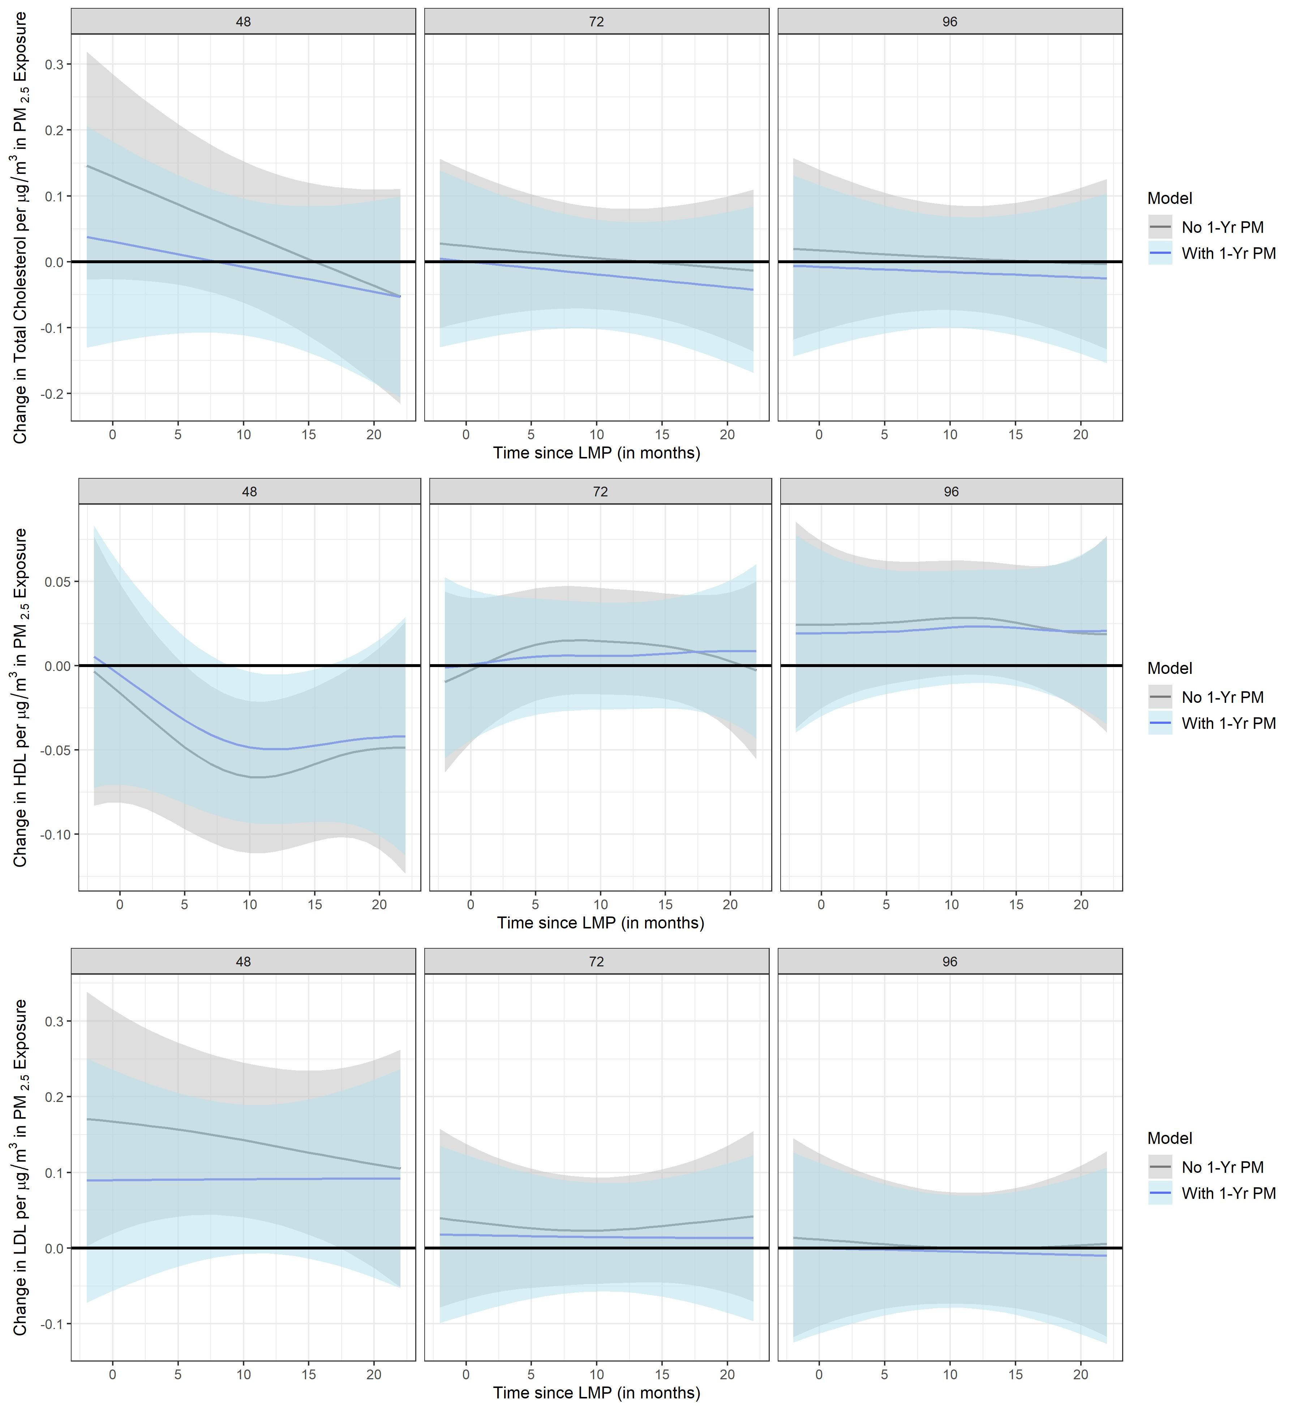
Supplemental Figure 8. Sensitivity analyses for anthropometric measures showing overlaying plots with original distributed lag interaction models (DLIMs) controlling for time-varying pregnancies as a covariate in gray color and DLIMs not controlling for time-varying pregnancies in blue color. All models were additionally adjusted for age, pre-pregnancy BMI, socio-economic status, smoking during pregnancy, marital status, parity at enrollment, meteorological season, cardiometabolic medications, alcohol intake, stage, and follow-up time in months squared to allow for a nonlinear effect. Estimates of the association and 95% confidence interval (95% CI) between monthly PM_{2.5} exposure and anthropometric measures Body Mass Index (BMI), Waist Circumference (WC), body fat percentage at 48, 72, and 96 months after parturition using DLIMs with penalization and non-linear modification. Negative and positive values on the x-axis indicate months before and after last menstrual period (LMP), respectively. Month 0 indicates the LMP month (month 0). Sample sizes for analyses with BMI were n=516 and sample sizes for analyses with WC and body fat were n=515.
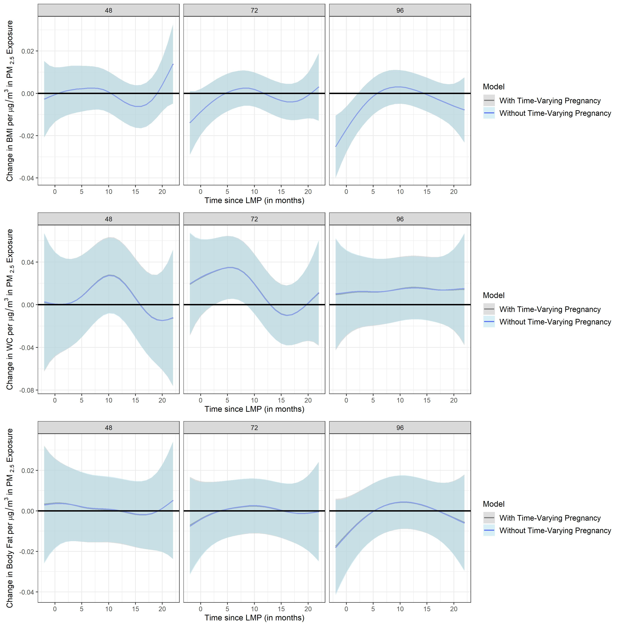

Supplemental Figure 9. Sensitivity analyses for cholesterol biomarkers showing overlaying plots with original distributed lag interaction models (DLIMs) controlling for time-varying pregnancies as a covariate in gray color and DLIMs not controlling for time-varying pregnancies in blue color. All models were additionally adjusted for age, pre-pregnancy BMI, socio-economic status, smoking during pregnancy, marital status, parity at enrollment, meteorological season, cardiometabolic medications, alcohol intake, stage, and follow-up time in months squared to allow for a nonlinear effect. Estimates of the association and 95% confidence interval (95% CI) between monthly PM_{2.5} exposure and total cholesterol, high-density lipoprotein (HDL), low-density lipoprotein (LDL) at 48, 72, and 96 months after parturition using DLIMs with penalization and non-linear modification. Negative and positive values on the x-axis indicate months before and after last menstrual period (LMP), respectively. Month 0 indicates the LMP month (month 0). Sample sizes for analyses with total cholesterol, HDL, and LDL were n=517.
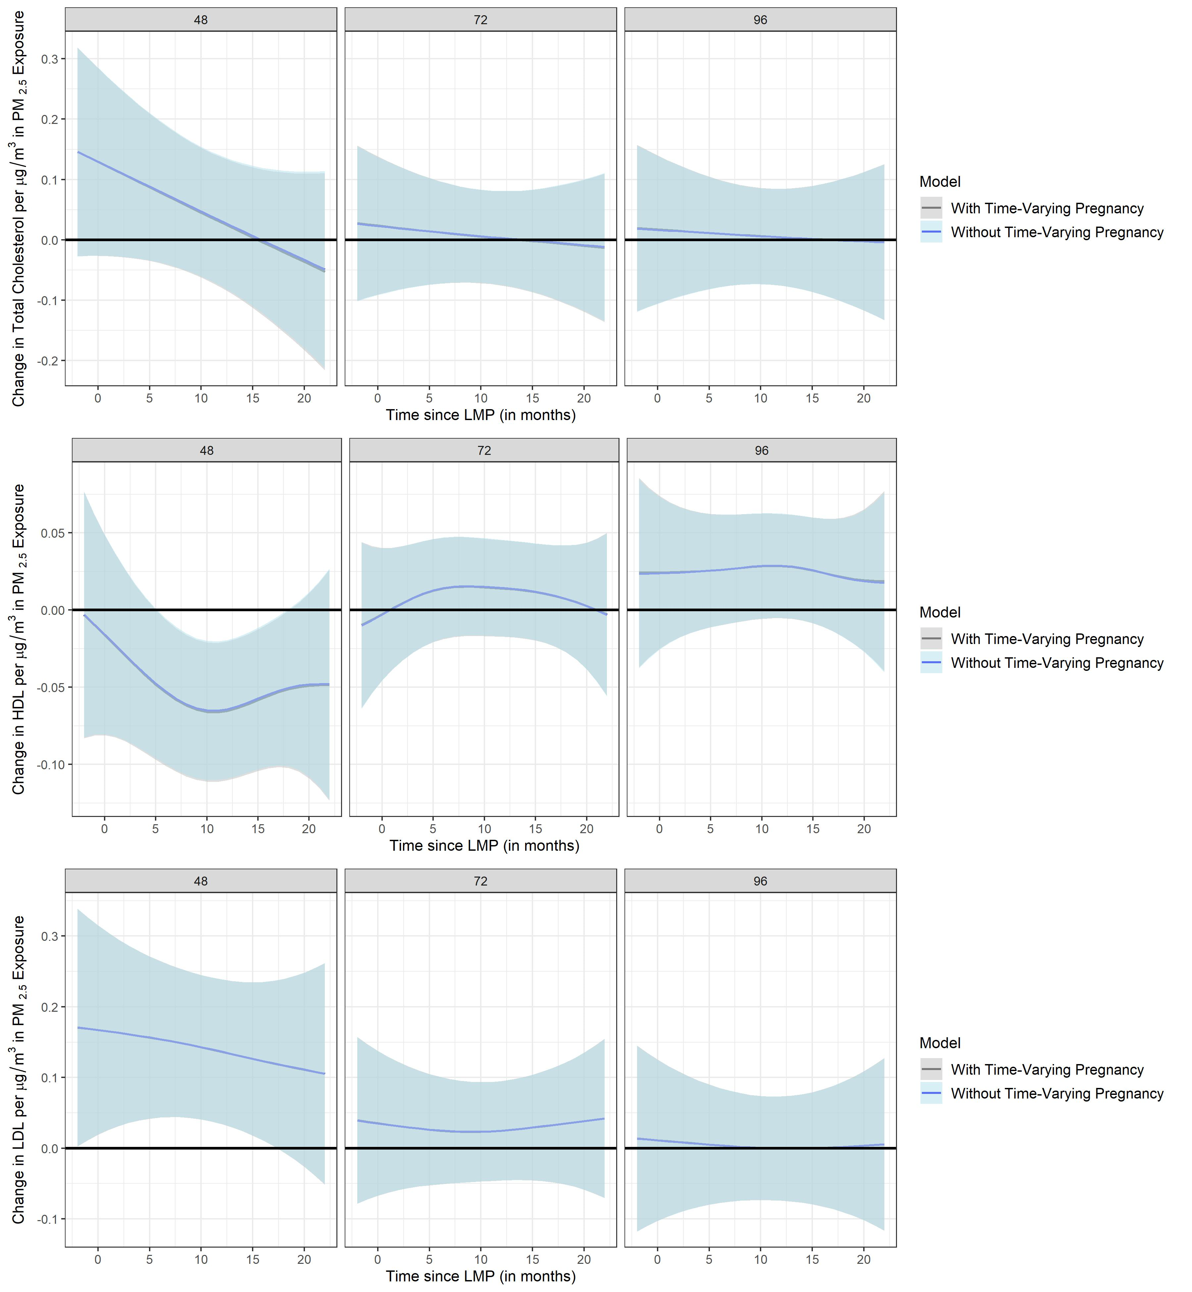

Supplemental Figure 10. Stratified analyses by fetal sex (pregnant mothers carrying either a male or female fetus) using distributed lag interaction models (DLIMs) with penalization and non-linear modification. Estimates of the association (blue dots) and 95% confidence interval (95% CI) (grey whiskers) between monthly PM_{2.5} exposure and Body Mass Index (BMI) at 48, 72, and 96 months after parturition. Negative and positive values on the x-axis indicate months before and after last menstrual period (LMP), respectively. Month 0 indicates the LMP month (month 0). Models were adjusted for age, pre-pregnancy BMI, socio-economic status, smoking during pregnancy, marital status, parity at enrollment, meteorological season, cardiometabolic medications, alcohol intake, multiple pregnancies throughout follow-up, stage, and follow-up time in months squared to allow for a nonlinear effect. Sample sizes for stratified analyses in pregnant mothers were n=267 for the male fetus carrier group and n=249 for the female fetus carrier group.
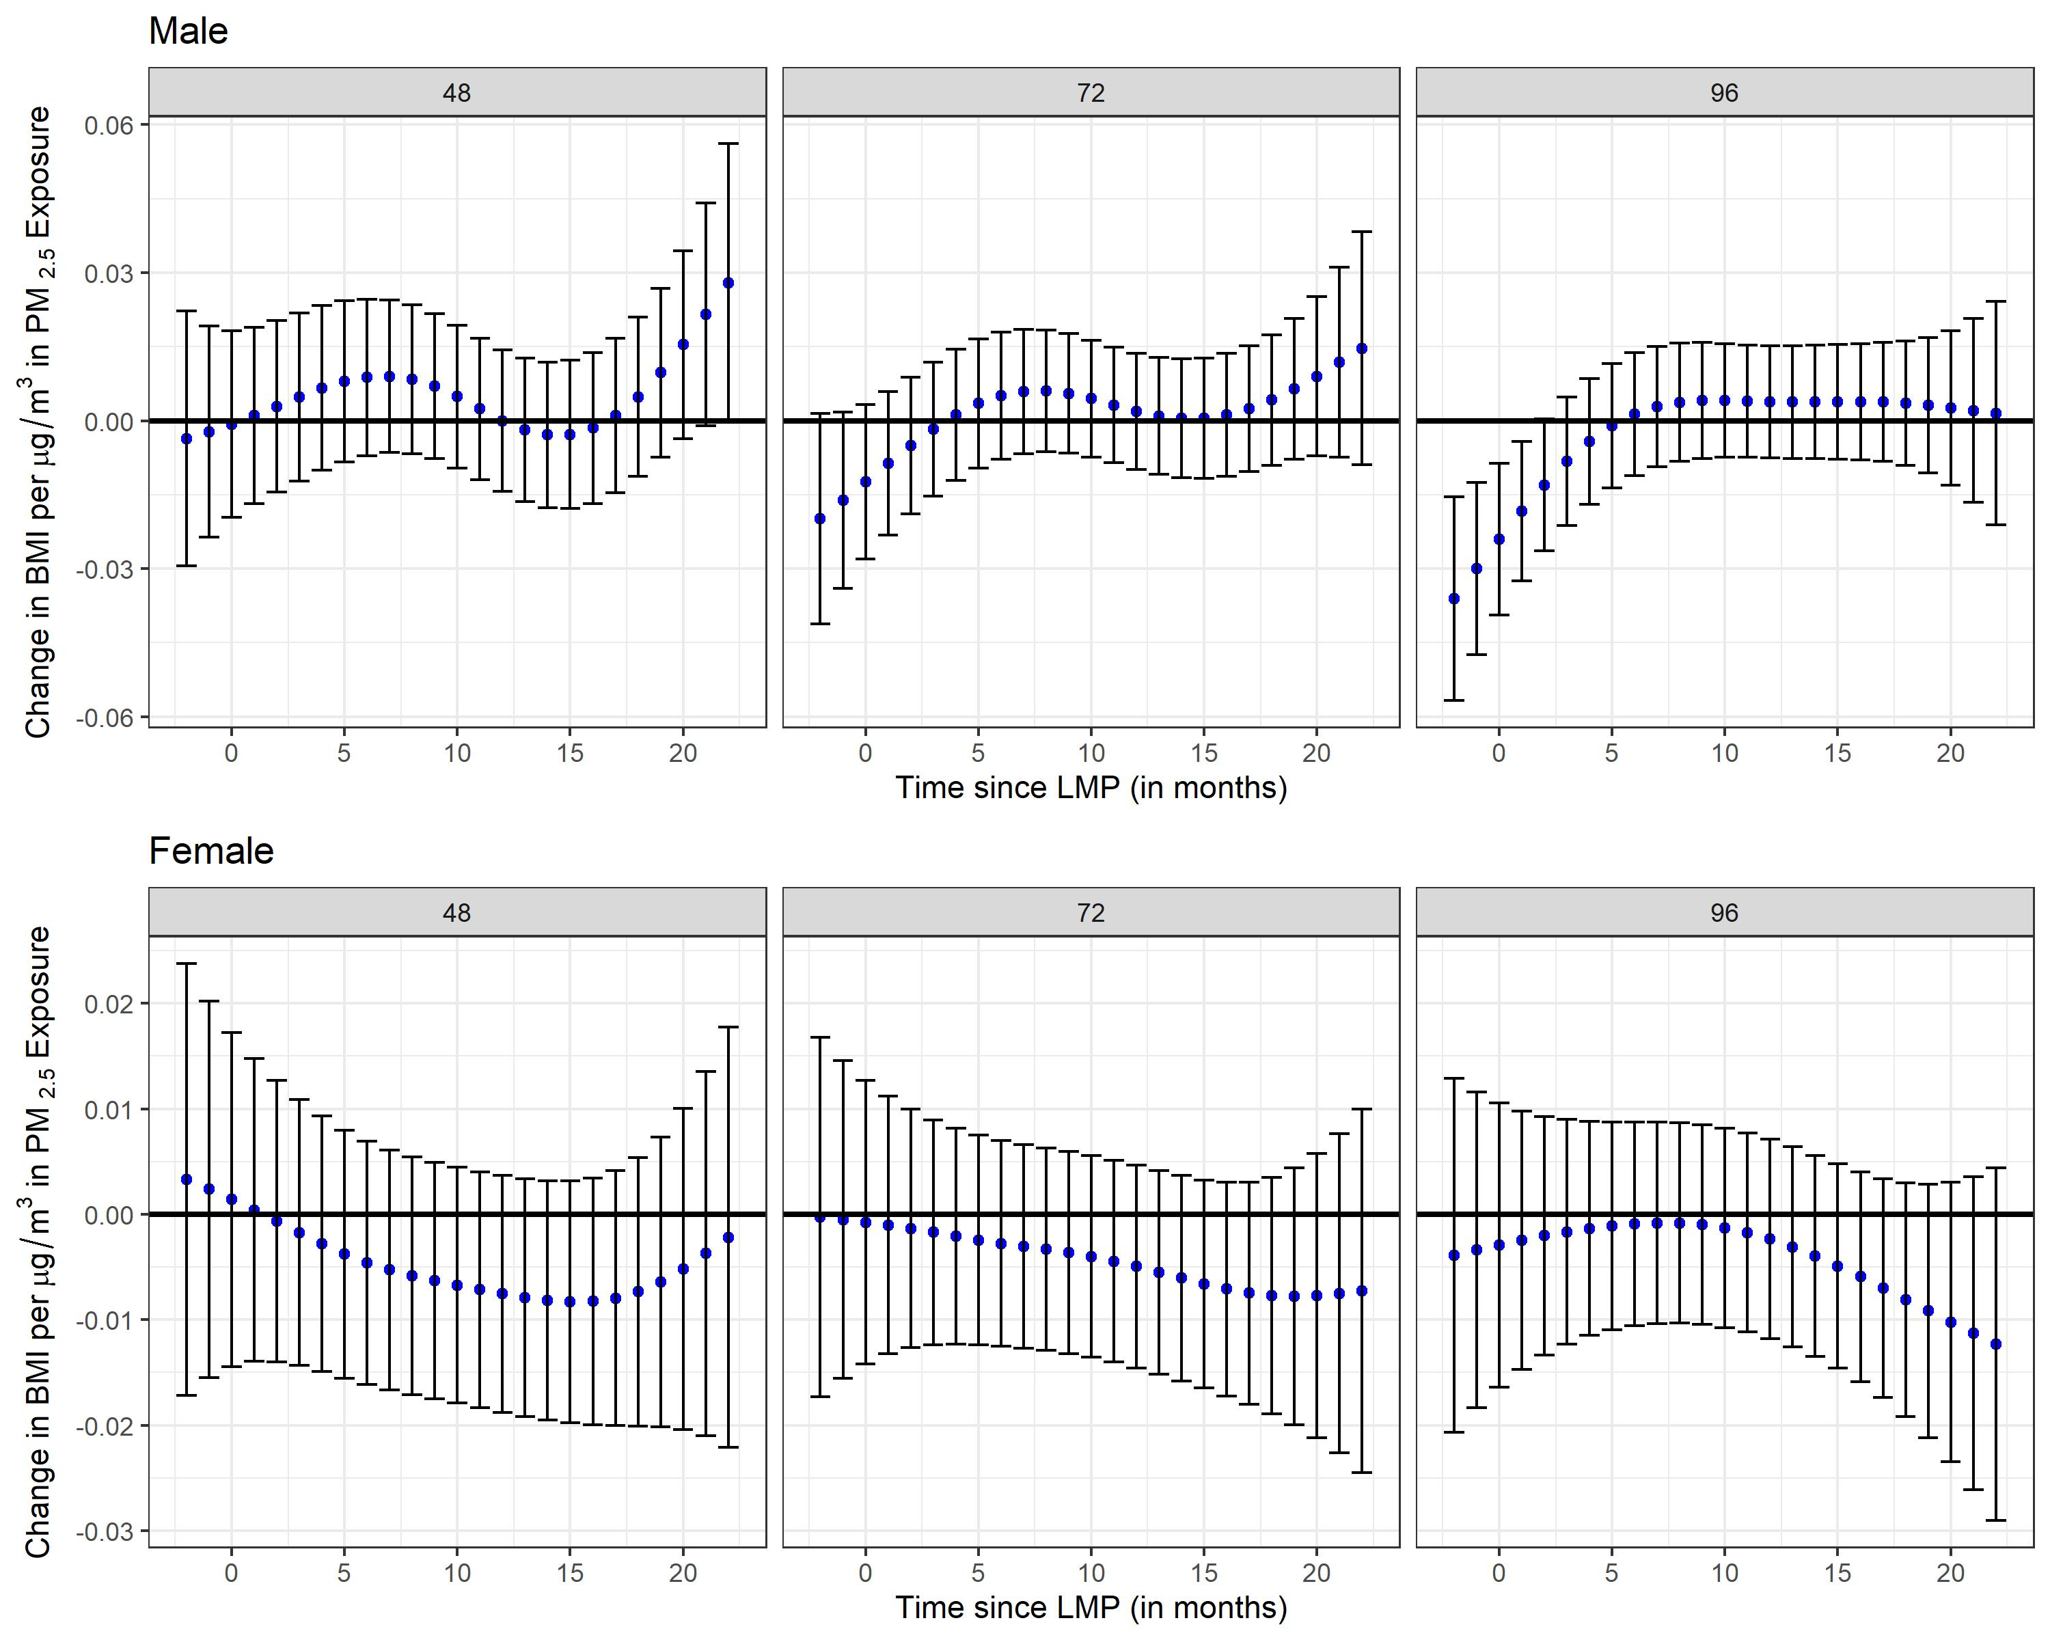

Supplemental Figure 11. Stratified analyses by fetal sex (pregnant mothers carrying either a male or female fetus) using distributed lag interaction models (DLIMs) with penalization and non-linear modification. Estimates of the association (blue dots) and 95% confidence interval (95% CI) (grey whiskers) between monthly PM_{2.5} exposure and Waist Circumference (WC) at 48, 72, and 96 months after parturition. Negative and positive values on the x-axis indicate months before and after last menstrual period (LMP), respectively. Month 0 indicates the LMP month (month 0). Models were adjusted for age, pre-pregnancy BMI, socio-economic status, smoking during pregnancy, marital status, parity at enrollment, meteorological season, cardiometabolic medications, alcohol intake, multiple pregnancies throughout follow-up, stage, and follow-up time in months squared to allow for a nonlinear effect. Sample sizes for stratified analyses in pregnant mothers were n=266 for the male fetus carrier group and n=249 for the female fetus carrier group.
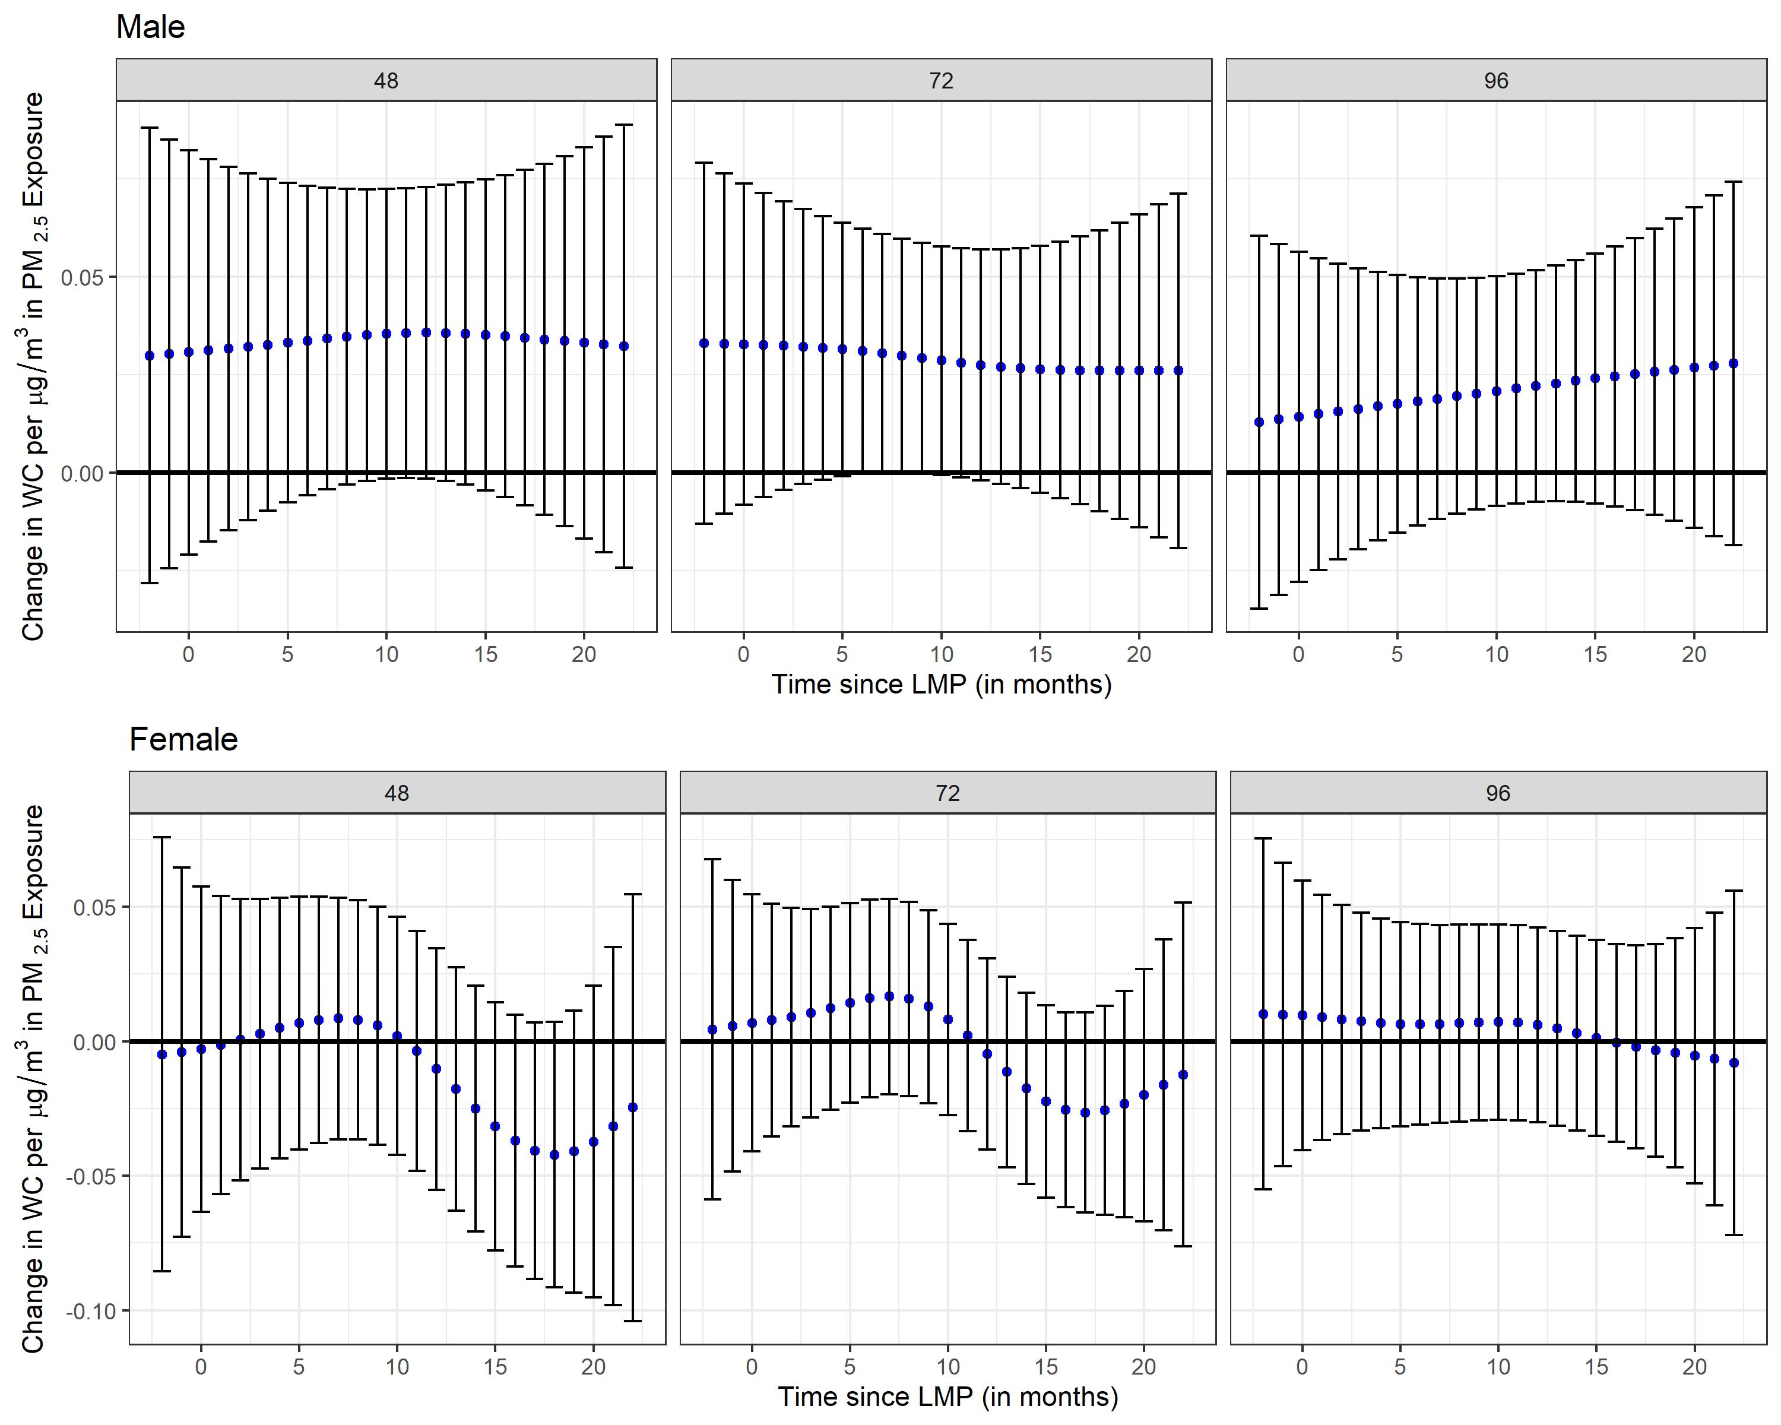

Supplemental Figure 12. Stratified analyses by fetal sex (pregnant mothers carrying either a male or female fetus) using distributed lag interaction models (DLIMs) with penalization and non-linear modification. Estimates of the association (blue dots) and 95% confidence interval (95% CI) (grey whiskers) between monthly PM_{2.5} exposure and body fat percentage at 48, 72, and 96 months after parturition. Negative and positive values on the x-axis indicate months before and after last menstrual period (LMP), respectively. Month 0 indicates the LMP month (month 0). Models were adjusted for age, pre-pregnancy BMI, socio-economic status, smoking during pregnancy, marital status, parity at enrollment, meteorological season, cardiometabolic medications, alcohol intake, multiple pregnancies throughout follow-up, stage, and follow-up time in months squared to allow for a nonlinear effect. Sample sizes for stratified analyses in pregnant mothers were n=266 for the male fetus carrier group and n=249 for the female fetus carrier group.
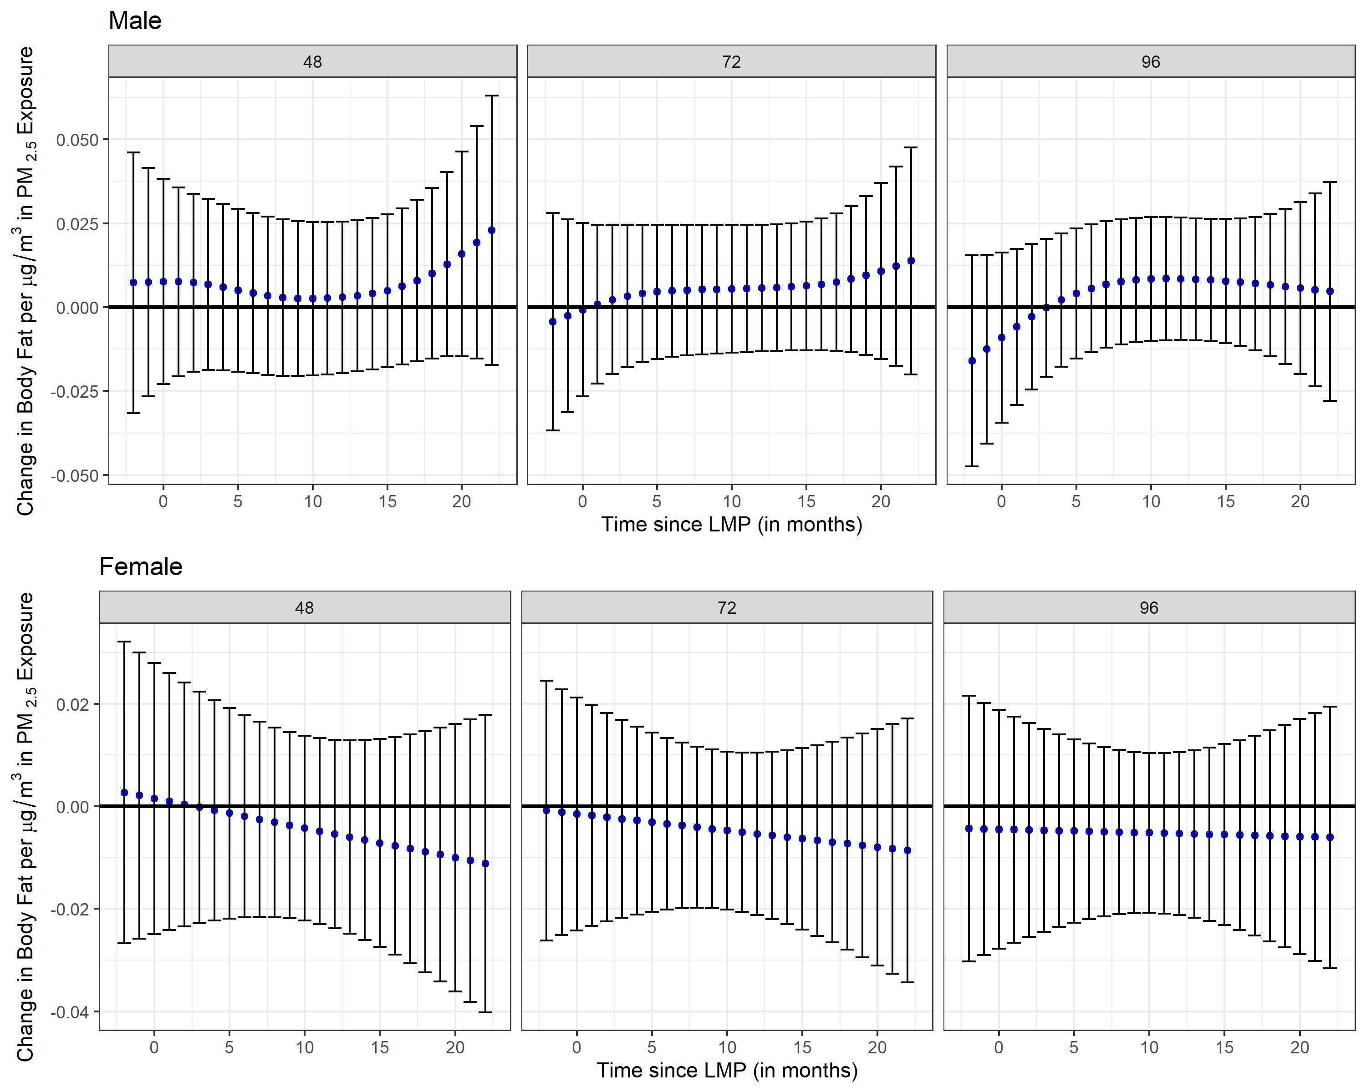

Supplemental Figure 13. Stratified analyses by fetal sex (pregnant mothers carrying either a male or female fetus) using distributed lag interaction models (DLIMs) with penalization and non-linear modification. Estimates of the association (blue dots) and 95% confidence interval (95% CI) (grey whiskers) between monthly PM_{2.5} exposure and total cholesterol at 48, 72, and 96 months after parturition. Negative and positive values on the x-axis indicate months before and after last menstrual period (LMP), respectively. Month 0 indicates the LMP month (month 0). Models were adjusted for age, pre-pregnancy BMI, socio-economic status, smoking during pregnancy, marital status, parity at enrollment, meteorological season, cardiometabolic medications, alcohol intake, multiple pregnancies throughout follow-up, stage, and follow-up time in months squared to allow for a nonlinear effect. Sample sizes for stratified analyses in pregnant mothers were n=267 for the male fetus carrier group and n=250 for the female fetus carrier group.
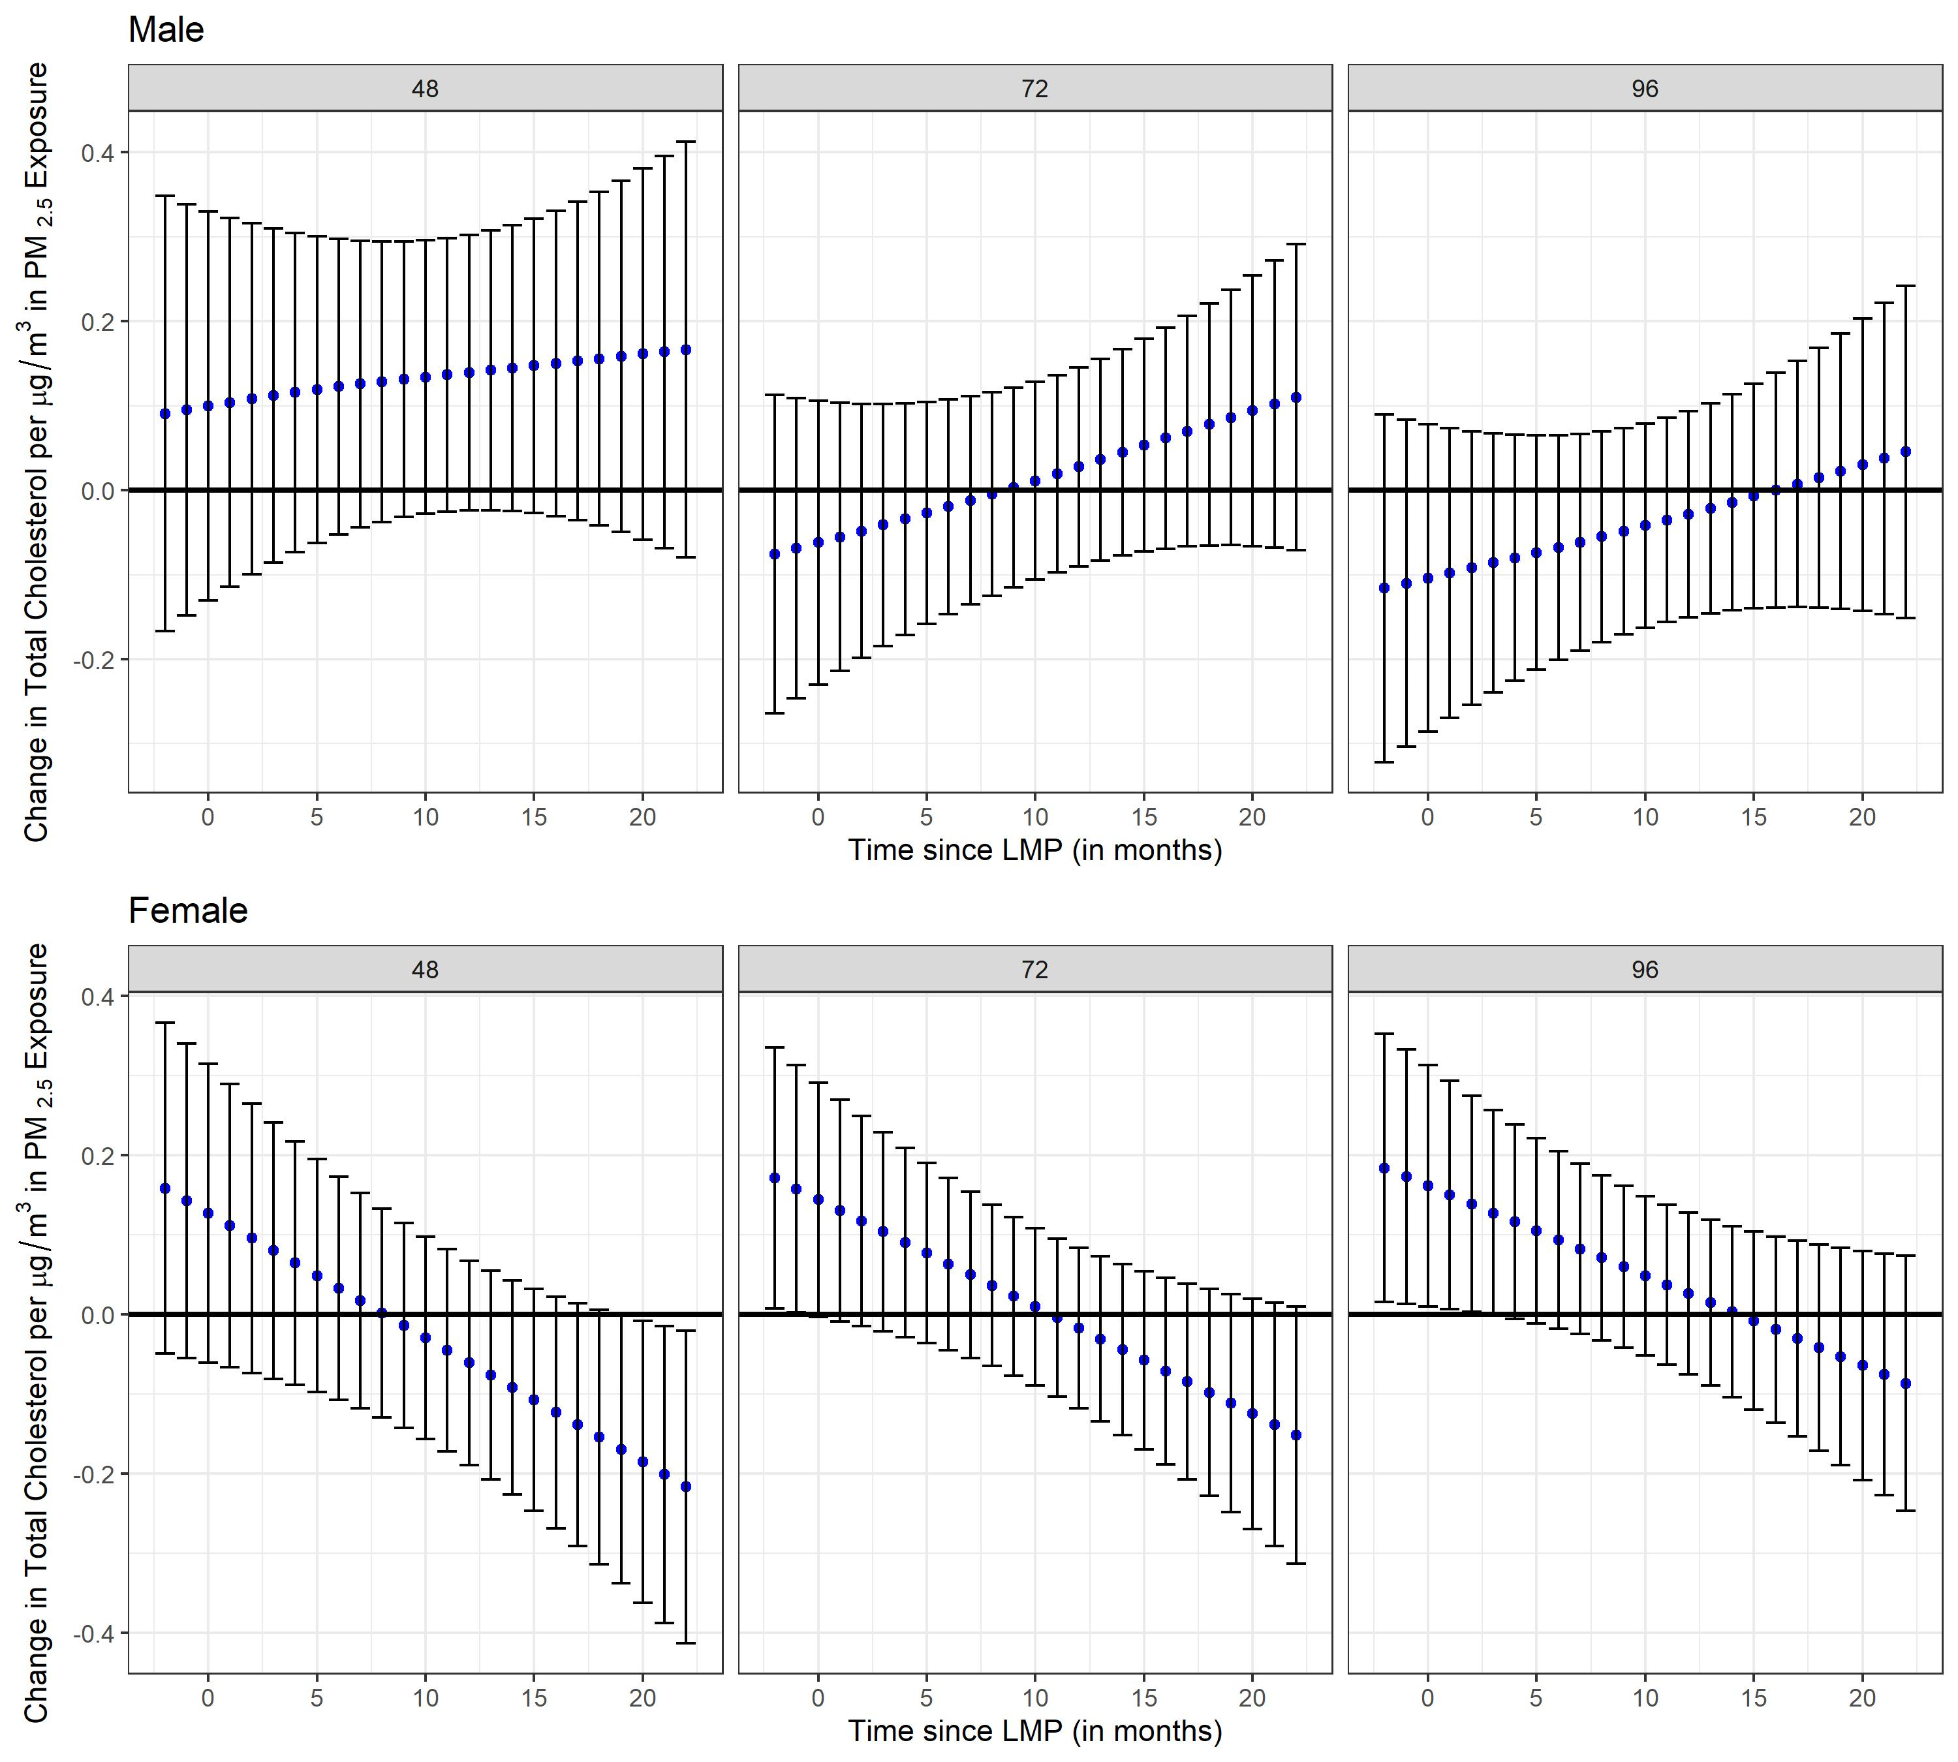

Supplemental Figure 14. Stratified analyses by fetal sex (pregnant mothers carrying either a male or female fetus) using distributed lag interaction models (DLIMs) with penalization and non-linear modification. Estimates of the association (blue dots) and 95% confidence interval (95% CI) (grey whiskers) between monthly PM_{2.5} exposure and high-density lipoprotein (HDL) at 48, 72, and 96 months after parturition. Negative and positive values on the x-axis indicate months before and after last menstrual period (LMP), respectively. Month 0 indicates the LMP month (month 0). Models were adjusted for age, pre-pregnancy BMI, socio-economic status, smoking during pregnancy, marital status, parity at enrollment, meteorological season, cardiometabolic medications, alcohol intake, multiple pregnancies throughout follow-up, stage, and follow-up time in months squared to allow for a nonlinear effect. Sample sizes for stratified analyses in pregnant mothers were n=267 for the male fetus carrier group and n=250 for the female fetus carrier group.
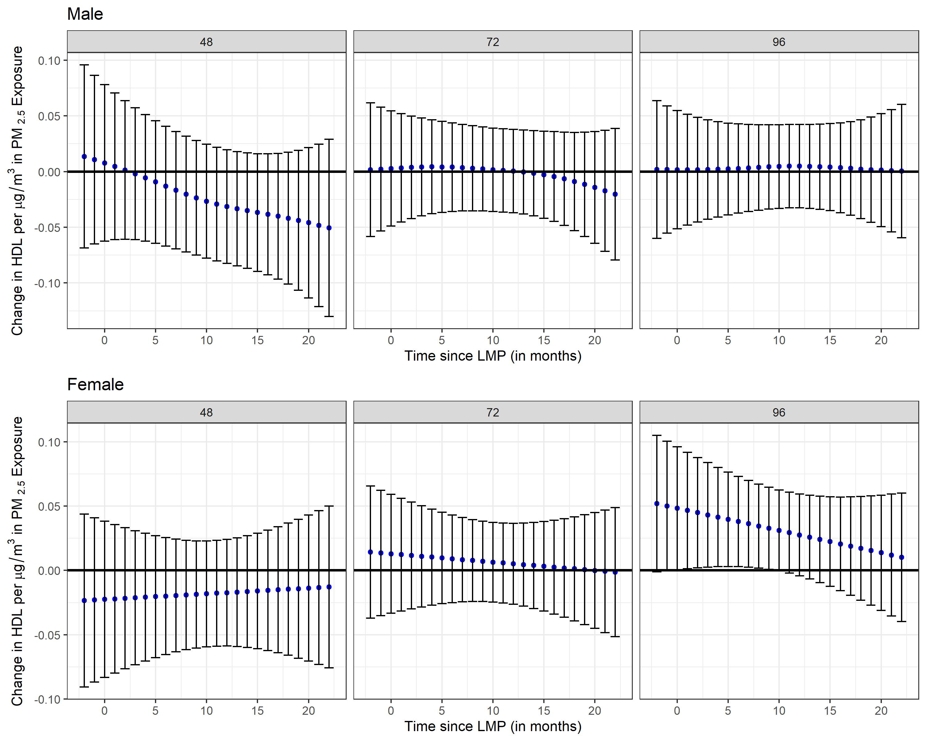

Supplemental Figure 15. Stratified analyses by fetal sex (pregnant mothers carrying either a male or female fetus) using distributed lag interaction models (DLIMs) with penalization and non-linear modification. Estimates of the association (blue dots) and 95% confidence interval (95% CI) (grey whiskers) between monthly PM_{2.5} exposure and low-density lipoprotein (LDL) at 48, 72, and 96 months after parturition. Negative and positive values on the x-axis indicate months before and after last menstrual period (LMP), respectively. Month 0 indicates the LMP month (month 0). Models were adjusted for age, pre-pregnancy BMI, socio-economic status, smoking during pregnancy, marital status, parity at enrollment, meteorological season, cardiometabolic medications, alcohol intake, multiple pregnancies throughout follow-up, stage, and follow-up time in months squared to allow for a nonlinear effect. Sample sizes for stratified analyses in pregnant mothers were n=267 for the male fetus carrier group and n=250 for the female fetus carrier group.
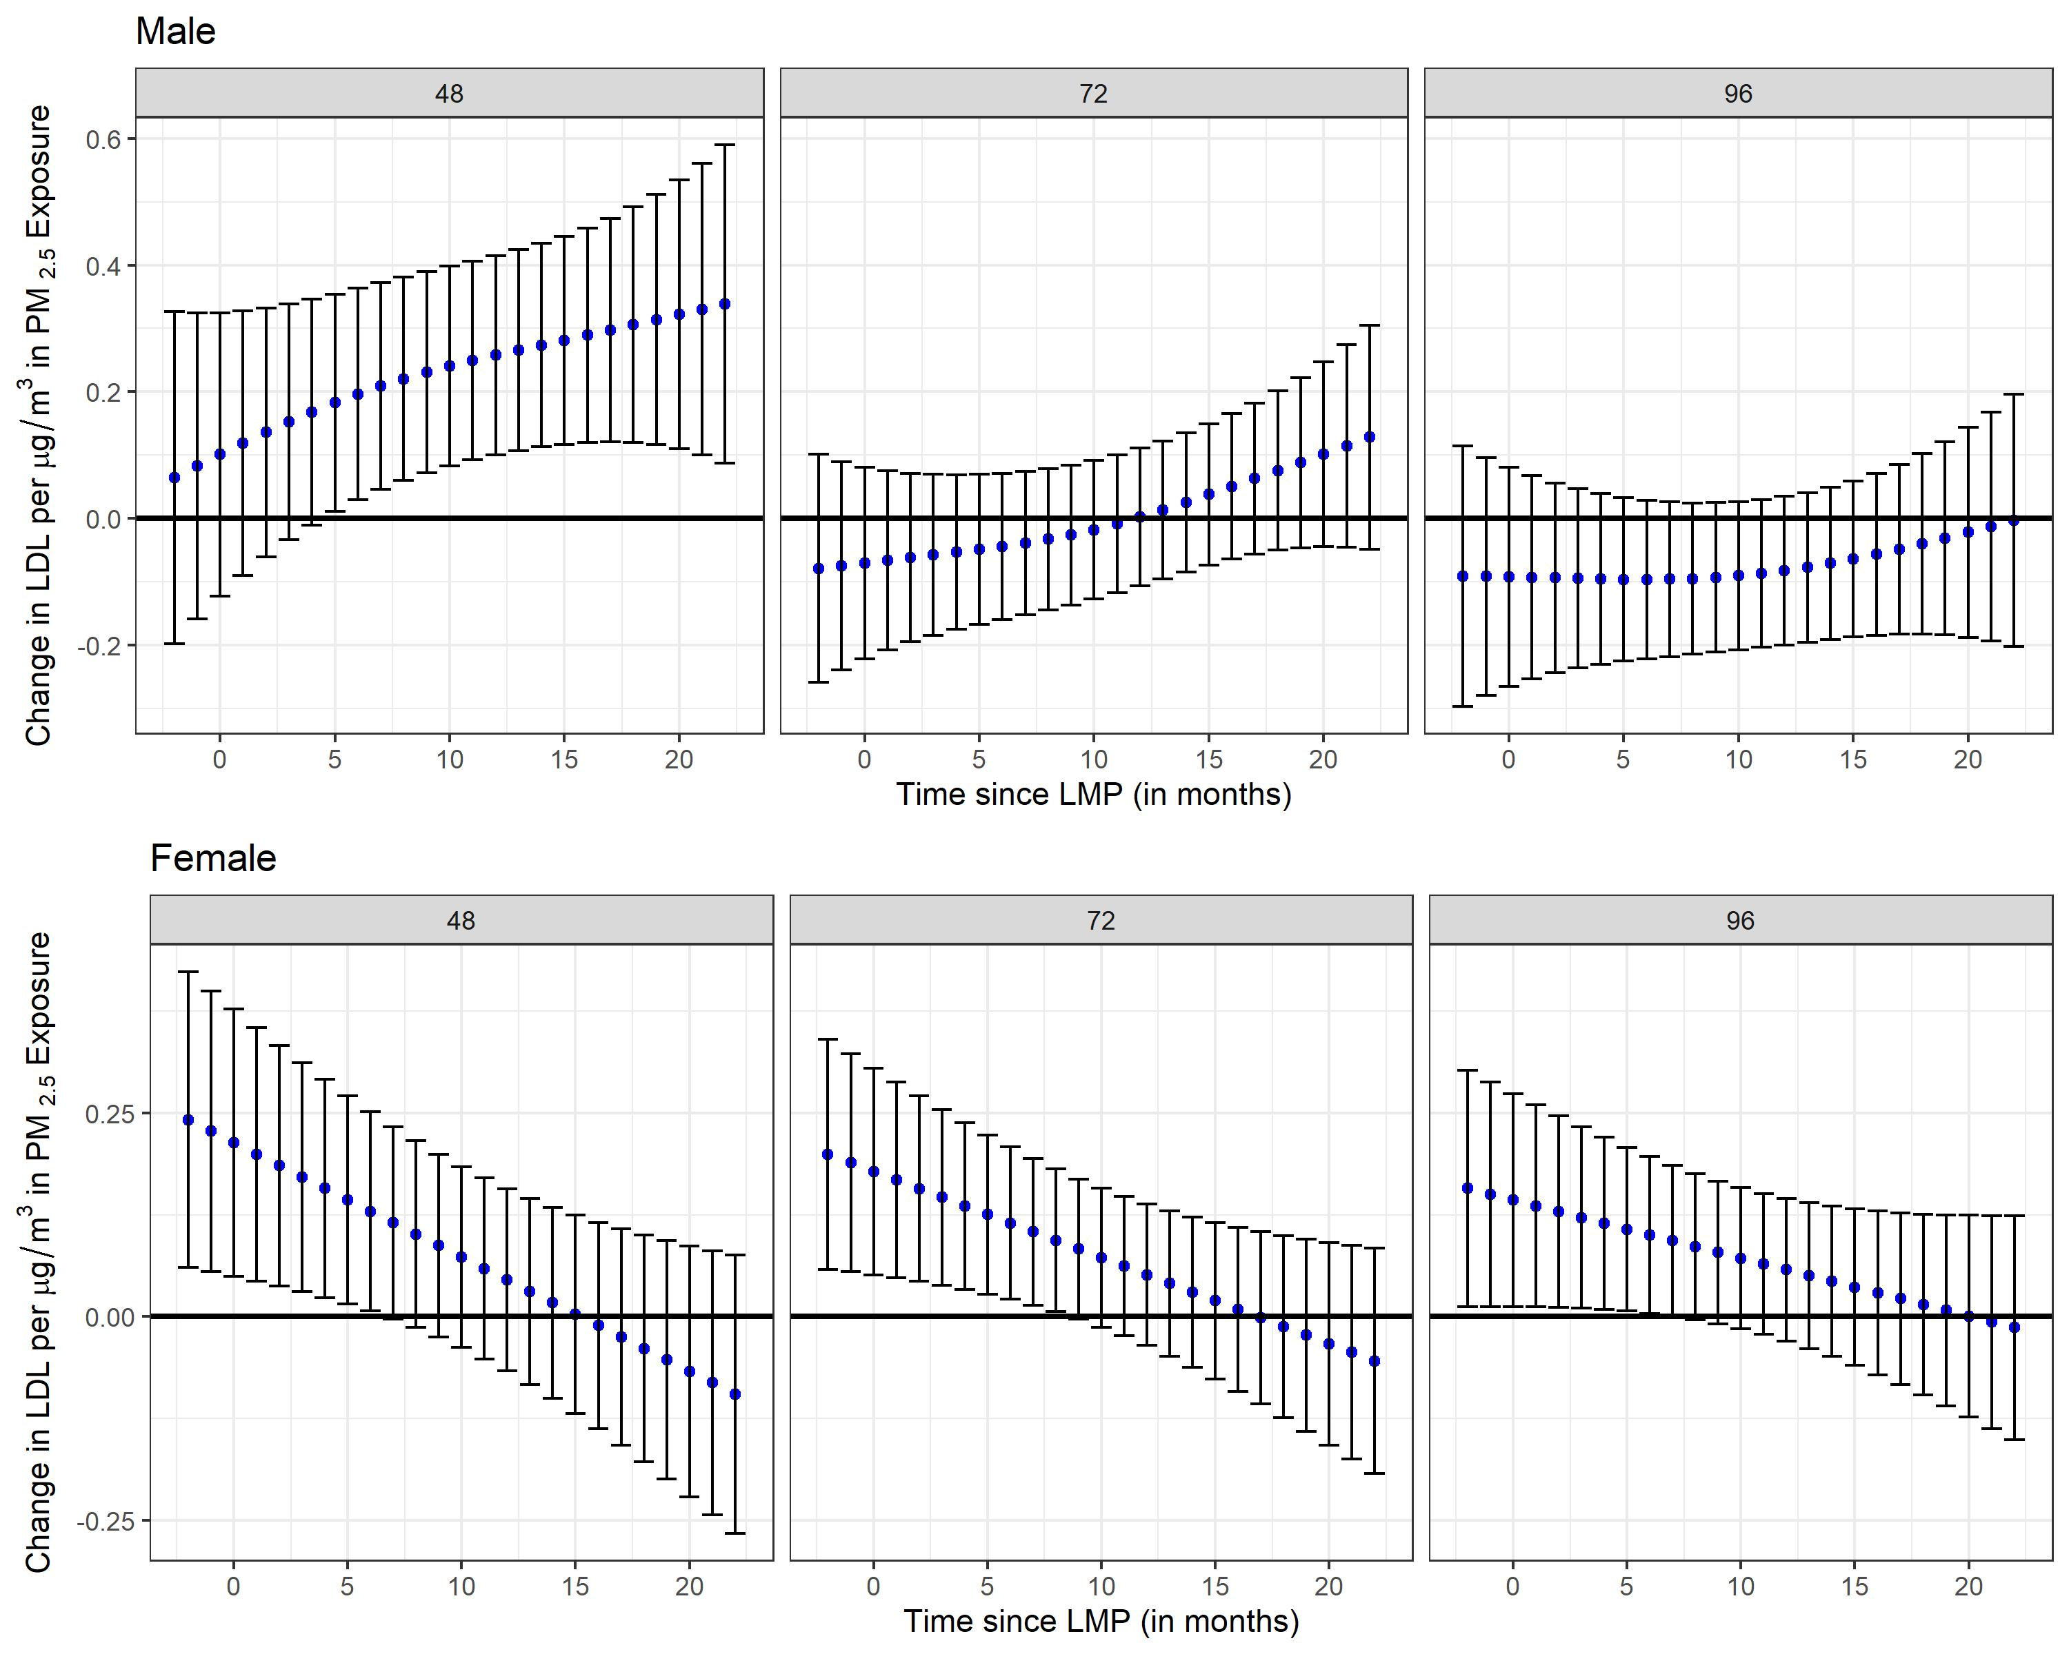

Supplemental Figure 16. Stratified analyses by folic acid (FA) supplementation during pregnancy (FA <600 mcg/day vs. FA ≥ 600 mcg/day) using distributed lag interaction models (DLIMs) with penalization and non-linear modification. Estimates of the association (blue dots) and 95% confidence interval (95% CI) (grey whiskers) between monthly PM_{2.5} exposure and Body Mass Index (BMI) at 48, 72, and 96 months after parturition. Negative and positive values on the x-axis indicate months before and after last menstrual period (LMP), respectively. Month 0 indicates the LMP month (month 0). Models were adjusted for age, pre-pregnancy BMI, socio-economic status, smoking during pregnancy, marital status, parity at enrollment, meteorological season, cardiometabolic medications, alcohol intake, multiple pregnancies throughout follow-up, stage, and follow-up time in months squared to allow for a nonlinear effect. Sample sizes for stratified analyses in pregnant mothers were n=338 for the low FA group (FA <600 mcg/day) and n=97 for the high FA group (FA ≥600 mcg/day).
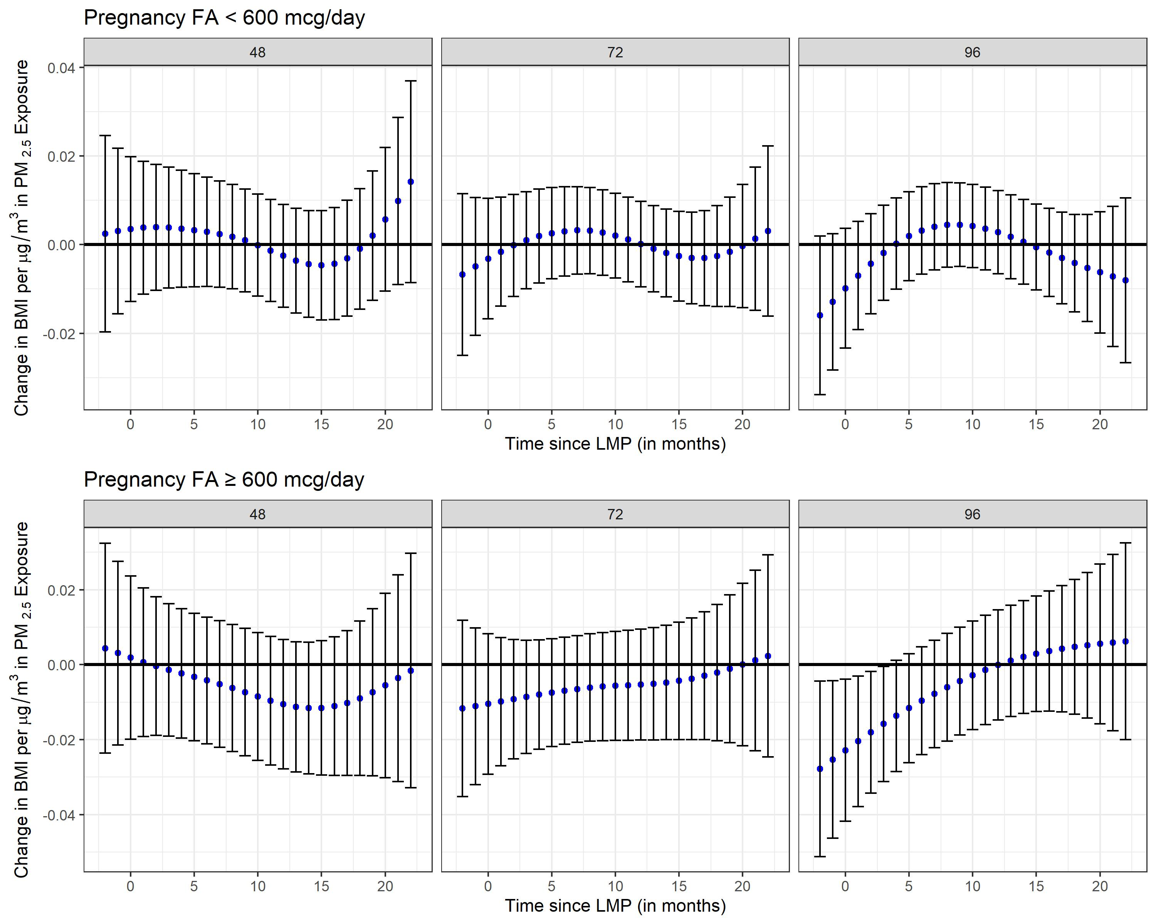

Supplemental Figure 17. Stratified analyses by folic acid (FA) supplementation during pregnancy (FA <600 mcg/day vs. FA ≥ 600 mcg/day) using distributed lag interaction models (DLIMs) with penalization and non-linear modification. Estimates of the association (blue dots) and 95% confidence interval (95% CI) (grey whiskers) between monthly PM_{2.5} exposure and Waist Circumference (WC) at 48, 72, and 96 months after parturition. Negative and positive values on the x-axis indicate months before and after last menstrual period (LMP), respectively. Month 0 indicates the LMP month (month 0). Models were adjusted for age, pre-pregnancy BMI, socio-economic status, smoking during pregnancy, marital status, parity at enrollment, meteorological season, cardiometabolic medications, alcohol intake, multiple pregnancies throughout follow-up, stage, and follow-up time in months squared to allow for a nonlinear effect. Sample sizes for stratified analyses in pregnant mothers were n=337 for the low FA group (FA <600 mcg/day) and n=97 for the high FA group (FA ≥600 mcg/day).
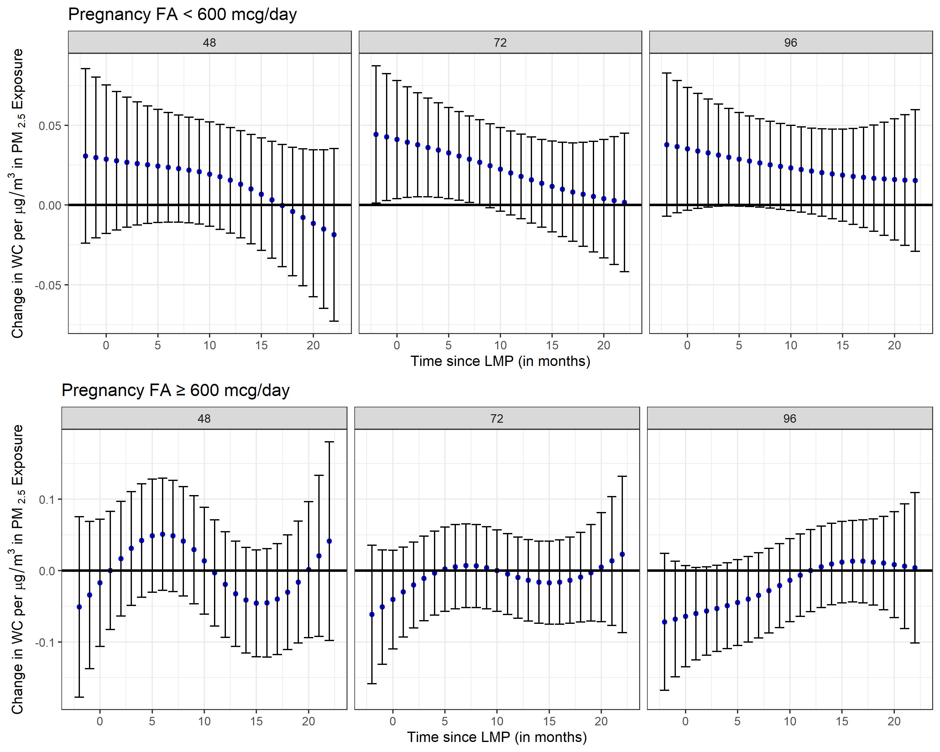

Supplemental Figure 18. Stratified analyses by folic acid (FA) supplementation during pregnancy (FA <600 mcg/day vs. FA ≥ 600 mcg/day) using distributed lag interaction models (DLIMs) with penalization and non-linear modification. Estimates of the association (blue dots) and 95% confidence interval (95% CI) (grey whiskers) between monthly PM_{2.5} exposure and body fat percentage at 48, 72, and 96 months after parturition. Negative and positive values on the x-axis indicate months before and after last menstrual period (LMP), respectively. Month 0 indicates the LMP month (month 0). Models were adjusted for age, pre-pregnancy BMI, socio-economic status, smoking during pregnancy, marital status, parity at enrollment, meteorological season, cardiometabolic medications, alcohol intake, multiple pregnancies throughout follow-up, stage, and follow-up time in months squared to allow for a nonlinear effect. Sample sizes for stratified analyses in pregnant mothers were n=337 for the low FA group (FA <600 mcg/day) and n=97 for the high FA group (FA ≥600 mcg/day).
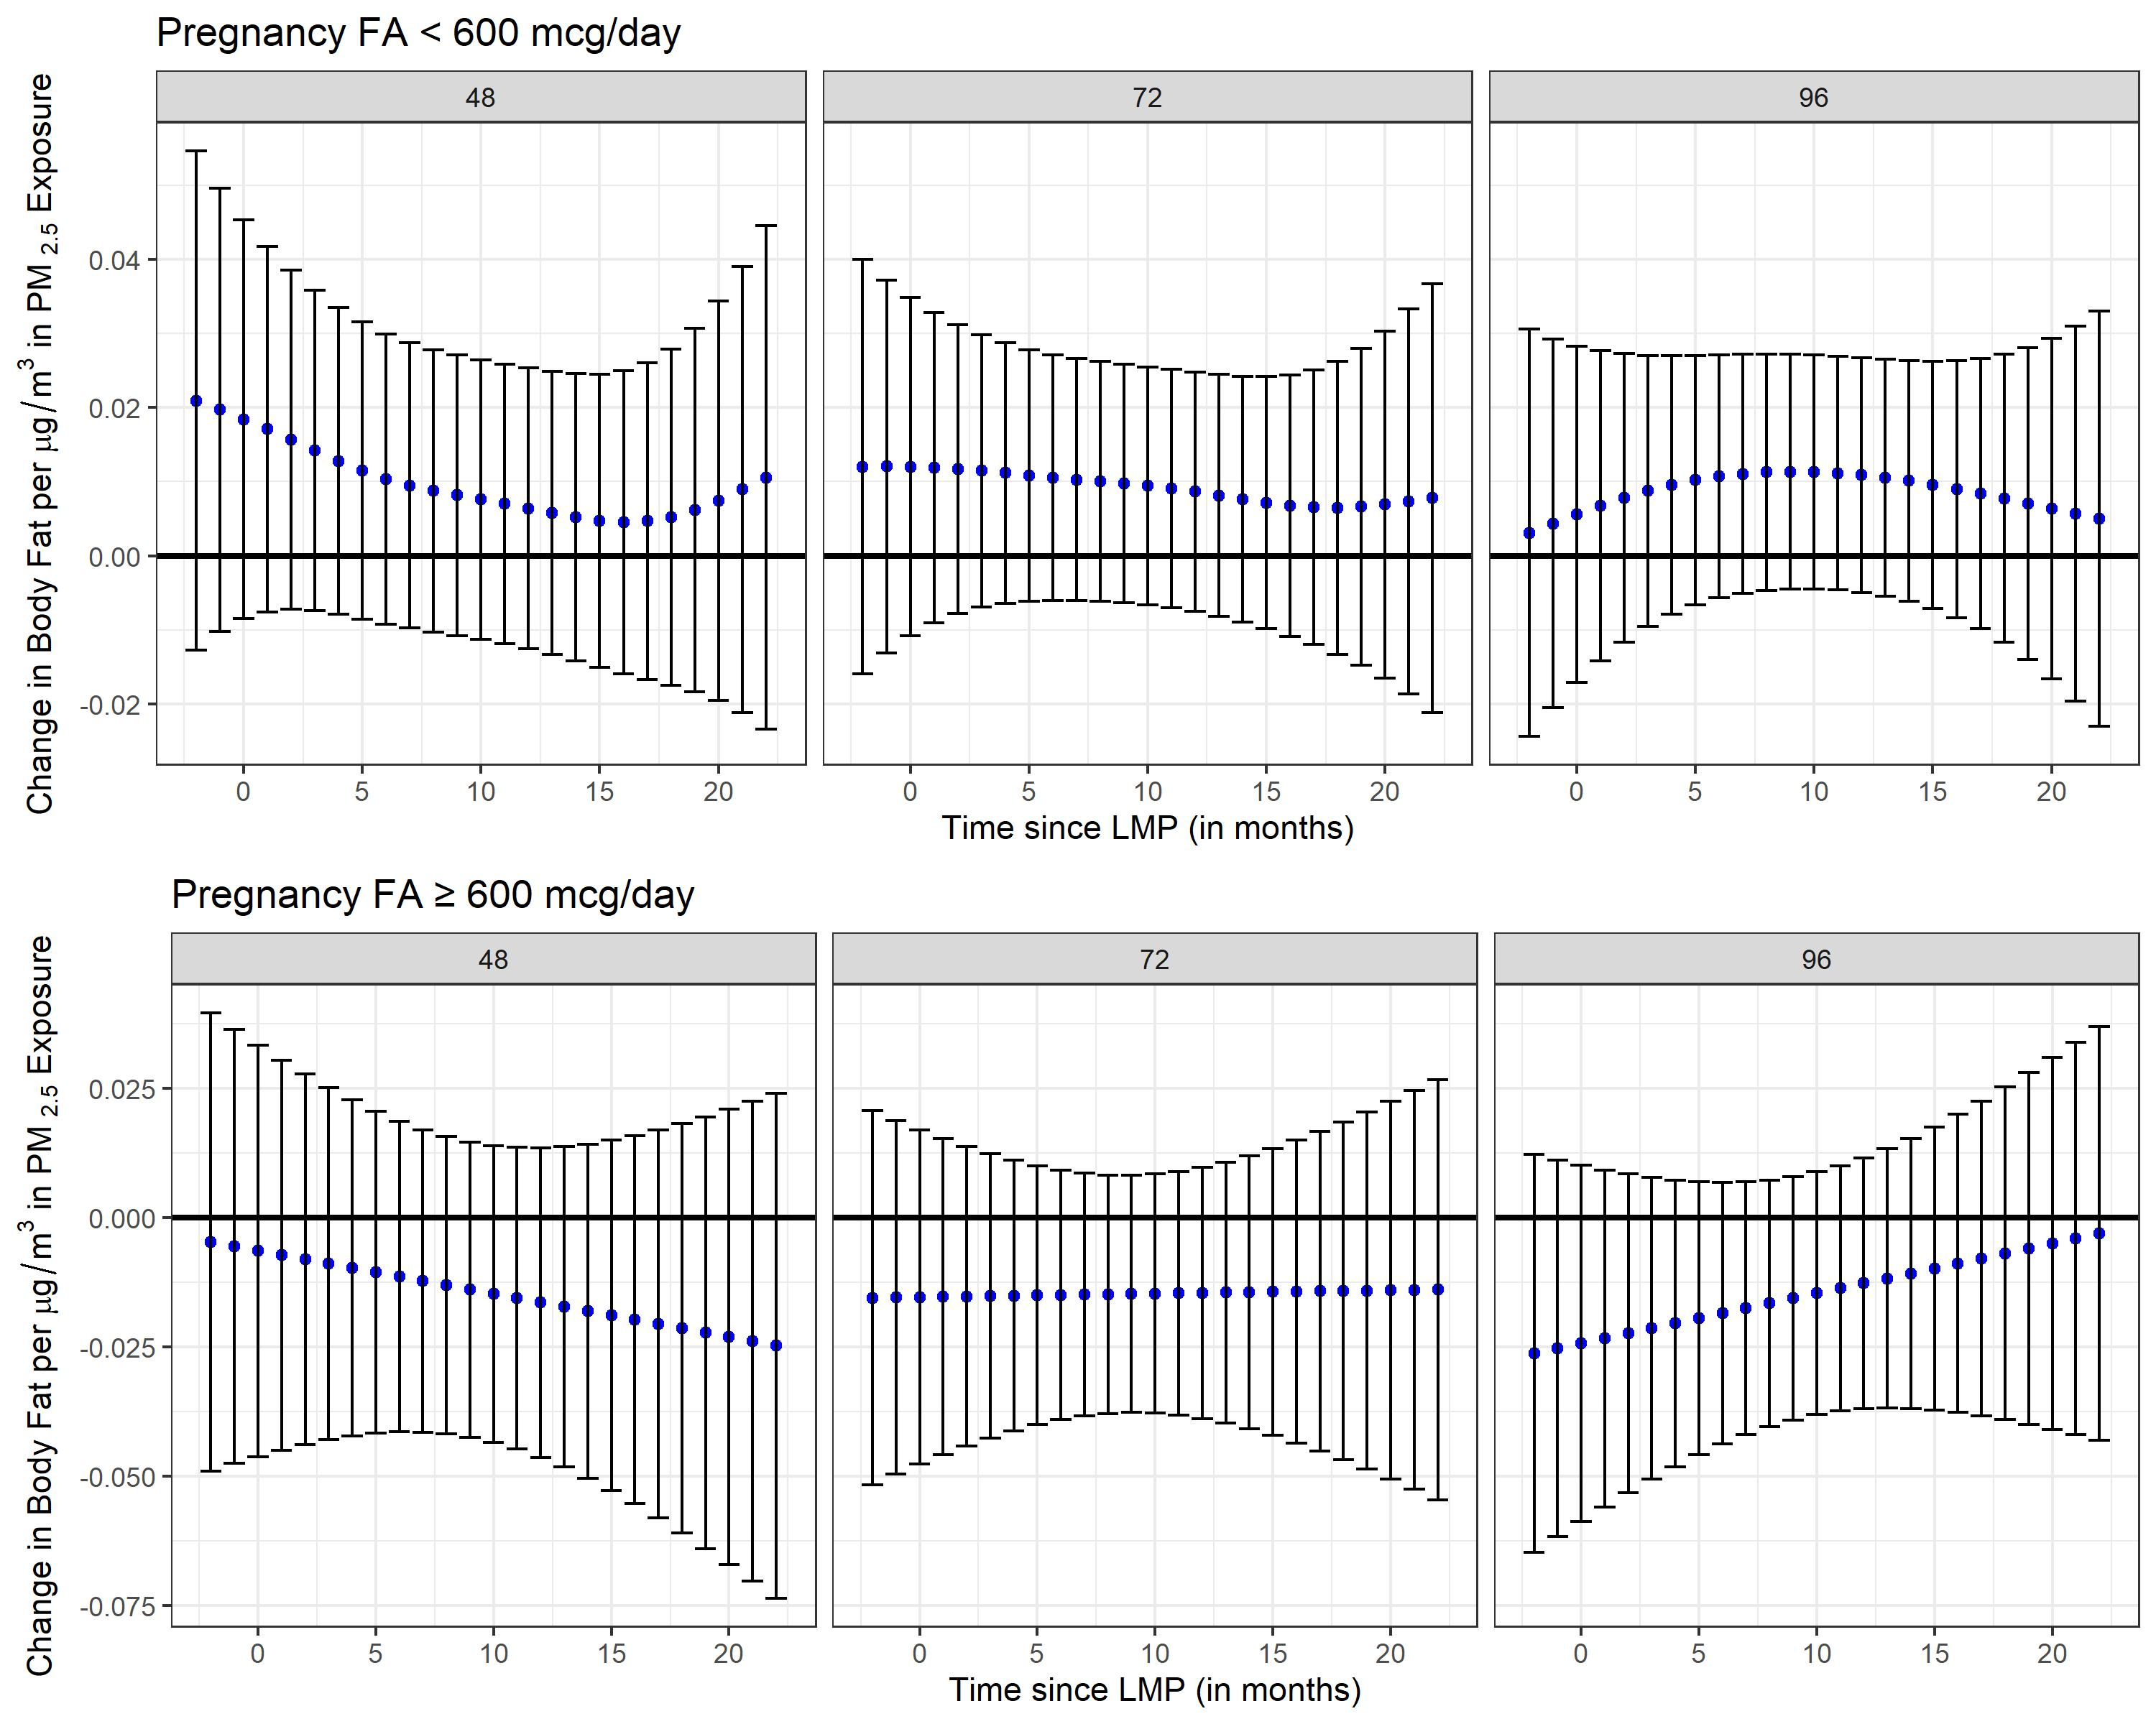

Supplemental Figure 19. Stratified analyses by folic acid (FA) supplementation during pregnancy (FA <600 mcg/day vs. FA ≥ 600 mcg/day) using distributed lag interaction models (DLIMs) with penalization and non-linear modification. Estimates of the association (blue dots) and 95% confidence interval (95% CI) (grey whiskers) between monthly PM_{2.5} exposure and total cholesterol at 48, 72, and 96 months after parturition. Negative and positive values on the x-axis indicate months before and after last menstrual period (LMP), respectively. Month 0 indicates the LMP month (month 0). Models were adjusted for age, pre-pregnancy BMI, socio-economic status, smoking during pregnancy, marital status, parity at enrollment, meteorological season, cardiometabolic medications, alcohol intake, multiple pregnancies throughout follow-up, stage, and follow-up time in months squared to allow for a nonlinear effect. Sample sizes for stratified analyses in pregnant mothers were n=339 for the low FA group (FA <600 mcg/day) and n=97 for the high FA group (FA ≥600 mcg/day).
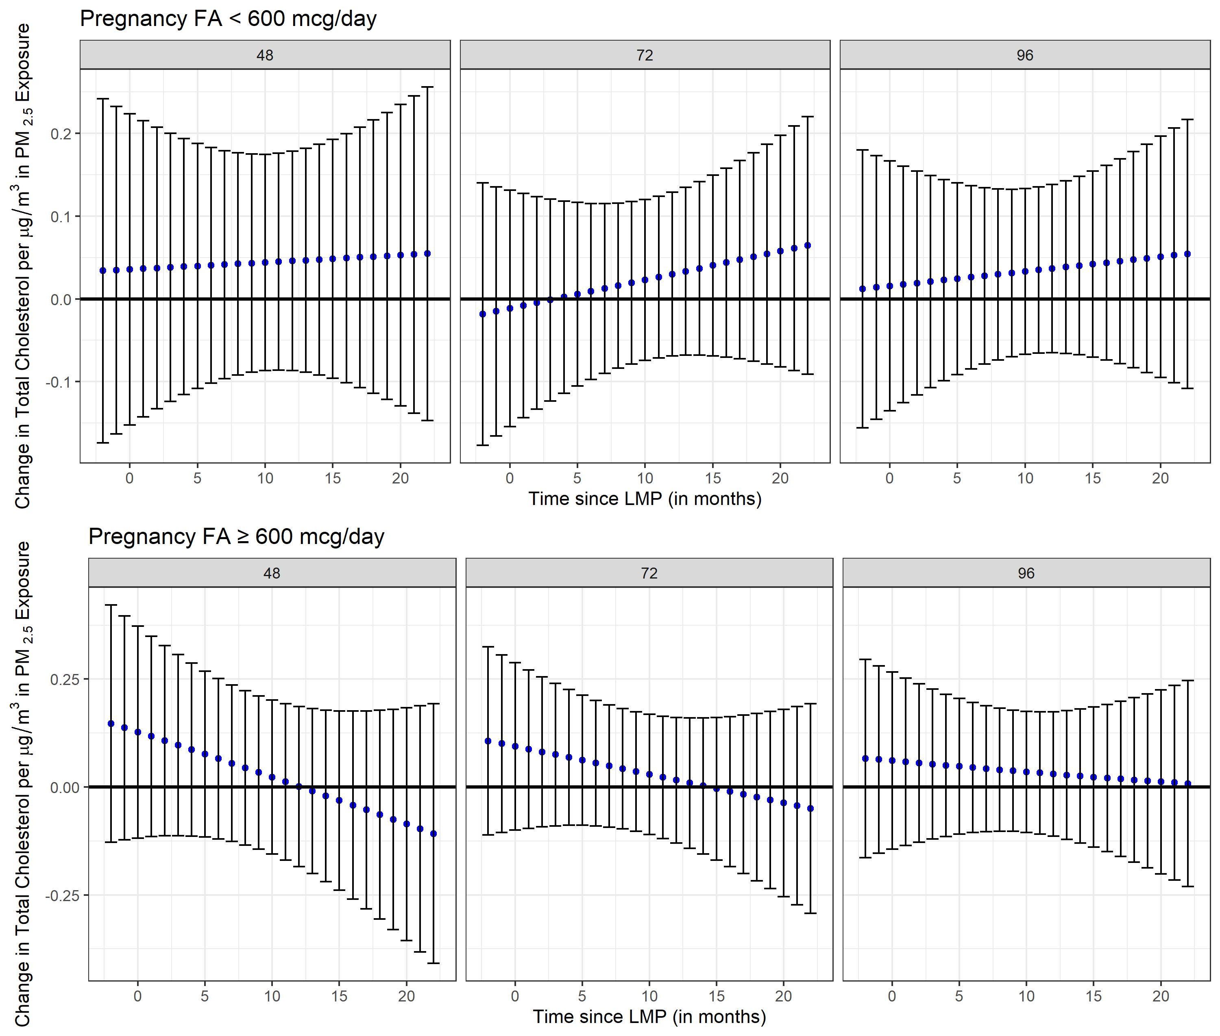

Supplemental Figure 20. Stratified analyses by folic acid (FA) supplementation during pregnancy (FA <600 mcg/day vs. FA ≥ 600 mcg/day) using distributed lag interaction models (DLIMs) with penalization and non-linear modification. Estimates of the association (blue dots) and 95% confidence interval (95% CI) (grey whiskers) between monthly PM_{2.5} exposure and high-density lipoprotein (HDL) at 48, 72, and 96 months after parturition. Negative and positive values on the x-axis indicate months before and after last menstrual period (LMP), respectively. Month 0 indicates the LMP month (month 0). Models were adjusted for age, pre-pregnancy BMI, socio-economic status, smoking during pregnancy, marital status, parity at enrollment, meteorological season, cardiometabolic medications, alcohol intake, multiple pregnancies throughout follow-up, stage, and follow-up time in months squared to allow for a nonlinear effect. Sample sizes for stratified analyses in pregnant mothers were n=339 for the low FA group (FA <600 mcg/day) and n=97 for the high FA group (FA ≥600 mcg/day).
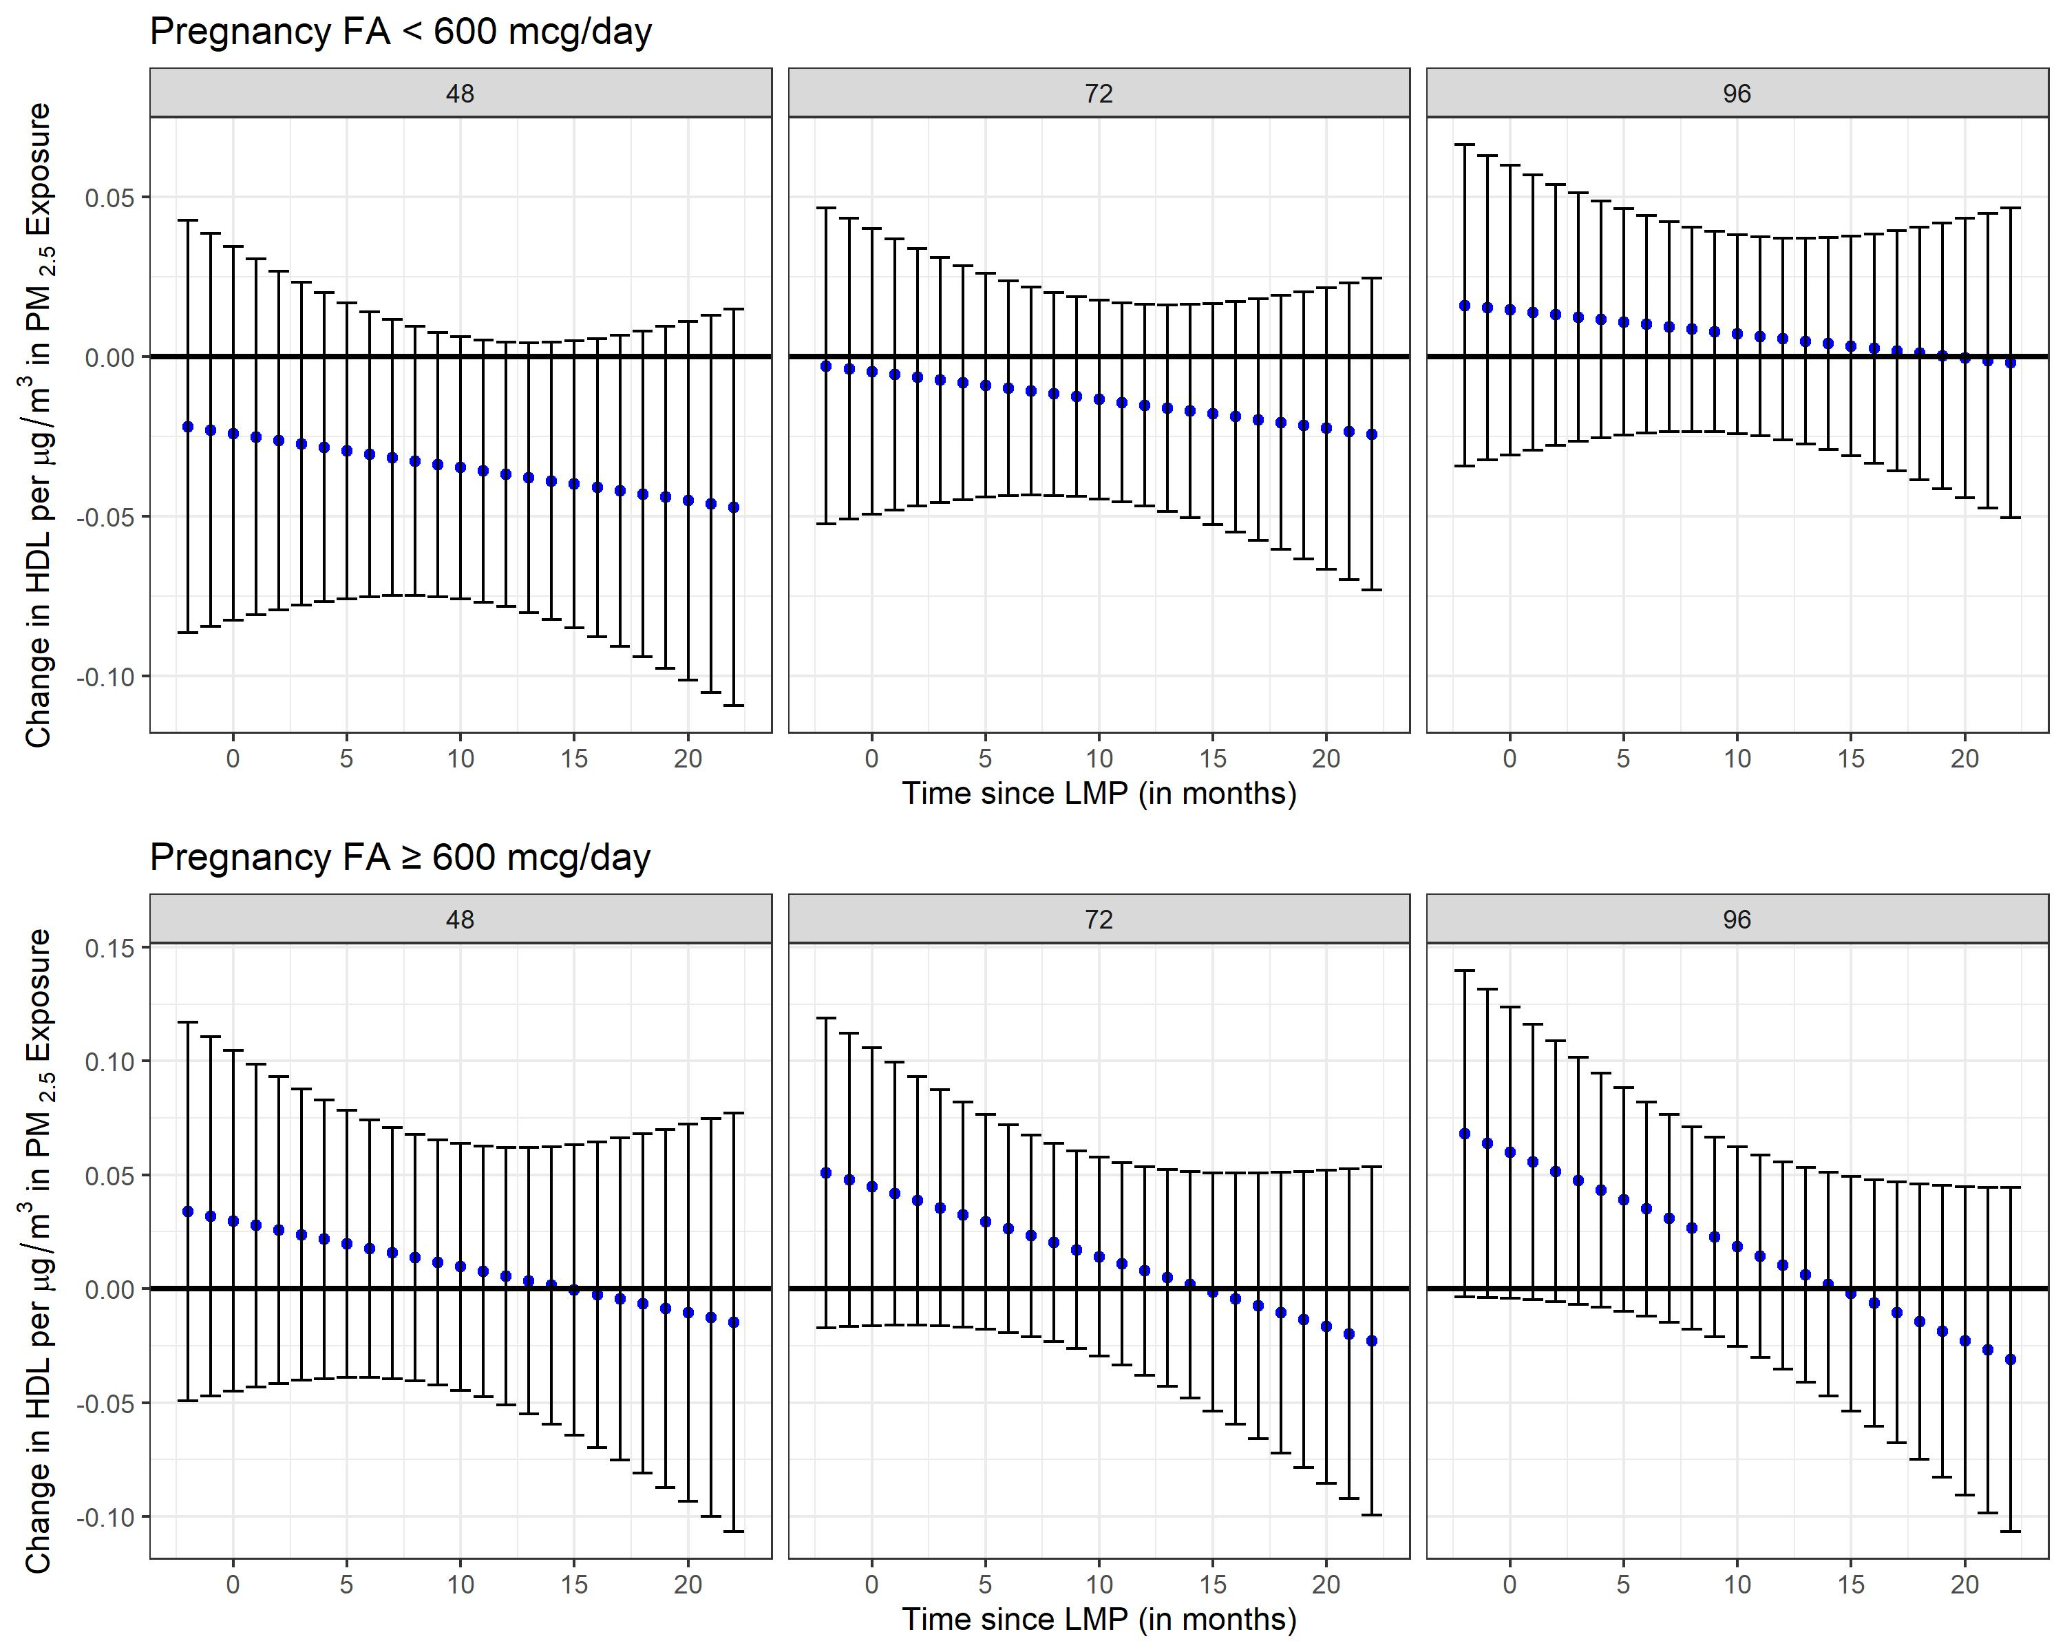

Supplemental Figure 21. Stratified analyses by folic acid (FA) supplementation during pregnancy (FA <600 mcg/day vs. FA ≥ 600 mcg/day) using distributed lag interaction models (DLIMs) with penalization and non-linear modification. Estimates of the association (blue dots) and 95% confidence interval (95% CI) (grey whiskers) between monthly PM_{2.5} exposure and low-density lipoprotein (LDL) at 48, 72, and 96 months after parturition. Negative and positive values on the x-axis indicate months before and after last menstrual period (LMP), respectively. Month 0 indicates the LMP month (month 0). Models were adjusted for age, pre-pregnancy BMI, socio-economic status, smoking during pregnancy, marital status, parity at enrollment, meteorological season, cardiometabolic medications, alcohol intake, multiple pregnancies throughout follow-up, stage, and follow-up time in months squared to allow for a nonlinear effect. Sample sizes for stratified analyses in pregnant mothers were n=339 for the low FA group (FA <600 mcg/day) and n=97 for the high FA group (FA ≥600 mcg/day).
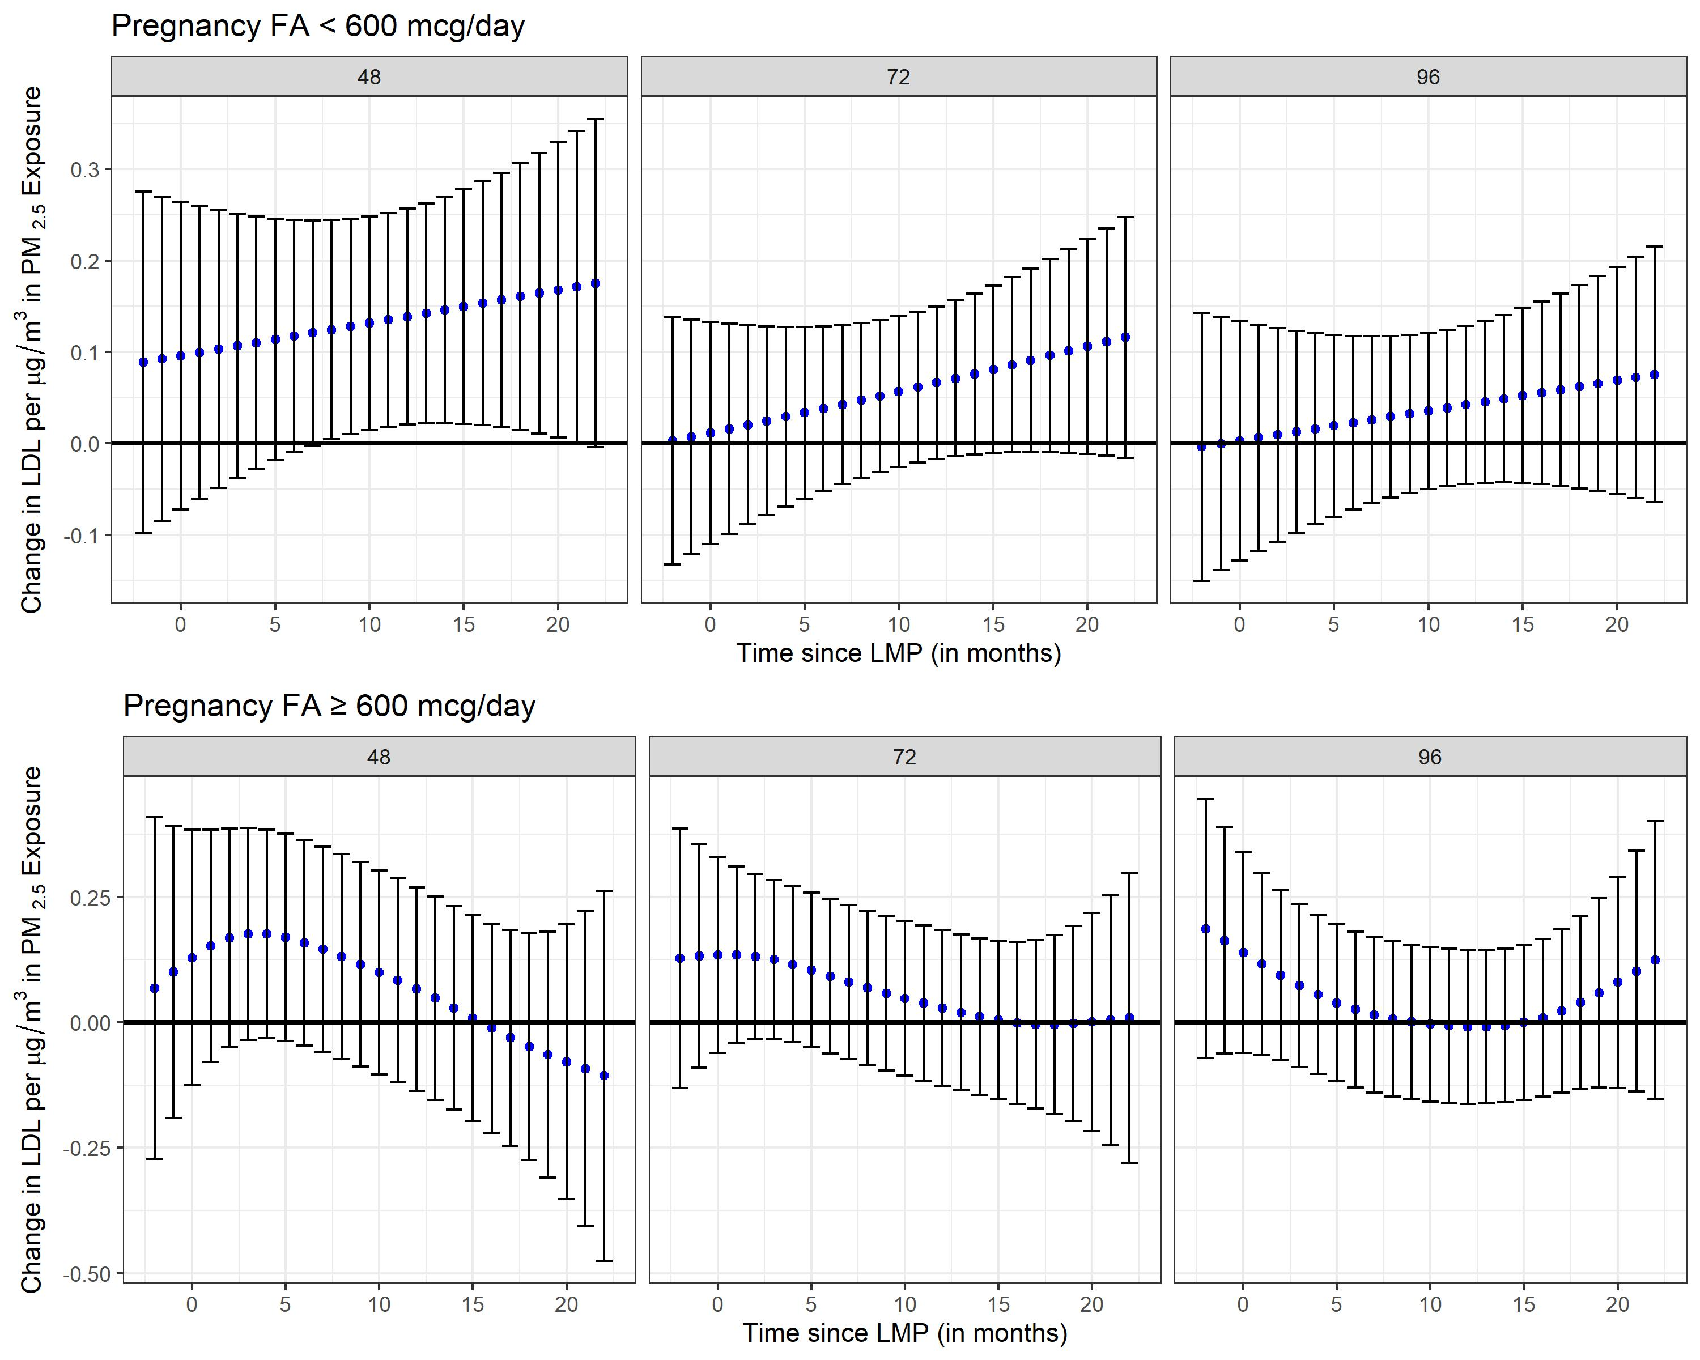

References
1 Gutiérrez-Avila, I. et al. Prediction of daily mean and one-hour maximum PM2.5 concentrations and applications in Central Mexico using satellite-based machine-learning models. Journal of Exposure Science & Environmental Epidemiology (2022). https://doi.org:10.1038/s41370-022-00471-4
2 Nesti, L. & Natali, A. Metformin effects on the heart and the cardiovascular system: A&#xa0;review of experimental and clinical data. Nutrition, Metabolism and Cardiovascular Diseases 27, 657-669 (2017). https://doi.org:10.1016/j.numecd.2017.04.009
3 Gasparrini, A., Scheipl, F., Armstrong, B. & Kenward, M. G. A Penalized Framework for Distributed Lag Non-Linear Models. Biometrics 73, 938-948 (2017). https://doi.org:10.1111/biom.12645
4 Demateis, D., Keller, K. P., Rojas-Rueda, D., Kioumourtzoglou, M.-A. & Wilson, A. Penalized distributed lag interaction model: Air pollution, birth weight, and neighborhood vulnerability. Environmetrics 35, e2843 (2024). https://doi.org:https://doi.org/10.1002/env.2843

