**Additional file 7**

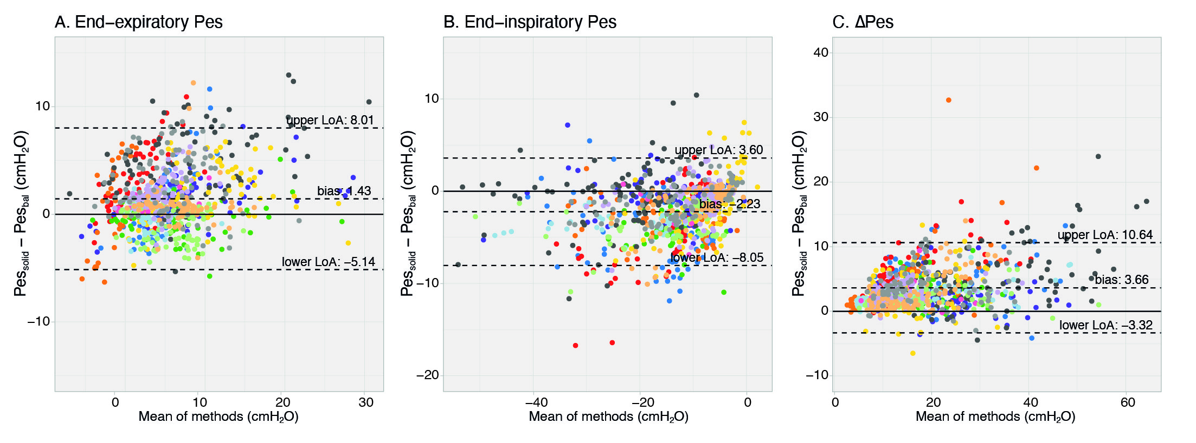

**Additional figure 7.** Healthy volunteers: Bland-Altman results for Baydur balloon within range 0.8-1.2. Each color represent a different subject.