**Additional file 10**

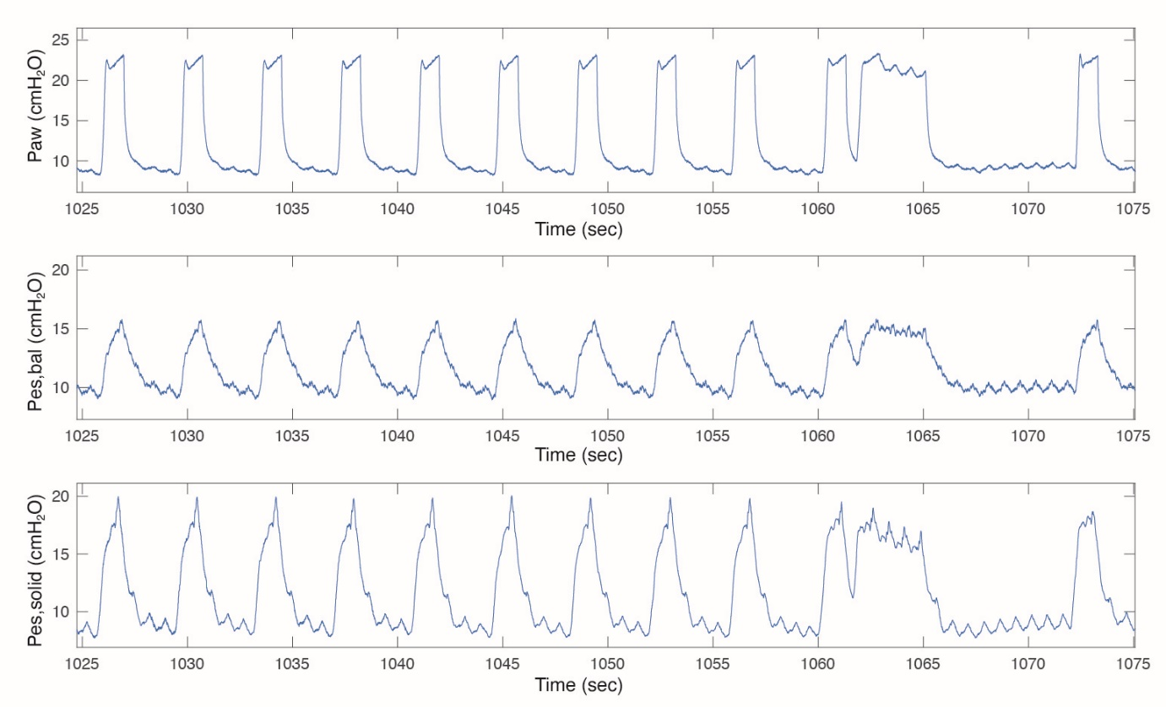

**Additional figure 10.** Example of a patient with very high inspiratory and thus also high ΔPessolid values that we could not attribute to cardiac artifacts only.