**SUPPLEMENTARY FIGURES**

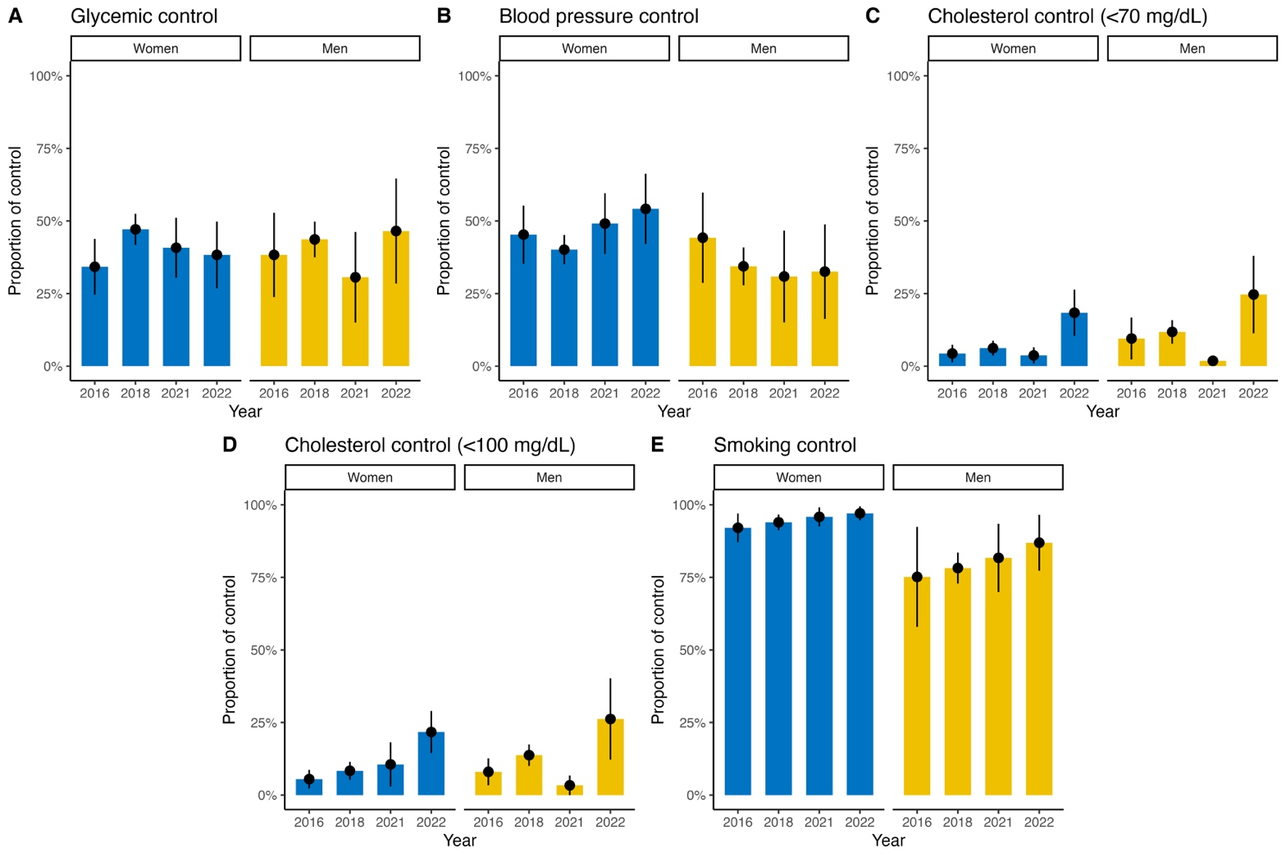

**Supplementary Figure 1.** Prevalence of control achievement in individuals with diagnosed diabetes in Mexico during 2016-2022 stratified by sex. (A) Prevalence of glycemic control, (B) Prevalence of blood pressure control, (C) Prevalence of cholesterol control (<70 mg/dL), (D) Prevalence of cholesterol control (<100 mg/dL), (E) Prevalence of smoking control.

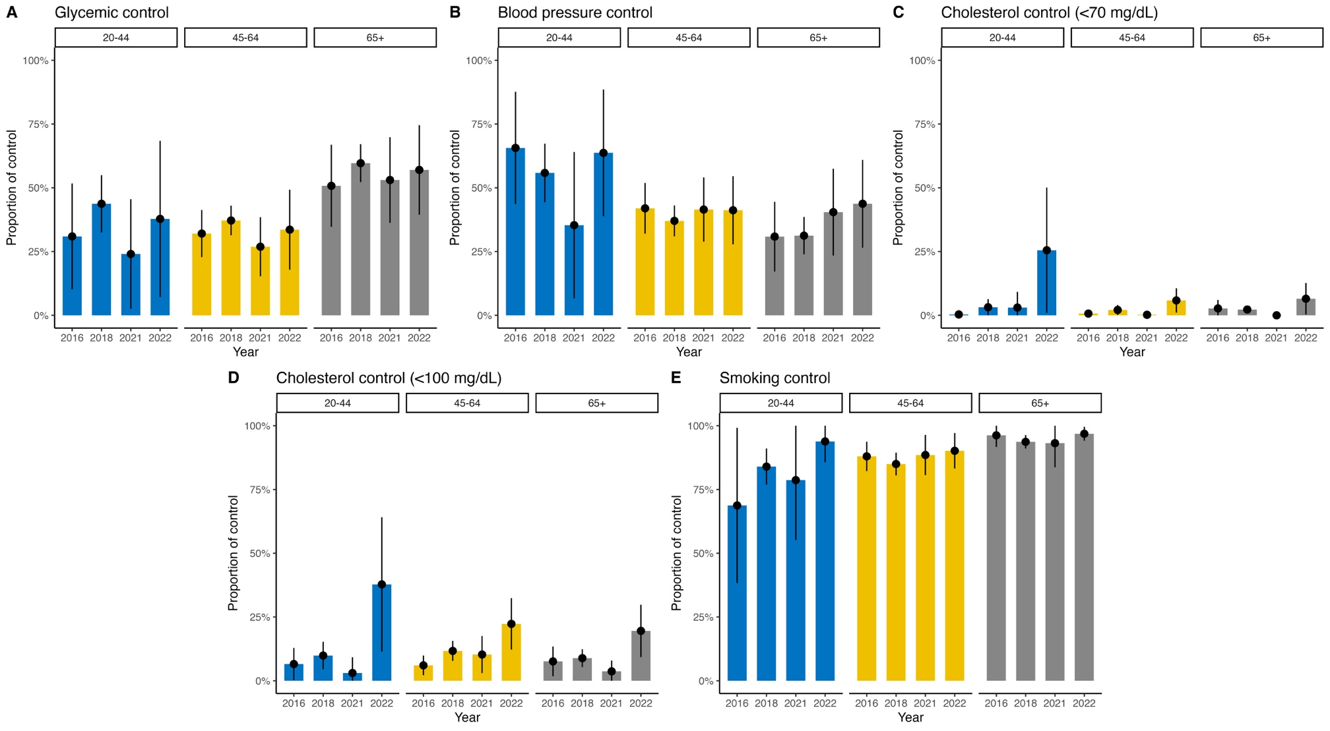

**Supplementary Figure 2.** Prevalence of control achievement in individuals with diagnosed diabetes in Mexico during 2016-2022 stratified by age groups. (A) Prevalence of glycemic control, (B) Prevalence of blood pressure control, (C) Prevalence of cholesterol control (<70 mg/dL), (D) Prevalence of cholesterol control (<100 mg/dL), (E) Prevalence of smoking control.

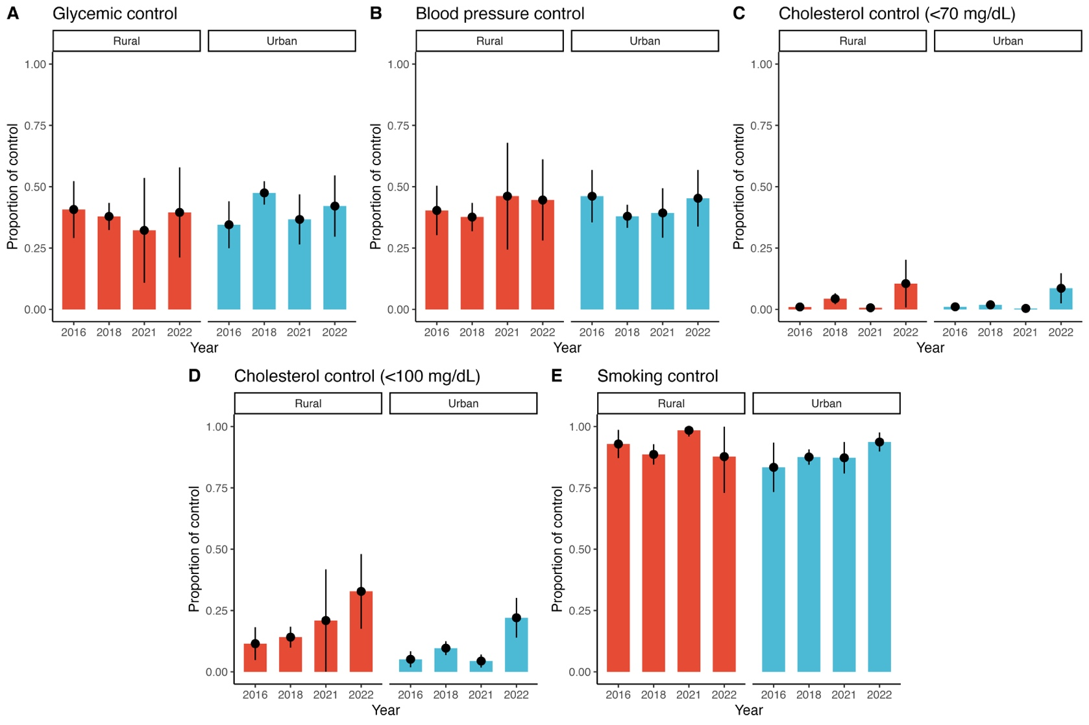

**Supplementary Figure 3.** Prevalence of control achievement in individuals with diagnosed diabetes in Mexico during 2016-2022 stratified by urban versus rural region. (A) Prevalence of glycemic control, (B) Prevalence of blood pressure control, (C) Prevalence of cholesterol control (<70 mg/dL), (D) Prevalence of cholesterol control (<100 mg/dL), (E) Prevalence of smoking control.

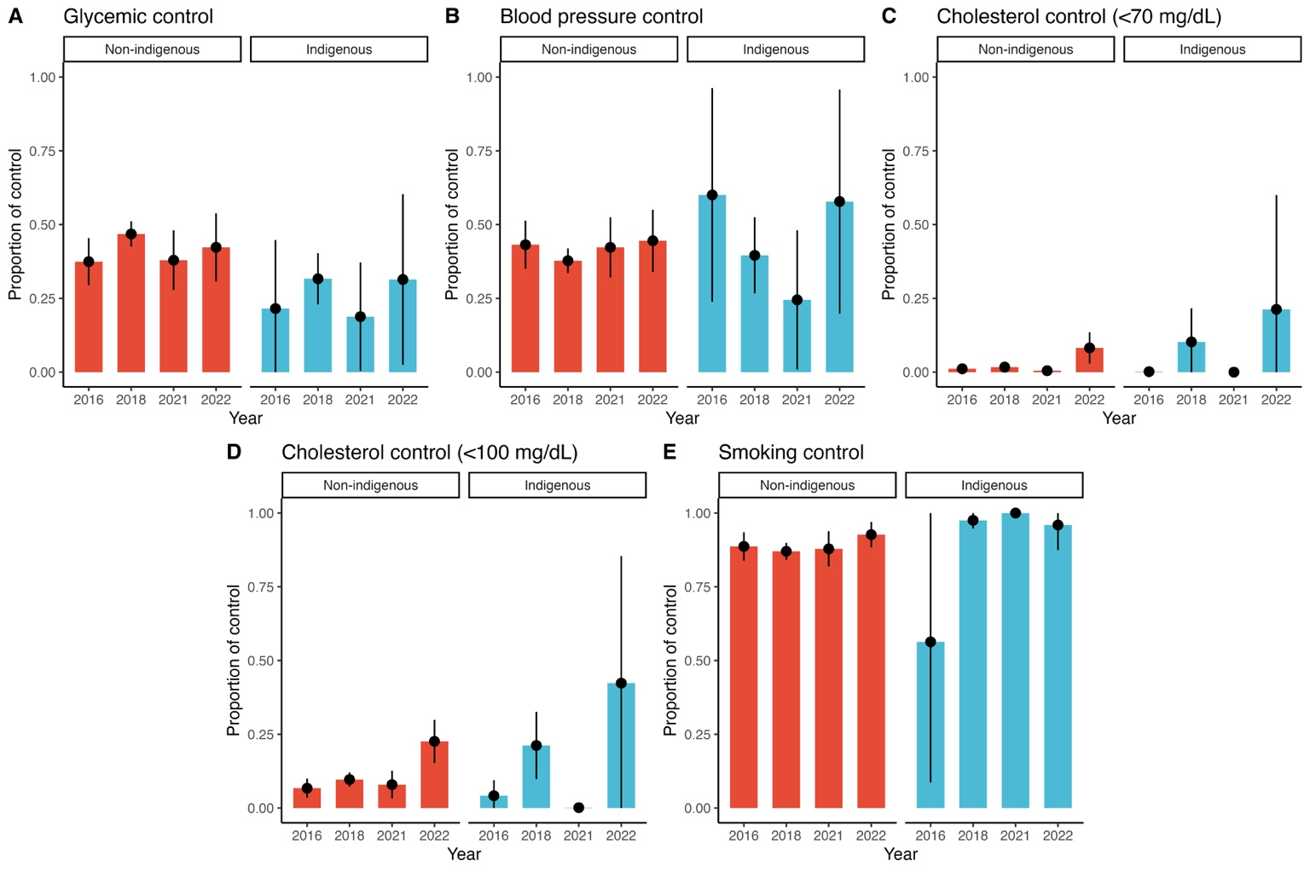

**Supplementary Figure 4.** Prevalence of control achievement in individuals with diagnosed diabetes in Mexico during 2016-2022 stratified by indigenous identity. (A) Prevalence of glycemic control, (B) Prevalence of blood pressure control, (C) Prevalence of cholesterol control (<70 mg/dL), (D) Prevalence of cholesterol control (<100 mg/dL), (E) Prevalence of smoking control.

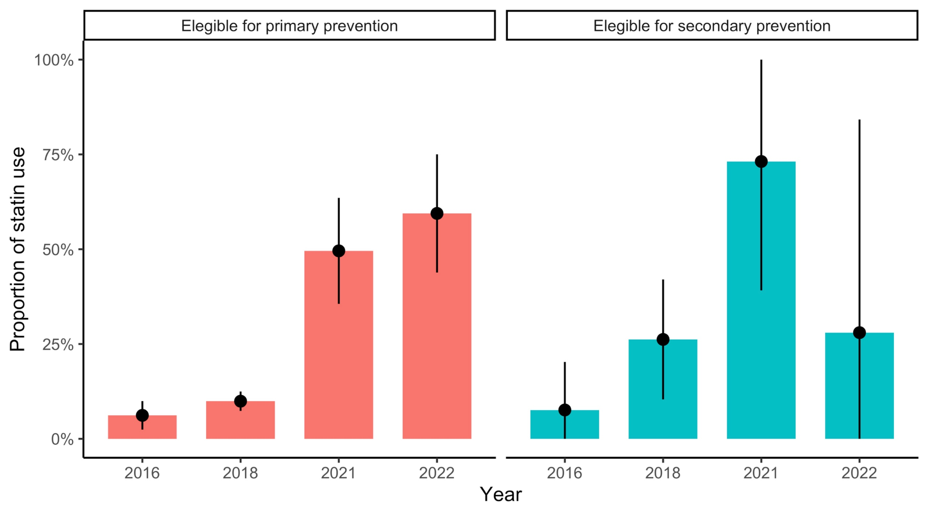

**Supplementary Figure 5.** Prevalence of statin users amongst individuals with diabetes eligible for primary and secondary prevention during the 2016-2022 period.