Supplementary Figures

Supplementary Figure S1. Single SNP analysis from UVMR of NMR on chronotype UK Biobank stratified by smoking status

- Current smokers
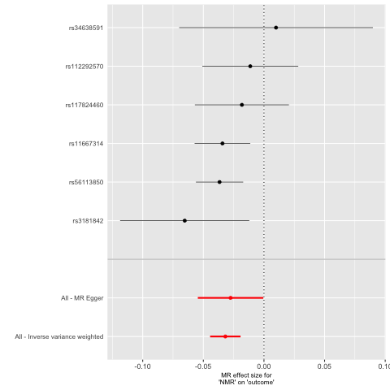

- Ever smokers

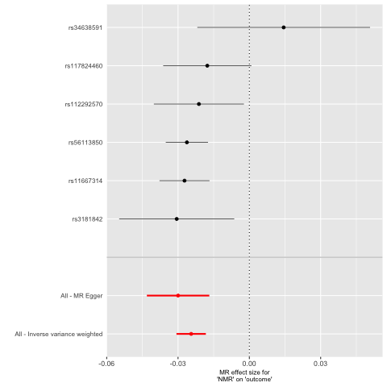

- Former smokers
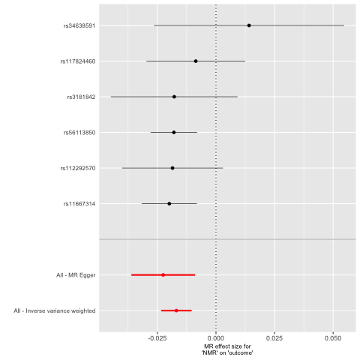

- Never smokers
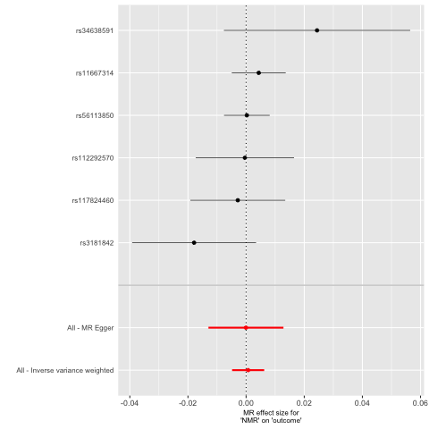

Supplementary Figure 2. Funnel plot from UVMR of NMR on chronotype UK Biobank stratified by smoking status

- Current smokers
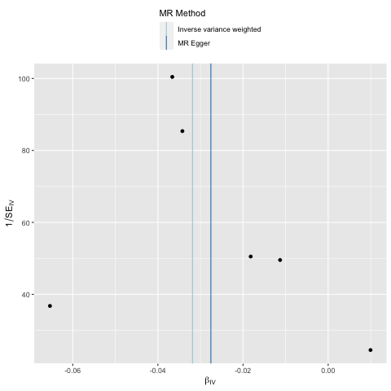

- Ever smokers

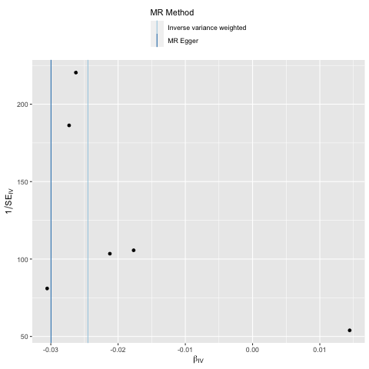

- Former smokers

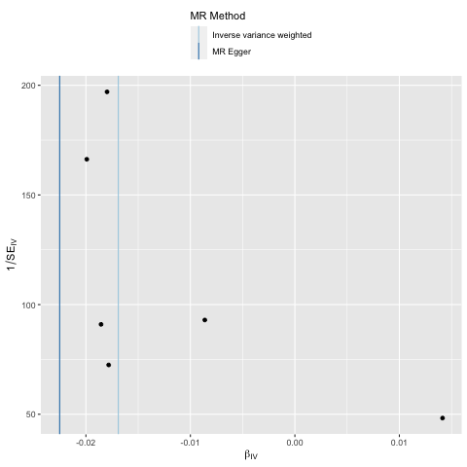

- Never smokers
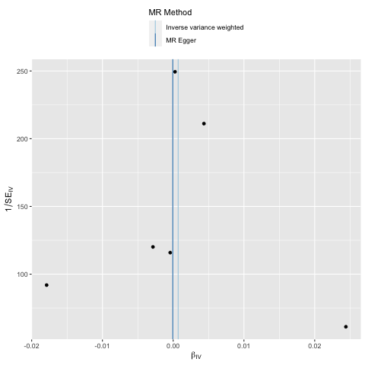

Supplementary Figure 3. Leave one out analysis from UVMR of NMR on chronotype UK Biobank stratified by smoking status

- Current smokers
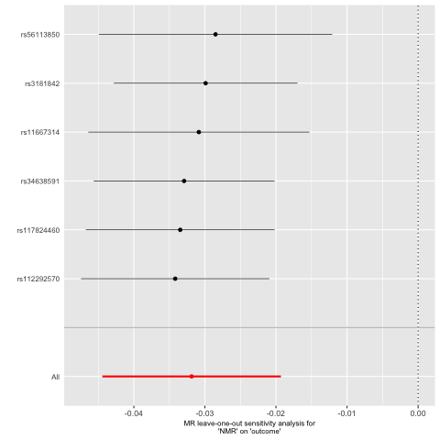

- Ever smokers
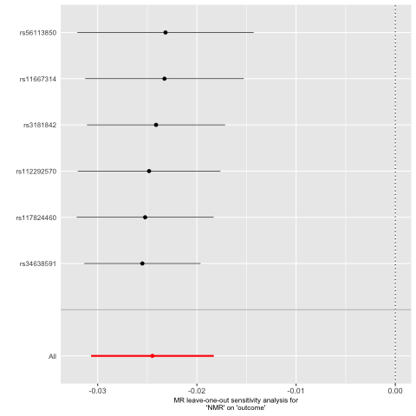

- Former smokers
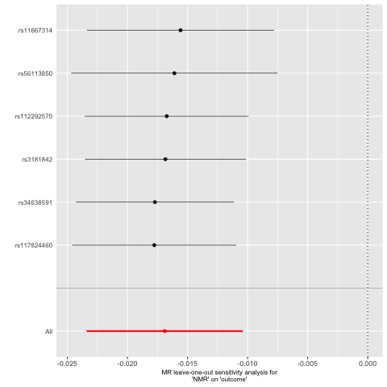

- Never smokers
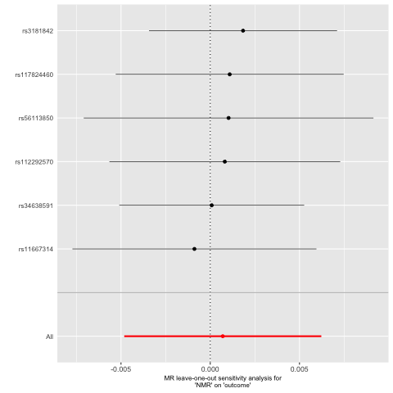

Supplementary Figure 4. Single SNP analysis from UVMR of NMR on getting up UK Biobank stratified by smoking status

- Current smokers
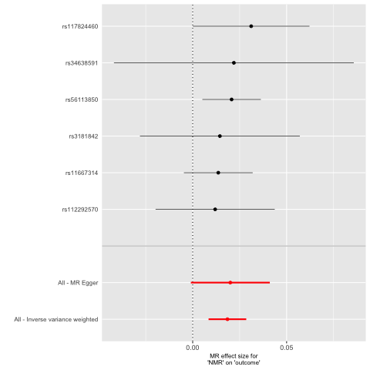

- Ever smokers
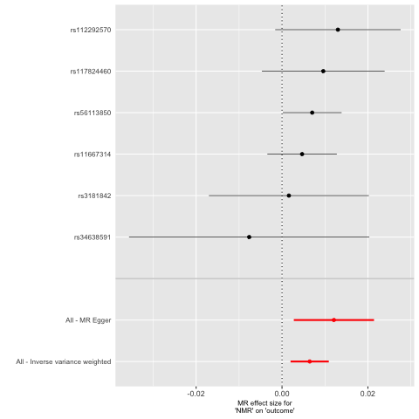

- Former smokers
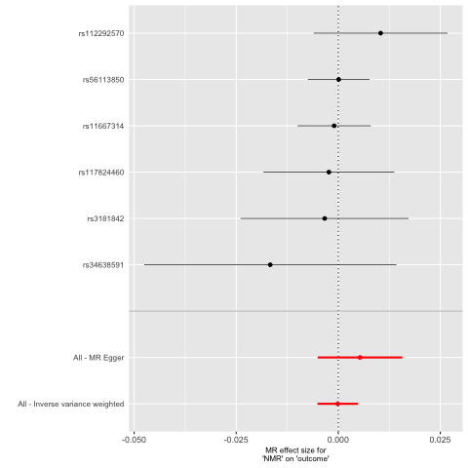

- Never smokers
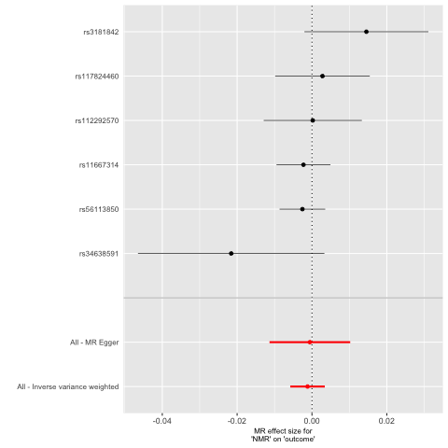

Supplementary Figure 5. Funnel plot from UVMR of NMR on getting up UK Biobank stratified by smoking status

- Current smokers
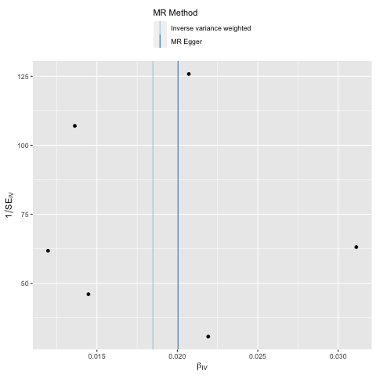

- Ever smokers
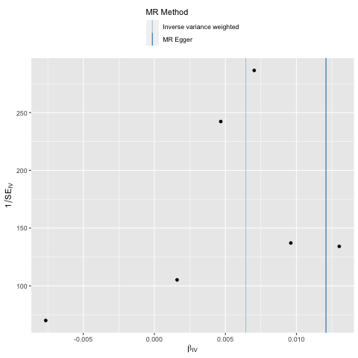

- Former smokers
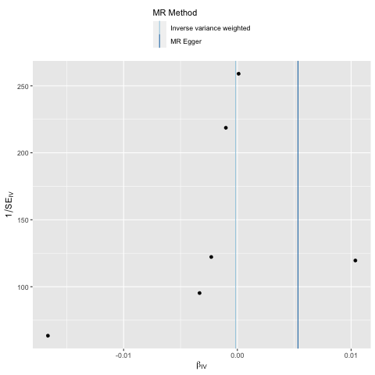

- Never smokers
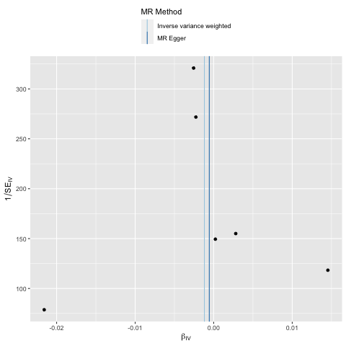

Supplementary Figure 6. Leave one out analysis from UVMR of NMR on getting up UK Biobank stratified by smoking status
- Current smokers
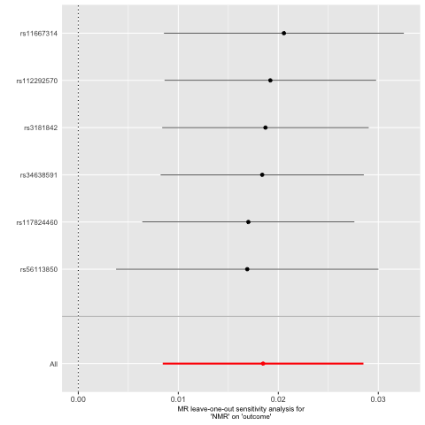

- Ever smokers
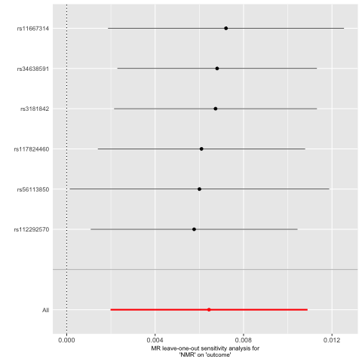

- Former smokers
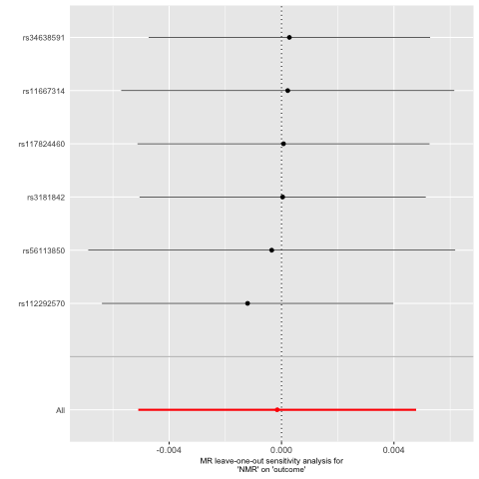

- Never smokers

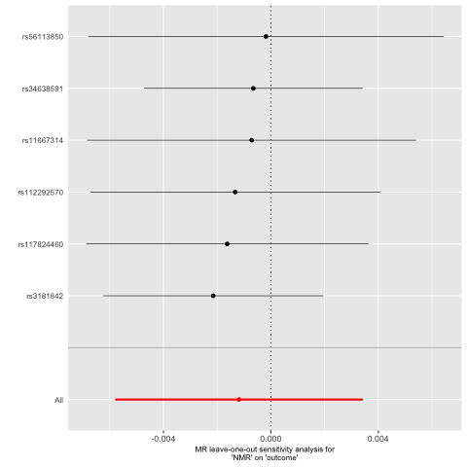

Supplementary Figure 7. Single SNP analysis from UVMR of NMR on insomnia symptoms UK Biobank stratified by smoking status

- Current smokers
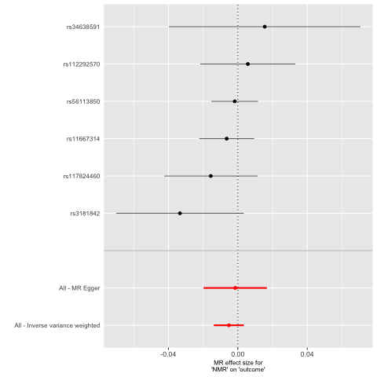

- Ever smokers
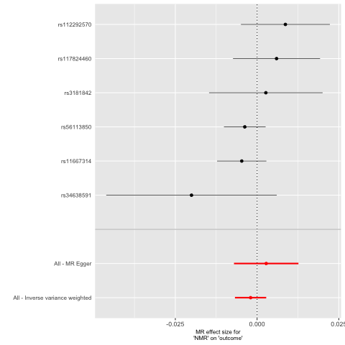

- Former smokers

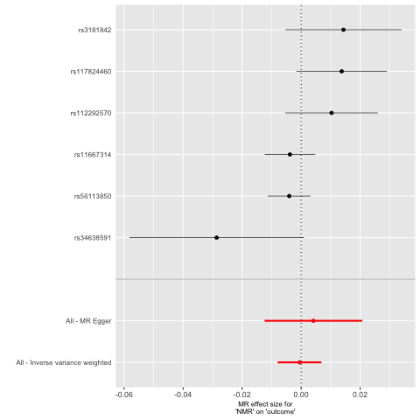

- Never smokers

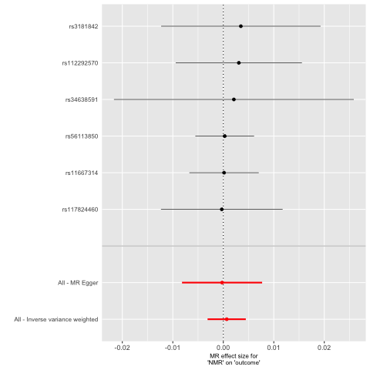

Supplementary Figure 8. Funnel plot from UVMR of NMR on insomnia symptoms UK Biobank stratified by smoking status

- Current smokers
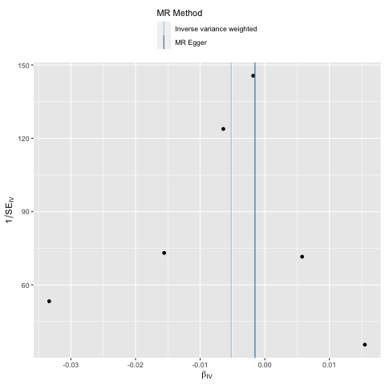

- Ever smokers
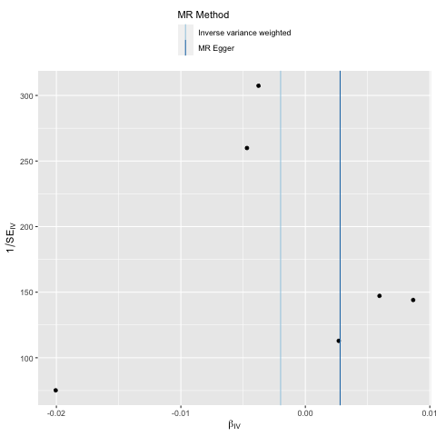

- Former smokers
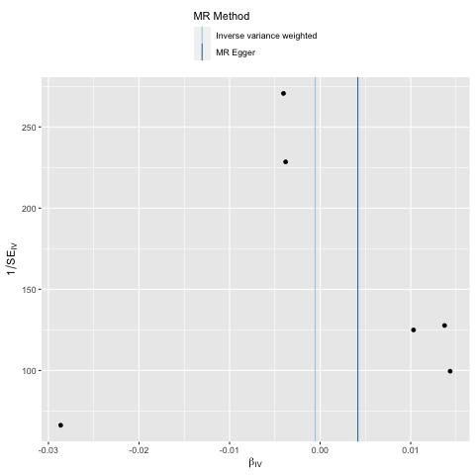

- Never smokers

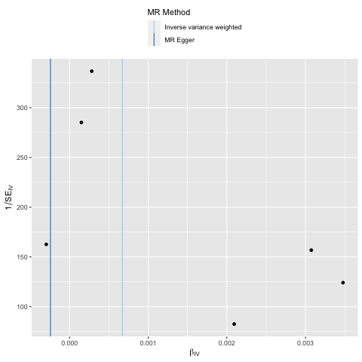

Supplementary Figure 9. Leave one out analysis from UVMR of NMR on insomnia symptoms UK Biobank stratified by smoking status

- Current smokers
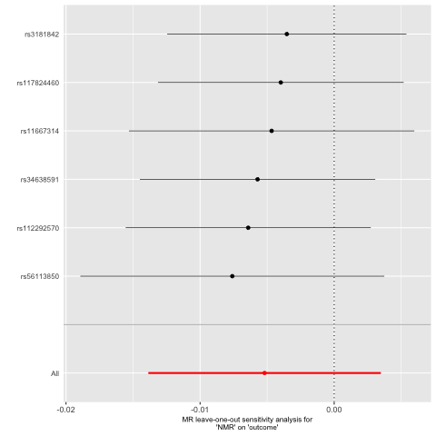

- Ever smokers

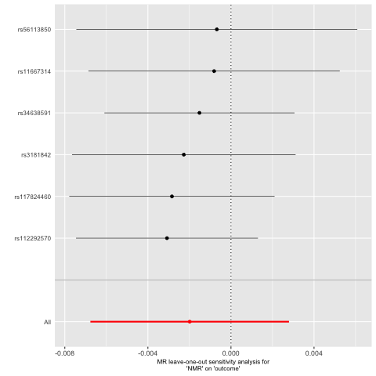

- Former smokers

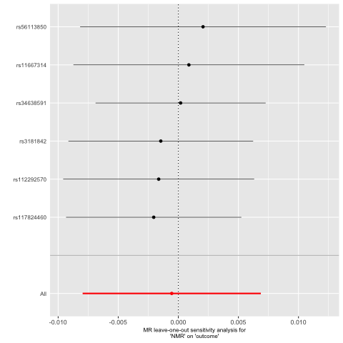

- Never smokers

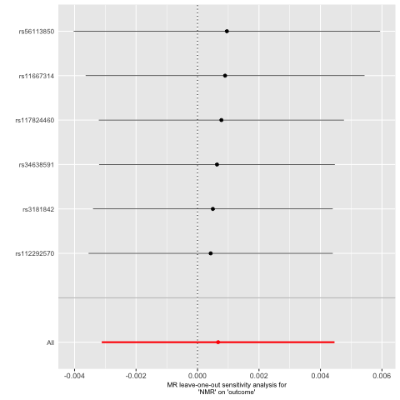

Supplementary Figure 10. Single SNP analysis from UVMR of NMR on napping UK Biobank stratified by smoking status

- Current smokers
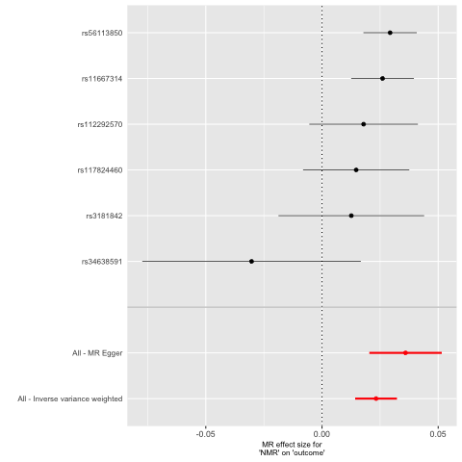

- Ever smokers

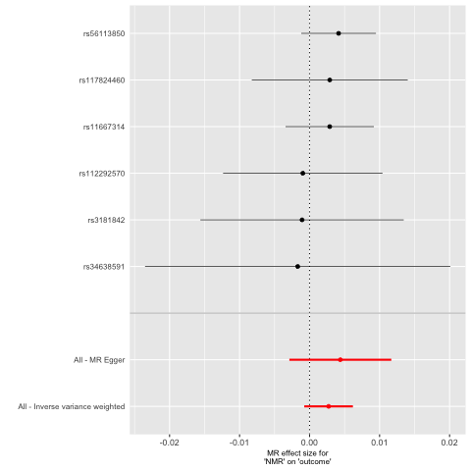

- Former smokers

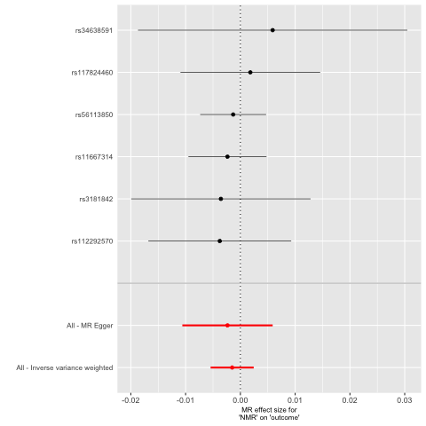

- Never smokers

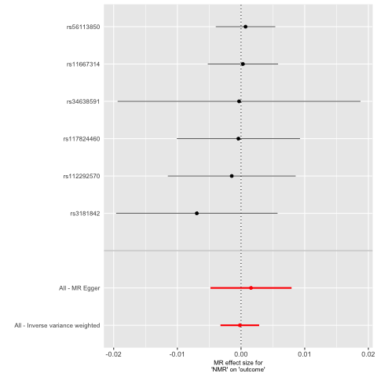

Supplementary Figure 11. Funnel plot from UVMR of NMR on napping UK Biobank stratified by smoking status

- Current smokers
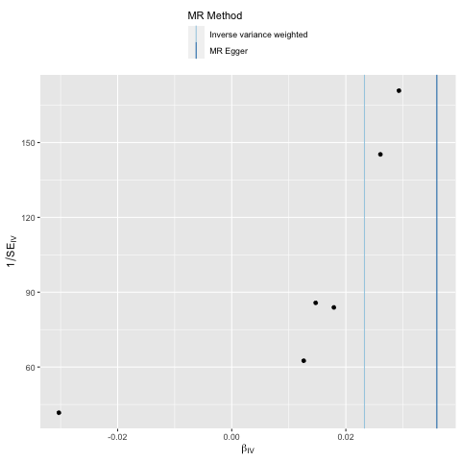

- Ever smokers

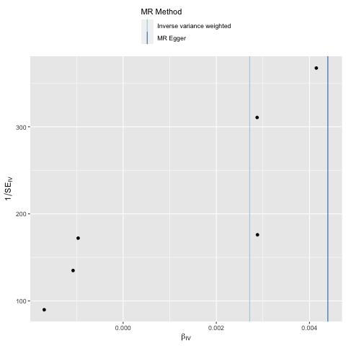

- Former smokers

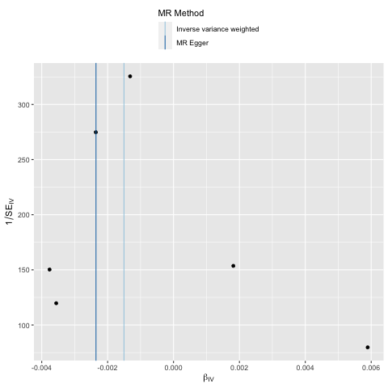

- Never smokers

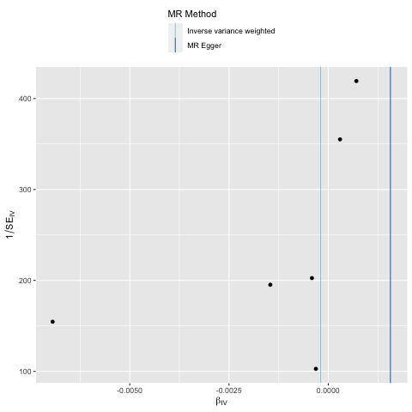

Supplementary Figure 12. Leave one out analysis from UVMR of NMR on napping UK Biobank stratified by smoking status

- Current smokers

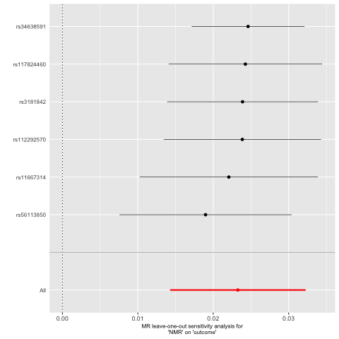

- Ever smokers

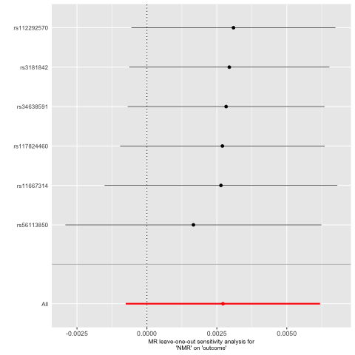

- Former smokers

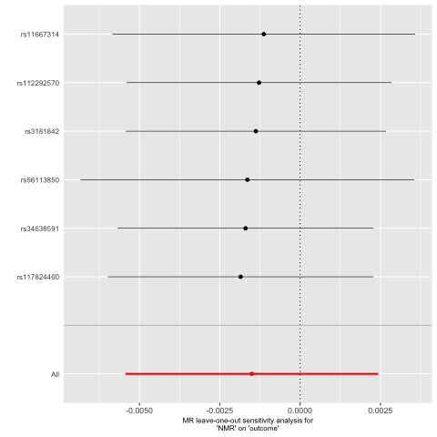

- Never smokers

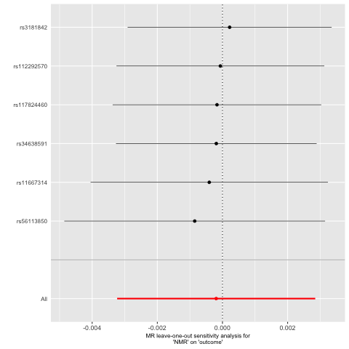

Supplementary Figure 13. Single SNP analysis from UVMR of NMR on daytime sleepiness UK Biobank stratified by smoking status

- Current smokers

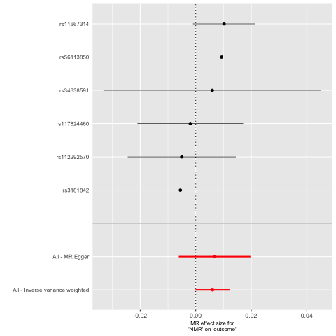

- Ever smokers

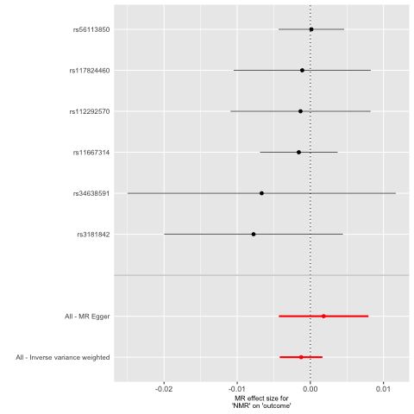

- Former smokers

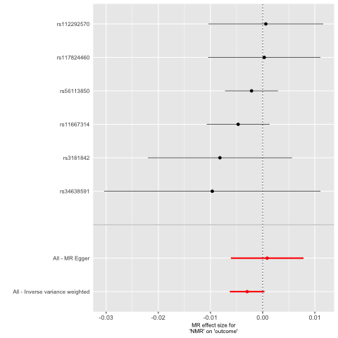

- Never smokers

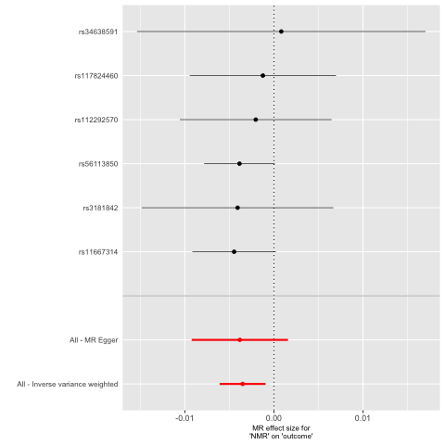

Supplementary Figure 14. Funnel plot from UVMR of NMR on daytime sleepiness UK Biobank stratified by smoking status

- Current smokers

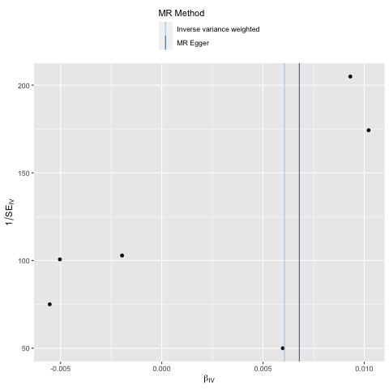

- Ever smokers

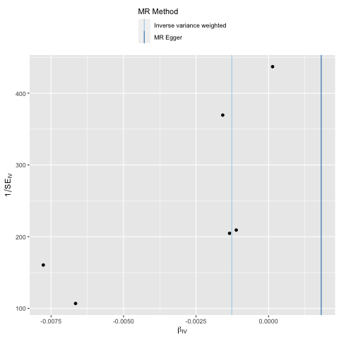

- Former smokers

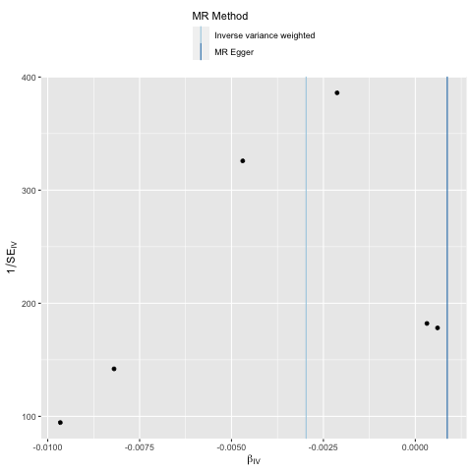

- Never smokers

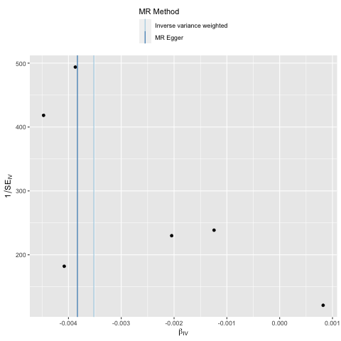

Supplementary Figure 15. Leave one out analysis from UVMR of NMR on daytime sleepiness UK Biobank stratified by smoking status

- Current smokers

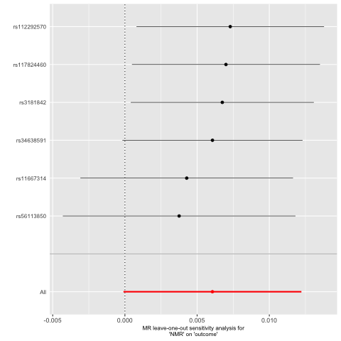

- Ever smokers

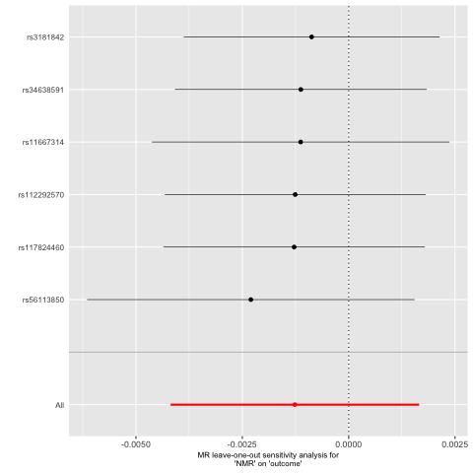

- Former smokers

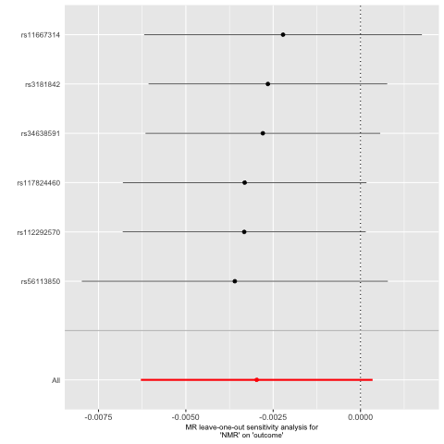

- Never smokers

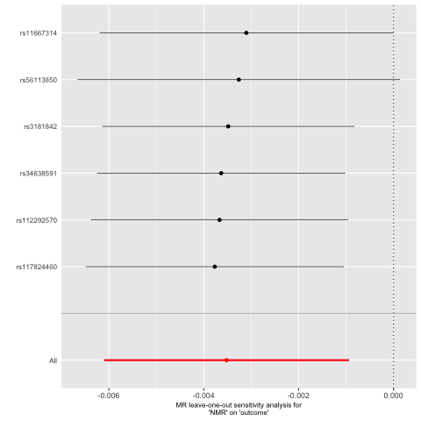

Supplementary Figure 16. Single SNP analysis from UVMR of NMR on sleep duration UK Biobank stratified by smoking status

- Current smokers

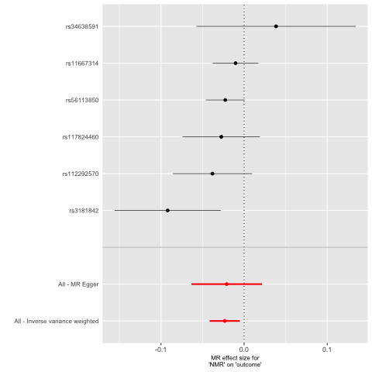

- Ever smokers

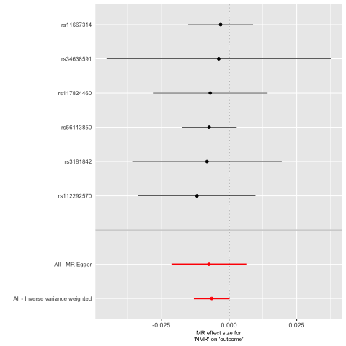

- Former smokers

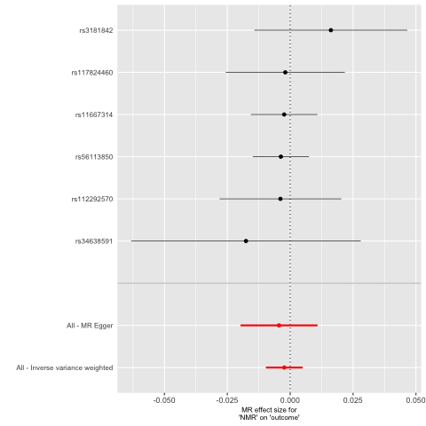

- Never smokers

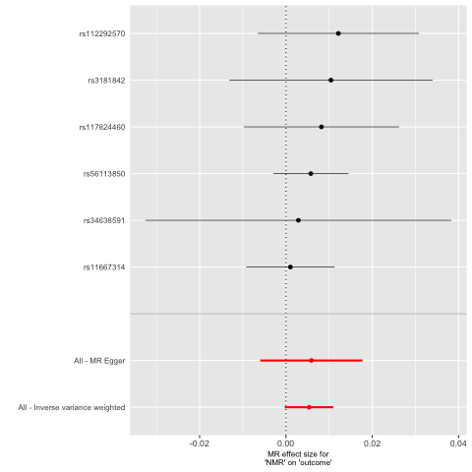

Supplementary Figure 17. Funnel plot from UVMR of NMR on sleep duration UK Biobank stratified by smoking status

- Current smokers

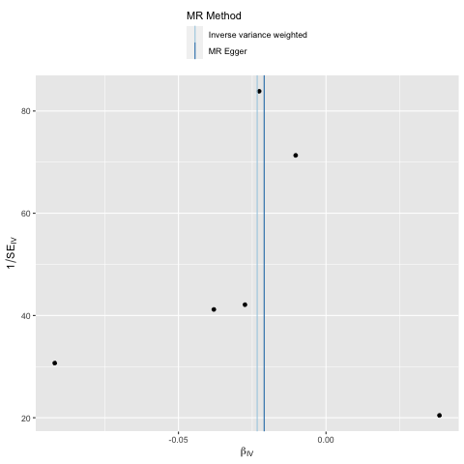

- Ever smokers

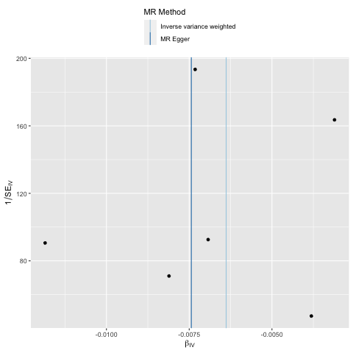

- Former smokers

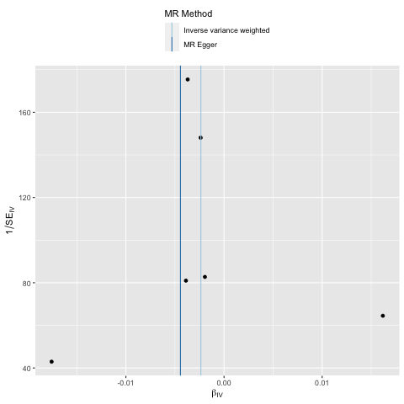

- Never smokers

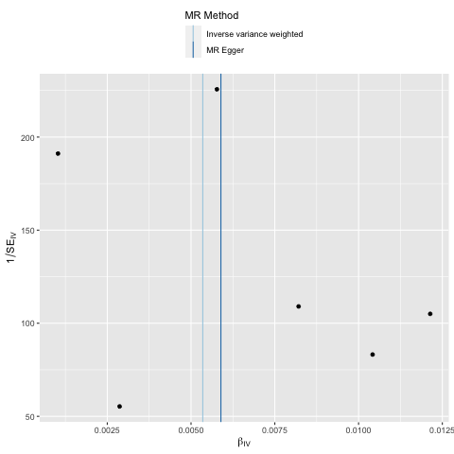

Supplementary Figure 18. Leave one out analysis from UVMR of NMR on sleep duration UK Biobank stratified by smoking status

- Current smokers

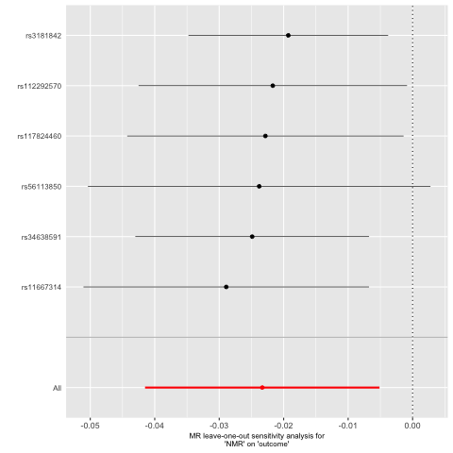

- Ever smokers

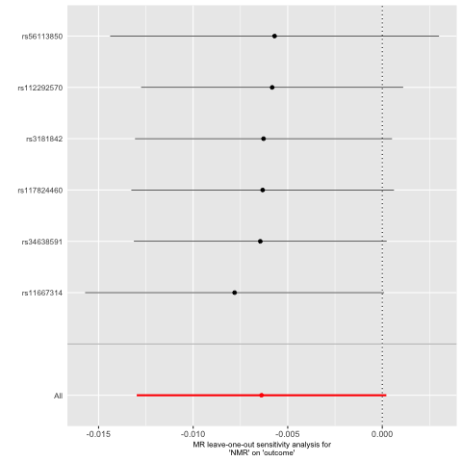

- Former smokers

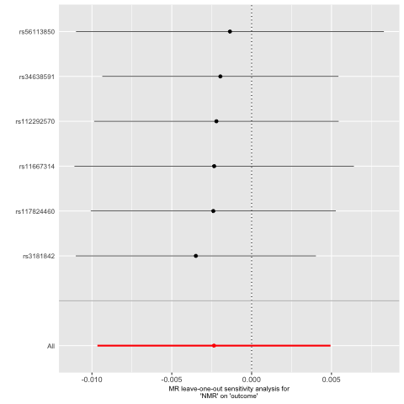

- Never smokers

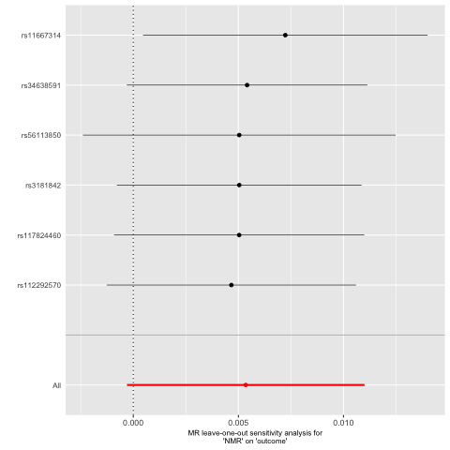

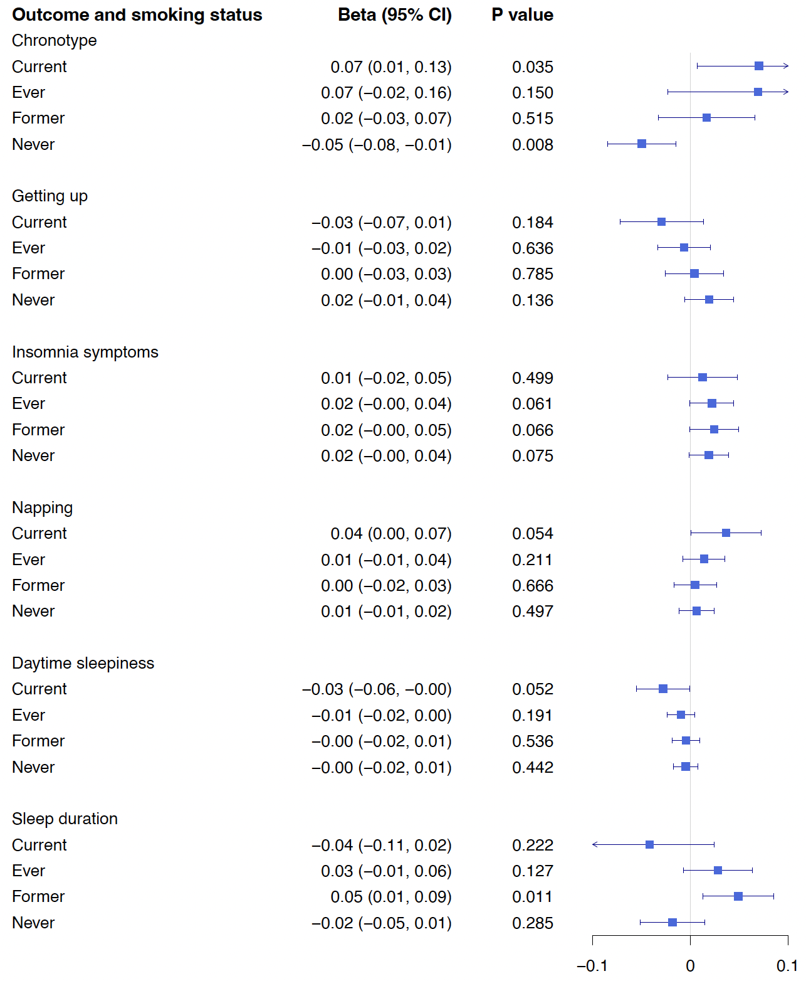
Supplementary Figure 19. Forest plot of results from IVW-MVMR analysis of CPD and sleep outcomes measured in UK Biobank stratified by smoking status

