SUPPLEMENTAL FIGURES:
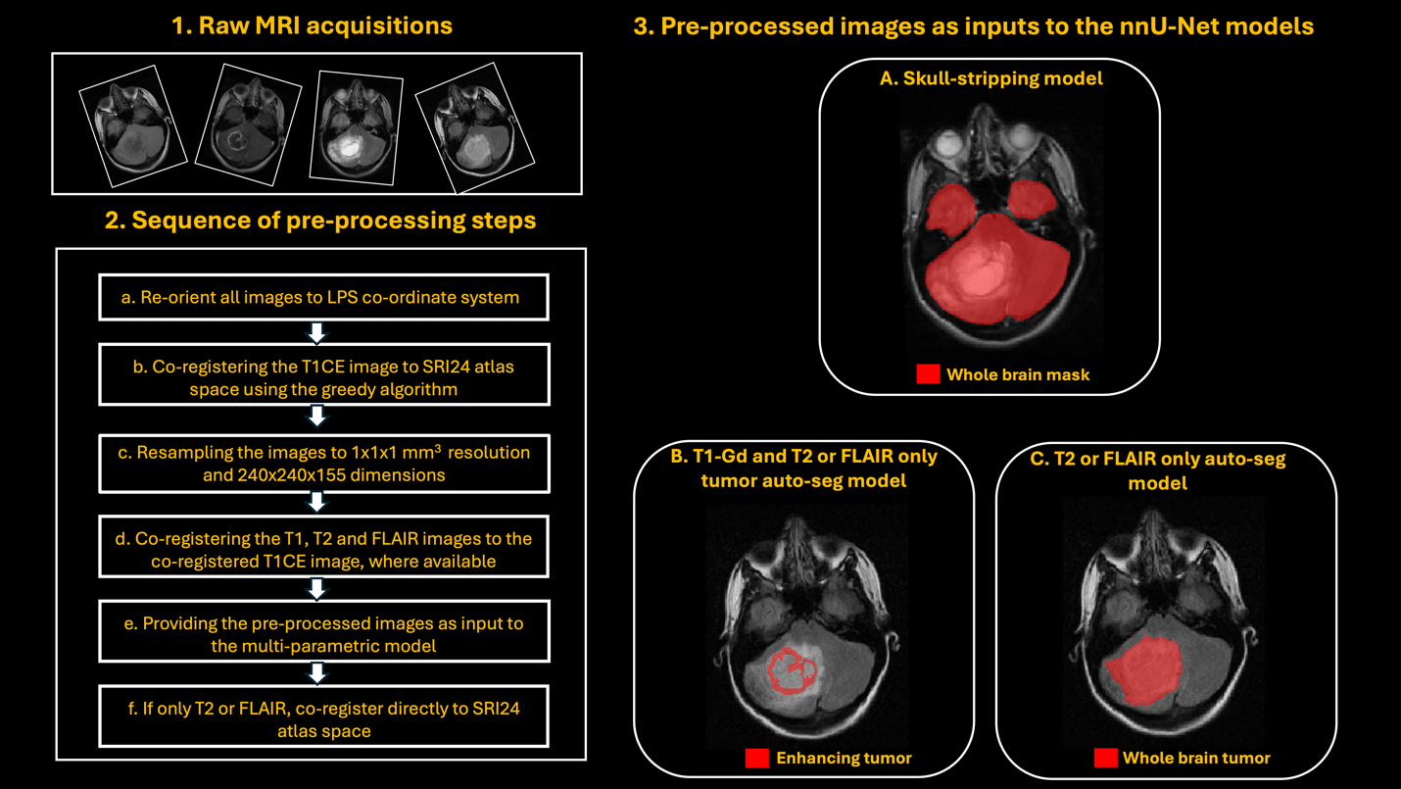
Supplemental Figure 1. Workflow of the entire end-to-end pediatric brain MRI pre-processing and fully automatic skull-stripping and tumor segmentation models. 1) Input raw brain MRI acquisitions, 2) Sequential steps for pre-processing the raw input images, along with the resulting pre-processed images, and 3) Pre-processed images as inputs to various nnU-Net models: A) Automatic skull-stripping, B) T1-Gd and T2 or FLAIR models for segmenting enhancing tumor (ET) and C) T2 or FLAIR model for segmenting just the whole tumor (WT) region.
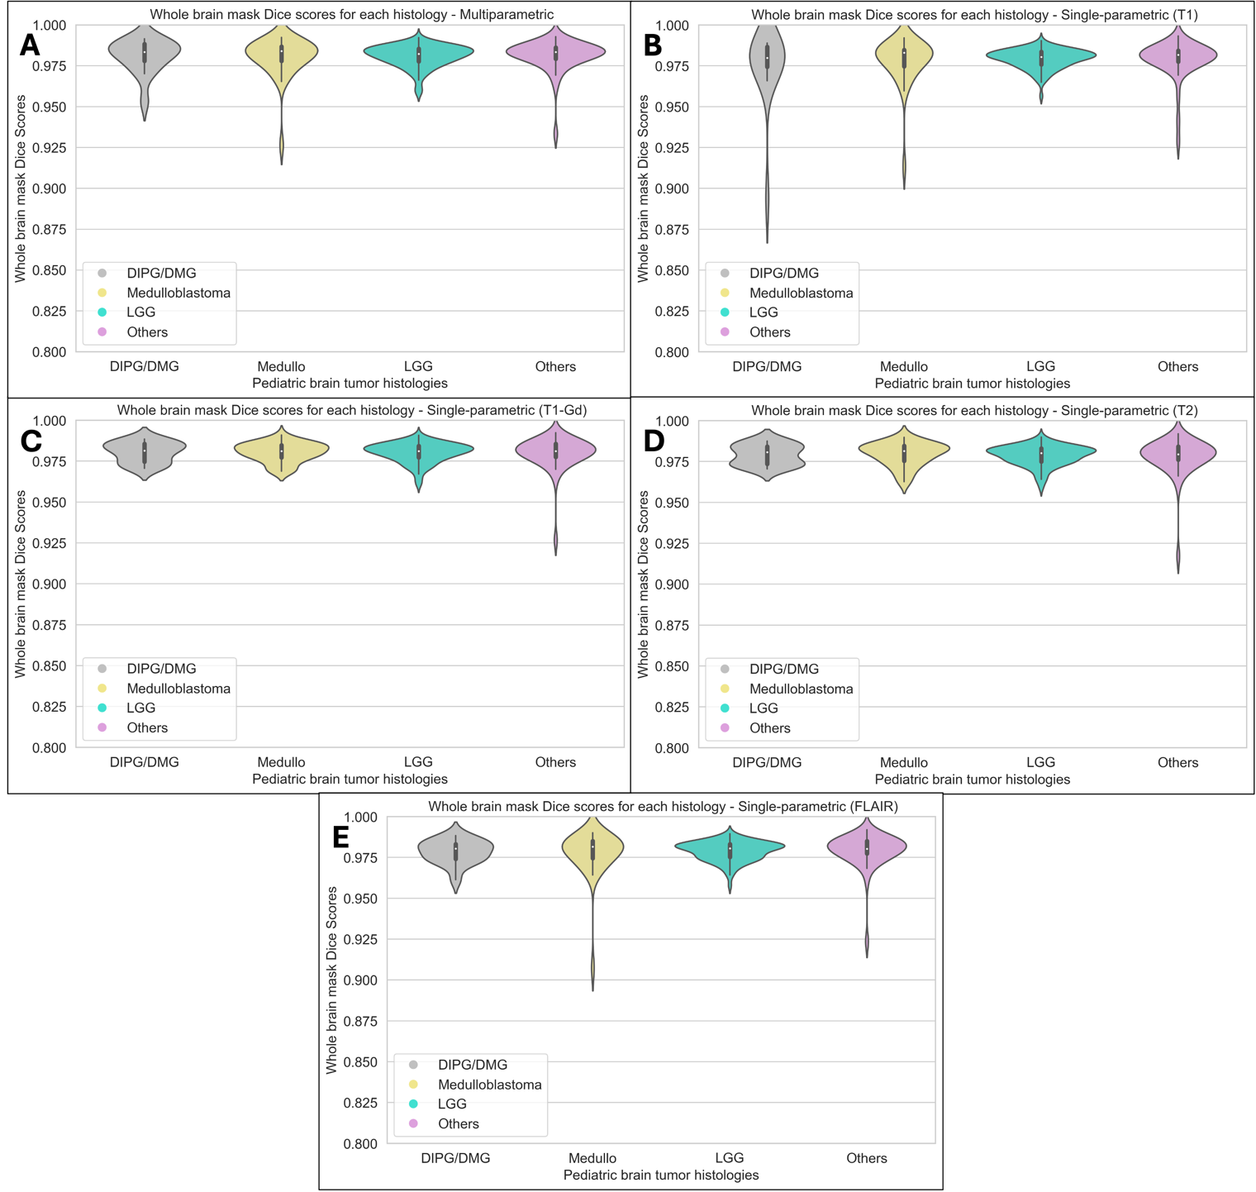
Supplemental Figure 2. Violin plots showing the distribution of whole brain mask Dice scores obtained using the multi-parametric skull-stripping model (A), and single-parametric skull-stripping model for each modality (B – T1, C – T1-Gd, D – T2 and E – FLAIR). These plots compare performance among various brain tumor histologies: DMG, medulloblastoma, LGG and Other histologies.
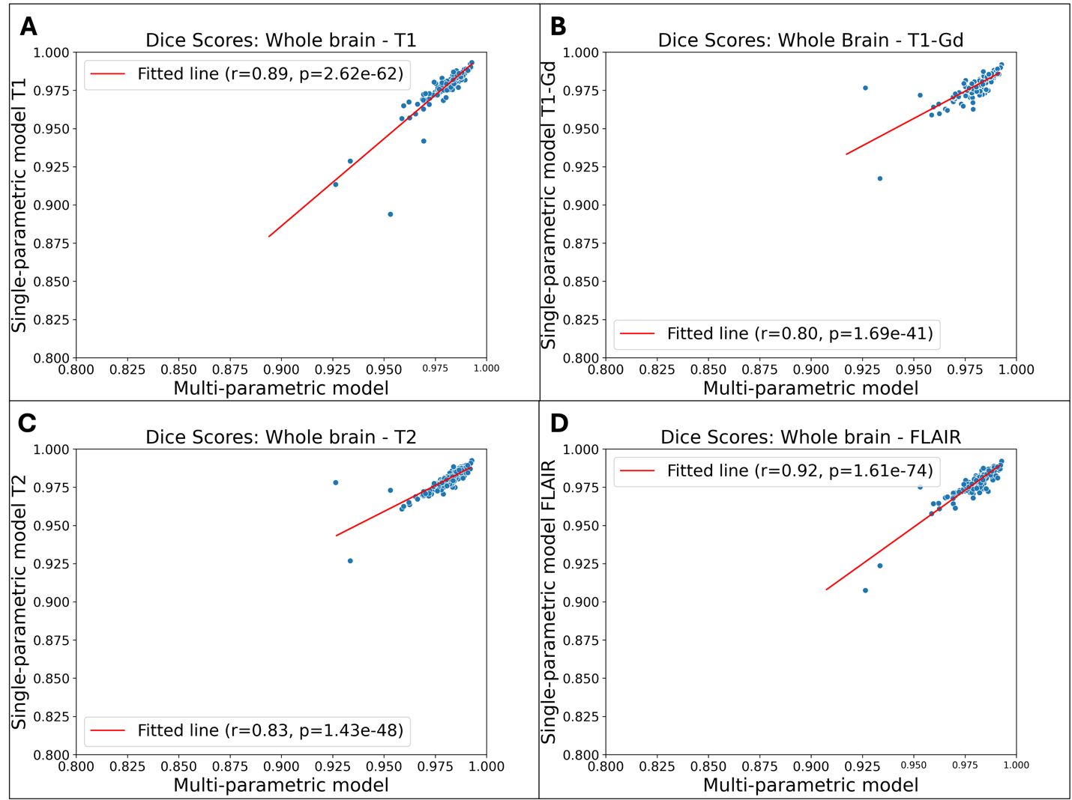
Supplemental Figure 3. Scatter plots showing the correlation between Dice scores obtained from the multi-parametric and single-parametric skull-stripping models with individual MRI sequences as inputs. There is a significant correlation between whole brain Dice scores obtained from the multi-parametric and each single-parametric model.

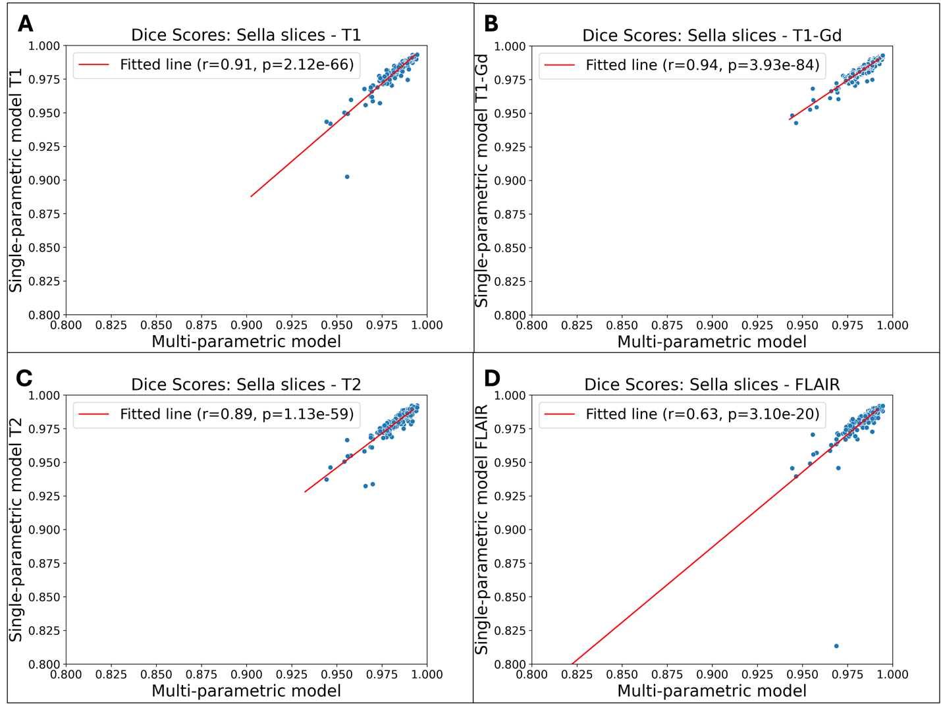

Supplemental Figure 4. Scatter plots showing the correlation between Dice scores obtained from the multi-parametric model and single-parametric models with individual MRI sequences as input for the sellar slices. There is a significant correlation between Dice scores obtained from the multi-parametric and each single-parametric model in the sellar/suprasellar regions.

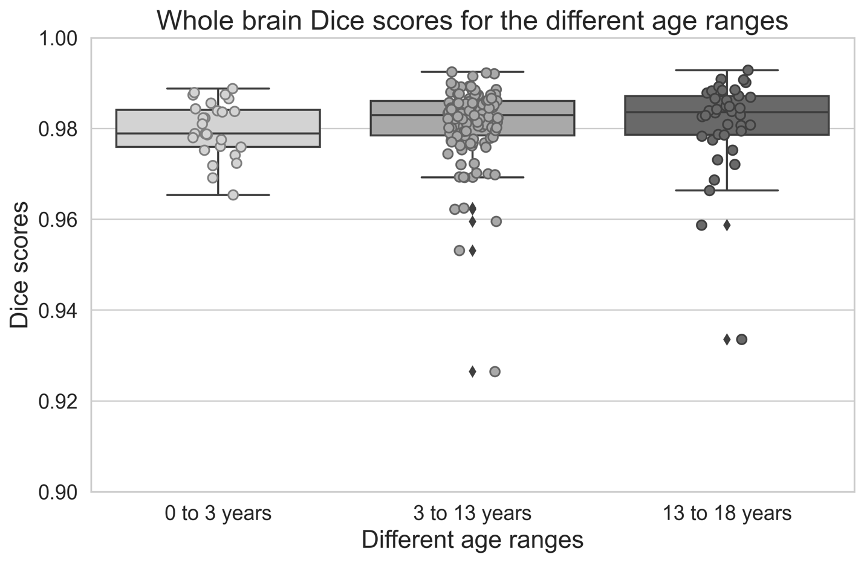
Supplemental Figure 5. Distribution of whole brain Dice scores using the multi-parametric skull-stripping model for different age ranges: 0 - 3 years, 3 - 13 years, and 13 - 18 years. There is no significant difference in the whole brain Dice scores between subjects from different age ranges (all p>0.05).

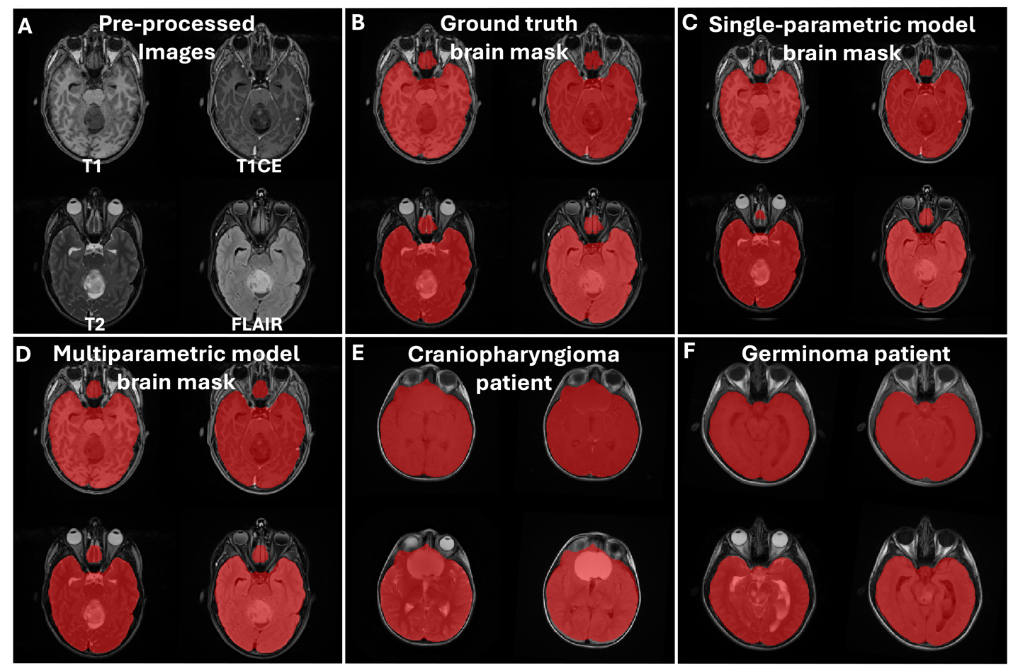
Supplemental Figure 6. Example pre-processed brain MR images (A) with overlaid ground truth brain mask segmentations (B), single-parametric skull-stripping model prediction (C), multi-parametric skull-stripping model prediction (D), along with example multi-parametric model predicted brain masks for a craniopharyngioma patient (E) and a germinoma patient (F). These images qualitatively demonstrate the superior performance of the two skull-stripping models.

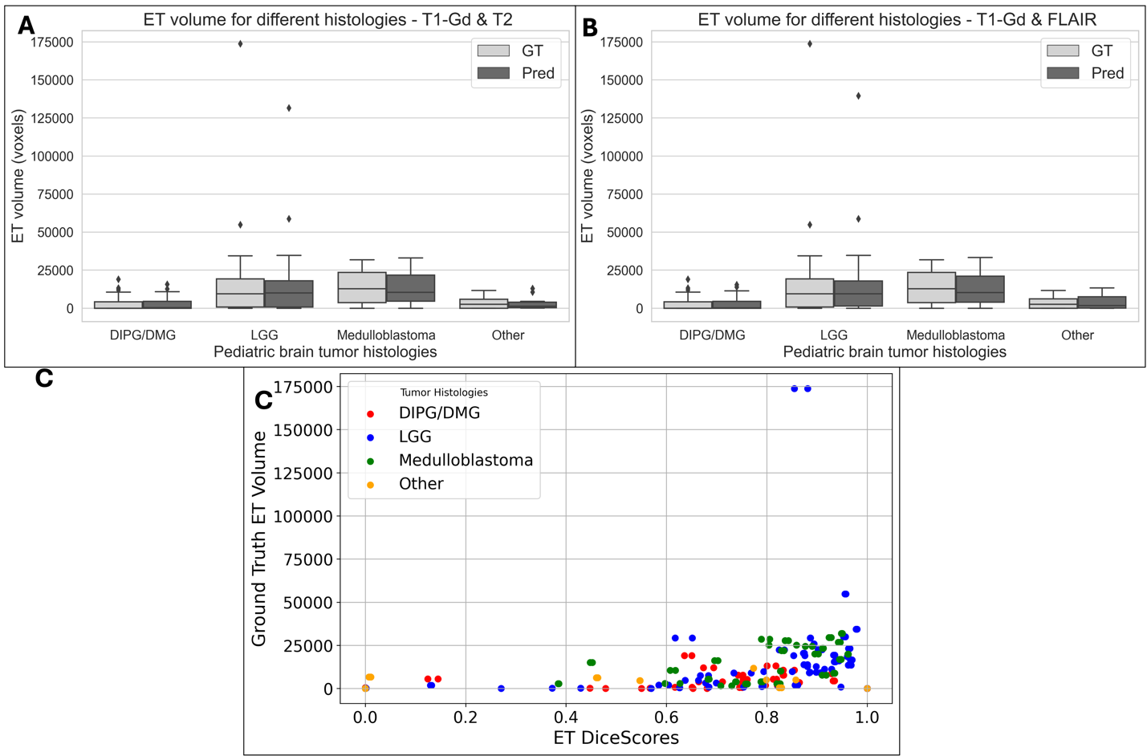
Supplemental Figure 7. Box plots showing the distribution of ET tumor volumes for ground truth and model-predicted segmentations with T1-Gd and T2 as inputs (A), and T1-Gd and FLAIR as inputs (B). Panel (C) shows the significant correlation between ET Dice scores and ground truth ET volumes.

Supplemental Table 1. Performance metrics for multi-parametric and single-parametric skull-stripping models (T1, T1-Gd, T2 and FLAIR inputs)– for both whole brain and sellar/suprasellar slices.
Region / Metric | Dice scores  Mean ± sd (Median) | Sensitivity  Mean ± sd (Median) | 95% Hausdorff distance mm  Mean ± sd (Median)
multi-parametric model – Whole brain
Brain Mask | 0.98±0.01 (0.98) | 0.98±0.02 (0.99) | 2.44±1.17 (2.24)
multi-parametric model – Only sellar/suprasellar slices
Brain Mask | 0.98±0.01  (0.99) | 0.98±0.01  (0.99) | 1.06±0.32 (1.00)
single-parametric model – Whole brain
T1 | 0.98±0.01 (0.98) | 0.98±0.02 (0.98) | 2.66±1.3 (2.24)
T1-Gd | 0.98±0.01 (0.981) | 0.98±0.01 (0.98) | 2.43±1.01 (2.24)
T2 | 0.98±0.01 (0.98) | 0.98±0.01 (0.98) | 2.56±1.04 (2.24)
FLAIR | 0.98±0.01 (0.98) | 0.98±0.02 (0.98) | 2.6±1.18 (2.24)
single-parametric model – Only sellar/suprasellar slices
T1 | 0.98±0.01 (0.99) | 0.98±0.01 (0.98) | 1.12±0.40 (1.00)
T1-Gd | 0.98±0.01 (0.98) | 0.98±0.01 (0.99) | 1.09±0.27 (1.000)
T2 | 0.98±0.01 (0.98) | 0.98±0.02 (0.98) | 1.14±0.37 (1.00)
FLAIR | 0.98±0.02 (0.98) | 0.98±0.03 (0.98) | 1.15±0.59 (1.00)

Supplemental Table 2. Performance metrics for whole tumor segmentation using skull-stripped versus non-skull-stripped images.
Patients with sellar/suprasellar tumors | WT Dice score (GT vs non-skull-stripped input) | WT Dice score (GT vs skull-stripped input)
Dice scores  Mean ± sd (Median) | 0.9±0.09(0.93) | 0.89±0.1(0.93)
Sensitivity  Mean ± sd (Median) | 0.86±0.11(0.89) | 0.85±0.14(0.88)
95% Hausdorff distance mm  Mean ± sd (Median) | 2.74±1.18(2.24) | 3.01±1.35(2.53)

Supplemental Table 3. MRI scanner field strength and manufacturer information for the skull stripping and brain tumor segmentation model cohorts.
MRI scanner field strength and manufacturer information | Skull stripping model cohort | Brain tumor segmentation model cohort
Total Patients | 336 | 489
Scanner Magnetic Field Strength  0.7T  1.16T  1.5T  3T  Information unavailable | 1  1  102  189  43 | 1  1  151  234  102
Scanner Manufacturer  Siemens  GE  Phillips  Toshiba | 257  30  4  1 | 329  47  9  1
Hitachi  Information unavailable | 1  43 | 1  102

