**PACA-AU Squamous subtype: worst prognosis**

**PACA-AU Progenitor subtype: best prognosis**

**B0**

**A**

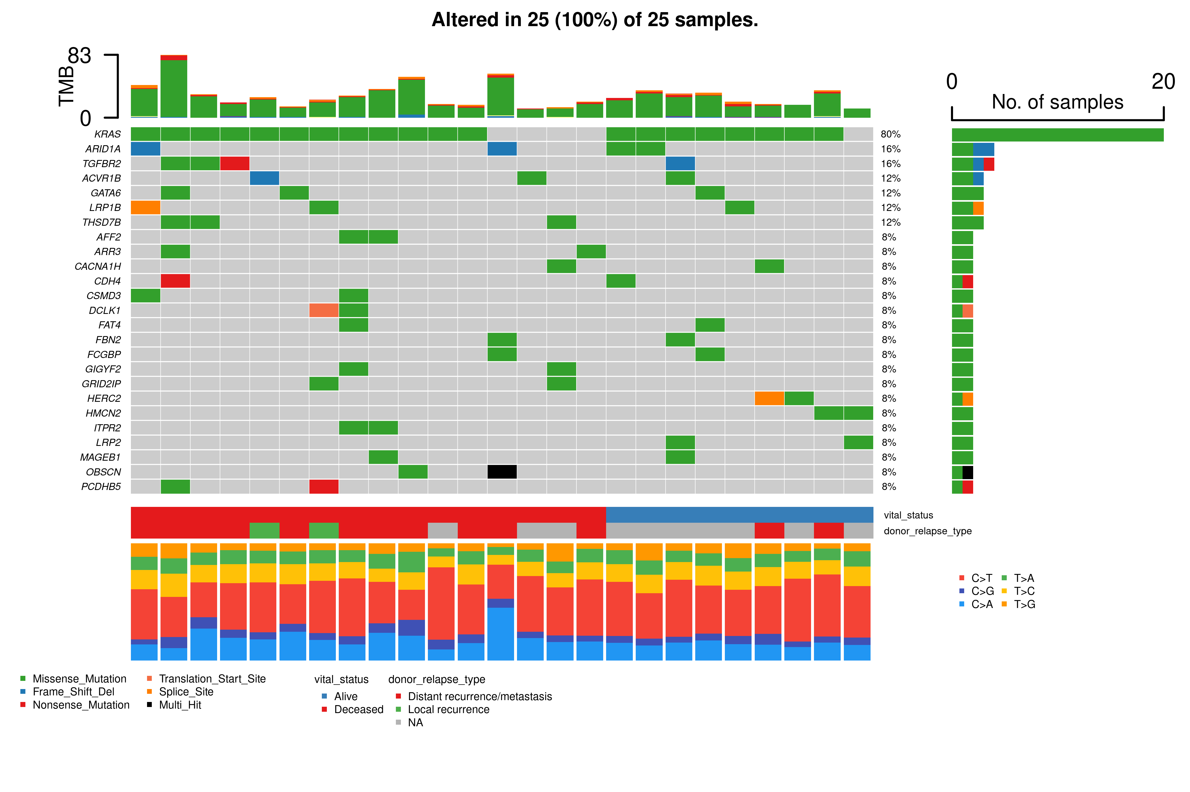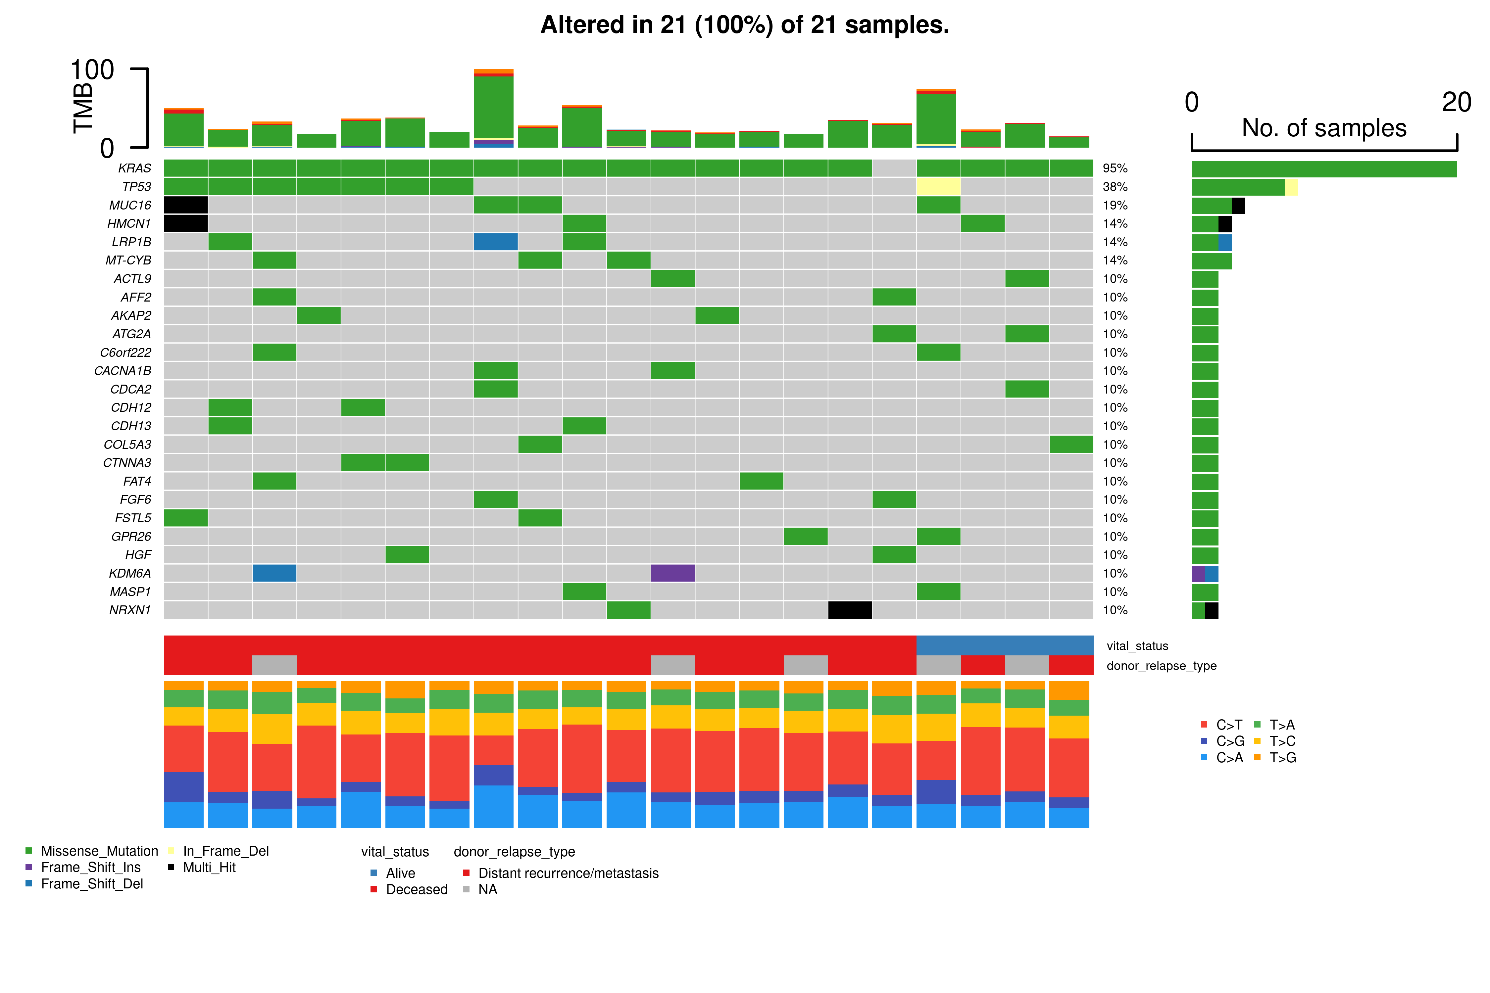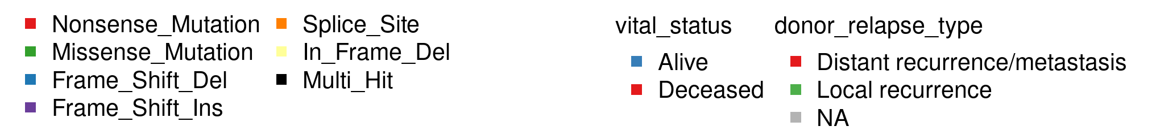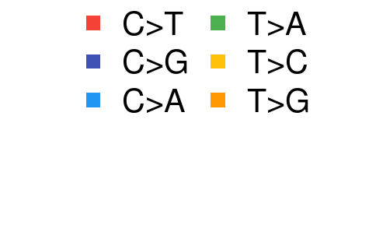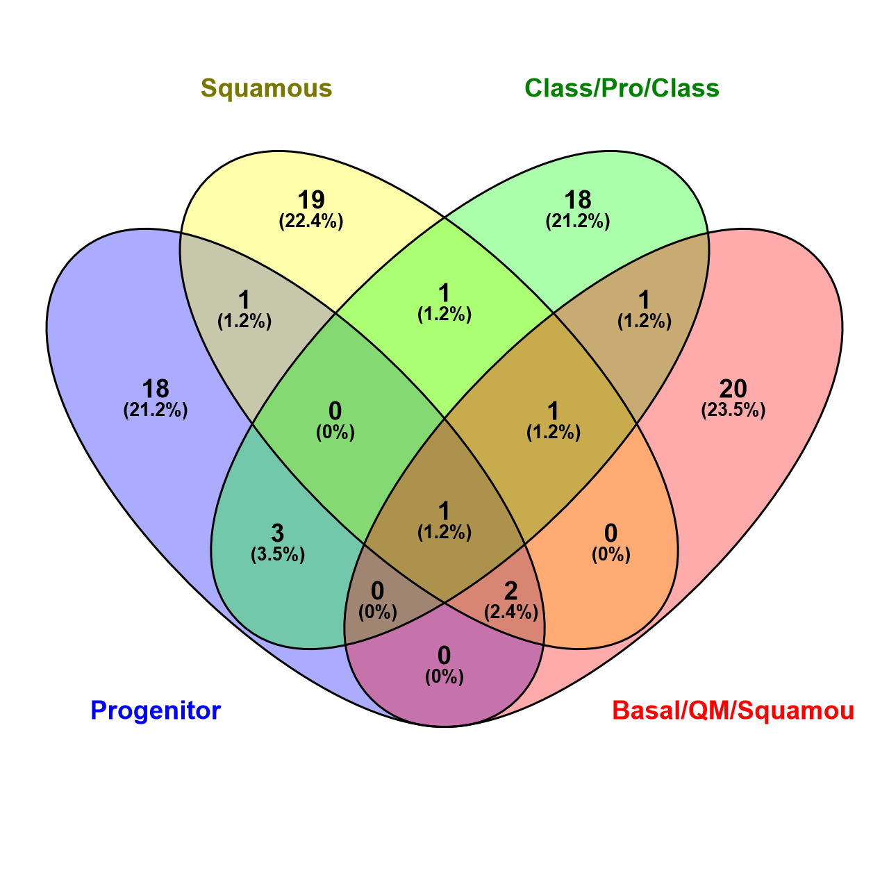

**PACA-AU**

**Squamous**

**TCGA**

**Classical/Progenitor**

**TCGA**

**Basal/QM/Squamous**

**PACA-AU**

**Progenitor**

***KRAS***

***MUC16***

***TP53***

***CDKN2A***

***AFF2***

***FAT4***

***ARID1A***

***CACNA1H***

***CSMD3***

***LRP1B***

**TCGA**

**Basal/QM/Squamous**

**TCGA**

**Basal/QM/Squamous**

**C0**

**Supplementary Figure 1**. **Frequently mutated genes in ICGC PDAC (PACA-AU) Progenitor (best prognosis) and Squamous (worst prognosis) subtypes.**

Oncoplots* showing the top 25 most frequently mutated genes in ICGC PACA-AU PDAC samples classified as either **(A)** *progenitor* (n=25)or **(B)** *squamous* (n=21) subtype. **(C)** Venn diagram showing limited overlap between somatic variants underlying the best/worst prognosis transcriptomic subtypes from the TCGA and ICGC cohorts separately: *classical vs basal* and *progenitor vs. squamous*, respectively. Plot created in [Venny 2.1](https://bioinfogp.cnb.csic.es/tools/venny/index.html).

*Mutated genes are ranked in order of the *total* number of *mutations* in each given gene (genes with >1 mutation present are shown in black as ‘multi-hit’), while the percentage annotations to the right of each bar reflects the proportion of *samples* altered in the cohort.

TCGA PDAC consensus worst prognosis subtype (n=16):

Moffitt (Basal), Bailey (Squamous), Collisson (QM)

TCGA PDAC consensus best prognosis subtype (n=27):

Moffitt (Classical), Bailey (Progenitor), Collisson (Classical)

**A**

**B0**

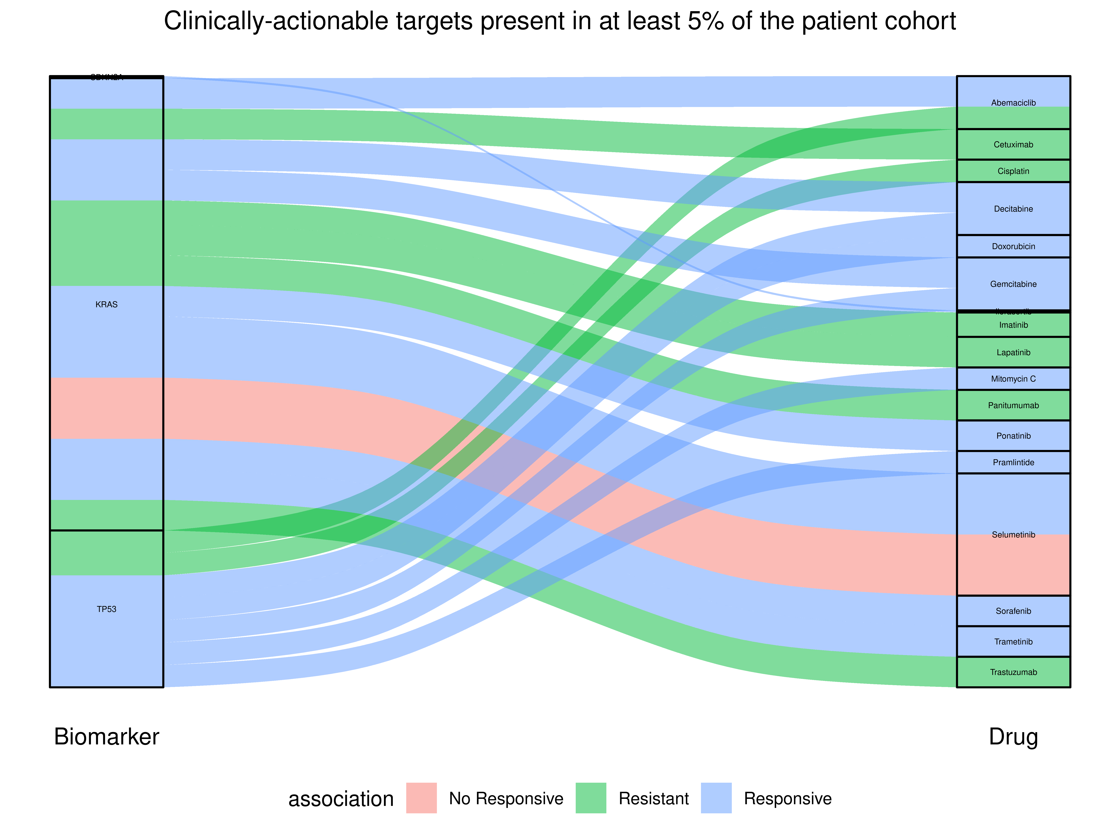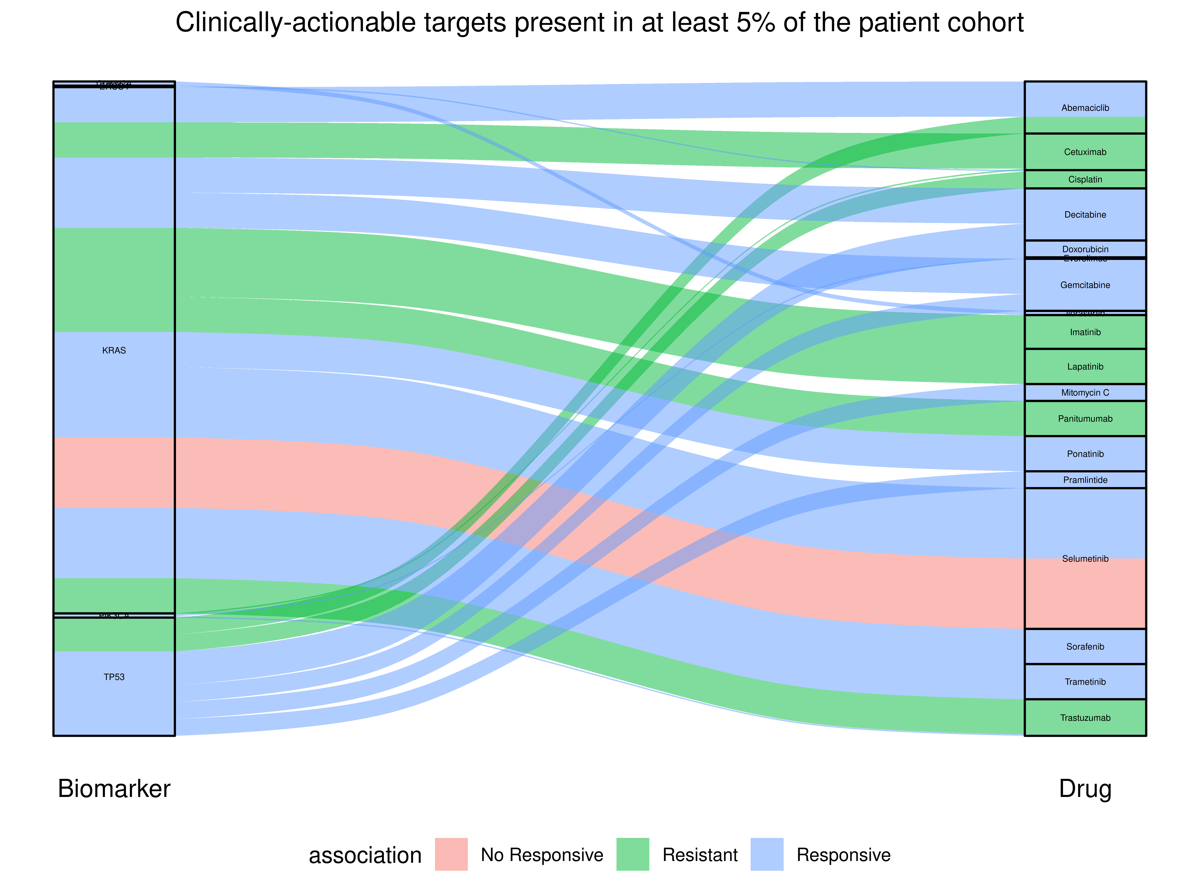

**C0**

**D0**

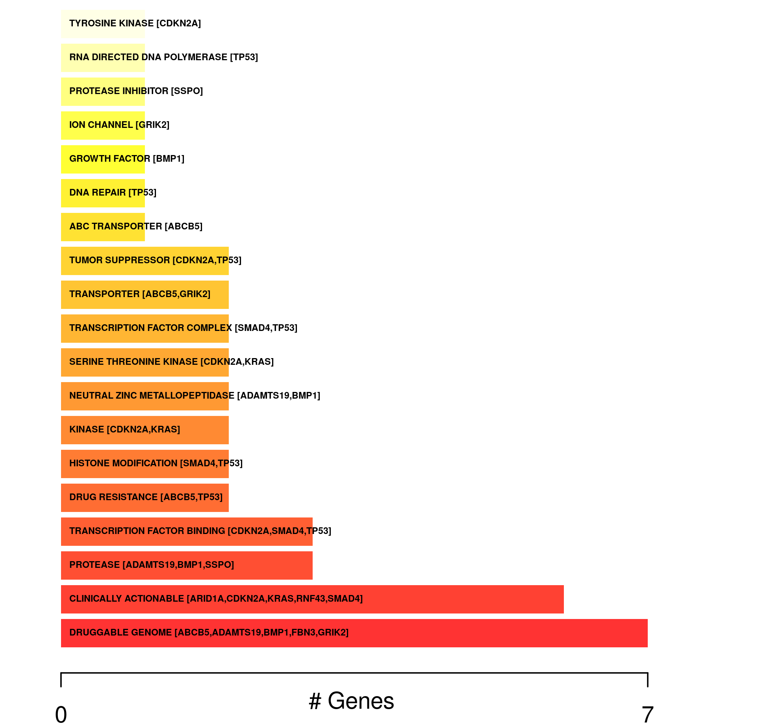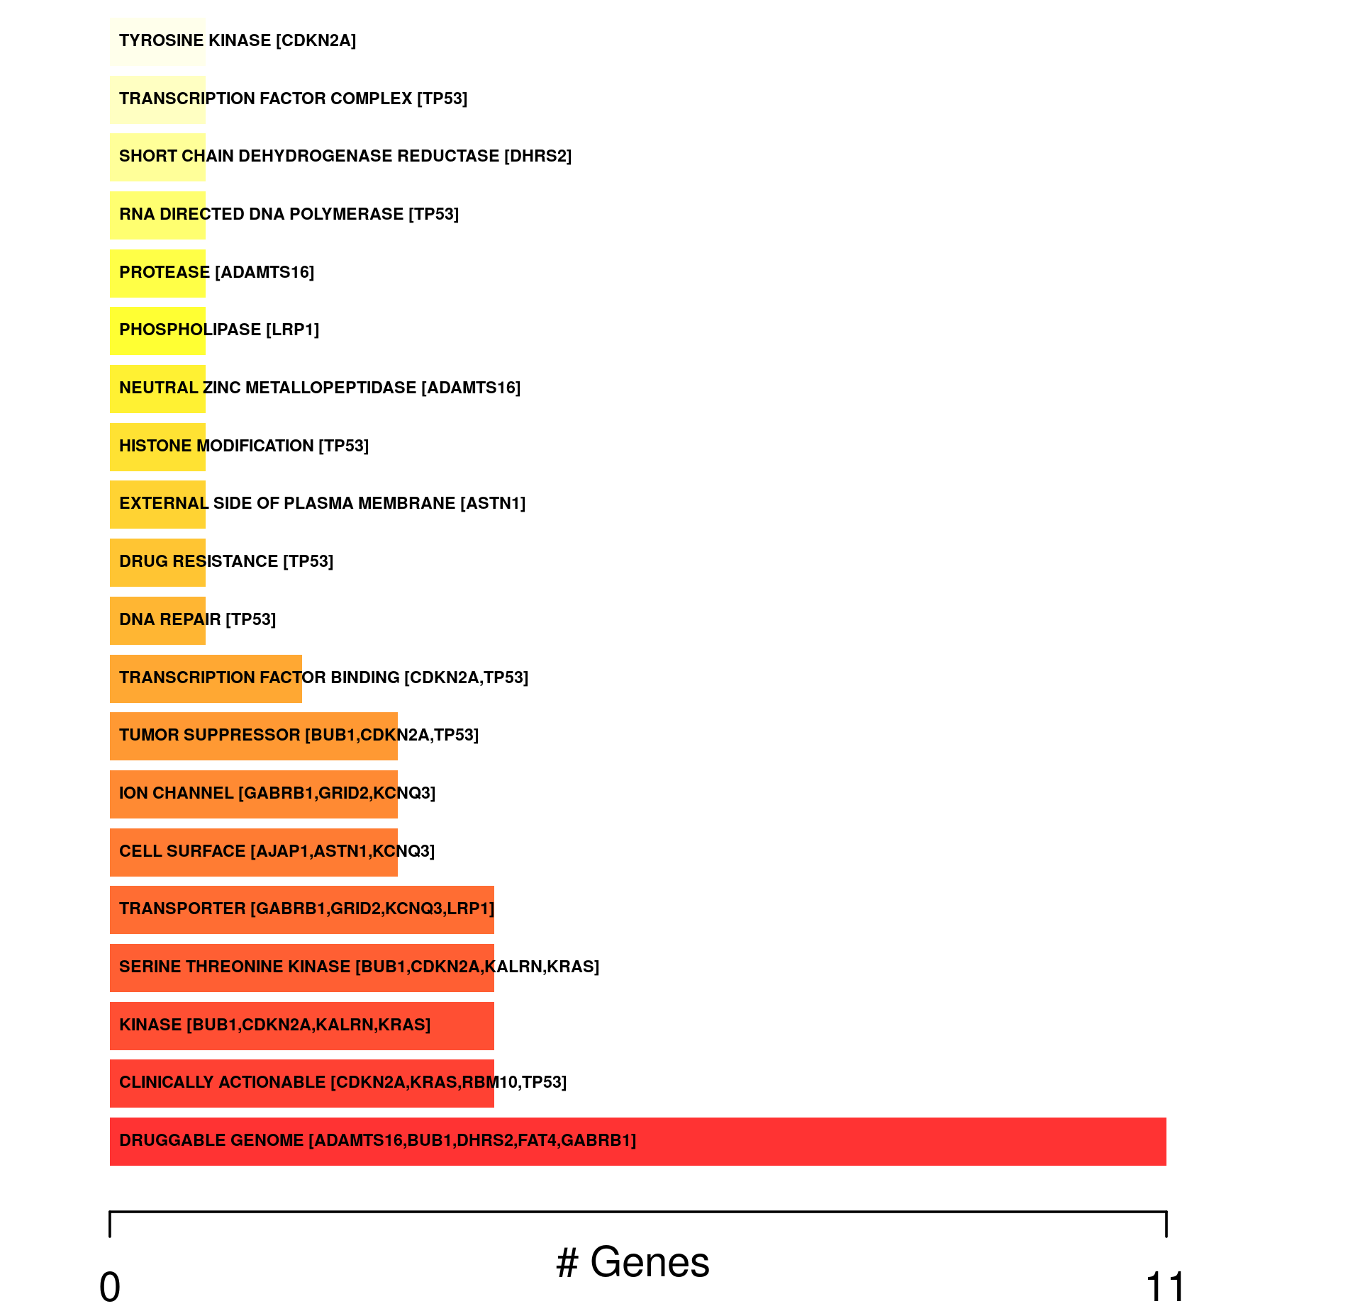

**Supplementary Figure 2**. **Summary of the most frequently altered clinically actionable targets in best and worst prognosis TCGA PDAC tumours.** Alluvial plots showing the most frequently altered clinically actionable gene targets (*KRAS* and *TP53*) present in 5% of the selected patient cohort across **(A)** classical/progenitor/classical (best prognosis), and **(B)** basal-like/QM/squamous (worst prognosis) subtypes, as identified by the Cancer Genome Interpreter; subtype-specific gene/biomarker combinations not present at >5% are highlighted. The number and type of mutated genes associated with each patient group are further summarised into functional categories, compiled from the Drug Interaction Database: best prognosis (**C**) vs worst prognosis (**D**).

Best prognosis subtype (n=25): ICGC PDAC

*Progenitor* (Bailey)

**AA**

**BA**

Worst prognosis subtype (n=21): ICGC PDAC

*Squamous* (Bailey)

**Supplementary Figure 3**. **mRNA expression levels of TP53 in ICGC PACA-AU patients.**

Box and whisker plots showing the distribution of TP53 mRNA expression levels in the ICGC PACA-AU PDAC patients, filtered according to Bailey et al. (2016) prognostic subtype: **(A)** Progenitor subtype (best prognosis) has relatively higher median levels of TP53 expression than **(B)** Squamous subtype (worst prognosis).