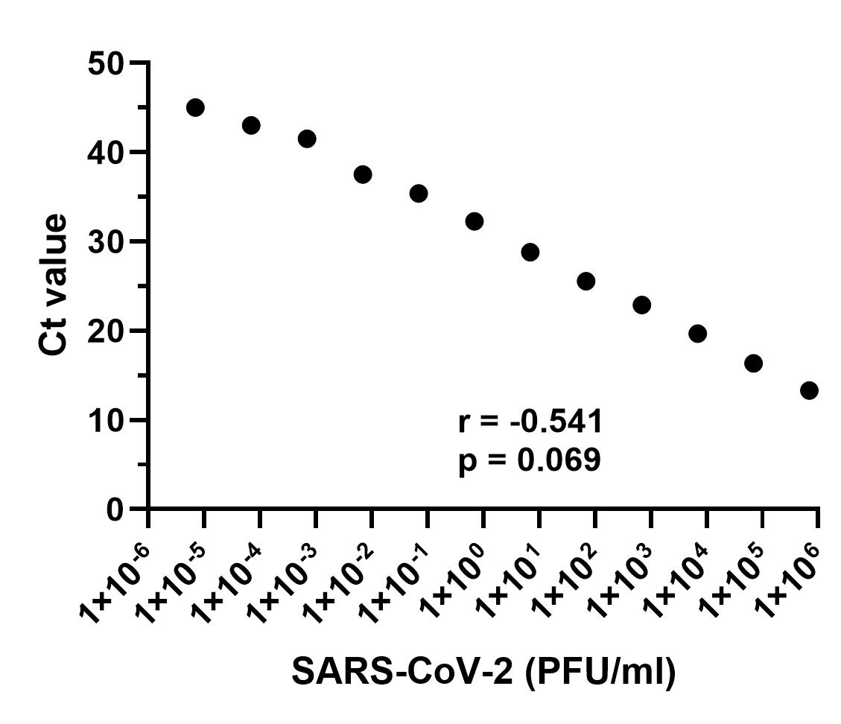

***Supplementary Figure 2.*** *Correlation between viral titer expressed as plaque forming units (PFU/ml) of SARS-CoV-2 and the corresponding Ct value observed in SARS-CoV-2 qRT-PCR.*