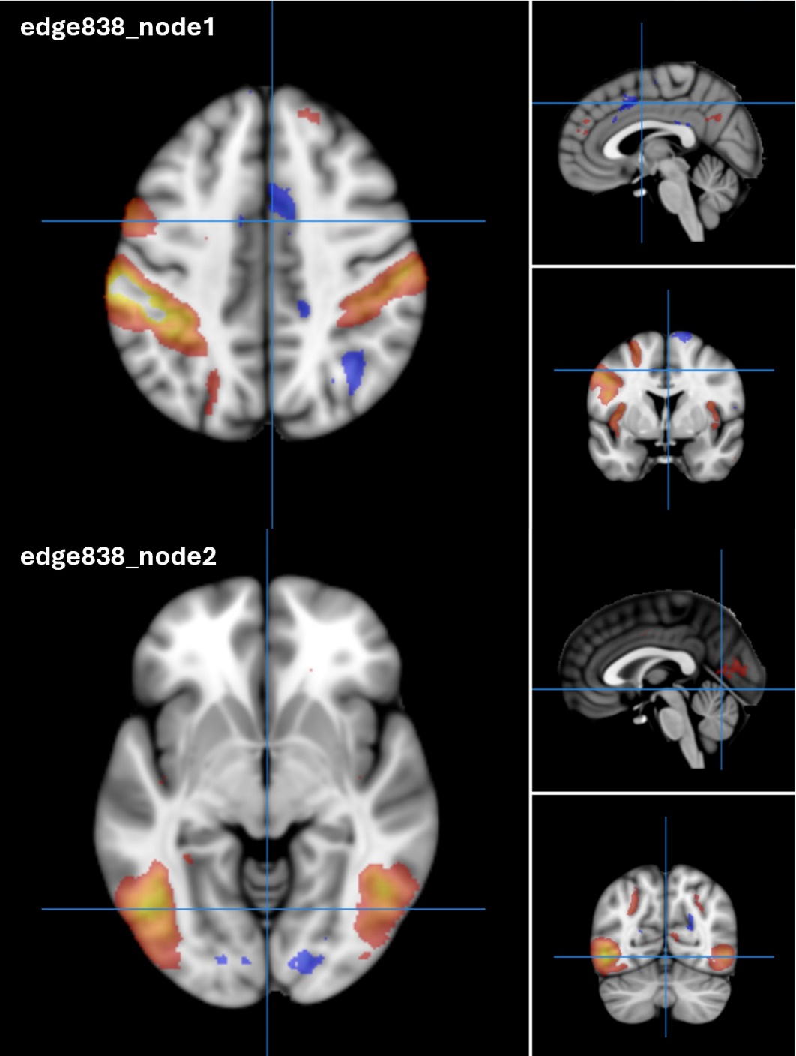

Supplemental Fig. 1: Brain imaging-derived phenotypes (IDP) 3266 reflecting edge 838 of dimensionality 100 separated by spatial Independent Component Analysis (ICA) in resting-state functional magnetic resonance imaging.

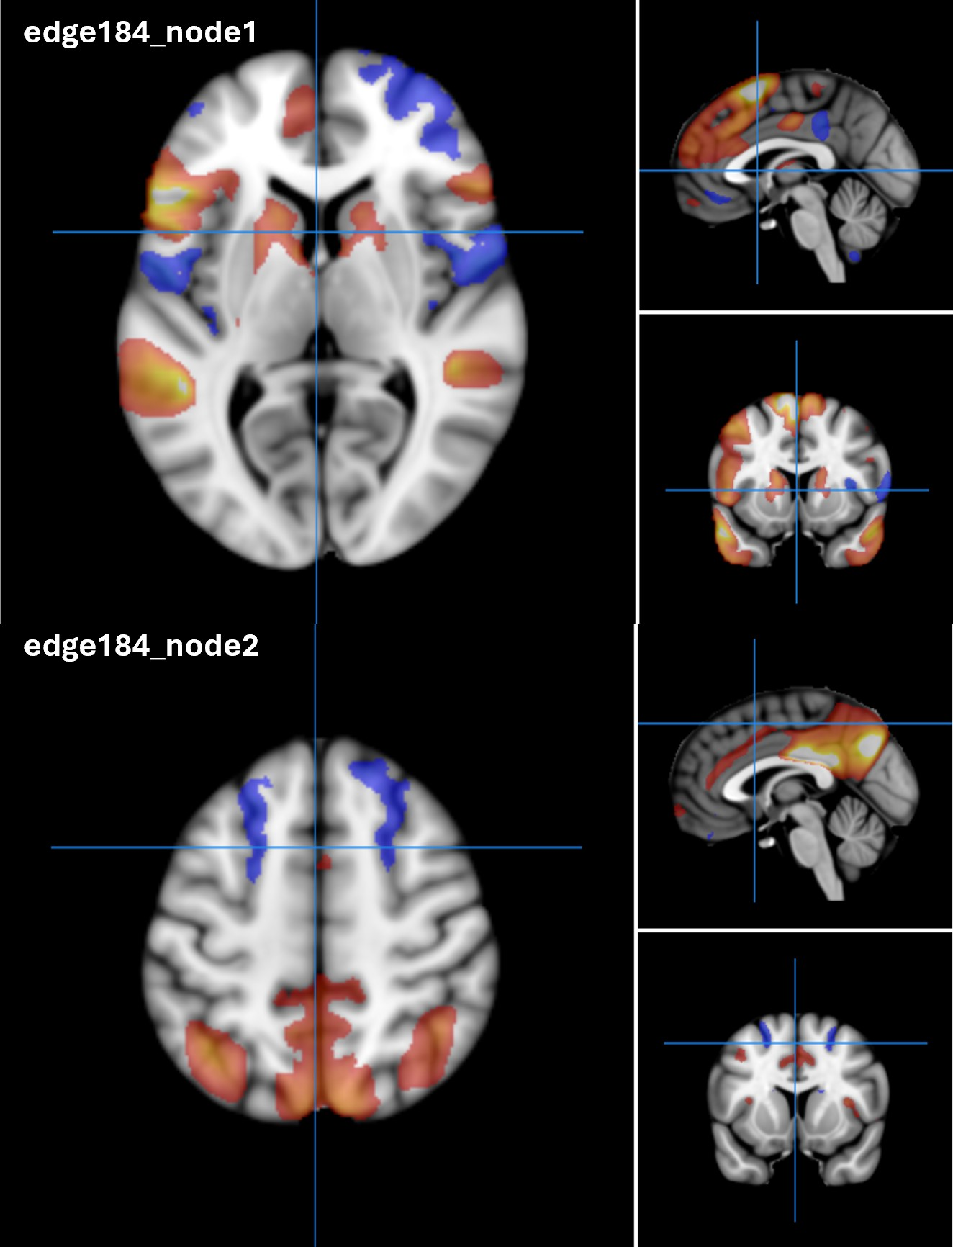
Supplemental Fig. 2: IDP 2402 reflecting edge 184 of dimensionality 25 separated by spatial ICA in resting-state functional magnetic resonance imaging.

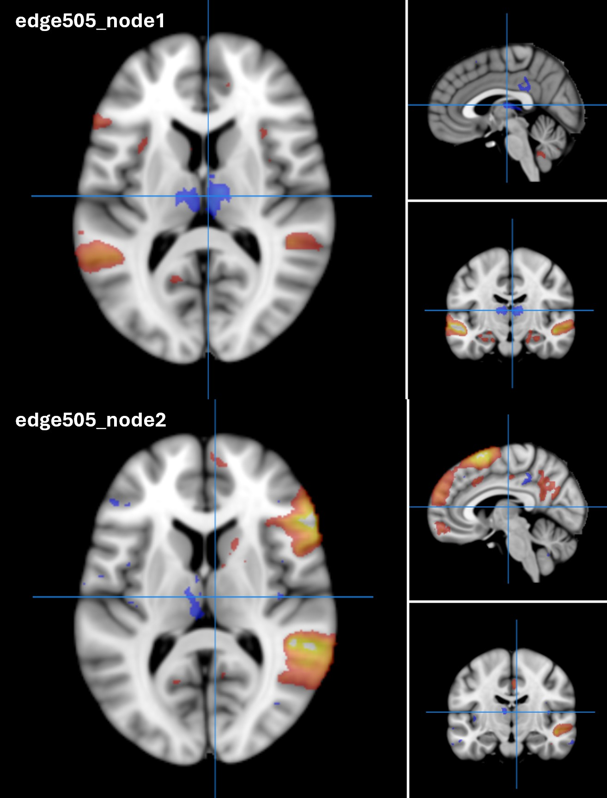
Supplemental Fig. 3: IDP 2933 reflecting edge 505 of dimensionality 100 separated by spatial ICA in resting-state functional magnetic resonance imaging.

